|  |  |
| --- | --- |
| cetlogo ***CHEMICAL ENGINEERING TRANSACTIONS***  ***VOL. xxx, 2025*** | A publication of  aidiclogo_grande |
| The Italian Association  of Chemical Engineering  Online at www.cetjournal.it |
| Guest Editors: Bruno Fabiano, Valerio Cozzani  Copyright © 2025, AIDIC Servizi S.r.l. **ISBN** 979-12-81206-xx-y; **ISSN** 2283-9216 | |

EuroValve: Stable operation of spring-loaded safety valves in gas service through damping and internal modifications

Gergely Keszthelyia,\*, Jürgen Schmidta, Jens Deneckea,b

aCSE Center of Safety Excellence (CSE-Institut), Joseph-von-Fraunhofer-Str. 9, 76327 Pfinztal, Germany

bUniversity of Applied Sciences, Moltkestrasse 30, 76133 Karlsruhe, Germany

\* gergely.keszthelyi@cse-institut.de

The stable operation of safety valves is required for the adequate protection of chemical plants. Instabilities like flattering and chattering of safety valves have caused severe damage to plants in the past. The publication introduces the results of the Eurovalve project investigated at the CSE Center of Safety Excellence.

Various models for safety valves are presented along with the equations used for numerical solution. It is shown that the stability of safety valves cannot be precisely pre-determined with the models currently available. Therefore, two methods of improving the stability that require the modification of the valve are proposed.

One such solution is the addition of different types of dampers to the safety valves. Measurements have been conducted to investigate the effect of friction dampers, and the results are analysed. The stability of the safety valve improves, but the safety valve reseating pressure drops below what is permissible by the standard. Simulations are used to test the effect damping on the system, showing that the analysed safety valve opens in a stable manner with a damping that reaches the critical damping of the spring mass-damper system.

The other possible solution presented in this paper is the modification of the force acting on the safety valve disk. The theoretical effects of modifying the safety valve disk are evaluated by varying the effective area of the safety valve. Limits for the effective area are derived based on the requirements of the international standards. Four different cases are examined within and out of these limits, showing that further investigations are necessary to adhere the standards.

* 1. Introduction

Safety valves are used across the chemical and other industries to protect vessels from overpressure. As such, the error-free operation of these devices is paramount. One of the issues of safety valve operation is a rapid movement of the safety valve disk called chatter. This phenomenon can have in catastrophic results, such as a refinery explosion in Italy in 1985 (European Process Safety Centre, 2020), or a more recent steam cracker explosion and fire in the Czech Republic in 2015 (Herink et al., 2022).

Measurement results from the United States such as the ERPI dataset focusing on steam safety valves in the nuclear industry (EPRI Valve Test Program Staff, 1982) or the newer ones conducted by Aldeeb, Darby and Arndt (2014) on valves in gas service showed that safety valves can chatter even in cases the safety valve is sized according to the current regulatory standards. As American safety valves are constructed differently to Europeans, the Eurovalve project was initiated to investigate the phenomenon of chatter and determine its effect on safety valves in gas service designed and sized in Europe, and present solutions to increase the stability of existing European safety valves.

* 1. Safety valve stability modelling

The relevant ISO 4126-7:2007 (International Organization for Standardization, 2007) and API 520 (American Petroleum Institute, 2015) standards proscribe the use of the so-called 3% rule to guarantee the safe operation of safety valves. This model is based on limiting the stagnation pressure drop in the inlet line to a maximum of 3% of the set pressure, and is based on the original research of Sylvander and Katz (1948).

Since the publication of the 3% rule described, there have been multiple competing methods proposed to predict the stability of the safety valve. Notable examples are:

* the simple force balance of Melhem ( 2014a, 2014b) based on the forces acting on the valve disk, including the initial Joukowsky wave;
* the Izuchi model (Izuchi, 2008), based on a transfer function of the safety valve and its inlet line;
* and the quarter-wave model (Hős et al., 2014), which assumes that the pressure and velocity distribution in the inlet line follows that of a quarter wave.

Another option is the numerical modelling of the safety valve and the inlet line, which has been used by the authors to validate their stability models. In these cases, the safety valve is described as a spring-mass-damper system:

|  |  |
| --- | --- |
| $$F_{f}=m\ddot{x}+c\dot{x}+k\left(x+x_{0}\right)$$ | (1) |

with the dot denoting the derivation according to time. The force acting on the valve disk is dependent on multiple factors but is modeled as being only dependent on the valve lift and the pressure in front of the valve.

One empirical method used to include the lacking factors is the effective area model. Using this model the force acting on the safety valve disk is calculated by multiplying the pressure difference between the inlet and outlet of the safety valve with the effective area.

|  |  |
| --- | --- |
| $$F_{f}=A_{eff}\left(x\right)⋅(p_{in}-p_{b})$$ | (2) |

To properly simulate the safety valve in its closed status, the effective area is equal to the area of the nozzle when the safety valve is closed (i.e. $x=0$).

The inlet pipe is treated as one-dimensional, and the mass, momentum and energy equations are solved on an ideal fluid:

|  |  |
| --- | --- |
| $$\frac{∂ρ}{∂t}+\frac{∂}{∂l}\left(ρw\right)=0$$ | (3) |
|  | (4) |
| $$\frac{∂}{∂t}\left(ρe\right)+\frac{∂}{∂l}\left(ρew+pw\right)=0$$ | (5) |

assuming a constant pipe diameter and constant friction factor. The parameters are always meant as cross sectional averaged, with $\frac{∂}{∂l}$ denoting derivation along the axis of the pipe.

The two models are usually coupled by describing the mass flow through the safety valve using the nozzle equation for gas flow:

|  |  |
| --- | --- |
| $$\dot{m}=K_{d}⋅Ψ⋅A_{flow}\left(x\right)\sqrt{\frac{2⋅p_{in,t}}{ρ_{in,t}}}$$ | (6) |

with the $A_{flow}\left(x\right)$ being the smallest cross section available for the fluid. This is either the cylindrical area between the inlet nozzle and the valve disk, or the nozzle itself, whichever is smaller.

An analysis of the models used to describe the movement of the safety valve (Keszthelyi et al., 2024) has shown that the current modelling of safety valves is not sufficient to guarantee the stability of the safety valve due to the variety of parameters needed to describe the stability of the safety valve, and the changes of these parameters during the lifetime of the safety valve.

There are multiple parameters that could possibly be modified to create a stable safety valve, such as the fluid force acting on the disk, the moving mass of the safety valve, the spring stiffness of the system, and additional damping within the system. Two such options will be explored in this publication – increasing the damping of the safety valve externally, and a modification of the fluid force acting on the valve disk.

* 1. Increased damping

Increasing the stability of the safety valve has been proposed as a solution to safety valve instability as early as the 1980-s, when Singh (1982) calculated the positive effects of damping on a safety valve. The positive effects of damping were also measured by Cremers, Friedel and Pallaks (2001), but neither provided a method for sizing a safety valve damper. Hydraulic dampers were also patented by Framatome engineers, but valves equipped with such dampers are currently not available.

Other types of dampers are available as an extension of safety valves, such as the O-ring damper by LESER, or the graphite element by IMI Bopp&Reuther. These elements are based on increasing the friction on the safety valve spindle, and work both during the opening and the closing of a safety valve. The damping factor of these elements is not provided, only a qualitative improvement is mentioned in the manufacturer catalogues.

To determine the effects of commercial friction dampers on the stability and operation of safety valves, measurements were conducted at the CSE High-Pressure Loop (Dannenmaier et al., 2018) with such a device. The measurements were conducted with a European DN25x40 valve, for which the base parameters can be seen in Table 1. The safety valve was connected to a puffer vessel by a 2.25m long, DN25 inlet line, and was without any outlet piping. The pressure was measured in the vessel and in three points along the inlet line, including directly in front of the safety valve.

Table 1. Parameters of the safety valve tested with increased damping

|  |  |  |  |  |
| --- | --- | --- | --- | --- |
| Set pressure | Moving mass | Spring stiff. | Nozzle diam. | Medium |
| 5.43 bar(g) | 0.396 kg | 28.615 kN/m | 23 mm | Air |

Measurements were conducted with and without the damper. A plot of the lift of the safety valve and the static pressure measured at the inlet flange of the safety valve can be seen in Figure 1. As the figure shows, the otherwise chattering safety valve opened and closed in a stable manner with a friction damper. The ISO4126-7 standard currently proscribes that the safety valve must achieve its full lift by 110% of the set pressure and must reclose by 85% of the set pressure in gauge. These values can be seen on the black dashed lines. The results show that at the time of closing (blue vertical dashed lines) the pressure in front of the safety valve had dropped below the reseating pressure required by the ISO standard.

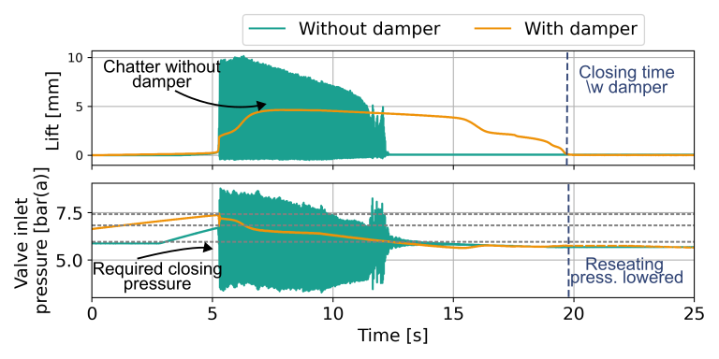

Figure 1. Measurements of a European safety valve with and without a friction damper

Both effects are due to the friction force, which acts in the reverse to the movement of the safety valve disk. During the opening, the friction force works downwards, slowing down the safety valve, and enhancing the stability. However, during closing it works against the closure of the safety valve, meaning that the pressure needs to drop further so that the safety valve can fully close.

To further investigate of the effects of stabilizers, one-dimensional CFD simulations of the opening of a safety valve connected to an inlet line were conducted using the simulation model 1DCSE (Keszthelyi et al., 2024). The input parameters were set to match the measurements described in Table 1. During the simulations, the damping was varied between no damping and a damping equivalent to the critical damping of the spring-mass damper system with steps of 0.1. At every damping, simulations were carried out at 19 different lengths between 0.5 m and 5 m with a half-meter step, resulting in 209 simulations.

The results of the simulations can be seen in Figure 2, with the red crosses denoting an unstable, and green crosses denoting a stable simulation. The results show that the safety valve is only stable under a length of less than 1 m with no damping. Increasing the relative damping does introduce stable positions but does not increase the lowest inlet line length where the safety valve is stable. That value only increases at 90% of the critical damping. The safety valve is stable in all inlet pipe lengths tested with a damping equivalent to the critical damping.

The results of the simulation and the measurement align with expectations. Increasing the damping can improve the stability of the safety valve, but for the damping to have an effect at all lengths, a high damping was required. This, however, does result in a drop in the reseating pressure of the safety valve.

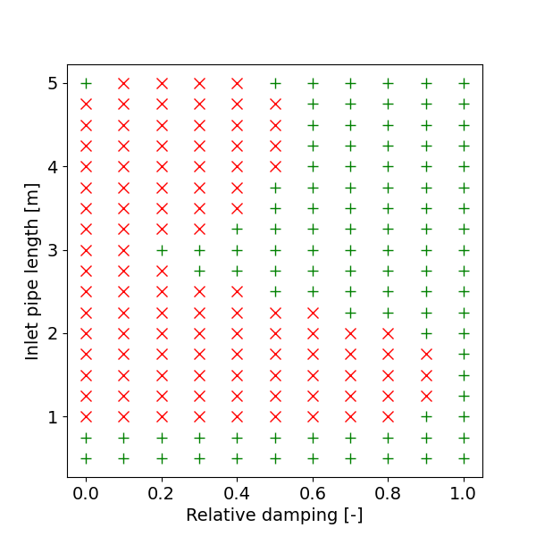

Figure 2. Stability map of simulations with varied damping and inlet pipe length. Red crosses mean an unstable, green crosses mean a stable opening

* 1. Force curve optimization

Another option for securing the stability of the safety valve is changing the fluid force acting on the valve disk, which can, for example, be achieved by modifying the valve disk itself. The fluid force acting on the disk is often simplified and ignored in numerical simulations or the various empirical models by taking the effective area shown in Equation 2 as a constant. Keszthelyi et al. (2022) have shown that an increase in the effective area has a positive effect on valve stability. Effective area modifications tend to close the valve at pressures below the reseating pressure proscribed by the standard. The aim is to evaluate theoretical safety valve characteristics to get possible force curves within the limitations prescribed by the standards.

To guarantee that the valve fully opens at 110% set pressure the fluid force must be larger than the spring force at every possible opening, as otherwise there could be a stable solution for Equation 1 that is not the full opening of the safety valve. Using the effective area introduced in Equation 2, and assuming that the back pressure is the atmospheric pressure, this inequality takes the form of:

|  |  |
| --- | --- |
| $$A_{eff}\left(x\right)⋅\left(p_{set}⋅1.1\right)>k⋅(x+x_{0})$$ | (7) |

with the set pressure being defined in bar(g). Similarly, for the safety valve to close by reaching the minimum pressure allowed by the standard, the force acting on the disk needs to be smaller than the force exhibited by the spring at every possible opening. This inequality takes the form of:

|  |  |
| --- | --- |
| $$A_{eff}\left(x\right)⋅\left(p_{set}⋅0.85\right)<k⋅(x+x_{0})$$ | (8) |

Combining these equations, and reorganizing for the effective area, it yields:

|  |  |
| --- | --- |
| $$\frac{k⋅(x+x_{0})}{p_{set}}⋅\frac{1}{1.1}<A_{eff}\left(x\right)<\frac{k⋅(x+x_{0})}{p_{set}}⋅\frac{1}{0.85}$$ | (9) |

Therefore, for the safety valve to open and close as specified within the standard, the force curve must be optimized in such a way, that the curve stays between the limits prescribed in Equation 9. A visualization can be seen in Figure 3, which also shows four selected effective area curves: the constant nozzle area in black as a reference, a suitably large increase in blue, and the maximum and minimum curves modified to start in the nozzle area when the valve is closed in green and orange.

To evaluate the opening and closing behaviour of these effective area curves, a simulation without a pipe were conducted. In these simulations the vessel pressure was increased from 95% of the set pressure to 110% of the set pressure with a pressure increase of 0.1 bar/s, and then after 3 seconds the pressure was reduced to 85% of the set pressure, with the same speed. The results of these simulations can be seen in the left Figure 4, which on the image shows the lift of the different effective area curves tested, with the colours matching the ones seen in Figure 3. The right side of Figure 4. shows the results of the same setup, but with an inlet line of one meter. The pressure in the vessel during the opening can be seen in the middle of the image.

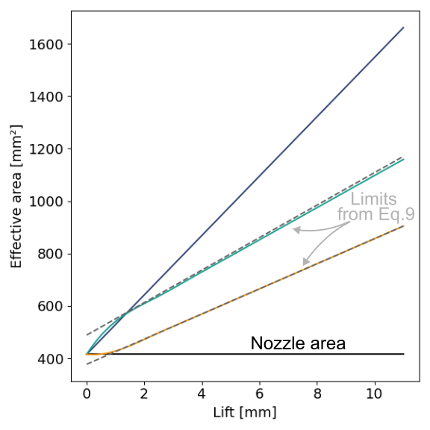

Figure 3. Effective areas used in simulations to compare their opening and closing behavior

The results of evaluating different force curves show that an increase in the additional force acting on the safety valve can drastically improve the stability of the safety valve, at the expense of the reseating pressure of the safety valve. However, staying within the limits of the current standard would mean that the improvements in the safety valve stability are negligible. Optimization algorithms were tested within the limits but could not increase stability. One possible method to combat this would be to create such designs in which the force curve is not constant (as assumed in this section) but changes during time, reaching higher forces during the opening of the valve, compared to the closing of the valve.

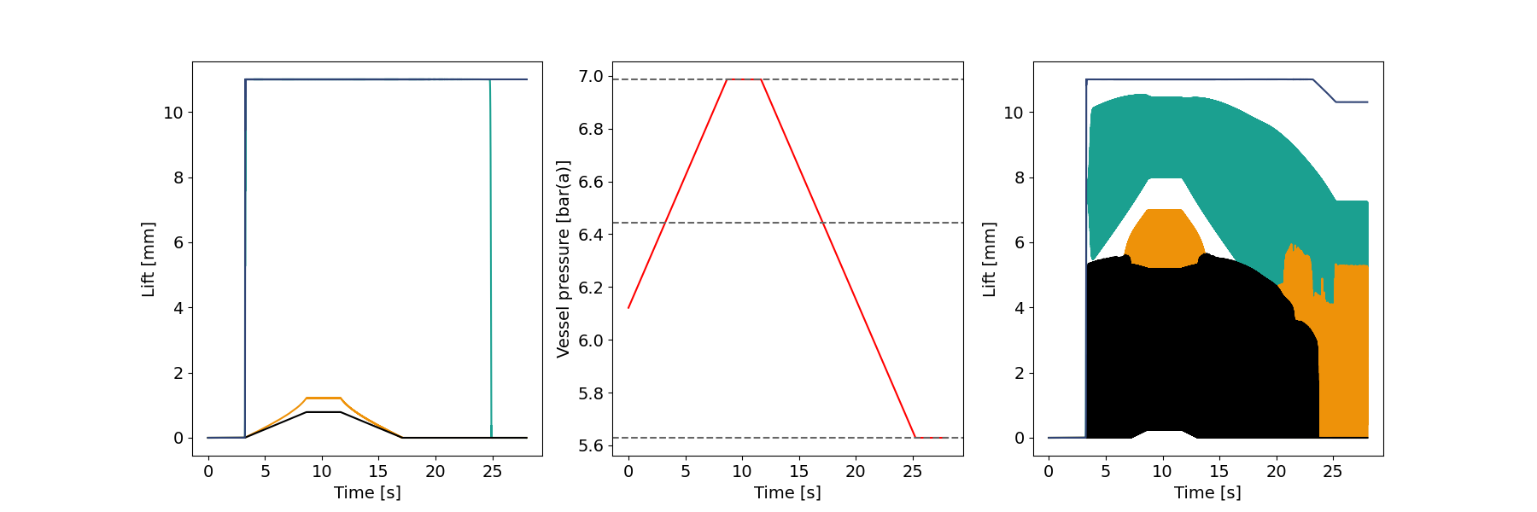

Figure 4. The opening of different safety valve effective area curves. The left image shows the opening without inlet piping, while the right one with one-meter inlet line length

* 1. Conclusions

Safety valve stability is a complex phenomenon that cannot be predicted with a limited number of inputs. This has been proven by various methods tested to reliably predict a stable valve operation.

Increasing the damping of the safety valve is an idea explored previously, but no detailed measurements have been published. Measurements with friction dampers available for purchase have shown an improvement in the stability of the safety valve but reduced the reseating pressure to a value below that allowed by the standard. One possible solution could be a hydraulic damper, which in patented designs are unidirectional with the force only acting on when the valve is opening. These increase prices significantly and maintenance requirements. Evaluation of the effects of modifying the force acting on the safety valve has also shown similar results – the safety valve would not close with forces large enough to stabilize the valve.

Improving the stability of the safety valve with a constant force acting upwards means a decrease in the pressure at which the safety valve reaches its seat. The solution would be to utilize such a force that appears only during the opening of the safety valve or only for a limited time after the opening. Further research is necessary on how such forces could be provided in a cost-effective manner.

Nomenclature

$A_{eff}$– effective area , m²

$A_{flow}$– flow area , m²

$c$– damping, Ns/m

$d_{p}$– pipe internal diameter m

$e$– internal energy along the pipe, J

$F_{f}$– Fluid force, N

$K_{d}$– discharge coefficient of the valve, -

$k$– string stiffness, N/m

$l$– coordinate along the pipe, m

$m$– moving mass, kg

$\dot{m}$– mass flow through the valve nozzle, kg/s

$p$– pressure along the pipe, bar(a)

$p_{back}$– pressure after the valve, bar(a)

$p_{in}$– pressure in front of the valve, bar(a)

$p_{in,t}$–total pressure in front of the valve, bar(a)

$p_{set}$– set pressure of the valve, bar(g)

$t$– time, s

$x$– valve lift, m

$x_{0}$– spring pre-compression, m

$w$– velocity along the pipe, m/s

$λ$– Darcy fiction factor in the pipe, -

$ρ$– density along the pipe, kg/m³

$ρ_{in,t}$–stagn. density in front of the valve, kg/m³

$Ψ$– nozzle discharge function, -

Acknowledgments

Jens Denecke is also working at the CSE Center of Safety Excellence (CSE-Institut).

References

Aldeeb, A.A., Darby, R., Arndt, S., 2014. The dynamic response of pressure relief valves in vapor or gas service. Part II: Experimental investigation. J. Loss Prev. Process Ind. 31, 127–132. https://doi.org/10.1016/j.jlp.2014.06.002

American Petroleum Institute, 2015. Sizing, Selection, and Installation of Pressure-relieving Devices; Part II—Installation, 6th ed.

Cremers, J., Friedel, L., Pallaks, B., 2001. Validated sizing rule against chatter of relief valves during gas service. J. Loss Prev. Process Ind. 14, 261–267. https://doi.org/10.1016/S0950-4230(00)00054-1

Dannenmaier, T.S., Schmidt, J., Denecke, J., Odenwald, O., Jablonski, D., 2018. Formation and Propagation of Pressure Surges In Inlet Lines of Safety Valves and their Influence on Valve Stability, in: Conference on Modelling Fluid Flow (CMFF’18) The 17th International Conference on Fluid Flow Technologies. Budapest, pp. 1–16.

EPRI Valve Test Program Staff, 1982. Epri PWR Safety and Relief Valve Test Program: Safety and Relief Valve Test Report, Electric Power Research Institute (Report) EPRI NP. Palo Alto CA.

European Process Safety Centre, 2020. Chattering PSV.

Herink, T., Doskočil, J., Růžička, M., Henry, P.A., Sadowski, R.A., Zámostný, P., 2022. Propylene column pressure relief valves chattering resulting in explosion and fire of the Steam Cracker unit. J. Loss Prev. Process Ind. 74, 104658. https://doi.org/10.1016/j.jlp.2021.104658

Hős, C.J., Champneys, A.R., Paul, K., McNeely, M., 2014. Dynamic behavior of direct spring loaded pressure relief valves in gas service: Model development, measurements and instability mechanisms. J. Loss Prev. Process Ind. 31, 70–81. https://doi.org/10.1016/j.jlp.2014.06.005

International Organization for Standardization, 2007. ISO 4126 Safety devices for protection against excessive pressure – Part 7: Common data.

Izuchi, H., 2008. Stability Analysis of Safety Valve. Proc. Dyn. Des. Conf. 2008, 238-1-238–6. https://doi.org/10.1299/jsmedmc.2008.\_238-1\_

Keszthelyi, G., Schmidt, J., Denecke, J., 2024. Evaluation of one-dimensional models to predict chatter in spring-loaded pressure relief valves for gas service. Process Saf. Environ. Prot. 182, 1097–1109. https://doi.org/10.1016/j.psep.2023.12.040

Keszthelyi, G., Schmidt, J., Denecke, J., 2022. Effects of Valve Characteristics and Fluid Force on Valve Stability, in: Conference on Modelling Fluid Flow (CMFF’22). Budapest, Hungary, pp. 1–8.

Melhem, G.A., 2014a. Analysis of PRV Stability In Relief Systems Part I – Detailed Dynamics [WWW Document]. ioMosaic Corp. White Pap. URL https://iomosaic.com/docs/default-source/papers/analysis-of-prv-stability-in-relief-systems-part-i.pdf (accessed 11.10.22).

Melhem, G.A., 2014b. Analysis of PRV Stability In Relief Systems Part II - Screening [WWW Document]. ioMosaic Corp. White Pap. URL https://iomosaic.com/docs/default-source/papers/analysis\_of\_prv\_stability\_in\_relief\_systems\_partii.pdf (accessed 11.10.22).

Singh, A., 1982. An analytical study of the dynamics and stability of a spring loaded safety valve. Nucl. Eng. Des. 72, 197–204. https://doi.org/10.1016/0029-5493(82)90215-1

Sylvander, N.E., Katz, D.L., 1948. The Design and Construction of Pressure Relieving Systems, Engineering research bulletin. Ann Arbor. https://doi.org/10.1038/087240a0