|  |  |
| --- | --- |
| cetlogo ***CHEMICAL ENGINEERING TRANSACTIONS***  ***VOL. xxx, 2025*** | A publication of  aidiclogo_grande |
| The Italian Association  of Chemical Engineering  Online at www.cetjournal.it |
| Guest Editors: Bruno Fabiano, Valerio Cozzani  Copyright © 2025, AIDIC Servizi S.r.l. **ISBN** 979-12-81206-xx-y; **ISSN** 2283-9216 | |

Evolution of turbulent burning velocity and turbulence intensity during aluminum flame propagation

Clément Chanuta,\*, Fares Saad Al Hadidia, Frédéric Heymesa, Ernesto Salzanob

aLaboratoire des Sciences des Risques, IMT Mines Alès, Alès, France

bDipartimento di Ingegneria Civile, Ambientale, e dei Materiali, Università di Bologna, Bologna, Italy

\*clement.chanut@mines-ales.fr

Burning velocity, i.e. the consumption rate of the reactant by the flame front, is a key parameter for modelling flame propagation during accidental gas or dust explosions. Experimental investigations are thus needed to determine this burning velocity and to accurately validate numerical models. In this article, aluminum dust flame propagation inside a vertical tube is investigated. An innovative “direct method” is implemented to determine the burning velocity just ahead of the propagating flame front. This method is based on the Time-Resolved Particle Image Velocimetry (TR-PIV) technique to determine the unburned flow velocity. With this experimental setup, the turbulence intensity just ahead of the propagating flame front can thus also be estimated. Two granulometric distributions (with a median diameter of 6 μm and 20 μm), with three different dust concentrations for each granulometric distribution are investigated. An increase of the burning velocity with a decrease of the particle size is observed. Nevertheless, due to low levels of turbulence in front of the flame front during flame propagation, no significant influence of turbulence on burning velocity is observed during these experiments.

* 1. Introduction

Dust explosion is a major concern in industries dealing with combustible dusts. Numerical simulations are needed to model the flame propagation process during such accidental explosions in industrial facilities to predict the potential consequences (thermal effects, overpressures, projectiles). Models, based on gas explosions models, are adapted and developed for predicting the consequences of dust explosions involving general organic dusts (Skjold, 2007). Nevertheless, these models seem not adapted for evaluating the consequences of dust explosions involving non-volatile particles, such as metals. Goroshin et al. (2022) highlighted the need for extensive research on the specific field of non-volatile dusts.

One key parameter for modelling flame propagation is the burning velocity, i.e. the consumption rate of the reactants by the flame front, and the relation between turbulence and burning velocity. As highlighted in a previous paper, experimental determination of the burning velocity is challenging, especially in the case of a propagating flame, and is in general based on many assumptions (Chanut et al., 2024a). In another previous paper, an innovative “direct method” was proposed to determine the burning velocity without many assumptions, based on the implementation of a specific Time-Resolved Particle Image Velocimetry (TR-PIV) setup. With this optical technique, the unburned flow field is determined and the turbulence intensity just ahead of the propagating flame front can be evaluated. Thus, the implementation of this optical technique and the development of this “direct method” is promising to get a deeper understanding of the flame propagation process. These experiments have a dual objective: evaluating fundamental input data of models (such as burning velocity and influence of turbulence on burning velocity) and obtaining accurate and detailed experimental data for validating numerical simulation (such as the flame propagation velocity, the unburned flow velocity and the turbulence intensity). Indeed, many numerical simulations are validated through the study of the evolution of the pressure inside closed vessels or through the study of only the flame propagation velocity along tubes. Experimental data on the characteristics of the unburned flow ahead of the propagating flames are thus important for accurately validating the numerical models.

In this article, aluminum flame propagation inside a vertical tube is investigated. Two aluminum powders, with two granulometric distributions of median diameter 6 μm and 20 μm, are studied. For both powders, three dust concentrations, corresponding to fuel-lean and fuel-rich mixtures, are investigated. Two TR-PIV setups are simultaneously implemented for each experiment to evaluate the evolution of burning velocity and turbulence intensity ahead of the flame front during its propagation along the tube. In this study, influences of particle size, dust concentration and turbulence on burning velocity are investigated.

* 1. Methodology

The objective of this paper is to determine the turbulent burning velocity using the innovative “direct method” and to estimate the turbulence intensity in front of the propagating flame front.

* + 1. Experimental apparatus

Aluminum flame propagation is studied inside a vertical tube (150 x 150 mm square cross-section) divided into three different sections (700 mm height for each section). This vertical tube is closed at the bottom end and open at the top end (connected to an exhaust duct). Dust is injected only in the two lower sections of the prototype equipped with four injection tubes located in the corners of these sections, as represented in Figure 1. Dust is injected by the discharge of compressed air through holes oriented toward the center of the prototype and located along these injection tubes. Nominal dust concentration is estimated by weighing the powder inside the injection tubes before and after each experiment. Characterization of this dust dispersion system and the evaluation of the state of the cloud (homogeneity and turbulence) at the moment of ignition have been previously studied (Asquini, 2019). Aluminum dust cloud is ignited by an electric spark located at the bottom of the prototype. Thus, flame propagates from the bottom closed end to the open top end of the prototype.

Two aluminum powders with two median diameters of 6 μm and 20 μm, referred to as “6-μm powder” and “20-μm powder” respectively, are studied. Detailed granulometric distributions of both powders are detailed in Figure 1. For each particle size, three dust concentrations are investigated; defined in terms of equivalence ratio which corresponds to the ratio of the actual nominal dust concentration and the stoichiometric concentration (about 310 g.m-3). For the 20-μm powder, equivalence ratios of 1, 1.2 and 1.4 are studied corresponding to fuel-rich mixtures. For the 6-μm powder, equivalence ratios of 0.8, 0.9 and 1 are investigated, corresponding to fuel-lean mixtures. These choices of equivalence ratios for each powder are the consequences of experimental difficulties. While studying fuel-lean mixtures, difficulties for igniting the mixtures with the 20-μm powder were observed; on the contrary, while studying stoichiometric concentrations with the 6-μm powder, high reactivity of the dust caused quite high pressure inside the tubes, thus fuel-rich mixtures are not investigated. For each experimental configuration (defined by the median diameter of the powder and the equivalence ratio of the dust-air mixture), two experiments were performed and analyzed.

Figure 1: Experimental setup and granulometric distributions of the powders

Two experimental techniques are implemented to determine burning velocity and turbulence intensity during aluminum flame propagation: the direct visualization technique and the Time-Resolved Particle Image Velocimetry (TR-PIV) technique. The direct visualization technique consists of recording the light emitted by the flame with a high-speed camera. With this technique, the propagation of the flame is observed, and the flame propagation velocity is deduced. For these experiments, two high-speed cameras are used to record with a high spatial resolution the movement of the flame along the height of the prototype.

The TR-PIV technique consists in recording the movement of the particles illuminated by a laser sheet; with this technique, particle velocity is deduced in a plane of the flow. Because of the intrinsic characteristics of the experiments (dense cloud of particles, fast phenomena, very luminous flame…), implementation of this TR-PIV technique is challenging (Chanut et al., 2022). Nevertheless, using a high-repetition-rate and powerful laser synchronized with a high-speed camera equipped with a bandpass filter, it is possible to implement this technique to observe the unburned flow field in front of the aluminum propagating flame. Figure 2 shows an example of images obtained with this technique with the 20-μm powder.

Two TR-PIV setups are implemented to investigate the evolution of burning velocity and turbulence for each experiment. The first PIV measurement zone (PIV zone 1) is located in the middle of the second (middle) section of the prototype. The second PIV measurement (PIV zone 2) is located at the top of the third (top) section of the prototype. Characteristics of the cameras and lasers used for these experiments are detailed on (Chanut et al., 2022).

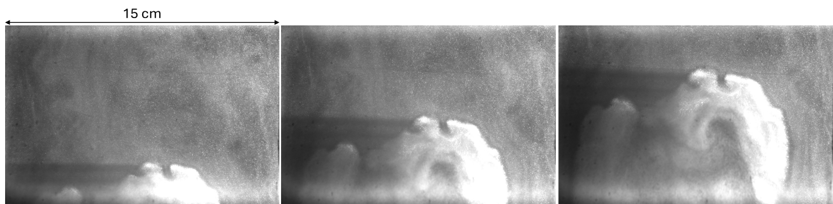

Figure 2: TR-PIV images obtained with the 20-μm powder (delay between images: 1 ms)

* + 1. Burning velocity

The burning velocity corresponds to the consumption rate of the reactants by the flame front. The “direct method” is based on the measurement of the flame propagation velocity and the unburned flow velocity just ahead of the propagating flame front. At the top of the flame front, these vectors are colinear and the burning velocity can be defined as the difference between these two velocities. The main difficulty in using this method is the accurate determination of the unburned flow velocity just ahead of the flame front. As previously mentioned, in this study, this velocity is determined by the TR-PIV technique.

The software Dynamic Studio (Dantec Dynamics) is used to perform the PIV analysis. Before performing the PIV algorithm, a first step of pre-processing is mandatory to improve the quality of the raw images obtained with the optical setup. Indeed, because of the presence of a high-density dust cloud, the laser sheet is attenuated. Moreover, the two cavities of the laser (corresponding to the two pulses used for performing the PIV algorithm) do not have the same exact power, thus resulting in images with slight differences in luminosity. The objective of this preliminary step is to uniform the luminosity inside each image and between each pulse. An adaptative PIV algorithm is then used to modify the shape and the size of each interrogation area depending on the local velocity and concentration gradients. The quality of the images obtained with the 6-μm powder and with the 20-μm powder are different; thus the parameters used for performing the adaptive PIV algorithm are slightly different. For the 20-μm powder, the distance between two velocity vectors is about 0.5 mm while for the 6-μm powder this distance is about 1 mm.

* + 1. Turbulence intensity

Turbulence intensity just ahead of the flame front can also be evaluated by analyzing the velocity vector maps obtained after performing the adaptative PIV algorithms. For this purpose, a local zone just ahead of the propagating flame is analyzed. The size of this analysis zone corresponds to a height of 10 interrogation areas and a width of 20 interrogation areas located just ahead of the highest point of the flame front.

From all the velocity vectors located inside the analysis zone, the turbulence intensity ($V_{RMS}$) can be estimated with the following equation:

|  |  |
| --- | --- |
| $$V_{RMS}=\sqrt{\frac{1}{n}\sum_{i,j}{(V_{i,j}-\overline{V_{i}}})²+\frac{2}{n}\sum_{i,j}{(U_{i,j}-\overline{U}})²}$$ | (1) |

where $V$ and $U$ correspond to the vertical (in the direction of the main flow) and horizontal components of the velocity respectively, $\overline{V_{i}}$ and $\overline{U}$ correspond to the mean flow velocity components, $i$ refers to the relative vertical coordinate of the velocity vector and j refers to the relative horizontal coordinate of the velocity vector. The horizontal component of the velocity is multiplied by two by considering isotropic turbulence in the horizontal plane. The vertical mean velocity varies along the vertical axis ($\overline{V_{i}}$) as the vertical component of the velocity increases close to the flame front, as explained in the following section.

* 1. Results
     1. Unburned flow velocity

From the TR-PIV images and the velocity vectors obtained after analysis, it is possible to determine the evolution of the unburned flow velocity in front of the propagating flame front. For this purpose, the mean flow velocity as a function of the distance to the flame front is investigated. The mean flow velocity is defined as the spatial mean of 10 velocity vectors along the horizontal axis.

Figure 3 represents the evolution of the unburned flow velocity as a function of the distance to the flame front corresponding to an experiment with the 20-μm at the equivalence ratio of 1.2 in the PIV measurement zone 1 (located at the middle of the second section of the prototype). Nevertheless, the same evolution is obtained for all the configurations (granulometric distribution and equivalence ratio). An increase in the unburned flow velocity as the unburned particles are closer to the flame front is observed. Indeed, the mean unburned flow velocity is about 8.8 m.s-1 far from the flame front while it is about 9.8 m.s-1 close to the flame front. Han et al. (2001) also observed an increase in the velocity in front of the flame front while studying flame propagation of lycopodium dust.

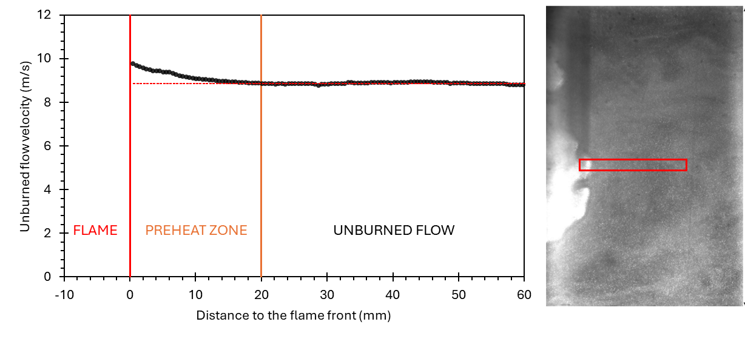

Figure 3: Evolution of the unburned flow velocity as a function of the distance to the flame front

This increase in the unburned flow velocity could correspond to the preheat zone of the flame. Indeed, as the temperature increases in the preheat zone, the density decreases, thus the unburned flow velocity increases. The size of this “preheat zone” ($δ_{preheat}$) can be estimated; for this experiment, a value of about 2 cm is obtained. After determining the burning velocity ($S_{u}$) for this specific experiment, it is possible to estimate the residence time of the particle in this “preheat zone” and thus have an estimation of the “preheat time” ($t_{preheat}$) using the following formula:

|  |  |
| --- | --- |
| $$t_{preheat}=\frac{δ_{preheat}}{S_{u}}$$ | (2) |

For our experiment, a value of about 10-15 ms is obtained for 20-μm powder.

While studying stationary aluminum flame (mean diameter: 7.1 μm) and using the PIV technique, Lomba et al. (2019) estimated the time for a particle to cross the preheating zone and the reaction zone. They obtained a value of the order of 6 ms. For our experiments with the 6-μm powder, a value of about 5 ms is obtained. If the reaction zone is much smaller than the preheat zone, the values obtained with these two different setups are consistent.

The evolution of the unburned flow velocity as a function of the propagating flame front highlights the importance of taking into consideration the velocity vector as close as possible to the flame front to evaluate the burning velocity, but also to consider the evolution of the mean flow along the vertical axis to determine the turbulence intensity (equation 1).

* + 1. Turbulent burning velocity

Turbulent burning velocity is estimated, using the previously described method, for each experiment and each TR-PIV measurement zone. As a reminder, the “PIV zone 1” corresponds to the middle of the second section of the prototype and the “PIV zone 2” corresponds to the top of the prototype. The results of turbulent burning velocity are shown in Figure 4, highlighting the influences of the particle size, the location of the analysis zone and the equivalence ratio. While analyzing the influences of equivalence ratio and particle size on burning velocity, one has to remember that the experiments with the 20-μm powder correspond to fuel-rich mixtures while the experiments with the 6-μm powder correspond to fuel-lean mixtures.

As expected, as the particle size decreases, the turbulent burning velocity increases. This is due to the well-known higher reactivity of finer particles (Vignes et al., 2019). Moreover, an increase in the burning velocity with the PIV zone number is also observed. This increase is probably due to an increase in the turbulence, thus increasing the turbulent burning velocity.

Figure 4: Results of turbulent burning velocity

Concerning the influence of the equivalence ratio on burning velocity, with the 6-μm powder, an increase in the burning velocity with the equivalence ratio is observed. These experiments correspond to fuel-lean mixtures, thus increasing the equivalence ratio increases the reactivity of the mixture and thus the burning velocity. On the contrary, with the 20-μm powder, no significant influence of the equivalence ratio on the burning velocity is observed. These experiments correspond to fuel-rich mixtures, thus increasing the equivalence ratio does not increase the reactivity of the mixture; in fact, the particles that do not participate in the combustion could act as “heat sinks” and contribute to decreasing the burning velocity. This different influence of the equivalence ratio on the reactivity of the mixture for fuel-rich and fuel-lean mixtures has been widely observed in the past, for example analyzing the maximum rate of pressure rise during explosions inside closed spheres (Guo et al., 2019).

For each experiment and each TR-PIV measurement zone, the turbulence intensity can be estimated using the previously described method. Nevertheless, due to the low levels of turbulence (less than 5 % of the mean flow), no significant influence of turbulence on the burning velocity is observed.

* 1. Conclusions

Aluminum flame propagation inside a vertical tube has been studied. The main objectives were to evaluate the burning velocity and to investigate the influences of the particle sizes, the equivalence ratio and the turbulent intensity on the burning velocity. Indeed, the burning velocity is a key parameter for the numerical models used for predicting the consequences of accidental dust explosions in industrial facilities. For this purpose, two TR-PIV optical systems have been implemented to determine the unburned flow velocity just ahead of the propagating flame front. Based on this TR-PIV system, the “direct method” has been used to determine the burning velocity.

An increase of the unburned flow velocity is observed in a zone just in front of the propagating flame front. This zone could correspond to the preheat zone of the flame. This hypothesis seems coherent while comparing our results with previous studies. Further investigation is still needed to analyze much deeper the results and to investigate the influences of equivalence ratio and particle size on both the preheat zone thickness and the reaction zone thickness.

As expected, the smaller the particle size, the higher the burning velocity. Furthermore, for the fuel-lean mixture, an increase in the burning velocity with the equivalence ratio is observed. On the contrary, no influence of the equivalence ratio on the burning velocity is observed for fuel-rich mixtures.

Due to the low levels of turbulence (less than 5 % of the mean flow), no significant influence of turbulence on the burning velocity is observed. More experiments will be realized by implementing obstacles inside this vertical tube to increase the turbulent intensity and investigate its influence on the burning velocity: the first promising experiments have already been realized (Chanut et al., 2024b).

Acknowledgments

The authors are grateful to IRSN (Institut de Radioprotection et de Sûreté Nucléaire) for scientific and financial support to this project.

References

Asquini, E., 2019. Influence of turbulence on flame propagation during dust explosion. Sapienza University of Rome. https://doi.org/10.5281/zenodo.3706671

Chanut, C., Saad Al Hadidi, F., Heymes, F., Lopez, C., 2022. Simultaneous Measurement of Burning Velocity and Turbulence Intensity Ahead of the Flame Front during Aluminium Flame Propagation. Chem. Eng. Trans. 90, 391–396. https://doi.org/10.3303/CET2290066

Chanut, C., Saad Al Hadidi, F., Heymes, F., Salzano, E., 2024a. Direct determination of turbulent burning velocity during aluminum flame propagation : comparison to the classical open-tube method, in: 15th International Symposium on Hazards, Prevention, and Mitigation of Industrial Explosions.

Chanut, C., Saad Al Hadidi, F., Heymes, F., Salzano, E., 2024b. Experimental Study of Aluminum Flame Propagation in Duct with Obstacles. Chem. Eng. Trans. 111, 625–630. https://doi.org/10.3303/CET24111105

Goroshin, S., Pale, J., Bergthorson, J.M., 2022. Some fundamental aspects of laminar flames in nonvolatile solid fuel suspensions. Prog. Energy Combust. Sci. 91. https://doi.org/10.1016/j.pecs.2022.100994

Guo, L., Xiao, Q., Zhu, N., Wang, Y., Chen, X., Xu, C., 2019. Comparative studies on the explosion severity of different wood dusts from fiberboard production. BioResources 14, 3182–3199. https://doi.org/10.15376/biores.14.2.3182-3199

Han, O.S., Yashùima, M., Matsuda, T., Matsui, H., Miyake, A., Ogawa, T., 2001. A study of flame propagation mechanisms in lycopodium dust clouds based on dust particles’ behavior. J. Loss Prev. Process Ind. 14, 153–160. https://doi.org/10.1016/S0950-4230(00)00049-8

Lomba, R., Laboureur, P., Dumand, C., Chauveau, C., Halter, F., 2019. Determination of aluminum-air burning velocities using PIV and Laser sheet tomography. Proc. Combust. Inst. 37, 3143–3150. https://doi.org/10.1016/j.proci.2018.07.013

Skjold, T., 2007. Review of the DESC project. J. Loss Prev. Process Ind. 20, 291–302. https://doi.org/10.1016/j.jlp.2007.04.017

Vignes, A., Krietsch, A., Dufaud, O., Santandréa, A., Perrin, L., Bouillard, J., 2019. Course of explosion behaviour of metallic powders – From micron to nanosize. J. Hazard. Mater. 379, 120767. https://doi.org/10.1016/j.jhazmat.2019.120767