Determination of long-term stabilities of weak autocatalytically decomposing substances

David Zink*1, Sebastian Kimpel2, Julian Sartorius1, Christina Kuchta1, Christian Bernstein2

1 consilab, Industriepark Höchst G830, 65926 Frankfurt am Main

2 consilab, Chempark Leverkusen, Q18L, 51369 Leverkusen

*Corresponding author E-Mail: David.Zink@consilab.de

1. Introduction

The safety-related assessment of the thermal stability for decomposing substances in context of process safety is typically based on DSC measurements or adiabatic calorimetry described for example in the German guideline TRAS 410. In case of autocatalytically decomposing substances, the assessment is quite challenging. Technical regulations give no specific support and the assessment is typically based on a worst-case consideration (e.g. H.3 SADT test).

For strong autocatalytic reactions the assessment of the safe storage of a substance based on isothermal induction times is possible, if no relevant heat production rate is present during the induction time. That is for example the case for stabilized acrylates, which show a quasi-autocatalytic reaction behavior. During the period in which stabilization is still present, the heat production rate is nearly zero. If the stabilizer is consumed the polymerization and therefore the heat production rate increases rapidly.

But what is a possible strategy to assess the storage of a weak autocatalytically decomposing substance? Weak autocatalytic decomposition means that a significant heat production rate is already present for a fresh, thermally non-aged substance and the heat production rate increases with increasing thermal history, the autocatalytic reaction path of the decomposition. Typically, a worst-case consideration is not target oriented, because it is too conservative for safety-related application. On the other hand, an assessment based on methods for non-autocatalytically decomposing substances underestimates the criticality of the decomposition reaction.

Nitro aromatic compounds are typical representatives for weak autocatalytic decomposition. Hereby, depending on the melting point of the substance a storage at higher temperatures is necessary and makes a safety-related assessment more relevant.

2. Methods

**DSC-measurements**

The thermal stability of a compound is determined by Differential Scanning Calorimetry (DSC). Here some milligrams of material are weighed into a glass or gold-plated stainless-steel crucible. The glass crucible is then sealed using an oxyhydrogen flame, the steel crucible is closed using a crucible press. These crucibles are then placed in the equipment DSC-1 Star DSC of Mettler-Toledo to record the DSC thermal-trace of the compound. The sample is measured in comparison to a reference crucible. In case of the glass crucible the reference crucible is filled with aluminium oxide. The gold-plated steel reference crucible remains empty. Both, the sample and the reference, are heated with a heating rate of 3 K/min.

The preparation of the sample is carried out under air. Hence there will be residual oxygen within the crucible after sealing. During the test, this residual oxygen may react with the substance and thus cause heat generation of approximately -20 J/g. Because of the low heat generation and the small amount of oxygen present, this effect can be neglected.

The DSC-equipment is regularly calibrated according to established standards. Therefore, the heat generation of a chemical reaction can be determined reliably. According to DIN EN ISO 11357-1 energy values of endothermic signals are indicated by a positive sign, exothermic signals by a negative sign.

**Pressure/ Heat Accumulation Test**

The determination of the adiabatic reaction behaviour is performed in the adiabatic heat-storage test and is carried out according to UN-Transport Guideline, UN-Test H.2. in the experimental setup according to Grewer and Klais and VDI-Guideline 2263 Page 1, respectively.

The test setup consists of a pressure vessel with a volume of approx. 0.75 L. In this autoclave a Dewar-vessel with a capacity of approximately 0.2 L is placed. The Dewar-vessel is thermally isolated from its surroundings by a double walled vacuum jacket with a reflective coating. The autoclave is closed, placed in an oven and heated up. After a reaction starts the temperature of the oven is regulated to track the sample temperature. Therefore, above the start temperature reactions or decompositions can be investigated under quasi-adiabatic conditions. The sample temperature is measured with a thermocouple, which is placed in the centre of the sample and surrounded by a glass cover; hence the sample is only in contact with glass. Additionally, the pressure in the headspace is measured and recorded.

The time resolved course of the temperature and the pressure during the experiment are recorded.

The experiments are typically carried out under nitrogen atmosphere.

3. Results and discussion

First, a dynamic DSC of the nitro-aromatic-compound was measured. Figure 1 shows the thermogram. From this thermogram an autocatalytic decomposition behavior is not obvious. The isothermal DSC at 250 °C (see Figure 2) clearly shows a weak autocatalytic reaction behavior. At the beginning of the measurement (0 to 100 min), a significant heat flow of approx. -5 W/kg is already detected, which, however, increases to a maximum heat flow of -90 W/kg after approx. 1700 min under isothermal conditions. This behavior, an increase of the heat flow with the measuring time, clearly proves the autocatalytic decomposition properties. The evaluation of thermal stability, for example on the basis of the safe handling temperature Texo in the sense of TRAS 410, can no longer be regarded as sufficiently reliable. If an autocatalytic decomposition mechanism is detected, an initial worst-case assessment based on isothermal calorimetry is recommended. This evaluation option is also used in the SADT-UN test H.3. As an example, a total of five isothermal DSC measurements of the nitro-aromatic compound were measured at temperatures between 250 °C and 290 °C (see Figure 3 a)). The peak maxima detected at the corresponding temperatures are plotted according to 0 th. order Arrhenius kinetics and linearly adjusted. For safety-related conservative reasons, it is advisable to calculate a confidence interval (95 % in this example), whereby the straight line with the higher temperature-dependent heat production rates should serve as the basis for further calculations (see Figure 3 b) red straight line). Unlike in conventional screening DSC measurements, small sample weights should be preferred when carrying out isothermal calorimetric measurements. Exothermic decomposition can lead to heat build-up inside the crucible, if the used sample amount is too much, causing the temperature of the test object to exceed the reference/oven temperature. As this effect increases with increasing temperature within a series of measurements and the heat production rate is therefore overestimated at higher temperatures, the activation energy of the derived kinetics increases incorrectly. This leads to lower heat production rates and therefore less critical results when extrapolating towards lower temperatures. In the isothermal DSC measurements shown, the sample weight used was approx. 5 mg.



Figure 1. Dynamic DSC of nitro-aromatic compound in closed crucible (3 K/min)



Figure 2. Isothermal DSC of a nitro-aromatic compound in closed crucible at 250 °C

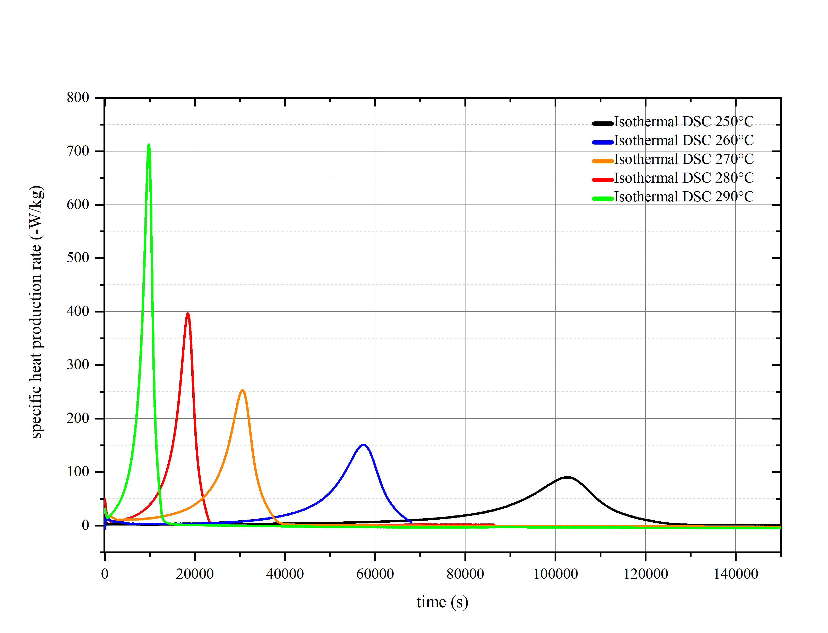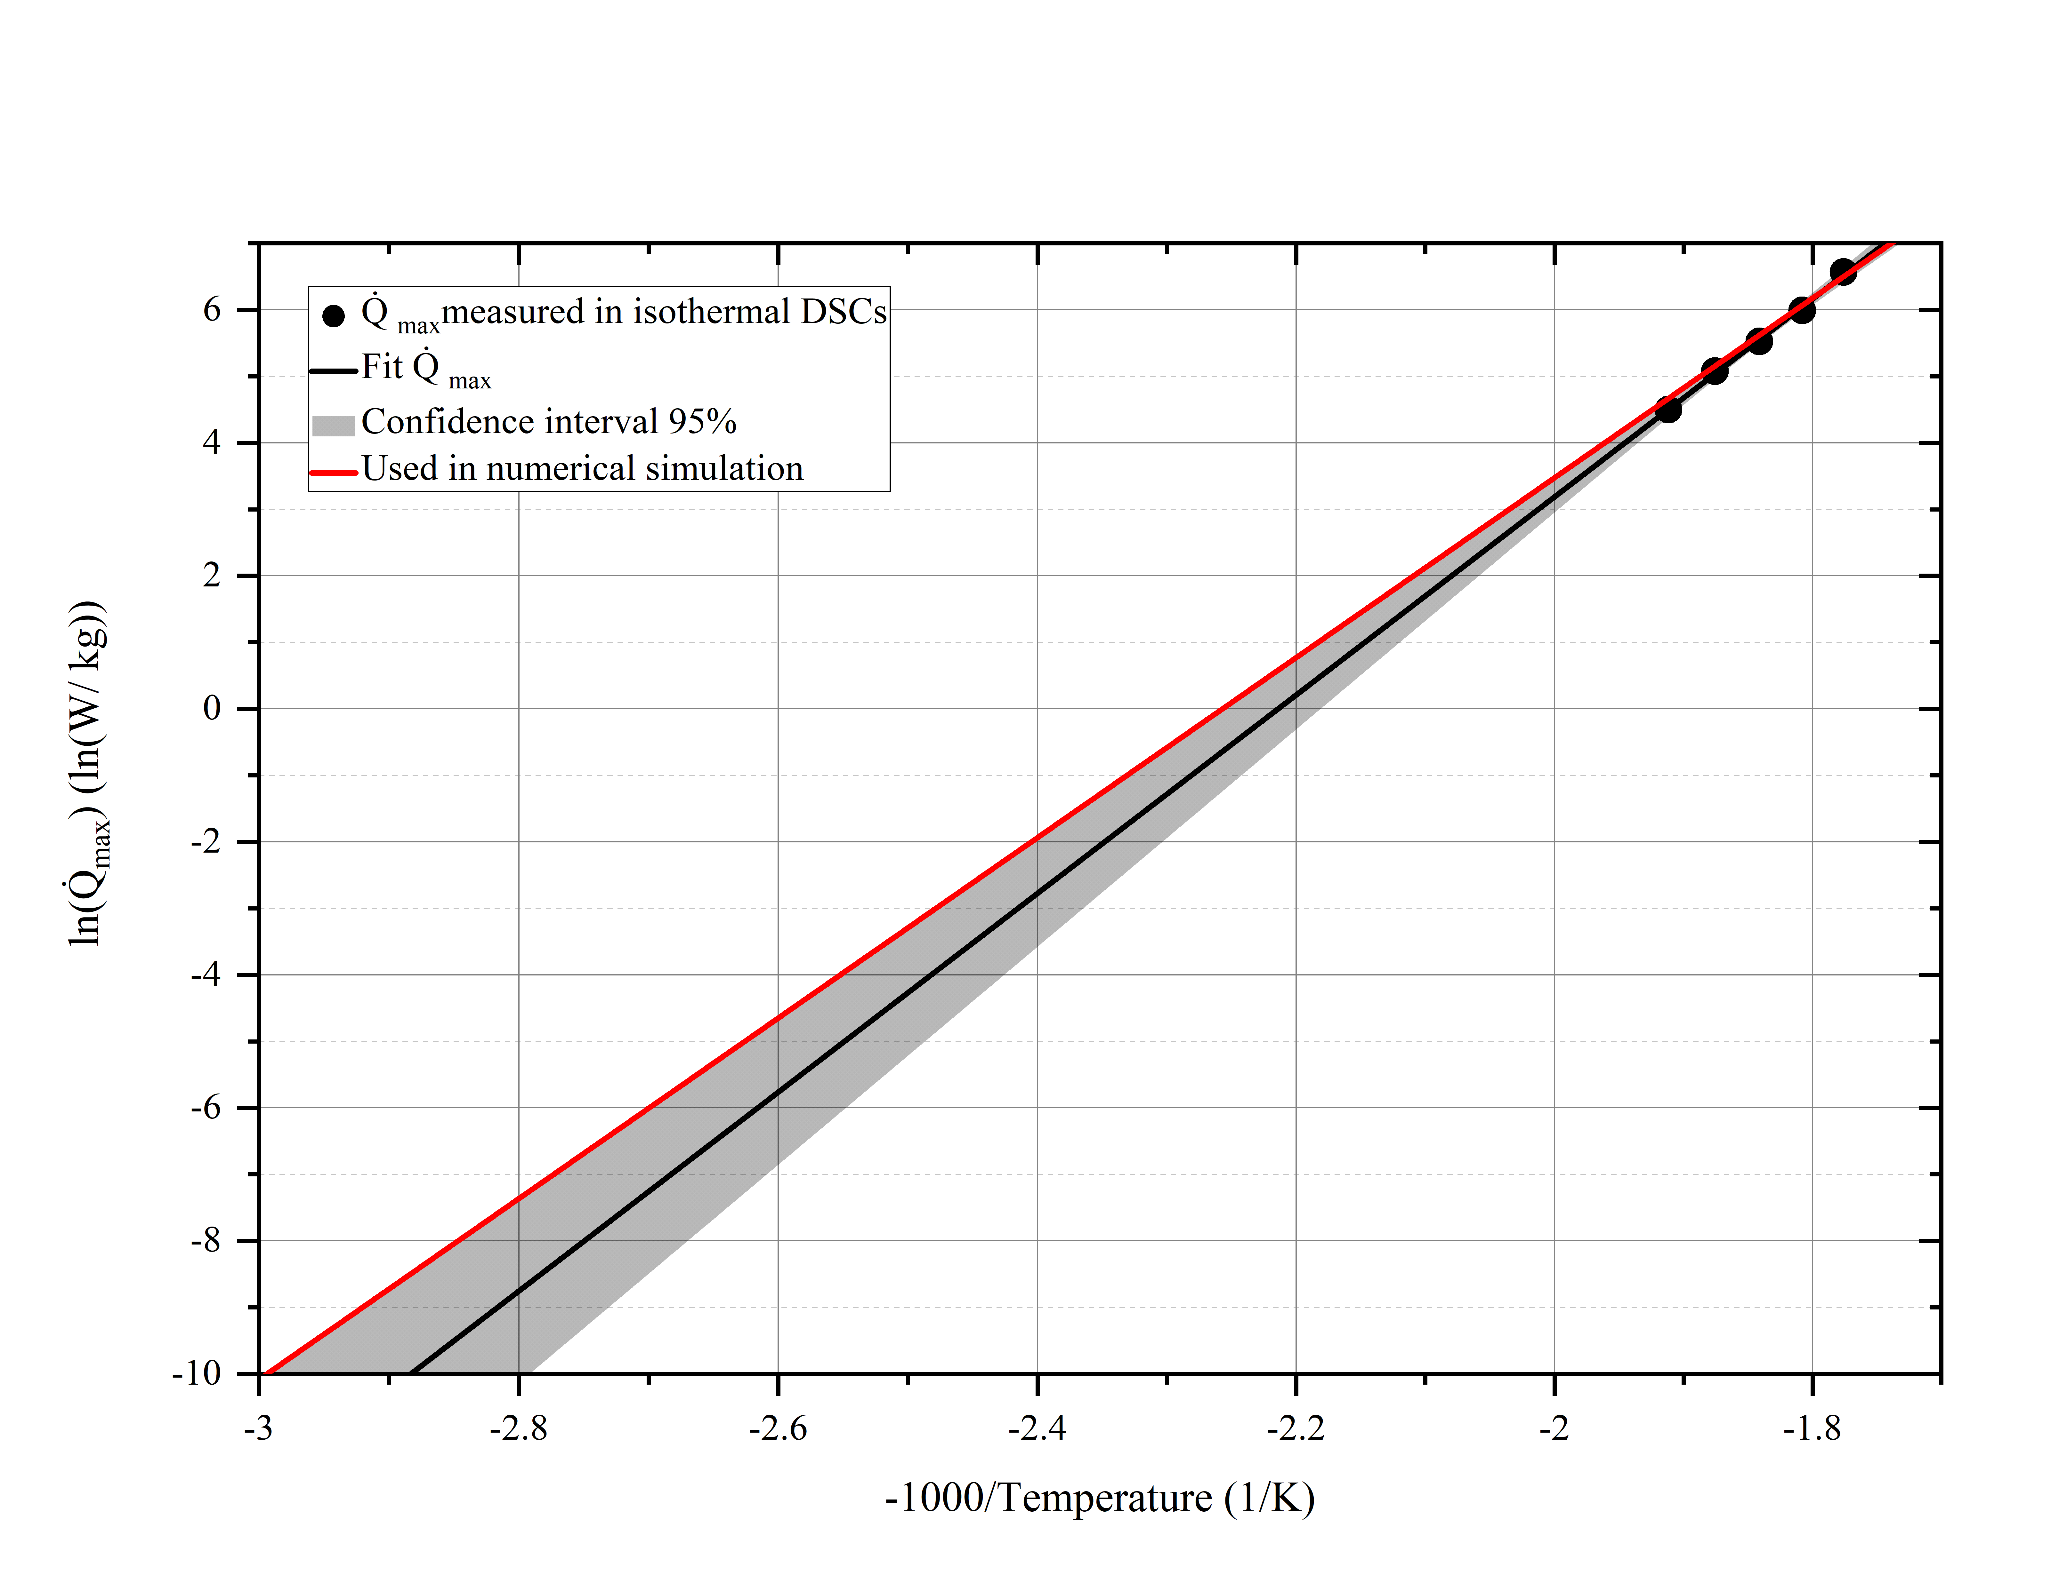

b)

a)

Figure 3.a) Isothermal DSCs of a nitro-aromatic compound in closed crucible at different temperatures – time-dependent specific heat production rate, b) Arrhenius-plot with fit of the maximum heat production rates

Based on the derived worst-case kinetics (Figure 3 b, red line), adiabatic induction times or SADTs can be determined by means of a simple numerical simulation, taking into account a heat dissipation term. This is shown in Figure 4 for the temperatures 130 °C, 140 °C and 160 °C, where the temperature curve over time was calculated under adiabatic conditions and taking into account a heat dissipation term of 30 mW/(kg∙K). The numerical simulation can be programmed using Microsoft Excel VBA, for example.

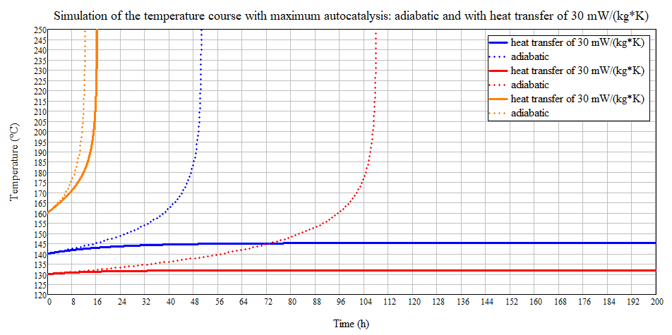

Figure 4. Numerical simulation of the time-dependent temperature course based on the maximum autocatalysis kinetic (worst-case consideration) under adiabatic conditions and under consideration of a heat transfer of 30 W/(kg∙K)

The advantage of this worst-case consideration of autocatalytic decomposition is the time-independence of the calculated safety-related parameters. A maximum temperature for the heating medium can be derived taking into account a representative heat dissipation term, particularly for smaller appliances or pipes. A main result of this worst-case consideration is that, for example, a critically self-accelerating decomposition reaction (heat explosion) can be excluded within a pipe network by limiting the teamperature of the heating medium to 140 °C, regardless of the residence time. This consideration is particularly helpful for pipe networks, as a representative temperature monitoring inside pipes is difficult to implement.

Due to its conservatism, this worst-case consideration as a basis for the safety assessment is not expedient for all process conditions. If, for example, maximum heating temperatures of 130 °C are required in larger tanks, the worst-case consideration would result in an adiabatic induction time of approx. 48 hours. As a result of which the storage of the nitro aromatic compound at 130 °C would be classified as too critical and unsafe by a safety-related assessment.

At this point, it makes sense to derive more detailed decomposition kinetics that take the time dependency of the autocatalytic decomposition into account. Therefore, the nitro aromatic compound is investigated by an adiabatic heat-pressure-accumulation test. The temperature-pressure curve over time is shown in Figure 5. The detected temperatures and pressures illustrate the criticality of the runaway reaction of a nitro-aromatic-compound.

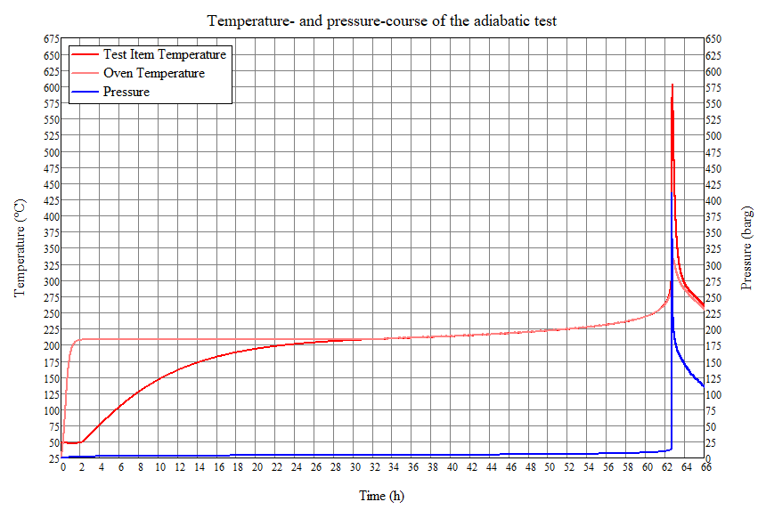

Figure 5. Temperature and pressure course measured in the adiabatic heat storage test of an aromatic nitro compound

The Arrhenius plot of the adiabatic temperature curve is shown in Figure 6. The decomposition kinetics at low conversion are determined by fitting a 0 th. order kinetics in a small temperature range (in this example 210 °C to 230 °C) at the beginning of the decomposition. The temperature-dependent heat production rate obtained in this manner characterizes the decomposition at a conversion of 0 % (see fit Figure 6). Compared to the DSC with a sensitivity of approx. 10 W/kg, the adiabatic heat storage test with a sensitivity of 0.03 W/kg is more reliable to get correct results for low heat production rates (see Figure 7).

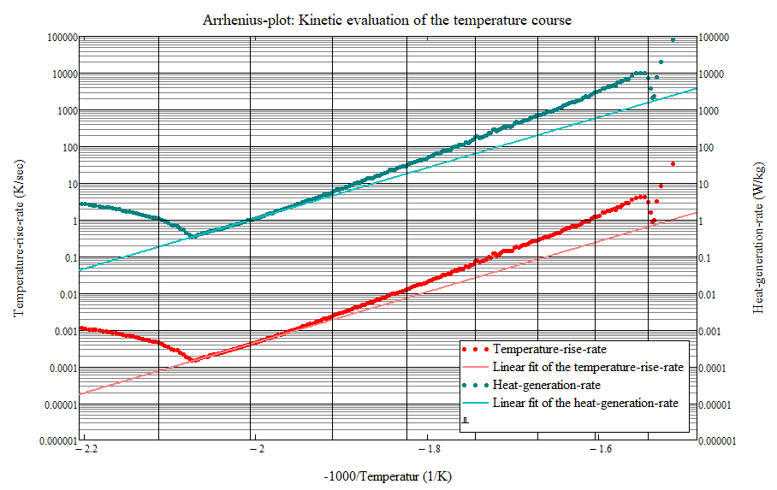

200 °C 225 °C 250 °C 275 °C 300 °C 325 °C 350 °C 375 °C

Figure 6. Kinetic evaluation at low conversion of the temperature in the Arrhenius-plot based on the adiabatic heat storage measurement. The kinetic fit is used as the baseline for 0 % conversion in the numerical simulation.

Figure 7 explains how the conversion dependence of autocatalysis can be described in a simple way. Here, the heat production rates recorded in the isothermal DSCs are plotted against the decomposition energy released up to the respective point in time. The maximum heat production rates (maximum autocatalysis) are achieved for the investigated nitro-aromatic-compound at a decomposition energy of approx. -1500 J/g. In order to be able to describe the conversion dependency of the autocatalytic decomposition reaction, the function Q̇(T,C) must be determined (C corresponds to conversion). The plane Q̇(T,C) is spanned by a simple linear interpolation of the derived kinetics for 0 % conversion (adiabatic-heat-pressure-accumulation test) and the worst-case kinetics (100 % conversion corresponds to -1500 J/g) (see Figure 8, projection Q̇(T,C) into the Q̇(T) plane). From a conservative safety point of view, it is assumed in the simulation that the maximum heat production rate is already reached at a released energy of -1000 J/g. As can be seen from Figure 7, the specific temperature- and conversion-dependent heat production rate used for the simulation is higher than the values determined in the DSCs. The following five parameters are therefore necessary in the description of the heat production rate Q̇(T, C):

the description of the Arrhenius kinetics for 0 % conversion based on the adiabatic pressurized heat accumulation test with the pre-exponential factor Q̇0,0%conversion and the activation energy EA,0%conversion, the description of the Arrhenius kinetics for 100 % conversion (maximum autocatalysis) based on the isothermal DSCs with the pre-exponential factors Q̇0,100%conversion and the activation energy EA,100%conversion, as well as the value Qmax. autocatalysis (here -1000 J/g) which describes the conversion dependency. The smaller Qmax. autocatalysis is selected (see experimental data from the isothermal DSCs Figure 7), the more conservative the model is in terms of safety.

If wide extrapolations to low temperatures are necessary, additional isothermal microcalorimetric measurements, e.g. with TAM or C80, can be used as base point for a better model fit.

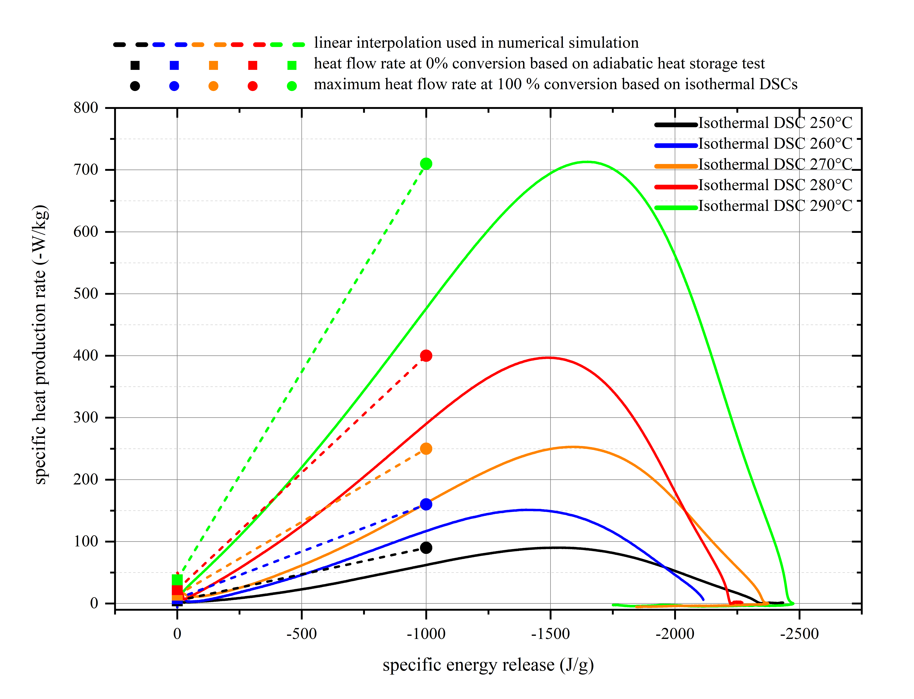

Figure 7. Derivation of the temperature- and conversion-dependent heat production rate based on isothermal DSCs and an adiabatic heat storage test

Based on this empirical kinetic model, the heat balance can be calculated numerically. The calculated adiabatic time-dependent temperature curve starting from 130 °C of the thermally unaged nitro aromatic compound is shown in Figure 8.

Without taking autocatalysis into account an adiabatic induction time of approx. 7500 hours (blue temperature curve Figure 9) is obtained. The adiabatic induction time based on the worst-case model results in an adiabatic induction time of 48 hours (orange temperature curve). Taking the dependency of the autocatalysis into account results in an adiabatic induction time of approx. 4300 hours.

The safety assessment of the storage of the nitro aromatic compound at 130 °C can be carried out on the basis of this adiabatic induction time of 4300 hours, e.g. taking into account the maximum residence time in the storage tank. If thermal aging takes place in upstream process steps at elevated temperatures, the adiabatic induction time for subsequent storage is reduced. These possible pre-aging processes or failure scenarios should be evaluated in a failure analysis. Based on the model presented, the effect of pre-aging on the adiabatic induction time can be taken into account without further experimental investigations.

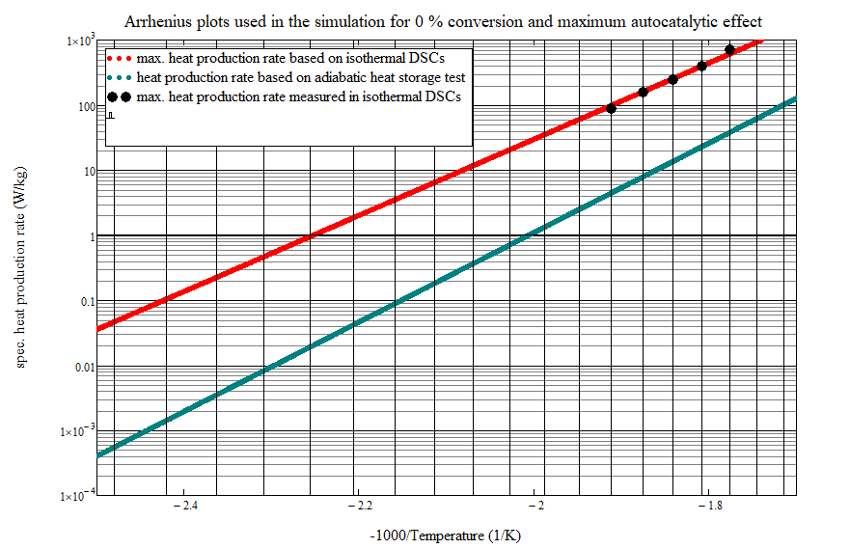

Conversion 0 %

Conversion 100 %

130 °C 150 °C 170 °C 190 °C 210 °C 230 °C 250 °C 270 °C 290 °C

Figure 8. Arrhenius plots used in the simulation for 0 % conversion based on adiabatic testing and maximum autocatalytic effect based on isothermal DSCs. The conversion dependency of the heat production rate is described by a simple linear extrapolation at specific temperature between these Arrhenius plots (see explanation Figure 4)

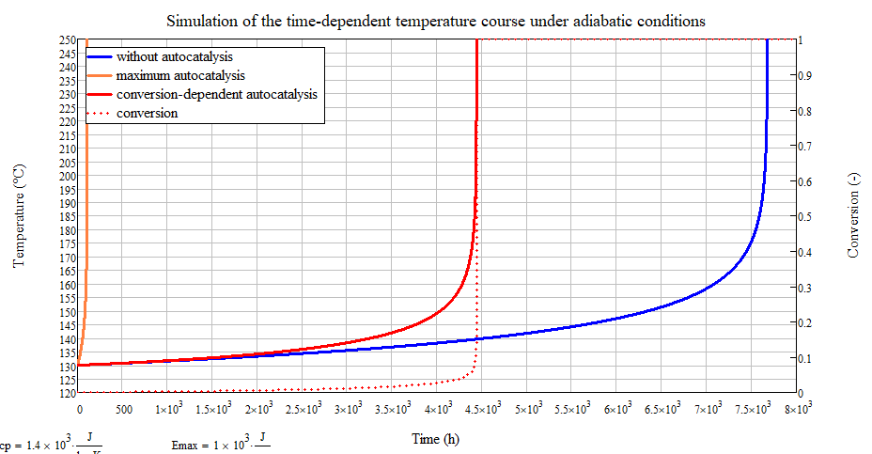

Figure 9. Numerical simulation under adiabatic conditions of the time-dependent temperature course with the detailed conversion dependent kinetics in comparison to the worst-case kinetics and the non-autocatalytic kinetics based on the adiabatic heat storage test

4. Conclusions and outlook

The presented empirical model approach for the description of weak autocatalytic decompositions enables a comprehensive safety assessment with a comparatively low experimental effort. This is made possible by the combination of isothermal DSC measurements and adiabatic calorimetry. The simple linear adjustment of the conversion dependency of the autocatalysis avoids the complex adjustment of a kinetic model. Simple numerical simulation can be used to calculate adiabatic induction times or induction times taking heat dissipation into account, on the basis of which the safety assessment of the process step can be carried out.

This was demonstrated using the example of a nitro-aromatic compound. Once the specific heat production rate Q̇(T,C) has been determined, the influence of increased ageing due to, for example, increased residence times caused by errors in operational processes, on the adiabatic induction times can be calculated using an adapted simulation.

Overall, it should be noted that autocatalytic systems react sensitively to impurities and varying compositions. The derived empirical kinetic model is only applicable to the specific sample composition investigated. This must be taken into account when planning experiments with regard to different sample compositions. In order to be able to identify critical samples, the use of isothermal DSC measurements is recommended, especially for autocatalytically decomposing compounds.

References

UN-Transportbook:  
UN Recommendations on the Transport of Dangerous Goods: Manual of Tests and Criteria, Rev. 8 (2023) and UN-Model Regulations, Rev. 23 (2023)

VDI Guideline 2263, Part 1: “Dust fires and dust explosions; hazards, assessment, safety measures; safety related parameters of bulk goods.” (2022)

TRAS 410: „Erkennen und Beherrschen exothermer chemischer Reaktionen“

F. Stoessel: Thermal Safety of Chemical Processes“ by Francis Stoessel, Wiley-VCH (2020)

S. Kimpel, C. Hernandez, J. Horn, 2016: An Alternative Way to Determine the Self-Accelerating Decomposition Temperature by Using the Adiabatic Heat- Pressure Accumulation Test, Chemical Engineering Transactions. 48, 139-144

Th. Grewer, O. Klais: Exotherme Zersetzung — Untersuchung der charakteristischen Stoffeigenschaften, VDI-Verlag (1988)