 CHEMICAL ENGINEERING TRANSACTIONS  VOL. xxx, 2025 | A publication of  
The Italian Association
of Chemical Engineering
Online at www.cetjournal.it
Guest Editors: Bruno Fabiano, Valerio Cozzani
Copyright © 2025, AIDIC Servizi S.r.l.
ISBN 979-12-81206-xx-y; ISSN 2283-9216

Extension of QRA event trees for risk assessment of R290 refrigerant applications
Rocco di Filippo*, Gianluca Maracchini, Oreste S. Bursi
Department of Civil, Environmental & Mechanical Engineering, University of Trento, Via Mesiano 77, Trento, Italy
*rocco.difilippo@unitn.it

After the 1987 Montreal Protocol banned chlorofluorocarbons (CFCs) for their ozone-depleting effects, hydrochlorofluorocarbons (HFCs) became the preferred refrigerants. Although HFCs do not damage the ozone layer, they contribute significantly to global warming. HFCs possess, indeed, a global warming potential (GWP) hundreds of times higher than CO2. Therefore, the 2016 Kigali Amendment introduced an international plan to phase out high-GWP HFCs. The most suitable alternatives for residential refrigerants are hydrocarbons (HCs) such as R600 (isobutane) and R290 (propane), which exhibit a negligible GWP but are characterised by high flammability. While R600 has been safely used in refrigerators due to its low charge requirements, safety concerns about using R290 in air conditioning have been raised. These concerns have led to international standards capping the permissible R290 charge to amounts that made it unfeasible for widespread HVAC applications. Still, IEC 60335-2-40:2022 increased the maximum allowable charge in 2022 to remove a barrier to heating electrification and energy transition, effectively. Risk mitigation measures have focused on R290 leak control in enclosed spaces. According to current research and regulations, the leakage of R290 is considered the primary source of fire hazard for these applications. However, despite empirical, experimental, and numerical evidence, less attention has been given to the behaviour of air conditioning and refrigeration units in independent fires. As a result, quantitative risk assessment (QRA) methods have been mainly applied with leakage as a starting event. Conversely, this study introduces new event trees for QRA, considering an independent fire as a starting event. Preliminary probability assessments are also provided to compare the likelihood of fire consequences. The findings stress the importance of considering fire reactions of HC equipment together with leakage risks.
  - Introduction
The 1987 Montreal Protocol effectively banned chlorofluorocarbons (CFCs), a class of chemicals that deplete the ozone layer, which has since shown signs of recovery. CFCs, once prevalent in aerosol sprays and refrigeration, were initially replaced by hydrochlorofluorocarbons (HCFCs) and later by hydrofluorocarbons (HFCs) (Maracchini et al., 2023). Although HFCs are ozone-safe, they have high global warming potential (GWP) and are projected to contribute significantly to global warming if left unregulated (Heath, 2016). The Kigali Amendment, therefore, mandates a gradual phase-out of HFCs to reduce their climate impact, especially because of the expected wider adoption of electricity-based systems for thermal regulation (di Filippo et al., 2024). With HFC reductions underway, hydrocarbons (HCs) are now being adopted as low-GWP refrigerants. However, HCs pose additional challenges compared to HFCs mainly related to possible increased fire hazards. Leakage is a prominent concern due to HCs’ high flammability (ISO, 2014), lower ignition temperatures, and broader flammability range, i.e. a refrigerant class A3. If leaked, HCs can easily ignite, especially in confined spaces, making leakage the primary fire hazard in refrigerant-based systems (Li et al., 2023). To manage these risks, international standards set maximum allowable charges (MAC) for HCs and implement stricter guidelines to control their use in refrigeration, air conditioning, and heat pump (RACHP) systems (Colbourne et al., 2020).
In 2017, UNEP-TEAP advocated for updates to international standards on MACs to encourage the use of low-GWP refrigerants (Polonara et al., 2017). Consequently, the IEC standards were revised in 2020 for commercial applications and in 2022 for residential use, permitting higher charges for A3 refrigerants under certain leakage control conditions (IEC, 2022). However, in addition to leakage risks, RACHP components can contribute to fire hazards by reacting to independent fires (IFs), especially in scenarios where such components worsen IFs’ consequences. For example, HVAC systems may spread flames or smoke through air ducts, while RACHP units close to combustible materials can ignite, exacerbating fire spread on building facades (Anderson et al., 2017). In particular, studies show that refrigerant-based equipment can ignite when exposed to external fires (Zhang et al., 2013). The fire risk is further compounded in buildings with combustible thermal insulation, where combustible insulation materials have been shown to worsen fire outcomes (di Filippo et al., 2023).
While HCs as HFC replacements support low-emission goals, they introduce dual fire hazards linked to leakage and fire reaction as described in Section 2. Given that the latter case has been less explored in literature and considered by relevant standards, this study aims to investigate its characteristics and verify its significance in Section 3. The results are presented in Section 4 while the main conclusions are drawn in Section 5.
  - Flammable refrigerant and fire risk scenarios
We categorize potential fire scenarios involving RACHP equipment with flammable refrigerants into two main types. The first type involves refrigerant leakage into enclosed spaces as a fire hazard source; i.e. leakage-induced fire (LIF) scenario. The second type involves an independent fire (IF) where the fire reaction of RACHP equipment influences the fire consequences severity, i.e. reaction-influenced fire (RIF) scenario.
    - Leakage-Induced Fire Scenario
Quantitative risk assessment (QRA) is an established approach for assessing risks from leakage of dangerous compounds, commonly using "event trees" (ETs) to describe and quantify the likelihood of adverse events. These trees illustrate complex scenarios by breaking them into possible outcomes and sequential events. In Leakage-Induced Fire (LIF) scenarios, ETs typically include four steps: i) refrigerant leakage within an enclosed space, ii) reaching the lower flammability limit (LFL), iii) the presence of a Source of Ignition (SOI), and iv) ignition leading to secondary fires, excessive thermal radiation or overpressure (Li et al., 2023), as depicted in Figure 1. Experimental studies on LIF scenarios for flammable refrigerants have identified critical factors influencing refrigerant concentration and ignition risk, such as equipment positioning, installation height, airflow, and natural ventilation (Ning, 2023). Indeed, to address risk from LIF scenarios, standards like IEC 60335-2-40 (IEC, 2022) prescribe a maximum allowable charge (MAC) based on factors like flammability classification, room size, ventilation, and "enhanced tightness" (ENT). ENT and "releasable charge" (RC) features aim to prevent leaks, with RC limiting the refrigerant amount released by automatically closing valves during a detected leak. These measures have enabled higher MAC limits in newer standards, allowing, for example, 500 grams of A3 refrigerant in 12 m² rooms versus 30 m² under the previous version of the IEC code.
    - Reaction-influenced Fire scenario
In Reaction-Influenced Fire (RIF) scenarios, the primary event is an independent fire, followed by the fire reaction of RACHP equipment and its potential to exacerbate fire outcomes. It is important to underline that the final stage in RIF scenarios should lead to fire consequences worsened beyond what would occur in an independent fire without RACHP units. A simplified scheme of the RIF event tree is depicted in Fig.1.
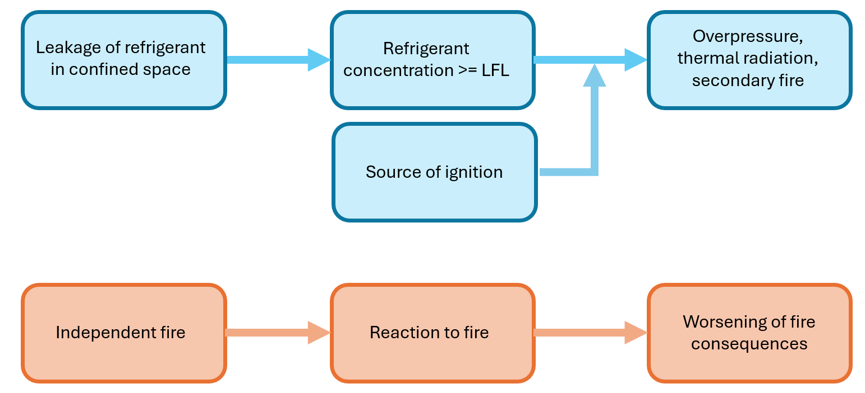
Figure 1: Schemes representing the LIF, in blue, and the RIF, in orange, scenarios.

Real-world incidents highlight this impact. For instance, the 2014 Lacrosse building fire in Melbourne spread via combustible facade cladding, with air conditioner compressors on balconies adding to the fire load as the sprinkler system only covered indoor areas (Anderson et al., 2017). A similar occurrence was reported in 2019 at the All-India Institute of Medical Sciences (AIIMS) in New Delhi, where external AC units reportedly acted as a catalyst for fire spread (Darrock et al., 2019). Additionally, in the 2017 Grenfell Tower fire, a refrigerator was suspected to have supported the initial development of the fire (McKenna et al., 2019)
Experimental research on RACHP units in RIF settings is limited. A study by (Colbourne et al., 1997) observed similar fire reactions in chest freezers with different refrigerants (R12 and a mix of R290 and R600), with both causing brazed joints to fail, allowing refrigerant leakage and ignition. Another comprehensive study involving various appliances found that refrigerators with R134a, R600, or R12 refrigerants had high heat release rates (HRR) and could easily trigger a flashover in a kitchen setup (Hietaniemi et al., 2001). Tests of indoor STHAC units filled with R290 and R22 refrigerants showed that both reached a high peak Heat Release Rate (HRRs), up to 1000 kW. after refrigerant ignition, suggesting that the lubricant oil could increase flammability even in “non-flammable” refrigerants like R22 (Zhang et al., 2013).
While the UNEP-TEAP report mentioned above (Polonara et al., 2017) acknowledges RIF scenarios, current international standards for RACHP lack targeted measures to mitigate RIF risks. A notable exception is the recent Italy’s RTV standard (MINT, 2022) which mandates fire barriers around technological components on facades, originally designed for PV systems but also applicable to RACHP units (FRISBEE, 2024).
  - Fire scenario comparison: methodology
This section aims to investigate the relative significance of RIF scenarios presenting a comparison between the occurrence and consequences of LIF and RIF scenarios. The comparison is carried out based on available statistics in Subsections 3.1 and 3.2.
    - QRA of LIF scenarios
LIF scenarios are central in Quantitative Risk Assessments (QRA) for applications involving flammable refrigerants, an area extensively reviewed in the 2017 UNEP-TEAP safety standards assessment (Polonara et al., 2017). QRA can quantify event frequencies by combining elements within an Event Tree (ET), applying a frequentist probability approach. In LIF scenarios, the first event is a flammable refrigerant leak, influenced by leak intensity and hole size. For instance, (Colbourne et al., 2015) provide an annual frequency estimate for leaks in Split-Type Household Air Conditioner (STHAC) units, ranging from 10⁻⁵/y to 10⁻⁶/y for severe leaks from 3mm holes. Ignition probability must account for the likelihood of reaching the LFL within an enclosed space which depends on the leak rate and available air circulation. If the LFL is reached, a SOI is necessary for fire initiation. The probability of SOI within a residential room, often due to electrical faults, is approximately 10⁻³/y (Colbourne et al., 2015). This value factors in the duration of the spark (about 1s) and the time LFL is present. (Colbourne et al., 2015) calculated P_{I} to be 4 · 1⁻¹⁰/y for a 20 m² room with an R290 STHAC unit.
Similarly, (Rajadhyaksha et al., 2015) found P_{I} values from 6.7 · 1⁻¹⁰/y to 3.8 · 1⁻⁹/y for varying room sizes (10 to 30 m²), circuit piping length, and ventilation characteristics.
In a recent study, (Guo et al., 2024) estimated P_{I} between 0.13 · 1⁻¹¹/y and 0.93 · 1⁻¹⁰/y for an AC cabinet in a 20 m^2 room, showing that variables like charge size, leak location, and ventilation significantly affect ignition frequencies. The summary of P_{I} for R290 residential AC units is shown in Table 1, where frequencies are generally consistent across studies due to similar QRA methodologies. It is worth noting that consequences following ignition, including potential damage to property or individuals, are generally an order of magnitude less probable than the ignition event itself (Rajadhyaksha et al., 2015; Colbourne et al., 2015). These outcomes are more variable, with factors like the presence of windows or doors substantially influencing risk levels and impact by affecting overpressure levels.

Table 1: Probability of ignition (P_{I}) of R290 residential AC units within enclosed space
Study | Charge (kg) | Room size (m²) | P_{I} (y⁻¹)
Colbourne et al., 2015 | 0.4 | 20 | 4 · 10⁻¹⁰
Rajadhyaksha et al., 2015 | 0.31 | 10-30 | 6.7 · 10⁻¹⁰ - 3.8 · 10⁻⁹
Guo et al., 2024 | 0.15 | 24-40 | 0.13 · 10⁻¹¹ - 0.93 · 10⁻¹⁰
    - Likelihood and consequences of RIF scenarios
To date, no studies have applied QRA specifically to Reaction-Influenced Fire (RIF) scenarios. This section explores RIF likelihood and outcomes by reviewing (i) fire occurrence statistics, (ii) the impact of Heat Release Rate (HRR) from RACHP components, and (iii) RACHP interactions with combustible ETICS.

3.2.1 Occurrence of Independent Fire
Fire probability (P_{F}) for residential buildings is often expressed as an annual frequency, calculated based on factors like building type, surface, fire safety measures and others. In this work, we will consider P_{F} as the annual frequency of fires referred to a single residential unit, i.e. a dwelling. For instance, based on 2014 residential fire data from the UK. (Manes et al., 2018) estimates P_{F} at 1.33 · 10⁻³/y. Likewise, in Greece, P_{F} is 0.97 · 10⁻³/y from 2000-2019 data (Filikas et al., 2022). In the US, a higher rate of 3.01 · 10⁻³/y was estimated based on 2020 statistics (di Filippo et al., 2023). These probabilities, summarized in Table 2, appear to be consistently within the same order of magnitude, despite regional differences.

Table 2: Annual frequency of fire (P_{F}) within residential buildings
Country | Year Data | P_{F} (y⁻¹) | Source
UK | 0.4 | 1.33 · 10⁻³ | Manes et al., 2018
Greece | 0.31 | 0.97 · 10⁻³ | Filikas et al., 2022
US | 0.15 | 3.01 · 10⁻³ | di Filippo et al., 2023

3.2.2 Influence on Fire Load and Heat Release Rate
Fire Load and Heat Release Rate (HRR) are commonly considered critical parameters in the development and severity of fires (Hietaniemi et al., 2001). Experimental studies have demonstrated that RACHP equipment, though generally contributing modestly to overall fire load, can produce a significant HR) that impacts fire dynamics, especially in confined spaces. For instance, tests on refrigerators filled with various refrigerants, such as R600 and R290, showed peak HRRs between 1148 and 2125 kW (Hietaniemi et al., 2001). Besides, (Zhang et al., 2013) investigated internal STHAC units and found that units containing R290 refrigerant exhibited HRRs around 1000 kW. Interestingly, a similar value was found for R22, an A1-class refrigerant. These results, reported together with experimental fire load in Table 3, indicate that refrigerants can intensify fire behavior.

Table 3: Experimental Fire Load and HRR of RACHP equipment
Study | RACHP Equipment | Fire Load (MJ) | Peak HRR (kW)
Hietaniemi et al., 2001 | 4 refrigerators | 506 | 2125
 |  | 402 | 1816
 |  | 611 | 1148
 |  | 286 | 1904
Zhang et al., 2013 | STHAC – no refrigerant | 111 | ≈400
 | STHAC – R22 | 100 | ≈1000
 | STHAC – R290 | 131 | ≈1000

Compared to other common household appliances, the HRR values for RACHP systems are relatively high. For example, washing machines and dishwashers were found to produce peak HRRs of 333 kW and 548 kW, respectively (Hietaniemi et al, 2001). Electric printers and televisions tested in other studies produced maximum HRRs of around 100 kW and 306 kW, respectively (Simonson et al., 2004). This comparison highlights that RACHP systems, particularly those with flammable refrigerants, are among the more intense heat-producing appliances during a fire. This HRR can contribute to rapid fire growth, and it is close to the required HRR for flashover according to the results of (Dundar et al., 2023), which can be as low as 1900 kW. According to the same study, which involved simulations of fires in apartment-type dwellings, average fire load densities range from 526 to 460 MJ/m² with peak HRRs reaching between 8 and 25 MW (Dundar et al., 2023). Hence RACHP equipment alone does not significantly contribute to fire load, but their peak HRR can worsen fire development.

3.2.3 Interaction with Facade Fires and Combustible Thermal Insulation
External RACHP units may be able to propagate and support fire to combustible External Thermal Insulation Composite Systems (ETICS) and, consequently, exacerbate facade fires. For instance, this occurrence was confirmed in the 2014 Lacrosse building fire in Australia (Anderson et al., 2017), see Figure 2 for reference.
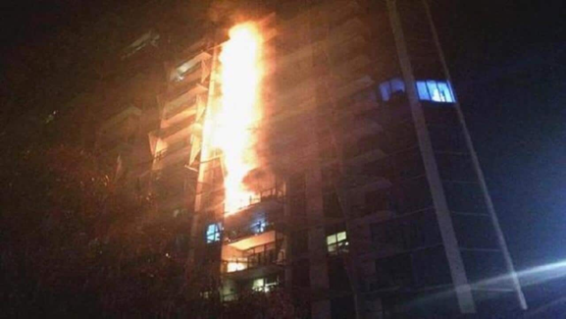 | 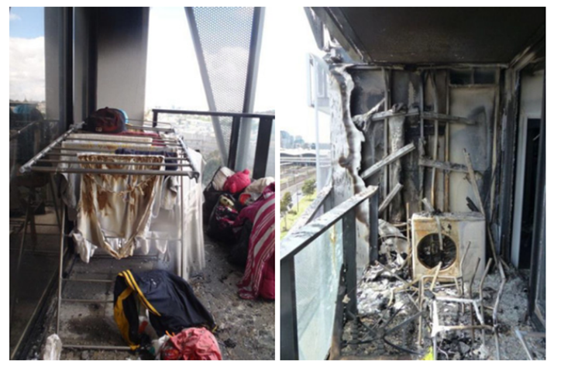
Figure 2: 2014 Lacrosse building fire and one external RACHP unit that supported the façade fire.
Indeed, the participation of combustible ETICS in fires can significantly increase fire load and aggravate consequences (di Filippo et al., 2023). Data shows that 2-6% of building fires impact external facades, with a certain variability depending on the region (White et al., 2015), as reported in Table 4.
Safety measures like Minimum Fire Performance (MFP) standards and fire barriers (FBs) can mitigate fire spread and consequences. Experiments suggest however that FBs are not able to avoid, but only delaying, fire spreading on combustible facade materials, for instance, those materials with a European fire reaction class B (Rukavina et al., 2017). In this respect, the presence of RACHP external units can deteriorate further the mitigation capacity of FBs.

Table 4: Share of residential fires that starts from or involve
Country | Year Data | Share of total fires | Source
US | 2007-2011 | 2% | Statistics (White et al., 2015)
Australia | 2003-2007 | 1.8%
New Zealand | 2005-2010 | 5%
  - Results and discussion
Based on the analysis in Sections 2 and 3, the significance of reaction-influenced fire (RIF) scenarios appears to be not negligible mainly due to the following reasons:
- The likelihood of an external fire, 𝑃_{𝐹} from Table 2, is 7-8 orders of magnitude higher than the likelihood of a leakage ignition, 𝑃_{𝐼} from Table 1. The value of peak HRR, from Table 3, is significant when compared to the expected HRR from an average residential fire. Besides, the presence of refrigerants has been found to increase peak HRR, which underlines the possibility of a positive correlation with charge size. Moreover, the fire reaction of some RACHP units, such as refrigerators, can lead to a flashover.
- The probability that a fire can reach an external RACHP unit can be retrieved by combining the values from Table 4 with 𝑃_{𝐹} from Table 2. For reference, this instance still presents a likelihood 5-6 orders of magnitude higher than the ignition probability 𝑃_{𝐼} from leakage-induced fire (LIF) scenarios.
- There is an overall scarcity of experimental data on the fire reaction of RACHP units filled with A3 or other classes of refrigerants. In this respect, it has been possible to retrieve the results of only three experimental campaigns (Coulborne et al., 1997; Hietaniemi et al., 2001; Zhang et al., 2013). This contrasts with the empirical evidence from past accidents, the variety of RACHP applications, refrigerant charge sizes, and the established trends towards electrification and adoption of A3 refrigerants.
- The newly introduced or revised mitigation measures within the new IEC 60335-2-40:2022 (IEC, 2022) are conceived for LIF scenarios only. Limits for charge sizes and enhanced tightness are relevant to a single circuit. Therefore, no limits exist on the total number of circuits within an enclosed space or on the exterior where neither charge limits apply.
- The Italian building fire code (MINT, 2022), introduced mandatory facade fire barriers around technological components, including RACHP units. While this is supported by reasonable caution, given to the lack of component-specific experimental data, it is unclear if this approach is over- or under-conservative.
In sum, the extension of QRA to RIF scenarios may improve the risk assessment of flammable refrigerant applications and the formulation of efficient mitigation measures. The statistics examined in this work are linked to residential stocks, but the findings may be relevant to industrial and commercial ones too.
  - Conclusions
The shift towards low-GWP refrigerants like hydrocarbons is crucial for mitigating environmental impacts. However, this transition introduces new fire safety challenges due to the increased flammability of HCs. While extensive research and Quantitative Risk Assessments have been conducted on Leakage-Induced Fire scenarios, our review reveals a significant gap in understanding reaction-influenced fire (RIF) scenarios involving RACHP equipment. Experimental studies indicate that RACHP components can contribute substantially to heat release rates, potentially accelerating fire growth and leading to flashover conditions. Additionally, the interaction between RACHP units and combustible facade materials like External Thermal Insulation Composite Systems can exacerbate fire spread on building exteriors. Given the consistent probability of independent fires across various regions and the potential for RACHP equipment to influence fire severity, future research will focus on expanding QRA methodologies to include RIF scenarios and, ideally, adopt a performance-based probabilistic approach. Its extension and validity to these specific conditions should be developed and verified. Finally, future research should comprise full-scale fire testing and the development of comprehensive safety standards that address both leakage risks and the fire reaction of RACHP systems.
Acknowledgements
This work has been funded by the University of Trento, Italy, within the framework of the project BETTER (CUP E63C22000500003).
References
Anderson, J., Boström, L., & Jansson McNamee, R., 2017. Fire safety of façades, Tech. Rep. 2017:37, RISE - Research Institutes of Sweden (2017-2019), Safety.
Colbourne, D., 1997. A comparison of fire advancement in chest freezers subjected to a high-intensity fire when charged with Care 30 and CFC-12, Internal Appliance Fire Test Report CAS-059, Calor Gas, Warwick.
Colbourne, D., & Suen, K., 2015. Comparative evaluation of risk of a split air conditioner and refrigerator using hydrocarbon refrigerants, International Journal of Refrigeration 59, 295–303.
Colbourne, D., Suen, K., Li, T.-X., Vince, I., & Vonsild, A., 2020. General framework for revising class A3 refrigerant charge limits - a discussion, International Journal of Refrigeration 117, 209-2017.
Darroch, G., 2019. Watch out! Your AC can start a massive fire, India Today, September 3. https://www.indiatoday.in/mail-today/story/watch-out-your-ac-can-start-a-massive-fire-1595177-2019-09-03
Di Filippo, R., Possidente, L., Tondini, N., & Bursi, O. S., 2023. Quantitative integration of fire risk with life cycle analysis of building: The case of thermal insulation, Journal of Building Engineering 160, 683–694.
Di Filippo, R., Maracchini, G., 2024. A probabilistic framework for stranding risk assessment and EPBD IV scenario analysis for the Italian building stock, Journal of Building Engineering 96, 110448.
Dundar, U., & Selamet, S., 2023. Fire load and fire growth characteristics in modern high-rise buildings, Fire Safety Journal 135, 103710.
Georgiadis Filikas, K., Bakas, I., & Kontoleon, K., 2022. Statistical analysis and review of fire incidents data of Greece, with special focus on residential cases 2000–2019, Fire Technology.
Guo, C., Yang, Z., He, H., Li, J., Hou, Z., Zhao, Y., Hu, Y., & Shu, Y., 2024. Investigation of the application safety of R-290 in residential air conditioning systems, Journal of Building Engineering 94.
Heath, E. A., 2017. Amendment to the Montreal protocol on substances that deplete the ozone layer (Kigali Amendment), International Legal Materials 56 (1), 193–205. doi:10.1017/ilm.2016.2.
Hietaniemi, J., Mangs, J., & Hakkarainen, T., 2001. Burning of electrical household appliances an experimental study (3–60). - https://publications.vtt.fi/pdf/tiedotteet/2001/T2084.pdf
International Electrotechnical Commission, IEC, 2022. IEC60335-2-40:2022 Edition 7.0, Household and similar electrical appliances - Safety - Part 2-40, International Standard, TC 61/SC 61D.
ISO, International Organization for Standardization, 2014. ISO 817:2014 Refrigerants — Designation and safety classification, Standard, Geneva, CH.
Li, Y., et al., 2023. Leakage, diffusion and distribution characteristics of refrigerant in a limited space: a comprehensive review, Thermal Science and Engineering Progress 40, 101731.
Manes, M., & Rush, D., 2018. A critical evaluation of BS PD 7974-7 structural response data based on USA fire statistics, Fire Technology 55, 10.
Maracchini, G., Di Filippo, R., Albatici, R., & Bursi, O. S., Di Maggio, R., 2023. Sustainable retrofit of existing buildings: Impact assessment of residual fluorocarbons through uncertainty and sensitivity analyses, Energies 16 (7).
MINT, Ministero dell’Interno, 2022. DM 30 marzo 2022 Norme tecniche di prevenzione incendi per le chiusure d’ambito degli edifici civili, ai sensi dell’articolo 15 del decreto legislativo 8 marzo 2006, n. 139. (22A02207).
McKenna, S. T., et al., 2019. Fire behaviour of modern façade materials – understanding the Grenfell tower fire, Journal of Hazardous Materials 368.
Ning, Q., et al., 2022. R290 leakage hazards assessment of a 1 hp split-type household air conditioner by concentration detection and ignition experiment, International Journal of Refrigeration 139, 70–83.
Polonara, F., et al., 2017. Decision XXVIII/4 Task Force: Safety Standards For Flammable Low Global-Warming-Potential (GWP) Refrigerants, Tech. rep., United Nations Environment Programme, Nairobi, Kenya.
Project, F., ZAG, 2024. Frissbe-zag BAPV fire safety guideline, version 3.0 (May).
Rajadhyaksha, D., Wadia, B., Acharekar, A. A., & Colbourne, D., 2015. The first 100 000 hc-290 split air conditioners in India, International Journal of Refrigeration 60, 289–296.
Rukavina, M. J., Carevic, M., & Pecur, I. B., 2017. Fire Protection of Facades: The Guidelines for Designers, Architects, Engineers, and Fire Experts, University of Zagreb, Faculty of Civil Engineering.
Simonson, M., Andersson, P., & Bliss, D., 2004. Fire performance of selected IT equipment, Fire Technol., 40.
White, N., & Delichatsios, M., 2015. Fire hazards of exterior wall assemblies containing combustible components, 1st Edition, SpringerBriefs in Fire, Springer, New York, NY.
Zhang, W. et al., 2013. Research on the flammability hazards of an air conditioner using refrigerant R-290, International Journal of Refrigeration 36 (5), 1483–1494.

