|  |  |
| --- | --- |
| cetlogo ***CHEMICAL ENGINEERING TRANSACTIONS***  ***VOL. xxx, 2025*** | A publication of  aidiclogo_grande |
| The Italian Association  of Chemical Engineering  Online at www.cetjournal.it |
| Guest Editors: Bruno Fabiano, Valerio Cozzani  Copyright © 2025, AIDIC Servizi S.r.l. **ISBN** 979-12-81206-xx-y; **ISSN** 2283-9216 | |

A novel QRA model for coupling accidents - a case study of utility tunnels

Yiping Baia,\*, Kunqi Liub, Wenguo Wenga, Jiansong Wub

a School of Safety Science, Tsinghua University

b School of Emergency Management and Safety Engineering, China University of Mining & Technology-Beijing

[baiyiping\_1995@163.com](mailto:baiyiping_1995@163.com); [baiyiping@tsinghua.edu.cn](mailto:baiyiping@tsinghua.edu.cn)

Since there are more emerging and interacted process installations, the traditional QRA treating risks as independent ones may ignore coupling effects and result in risk underestimation. The utility tunnel is a new process installation with multiple hazardous pipelines inside a confined space. Existing studies of utility tunnel risks focus more on single accidents like cable fire or gas explosion, with limited analysis of the coupling effect. In this paper, a novel QRA model for coupling risks is proposed in a new perspective for the coupling risk assessment of process installations. The ponding inside utility tunnels coupled with personnel evacuation is analysed as a case study. The results show that the current design of utility tunnels is insufficient for preventing ponding-triggered drowning in heavy rain like the “7.20” rainstorm. Heightening the water barrier of ground ventilation openings to over 0.6 m can effectively reduce the coupling risks. Besides, the proposed model can also be further applied to other coupling risks.

* 1. Introduction

Utility tunnels are built for convenient maintenance and efficient use of underground space, containing a variety of pipelines like electricity, communications, natural gas, heating, water supply, and drainage. Utility tunnels can also significantly strengthen the reliability and service life of underground pipelines in chemical parks or cities. However, such integration is prone to trigger coupling accidents like gas leakage, fire, explosion, and ponding, which can lead to the paralysis of energy supply systems and corresponding productions.

The current QRA models of process industries mainly focus on single risks. Zhu et al. (2024) proposed a fire risk assessment model for cable fires by integrating FDS and DBN. Since there are various hazardous pipelines with corresponding accidents in a utility tunnel, ignoring the coupling effect between different risk factors or incomplete consideration of the consequences will lead to deviations in consequence assessment. There are a few research implemented so far, Hai et al (2022) applied the N-K model to quantify the coupling relationship among human error, equipment failure and management mistakes to quantify the coupling effect, but the process relies on expert judgment and lacks measurement of physical effect. Gu et al. (2025) established a knowledge base of evolution paths of typical coupling accidents in the case of earthquakes but lacks the consequence quantification and detailed decision-making. Therefore, there is still an essential need for dynamic coupling risk assessment methods to comprehensively analyze potential coupled risks of utility tunnels and similar confined spaces in the process industries.

Meanwhile, in the case of flooding, the water intrusion into the utility tunnel has a severe impact on the pipeline and personnel inside, the ponding inside and corresponding evacuations have a significant coupling effect and may result in fatalities. He et al (2024) conducted a risk assessment of the flood disaster in the underground space and put forward resilience enhancement measures. Yuan et al (2024) simulated the risk distribution of flooding in the underground space. However, the existing research does not take enough consideration on the relevance of the coupling effect in the case of flooding of a utility tunnel.

In this paper, a novel QRA model for coupling risks was proposed to measure the coupling effect systematically. The rest of the work is presented as follows: section 2 introduced the methodology, section 3 conducted a case study on ponding risks in utility tunnels, and section 4 concluded the whole work.

* 1. Methodology

Based on the energy out-of-control theory for risk identification and scenario construction of utility tunnels proposed by authors before (Bai et al., 2024). A novel QRA model for coupling risks of hazardous process installations is introduced in this work in Figure 1. The proposed model begins with analyzing the out-of-control energy and identifying corresponding vulnerable targets associated with the primary event. Subsequently, the occurrence of cascading accidents is evaluated based on predefined escalation criteria. If the target remains intact, the QRA of the primary event should be performed and the process ends. In the case of one or more cascading accidents occurring with multiple energy coexisting and considerable coupling effects, QRA considering coupling effect should be conducted. Conversely, if out-of-control energy does not coexist or no coupling effect is observed, the effects of each out-of-control energy should be compared. If there is one of the energies far greater than others, QRA focusing on the worst accident should be conducted. If not, (i.e. multiple out-of-control energies are considerable) the QRA for each accident should be performed and summed up. For typical accidents of utility tunnels, the QRA of gas leakage and explosion should be QRA for the worst accidents, since the consequence of explosion is far greater than leakage. In case of cascading cable fires, the QRA should consider multiple cable damage and sum them up. For the ponding and evacuation inside utility tunnels or other confined spaces, there is a considerable coupling effect that should be quantified, which will be elaborated in the following.

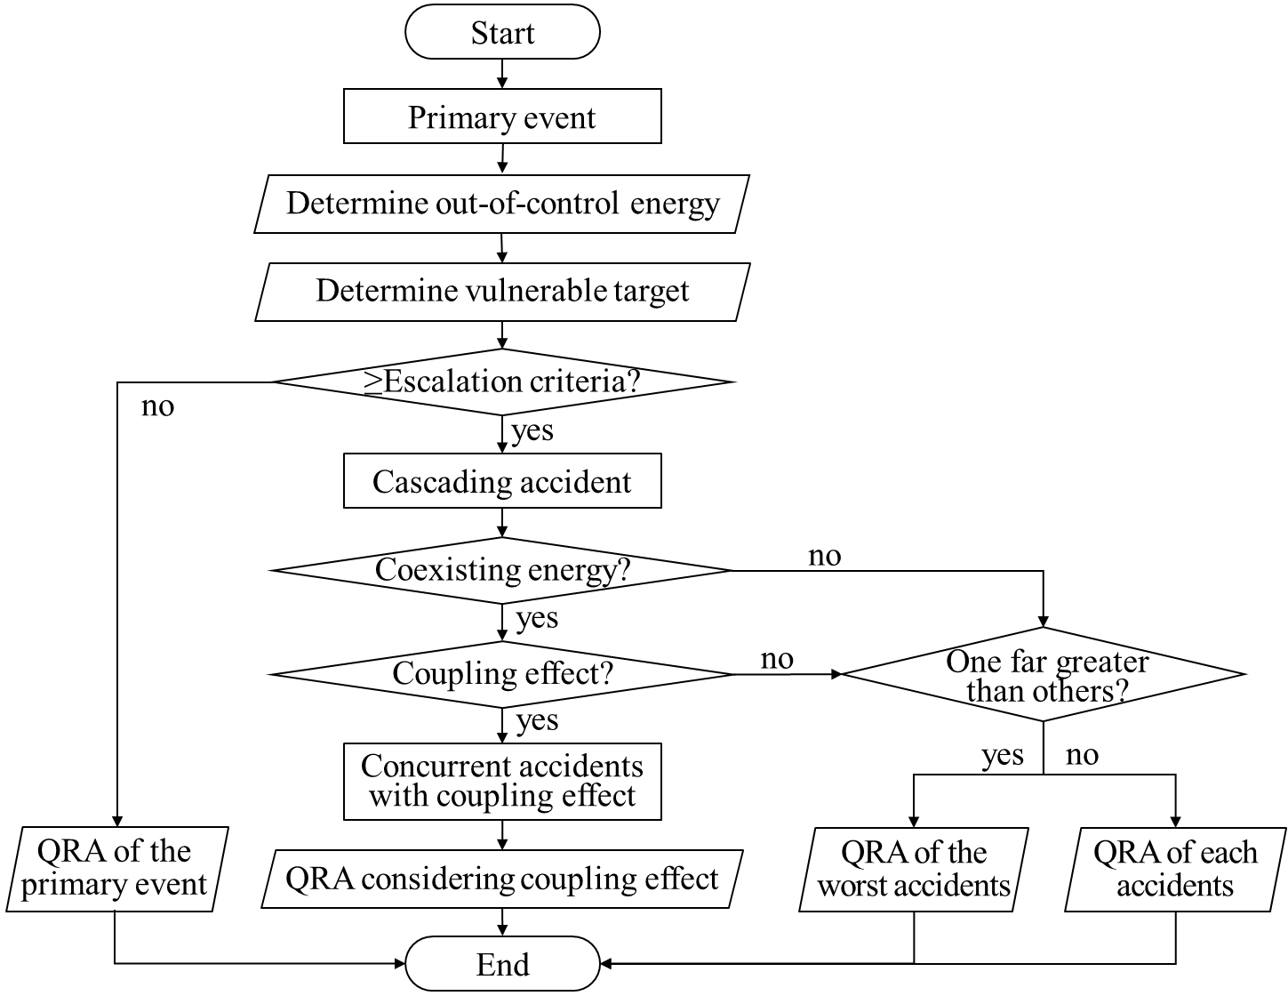

Figure 1 Flow chart of the proposed QRA model for coupling risks

* 1. Case study

Utility tunnel is an emerging underground infrastructure, and mostly the lowest location of the chemical parks or urban areas, therefore, ponding inside the utility tunnel can break in through the escape openings, ventilation openings, and other ground openings. Meanwhile, heavy rain or flooding can lead to coupling accidents, which will be analysed and measured in this section.

* + 1. Preliminaries

This section primarily discusses the typical event chain caused by flooding in utility tunnels during heavy rain. Ponding entering through ventilation openings (as shown in Figure 2) may not be efficiently drained by the internal drainage system to threaten maintenance personnel inside. The event chain with the coupling effect of ponding within utility tunnels can be described as follows: rainwater enters through the ventilation opening, where gravitational energy is converted into mechanical energy; the water then accumulates inside the tunnel, threatening personnel as the mechanical energy shifts back to gravitational energy; and finally, pipeline failure occurs when the mechanical energy of the water is transferred to the pipeline’s mechanical system, leading to a rupture or malfunction.

The rate of water intake from the ventilation opening varies with the depth of depth of the surface water. Therefore, in the first stage, when the depth of surface water around the ground ventilation opening is relatively low, the water discharges from the ventilation opening in the form of a weir flow, as a result, the ponding of water in this stage of the utility tunnel can be calculated by Equation 1-2 (assuming the drainage system fails) (Xia et al., 2022):

|  |  |
| --- | --- |
| $$Q=C_{W}P\sqrt{2g}H^{1.5}$$ | (1) |
| $$Hg=h-h_{0}+{u^{2}}/{2g}$$ | (2) |

where *Q* is the inlet flow rate to the vent, m3/s; *Cw* is the inlet discharge coefficient for the weir flow pattern; *g* is the gravitational acceleration, m/s2; *H* is the upstream specific energy; *h* is the water depth over ventilation opening, m; *u* is the corresponding velocities 1 m upstream of the opening, m/s; and *P* is the perimeter of the openings.

Then, the temporal evolution of water depth (*hI*) inside the utility tunnel can be calculated by Equation 3 (assuming the compartment is empty):

|  |  |
| --- | --- |
| $$h_{I}=\frac{(Q-q_{w})×t}{L×W}$$ | (3) |

where *qw* is the drainage volume of the utility tunnel drainage system, m3; *L* and *W* are the length and width of the utility tunnels.

When the accumulated water reaches a critical depth, people will find it difficult to evacuate inside. So, current research has proposed a microscopic model for pedestrian evacuation in underground space under flood, according to the experimental results of Zheng et al. (2019), when the depth of the flood water in the utility tunnel rises gradually, the change of the maintenance personnel's moving speed can be described by the following equations.

|  |  |
| --- | --- |
| $$v=\left\{\begin{aligned}v_{g0}，h_{I}=0 \\ \left[v_{g0}\right.\left.×B×ω/0.5\right]×0.5,h_{I}>0\end{aligned}\right.$$ | (4) |
| $$B=1-h_{I}/h'$$ | (5) |
| $$ω=1.0/(0.982+\exp\left(1.12t-4.0\right))$$ | (6) |

where *vg* is the maintenance personnel's velocity, *ω* is the ratio of speed decrease due to tiredness. *h’* is the height of a utility tunnel, and *hI* is the depth of water in a utility tunnel. When maintenance personnel are walking on the ground, the maximum speed is *vg0*, which decreases as the ponding depth rises.

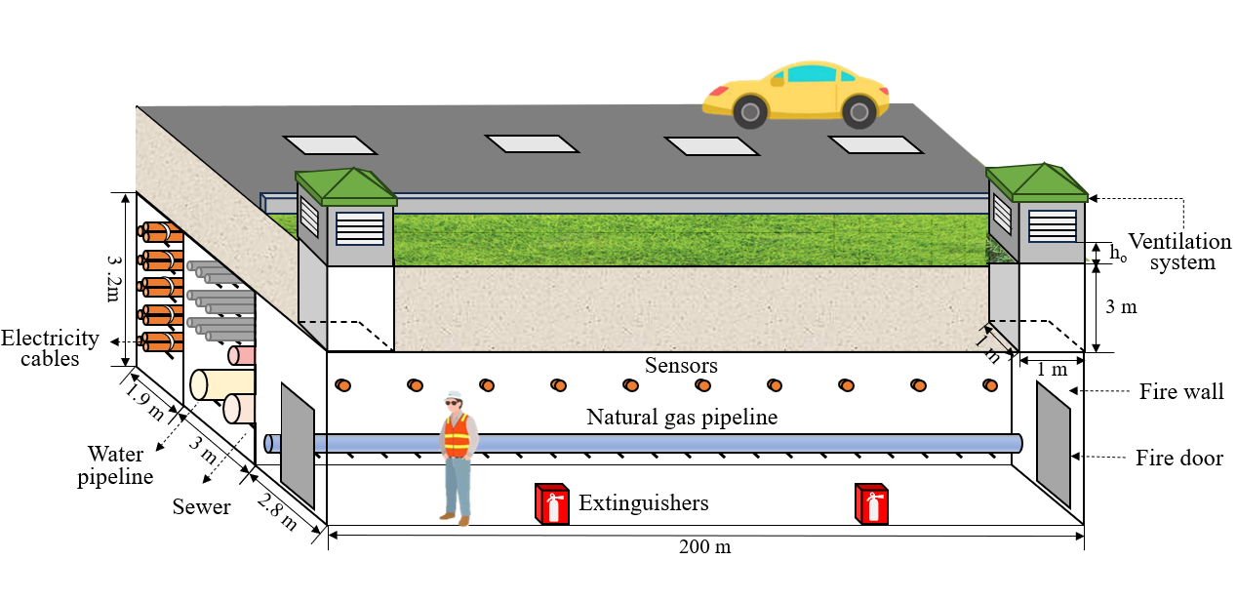

Figure 2 Schematic diagram of the cross-section of a utility tunnel

* + 1. Risk assessment of the typical scenario

In the era of global climate change, there may occur more flooding and other severe convection weather. The underground space may be more vulnerable than the surface for ponding during heavy rain or flood. In the event of urban flooding, water may enter the utility tunnel from the ventilation openings, threatening the cables, pipelines and personnel in the tunnel. The risk assessment of this case focuses on the consequences of the actual case. Collecting the time-dependent water depth evolution data of the extremely heavy rainfall in Zhengzhou, Henan, China on July 20, 2021 (T16 - T16.8 in Figure 3, because the depth of groundwater in T16 is 0.5 m, which is equal to the height of the ground ventilation openings), the equation for the time-dependent development of the depth of groundwater can be roughly assumed as Equation 7 (only for this case).

 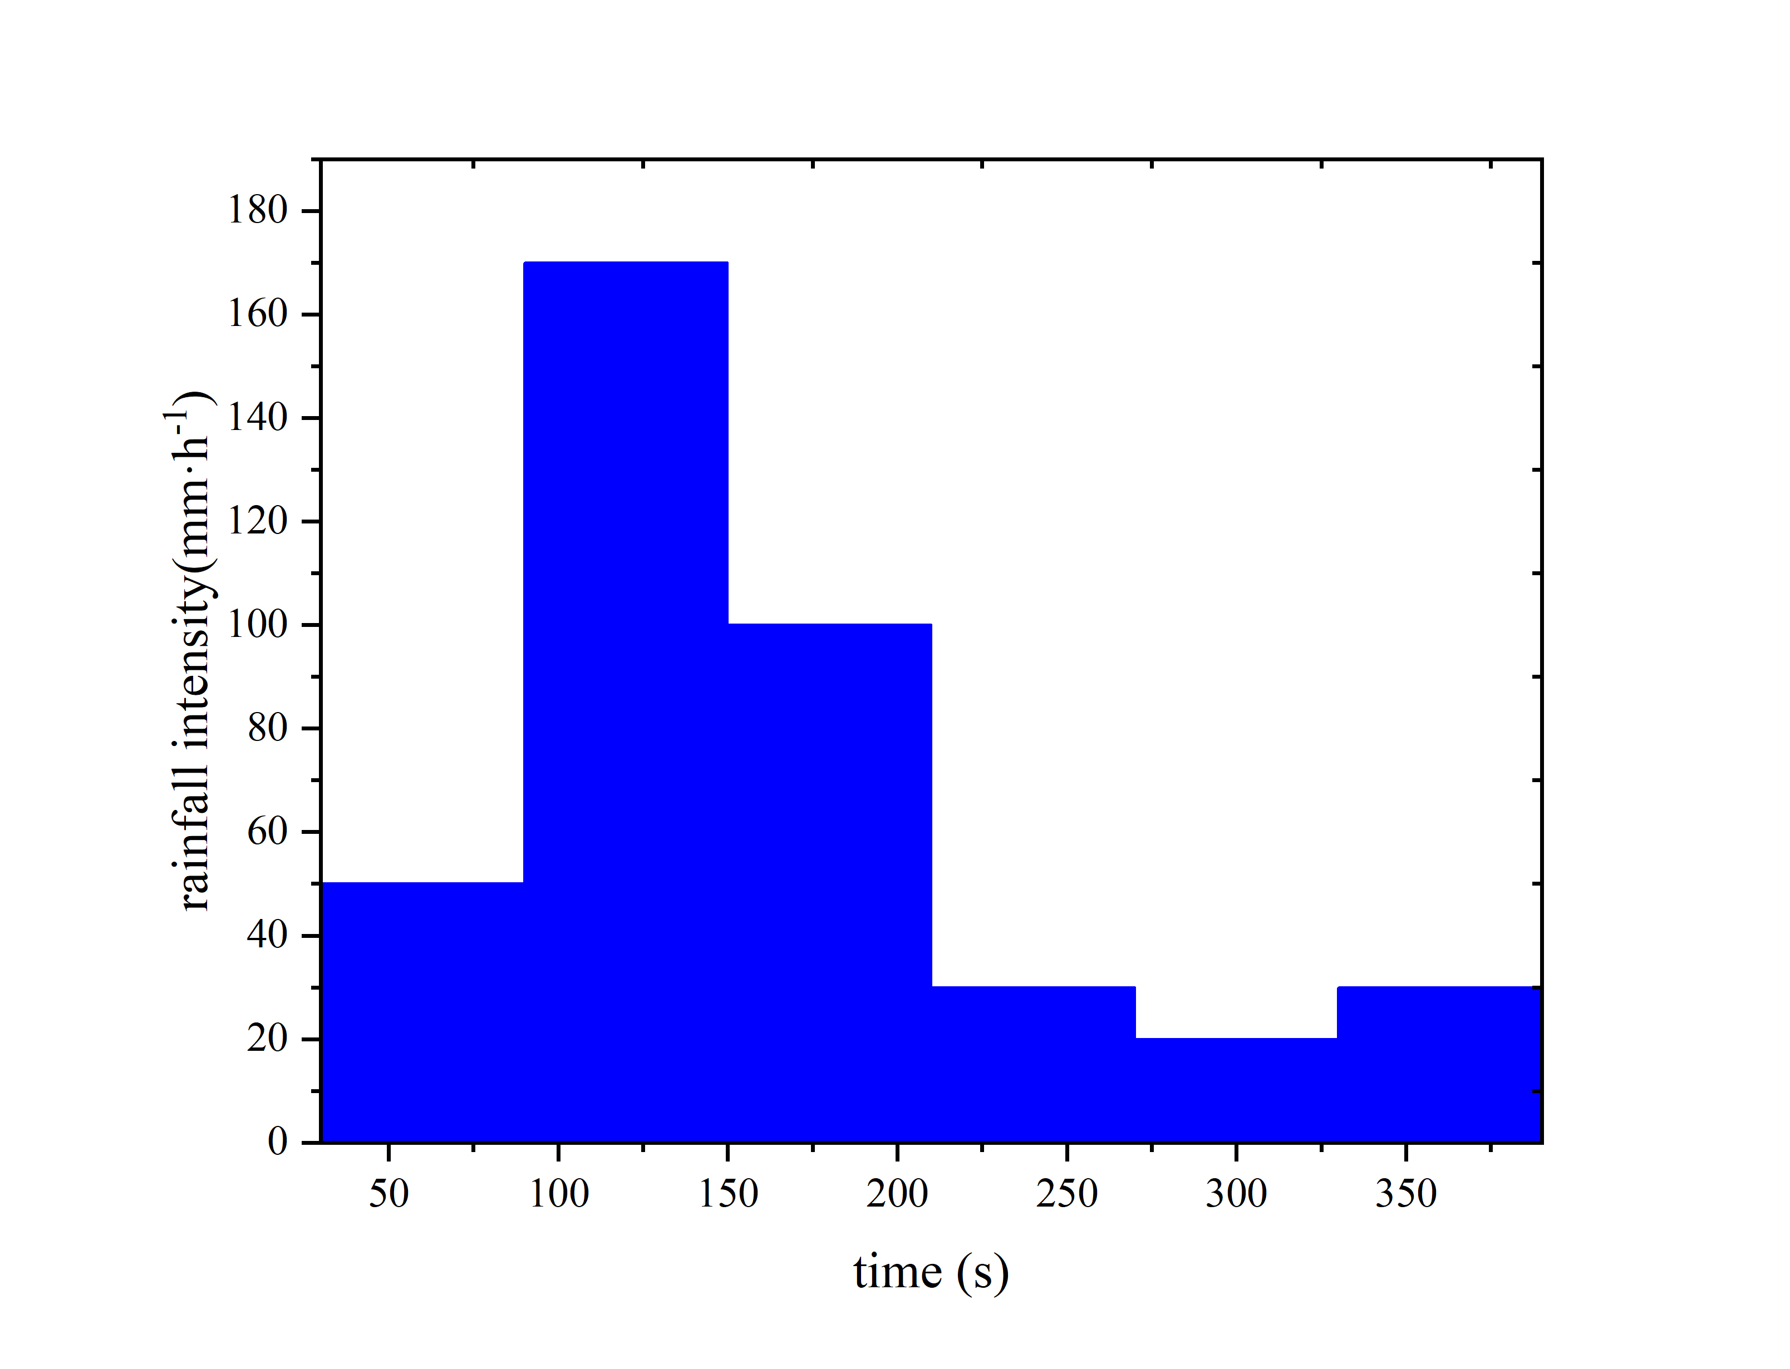

Figure 3 The temporal water depth of a typical site in Zhengzhou, China

|  |  |
| --- | --- |
| $$\begin{aligned}h=2.0924e^{0.00057t}-1.77507\end{aligned}$$ | (7) |

Based on Equation 4-7, in the early stage of ponding without tunnel drainage activation, the inlet flow rate *Q* can be presented in Equation 8. Also, the internal water depth *hI* can be proposed in Equation 9, where the flow rate of inside drainage system *qw* was set as 20 m3/h in this case based on construction practice. Therefore, the temporal evolution of water depth in the cable compartment, natural gas compartment, and comprehensive compartment of utility tunnels are shown in Figure 4a. The results indicate that the cable compartment is more vulnerable to heavy rain and consequent ponding, so the following research mainly focuses on the cable compartment.

|  |  |
| --- | --- |
| $$\begin{aligned}Q=2.977{\left(2.0924e^{0.00057x}-1.77507+{0.0225}/{19.6}\right)}^{1.5}\end{aligned}$$ | (8) |
| $$\begin{aligned}h_{I}=\frac{\int_{0}^{t}{2*\left\{2.977{\left(2.0924e^{0.00057t}-1.77392\right)}^{1.5}t-0.0056t\right\}dt}}{200×W}\end{aligned}$$ | (9) |

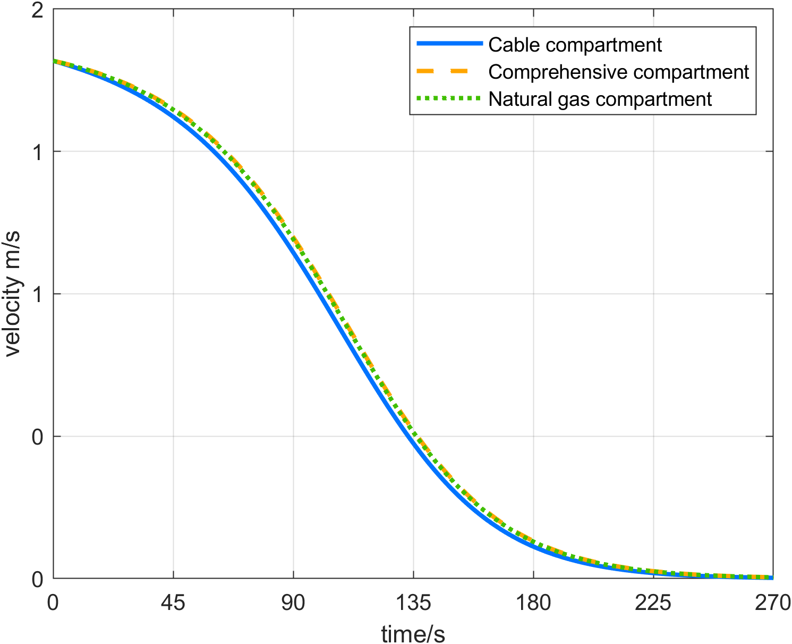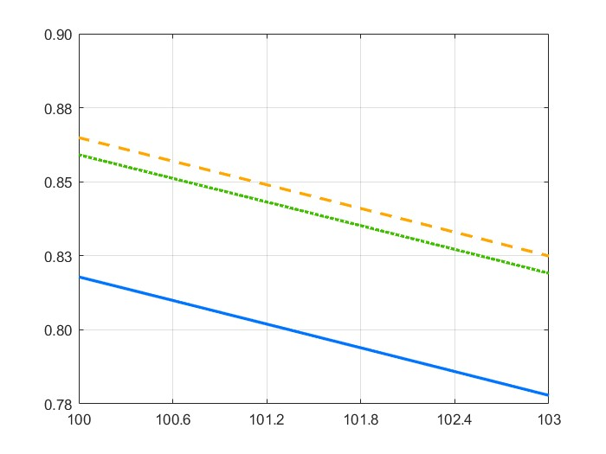

b

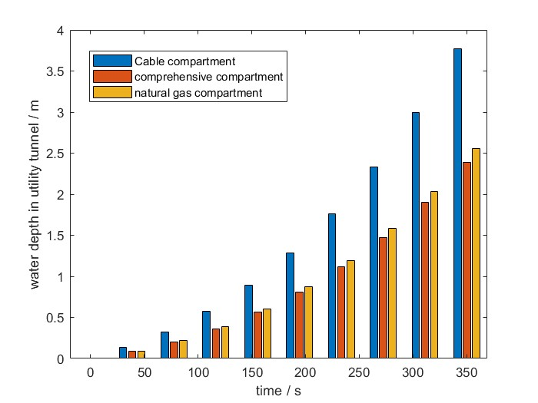

a

Figure 4 Temporal evolution of water depth inside utility tunnels and evolution of movement speed

|  |  |
| --- | --- |
| $$v=\left[v_{g0}\left(1-\frac{\int_{0}^{t}{2*\left\{2.977{\left(2.0924e^{0.00057t}-1.77392\right)}^{1.5}t-0.0056t\right\}dt}}{200×W}/3.2\right)×\left(1.0/(0.982+\exp\left(1.12t-4.0\right))\right)/0.5\right]×0.5$$ | (10) |

Based on Equation 4-6, the temporal movement speed can be calculated in Equation 10 and illustrated in Figure 4b based on the above water accumulation equation. The results indicate that in the early stage when the water depth is less than 0.5m, its adverse impact on walking of the personnel is limited, while the water depth is higher than 0.5m, the moving speed will be greatly reduced with the increase of the water depth.

* + 1. Risk mitigation analysis

Further, based on the above results and formulas, assume that the maintenance personnel at the center of the two ventilation openings in the utility, which is the worst scenario for evacuation. The results are shown in Figure 5, where the blue line represents the variation in water depth within the cable compartment, while the yellow line indicates the evacuation distance affected by the temporal accumulated water. Since the personnel evacuation distance inside the utility tunnel is 100 m (the distance from the center of the 200-m fire zone to the exits) and the average height of the personnel is assumed as 1.7 m. The red line represents the criteria for the successful evacuation of personnel. Based on the results of the typical case study shown in Figure 5, it is evident that the current design of the utility tunnel is insufficient to protect inside personnel during extreme rainfall. Therefore, further risk mitigation analysis of ponding in utility tunnels is conducted in the following part.

Figure 5 Criteria of evacuation from ponding in utility tunnels

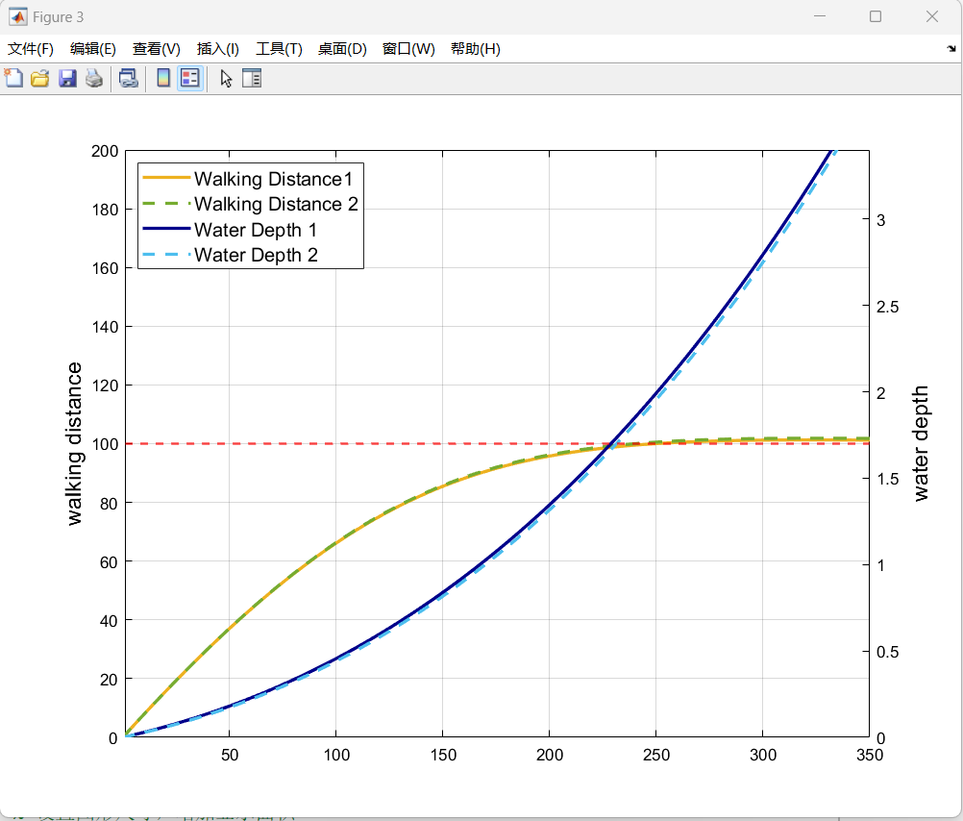

a

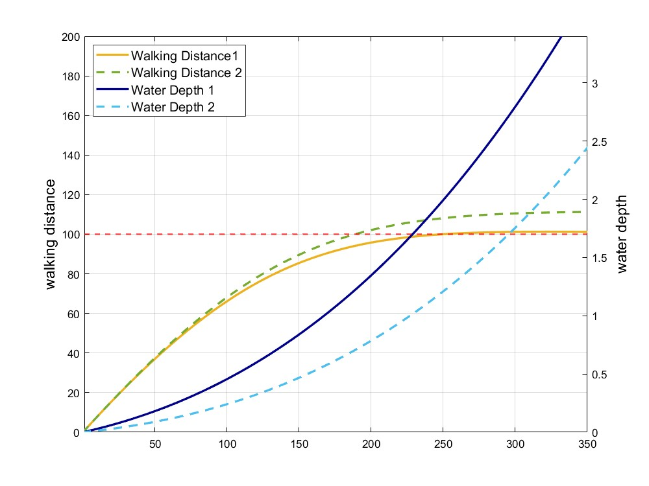

b

Figure 6 Temporal evolution of water depth and walking distance with different mitigation approaches

For mitigating ponding risks of utility tunnels, there are mainly two approaches, strengthening drainage system capacity and heightening the water barrier. The typical drainage capacity of the pumps in a single fire zone is 20m³/h. In this section, the drainage capacity is further increased to 40m³/h to compare the evacuation process in the case of ponding. As shown in Figure 6, the solid line indicates the original case, and the dashed line indicates the improved case. The results in Figure 6a show that increasing the drainage capacity has a positive but very limited effect on mitigating ponding risks within the utility tunnel. After the drainage capacity is doubled, there is still a drowning possibility since the walking distance is only 98.76 m when the water depth reaches 1.7 m. Comparing the capacity-doubled scenario and the initial scenario, there is only 0.1 m more walking distance.

Therefore, the heightening groundwater barrier of the utility tunnel is further analysed. Based on the current ventilation height of 0.5 m, more 0.1 m is added, and the results are shown in Figure 6b based on the weir flow equations. The results show that the water accumulation in the compartment of the utility tunnel is significantly reduced compared to the initial state, and the evacuation possibility of the personnel is also improved. At 203 s, the walking distance reaches 100 m, and the water depth is only 1.04 m, which is far lower than the 1.7-m drowning criteria, which means even the personnel at the worst position can successfully be evacuated.

* 1. Conclusions

Utility tunnels are emerging process installations for efficient maintenance of pipelines, but also raise concerns about the coupling effect among multiple hazardous pipelines, which have not been systematically analyzed in previous research. In this paper, a novel QRA model for coupling risks is innovatively proposed to put forward a new perspective for the coupling risk assessment of process industries. The ponding of utility tunnels with personnel evacuation is selected as a typical accident chain with a coupling effect in the case study. The results show that the current 0.5-m height of the ground ventilation opening of the utility tunnel is insufficient for mitigating ponding risks in heavy rain like the “7.20” rainstorm and may lead to the drowning of the personnel inside the utility tunnels. By comparing risk mitigation approaches such as strengthening drainage system capacity and heightening the water barrier, it can be concluded that heightening the water barrier to over 0.6 m can effectively and economically improve the risk mitigation ability while strengthening drainage capacity is inefficient and impractical to reach the safe criteria.

Acknowledgements

This work was supported by the National Key Research and Development Program of China (Grant No. 2023YFC3807600), the National Natural Science Foundation of China (Grant No. 72034004)

References

Bai, Y., Wu, J., Liu, K., Sun, Y., Shen, S., Cao, J., & Cai, J., 2024, Energy-based coupling risk assessment (CRA) model for urban underground utility tunnels, Reliability Engineering & System Safety, 110255.

Gu, Y., Wang, C., Liu, Y., & Zhou, R., 2025, An ontology-based multi-hazard coupling accidents simulation and deduction system for underground utility tunnel-A case study of earthquake-induced disaster chain, Reliability Engineering & System Safety, 253, 110559.

Hai, N., Gong, D., Liu, S., & Dai, Z., 2022. Dynamic coupling risk assessment model of utility tunnels based on multimethod fusion, Reliability Engineering & System Safety, 228, 108773.

He, R., Tiong, R. L., Yuan, Y., & Zhang, L., 2024, Enhancing resilience of urban underground space under floods: Current status and future directions, Tunnelling and Underground Space Technology, 147, 105674.

Ouyang, M., Liu, C., Wu, S., 2020. Worst-case vulnerability assessment and mitigation model of urban utility tunnels, Reliability Engineering & System Safety, 197, 106856.

Xia, J., Dong, B., Zhou, M., Ahmadian, R., Falconer, R.A., Li, Q., et al., 2022. A unified formula for discharge capacity of street inlets for urban flood management, Journal of Hydrology, 609, 127667.

Yuan, X., Wu, M., Tian, F., Wang, X., & Wang, R. (2024). Identification of influencing factors and risk assessment of underground space flooding in the mountain city. International Journal of Disaster Risk Reduction, 113, 104807.

Zhu, X., Wu, J., Bai, Y., Wang, D., Zhang, J., 2024. Integrating FBN and FDS for quantitative risk assessment of cable fire in utility tunnel, Journal of Loss Prevention in the Process Industries, 88, 105266.

Zheng, Y., Li, X. G., Jia, B., & Jiang, R., 2019, Simulation of pedestrians’ evacuation dynamics with underground flood spreading based on cellular automaton, Simulation Modelling Practice and Theory, 94, 149-161.