|  |  |
| --- | --- |
| cetlogo ***CHEMICAL ENGINEERING TRANSACTIONS***  ***VOL. xxx, 2025*** | A publication of  aidiclogo_grande |
| The Italian Association  of Chemical Engineering  Online at www.cetjournal.it |
| Guest Editors:  Copyright © 2025, AIDIC Servizi S.r.l. **ISBN** 979-12-81206-xxx; **ISSN** 2283-9216 | |

Natech risk induced by lightning. Case study of a floating roof atmospheric fuel storage tank

Giovanni Grillonea,\*, Antonino Muratoreb, Eleonora Gencoc, Alberto Firenzed, Maurilio Bellissimoa, Vincenzo Nastasia

aInail, UOT Palermo, Viale del Fante 58/D - 90146 Palermo, Italy

bInail, UOT Como, Via Petrarca 4 - 22100 Como, Italy

cUniversità di Palermo, Scuola di Specializzazione in Medicina del Lavoro, Piazza delle Cliniche, 2 - 90127 Palermo, Italy

dUniversità di Palermo, Dipartimento della Promozione della Salute, Materno-Infantile, di Medicina Interna e Specialistica di Eccellenza “G. D’Alessandro” (PROMISE), Piazza delle Cliniche, 2 - 90127 Palermo, Italy

\*g.grillone@inail.it

The main international databases highlight that lightning strikes are the most frequent initiating events for NaTech incidents (Natural Hazard Triggering Technological Disasters) in industrial establishments with major accident hazards. This is because lightning can interact with industrial equipment both directly and indirectly, for example, through control systems and electrical circuits.

An incident is more likely when the materials released post-lightning are flammable, with fire being the most common outcome. The worst damage mechanisms are due to the direct action of lightning, which heats the affected areas, causes breaks and/or perforations in tanks and/or connecting pipelines, and, for example, ignites vapors found on floating roofs of atmospheric tanks containing liquid fuels, typically resulting in the entire tank catching fire.

The article aims to introduce a simplified index-based method to provide an initial assessment of NaTech risk from lightning, RNatech,F, for each equipment capable of causing a major accident, based on three main factors: Ng = ground lightning density; V = vulnerability of the equipment; E = exposure, understood as the extent and severity of damage to receptors potentially affected by the consequences of lightning-initiated accidents (workers, population, environment, assets, infrastructure).

After evaluating the RNatech,F for all the equipment installed in the industrial establishment studied, appropriate proposals for the prevention and mitigation of the risk are described. A case study of an atmospheric fuel storage tank with a floating roof is illustrated as an application example.

Furthermore, authors describe the main effects on the health of workers and citizens living near industrial plants, caused by lightning-induced accidents that lead to fires, explosions, and the release of toxic substances.

*Keywords*: NaTech, lightning, major accident hazards, safe management, workers’ health, citizens’ health

1. Introduction: analysis of NaTech incidents caused by lightning phenomena

The most common trigger for NaTech incidents (Natural Hazard Triggering Technological Disasters) is lightning (Necci et al. 2018). Lightning can interact with industrial equipment through direct or indirect contact (e.g., control systems and electrical circuits). Types of NaTech incidents are catalogued in the databases (Necci et al., 2018):

* MHIDAS (Major Hazard Incident DAta Service – UK): lightning, 56%; temperature, 17%; flooding, 13%; wind, 7%; earthquake, 5%;
* ARIA (Analyse, Recherche et Information sur les Accidents – France): lightning, 20%; temperature, 11%; flooding, 17%; wind/storm, 7%; earthquake, 3%; heavy rain, 29%;
* EMARS (European Commission): lightning, 21%; temperature, 9%; flooding, 12%; wind/storm, 24%; heavy rain, 3%; freeze, 28%;
* TAD (product of the Institution of the Chemical Engineers, IChemE): lightning, 38%; temperature, 6%; flooding, 2%; wind/storm, 9%; earthquake, 5%; heavy rain, 4%.

The structures affected by lightning in NaTech incidents are (Necci et al., 2018): 1) storage, 74%; 2) process equipment, 8%; 3) electrical equipment, 5%; 4) building or structure, 2%; etc. .

Finally, NaTech incidents caused by lightning result in: fire, 58%; explosion and fire, 19%; explosion, 6%; damage to equipment, 6%; gas/vapour release, 2%, etc. (Necci et al., 2018).

Considering the ongoing climate changes, several studies and research conducted over the years indicate an expected increase in lightning frequency ranging from 5-6% (Price and Rind, 1994) to 10-20% (Pinto et al., 2013) for each degree of increase in Earth's surface temperature.

Although the danger of lightning is well known, not much has been yet learned from past events to improve risk management procedures. In this article, the authors, basing on their institutional experience in checks and inspections, introduce an index-based method to determine the NaTech risk level (for each type of critical equipment) induced by lightning (RNatech,F). Following this, the main prevention and/or protection measures are identified.

1. Factors influencing NaTech risks from lightning

To assess NaTech risks from lightning, three main factors must be considered: 1) probability associated with the occurrence of a natural event of specific intensity over a period of time; in the case of lightning, the parameter "Ng" is considered, representing the ground lightning density (average number of lightning strikes per km² per year; a value obtainable from lightning location networks distributed across the area); 2) vulnerability of critical equipment “V” (e.g., atmospheric fuel tanks with floating or fixed roofs, pressurized tanks containing flammable substances such as LPG, connecting pipelines, etc.); 3) exposure “E”, understood as the extent and severity of damage to receptors potentially impacted by the effects of lightning-initiated accidental events (workers, population, environment, assets, infrastructures).

Therefore, the value of NaTech risk induced by lightning “RNatech,F”is a function of three factors:

RNatech,F = f (Ng,V,E) (1)

The expression (1) is not easy to calculate, as its three variables depend on many other variables. Therefore, the authors propose a simplified index method based on the following expression (2), applying it to the individual critical primary containment systems within the industrial establishment:

IRNatech,F = INg \* IV \* IE (2)

where IRNatech,F​, INg, IV​, and IE are, respectively, the NaTech risk index for lightning, the ground lightning density index, the vulnerability index of the considered equipment, and the exposure index for incidental events caused by lightning. The indices INg, IV, and IE are assigned increasing numerical values as the risk increases (integer values ranging from 1 to 4), to determine the NaTech lightning risk index (IRNatech,F​) for all critical equipment within the industrial plant; this assessment will guide the selection of preventive and/or protective measures against the risk.

1. Gathering information on lightning hazards in the plant area. Ground lightning density, Ng. Ground lightning density index, INg

Figure 1 shows lightning strikes around the world in 2021 (2021 U.S. Lightning Report, 2022). Among the countries with the highest total number of lightning strikes are Brazil and the United States, while Italy is the European country with the highest average number of lightning strikes per square kilometer. In 2021, Italy received more lightning strikes than any other European country, totalling 2.7 million strikes, with an average of nearly 12 strikes per square kilometer (2021 U.S. Lightning Report, 2022). In the Balkans, the average is higher, reaching a maximum of 14.4 strikes per square kilometer in Montenegro (2021 U.S. Lightning Report, 2022).

Industrial establishment managers/employers can refer to lightning density data available on the Vaisala website (www.vaisala.com) for an initial assessment, where reports on these recordings are published.

In Italy, it is possible to determine the impact point of a lightning strike with an accuracy of approximately 500 meters, thanks to the SIRF (Italian Lightning Detection System) of CESI (Italian Experimental Electrotechnical Center).

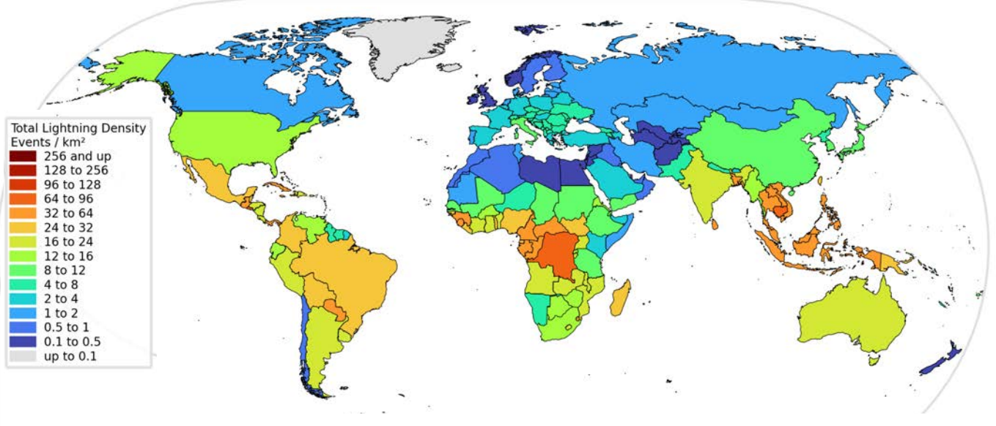

Figure 1 - Global lightning density 2021 (2021 U.S. Lightning Report, 2022)

For the analysis of the chronology of lightning events, it is possible to refer to the online application CEI ProDis™ (https://prodis.ceinorme.it/home.html) by the CEI (Italian Electrotechnical Committee). This application is based on data acquired by the SIRF monitoring network and provides an Ng value based on lightning data collected over more than ten years across the entire Italian territory.

Using the CEI ProDis™ application, the manager of an Italian industrial establishment can determine the Ng value for their site. Higher Ng values correspond to a higher likelihood that lightning will strike the industrial site under assessment. Based on the authors' field experience, Ng can be correlated with the index introduced in the previous paragraph, INg (ground lightning density index), which takes integer values between 1 and 4 (table 1).

Table 1. Relationship between Ng (ground lightning density, measured as the average number of lightning strikes per km² per year) and INg (ground lightning density index, dimensionless).

|  |  |
| --- | --- |
| Ng [lightning strikes per km² per year] | INg |
| Value up to 1.00  Value from 1.00 to 2.99  Value from 3.00 to 4.99  Value higher than or equal to 5.00 | 1  2  3  4 |

1. Lightning vulnerability index of equipment, IV

In industrial establishments, it is important to identify the vulnerability of critical equipment that could trigger NaTech events due to lightning strikes. This work focuses on the most critical equipment containing hazardous substances found in the processing and storage industries: pressurized equipment (spheres, columns, reactors, exchangers, tanks, furnaces), atmospheric storage tanks (fixed or floating roof), and piping systems containing or conveying hazardous substances (both pressurized and non-pressurized).

Table 2 shows, based on the authors' field experience, the relationship between the type of equipment containing hazardous substances and the vulnerability index "IV" (integer values between 1 and 4), under conditions of good maintenance.

Table 2. Values of the lightning vulnerability index (IV) of a specific equipment.

|  |  |  |  |
| --- | --- | --- | --- |
| Type of equipment | Degree of filling | Construction characteristics | lightning vulnerability index (IV) |
| Floating roof tank | >50% / < 50% |  | 4 / 3 |
| Fixed-roof tank | >50 % /< 50% |  | 3 / 2 |
| Pressurized tanks (spheres, columns, reactors, furnaces, etc.) |  | According to the PED directive (1997) / Before the introduction of PED Directive | 3 / 2 |
| Pressure pipes |  | According to the PED directive (1997) / Before the introduction of PED Directive | 2 / 1 |
| Non-pressure pipes |  | According to the PED directive / Before the introduction of PED Directive | 1 |

In Table 2, the IV value of a tank is assessed based on its filling level, as when the atmospheric tank is full or nearly full (i.e., the floating roof is in the high position), the lightning current discharges directly onto the shunts (conductors that allow the current flow to discharge to the ground) at the point where the lightning strikes. Conversely, when the floating roof is in the low position (filling level < 50%), the lightning current, due to its distribution along the wall, will reach the shunts with much lower intensity (Figure 2, Lanzoni, 2009).

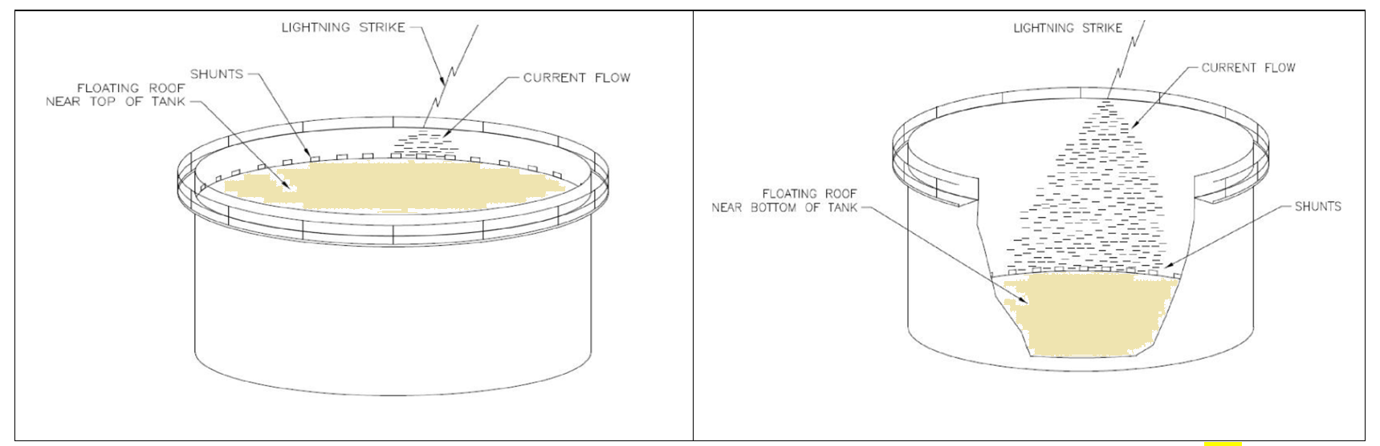Figure 2. Current concentration flashover with floating roof in high-low position (Lanzoni, 2009)

1. Exposure index IE

"Exposure" refers to the extent and severity of damage to receptors potentially affected by the consequences of lightning-related incidents (workers, population, environment, assets, infrastructure). Regarding industrial facilities (including buildings, plant sections, equipment, pipelines, etc., or electrical connection lines of industrial establishments), the analysis of NaTech incidents triggered by lightning strikes highlights two different impact mechanisms: 1) direct impacts, which cause harm to operators within or near the structure and damage to structures or the ignition of explosive substances or flammable vapors from the discharge (such as in the case of floating roof tanks); 2) indirect impacts, which may lead to a loss of containment, with the potential for fire and/or explosion if they contain combustible, flammable, or explosive substances; due to process disruptions from power outages, voltage drops, and impacts on electrical and electronic control and safety systems, equipment, and devices.

The consequences of damage and malfunctions can extend to the surroundings of the facility, affecting other parts of the plant and, in certain cases, even impacting the surrounding environment (domino effect). In relation to the above, the authors propose assigning the exposure index “IE” from lightning strikes integer values between 1 and 4, as shown in Table 3.

Table 3. Exposure index IE as a function of lightning exposure.

|  |  |
| --- | --- |
| Type of lightning exposure | IE |
| Only possible indirect impacts | 1 |
| Possible direct and indirect impacts in proximity of the affected unit. There is no possibility of a domino effect (e.g., a tank adjacent to other tanks). | 2 |
| Possible direct and indirect impacts that may affect the entire establishment. There is the potential for a domino effect (e.g., a tank located near other tanks). | 3 |
| Possible direct and indirect impacts that may involve the outside of the facility with the potential for a domino effect. | 4 |

1. Acceptability level of NaTech risk from lightning

Once the three factors influencing NaTech risk from lightning have been identified, using the indices INg, IV, and IE, the NaTech risk index from lightning (IRNatech,F) is determined using relationship (2).

From a graphical perspective, a 4x4x4 risk matrix can be referenced. Up to “IRNatech,F” values of 4, the NaTech risk is acceptable. For IRNatech,F values between 4 and 8, the risk is acceptable but requires appropriate prevention and mitigation measures to be planned over time. For IRNatech,F values between 8 and 32, urgent prevention and protection interventions must be implemented to have a NaTech lightning risk acceptable (< 8). For IRNatech,F values higher than 32, the NaTech lightning risk is unacceptable.

1. New and existing establishments. Measures to reduce the NaTech risk vulnerability from lightning

For newly constructed industrial establishments, it is essential to select an appropriate installation site. This approach allows for better management of the three lightning risk factors: “Ng,” “E,” and “V,” aiming to reduce them to the lowest possible values. For existing facilities, when managing NaTech risk from lightning, actions can be taken only on one factor, vulnerability “V”, because there is low possibility to reduce one out of the two factors “E” and “Ng,” which depend on the location of the industrial site and the surrounding urbanization. Below are some examples (not exhaustive) of how to reduce the vulnerability of critical industrial establishments:

**A) Technical Interventions**: To reduce the vulnerability "V" of critical equipment, it is necessary to install devices that ensure electrical continuity or limit overvoltages, adopting protective measures to ensure that: a) lightning paths are kept away from flammable and explosive substances, using low-impedance preferential routes and taking advantage of the conductive properties of metals; b) overheating of conductors is prevented; c) potential increases in grounding system electrodes are avoided; d) surface resistivity is increased within a 3-meter perimeter around the structure to be protected; e) surface resistivity of the structure's internal floors is increased; f) shielding of the structure; g) shielding of internal circuits within the structure; h) appropriate distribution of cabling for internal circuits within the structure; i) shielding of incoming power lines; etc..

**B) Maintenance, Control, and Verification Measures**: Appropriate maintenance and inspection of lightning protection systems should be planned, including the performance of tests and electrical continuity measurements. This is essential because lightning protection systems tend to lose effectiveness over time due to corrosion and damage caused by environmental conditions, mechanical impacts, and lightning strikes.

**C) Organizational interventions**: In addition to the above, organizational interventions can be implemented (e.g., lowering the fill level of atmospheric storage tanks while waiting to schedule maintenance and prevention interventions).

1. Case study of a floating roof atmospheric fuel storage tank

Let's consider the case study of an atmospheric gasoline storage tank with a floating roof. This tank is part of a tank farm at a fuel depot, where there is a potential domino effect in the event of a NaTech incident from a lightning strike. The tank's fill level is at 75%. The tank is located within the establishment at the geographic coordinates Latitude: 38.092423° N, Longitude: 13.402614° E; prom this position, an Ng = 1.41 lightning strikes / (year km²) is obtained (using CEI ProDisTM), leading to an INg = 2 (Table 1). Using Tables 2 and 3, IV=4 and IE=4. Thus, the risk index from lightning is evaluated by means of relationship (2):

IRNatech,F= INg x IV x IE = 2x4x4= 32

and, thus, the risk is unacceptable (see paragraph 6).

A possible immediate organizational intervention is to maintain the fuel tank filling level at a maximum of 45% capacity, resulting in a lower value of IRNatech,F=2x3x4=24.

For IRNatech,F=24, it is necessary to plan urgent preventive, protective, and mitigation measures to make it acceptable (<8) (see paragraph 7).

1. Lightning injuries

Lightning has a mortality rate of about 10% (National Weather Service) and causes approximately 30 deaths and several hundred injuries each year in the USA (Centers for Disease Control and Prevention, 2022); cardiopulmonary arrest at the time of electrocution is the most common cause of death.

Lightning tends to strike isolated objects, such as a person in an open field, usually causing damage to the nervous system in the person struck, affecting the brain, autonomic nervous system, and peripheral nerves. It rarely causes severe skin injuries and seldom leads to rhabdomyolysis or severe damage to internal tissues.

Neurological issues may include confusion, cognitive deficits, and peripheral neuropathy, with possible neuropsychological sequelae (e.g., sleep disorders, attention and memory deficits) (Runde, 2024). The most common long-term complications are cognitive deficits, pain syndromes, and damage to the sympathetic nervous system.

The medical investigation requires an Electrocardiogram (ECG) if the injury is severe and cardiovascular effects are suspected. Additionally, cardiac enzyme titration is performed in patients presenting with the following symptoms: a) chest pain; b) abnormal ECG; c) altered mental state.

For patients with an initially altered mental state or one that is deteriorating, or with focal neurological deficits consistent with a central nervous system injury, a head CT and/or a MRI (Magnetic Resonance Imaging) should be requested.

The treatment of lightning injuries consists, if necessary, of prompt cardiopulmonary resuscitation (in cases of cardiac or respiratory arrest, or both) and, generally, supportive therapy, with reduced fluid intake to minimize potential cerebral edema (Runde, 2024).

Lightning injuries can be prevented by staying informed about weather conditions and avoiding going outdoors during a thunderstorm, avoiding small open structures like gazebos, and instead having an evacuation plan that includes moving to a safe area (preferably a large habitable building).

Moreover, when indoors during an electrical storm, it is advisable to: 1) avoid contact with plumbing and electrical lines; 2) stay away from windows and external doors; 3) refrain from using phones, video game consoles, or computers connected to the power network, or headphones connected by a cable to an audio system.

1. Conclusions

The purpose of this work, based on the authors' experience, is to propose an index-based method to determine the level of NaTech risk from lightning in order to identify the critical units of a given industrial establishment. A concise overview of technical, maintenance, monitoring, and verification measures, as well as organizational interventions aimed at reducing the NaTech risk from lightning, is subsequently provided. A case study is presented for an atmospheric storage tank with a floating roof. Lastly, medical guidelines are provided to prevent and manage lightning injuries.

References

CEI ProDisTM, (2014). Application on line that allows the access to ceraunica density for Italy. Available at: https://prodis.ceinorme.it/home.html

Centers for Disease Control and Prevention: National Center for Environmental Health: Lightning Strike Victim Data (2022). Available at https://www.cdc.gov/lightning/data-research/index.html. Consulted on 08/31/2024.

European Communities, 1997. Directive 97/23/EC of the European Parliament and of the Council of 29 May 1997 on the approximation of the laws of the Member States concerning pressure equipment, Official Journal of the European Communities, L181, Vol. 40, p.1-55.

Lanzoni J. A., 2009, Improving Lightning Safety of Petroleum Storage Tanks. Available at: https://www.lightningprotection.com/wp-content/uploads/2017/04/improving\_lightning\_safety\_of\_petroleum \_storage\_tanks-oct\_2009-lanzoni.pdf.

National Weather Service. National Safety Program: How Dangerous is Lightning?. Available at: https://www.weather.gov. Consulted on 08/31/2024.

Necci, A., Girgin, S., Krausmann, E., 2018. Understanding Natech Risk Due to Storms – Analysis , Lessons Learned and Recommendations. EUR 29507 EN, Publications Office of the European Union, Luxembourg, 2018, ISBN 978-92-79-98274-3, doi:10.2760/21366, JRC114176.

Pinto Jr., O. , Pinto, I. and Neto, O., 2013. Lightning Enhancement in the Amazon Region Due to Urban Activity. American Journal of Climate Change, 2, 270-274. doi: 10.4236/ajcc.2013.24026.

Price, C., and D. Rind, 1994. Possible implications of global climate change on global lightning distributions and frequencies. J. Geophys. Res., 99, 10823-10831, doi:10.1029/94JD00019.

Runde D.P. (2024). Lightning injuries. Available at <https://www.msdmanuals.com/>. Consulted on 09/15/2024.

2021 U.S. Lightning Report, 2022. Publisher: Vaisala. Available at://www.vaisala.com/sites/default/files/ documents/WEA-MET-2021-Annual-Lightning-Report-B212465EN-A.pdf.