Explosion and Ignition behavior of NH3/H2 mixtures in the

20-liter sphere

Dieter Gabel 1*, Ulrich Krause1

1 Otto-von-Guericke University, Magdeburg, Germany

*Corresponding author E-Mail: dieter.gabel@ovgu.de

1. Introduction

Ammonia is one of the possible future energy carriers for transporting (green) hydrogen or it will be used as fuel directly. In both cases mixtures of NH3 and H2 in air can occur during normal operation or accidental release. To ensure the uphold of the explosion protection principles the explosion and ignition behavior of such mixtures need to be known.

In this ongoing project the ignition limits and explosions characteristics of mixtures of Ammonia and Hydrogen in air are systematically determined in the 20-l-sphere. Unlike the standard procedure (DIN EN 1839) all measurements were conducted in a closed vessel, recording the time sequence of the pressure rise. Besides the ignition limits, the maximum explosion pressure and the pressure rise velocity are determined for the complete explosion range.

The advantage of the closed setup is that in all cases a release of Ammonia into the environment can be avoided. Therefore, the operation procedure was adapted in a way that mixtures that could not be ignited were forced to react in a second step. This is possible by either adding additional fuel or Oxygen (air) and force an ignition before releasing the exhaust gases.

Furthermore, the 20-l-sphere enables to test for different conditions and ignition sources. Besides the quiescent mixture with electrical spark ignition test are conducted in turbulent mode, comparable to the dust explosion standard (DIN EN 14034). In addition, the influence of the ignition source is punctually tested by applying pyrotechnical igniters with 2 kJ and 10 kJ.

2. Background

Whether an unintended release of a combustible gas in air leads to an ignition or not depends mostly on the concentration of that substance. For gas ignition in most cases it can be assumed that a strong enough ignition source is present. The ignition regions of many pure gases are well known and published (Molnárné 2003). To represent the dependency on the Oxygen content triangle diagrams are used as shown in Figure 1 für pure Hydrogen and Ammonia.

The availability of such data for mixtures of combustible gases is much less. Already almost a century ago explosion ranges of Ammonia/Hydrogen/Oxygen and Ammonia/Hydrogen/Air mixtures were published (Jorissen,1926). The current project aims in renewing the findings presented in Figure 2 utilizing a standardized setup. Additionally, the maximum explosion pressures and pressure rise velocities are determined as well to be able to judge the severity of the ignitions.

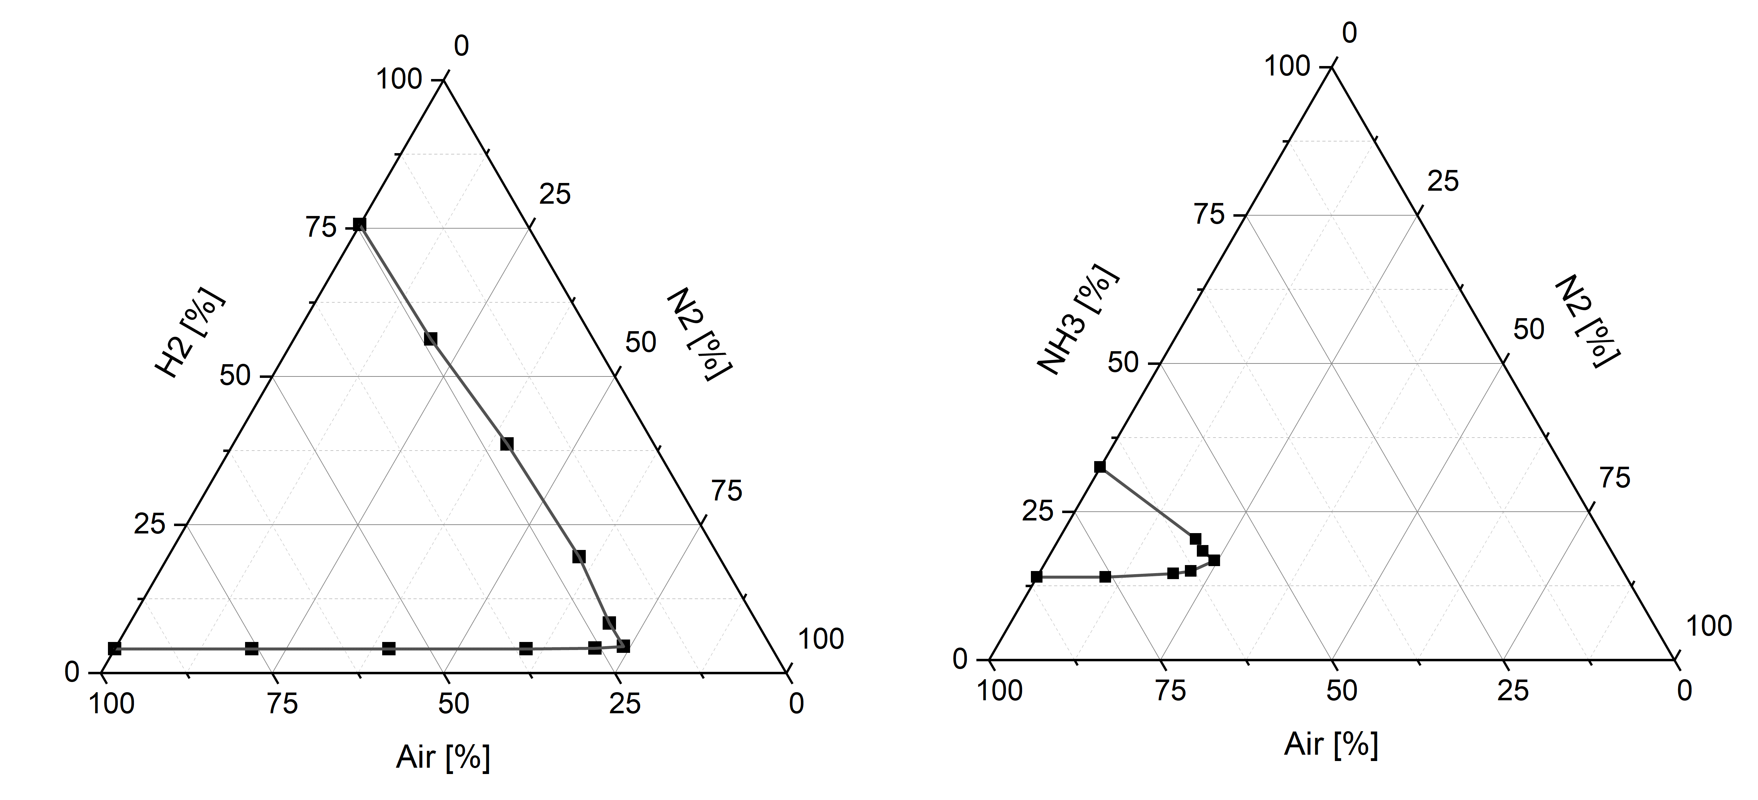

Figure 1. Ignition area of pure Hydrogen (left) and Ammonia (right) in Air and Nitrogen (Molnárné 2003).

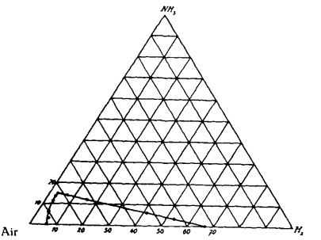

Figure 2. Explosions range of Ammonia/Hydrogen/Air mixtures (Jorissen,1926)

3. Method

The experimental setup used is the 20 Liter sphere known from the dust explosion standard DIN EN 14034. If used for gases the setup complies to the procedure B – Bomb method of the gas standard DIN EN 1839. For the experiments the extensions of the dust standard for hybrid mixtures published as DIN/TS 31018-1. The validity of this procedure was proven in two international round robin tests (Spitzer 2023). The schematic of the setup is shown in Figure 3.

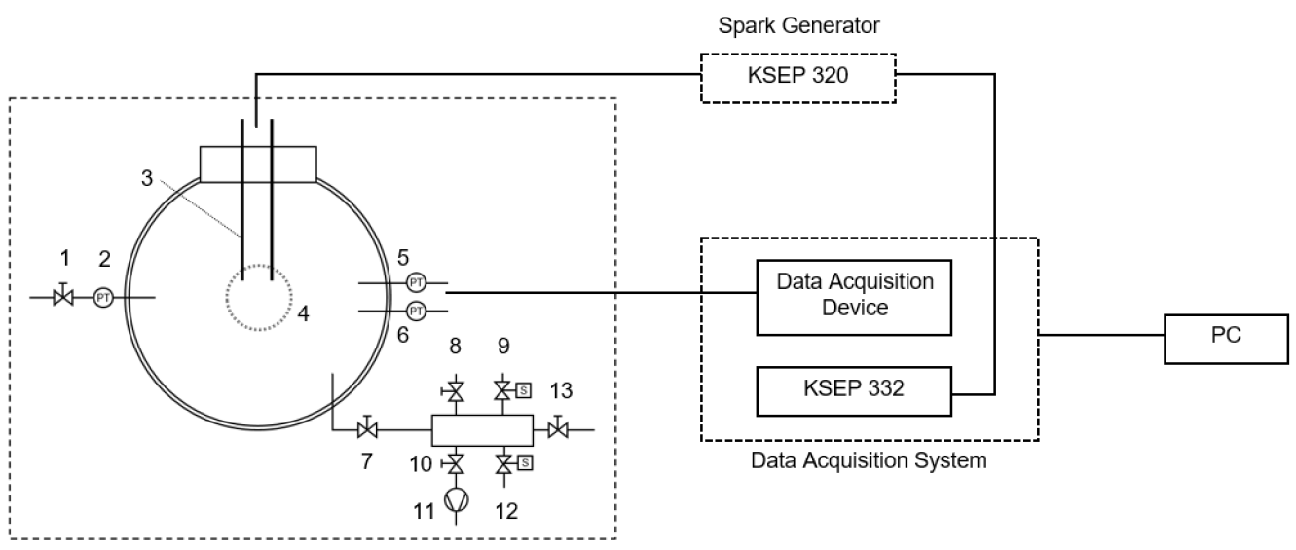

Figure 3. Schematic diagram of the experimental setup with

|  |  |  |  |
| --- | --- | --- | --- |
| *1* | *Valve out* | *8* | *Manual valve to ammonia source* |
| *2* | *Pressure sensor* | *9* | *Solenoid valve to hydrogen source* |
| *3* | *Ignition source* | *10* | *Manual valve to vacuum pump* |
| *4* | *Observation window* | *11* | *Vacuum pump* |
| *5* | *Pressure sensor P1* | *12* | *Solenoid valve to surrounding* |
| *6* | *Pressure sensor P3* | *13* | *Valve for flushing air* |
| *7* | *Valve in prior to chamber* |  |  |

Additionally, the spark ignition source can be replaced by the pyrotechnical igniters used for dust explosions experiments. With energies of 2kJ or 10kJ the available ignition potential is much higher. This might influence the ignition boundaries as well as maximum values of the explosion pressures and pressure rise velocities.

4. Results and discussion

The focus of this ongoing project in the beginning was on the regions of the lower explosion limits with spark ignitions. Due to safety and environmental considerations mixtures with low content of Hydrogen and Ammonia a better to handle. A procedure to consequently reignite unignited mixtures was applied before releasing the mixtures into the exhaust system.

The outcome so far is represented in Figure 4. These ternary diagrams with contour plots show the explosions limits as well as the developments of the explosion pressure and pressure rise velocity for Ammonia/Hydrogen/Air mixtures with spark ignition.

The data behind these diagrams is quite extensive and needs to be discussed in detail. A much smaller dataset for ignition with pyrotechnical igniters exists, too.

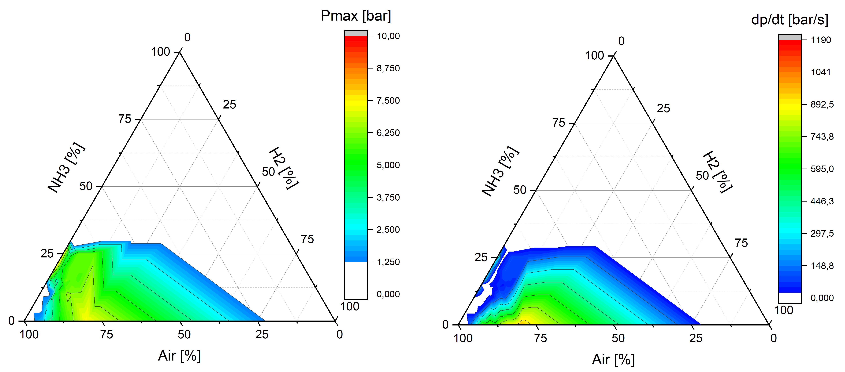

Figure 4. Ternary diagrams of the explosion pressure (left) and pressure rise velocity (right) for Ammonia/Hydrogen/Air mixtures with spark ignition.

4. Conclusions

The knowledge of the ignition and explosion behavior of mixtures of Hydrogen and Ammonia in air will be essential to ensure a reasonable design of safety measure in the emerging Hydrogen society, were Ammonia might be used as an energy carrier or storage. The use of the 20 Liter Sphere enables for a variety of conditions to be tested, that can better reflect real accidental release situations.

References

DIN/TS 31018-1:2024. Bestimmungsverfahren für sicherheitstechnische Kenngrößen des Explosionsschutzes für hybride Stoffgemische - Teil 1: Gase

DIN EN 1839:2012. Determination of explosion limits of gases and vapours; German version

DIN EN 14034-1:2011. Determination of explosion characteristics of dust clouds - Part 1: Determination of the maximum explosion pressure pmax of dust clouds

Jorissen, W. P., Ongkiehong, B. L, 1926. Explosion regions, VIII: The explosion regions of hydrogen-ammonia-air and hydrogen-ammonia-oxygen mixtures. In: Recueil des Travaux Chimiques des Pays-Bas 45, 224–231. https://doi.org/10.1002/recl.19260450312

Molnárné, Maria, Schendler, Thomas, Schröder, Volkmar, 2003. Sicherheitstechnische Kenngrößen: Band 2: Explosionsbereiche von Gasgemischen. Bremerhaven : Wirtschaftsverl. NW, Verl. für Neue Wiss – ISBN 3–89701–746–6

Spitzer, Stefan H. et. Al., 2023. 1st International Round Robin Test on Safety Characteristics of Hybrid Mixtures, Journal of Loss Prevention in the Process Industries. Verfügbar unter: <https://doi.org/10.1016/j.jlp.2022.104947>