 CHEMICAL ENGINEERING TRANSACTIONS  VOL. xxx, 2025 | A publication of  
The Italian Association
of Chemical Engineering
Online at www.cetjournal.it
Guest Editors: Bruno Fabiano, Valerio Cozzani
Copyright © 2025, AIDIC Servizi S.r.l.
ISBN 979-12-81206-xx-y; ISSN 2283-9216

Modelling of Liquid Hydrogen Transfer Operations through steady-state simulations
Lucas M. Claussner^{a,}*, Pramoth Thumattin Sathiamoorthyª, Federico Ustolinª
ªNorwegian University of Science and Technology NTNU, Richard Birkelands vei 2B, 7034 Trondheim, Norway
*lucas.claussner@ntnu.no
This study investigates the transfer processes of liquid hydrogen (LH2), a versatile energy carrier widely used in sectors such as space exploration, aviation, land-based mobility, industrial processes, and maritime operations. Despite its potential, the low boiling point and density of LH2 present significant challenges in handling, storage, and transportation, with limited current understanding of the thermodynamics involved in storing and filling cryogenic LH2 tanks. To address this, a static model for LH2 transfer via pipelines was developed using Aspen HYSYS, incorporating key variables such as mass flow rate, pressure, temperature, and pipeline roughness. The simulations explored a range of operating conditions, including mass flow rates (5 to 400 kg/h), inlet pressures (1.5, 6, and 10 bar), and inlet temperatures (19 K, 20 K, and saturation temperatures), as well as pipeline roughness (1.5 mm). The results demonstrate that pipeline roughness and flow rate are critical factors influencing pressure drop and vapor formation, while control valve positioning is essential for optimizing the filling process. This study offers valuable insights into improving the efficiency and safety of LH2 transfer systems, providing practical recommendations for industries reliant on cryogenic technologies. Additionally, optimizing the transfer process could mitigate hydrogen loss through boil-off gas (BOG) venting and reduce the risk of overpressure, preventing the activation of safety devices that could potentially lead to containment breaches. Future research should extend the model to account for inclined pipelines, flexible piping systems, and additional cryogenic components, further enhancing its industrial applicability.
  - Introduction
As concerns about climate change and environmental damage intensify, the demand for sustainable energy is urgent. Hydrogen, with its emissions-free potential, offers a promising solution for decarbonizing transportation, industry, and power generation, making it vital to a sustainable future. Despite its potential, hydrogen also presents unique challenges. It is highly flammable, requiring only 0.017 mJ of ignition energy (Ono et al., 2007), and its small molecular size, allowing it to escape through microscopic holes, complicating containment efforts. Additionally, its flame is nearly invisible in daylight (Schefer et al., 2009), and its low density (0.0883 kg/m³ at atmospheric conditions) necessitates compression or liquefaction for practical storage. In its liquid form (LH2), hydrogen is stored as a cryogenic fluid at approximately 20.3 K under atmospheric pressure, increasing its density to 70.9 kg/m³ (“NIST Chemistry WebBook,” 2024). The transfer operation is critical due to significant hydrogen losses during the process and the lack of international standards, leading to challenges in both efficiency and safety. Despite these issues, LH2 remains a viable option in industries such as aerospace, aeronautics, and maritime, where high energy density and large fuel volumes are essential, as well as in applications that require increased stationary storage capacity. This paper explores the complexities and opportunities of LH2 transfer through pipelines, focusing on the operational efficiency. The primary objective of this work is to develop a model for LH2 transfer using Aspen HYSYS software. To support this, the study presents a description of the layout and components of liquid cryogen transfer facilities and the fundamental principles of LH2 transfer. Additionally, steady-state modelling of LH2 transfer in rigid pipelines was performed using Aspen HYSYS. This work also aims to establish a foundation for future research in LH2 transfer technologies, contributing to the advancement of efficient and safe hydrogen transfer systems.
  - Liquid hydrogen storage facilities and operations
LH2 facilities are equipped with several critical components. Central to any LH2 facility are cryogenic storage tanks, which are typically double-walled containers insulated to minimize heat transfer and reduce the generation of BOG. Insulation materials such as multi-layer insulation (MLI), glass microspheres, aerogel, foams, and perlite are commonly employed. In addition to storage tanks, transfer systems play a crucial role in handling LH2 within the facility. These systems include cryogenic transfer lines, valves, and piping, as well as pumps that facilitate the LH2 transfer. The effective operation of these systems is essential to maintaining hydrogen in its liquid form during distribution. A key challenge in LH2 storage and transfer is self-pressurization, where heat ingress causes LH2 to evaporate, leading to the formation of BOG and therefore to increased pressure within the tank. Tank management and venting systems are required to relieve excess pressure while minimizing hydrogen loss. Safety and control systems further ensure the integrity of the facility by continuously monitoring critical parameters such as temperature and pressure, thereby preventing conditions that could lead to and loss of containment.
    - Layout and components
In LH2 applications, transfer typically occurs between two storage tanks linked by transfer lines that enable controlled movement of the fluid. Figure 1 illustrates a schematic layout of such a theoretical LH2 transfer system, showing key components including storage tanks, transfer lines, valves, a heat exchanger, and a venting system.

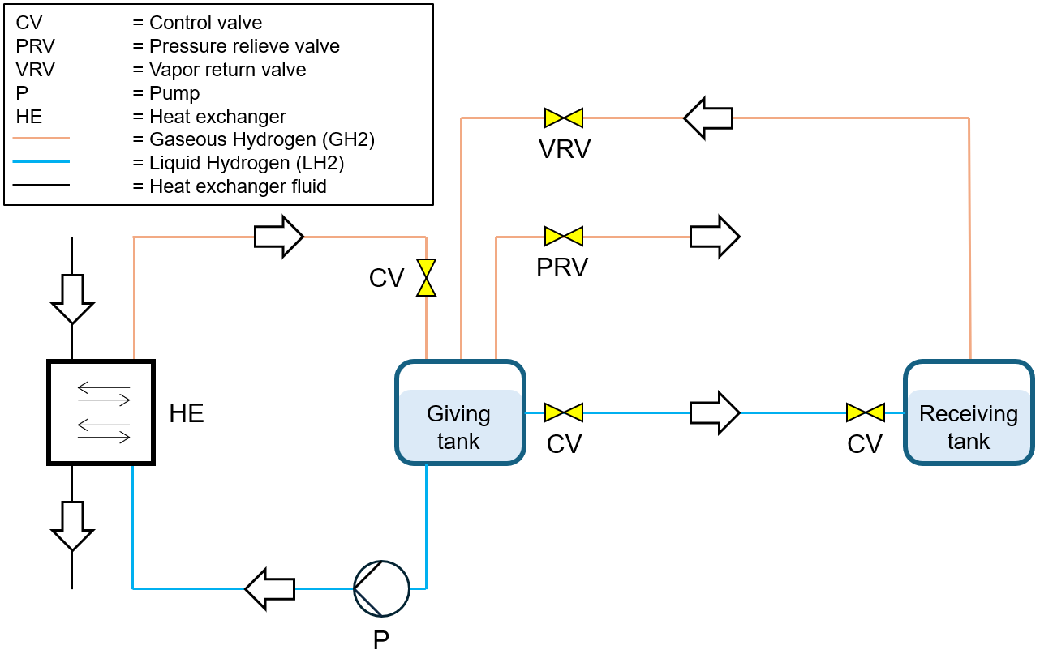
Figure 1: Layout and components of LH2 storage and transfer system adapted from (Sathiamoorthy, 2024)
The transfer of LH2 can be achieved through pressure difference between the tanks. This pressure differential allows LH2 to flow from the releasing/giving tank to the receiving tank. To establish this pressure difference, a heat exchanger is warming up some of the LH2 which is extracted from the giving tank for that purpose. The LH2 is taking up energy in the heat exchanger what leads to the accelerated formation of BOG and therefore to an expansion of the fluid. The warmed hydrogen is then directed back into the giving tank to drive pressurization. This method is advantageous as it minimizes the need for mechanical pumping. However, in cases where rapid pressurization is not feasible or when precise flow control is needed, pumps may be introduced into the system. LH2 pumps are specifically adapted to handle cryogenic conditions. Centrifugal pumps are widely used for low- to medium-pressure transfer, though they generate heat that can cause vaporization, leading to efficiency losses. Positive displacement pumps, such as piston pumps, are better suited for high-pressure applications because they introduce minimal heat, helping reduce BOG formation (Long, 2024). The low density and viscosity of LH2 create unique design challenges, including reduced rotor stability in centrifugal pumps. Material selection is also critical, with stainless steel alloys often used to prevent hydrogen embrittlement (Long, 2024). Furthermore, components like valves and venting installations are critical for regulating pressure and preventing over-pressurization, which could lead to dangerous leaks or equipment damage. The venting installation is crucial for safely releasing excess BOG, maintaining a stable operating environment and protecting structural integrity.
    - Transfer of cryogenic fluids
The process of transferring LH2 begins with preparation and safety checks: safety protocols, such as grounding equipment to prevent static discharges, must be followed, as described in “safety in Storage, Handling and Distribution of Liquid Hydrogen” by EIGA. Both tanks are inspected for integrity, ensuring that safety relief valves and venting systems are functional (EIGA, 2019). Next, purging the transfer lines and equipment is essential to prevent flammable mixtures by displacing atmospheric gases, particularly oxygen, and to prevent condensation. Helium is ideal for this due to its low boiling point, allowing it to remain gaseous even at LH2’s cryogenic temperatures. While effective, helium is costly, so nitrogen can serve as an alternative. When using nitrogen, it is first introduced to clear oxygen, then followed by gaseous hydrogen at ambient temperatures to displace any remaining nitrogen. Purging systems should be integrated within tanks and pipelines to ensure thorough evacuation of atmospheric gases before LH2 handling (Aziz, 2021). Following this, the cool-down phase is initiated. A small amount of LH2 is introduced gradually to pre-cool the transfer lines and receiving tank. Is the hardware still too warm, there will be formation of BOG that needs to be vented to keep the pressure stabile until the cool down is completed (Hartwig et al., 2019). Once the system is cooled, the controlled transfer begins. LH2 is allowed to flow slowly to maintain steady transfer and prevent rapid pressure changes. A pump or pressure differential may be used to drive LH2 from the source to the receiving tank. The transfer system itself should be insulated to minimize heat influx, further reducing BOG losses (Aziz, 2021). During transfer, monitoring temperature and pressure continuously is crucial to avoid over-pressurization and potential venting. When the desired amount of LH2 is transferred, the flow is gradually reduced to prevent pressure drops, and any remaining BOG is vented safely. Post-transfer purging with helium is then conducted to clear residual LH2 from the lines, which prevents condensation of atmospheric moisture. Finally, a comprehensive safety check ensures all valves are secured, pressures are stable, and the system is prepared for safe storage or subsequent transfers (Aziz, 2021).
  - Methodology
For the steady-state modelling of a double walled rigid pipeline as part of a LH2 transfer system, a fluid package and a component have been selected in Aspen HYSYS. Under “Aspen Properties” the property package “Peng-Robinson” was chosen. The component in use for the modelling is “Para-Hydrogen” which can be found in the “Aspen Properties Databank”. The pipe segment under analysis serves as a key element of the LH2 transfer system. The pipeline is 20 meters long with no elevation change. The pipe is insulated with an evacuated anulus. The distance between the inner and the outer shell is 50mm resulting in an insulation thickness of the same extend. The pipe is made of ASTM A240 Type 316L stainless steel, a material known for its strength and corrosion resistance, particularly in cryogenic environments, making it ideal for LH2 pipelines (ISO 13984, 1999). The pipe’s roughness, set at 15×10⁻⁶ m, is a crucial parameter affecting fluid flow, especially the pressure-drop along the pipeline. The temperature of the air surrounding the pipe is 25℃. Furthermore, the air moves with a velocity of one meter per second. The pipe wall's thermal conductivity, measured at 16.3 W/m·K, is essential for calculating heat transfer rates to maintain the LH2's temperature during transfer. The pipeline is divided into 100 increments for detailed analysis of fluid properties along its length. The following Table 1 provides an overview of the parameters relevant for the layout of the pipe model.

Table 1: Specifications for modelling of the pipe segment and initial conditions
Parameter | Value | Unit | Note
Length | 20 | m | Length of the rigid pipe
Elevation change | 0 | m | Pipeline position is considered horizontal
Outer diameter | 45 | mm | -
Inner diameter | 25 | mm | -
Pipe Material | - | - | ASTM A 240, type 316 L stainless steel
Roughness | 1.500e-005 | m | Roughness of inner pipe wall
Pipe wall conductivity | 16.30 | W/m·K | -
Insulation type | Evacuated anulus |  | -
Thermal conductivity of insulation | 5e-004 | W/m·K | -
Insulation thickness | 50 | mm | -
Mass flow rate | 500-400 | kg/h | -
Pressure | 1.5, 6.0, 10.0 | bar | -
Temperature | 21.56, 27.94, 31.14 | K | -

For the modelling of the pipe flow Aspen HYSYS offers different correlations. Developing and solving equations to describe the flow patterns in a pipe is challenging due to the complexity of the phenomena involved. As a practical approach, the multiphase fluid is often approximated as a homogeneous fluid, and a generalized energy equation is applied to this hypothetical phase. This equation is typically expressed in terms of the total pressure gradient along the pipe's length:
$$\frac{dp}{dL}=ρ_{m}g\sin{θ}+{\left(\frac{dp}{dL}\right)}_{f}+ρ_{m}v\frac{dv}{dL}$$ | (1)
The first term on the right-hand side accounts for the pressure gradient due to gravitational forces, where $ρ_{m}$ ​ is the fluid density, and $θ$ is the pipe's inclination angle. The second term represents pressure losses caused by fluid friction, which are irreversible. The final term describes the kinetic or acceleration component of the pressure drop, which depends on changes in the fluid velocity $v$ (Aspen Tech, 2024). Each term can dominate the overall pressure drop depending on the specific conditions. Accurate determination of the total pressure drop requires precise estimation of the fluid density. While the fluid density is explicitly included in the gravitational and acceleration terms, it also implicitly affects the frictional term. Therefore, obtaining a reliable estimate of fluid density is crucial. In multiphase flow, the fluid density depends on the liquid holdup in the pipe. It is common practice to use correlations to estimate liquid holdup for each pipe segment. Similarly, correlations are employed to estimate the frictional pressure losses, which arise from interactions between the fluid phases and the pipe wall. These losses are particularly complex in multiphase flow because multiple phases interact with the pipe wall, generating interfacial friction, and the flow often exhibits a non-uniform velocity distribution. Given the importance of accurately estimating both frictional losses and liquid holdup, numerous correlations have been developed for multiphase pipe flow. However, no single correlation is universally applicable across all conditions. Most correlations are derived from specific experimental datasets and are suitable only for particular flow-scenarios. (Aspen Tech, 2024).
For the model described in this paper the Tulsa Unified Model (2-Phase) was selected. The Tulsa Unified Model was designed to simulate multiphase flow in pipelines, using a mechanistic approach rooted in slug dynamics. Consequently, slug flow serves as the focal point of the flow map, with other regimes such as stratified and bubbly flows surrounding it. The model is versatile, accommodating pipe inclination angles ranging from -90° to +90°. In its two-phase configuration, the model treats the fluid as comprising a distinct gas phase and a single liquid phase. The model is described in detail in (Zhang et al., 2003a), (Zhang et al., 2003b) and (Zhang and Sarica, 2006). Furthermore, the modelling in Aspen HYSYS is based on several fundamental physical principles, including the conservation of mass, conservation of energy. The principles of mass and energy conservation are described in detail by (Moran and Shapiro, 2006). The Peng-Robinson equation of state was selected to estimate the thermodynamic properties of LH2. To investigate the effects on pressure-drop and vapor generation at the pipeline exit, several inlet parameters were systematically varied. These parameters included mass flow rate, inlet pressure and inlet temperature. The mass flow rate was varied from 50 kg/h to 400 kg/h. The exact values can be seen in Figure 2. The variations of mass flow were performed for three different pairings of absolute pressure and temperature at the pipe inlet. The values for the pressure were chosen as 1.5 bar, 6 bar and 10 bar. For each inlet pressure the corresponding saturation temperature was selected and fine tuned so that there is only liquid at the inlet. For 1.5 bar the saturation temperature is 21.56 K, for 6 bar it is 27.94 K and for 10 bar the temperature is 31.14 K.
  - Results and discussion
The study aimed to explore how initial conditions in the pipeline affect the flow dynamics, focusing specifically on pressure drop and BOG formation at the outlet. By systematically varying initial conditions - specifically temperature, pressure and mass flow - the study provided insights into pipeline performance under different operational scenarios. The results are visualized in Figure 2 and show a clear trend where pressure drop increases with rising mass flow rates. This is expected, as higher mass flow rates lead to greater frictional losses along the pipeline. Additionally, for a given mass flow rate, pressure drop is higher at higher pressures and temperatures, as shown in Figure 2(a). For example, at a mass flow rate of around 400 kg/h, the pressure drop reaches nearly 7.8 kPa at 10 bar and 31.14 K, compared to about 6.2 kPa at 1.5 bar and 21.56 K. In addition to pressure drop, the study examined BOG formation, represented by the vapor fraction at the outlet (right plot). The findings indicate that BOG formation is minimal when the mass flow rate is roughly between 100 and 150 kg/h across all temperature-pressure combinations. Outside this range, the highest BOG formation occurs at 31.14 K and 10 bar, while surprisingly, the lowest BOG formation is observed at 27.94 K and 6 bar, rather than at the lowest temperature-pressure condition (21.56 K and 1.5 bar).
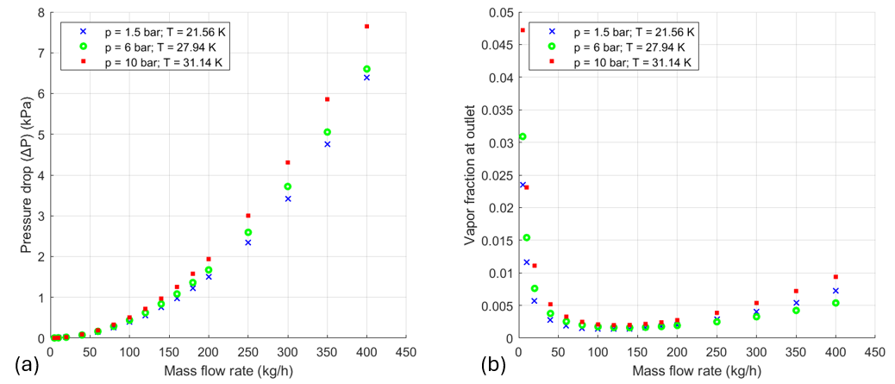

Figure 2: Effect of varying mass flow rate on pressure drop at different saturation conditions (a)
Effect of varying mass flow rate on vapor fraction at pipe outlet at different saturation conditions (b)

The results provide valuable insights into pressure drop and BOG formation in an LH2 pipeline, but there are limitations that should be considered for a better understanding. Firstly, the simulation assumes that the pipeline is already cooled to cryogenic temperatures and that the flow at the inlet consists entirely of LH2, neglecting any potential 2-phase flow. This assumption simplifies the analysis but may not fully capture the initial cooling phase or scenarios where vapor and liquid phases coexist, which could significantly affect pressure drop and BOG formation. Secondly, the study was conducted as a steady-state simulation assuming, that flow conditions remain constant over time. While steady-state results offer insights into average pipeline performance, they do not account for dynamic changes that may occur during the transfer process, such as fluctuations in mass flow rate, pressure, or temperature. Dynamic effects are especially important in real-world applications where transient behaviors influence system stability. Lastly, the physical model used assumes a straight, rigid pipeline without any restrictions, elbows, valves, or other fittings that would likely be present in an actual pipeline system. These components can cause additional pressure losses and may create localized points of BOG formation, altering the overall flow behavior.
As previously noted, the lowest BOG formation is observed at 27.94 K and 6 bar, rather than at the expected lowest temperature-pressure condition of 21.56 K and 1.5 bar. These results necessitate further investigation, as the unexpected vapor fractions at the pipe outlet may arise from thermodynamic factors or potential inaccuracies within the simulation software. Future research should focus on comparing these findings with other simulation tools and experimental data. Future research should also address limitations by expanding the scope of the simulations to include more realistic conditions. Investigating the effect of pipeline material and surface roughness, for instance, would help clarify how these factors influence pressure drop and BOG formation. Comparing the behavior of a rigid pipeline with that of a flexible hose, which typically has different surface roughness, could provide a deeper understanding of how pipeline characteristics impact LH2 flow. Moreover, incorporating the entire LH2 transfer system into the simulation - accounting for storage tanks, connectors, and any intermediate fittings - would yield a more comprehensive view of potential operational challenges and the locations where BOG formation might occur throughout the transfer process. Finally, conducting dynamic simulations that capture transient behavior would offer insights into how pressure, temperature, and flow rate evolve over time during LH2 transfer operations. This approach would better reflect real-world scenarios and allow for the development of control strategies to minimize BOG formation and pressure losses, especially during transient states.
  - Conclusions
This study has provided insights into the complexities of LH2 transfer through pipelines, with a focus on the operational efficiency and safety of cryogenic transfer systems. By developing a steady-state model using Aspen HYSYS, the impact of various parameters, such as mass flow rate, inlet pressure, and temperature, on key performance indicators such as pressure drop and BOG formation, was analyzed. As expected, higher mass flow rates led to increased pressure drop due to higher frictional losses, with the pressure drop being more significant at higher pressures and temperatures. Regarding BOG formation, it was found to be minimal within a specific mass flow range (100–150 kg/h) across all pressure-temperature conditions. Interestingly, BOG formation was lowest at 27.94 K and 6 bar. The results highlight the challenges associated with maintaining a stable flow of LH2, particularly the influence of mass flow rate and operating conditions on pressure losses and vapor generation. Furthermore, the study underscored the importance of pipeline insulation, valve and venting systems, and cryogenic pumps in minimizing BOG losses and ensuring safe operation. Despite the insights gained, several limitations in the study suggest opportunities for future research. The steady-state simulation did not account for dynamic variations in flow conditions, which are essential for understanding transient behaviors in real-world systems. Additionally, simplifying assumptions such as neglecting bi-phase flow and disregarding complex pipeline geometries may not fully capture the challenges of LH2 transfer under operational conditions. Future investigations could incorporate dynamic simulations, realistic system configurations, and a broader range of material properties to provide a more comprehensive understanding of LH2 pipeline behavior. Such studies will be crucial for optimizing LH2 transfer systems, minimizing efficiency losses, and enhancing safety protocols for large-scale hydrogen distribution, ultimately supporting the transition to a sustainable hydrogen economy.

Acknowledgments
This work was undertaken as part of the ELVHYS project No. 101101381 supported by the Clean Hydrogen Partnership and its members and the European Union. UK participants in Horizon Europe Project ELVHYS are supported by UKRI grant numbers 10063519 (University of Ulster) and 10070592 (Health and Safety Executive). Funded by the European Union. Views and opinions expressed are however those of the author(s) only and do not necessarily reflect those of the European Union or Clean Hydrogen JU. Neither the European Union nor the granting authority can be held responsible for them.
References
Aspen Tech, 2024, Aspen Process Manuals <aspentech.com/en/products/engineering/aspen-process-manuals> accessed 12.9.24.
Aziz M., 2021, Liquid Hydrogen: A Review on Liquefaction, Storage, Transportation, and Safety. Energies, 14, 5917 <doi.org/10.3390/en14185917> accessed 20.10.2024.
EIGA, 2019. Safety in storage, handling and distribution of liquid hydrogen, European Industrial Gases Association AISBL, Doc 06/19.
Hartwig J., Styborski J., McQuillen J., Rame E., Chung J.N., 2019, Liquid hydrogen line chilldown experiments at high Reynolds Numbers. Optimal chilldown methods. International Journal of Heat and Mass Transfer, 137, 703–713 <doi.org/10.1016/j.ijheatmasstransfer.2019.03.090>
ISO 13984, 1999, Liquid Hydrogen-Land vehicle fuelling system interface, International Organization for Standardization, <standards.iteh.ai/catalog/standards/sist/f7cd2010-aed9-4748-a0f3-
2e6f46734dc3/iso-13984-1999> accessed 10.12.2024.
Long R., 2024, Pumping Liquid Hydrogen for Industrial & Transportation Applications | Pumps & Systems <www.pumpsandsystems.com/pumping-liquid-hydrogen-industrial-transportation-applications> accessed 11.14.24.
Moran M.J., Shapiro H.N., 2006, Fundamentals of Engineering Thermodynamics, John Wiley & Sons Ltd, 5th ed, Chichester.
NIST Chemistry WebBook, 2024, National Institute of Standards and Technology <webbook.nist.gov/-chemistry/> accessed 10.10.24.
Ono R., Nifuku M., Fujiwara S., Horiguchi S., Oda T., 2007, Minimum ignition energy of hydrogen–air mixture: Effects of humidity and spark duration, Journal of Electrostatics, 65, 87–93.
Sathiamoorthy P.T., 2024, Modelling of Liquid Hydrogen Transfer using Aspen HYSYS, Norwegian University of Science and Technology, Trondheim.
Schefer R.W., Kulatilaka W.D., Patterson B.D., Settersten T.B., 2009, Visible emission of hydrogen flames, Combustion and Flame, 156, 1234-1241 <doi.org/10.1016/j.combustflame> accessed 11.01.2024
Zhang H. Q., Sarica C., 2006, Unified Modeling of Gas/Oil/Water-Pipe Flow-Basic Approaches and Preliminary Validation, Society of Petroleum Engineers Projects, Facilities & Construction.
Zhang H. Q., Wang Q., Sarica C., Brill J.P., 2003a, Unified Model for Gas-Liquid Pipe Flow via Slug Dynamics-Part 1: Model Development, Journal of Energy Resources Technology, 125, 266-273.
Zhang H. Q., Wang Q., Sarica C., Brill J.P., 2003b, Unified Model for Gas-Liquid Pipe Flow via Slug Dynamics-Part 2: Model Validation, Journal of Energy Resources Technology, 125, 274-283.

