Identification of critical inputs in QRA studies using Monte Carlo-based sensitivity analysis
Mercedes Belda-Ley^{1,*}, Gürkan Sin¹
1 PROSYS, Department of Chemical and Biochemical Engineering, Technical University of Denmark, Kgs. Lyngby, DK-2800, Denmark
*Corresponding author E-Mail: mbele@kt.dtu.dk
1. Introduction
Quantitative Risk Assessment (QRA) is a well-established methodology used in different fields to identify, quantify and evaluate the risks associated with human and industrial activities. It provides a structured and extensive approach to calculate risk values, providing as a result the ability to identify major risk contributors and to assist with decision-making among others. Owed to its extensiveness and complexity, numerous decisions and assumptions are to be made throughout its execution. With the intention of harmonizing and facilitating the execution of QRAs, multiple guidelines and methodologies have been developed. However, these diverge depending on the country, region, and can further be translated differently by each risk analyst, aggravating the uncertainty in the estimation of QRA results. Consequently, QRA reliability has frequently been questioned, reiterating and analysing its – inherent – uncertainties and related implications (e.g., Rae et al., 2014). This scrutiny has led to proposing and developing diverse strategies for treating its uncertainty (e.g., Abrahamsson, 2002; Xu et al., 2023) as well as discussing the role of sensitivity analysis in QRA (e.g., Flage and Aven, 2009).

In this context, the Monte Carlo (MC) methods provide a suitable framework for performing uncertainty analysis to complex problems (Sin and Espuña, 2020) where the description of the context, e.g., possible inputs, can be highly uncertain, as is the case for QRA (Abrahamsson, 2002; Li et al., 2022). Instinctively, these methods also serve as an effective framework for sensitivity analysis, since it is closely related to uncertainty analysis. MC-based sensitivity analysis has been applied to specific sections composing QRA in Pandya et al. (2012), however, the focus of this work was set on analysing the influence of model parameters in the calculated output.

This study presents an initial framework for applying MC-based Global Sensitivity Analysis (GSA) to QRA with the goal of pinpointing the most critical input parameters driving uncertainty in risk estimates. The aim is to quantify the contribution of individual input uncertainties to the variance of the overall risk outputs, i.e., the impact that the assumptions and decisions made throughout the QRA studies may have in the calculated output.
2. Methods
This study examines the effects modelling of an instantaneous release from an acrylonitrile tank, whose subsequent events include liquid pool formation, liquid evaporation and dispersion. Acrylonitrile is a highly toxic and volatile flammable liquid generally stored in unpressurized tanks at ambient temperature. It is assumed that, after the release, acrylonitrile forms a liquid pool spreading to the available surface of the bund surrounding the storage area. This area includes three tanks for acrylonitrile storage of 500 m³ capacity each and the bund was designed following ITC – MIE APQ 7, the Complementary Technical Instruction for the Storage of Toxic Liquids in Fixed Containers (Royal Decree 656/2017). The sensitivity analysis comprises acrylonitrile pool evaporation – of the non-boiling pool – and subsequent dispersion – a neutrally buoyant gaussian dispersion. The input variables sampled consist of the wind speed, ambient temperature, cloud cover and day-time or night-time conditions. Wind speed and ambient temperature input distributions are based on available meteorological data (Danish Meteorological Institute, n.d.) and are respectively approximated to a Weibull distribution with parameters A = 5.6115 and B = 2.0647 (m/s) and to a normal distribution with μ = 10.8671 and σ = 6.7939 (°C). Cloud cover follows discrete distributions from 0 to 10 with equal probabilities.

Appropriate sampling strategies are selected for each input, and subsequently the stability class based on the Pasquill-Gifford classification is determined for each sample according to the cloud cover, wind speed and whether it is day-time or night-time. Followingly the pertinent dispersion coefficients for the y-axis, σ_{y}, and the z-axis, σ_{z}, are calculated. Two main outputs are calculated, first, the evaporation rate in g/s. The results are subsequently fed to the dispersion model as a continuous source of toxic gas in order to calculate the second output: acrylonitrile airborne concentration in g/m³ at a certain distance of interest downwind from the source, more particularly at 211 m.

Two different sensitivity indices are generated for the latter output. First, the Standardized Regression Coefficients (SRCs) are computed using available MATLAB functions for linear least-squares solver, lsqlin, and multiple linear regression, regress. Second, the first order effect (S_{i}) and total order effect (ST_{i}) indices are computed using the approximations of the variance-based GSA indices given by Sobol, Saltelli and Jansen, which are manually implemented in MATLAB. In order to ensure statistical consistency and reliability of the sensitivity indices, the convergence of the first two moments – mean and variance – of the output distributions, guided by the Law of Large Numbers (LLN), is implemented. In this regard, the graphical method of Maximum-to-Sum plots provides an indication of the required number of MC simulations for a re sensitivity analysis.
3. Results and discussion
MC simulations are executed sampling from the above-mentioned input distributions and the two outputs calculated, whose distributions are characterized by a mean value of 346.33 (g/s) and 0.3644 (g/m³) and standard deviation values of 107.89 (g/s) and 0.8899 (g/m³) respectively. These values indicate that the concentration values are highly spread in comparison to the evaporation rate, which exhibits a Coefficient of Variation (CV) of 0.31 against that for the concentration of 2.44. Figure 1 further demonstrates this statement by displaying a slower convergence of the logarithmic Maximum-to-Sum plots for concentration in comparison to the evaporation rate. This can be attributed to the fact that evaporation rate is only affected in this study by the ambient temperature, while concentration is additionally affected by the other input variables considered in the work.

The number of MC simulations performed – 500 000 – ensures the validity of the sensitivity analysis, by allowing the output distributions moments to converge towards zero, as can be seen in the Maximum-to-Sum plots in Figure 1. SRCs are calculated including as inputs the stability class and the dispersion coefficients, providing a goodness of the fit – coefficient of determination, R² – of 0.588 for lsqlin method and 0.622 for the regress method.

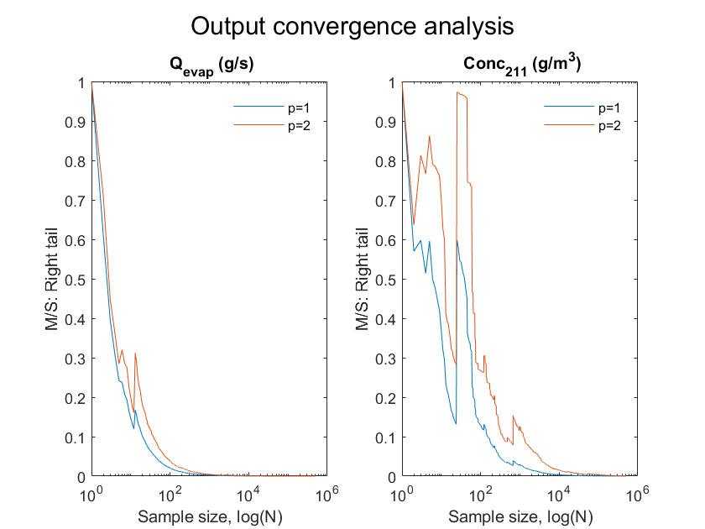
Figure 1. Logarithmic Maximum-to-Sum plots for evaporation rate (left) and concentration (right).
Table 1 shows that there is sufficient agreement between the two linear regression methods for the sampled inputs. On the contrary, the obtained SRC values for the stability class and dispersion coefficients show a significantly lower agreement. However, given that the of R² for both methods are below 0.7, the validity of these results is debatable.
Table 1. SRC and SRC² values for concentration (g/m³) at 211 m downwind.
Input variable | SRC - lsqlin | SRC² - lsqlin | SRC - regress | SRC² - regress
Wind speed (m/s) | -0.3214 | 0.1033 | -0.1639 | 0.0269
Cloud cover | -0.0976 | 0.0095 | -0.0785 | 0.00617
Day-time/Night-time | -0.1159 | 0.0134 | -0.1514 | 0.0229
Ambient temperature (°C) | 0.1242 | 0.0154 | 0.1243 | 0.0155
Stability class | 1.0000 | 1.0000 | 1.8726 | 3.5066
σ_{y} (m) | -0.3488 | 0.1216 | 1.1554 | 1.3348
σ_{z} (m) | 0.7607 | 0.5786 | 0.0905 | 0.0082

Global sensitivity analysis results, S_{i} and ST_{i}, presented in Table 2 show general agreement for all the sensitivity indices calculated – Jansen and Saltelli approximations to ST_{i} are the same. According to these results, wind speed variations – in other words, assumptions – are likely to have a considerable impact in the variability of the airborne acrylonitrile concentration, whereas the other factors play a less significant role in the uncertainty of the concentration estimates. This can be explained due to the fact that wind speed affects both, the gaussian dispersion calculations as well as the considered stability class for it.

Further analysis on the behaviour of the output led to the understanding that the concentration values differed significantly for each stability class. Figure 2 clearly depicts this difference, which is particularly noticeable for stability class F. From stability classes A to F, the mean and dispersion of the calculated concentration mostly increases. This observation agrees with the definition of the stability classes, which provides from A to F more stable atmospheric conditions, hence, preventing the dispersion of the toxic gas. Following this evidence, the output values were sorted and grouped according to their stability class and the SRC coefficients for each group were newly determined, this time dropping the stability class related inputs and day-time or night-time for SRC calculations. As a result of the separation the number of samples per stability class is different.
Table 2. First order and total order effects for concentration (g/m³) at 211 m downwind.
Input variable | S_{i} – Sobol | S_{i} – Saltelli | S_{i} – Jansen | ST_{i} – Sobol | ST_{i} – Saltelli / Jansen
Wind speed (m/s) | 0.4318 | 0.4444 | 0.4387 | 0.8788 | 0.8868
Cloud cover | 0.0107 | 0.0091 | 0.0095 | 0.1031 | 0.1050
Day-time/Night-time | 0.0737 | 0.0689 | 0.0738 | 0.4562 | 0.4536
Ambient temperature (°C) | 0.0163 | 0.0159 | 0.0142 | 0.0982 | 0.1022

The results included in Table 3 represent the results for the two implemented MATLAB regression functions, lsqlin and regress, as in this second estimation the computed coefficients align for both methods. The separation of the different stability classes for the sensitivity analysis provides a more suitable methodology for calculating sensitivity indices based on linear regression and MC methods. The R² values are mostly above 0.7, hence, indicating that linear regression is a sufficiently adequate method for this sensitivity analysis, except for stability class D. The reason behind stability class D presenting a poor fit for linear regression can be explained by the fact that, following the Pasquill-Gifford classification, overcast conditions, i.e., cloud cover of 10, are always assigned to belong to category D, regardless of the other atmospheric conditions. Consequently, there are wider ranges and more diverse combinations of input values in this stability class group.
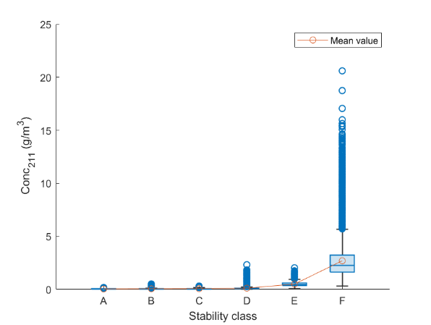
Figure 2. Box chart and mean for the calculated acrylonitrile concentration per stability class.
Furthermore, the CVs after the separation have been reduced in comparison to the one computed above for the combined stability classes. The updated CV values fall below 0.7 for all stability classes, being much lower than the previous value of 2.44. Beyond this, there is general agreement for all stability classes that the influence of the wind speed and ambient temperatures are significant. Naturally, the higher the wind speed, the more effective acrylonitrile dispersion and the lower its concentration at the point of interest. On the contrary, the higher the ambient temperature, the higher the evaporation rate of acrylonitrile from the liquid pool will be, resulting in a higher airborne concentration of the toxic substance. These logics are adequately evidenced in the SRCs, yielding negative values for wind speed and positive values for ambient temperature.
Table 3. SRC values for concentration (g/m³) at 211 m downwind per stability class calculated with the method.
Input variable | A | B | C | D | E | F
Wind speed (m/s) | -0.7384 | -0.7221 | -0.4929 | -0.5948 | -0.5300 | -0.7464
Cloud cover | -0.0271 | 0.0030 | 0.2733 | 0.0956 | 0.0067 | 0.0507
Ambient temperature (°C) | 0.5503 | 0.4657 | 0.5874 | 0.4585 | 0.8174 | 0.5141
R² | 0.8260 | 0.7487 | 0.8506 | 0.5793 | 0.9411 | 0.7911

Based on the SRC results depicted in Table 3 and the coefficient of variation reduction, it can be deduced that, despite the concentration values being determined after sampling from the same ensemble of input values, it would not be completely appropriate to consider that the output values belong to a unique output distribution. This circumstance is additionally related to the reason behind the requirements for high number of MC simulations for the distribution of the acrylonitrile concentration combining all stability classes to converge following the LLN. Instead, the concentrations obtained are better understood as separated distributions for each stability class, suggesting that complete QRA sensitivity analysis including all types of weather conditions is a challenging endeavour. However, the impact of this condition for GSA, in contrast to linear regression, would appear to be overcomed.
4. Conclusions
Overall, the work proposes a starting point for advanced, comprehensive sensitivity analysis based on MC methods for QRA. A sensitivity analysis is performed on two interconnected sub-models belonging to QRA where the LLN determines the necessary number of MC simulations to be conducted. The results provide evidence that the stability classification has a strong impact on the airborne concentration results for neutrally buoyant gases. As a result, the calculated output behaves in a more complicated manner than one solely distribution that can be straightforwardly studied through sensitivity analysis. Different requirements, challenges and suitable sensitivity analysis indicators for effectively applying sensitivity analysis to QRA are outlined in this study. The methodology showcases a framework for conducting GSA to QRA and an initial approach for the treatment of stability classes and its impact in effects modelling for QRA sensitivity analysis. The identification of key contributors to the variability in QRA results will be pivotal for harmonizing the QRA procedure and enhance its reliability.

Acknowledgments
This work is funded by the EU Horizon 2022 call HORIZON-MSCA-2022-DN-01, project number 101119358 as part of the Marie Sklodowska-Curie Actions.

References
Abrahamsson, M., 2002. Uncertainty in Quantitative Risk Analysis - Characterisation and Methods of Treatment. [Licentiate Thesis, Division of Fire Safety Engineering, Lund University]. Fire Safety Engineering and Systems Safety.
Flage, R. & Aven, T., 2009. Expressing and communicating uncertainty in relation to quantitative risk analysis. Reliability: Theory & Applications, 2(2–1,13), 9–18.
Li, Y., Wang, Y., Lai, Y., Shuai, J., & Zhang, L., 2022. Monte Carlo-based quantitative risk assessment of parking areas for vehicles carrying hazardous chemicals. Reliability Engineering & System Safety, 231, 109010. https://doi.org/10.1016/j.ress.2022.109010
Ministerio de Economía, Industria y Competitividad, 2017, Royal Decree 656/2017, of June 23, which approves the Regulations for the Storage of Chemical Products and their Complementary Technical Instructions MIE APQ 0 to 10, Boletín Oficial del Estado.
Danish Meteorological Institute, n.d. Observationer. DMI. https://www.dmi.dk/friedata/observationer
Pandya, N., Gabas, N., & Marsden, E., 2012. Sensitivity analysis of Phast’s atmospheric dispersion model for three toxic materials (nitric oxide, ammonia, chlorine). Journal of Loss Prevention in the Process Industries, 25(1), 20–32. https://doi.org/10.1016/j.jlp.2011.06.015
Rae, A., Alexander, R., & McDermid, J., 2014. Fixing the cracks in the crystal ball: A maturity model for quantitative risk assessment. Reliability Engineering & System Safety, 125, 67–81. https://doi.org/10.1016/j.ress.2013.09.008
Sin, G. and Espuña, A., 2020. Editorial: Applications of Monte Carlo Method in Chemical, Biochemical and Environmental Engineering. Front. Energy Res. 8:68. https://doi.org/10.3389/fenrg.2020.00068
Xu, Y., Reniers, G., Yang, M., Yuan, S., Chen, C., 2023. Uncertainties and their treatment in the quantitative risk assessment of domino effects: Classification and review. Process Safety and Environmental Protection, 172, 971-985. https://doi.org/10.1016/j.psep.2023.02.082

