Predicting Pressure Effects of Delayed Ignition in Gas Free Jets: Model Development and Validation with CFD Approach

Fabian Krieg1,*, Jens Denecke2,3, Lukas Bohlender1,2, Jürgen Schmidt2, Oliver Odenwald1

1 BASF SE, Carl-Bosch-Str. 38, 67056 Ludwigshafen, Germany;   
2 CSE Center of Safety Excellence (CSE-Institut), Joseph-von-Fraunhofer-Str. 9, 76327 Pfinztal, Germany  
3 University of Applied Sciences, Moltkestrasse 30, 76133 Karlsruhe, Germany

*Corresponding author E-Mail: Fabian.krieg@basf.com

1. Introduction

In the chemical industry, overpressure protection for equipment and plant components is typically achieved through mechanical safety devices such as safety valves and rupture discs. When gaseous or vapor releases occur, the gas is often released into the atmosphere with high momentum, potentially resulting in an ignitable free jet. Despite adherence to regulatory design standards for the outlet, ignition of the free jet cannot be entirely excluded. In such instances, the flame front propagates more rapidly due to the turbulence within the free jet compared to passive gas clouds. This results in higher pressure effects relative to a passive gas cloud with the same explosive mass (Sail, Blancheterie, Osman, Daubech, & Jamois, 2018).

Common models for evaluating the pressure effects of gas cloud explosions, such as the Baker-Strehlow-Tang (BST) (Pierorazio, Thomas, Baker, & Ketchum, 2005) and the TNO Multi-Energy Method (MEM) (van den Berg, 1985), account for turbulence caused by obstacles but do not consider the turbulence in the ignitable mixture due to high-momentum releases. Consequently, these models may not always provide conservative estimations of the pressure effects when applied to ignitable free jets.

The objective is to develop a model that offers conservative estimations of the pressure effects, including pressure and pressure impulse, for the ignition of gas free jets. This model should incorporate outlet conditions, substance-dependent properties, and represent the conservative case for other influencing factors such as ignition point, weather conditions, and time of ignition. The interaction of the free jet with objects will be investigated at a later stage. For validation, the model is compared to literature experiments on explosion pressures of horizontal free jets including ground interaction.

2. Methods

Firstly, the influencing variables of the parameters in the models for the pressure effect of the gas cloud explosion were analysed. The following were considered:

1. The Concentration on the free jet axis according to Schefer (Schefer, Houf, & Williams, 2008)
2. The mean velocity on the free jet axis according to Birch (Birch, Hughes, & Swaffield, 1987)
3. For the turbulence on the free jet axis, the approach by Hinze (Hinze, 1975)
4. For the turbulent flame velocity, the models to Bray (Bray, 1990), Bradley (Bradley, Lau, & Lawes, 1992), Peters (Peters, 2010)
5. Complete short-cut models such as BST (Pierorazio, Thomas, Baker, & Ketchum, 2005), MEM (van den Berg, 1985), Giesbrecht (Giesbrecht, 1987)

Experiments of an appropriate scale were identified based on these models and the industrial requirements (Jallais, Vyazmina, Miller, & Thomas, 2018), (Sail, Blancheterie, Osman, Daubech, & Jamois, 2018), (Miller, Eastwood, & K., 2015). Using these experiments, a suitable setup was developed using the CFD software FLACS from Gexcon to reproduce the pressure effects during the ignition of a free jet. This setup facilitated a comprehensive parameter study, from which the pressure effects during the delayed ignition of turbulent gas free jets were evaluated. Specifically, the substances methane, propane, ethylene, acetylene, and hydrogen were assessed within a mass flow range of 0.06 kg/s to 12 kg/s.

3. Results and discussion

The validation of the setup in FLACS has demonstrated that the experimental findings regarding the pressure effect during free jet explosions can be reproduced. The discrepancies between experimental data and simulation results are within a factor of two (figure 1, left). Deviations of the same order of magnitude are observed in repeated experimental trials (Chaineaux, 1993).

The extensive parameter study reveals that the pressure effect is significantly influenced by the type of medium and the released mass flow rate (figure 1, right).

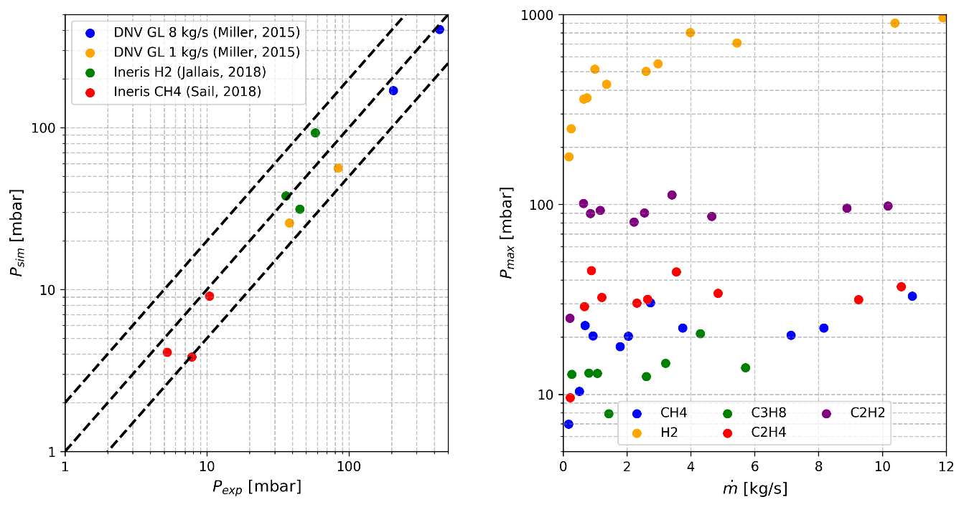

Figure 1. Comparison of the experimentally and simulatively measured peak overpressures for experiments in a technically relevant order of magnitude (left) and maximum peak overpressures on the jet axis as a function of the mass flow rate for several media (right).

4. Conclusions

The validation process has confirmed that the effects of free jet ignition can be simulated with an accuracy comparable to that of experimental results. A comprehensive parameter study, involving variations in the released medium and outlet conditions, reveals significant dependencies between pressure effects, medium properties, and outlet geometrical dimensions. These observed dependencies present an opportunity to develop an empirical model capable of predicting pressure and pressure impulse based on the specific properties of the released medium and the outlet conditions. The potential of an empirical model based on the findings from the simulations and experiments is discussed.

# References

Birch, A. D., Hughes, D., & Swaffield, F. (1987). Velocity Decay of High Pressure Jets. *Combustion science and technology*, 161-171.

Bradley, D., Lau, A. K., & Lawes, M. (1992). Flame stretch rate as a determinant of turbulent burning velocity. *Philosophical Transactions of the Royal Society of London. Series A: Physical and Engineering Science, 338*, 359-387.

Bray, K. N. (1990). Studies of the turbulent burning velocity. *Proceedings of the Royal Society of London. Series A: Mathematical and Physical Sciences, 431*, 315-335.

Chaineaux, J. (1993). *Projet MERGE - Rapport Final.* L'Institut national de l'environnement industriel et des risques (Ineris).

Giesbrecht. (1987). *Gefahren durch Druckwellen und Wärmestrahlung beim Zünden von Brenngasstrahlen - BASF internal.*

Hinze, J. (1975). *Turbulence.* McGraw-Hill.

Jallais, S., Vyazmina, E., Miller, D., & Thomas, J. K. (2018). Hydrogen Jet Vapor Cloud Explosion: A Model for Predicting Blast Size and Application to Risk Assessment. *Process safety progress*, 397-410.

Miller, D., Eastwood, C. D., & K., T. J. (2015). Hydrogen Jet Vapor Cloud Explosion: Test Data and Comparison with Predictions. *11th Global Congress on Process Safety, AIChE Annual Meeting*.

Peters, N. (2010). *Technische Verbrennung.* University of Aachen: Course Material (2006).

Pierorazio, A., Thomas, J., Baker, Q., & Ketchum, D. (2005). An update to the Baker–Strehlow–Tang vapor cloud explosion prediction methodology flame speed table. *Process Safety Progress*, 59-65.

Sail, J., Blancheterie, V., Osman, K., Daubech, J., & Jamois, D. (2018). *Review of knowledge and recent works on the influence of initial turbulence in methane explosion.* L'Institut national de l'environnement industriel et des risques (Ineris).

Schefer, R. W., Houf, W. G., & Williams, T. (2008). Investigation of small-scale unintended releases of hydrogen: momentum-dominated regime. *International Journal of Hydrogen Energy, 33*(21), 6373-6384.

van den Berg, A. C. (1985). The multi-energy method: a framework for vapour cloud explosion blast prediction. *Journal of Hazardous materials, 12*(1), 1-10.