Development of a Support System for the Analysis of Human Factors in Chemical Plant Accidents

Masaki Nakagawa1, Mamiko Takahara2

1 Mitsubishi Chemical Co., 1-1, Marunouch 1 Chome, Chiyoda-ku, Tokyo 100-8251, JAPAN；

masaki.nakagawa.ma@mcgc.com

2 Mitsubishi Chemical Co., 1-1, Marunouch 1 Chome, Chiyoda-ku, Tokyo 100-8251, JAPAN

mamiko.takahara.md@mcgc.com

1. Introduction

Variation Tree Analysis (VTA) and Why-Why analysis are methods for analysing the causes of accidents caused by human behaviour during manufacturing processes and maintenance work at chemical plants. VTA and Why-Why analysis are often used as a set.

VTA is a method of analysing the circumstances of an accident in time order, with particular emphasis on human behaviour and judgment (Figure 1). The progression of an accident is shown along a time series (the flow of time can be from top to bottom or bottom to top). In VTA, situations, tasks, judgments, or actions that deviate from normal conditions are picked up as variation factors. Among the variation factors, those that would not have caused the accident without this factor are specifically called elimination nodes This elimination node is the starting point of the Why-Why analysis.

Why-Why analysis is a method of continuously questioning the causes of an accident in a logical manner to identify the root causes of the accident and take countermeasures　 (Figure 2). Why-Why analysis is conducted through discussions among participants. The procedure of Why-Why analysis when used in combination with VTA is as follows,

1. Starting from the elimination node of the VTA, ask “why” it occurred.

2. Then turning the answer to the first question into a second “why” question.

3. After that, the next answer becomes the third “why” question, and so on.

4. Repeating the “why” until the root cause is identified, and appropriate measures are taken.

The process of deriving answers and putting them into writing in the conventional Why-Why analysis was very time-consuming. This is because in this analysis method, answers are listed one by one, referring to all information related to the occurrence of mistakes and problems. For this reason, the writing process varied from analyst to analyst in the analysis. In other words, the conventional analysis method had the problem that the results of the analysis varied depending on the analysts conducting the analysis, even if the analysis was conducted for the same accident.

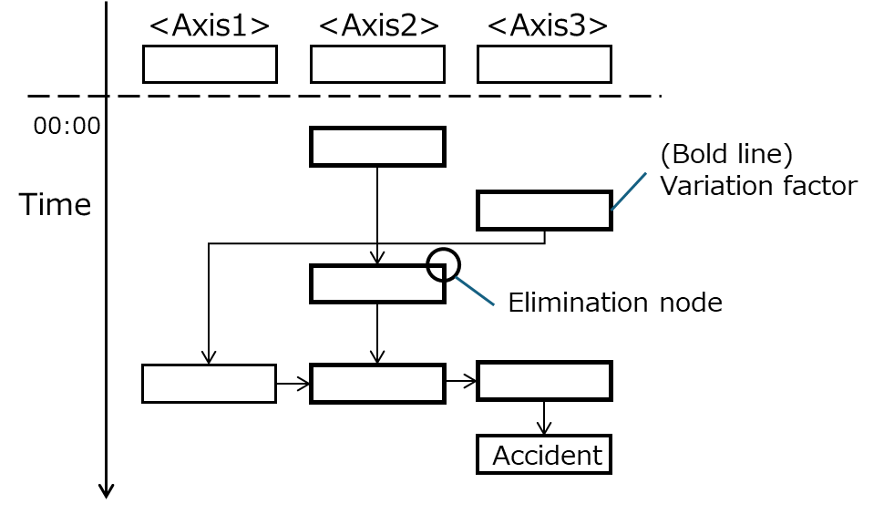

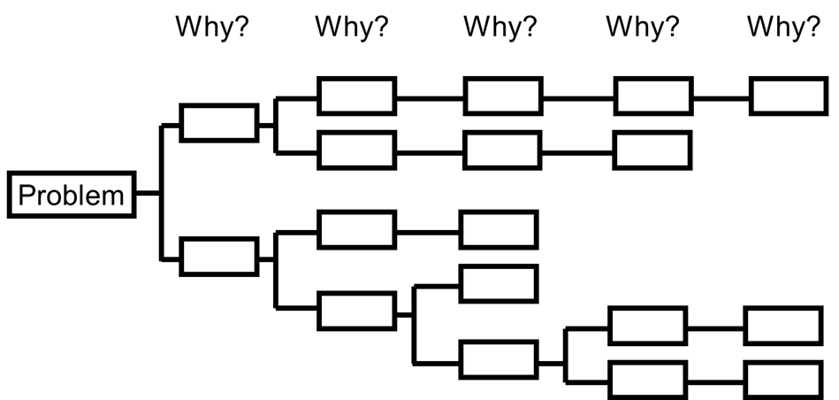

Figure 1. VTA. Figure 2. Why-Why Analysis.

To solve these problems, Nakagawa and Shibata (2016) describe a method that was devised to create templates for Why-Why analysis in advance from the viewpoint of human factors, and to efficiently perform Why-Why analysis by referring to these templates. However, in this method, the wording of the templates did not always facilitate the analysis. It is also failed to determine the accuracy of the logical structure of the Why-Why analysis when deviating from the structure of the template. Furthermore, there were problems such as the time and effort required to modify the template once it was created.

Therefore, there is a need to develop a tool that could ensure the quality of analysis, reduce analysis time and manpower, provide support that is in line with actual analysis, and provide flexible support according to the accident conditions.

**2. Methods**

In this study, to support Why-Why analysis, methods that patterns accident analysis results and supports Why-Why analysis using the patterned data are developed. This support methods have functions to accumulate the analysis results of Why-Why analysis, to learn new analysis results, to support the analyst in suggesting candidates for the next “why”, and to check the logical consistency of the Why-Why analysis results.

2.1 Patterned accident analysis results

Why-Why analysis consists of a series of short sentences, and each short sentence has a “cause” and “effect” relationship with each other. In this study, a method to organize each sentence that constitutes the result of Why-Why analysis in the form of abstracted words (concepts) is proposed. By implementing this approach, the Why-Why analysis is transformed from “the connection of short sentences” to “the connection of concepts” (Figure 3). Since the event that initiates the Why-Why analysis is the elimination node of the VTA, it is separately conceptualized as a problem event to facilitate ease of understanding and usability for analysts. The “why concept” and the next “why concept” are connected in terms of cause and effect. When the results of numerous Why-Why analyses are organized and tabulated in terms of the connection between “causes” and “effects” of “why concepts”, a tree-like diagram can be created (Figure 4). This diagram organizes the patterns of accident analysis results into a tree-like structure. In addition, if the tree is organized by a business field, it is useful to understand the trend of accidents and occupational injuries in each business field.

By organizing the results of the Why-Why analysis in the form of a concept tree, it is possible to visually grasp the patterns of accident analysis. This method allows the analyst to efficiently understand the relationship between cause and effect and to propose candidates for the next “why”.

2.2 Development of a support program

A support program is developed to facilitate Why-Why analysis by utilizing accident analysis data organized into a conceptual tree structure. This support program has the following functions as follows,

1. Accumulation function of analysis results: The results of past Why-Why analyses are accumulated in a database so that they can be utilized in later analyses.
2. Learning function for new analysis results: The newly obtained analysis results are learned and added to the database to modify the concept tree each time and improve the accuracy of the support program.
3. Next “why” candidate suggestion function: This function enhances the efficiency of analysis by proposing candidates for the next “why” to the analyst.
4. Logical consistency check function: This function checks the logical consistency of Why-Why analysis results by detecting contradictions and inconsistencies.

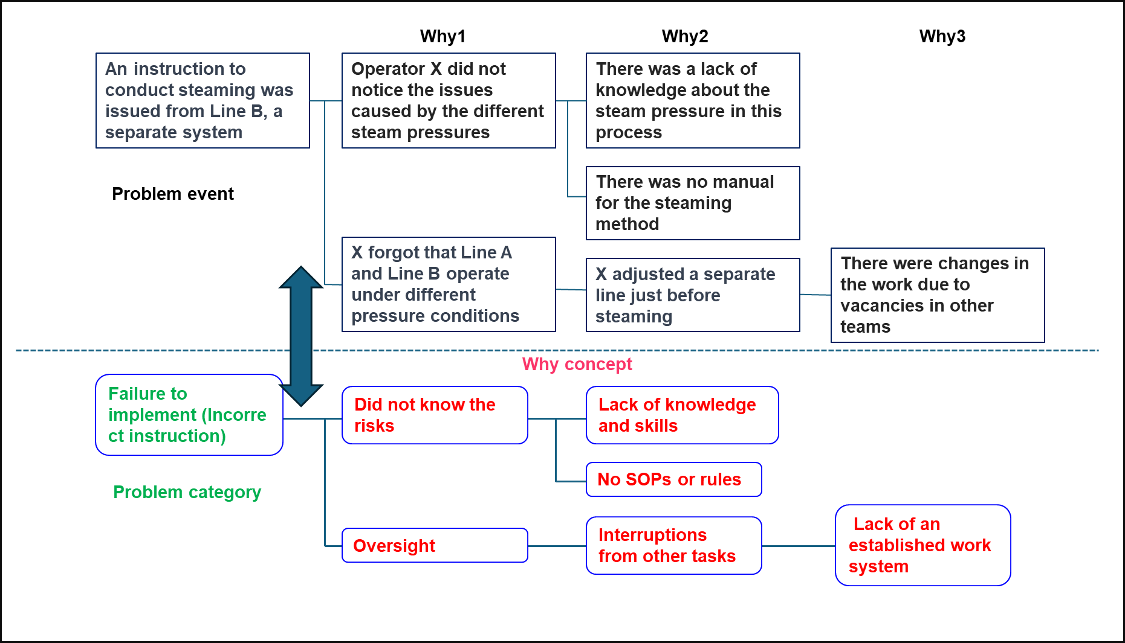

*Figure 3. Example of rewriting to the why concept.*

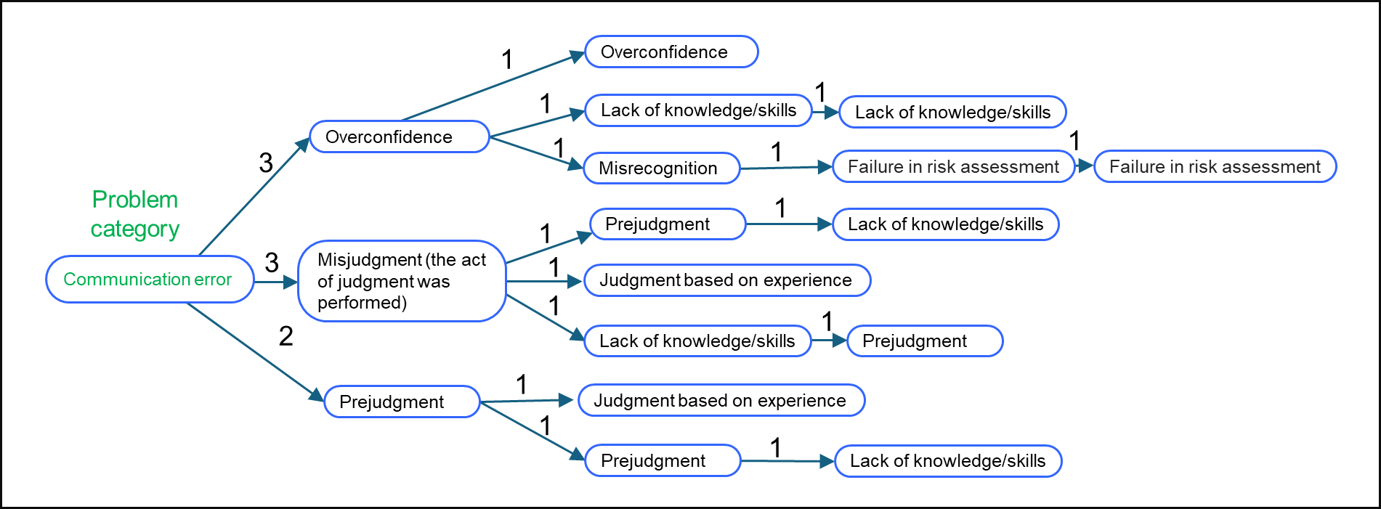

*Figure 4. Part of the concept tree. The numbers in the diagram indicate the aggregated values of the relationships between the “why concepts”.*

Analysis Methods Using Support Programs are as follows,

(1) Classification of problem categories

Problem categories are abstracted terms grouped as the starting points (problem events) of the Why-Why analysis. These terms are extracted from past accident analysis data and include around a dozen types, such as "Failure to respond" and "Equipment malfunction." When the analyst inputs the starting point of the Why-Why analysis, the AI predicts the appropriate problem category based on the words of the problem event and presents them in order of increasing certainty. For example, as shown in Figure 5, if the starting point of Why-Why analysis is the VTA elimination node “Operator X instructed to conduct steaming from Line B, a separate system”, the problem category is classified in terms of what kind of problem this problem event is in general. The analyst selects the problem category that finally seems to fit the content of this sentence from the presented problem categories (if there is no word to be selected, add it as appropriate). “Failure to respond (incorrect instruction)” is selected in this example.

(2) Classification into why concepts

The “why concepts” are grouped as abstract words, such as “Oversight”, “Inadvertent error”, and “Insufficient knowledge and skills”, for the answers to the “why” in the Why-Why analysis. Approximately 200 types are prepared from past accident analysis data. The AI predicts the “why concepts” that will be the causes of the next “why” from past data, based on the first problem category selected, and presents them as candidates in order of their high probability. In this case, the analyst selects “Oversight”, as in (2).

(3) Determining the why factor

When the analyst selects a “why concept”, specific examples of events corresponding to the “why concept” are presented. A concrete example related to “Oversight” is presented.

The analyst uses this as a reference to describe the next “why” factor. In (3), the analyst stated, “X forgot that Line A and B have different pressures”.

(4) Why-Why reasoning and countermeasure planning

Next, the AI predicts the next “why concept” from past data based on the event described in the “why”, and then analyst describes the next “why” factor using the predicted concept and specific examples as ideas. The analysis is continued repeatedly until specific measures are taken. For example, from the “Why 1 event”, “I forgot that Line A and B have

different pressures”, AI presents the concept of “Why 2”. If “Interruption from other tasks”, “Information overload”, or “Work stress” is selected, several more specific examples will be presented. The analyst should refer to this and describe the following why factors as in

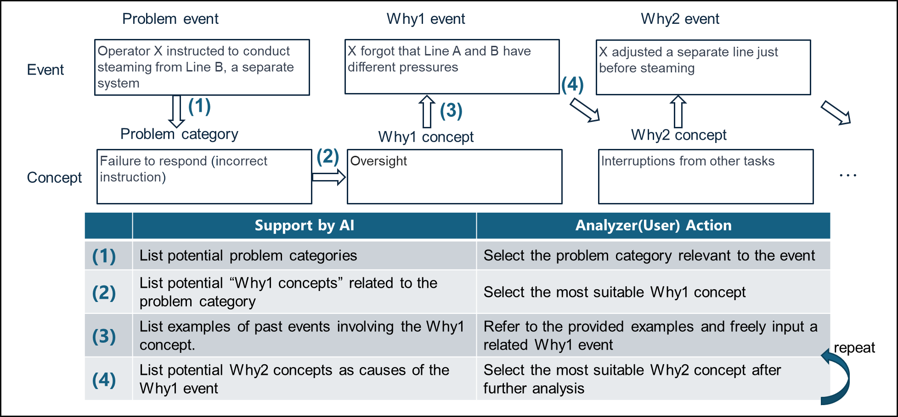

*Figure 5. The various inference parts of Why-Why analysis.*

(2). In (4), “X adjusted a separate line just before steaming” is described. The analyst repeats this process to arrive at the root cause in the “Why n” event and considers countermeasures.

The above reasoning part was divided into four steps (1) through (4), and algorithms were constructed for each of these steps. These can provide more appropriate support by using machine-learned models of accident analysis data for each business field. Furthermore, generative AI is utilized to verify the theoretical correctness of the connections between “Why n” event and “Why n+1” event in the Why-Why analysis.

3. Results and discussion

Although the support program proposed in this study contributes to improving the efficiency and accuracy of Why-Why analysis, several issues remain to be addressed.

3.1 Issues related to granularity of “why concepts”

Setting detailed “why concepts” related to SOPs may affect the accuracy of machine learning. This is because the corresponding examples will be dispersed and the number of examples corresponding to each “why concept” will decrease. On the other hand, if the concepts are set too broadly, the amount of data for each “why concept” will be biased and may require appropriate subdivision. Therefore, it is necessary to check the examples corresponding to the “why concepts”, subdivide the concepts for those that occur frequently, and if there are only a few examples, integrate those that can be lumped together and create “why concepts” as needed (Figure 6).

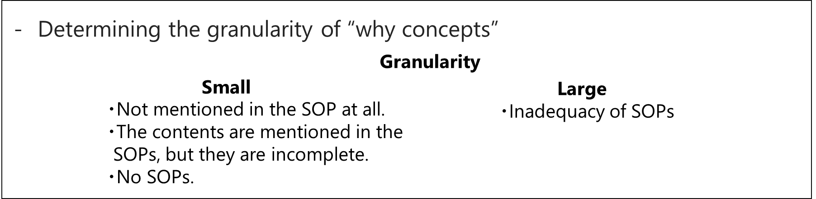

*Figure 6. Issues related to why concept granularity.*

3.2 Issues related to the wording of concept

Synonyms and indistinguishable terms may confuse analysts. To clarify these differences, terms are rewritten using alternative expressions (Figure 7). For example, “Did not understand” is revised to “Did not understand something”, and “Did not know” is revised to “Was unaware of the information”. These adjustments are made to ensure that the expressions are clear and comprehensible to the analysts.

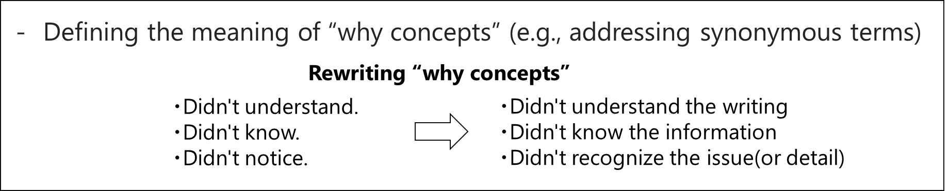

*Figure 7. Issues related to why concept granularity.*

3.3 Future work

The “why concepts” are being modified by using generative AI for more efficient study. Figure 8 shows some of the “why concepts” being organized, and the concepts themselves are being organized using the generative AI and modified to make them easier to reason about. The more data on these concepts is accumulated, the more room there will be for reexamination. Future research will continue to explore these concepts. Currently, this program has completed the machine learning component and is being developed as an application that can be used by anyone. When the application completed, it is expected that more data will be accumulated, and accuracy will be improved by having employees use the application.

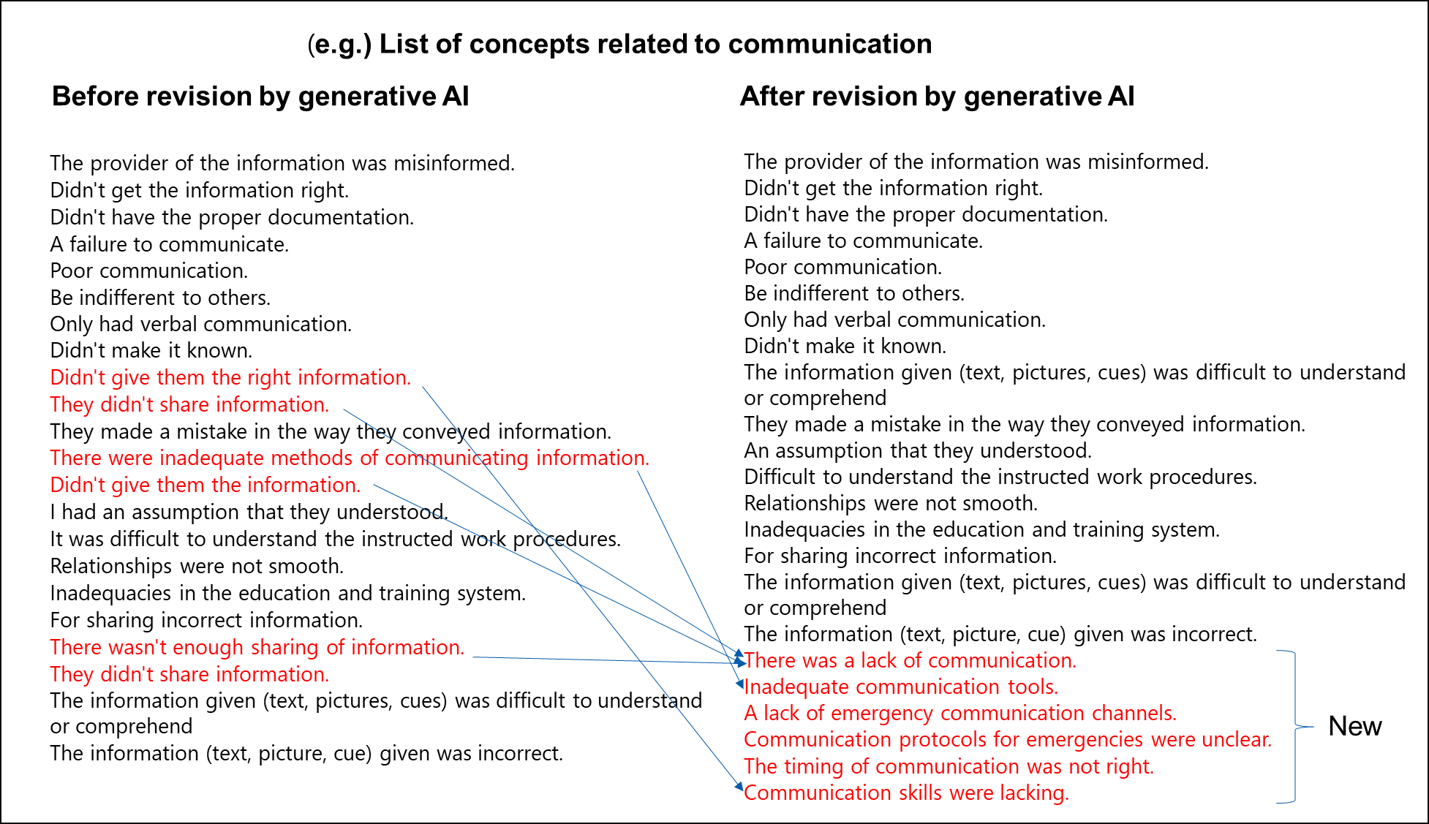

Figure 8. Organizing “why concept” with generative AI

4. Conclusions

This study involves the patterning of accident analysis results to support Why-Why analysis, leading to the development of the support program utilizing these patterned data.　 This support program has a function to accumulate the analysis results of Why-Why analysis, a function to learn new analysis results, a support function to suggest candidates for the next “why” to the analyst, and a function to check the logical consistency of the Why-Why analysis results.

The method proposed in this study contributes to improving the efficiency and accuracy of Why-Why analysis. Future work is required to apply the method to actual accident analysis and to verify its effectiveness.

References

Nakagawa M., Shibata T., 2016. Analysis Methods for Human Factors in Chemical Plant Accidents, CHEMICAL ENGINEERING TRANSACTIONS 48, 781-786.