 CHEMICAL ENGINEERING TRANSACTIONS  VOL. xxx, 2025 | A publication of  
The Italian Association
of Chemical Engineering
Online at www.cetjournal.it
Guest Editors: Bruno Fabiano, Valerio Cozzani
Copyright © 2025, AIDIC Servizi S.r.l.
ISBN 979-12-81206-xx-y; ISSN 2283-9216

Safety implications for petrochemical sites resulting from the use of alternatively powered trucks
Johan E.A. Reinders*, Nils Rosmuller, Henk Brans
Netherlands Institute for Public Safety (NIPV), P.O. box 7010, 6801 HA Arnhem, The Netherlands. www.nipv.nl
johan.reinders@NIPV.nl
As with passenger cars and buses, trucks are more and more powered by alternative (“sustainable”) fuels. This paper presents a study into the implication for safety of the use of Alternatively Powered Vehicles (APVs) on (petro)chemical sites. APVs are defined here as trucks that are powered by LNG, CNG, or Li-ion batteries.
Firstly we found that very little, if any, legislation regarding the fuel of trucks on chemical sites exists in Europe. However, there are various regulations that cover relevant vehicle, equipment or spatial aspects. Also, initiatives to develop APV-guidelines on industrial sites are being undertaken by (chemical) companies.
Secondly we have created and evaluated accident scenario’s involving the energy sources. For each of the four energy sources key incident scenarios were created for driving across the site, for cargo (un)loading and for parking. Consequences of these accidents differ considerably from those with diesel trucks. Failure of a fuel tank of a diesel truck leads to a pool of liquid that won’t easily ignite. Incidents with natural gas or hydrogen may cause jet fires, fire balls, explosions, or a BLEVE. Accidents with batteries may lead to a ‘thermal runaway’ generating sparks, flares and toxic and flammable gases, possibly resulting in damage or injuries. These effects require special measures that should be laid down in the company’s Safety Management System.
  - Introduction
Currently transport of goods over (petro)chemical sites takes place almost exclusively with diesel trucks, leading to emission of the greenhouse gas CO₂, causing global warming. Therefore, as with cars and buses, in freight transport fossil fuels are increasingly replaced by more “sustainable” alternative fuels, avoiding CO₂ emissions as much as possible. In the context of this study, alternative fuels refers to LNG, CNG, hydrogen Li-ion batteries.
Although alternatively powered trucks (APVs) currently make up only a very small proportion of the truck fleet in the Netherlands (about 1% in 2020), their share has increased by a factor of 3 during the period 2015-2020 (ACEA, 2021) and is expected to increase further given the Dutch ambition that all new trucks should be “zero emission” by 2040 (TLN, n.d.). However, this should not compromise safety. Therefore NIPV investigated the safety risks associated with the use of APVs at (petro)chemical sites. The research consisted of a literature study of regulations, requirements and private initiatives and an evaluation of representative (key) incident scenario’s with APVs at hazardous materials sites.
  - Method
Regulations, requirements and other initiatives were compiled through a desk (internet) study using Google. Also specific sites, known (from professional experience) to contain relevant information, were consulted. Relevant documents were analysed and from further links within these documents more information was retrieved (“snow ball method”).
For the second part of the study two workshops were held with representatives of the Dutch chemical industry, emergency responders and governmental organisations involved with industrial safety of “Seveso-sites”. During the workshops key incident scenarios were constructed and analysed. This is shown in Figure 1.
Because in principle numerous incidents are conceivable, prior to the workshops a number of example scenarios were prepared based on the principles of external safety assessments in the Netherlands (PGS 3, 2005). These were used as a starting point and combined with industry experience to construct key scenarios for three truck-related activities at petrochemical sites: driving, loading/unloading and parking. This was done for LNG-, CNG- and H₂-fuel tanks and Li-ion batteries, resulting in 12 key scenarios. For these scenarios type and extend (effect distances) of (adverse) effects were determined using the software tool EFFECTS, version 12 (Gexcon, 2025). Accidents yielding the largest effect distances (Worst Credible Accidents or WCAs) were used for further evaluation, i.e. for site impact.
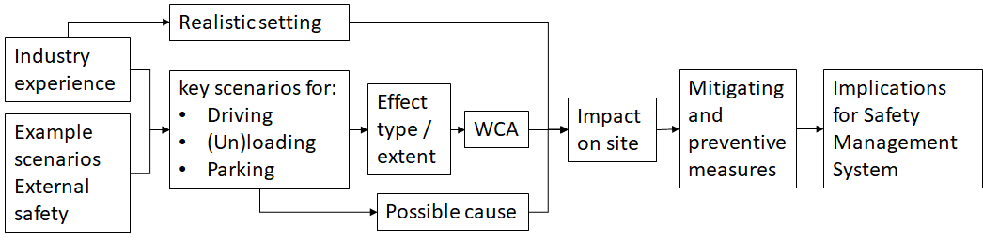
Figure 1: Working method to obtain WCAs and safety measures
To be able to estimate the impact of the scenarios on site and later work out the safety measures, realistic settings (working methods, location, environment etc.) for the scenarios are important. Input provided by workshop participants was essential for this purpose. Safety measures can be aimed at preventing the undesired event (preventive measures) or at limiting the consequences (mitigating or repressive measures). They can be of spatial (distance), organizational or technical nature.
As there is a wide variety of petrochemical companies, implementation of safety measures will vary. In a further workshop some companies reported on the implications this might have on their safety management system (SMS).
  - Results
    - Legislation, regulations and company initiatives
The literature review showed that there are no regulations for the use of alternatively powered vehicles in the European ‘Seveso-III-Directive’ (2012/18/EU) (EU, 2012). Regulations for the use of APVs at specific (chemical) sites in the USA were not found either.
However there are national and international requirements that alternatively powered vehicles must meet: UN/ECE Regulation No. 110 (UN, 2000) for natural gas and Regulation No. 134 (EU, 2019) for hydrogen (fuel cells). The safety requirements address reliability and integrity of (pressurised) tanks. UN/ECE R100 (EU2010) and Addendum 20 to GTR 20 (UN, 2018) deal with “thermal runaways” in electrically powered vehicles.
Also regulations for hydrogen and natural gas refuelling stations contain useful information: NFPA codes in the USA (NFPA 2, 2023; NFPA 55, 2023; NFPA 55, 2023), and PGS guidelines In the Netherlands (PGS 25, 2023; PGS 33-1, 2022; PGS 35, 2021).
In-company guidelines are still mostly missing, or, at best, under development. However, within (international) organizations, like the Energy Institute (EI, 2025), CEFIC and UN (ADR) initiatives are emerging (Pers. Comm., 2022).
    - Incident scenarios
Worst Credible Accidents
An incident scenario follows a chronological line of events. In an incident scenario an undesired event (often called Loss of containment or LOC) is described including the cause(s), physical effect(s) and consequence(s) for assets, people and/or the environment.
Many types of incidents can occur on a site. As evaluation of incident scenarios are typically part of Quantitative Risk Assessment (QRA) methods in external safety studies, a number of example scenario’s, derived using the principles of performing QRAs in the Netherlands (PGS 3, 2005), were used as the starting point to create key scenario’s (one for each sustainable energy source) for three activities: driving across a site, loading / unloading and parking. Refuelling or (re)charging of batteries was not included in the study.
“Worst Credible Accidents” (WCAs) were selected based on (largest) effect distance and (estimated) likelihood of occurrence. In other words accidents that were considered credible (by process safety and industry experts) on such locations and could (potentially) have very serious safety consequences on or around the location were selected for further evaluation.
Types of Loss Of Containment (LOC)
The following types of LOC were used:
- Complete and instantaneous failure or rupture of an energy holder. This can occur if a tank or battery pack is subjected to very large forces, for example in a violent collision or if it is exposed to extreme heat. It may also be caused by a serious structural failure or lack of maintenance.
- Damage of such magnitude that the hazardous contents is expelled from the tank or battery pack in, say,10 minutes. This represents a substantial impact with, for example, a heavy machine or the breaking off of a large pipe.
- A small hole in a tank. Consider a small connection breaking off or a crack due to corrosion. In case of electrically powered trucks, a slow formation of gases caused by ageing and their slow release could be the cause.
Damage criteria
To determine the distance to which injuries and property damage could occur as a result of the accidents, the following damage criteria were used, also derived from the field of external safety (PGS 3, 2005):
- For heat radiation: the distance from the source to the location where the radiation level is reduced to:
- 35 kW/m²: up to this distance combustible products like wood or plastic will quickly catch fire;
- 10 kW/m²: up to this distance persons may suffer lethal burns;
- For a BLEVE: the diameter of the fireball. This distance generally exceeds the effect distance of overpressure caused by a BLEVE. Within this fireball, flammable substances will ignite and persons may suffer lethal burns.
- For a jet flame: the length of the flame. Within the flame flammable substances will ignite and persons will suffer lethal burns.
- For a flammable cloud: the distance to the Lower Explosion Limit (LEL) and the distance to the 300 mbar overpressure contour upon ignition if 12.5% of the gas volume has accumulated in a confined space, measured from the centre of the cloud (RIVM, 2020).
- Toxicity of HF (for Li-ion battery electric vehicles or BEVs): Concentration level considered life-threatening upon x min exposure (LBW_{x}; e.g. LBW30min = 51 mg/m³ (RIVM, 2023)) and 1% mortality.
Outcome of calculations
As an example the evaluation of the key incident scenarios for the BEVs are summarised Figure 2. In yellow the effects and consequences for parking are shown, assumed to be a result of relatively slow processes taking place inside one of the battery packs e.g. as a result of ageing or (salt) water ingress. Damage to two (of the three present in the truck) battery packs caused by a fork lift during unloading of the vehicle is shown in orange. A heavy collision with a train, leading to a violent thermal runaway of the complete battery system is shown in red.
In Table 1 the WCAs resulting from the analyses of all scenarios are summarised. During the calculations Pasquil class D5 was used for atmospheric conditions. As a reference the effects of failure of a tank of a diesel truck was also calculated, assuming that such an incident would result in a pool fire, which is not very likely given the relatively high flammability temperature (around 55 °C) of diesel. The alternative energy sources clearly give rise to (new) safety concerns.
CNG and hydrogen are stored under high pressure in cylindrical tanks. Because of strict requirements, such a tank will not easily fail in a collision. However, a hole can occur if a pipe breaks off. The gas will then be blown out at high speed. Direct ignition, causing a jet fire of up to 30 m would account for the largest effect distance for the CNG cylinder. A flashfire (after formation of a flammable cloud and subsequent ignition) would result in the largest effect distance for hydrogen: 50 m. The jet fire and flashfire can cause burns and also lead to fire spreading at the site. If the gas has (partially) accumulated in a confined space, followed by ignition, a pressure wave may also cause explosion damage.
LNG is kept at around -162 °C. Although LNG tanks are well insulated the temperature, and hence pressure, will slowly rise in the tank. A hole in the LNG tank can then lead to a jet fire of almost 100 m. If an LNG-tank is exposed to an external fire it may fail, resulting in a BLEVE and a fireball about 30 m in diameter.
In BEVs the thermal runaway poses the greatest danger. This occurs if the temperature in a battery cell becomes too high, resulting in an, often lengthy, chain reaction of heat generation and gas formation that can spread through the battery(pack). Pressure will built up in the battery until at some point the battery fails and gases are released violentl. The flammable gases will cause sparks and flares. Also here, (delayed) ignition of accumulation combustible gases may cause explosion damage. Toxic gases may spread into the environment. Complete failure of a truck battery pack can generate enough toxic gas to cause (life threatening) health effects up to 30 meters.
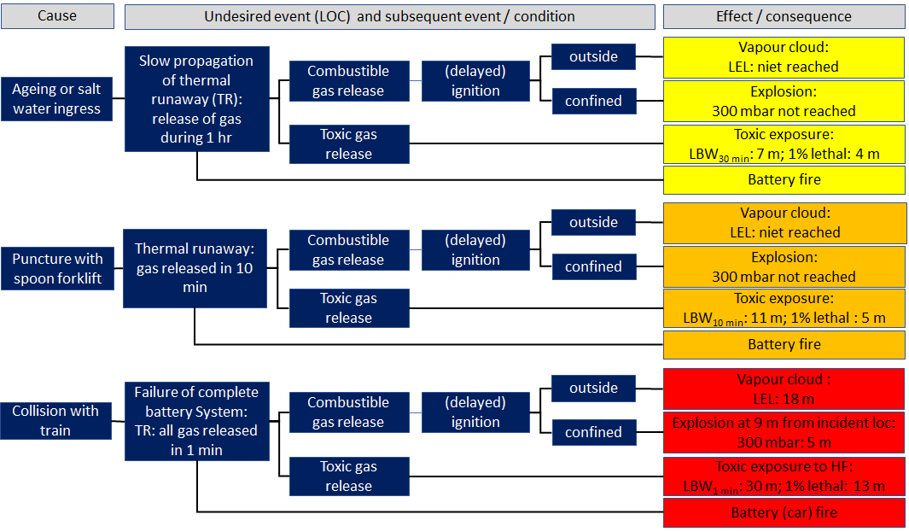
Figure 2: Example of the evaluation of the three incident scenarios for a Battery Electric Vehicle/Truck (BEV). Yellow: parking; orange: (un)loading; red: heavy collision while driving on site.
Table 1: Worst credible accidents and (in red) effects per energy source for each activity
Energy | Activity: Driving over site | Activity: Loading / unloading | Activity: Parking
Diesel (reference) | Failure tank:  → pool fire / lethality: 18 m | Not calculated | Not calculated
LNG | Collision: crack in tank  or large hole:  → jet length: 96 m | Rupture of pipe, large hole:  → jet length: 96 m | External fire / vandalism: Warm BLEVE  → fire ball diameter: 31 m
H₂ (FCEV) | Collision: cylinder displaced /  pipe rupture  → Flammable cloud: LEL: 50 m | Pipe rupture  → Flammable cloud: LEL: 50 m | External fire / vandalism: TPRD fails  → fire ball cross section: 12 m
CNG | Collision: cylinder displaced /  pipe rupture  → jet length: 27 m | Collision : cylinder displaced /  pipe rupture  → jet length: 27 m | External fire / vandalism: TPRD fails  → fire ball cross section: 18 m
Li-ion Battery | Collision with train:  thermal runaway of full  battery system  → Flammable cloud: LEL: 18 m  → LBW_{1min}: 30 m | Damaged battery packs:  thermal runaway  → battery fire  → LBW_{10min}: 11 m | Battery in bad condition: thermal runaway in part of system  → battery fire  → LBW_{30min}: 7 m
  - Safety measures
Evaluating the above analyses a number of safety measures were proposed by the team. These are summarised in Table 2. Participating companies in this project also agreed that this would affect various aspects of the Safety Management System of a company. Think of:
- Emergency Response: alarms, emergency shut-off devices (ESD), evacuation, fire fighting;
- Adjustments to work permits, classified areas, traffic rules, driving instructions (e.g. forklifts);
- Requirements for vehicles on site (ADR, R110, maximum tank pressure, battery condition: charging/not charging Li-ion batteries, battery damage);
- Possible conflicts with (now mandatory) activities under shelter or indoors;
- Parking location (indoor/outdoor, access), maximum parking time.
Table 2: Safety measures to prevent LOC or fire / explosion or to mitigate consequences
item | measure
Vehicle/ driver | Designed and built according to rules and labelled correctly (e.g. ISO17840-4)  Driver/operator should have knowledge of the hazards/risks;  ADR should allow transport of the goods (ADR, 2023).  No damage to tanks/ batteries.  Battery Management System (BMS) works well and shows no alarms or warnings;  Log is kept of age, (re)charging cycles, maintenance history, damages and repairs.
Driving | Safe road system: clear signs; maximum speed; minimal number of intersections; guard rails; no obstructions; traffic circulation system.
(un)loading | Extra protection on tank /batteries (e.g. while using forklift).  No other activities near the loading/unloading location;  Prevent gas explosions: no ignition sources; no gas / heat accumulation; use gas detectors
Parking | Prevent opening TPRD (limit maximum pressure and parking time);  Park outdoors away from ignition sources (e.g. flares);  Prevent unwanted access.
General | Batteries: be prepared for prolonged and intermittent periods of firefighting; much water is needed, possibly also to cool nearby installations (or keep distance).
  - Conclusions
In this study the impact of incidents with Alternatively Powered Vehicles (APVs) on (petro)chemical sites where hazardous substances are used was studied. APVs are defined here as trucks that use natural gas (LNG or CNG) or hydrogen (via fuel cells) as fuel, or that are Li-ion battery-electric powered.
First, applicable regulations and guidelines were compiled and studied. It was found that no regulations for the use of APVs on chemical sites exists, neither in Europe nor the USA. However, initiatives are emerging within (international) organizations such as CEFIC and the UN (ADR) as well as within companies, where so far guidelines are lacking. There are also national (Dutch PGS guidelines) and international (UN/ECE, NFPA) requirements that cover relevant aspects of APVs or equipment and the environment in which they are used.
Secondly, the safety risks of the use of APVs on (petro)chemical sites was studied by evaluating 12 dedicated (key) incident scenarios constructed by assuming each of the four vehicle types (i.e. CNG-, LNG-, H₂- or battery-powered) could be involved in a (key) incident, during three activities on site: driving, (un)loading, or parking. Based on type and extent of the (adverse) effects “Worst Credible Accidents” (WCAs) were selected for design of safety measures, thereby using realistic (industrial) settings.
The results showed that very different effects of incidents should be expected when changing from diesel to alternative energy sources. An incident with diesel will result in a liquid pool (that won’t easily ignite). Accidents with vehicles powered with gas could yield jet fires with lengths of up to 100 m (for LNG) and 30 m (for CNG) and flashfires for hydrogen, with a diameter of 50 m. A BLEVE of the LNG tank can produce a fireball about 30 m in diameter. Complete failure of a battery pack of a battery-electric powered truck can generate enough toxic HF to cause life threatening health effects up to 30 meters.
These new risks will require new safety measures on the (petro)chemical sites and adaptations to the Safety Management System. These measures will affect requirements for admission for vehicles on site, for onsite road-infrastructure and parking area, for working practices, working locations and for emergency services. The measures will impact procedures and hardware.
Acknowledgments
We would like to thank the Dutch Ministry of Infrastructure and Water Management and The Royal Association of the Dutch Chemical Industry (VNCI) for funding this research. We would also like to thank the VNCI, industry members and representatives of Dutch Safety Regions for participating in the study.
References
ACEA, 2021, Vehicles in use – Europe - Januari 2021, European Automobile Manufacturers Association < www.acea.auto/files/report-vehicles-in-use-europe-january-2021-1.pdf> accessed 09.04.2025.
ADR, 2023, ADR 2023 - Agreement concerning the International Carriage of Dangerous Goods by Road, Accord Européen Relatif au transport international des marchandises Dangereuses par Route <unece.org/transport/standards/transport/dangerous-goods/adr-2023-agreement-concerning-international-carriage> accessed 09.04.2025.
EI, 2021, Investigation into the risk and impact associated with non-diesel fuel engine vehicles, by type, whilst entering or working within hazardous storage locations, First edition Issued, Energy Institute London (accessible for members from <www.energyinst.org/>).
EU, 2010, Regulation No 100 of the Economic Commission for Europe of the United Nations (UN/ECE) — Uniform provisions concerning the approval of vehicles with regard to specific requirements for the electric power train <op.europa.eu/en/publication-detail/-/publication/fd8e6b47-d767-11e4-9de8-01aa75ed71a1> accessed 09.04.2025.
EU, 2012, DIRECTIVE 2012/18/EU OF THE EUROPEAN PARLIAMENT AND OF THE COUNCIL of 4 July 2012 on the control of major-accident hazards involving dangerous substances, amending and subsequently repealing Council Directive 96/82/EC, European Union <eur-lex.europa.eu/eli/dir/2012/18/oj/eng> accessed 09.04.2025.
EU, 2019, Regulation No 134 of the Economic Commission for Europe of the United Nations (UN/ECE) — Uniform provisions concerning the approval of motor vehicles and their components with regard to the safety-related performance of hydrogen-fuelled vehicles (HFCV) [2019/795] < op.europa.eu/en/publication-detail/-/publication/8aad3d19-7870-11e9-9f05-01aa75ed71a1/language-en> accessed 09.04.2025.
Gexcon, 2025, EFFECTS, <www.gexcon.com/software/effects/> accessed 09.04.2025.
NFPA 2, 2023, Hydrogen Technologies Code, The National Fire Protection Association (accessible for members from <www.nfpa.org/)> accessed 09.04.2025.
NFPA 52, 2023, Vehicular Natural Gas Fuel Systems Code, The National Fire Protection Association (accessible for members from <www.nfpa.org/>) accessed. 20.02.2025.
NFPA 55, 2023, Compressed Gases and Cryogenic Fluids Code, The National Fire Protection Association (accessible for members from <www.nfpa.org>/) accessed 09.04.2025.
NIPV, 2022, Incidents with Alternatively Powered Vehicles, Annual Report 2021 (in Dutch), Netherlands Institute for Public Safety, Arnhem, The Netherlands <nipv.nl/wp-content/uploads/2022/04/20220412-Jaarrapportage-2021-incidenten-met-AAV.pdf> accessed 09.04.2025.
Pers. Comm., 2022, (information obtained from the participants in in the project).
PGS 3, 2005, Guidelines for quantitative risk assessment, Publicatiereeks Gevaarlijke Stoffen <publicatiereeksgevaarlijkestoffen.nl/documents/81474/1664357417-pgs3-1999-v0-1-quantitative-risk-assessment.pdf> accessed 09.04.2025.
PGS 25, 2023, Natural gas delivery installations for motor vehicles (in Dutch), Publicatiereeks Gevaarlijke Stoffen <publicatiereeksgevaarlijkestoffen.nl/publicaties/online/pgs-25/2022/1-0-maart-2023#top> accessed 09.04.2025.
PGS 33-1, 2022, Liquefied natural gas (LNG) delivery installations for vehicles and equipment (in Dutch), Publicatiereeks Gevaarlijke Stoffen <publicatiereeksgevaarlijkestoffen.nl/publicaties/online/pgs-33-1/2021/1-1-mei-2022/#top> accessed 09.04.2025.
PGS 35, 2021, Hydrogen installations for delivering hydrogen to vehicles and tools (in Dutch), Publicatiereeks Gevaarlijke Stoffen <publicatiereeksgevaarlijkestoffen.nl/publicaties/online/pgs-35/2021/1-0-augustus-2021/#top> accessed 09.04.2025.
RIVM, 2020, Manual External Risk Calculations BEVI version 4.2 (in Dutch), National Institute for Public Health and the Environment <www.rivm.nl/sites/default/files/2020-04/Handleiding%20Risicoberekeningen%20Bevi%20versie%204.2.pdf> accessed 09.04.2025.
RIVM, 2023, Intervention values 2023 (in Dutch), National Institute for Public Health and the Environment <rvs.rivm.nl/sites/default/files/2024-01/Interventiewaarden%20ed%202023-1%20alfabet.pdf> accessed 09.04.2025.
TLN, n.d., Grid capacity blocks road transport electrification (in Dutch), Transport en Logistiek Nederland < www.tln.nl/actueel/netcapaciteit-blokkeert-elektrificatie-wegtransport> accessed 09.04.2025.
UN, 2000, 16. 110 United Nations Regulation No. 110. Uniform provisions concerning the approval of: I. Specific components of motor vehicles using compressed natural gas (CNG) and/or liquefied natural gas (LNG) in their propulsion system; II. Vehicles with regard to the installation of specific components of an approved type for the use of compressed natural gas (CNG) and/or liquefied natural gas (LNG) in their propulsion system, United Nations <treaties.un.org/pages/ViewDetails.aspx?src=TREATY&mtdsg_no=XI-B-16-110&chapter=11&clang=_en> accessed 09.04.2025.
UN, 2018, Addendum 20: Global Technical Regulation No. 20 - Global Technical Regulation on the Electric Vehicle Safety (EVS) <unece.org/fileadmin/DAM/trans/main/wp29/wp29wgs/wp29gen/wp29registry/ECE-TRANS-180a20e.pdf> accessed 09.04.2025.

