Impact of near-wall particle concentration on dust explosion in the 20 L sphere through numerical simulation

Kasun Weerasekara12*,Stefan H. Spitzer3, Sabine Zakel1,Holger Grosshans12

*1 Physikalisch-Technische Bundesanstalt, Bundesallee 100, Braunschweig, 38116, Germany;*

*2 Otto von Guericke University of Magdeburg, Universit¨atspl. 2, Magdeburg, 39106, Germany*

*3 EIfI-Tech, Universit¨atspark 1/1, Schw¨abisch Gm¨und, 73525, Germany.*

*\*Corresponding author E-Mail: kasun.weerasekara@ptb.de*

**1. Introduction**

A dust explosion is a hazardous chemical explosion that can occur in process industries such as flour mills, grain silos, textile industries, etc. Dust explosions occur when ignition starts in the confinement of combustible dust. Dust explosions can cause significant harm to human lives sna physical resources. Therefore, understanding and regulating dust explosions is essential to minimize the damage.

In laboratory level 20 L, the Siwek apparatus is used to investigate the explosion pressure (*P*ex) and the explosion pressure rise ((*dP/dt*)ex) for a particular dust type. The Siwek is a 20 L sphere with two chemical igniters at the center. Dust is conveyed through a nozzle into the sphere. A commonly used nozzle type is a rebound nozzle. Two pressure sensors measure the pressure development inside the sphere, which is the main finding of the experiment.

A uniform dust distribution inside the sphere is required to determine the dust’s minimum explosible concentration (MEC) and other safety characteristics. However, particles are more concentrated near the wall before the ignition. Kalejaiye O. et al. built a Siwek apparatus with six optical probes in different locations inside the sphere. They have found that the concentration of particles near the wall is higher than in other locations. Du B. et al. observed similar detailed results using a transparent 20 L Siwek sphere and shadowgraphy technique. They have suggested a new nozzle arrangement for better dust distribution before the ignition. However, experimental methods are minimal for visualizing dust distribution and movements inside the sphere. Well-validated computational fluid dynamic (CFD) simulation can provide more insight into dust distribution inside the sphere. Di Benedetto A. et al. simulated dust dispersion inside the 20 L sphere through the rebound nozzle using the ANSYS-Fluent cfd package. They have observed that particles are not uniform and are more converted near the wall. Beauce, when particles disperse into the sphere, it creates two counter-rotating vortexes inside the sphere. Later, particles settle down and reduce the turbulence inside.

In summary, both experiments and simulation confirm that particles are more concentrated near the wall and inhomogeneous. This study presents the near particle concentration impact on the explosion pressure and explosion pressure rise in the side 20 L sphere through the numerical simulation.

**2. Methodology**

**2.1 Dust Explosion Modelling**

Dust explosion is a multiphase problem involving solid and fluid phases. The Euler-Lagrangian approach was selected because the solid phase has a lower volume fraction. The numerical simulation uses the OpenFOAM open-source package and the “coalChemistryFoam” Euler-Lagrangian solver, which can also solve chemical reactions and radiation.

The Euler-Lagranian approach has separate sets of governing equations for each phase. The fluid/continuous phase consists of four equations based on Reynolds Average Navier-Stokes (RANS) equations and the conservation of species and energy. Each conservation equation has source terms coupled with the governing equations of the solid phase, which also consists of conservation energy of mass momentum and energy.

In dust explosion modeling, we assume that a particle includes solid, liquid, and gas phases. The solid phase consists of char and ash. The liquid phase consists of water (moisture), and the gas phase consists of volatile gases such as CH4 and H2. When the particle is heated from ignition, moisture evaporation starts first, followed by the devolatilization of gases and, finally, char combustion. Figure 1 shows an overview of modeling the combustion of a dust particle.

Moisture evaporation and devolatilization absorb energy from the surrounding fluid, and char combustion generates heat. These devolatile gases, evaporated moisture, and combustion products will be source terms for the fluid phase mass and species conservation equation, and absorbed or generated heat will be the source term for the fluid phase energy equation. While particles move in the fluid phase, they are subjected to drag, buoyancy, and gravity forces. The reaction of each force will be the source term for the momentum equation of the gas phase.

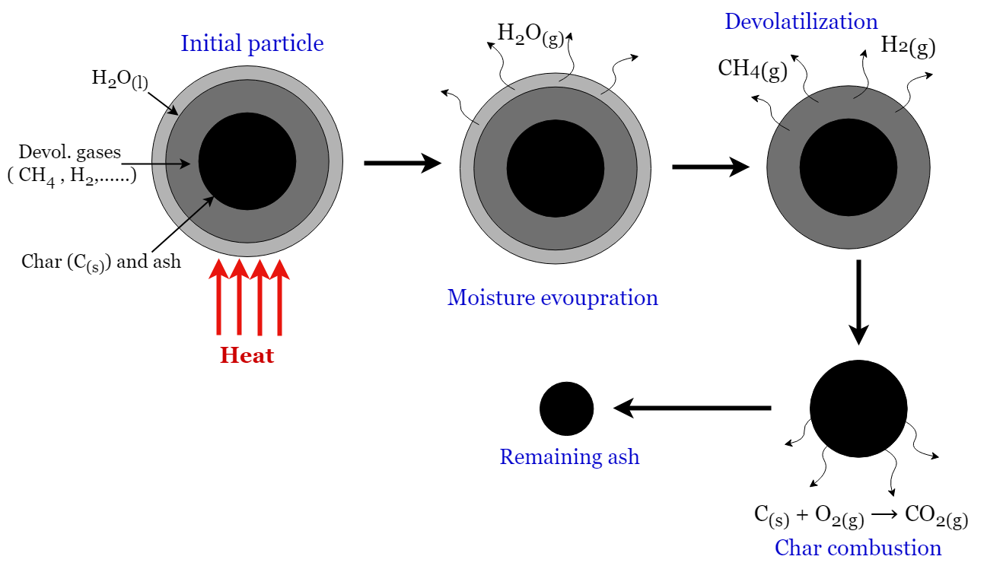

*Figure 1. Overview of a dust particle combustion process*

**2.1 Case Set-Up and Benchmark Test**

We selected the lycopodium dust explosion experiment to validate the numerical solver due to its comparatively uniform distribution compared to other dust types. The experiment uses the “Janovsky” nozzle to ensure a total dust mass inside the sphere. The numerical simulation required several material properties of the lycopodium dust and experiment parameters.

Sartorius MA35 test determined the composition of the dust, yielding a 3.4% weight percentage of moisture and a 3.8% weight percentage of volatile matter. We assume that CH4 is only a volatile gas and that the solid part is pure carbon, according to the study by Rasam H. et al. Lycopodium has a narrow size distribution of *d*50 = 30.6 μm, *d*10 = 25.3 μm, and *d*90 = 30.6 μm measure, and we assumed all particles are spheres with *d*50 as the particle diameter. The material density of lycopodium is 𝜌 = 100 kg/m3, and the specific heat capacity is *C*p = 1005 J/kgK. The devolatilazation temperature is *T*dev = 483 K and devolatzilzation latent heat is *ΔH*dev = 3.07⨉105 J/kg (Portarapillo M. et al).

The geometry is a sphere with a 0.168 m radius equivalent to 20 L volume. All the internal components, like the ignition mechanism nozzle, are neglected for simplicity. Dust particles are initially placed uniformly inside. The simulation domain has a single wall boundary. We set wall temperature to 294 K, velocity as no slip, and pressure as zero gradients as boundary conditions. Initially, the internal domain was set to uniform 294K temperature, 1 bar of pressure, and zero velocity field. Ignition is modeled as a temperature patch inside the sphere, adopted by Pan Y’s doctoral thesis. Ignition volume contains two spheres, a 4 cm radius each, and the center-to-center distance is 8cm at the sphere's center. Temperature is modeled as a first-order polynomial function *T(t)* = 2 ⨉105 *t* + 294 K with ignition duration of t = 20 ms. For the stability of the simulation, the CFL number is set to 0.1 with first-order Euler time integration. We used the k-ε turbulence model, which is a commonly used turbulence model in combustion problems.

The mesh convergence test involved six meshes ranging from 2.5 ⨉104 to 1.6 ⨉106 elements. A structured mesh with all hexagonal elements was generated, and Figure 2 compares the pressure development curve of each mesh case with the experimental results. Figure 3 illustrates the relationship between Pex, (*dP/dt*)ex, with the number of elements. After considering both computational time and accuracy, the mesh with 8 ⨉105 elements was selected, as it had a 3.5% and 2.5% error relative to the experimental value for *P*ex and (*dP/dt*)ex, respectively. Additionally, we use 5 ⨉105 no of particles.

**3. Particle Concentration Analysis and Results**

As discussed in the introduction section, the distribution of particles within a 20 L sphere is not uniform and is more concentrated near the wall. This study aims to investigate the impact of dust particle distribution on explosion characteristics. To achieve this, we simulate dust explosions of lycopodium for different particle distributions. Spherical coordinates, including radial distance, polar angle, and azimuthal angle can define the

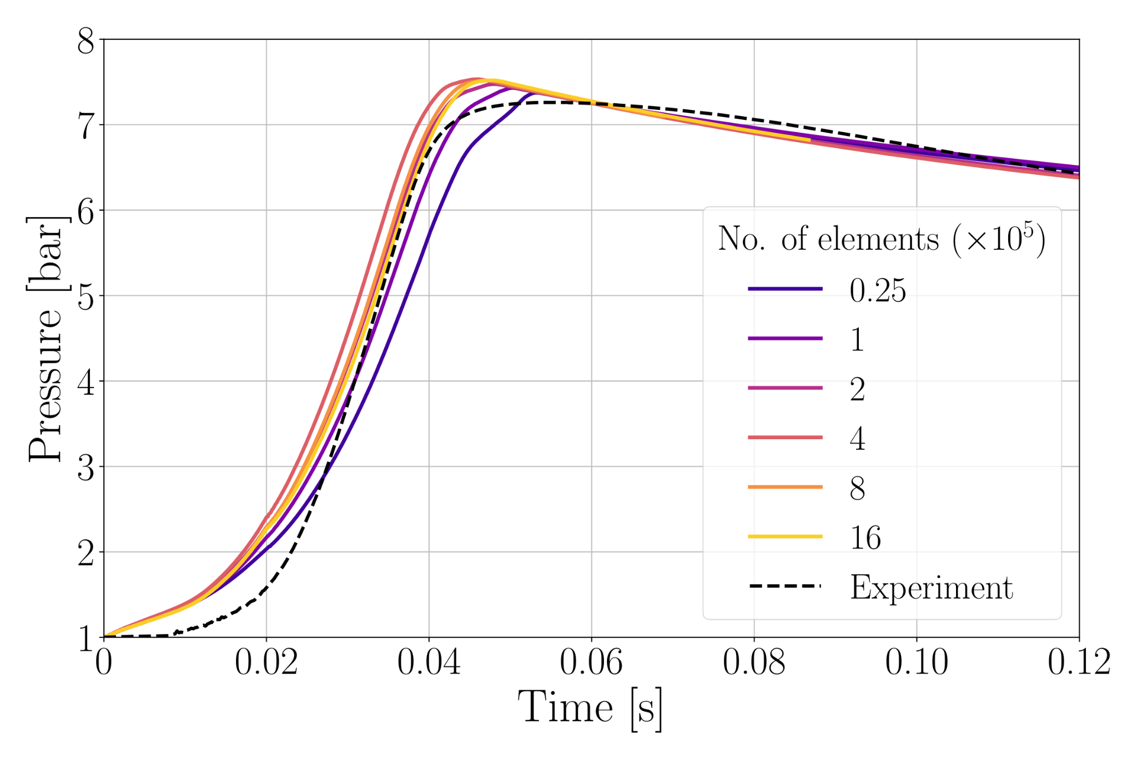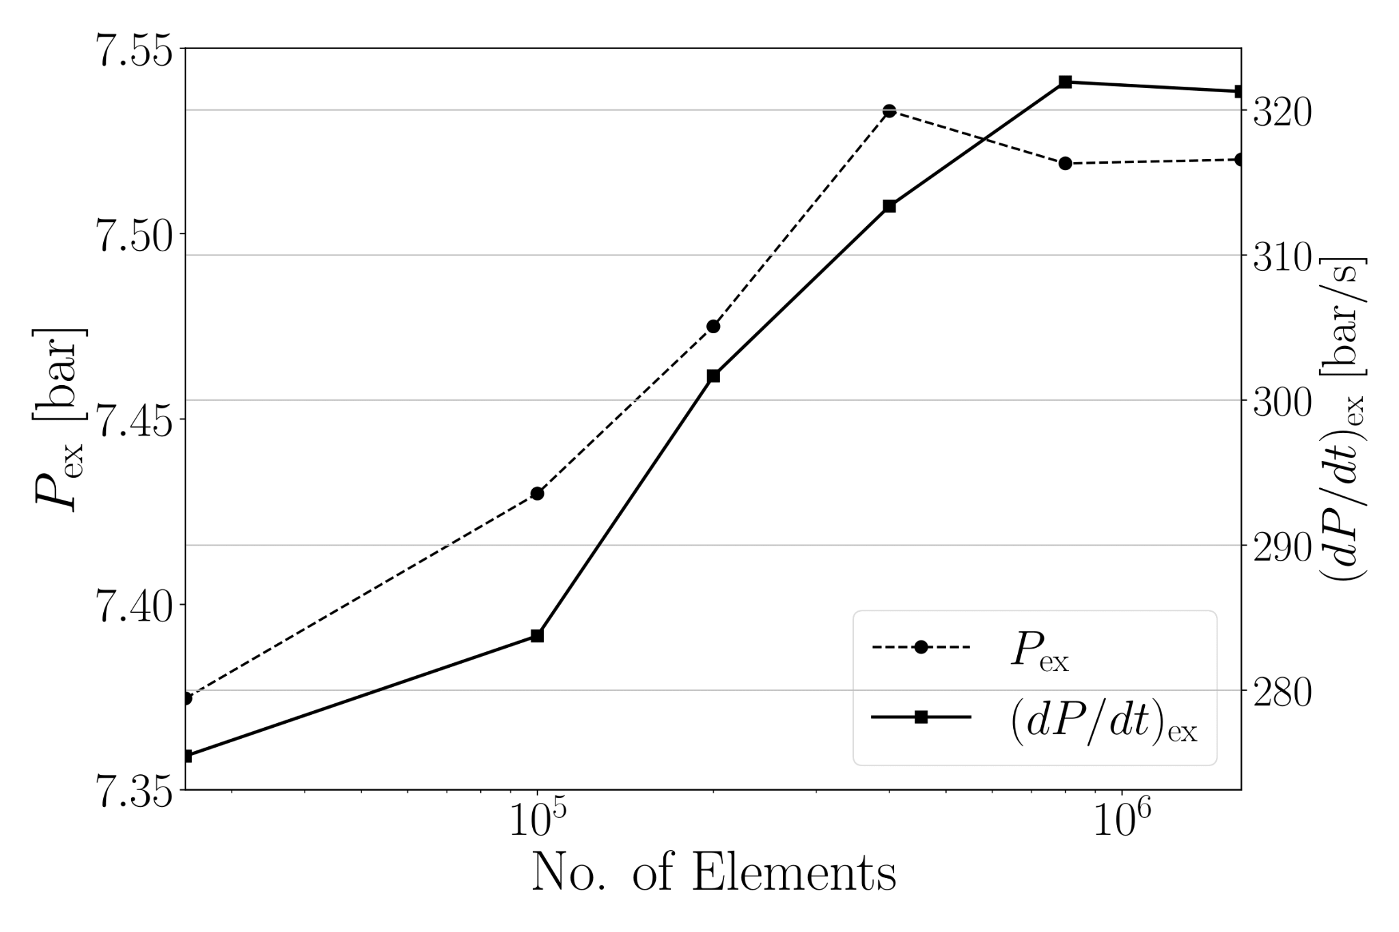

*Figure 2. Pressure curves of simulations with Figure 3. Pex and (dP/dt)ex for different different mesh sizes compared to experimental data mesh sizes*

position of a particle. To alter the radial homogeneity of the particles, we apply a power law function to the radial distances of the particles without changing the two angles of each particle. The coefficient of the power law, defined as the radial homogeneity of the distribution, is denoted as 𝛟.

The analysis begins with generating a uniform dust distribution within a unit radius sphere, with the radial distance of a particle denoted as *runi*. We then define the new radial distance of the particle with inhomogeneity (wall concentrated) as *r*𝛟 = *R(r*uni)𝛟. Here, *R* represents the scale of the sphere's radius, which is 0.166 m. The parameter 𝛟 varies between 0 and 1, with 𝛟 = 1 indicating a uniform distribution of particles and 𝛟 = 0 indicating all particles are on the wall. Figure 1 illustrates the uniform distribution (𝛟 = 1), and Figure 2 illustrates 𝛟 = 0.5 of particle distribution. For this study, we simulated 10 cases for 𝛟 = 0.1, 0.2, 0.3,...,1 while maintaining all parameters constant.

Figure 6 presents the pressure development curves for each particle distribution. As 𝛟 decreases from 1 to 0.4, the explosion delays and the time to reach the *P*ex increases. However, after 0.4, the time to reach the *P*ex is decreasing. When particles are uniformly distributed, immediate particle combustion begins once the ignition is initiated. However, when particles are more concentrated towards the wall, the flame front takes some time to reach the dust particles, thereby delaying the explosion. Moreover, when particles are extensively concentrated near a wall (𝛟 < 0.4), the flame front propagates towards the wall rapidly and encounters higher particle concentration, leading to an intense explosion. Figure 7 confirms these observations.

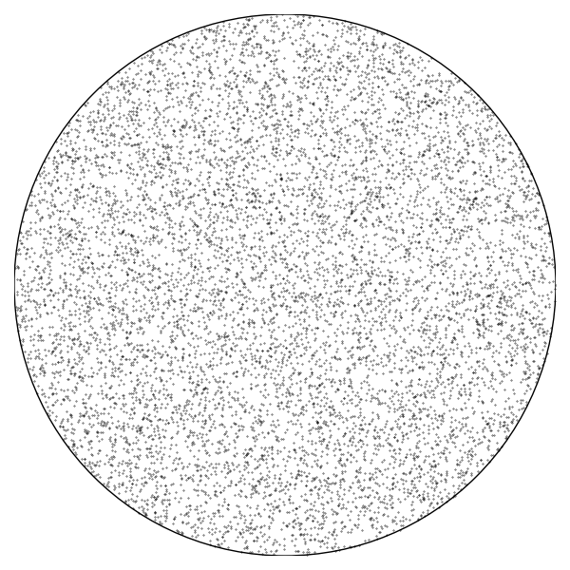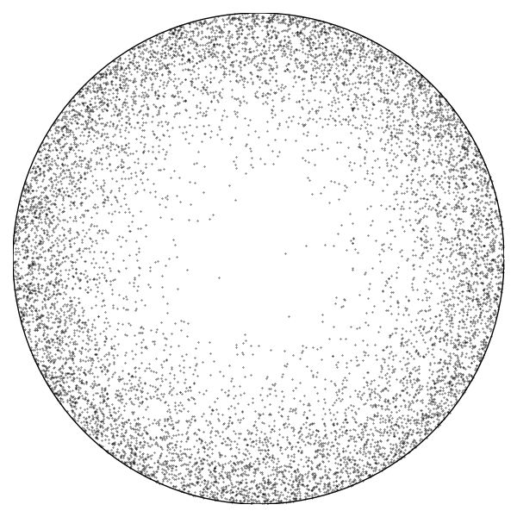

*Figure 4. Initial particle distribution for 𝛟 = 1 Figure 5. Initial particle distribution for 𝛟 = 0.5*

Figure 7 shows the variation in the pressure gradient over the time for each distribution. This trend is similar to the pressure development curve in Figure 6. The highest pressure gradient occurs when particles are extensively concentrated near the wall. When 𝛟 is decreasing, the time to reach (*dP/dt*)ex increases while the value of (*dP/dt*)ex also decreases. Still, the time to reach (*dP/dt*)ex is increasing until 𝛟 = 0.4, similar to Figure 6. However, (*dP/dt*)ex rises after the 𝛟 < 0.7. The highest value for *P*ex and (*dP/dt*)ex are reached when 𝛟 = 0.1, and they are 1.75% and 10% higher than when particles are uniformly distributed, respectively. The lowest value of *P*ex was reached when 𝛟 = 0.8 and for (*dP/dt*)ex, reached when 𝛟 = 0.7 are 0.25% and 5.6% lower compared to the uniform distribution (see Figure 8).

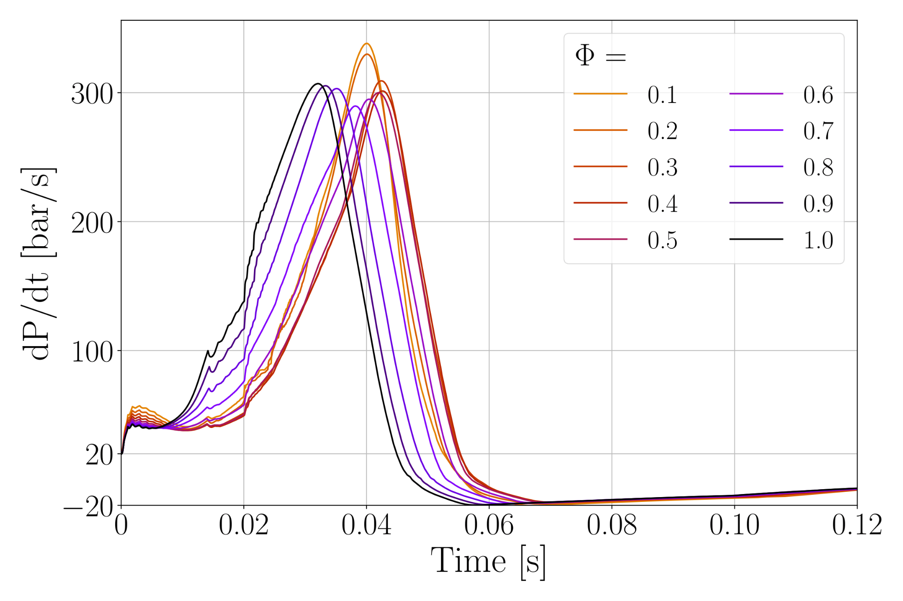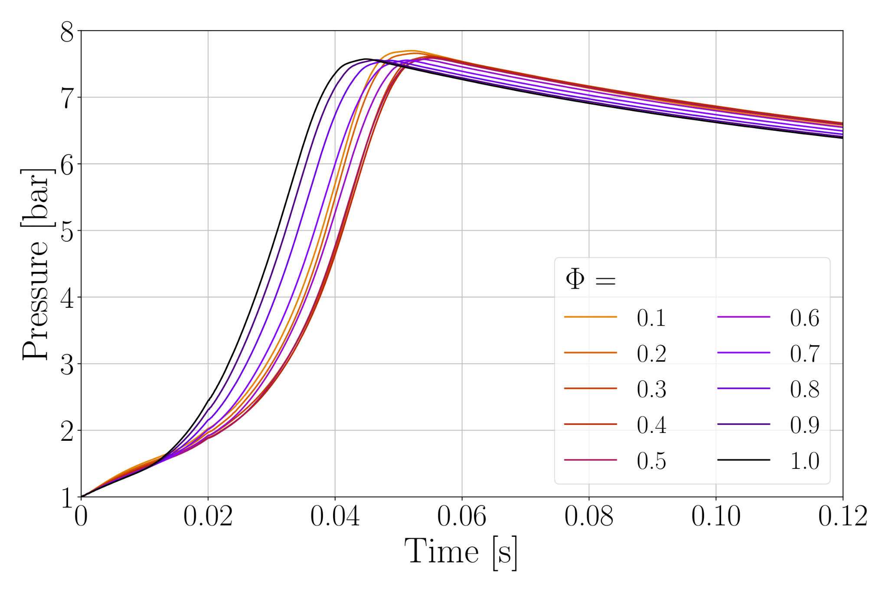

*Figure 6. Pressure development curve for each Figure 7. Pressure gradient curve for each particle distribution particle distribution*

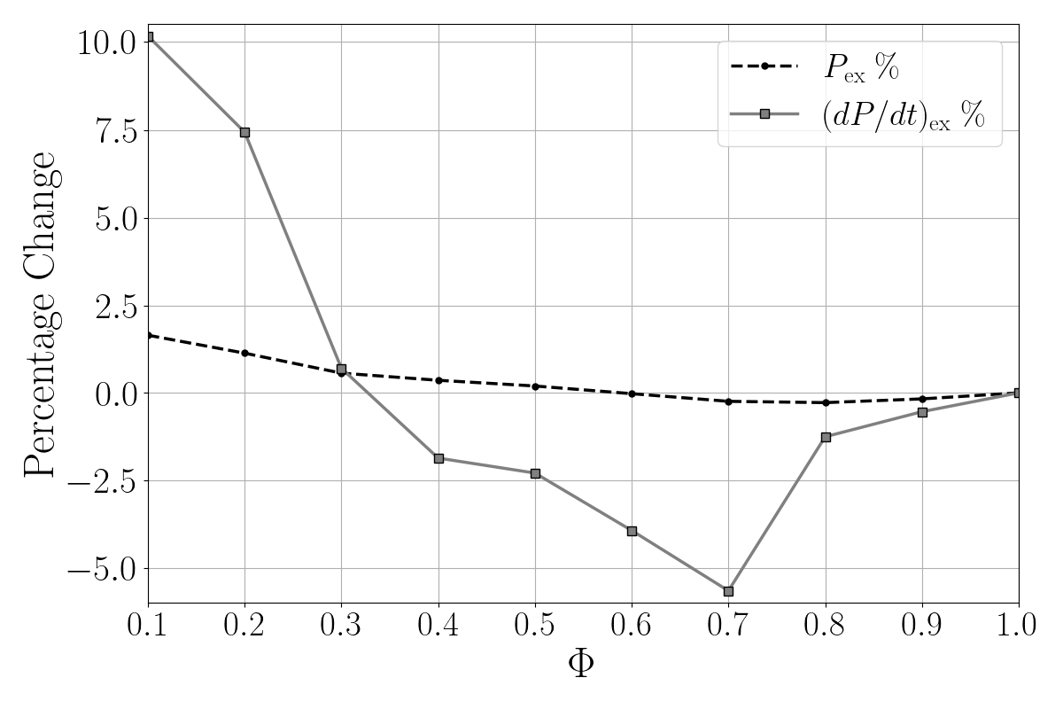

*Figure 8. Percentage of variation of Pex and (dP/dt)ex compared to uniform distribution for each 𝛟 value*

**4. Conclusions**

Uniform particle distribution is essential for accurate measurement of the safety characteristics of the 20 L sphere. However, in practice, particles are not uniform and are more concentrated near the wall. This study investigated the influence of particle distribution on the explosion characteristics of the 20 L sphere. The results indicate that the explosion is more intense when particles are concentrated near the chamber wall. The highest *P*ex and (*dP/dt*)ex are reached when the particles are most concentrated near the wall (𝛟 = 0.1), and the lowest values are reached for moderate wall concentration distributions (𝛟 = 0.8 and 𝛟 = 0.7, respectively). These findings have practical implications for safety engineering, highlighting the importance of considering particle distribution in safety assessments. As a future study, developing a correction factor for the safety characteristics of the 20 L sphere will be important due to the influence of wall particle concentration. Furthermore, this study can extend to different dust types and geometries like 1m3 explosion chamber, silos, and dust conveying pipes.

**References**

Du, Bing, Weixing Huang, Long Liu, Tan Zhang, Hao Li, Yidan Ren & HanlinWang. 2015. Visualization and analysis of dispersion process of combustible dust in a transparent Siwek 20-l chamber. Journal of Loss Prevention in the Process Industries 33. 213–221.

Kalejaiye, Omotayo, Paul R. Amyotte, Michael J. Pegg & Kenneth L. Cashdollar.2010. Effectiveness of dust dispersion in the 20 L Siwek chamber. Journal of Loss Prevention in the Process Industries 23(1). 46–59.

Pan, Yangyue. 2023. Flame behavior of coal dust explosion considering internal particle effects: Montanuniversitaet Leoben dissertation.

Portarapillo, M., R. Sanchirico, G. Luciani & A. Di Benedetto. 2023. Flame propagation of combustible dust: A Mallard-Le Chatelier inspired model. Combustion and Flame 251. 112737.

Rasam, Hamed, Maryam Nematollahi, Sadegh Sadeghi & Mehdi Bidabadi. 2019.An asymptotic assessment of non-premixed flames fed with porous biomass particles in counter-flow configuration considering the effects of thermal radiation and thermophoresis. Fuel 239. 747–763.