 CHEMICAL ENGINEERING TRANSACTIONS  VOL. xxx, 2025 | A publication of  
The Italian Association
of Chemical Engineering
Online at www.cetjournal.it
Guest Editors: Bruno Fabiano, Valerio Cozzani
Copyright © 2025, AIDIC Servizi S.r.l.
ISBN 979-12-81206-xx-y; ISSN 2283-9216

Quantitative Risk Assessment of FSRU and Connected Infrastructures in Harbour Area. A Comprehensive Applicative Experience from Early Design to Plant Operation
Giovanni Romano^{a,*}, Fabio Dattilo^{b}, Giuseppe Maschio^{b}, Bruno Fabiano^{c}
ªTecnologia Ricerca Rischi S.r.l., Via Saore 25, 24046, Osio Sotto (BG), Italy
^{b} Industrial Engineering Dept. University of Padova, Via Marzolo 9, 35131 Padova, Italy
^{c} DICCA – Civil, Chemical and Environmental Eng. Dept. – Genova University, Via Opera Pia, 15 – 16145 Genova, Italy
giovanni.romano@trr.it
Liquefied Natural Gas (LNG) is considered a prominent and strategic energy source to meet the growing demand within the current pathway towards EU decarbonization of the energy and transport sectors. This paper outlines the risk analysis approach developed within the preliminary and final design phase of an FSRU in an Italian harbor area, including technological solutions ad-hoc developed to prevent, minimize and manage environmental and accident risk. The process safety risks associated with side-by-side operations of LNG transfer from the carrier, the regassification process and the transfer to the national transfer infrastructure are thoroughly analyzed and faced by evaluating relevant scenarios and designing the connection infrastructures.
  - Introduction
The use of LNG (Liquefied Natural Gas) in the national and international energy scenario has significantly increased due to critical issues related to the supply of natural gas from the Russian Federation. Notably, interest in LNG as a marine fuel increased with the IMO regulations coming into force at the start of 2020 aiming at reducing emissions, improving efficiency and triggering cost benefits. FSRU (Floating Regassification Storage Unit) and LNGC (Liquified Natural Gas Carrier) refuelling units represent the technical solutions adopted by different countries with a short and mid-term time perspective. FSRU can be considered a ‘plug-and-play’ solution to importing LNG, with the flexibility of meeting demand as needed, also in hard-to-reach areas, before being possibly relocated elsewhere. Risk assessment methodology has been widely used in the LNG sector, the reader is addressed to the review paper by Animah and Shafiee (2020) covering RA methods and data sources applied in fixed installations, i.e. plants, terminals and offshore units, and mobile ones, i.e., LNG carriers and fuelled ships. More recently, Vairo et al. (2021) proposed the application of resilience in assessing the safety of ship LNG bunkering. The FSRU terminal in Piombino (LI) is managed by SNAM FSRU Italia (part of SNAM group) and is characterized by an annual regasification capacity of nearly 5 billion NG standard cubic meters corresponding to about one-sixth of the NG imported from Russia in the last years. The FSRU has a nominal storage of 170 thousand cubic meters of Liquefied Natural Gas (LNG) and it is able to receive and re-gasify LNG and transfer it to a new pipeline that conveys it to the junction point with the Italian Gas Pipeline Network, located about 9 km from the mooring point. The terminal includes the following infrastructures:
- the FSRU ship "Italis LNG" (previously called Golar Tundra) permanently moored through snuffing hooks;
- the following equipment installed at the East quay of the Port of Piombino (LI):
- the discharge system of the vaporized gas from the FSRU, consisting of high-pressure flexible hoses (75 barg);
- the power supply and control systems of the terminal;
- fire-fighting systems;
- pipelines between the gas discharge system from the FSRU and the Interception Point Line (PIL 1). The dielectric joint, immediately upstream of PIL 1, identifies the point of entry into the on-shore NG transmission network.
The FSRU is currently re-fuelled regularly (5/7 days) by LNGCs of different sizes, but it is also able to refuel small/medium-sized LNGCs. The main objective of this paper is to highlight the safety aspects of LNG regassification and transport in harbour areas, providing a summary of the most significant steps of the methodology adopted alongside the RA of the terminal and the design of the quay infrastructures.
  - MATERIALS AND METHODS
In this paragraph, we intend to provide a summary of the most significant steps of the methodology adopted in the risk analysis associated with the Terminal. It is worth mentioning that the present methodology is derived from sound and consolidated procedures available in the literature devoted to process safety, as well as prescribed by the current regulation for the safety of onshore LNG storage terminals (EC, 2012) implemented in Italy by the Legislative Decree 105 (Laurent et al., 2021). A set of reference loss of containment events is identified following consolidated QRA guidelines (Uijt de Haag and Ale, 2005) and the frequency and consequences of each conceived scenario are assessed relying on widely applied datasets.
2.1 FSRU Golar Tundra risk analysis and interference analysis with the adjacent quay
For the development of the risk analysis, 5 macro-areas were identified, namely: I- FSRU Filling Phase; II- FSRU in regasification; III- Sending NG to the pipeline; IV- LNG shipment to LNG carrier; V - Liquid fuel transfer. For all the conceived logical areas, operational analysis studies (HazOp) and statistical-historical analyses, based on failure rates and LOC available in the scientific international literature, (Uijt de Haag and Ale, 2005; SINTEF & NTNU, 2015; NFPA, 2019) were thoroughly carried out under conservative hypothesis assumptions.
2.2 Collision risk analysis of LNG carriers and other ships in the port of Piombino
A critical phase of the work is related to the risks of collision between ships in transit within Piombino Port (LI), which is characterized by high flows of incoming and outgoing commercial traffic (more than 90% of these flows concern ferries departing from and arriving to Elba Isle in the spring/summer period). The outcome of this step is the sound identification of accidental scenarios during the reference vessel motion (i.e., collision and maneuver upsets).
2.3 Finite element structural numerical analysis for the verification of impact between LNG and other ships
The structural crashworthiness of the LNG-fueled containership structures under specified ship-to-ship collision scenarios is analyzed using LS-DYNA nonlinear finite element method code (LS-DYNA, 2019a; 2019b), the next phase of the study consisted of a collision simulation with a finite element approach, taking into account the typical structural set-up of LNGCs internal tanks, as well as the characteristic materials, masses and profiles of the vessel. Different impact scenarios have been identified.
2.4 Computational fluid dynamics (CFD) analysis for dispersion, fire and explosion scenarios connected to flexible LNG unloading hoses from LNG Carrier to FSRU
The reference scenario analyzed in the study is the formation of an LNG pool on the sea surface; subsequently, the vapor cloud formed due to the evaporation of LNG right above the pool undergoes a rapid phase change that favors its dilution in air and, therefore, dispersion (Hightower et al., 2004). Regarding the numerical structural analysis, the aim of the study is mainly related to the structural investigation of the ship's hull (and LNGC internal tank) subjected to the thermal action of a fire scenario during the transfer operations between the FSRU and the LNGC. CFD analysis was developed by FLACS software (Gexcon, 2022), given its wide application in the given context (HSE, 2009). Finite element numerical analysis (FEM) for the structural verification was carried out by Ansys LS-DYNA (2019) software. An accurate structural model of the ship was created by faithfully replicating the primary and secondary structures, materials and thicknesses between the hull and the internal LNG tank, which was taken as a reference for modeling.
  - RESULTS AND DISCUSSION
Table 1 shows the frequencies calculated for all the incidental hypotheses formulated covering step 2.1- FSRU Golar Tundra risk analysis and interference analysis with the adjacent quay. The incidental hypotheses highlighted in gray were considered reasonably credible, being characterized by an occurrence frequency greater than or equal to 1·10⁻⁶ occasions per year. Tables 2, 3 and 4 summarize the results of the assessment of the incidental consequences, respectively referring to the reasonably "credible" fire, explosion and NG leak scenarios previously calculated. It should be noted that the scenarios related to the transfer of liquid-liquid LNG (during the transfer phase from the LNG Carrier to the Italis FSRU) and NG (during the discharge of natural gas to the pipeline at the quay) are both relevant for the risk analysis. The pipeline significant leak was calculated referring to hole area calculated based on 20%, or 100% of the pipe nominal diameter (ND), respectively for ND greater, or less than 200 mm. Additionally, it was considered the full-bore leak scenario.

Table 1: Calculated frequency of incidental hypotheses.
INITIATING CAUSES OF POTENTIAL ACCIDENT SCENARIOS |  | FREQUENCY  [OCC/YEAR]
I FSRU FILLING
1R - Flexible LNG unloading hoses from LNG Carrier to FSRU | Significant leak | 1.46 · 10⁻⁴
 | Severe adverse weather conditions with removal and tearing of hoses | 1.20 · 10⁻⁷
 | Severe adverse weather conditions with removal and ERS intervention | 9.13 · 10⁻⁶
2R - BOG return HD compressor to LNG Carrier | Hole (75 mm diameter) | 9.86 · 10⁻⁵
 | Pinhole / crack (25 mm diameter) | 4.38 · 10⁻³
3R - FSRU filling LNG manifold downstream of the hoses | Significant leak | 2.30 · 10⁻⁵
4R - FSRU tank loading lines during filling from an LNG Carrier | Significant leak | 3.20 · 10⁻⁶
5R - LNG Feed pump delivery lines and FSRU main LNG manifold during filling from a LNG Carrier | Significant leak | 2.20 · 10⁻⁵
6R - FSRU LNG recirculation lines during filling from an LNG Carrier | Significant leak | 2.02 · 10⁻⁴
13R - BOG return lines to LNG carrier | Significant leak | 2.13 · 10⁻⁵
1H - BOG return lines to LNG carrier | - | 1.80 · 10⁻³
5H - Roll over LNG internal tank | - | 8.90 · 10⁻⁹
II FSRU IN REGASIFICATION
7R - LNG Feed pump delivery lines and FSRU main LNG manifold | Significant leak | 1.21 · 10⁻⁴
8R - HP Booster high pressure pump delivery lines | Significant leak | 2.10 · 10⁻⁵
9R - BOG recovery LD compressor from FSRU LNG internal tanks | Hole (75 mm diameter) | 2,.0 · 10⁻⁴
 | Pinhole / crack (25 mm diameter) | 1.20 · 10⁻²
14R - BOG lines from FSRU LNG internal tanks | Significant leak | 1.17 · 10⁻⁴
2H - Overpressure (and consequent failure) of the gas manifold, after gasification | Significant leak | 3.00 · 10⁻¹⁴
6H - Breakage of one of the pipes of the HA 1100 A sea water exchanger | - | 1.20 · 10⁻⁵
7H - Sending LNG to unsuitable FSRU lines | - | 3.80 · 10⁻⁹
8H - HP Booster PA-1000 A/B high pressure cavitation pumps | - | 2.80 · 10⁻⁶
9H - VX-0050 recondenser overpressure | - | 3.40 · 10⁻⁵
10H - Overpressure exchanger HA-1100 A and related line | - | 3.80 · 10⁻¹⁰
11H - NG loss due to LNG vaporization | - | 2.60 · 10⁻¹⁰
12H - Overpressure KO-Drum VA-0070 | - | 3.70 · 10⁻¹⁵
III NG TO PIPELINE
10R - High pressure discharge flexible hoses from FSRU to onshore pipeline | Significant leak | 4.00 · 10⁻⁴
 | Severe adverse weather conditions with removal and tearing of hoses | 6.60 · 10⁻⁷
 | Severe adverse weather conditions with removal and ERS intervention | 5.00 · 10⁻⁵
11R - Onshore NG pipeline to PIL system | Significant leak | 2.13 · 10⁻⁴
3H - Breakage of gas manifold on NG pipeline, due to cryogenic embrittlement | - | 1.60 · 10⁻¹⁰
4H - Breakage of connection hose between FSRU vessel and NG pipeline due to mechanical failure due to overpressure | - | 3.40 · 10⁻¹⁷
IV LNG TO LNG Carrier
12R - Flexible LNG loading hoses on LNG Carrier from FSRU | Significant leak | 7.12 · 10⁻⁵
 | Severe adverse weather conditions with removal and tearing of hoses | 5.80 · 10⁻⁸
 | Severe adverse weather conditions with removal and ERS intervention | 4.45 · 10⁻⁶
V LIQUID FUEL TRANSFER
15R - Diesel filling hoses | Significant leak | 2.20 · 10⁻³

Table 5 summarizes the results of the probabilistic calculation step 2.2 - collision risk, performed starting from an accurate census of port traffic and the characteristics of the vessels in transit to the port of Piombino. The frequency of the collision event with potential penetration was reasonably credible, being characterized by an occurrence frequency equal to 1.6 ·10⁻⁵ occ/year for the entire port area of Piombino in the future situation including LNGC transits. The quantification of the risk increase allowed identifying criticalities and reducing the risk contributions of simultaneous transits, by the accurate design and implementation of prevention/mitigation barriers/actions.
Table 2: Summary of the major consequences of credible fire scenarios.
Macro  area | Incidental hypothesis | Consequent scenario | Fire
Distance [m] of radiation thresholds [kW/m²]
from the center of the pool
 |  |  | 12.5 | 7 | 5 | 3
I | 1R c - Flexible LNG unloading hoses serving the unloading arm from LNG Carrier to FSRU  Severe adverse weather conditions with critical separation between FSRU and LNG tanker during LNG unloading with ERS intervention - LNG release | Pool Fire  Wind 5 m/s Cat D | 128 | 160 | 183 | 223
II | 7R - LNG Feed pump delivery lines and FSRU main LNG manifold  Significant Leak - LNG Release | Jet Fire  Wind 2 m/s Cat F | 148 | 168 | 180 | 204
III | 10R c - High pressure discharge flexible hoses from FSRU to onshore pipeline  Full Bore - Release of NG | Jet Fire  Wind 2 m/s Cat F | 119 | 142 | 157 | 185
IV | 12R c - Flexible LNG loading hoses on LNG Carrier from FSRU  Severe adverse weather conditions with critical separation between FSRU and LNG tanker during LNG unloading with ERS intervention - LNG release | Pool Fire  Wind 5 m/s Cat D | 76 | 94 | 107 | 130
Table 3: Summary of the major consequences of credible explosion scenarios.
Macro area | Incidental hypothesis | Consequent scenario | Explosion
 |  |  | Distance [m] of overpressure thresholds [bar]
 |  |  | 0.3 | 0.14 | 0.07 | 0.03
I | 6R - FSRU LNG recirculation line during filling from a LNG Carrier  Significant Leak - Release | UVCE Wind 2 m/s Cat. F | - | - | 297 | 346
II | 7R - LNG Feed pump delivery lines and FSRU main LNG manifold  Significant Leak - LNG Release | UVCE Wind 2 m/s Cat. F | - | - | 365 | 425
III | 10R a - HP Booster high pressure flexible hoses for discharge from FSRU to onshore pipeline. Significant Leak - NG Release | UVCE Wind 2 m/s Cat. F | - | - | 90 | 104

Table 4: Summary of the major consequences of credible flammable gas (NG) leakage scenarios.
Macro  area | Incidental hypothesis | Consequent scenario | Dispersion
 |  |  | Distance [m] at which the reference thresholds are reached
 |  |  | LFL | ½ LFL
I | 3R - FSRU filling LNG manifold downstream the hoses. - Significant Leak - LNG Release | Flash fire  Wind 2 m/s Cat. F | 182 | 398
II | 7R - LNG Feed pump delivery lines and FSRU main LNG manifold. - Significant Leak - LNG Release | Flash fire  Wind 2 m/s Cat. F | 188 | 323
III | 10R c - High pressure discharge flexible hoses from FSRU to onshore pipeline. - Full Bore – NG Release | Flash fire  Wind 5 m/s Cat. D | 122 | 174
IV | 12R a - Flexible LNG loading hoses on LNG carrier from FSRU. Significant Leak (CFD Modeling Results) - LNG Release | Flash fire  Wind 2 m/s Cat. F | 152 | 157
The model estimating the probability of collision with penetration is to be considered as a preliminary indicator of a given situation and does not represent with absolute certainty the penetration with consequent leakage.
Table 5: Results of calculated accident collision frequency in the given port.
Reference scenario | CURRENT SITUATION  (traffic reference port year 2021) |  | FUTURE SITUATION  (current situation + LNG ship transits)
 | [occ/year]
Ship collision with penetration (all ships) |  | 6.9 · 10⁻⁶ |  | 1.6 · 10⁻⁵

Based on the quantitative assessment, the management of collision risk has been regulated by ordinances of the Maritime Authorities of Piombino Port. On these grounds, given the strategic importance of the terminal and its infrastructure, it was decided to investigate the collision risk near the port further, assuming extreme conditions of speed and tonnage of ships on a collision course. The scenarios considered for FEM were: 90° collision between LNGC and large cargo ship (198,000 t; v= 5 knots); 90° collision between LNGC and medium-sized freighter (38,000 t; v= 5knots); 90° collision between LNGC and passenger ferry (5,500 t; v=10 knots).
Referring to the step 2.4, the temporal evolution of the potential scenarios, was performed by CFD analysis considering F/2 and D/5 meteorological conditions corresponding to the Pasquill stability classes “stable” and “neutral” and setting the wind speed to 2 m/s and 5 m/s respectively, allowing for a conservative evaluation of the severity of consequences (CCPS, 2010). The most conservative cases from simulations are as follows.
For dispersion, taking into account the persistence of the cloud in flammable conditions until complete dispersion in the absence of ignition, 9 min 20 s.
For fire with immediate ignition, taking into account the persistence of the cloud within the flammable conditions and the consequent flame, duration less than 4 minutes.
For fire with delayed ignition an overall duration around 6 min, accounting for the persistence of the cloud within the flammable conditions (4 min 20 s) and fire duration (about 1 min 30 s).
For explosion, the flame advance speed is not higher than 180-200 m/s, fully consistent with a deflagration scenario, with a duration of a few seconds.

Dispersion | Pool Fire
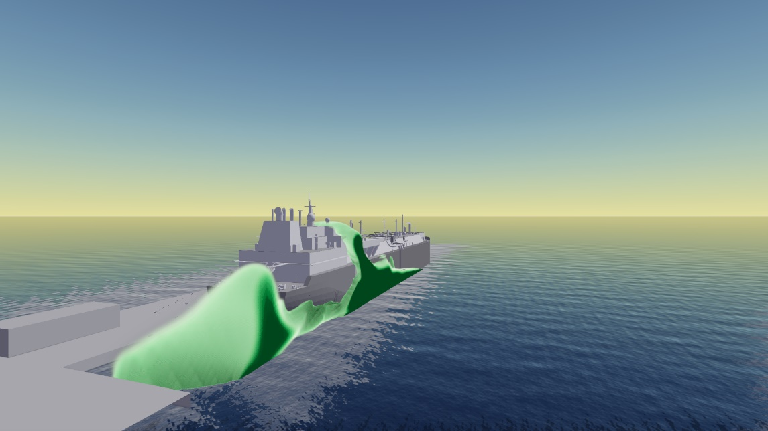 | 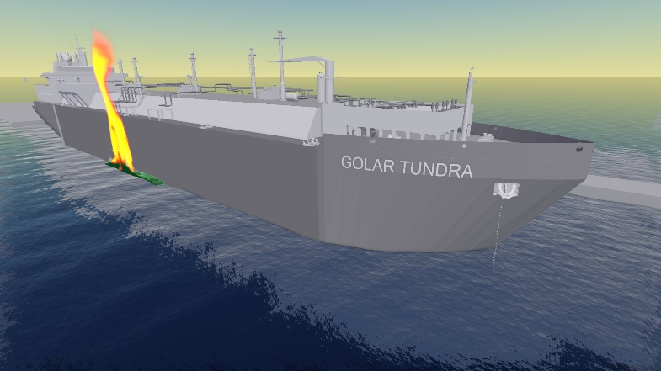
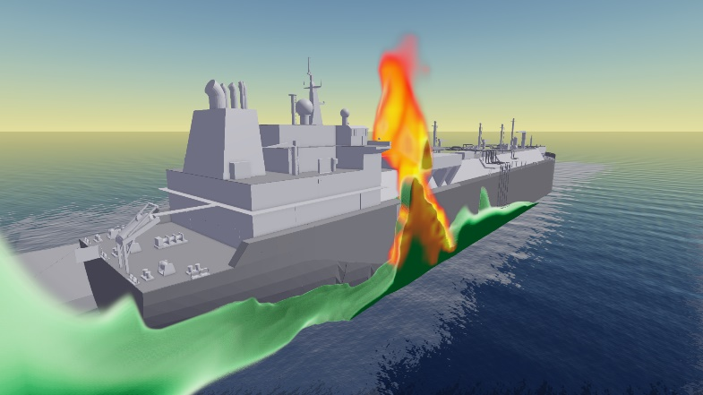 | 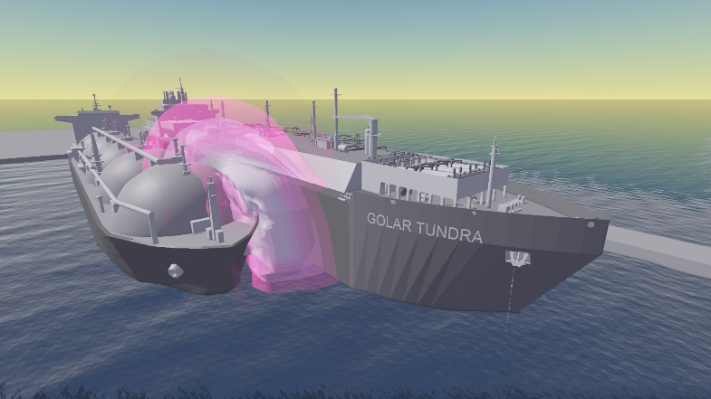
Flash Fire | Explosion
Figure 1: CFD modeling images covering different evolving accident scenarios.
In all the simulations carried out, the duration of the fire phenomenon is always below the threshold value of 10 minutes, defined by the Legislative Decree 105/2015, as the minimum value to trigger domino effects on structures and equipment. These preliminary assessments are also confirmed by the in-depth structural numerical analysis, which was carried out considering two types of loads:
- Permanent (mechanical) loads, due to gravity and pressures acting on the structure (internal pressure of the LNG/NG and external pressure on the hull of the water); these forces are self-balancing with each other but impose a "static" and permanent tensional state on the structure.
- Fire load (thermal), which imposes a temperature change on the outer surface of the outer shell of the LNGC.
From the simulations conducted, it follows that the external mantle of the FSRU does not reach a state of stress liable to lead to the collapse of the structure itself. The values obtained from the assessment of fire thermal load (equal to 3% of the plastic deformation), are by far lower than the breaking limit value (25% of the plastic deformation). Results evidence that the inner shell of the FSRU (internal tank) does not undergo plastic deformation, thus not reaching a critical stress state (being much less stressed than the outer mantle).
3.1 Preventative and mitigative design strategies
During the design phase, detailed studies were fully developed to direct the technical design pertaining to process safety and fire engineering for the quay infrastructure, being the potential criticalities towards the quay already thoroughly analyzed in the risk analysis developed in the Preliminary Safety Report. The intervention criteria are designed to prevent the cause or reduce/eliminate the effects of the undesirable event. The design rationally considered the RA inputs incorporating performance assessment of barriers and properly reconnecting to the identified risk sources in the plant and the process and identifying safety distances and exclusion zones. A non-exhaustive illustration of the designed and implemented protective and mitigating barriers is as follows.
- Automatic quick-release system of the hoses for adverse marine weather conditions.
- Fire pump room on the quay with adjoining dedicated water reserve.
- Fire protection of all structures on the quay (electrical room, control room, fire enclosure).
- Fire protection of the metal support structure of the hoses.
- The presence of (automatic) block valves on the quay connected to an emergency vent.
- Fire protection of the actuators of automatic valves on the quay.
- The presence of a water barrier on the East quay (ca.150 linear meters long) with a supply of 10,000 l/min.
- The presence on the quay of 8 remote-controlled automatic water monitors.
- The protection of the gas pipeline with a tunnel for the quay section, with fire resistance characteristics.
The competent Authorities, before giving the authorization to operate the Terminal, prescribed an additional water barrier on the North quay (ca. 100 linear meters long) with a further water availability of about 10,000 l/min. Additionally, the external emergency planning was designed to fully cover the contents of an external plan, e.g., organisation required in connection with relevant adverse scenarios, or losses, information to the public, as well as all the stages of preparation and application of emergency exercises.
  - CONCLUSIONS
The systematic QRA of the given case study can contribute standardizing the approach tailored to port areas suitable to be applied in quantifying and controlling the risks by effective barriers, when designing and managing LNG facilities in different environmental contexts. As a final remark, it should be noted that upon final design of the terminal and infrastructures and final Safety Report approved by all the competent Authorities, the risk management methods were transferred to the operational phase, by the identification of the safety and security barriers and the definition of the performance requirements that must be maintained (tests, inspections) during the terminal operation.
References
Animah I., Shafiee M., 2020, Application of risk analysis in the liquefied natural gas (LNG) sector: An overview. Journal of Loss Prevention in the Process Industries 63, 103980.
EC, 2012, Directive 2012/18/EU of the European Parliament and of the Council of 4 July 2012 on the control of major-accident hazards involving dangerous substances. Off. J. Eur. Union L 197, 1–37.
GEXCON, 2022, FLACS-CFD v22.1r2 User’s Manual.
Hightower M. M., Morrow C. W., Covan J. M., Gritzo L. A., Luketa A. L., Tieszen S. R., Wellman G. W., Kaneshige M. J., Melof B. M., 2004, Guidance on Risk Analysis and Safety Implications of a Large Liquefied Natural Gas (LNG) Spill Over Water, Sandia National Laboratories, Albuquerque, New Mexico.
Hissong D.W., 2007, Keys to modeling LNG spills on water, Journal of Hazardous Materials 140, 465-477.
HSE, 2009, Health Safety Laboratory: RR779 Research Report - Review of FLACS Version 9.0, Dispersion Modelling Capabilities. Norwich, U.K.
Laurent A., Pey A., Gurtel P., Fabiano B., 2021, A critical perspective on the implementation of the EU Council Seveso Directives in France, Germany, Italy and Spain, Process Saf. Environ. Prot., 148, 47-74.
LS-DYNA, 2019, User’s Manual R11 - Theory Manual R12. ANSYS, Inc., Canonsburg, PA, USA.
SINTEF & NTNU, 2015, Offshore and Onshore Reliability Data (OREDA), 6th Edition, Norway.
Uijt de Haag P.A.M., Ale B.J.M., 2005. Guidelines for Quantitative Risk Assessment (Purple Book).
Vairo T., Gualeni P., Reverberi A.P., Fabiano B., 2021, Resilience Dynamic Assessment Based on Precursor Events: Application to Ship LNG Bunkering Operations, Sustainability, 13, 6836.

