|  |  |
| --- | --- |
| cetlogo ***CHEMICAL ENGINEERING TRANSACTIONS***  ***VOL. xxx, 2025*** | A publication of  aidiclogo_grande |
| The Italian Association  of Chemical Engineering  Online at www.cetjournal.it |
| Guest Editors: Bruno Fabiano, Valerio Cozzani  Copyright © 2025, AIDIC Servizi S.r.l. **ISBN** 979-12-81206-xx-y; **ISSN** 2283-9216 | |

Cryogenic LH2 storage vessels in a fire

Martin Klugea,\*, Abdel Karim Habiba

aBundesanstalt für Materialforschung und –Prüfung, Unter den Eichen 87, 12205 Berlin, Germany

martin.kluge@bam.de

To investigate the hazards emanating from cryogenic LH2 storage Vessels in a fire, experiments have been performed at the Test Site Technical Safety of the Bundesanstalt für Materialforschung und –prüfung (BAM), Germany. Three double-walled vacuum insulated vessels of 1 m3 volume, filled to approximately 35-40 Vol.% with LH2 were put in a fire. The cylindrical Vessels differed in orientation (horizontal or vertical) and the insulation material used (perlite or multi-layer insulation (MLI)). The fire load was provided by a propane fed burner-system positioned under the storage vessel and designed to give a homogeneous fire load. During the tests the conditions in the vessel (temperatures and pressure) as well as external effects (heat radiation, blast waves, flame ball development and fragmentation) were measured. Two of these vessels, a horizontal and a vertical vessel both insulated with perlite withstood the fire loading for 1 hour 20 minutes and 4 hours respectively without catastrophic failure, but partly showing leakages. The horizontal vessel insulated with MLI failed by bursting after 1 hour and 6 minutes resulting in a fireball, fragments, and blast wave. The test results as well as the detailed examination of the non-destroyed vessels rose some interesting questions which type of insulation might be better to protect a vessel not only during its normal operation but also under fire loading against a heat flux from the surroundings, as well as to the suitability of cryogenic (safety) equipment under fire loading.

* 1. Introduction

Since hydrogen is becoming increasingly important as a renewable energy source, the hazards related to new applications must be investigated. Due to the very low gas phase density of hydrogen, transport is a challenge since it must be stored either at very high pressures (750 bar) or under liquefied conditions. The transport of liquid hydrogen (LH2) is related to some challenges regarding the tank insulation to reduce the boil-off. For this purpose, actual tank design comprises high vacuum insulated double walled tanks. The vacuum inhibiting the heat conduction from the outside to the inside. To inhibit the heat radiation on the inner tank the space between outer and inner wall is filled with insulation material. The type of this insulation is mainly defining the quality of the tank design. Whilst storage tanks and tanks for maritime transport have the advantage of a very high volume to surface ratio, leading to a thermodynamically favourable state, tanks for the transport on roads or even small decentral applications like the energy supply of individual houses are more restricted in their dimensions and therefore showing an unfavourable volume to surface ratio. In these cases, the chosen type of insulation becomes crucial. Whilst these considerations all aim towards an efficient usage of hydrogen, the question of safe(ty) usage must be investigated. Especially the small tanks dedicated to a decentralised use, are more likely to be involved in accident scenarios, e.g. accidents when transported on the road or exposition to external heat sources like fires. In the context of the SH2IFT project, a series of tests with three 1m³ LH2 transport vessels have been carried out at BAM. In these tests, all three tanks were exposed to a homogenous fire load to investigate their behaviour under fire conditions. Whilst the three tanks were of similar dimensions (the cylindrical double walled body is the same for all three), they differed in layout (two vessels with horizontal orientation and one with vertical orientation) as well as from the insulation material used (two insulated with perlite and one with multi layer insulation (MLI)). In this work a comparison of the three vessels under fire load is done with the aim of identifying optimization potential in the vessel design that might lead to a reduced hazard.

* 1. Experimental setup

The experiments were performed on the Test Site Technical Safety of BAM, Germany. The specimens investigated consisted of three double shelled vacuum insulated cylindrical tanks with an inner volume of 1 m³ and different insulation materials and spatial orientations (Figure 1). Two of the tanks, one oriented horizontally and one vertically, used perlite as insulation material and one oriented horizontally used MLI (multi layer insulation).

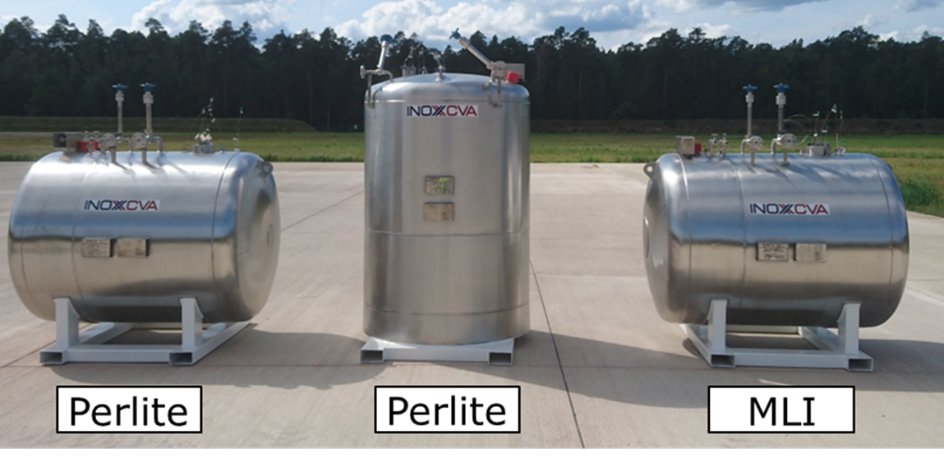

*Figure 1: The three specimens under investigation.*

The three specimens were filled from a LH2 Road Tanker, using a 46 m long vacuum insulated hose and a remote-controlled cryogenic valve system, which were purged with helium and then evacuated before each operation. The filling level of each tank was determined through weighing the tank during the filling process using 4 load cells with a maximum load of 10 t each (Figure 2). After the filling process, the load cells were removed and replaced by a propane burner system. All safety devices of the tanks were deactivated during the tests, to simulate the worst-case scenario. During each experiment the temperatures inside and outside the specimens were recorded, as well as the pressure of the inner tank. Additionally, a pressure sensor was installed such ways, that the vacuum insulation of the tank could be monitored. Several cameras were positioned around the tank as well as bolometers (in 50 m, 70 m and 90 m distance to the tank) to measure the heat radiation in the surroundings of a possible BLEVE event and also pencil probes (in 22.5 m and 26.4 m distance to the tank) for blast wave measurements. A more detailed description of the experimental setup and test procedure was already given in [Kluge et al. 2022].

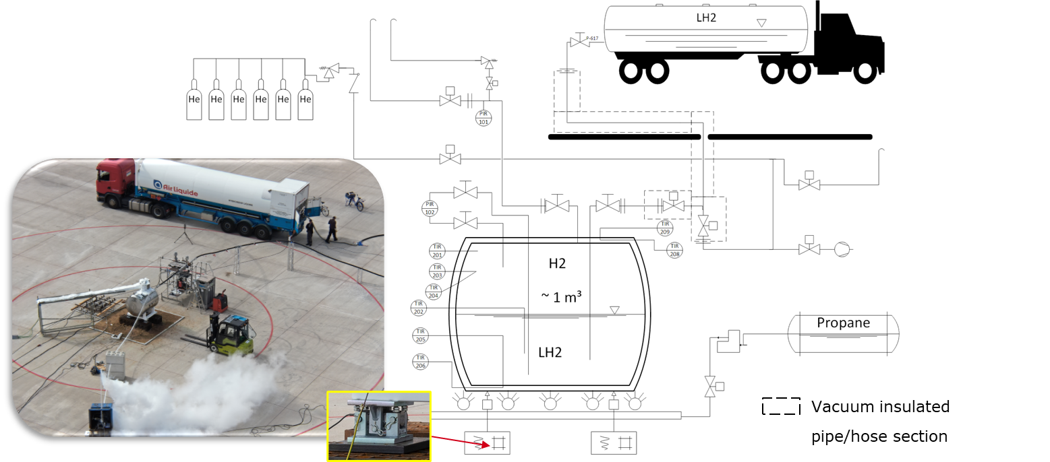

*Figure 2: Schematic of the experimental setup for filling and testing under fire load.*

* 1. Results

All three vessels withstood the fire load for at least one hour. From the three vessels only one (the tank with MLI) failed and burst after 4,090 s (= 1 h 8 min). The tank with perlite and a horizontal orientation was exposed to the fire load for 6,550 s (= 1 h 49 min) and the tank with perlite and a vertical orientation for 15,500 s (= 4 h 18 min) without failing. The shorter test duration of the horizontally oriented perlite tank was due to the fact, that a substantial part of the thermocouple sensors failed not allowing for a safe monitoring of the test anymore and one of the blind flanges mounted on the valves of the tank showed a leakage resulting in an approx. 4 m high hydrogen jet flame, which burnt for more than 20 min. resulting in the decision to stop the test.

* + 1. Indentation of the tanks

49 minWithin this first hour all three vessels showed a deformation of the outer shell (Figure 3) due to the weakening of the material strength at high temperatures (up to 800°C) and the force exerted by the ambient pressure from the outside.

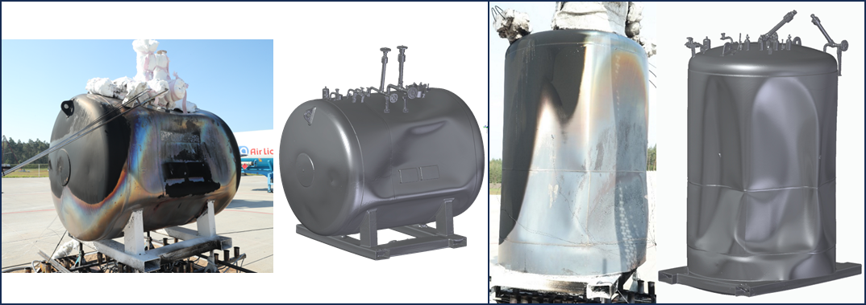

*Figure 3: Deformation of the outer shell of the tanks after exposition to a fire load. Form left to right: horizontal tank with perlite insulation, 3 D Scan of the vessel, vertical tank with perlite insulation, 3 D Scan of the vessel.*

The indentation of the vessels during the tests raised the question to what level the vacuum volume was filled with insulation material. The MLI will not have filled the space between outer and inner shell to 100%, so that there was enough space left for the deformation to occur. The perlite insulation should have filled the vacuum space (~1.5 m³) to 100%, leading to the question how the deformation (volume reduction of approx. 100 L = 7% of the vacuum volume) could be possible and if the inner vessel would show corresponding indentations. After the tests the (remaining) tanks were dismantled to check whether the perlite filling was not by 100% or if the inner tank showed corresponding indentations (Figure 4a). Since the inner tank was totally unaffected from the deformation of the outer shell, it can be assumed that the vacuum volume was not totally filled with insulation material at the time of deformation. This is supported by the occurrence of bigger cavities in the perlite (even going from the outer shell to the inner shell) discovered during the dismantling (Figure 4c) although a volume reduction already occurred during the test. It was also visible, that the perlite consistence was nearly that of powder and very compacted. The compression of the perlite was such, that it formed a solid block, that did not trickle down by itself but had to be removed mechanically (Figure 4b).

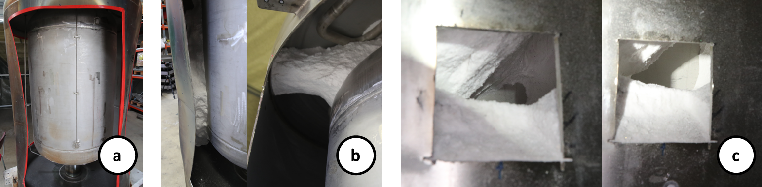

*Figure 4: a) Deformed outer shell and intact inner shell; b) compacted perlite sticking to the walls; c) cavities in the perlite (at middle height of the tank)*

From other studies [Fesmire et al. 2006] it is known that perlite can degrade mechanically from rough grains towards fine powder under the influence of vibrations and mechanical stress if the tank is moved. From internal investigations at BAM it was also noted that due to this degradation a compaction of volume up to 15% can be observed if the tank / perlite is subject to vibrations e.g. during transport. Since the tanks were shipped from India to Germany, these findings support the assumption that at the moment of testing the insulation was not filling the vacuum volume to 100 % anymore. Nevertheless, it’s insulation performance is still visibly better than that of MLI, since the two perlite tanks survived the tests and showed a slower pressure rise (3 - 4 mbar/s) during the exposition to the fire load than the MLI tank (20 mbar/s) *(*Figure 5). The different starting points if the pressure curves (Figure 5 Left) are due to a seemingly better cooling of the vessel during the filling process for the MLI insulation compared to the perlite tanks, which is in concordance with Literature, that MLI has very good cryogenic insulation properties [Adler, Martins 2022], [Mital et al. 2006].

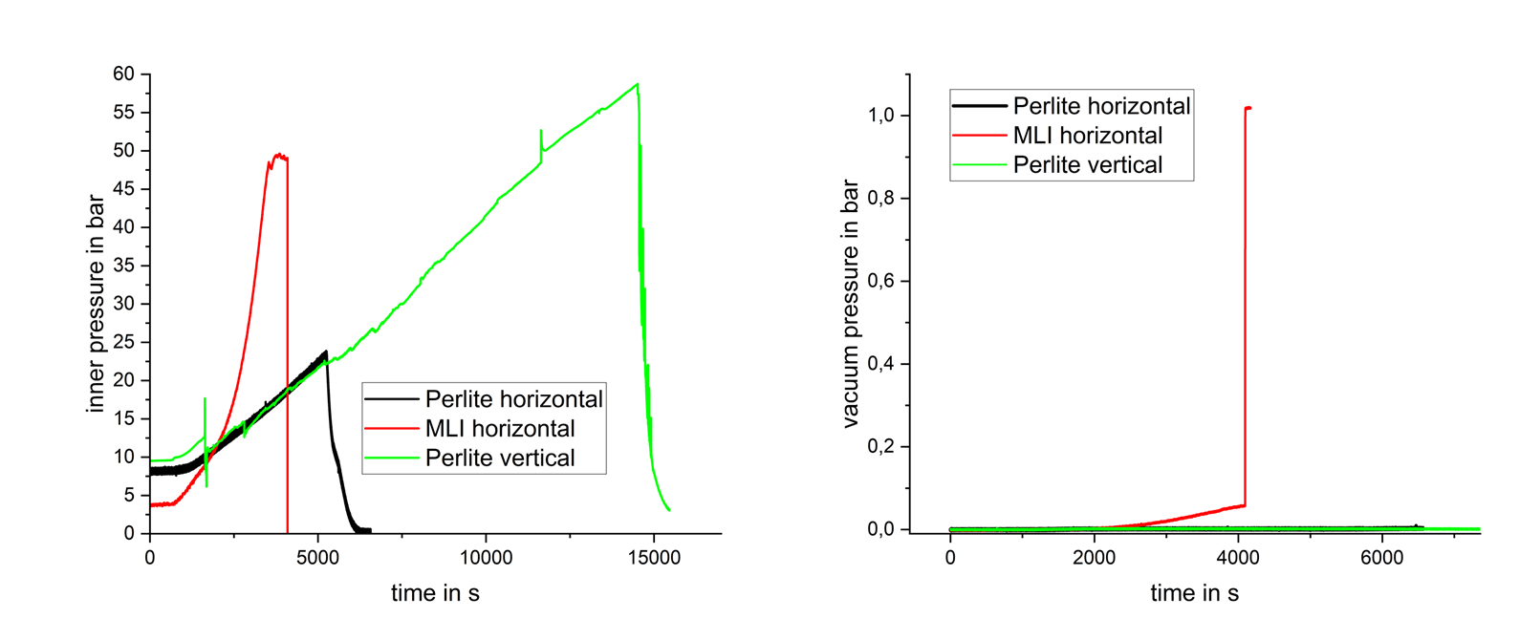

Figure 5: Left: Inner pressure of the three specimens over time; Right: Vacuum pressure of the three specimens over time.

* + 1. Catastrophic failure

As mentioned from the three specimens investigated, only the one with MLI failed and the tank burst at an inner pressure of 49.8 bar after 4,090 s under fire load (Figure 5). The resulting BLEVE occasioned a fire ball and sensible overpressures in the surroundings as well as hazards due to the fragments of the tank propelled away. The tank formed 7 main fragments (Figure 6) with masses ranging from 4 kg to 261 kg. The throw distances ranged from 7 m to 167 m, whereas the highest throwing distance was reached for a fragment with a mass of more than 70 kg.

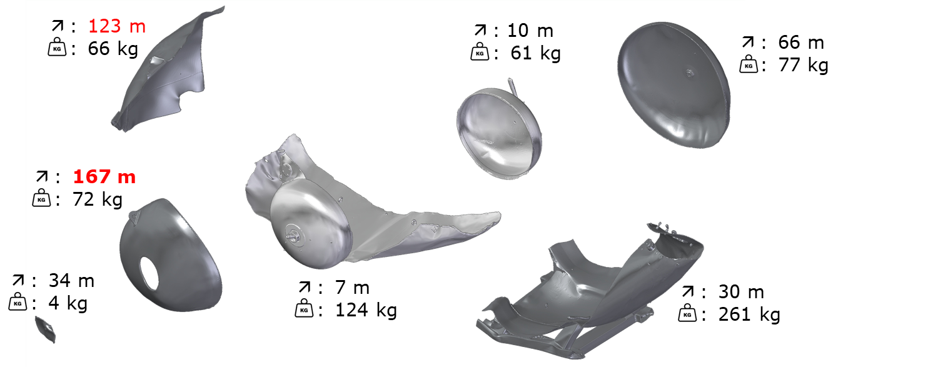

*Figure 6: 3D Scans of the fragments and their respective weights and throw distances (in red distances over 100 m).*

The BLEVE formed a fire ball of approx. 35 m diameter and incident heat radiation values exceeding a threshold value of 1.6 kW/m² (corresponding to the heat radiation causing a reversible effect comparable to a sun burn) in over 70 m distance (Figure 7Left). The resulting overpressures observed at the pencil probes still reached more than 90 mbar in 26.4 m distance, and from a regression calculation based on the pressure decay with the distance it could be estimated that 10 mbar overpressure (the threshold for 10 % of all windows breaking) will be reached only after 125 m (Figure 7Right).

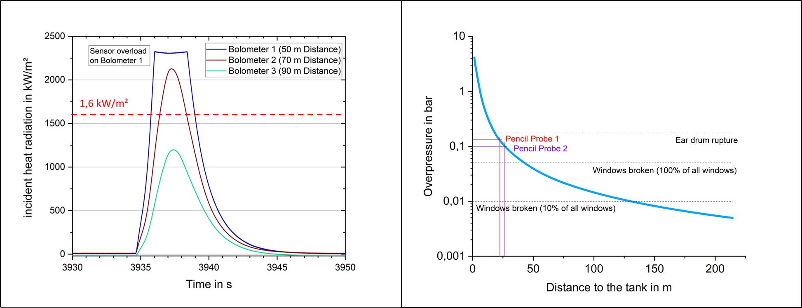

Figure 7: Left: Recorded heat radiation values; Right: regression curve for estimating the overpressure depending on the distance.

The reason for the failure of the tank itself cannot be explicitly identified, nevertheless several factors that could have directly caused or contributed to the failure. The pressure increase rate in the inner tank (Figure 5 Left) was considerably higher (by a factor of approx. 5) than for the tanks with perlite insulation. This could be attributed to a poorer performance of the MLI compared to perlite under fire load. Not only due to the much lower mass and therefore heat capacity which allows for a much quicker heating up of the insulation compared to bulk insulation materials, but [Eberwein et al. 2024] also identified that MLI shows a tendency to pyrolysis under fire load with formation of a gas phase sufficient to fill / break the vacuum, leading to an increase of the convective heat transfer. This phenomenon could be attributed to the observed pressure rise in the vacuum during the test for the MLI while the vacuum pressure for the perlite tanks stayed constant at the start value of a few mbar. In addition, [Eberwein et al. 2024] showed that the pyrolysis of some MLI leads to a coating of the tank shells such ways that the radiant heat transfer is increased by a factor of 10 compared to a vessel without any insulation material in the vacuum volume. This increased heat transfer could already affect the structural integrity of the inner tank sufficiently to cause the failure. The vacuum pressure curve of Figure 5 (Right) shows that after a slow increase of the pressure which could be associated to the pyrolysis of the MLI, the pressure suddenly increases to 1 bar around the time of the tank burst. Although the signal increase might be due to the burst of the tank and the loss of containment, the transient analysis shows that another mechanism could have taken place shortly before the tank failure. At the top of all 3 tanks an opening was located, supposedly used to fill in the perlite after manufacturing of the tanks. This opening was also found on the MLI tank. The opening was closed with a metal plug, held in place by the vacuum and sealed with an O-Ring made of Viton. This material only resists to temperatures up to 250°C. Although not observed on the perlite tanks, it might be conceivable, that, in addition to the MLI Pyrolysis, the O-ring failed, leading to the sudden loss of vacuum due to a sucking in of hot gases (several hundred degree Celsius) from the active fire load, impinging on the cryogenic inner shell and enhancing the mechanical stress and finally causing its failure.

* 1. Conclusions

The investigation of three cryogenic storage Vessels for LH2 under a fire load, showed that all specimens withstood the fire for at least one hour, although all safety devices were explicitly deactivated. From the three specimen one showed a catastrophic failure resulting in tank burst with a BLEVE. The ruptured tank was equipped with MLI as insulation material which turned out to be less suitable if a fire load cannot be excluded since it deteriorates at high temperatures resulting in a worsening of the insulation properties even compared to tanks with no insulation material. The consequences of the burst of a LH2 storage tank with 1 m³ inner volume under a fire load can reach distances of several 100 m due to fragments as well as from the pressure waves generated. Nevertheless, the ability to withstand a fire load for more than one hour with all safety devices deactivated, might give enough time to take counter measures as e.g. extinguishing the fire or evacuation procedures.

References

Adler, E. J., Martins, J. R. R. A., 2023, Hydrogen-Powered Aircraft: Fundamental Concepts, Key Technologies, and Environmental Impacts, Prog Aerosp Sci, pp. 1-59, <https://doi.org/10.1016/j.paerosci.2023.100922> .

Eberwein, R., Hajhariri, A., Camplese, D., Scarponi, G. E., Cozzani, V., Otremba, F., 2024, Experimental investigation on the behavior of thermal super insulation materials for cryogenic storage tanks in fire incidents, Process Saf Environ 187, <https://doi.org/10.1016/j.psep.2024.04.131> .

Fesmire, J. E., Augustynowicz, S. D., Nagy, Z. F., Sojourner, S. J., Morris, D. L., 2006, Vibration and Thermal Cycling Effects on Bulk‐fill Insulation Materials for Cryogenic Tanks, AIP Conf. Proc. 823, pp. 1359-1366.

Kluge M., Habib A.K., van Wingerden K., 2022, Large-scale tests to investigate the consequences of exposing cryogenic storage vessels containing liquid hydrogen to a fire load, Proceedings of the 14th International Symposium on Hazards, Prevention and Mitigation of Industrial Explosions, 168 – 181, <https://doi.org/10.7795/810.20221124> .

Mital, S.K. Gyekenyesi, J. Z., Arnold, S. M., Sullivan, R. M., Manderscheid, J. M., Murthy, P. L., N., 2006, Review of Current State of the Art and Key Design Issues With Potential Solutions for Liquid Hydrogen Cryogenic Storage Tank Structures for Aircraft Applications, NASA/TM—2006-214346.