On the NOx production of ammonia, hydrogen and methanol fuels for shipping purposes

Gianmaria Pio1, Olga Aneziris2, David Levovnik3, Vladislav Maras4, Ernesto Salzano1,*

1 Dep. of Civil, Chemical, Environmental, and Materials Eng., University of Bologna, Bologna, Italy; 2 NCSR “DEMOKRITOS”, Agia Paraskevi Attikis, Greece;

3 Department for Inorganic Chemistry and Technology, Jozef Stefan Institute, Ljubljana, Slovenia

4 Faculty of Transport and Traffic Engineering, University of Belgrade, Belgrade, Serbia

*Corresponding author E-Mail: ernesto.salzano@unibo.it

1. Introduction

The International Maritime Organization (IMO) has adopted a strategy for reducing greenhouse gas (GHG) emissions from ships, proposing to reduce carbon emissions in the global shipping industry by 50% by 2050 and to achieve zero carbon emissions in the global shipping industry in the 21st century. To this aim, the transition toward cleaner fuels, particularly for short-distance routes, port operations and long-term docking in urban harbours is necessary. Possible candidates are ammonia (NH3), hydrogen (H2) and methanol (CH3OH) (if produced from renewable sources). However, the transition to sustainable power requires careful consideration of multiple factors to ensure successful implementation, including safety, economic and environmental aspects (Aneziris et al., 2023; Zanobetti et al., 2023). In the EU Adrion project SUPERALFUEL, Key Performance Indicators (KPI) for the quantitative assessment of the sustainability of the cited three fuels, in the specific framework of harbour system, will be developed. For what concern the environmental indicators three main parameters should be considered. The first indicator is related to the total amount of NOx produced by any fuel per kWh of energy produced (KPI-ENV1), defined often as the NOx emission rate. This data can be compared with Nitrogen Oxides (NOx) – Regulation 13 - Tier III, which allows for a total weighted cycle emission limit of 2.0 g/KWh (for diesel ships) (Shaw & Van Heyst, 2022). The second parameter (KPI-ENV2) is related to the total amount of CO2 per kWh produced by the energy production, to evaluate the Global Warming Potential (GWP). In this regard, the N2O should be considered for comparison, as NH3) and H2 are intrinsically carbon-free on a tank-to-wake basis rather than a well-to-wake. For the calculation of the KPIs, a detailed kinetic model KIBO (Pio et al., 2024; Salzano et al., 2018) developed at the University of Bologna has been adopted for the above-cited fuels after extensive validation.

2. Methods

The detailed kinetic mechanism KIBO, which includes nitrogen-based chemistry was used. The adopted kinetic mechanism includes 172 species and 488 reactions. The design of KIBO prioritizes computational efficiency for practical implementation while maintaining accuracy, as evidenced by thorough validation documented in existing literature. A zero-dimensional reactor implemented in the open-source software Cantera (Goodwin, 2009), was utilized to represent the adiabatic conditions in a transient mode and to evaluate the composition of products either by using a pure thermodynamic approach based on the minimization of Gibbs-free energy or by assessing the laminar burning velocity. For details, the reader can refer to Pio et al. (2022). Results are given in terms of the molar fraction (composition) of combustion products (NO, N2O and NO2) for the three fuels by varying the stoichiometric fraction φ:

$φ=\frac{\frac{fuel}{O_{2}}}{{\left(\frac{fuel}{O_{2}}\right)}_{st}}$ (1)

Also, for each fuel, the amount of NOx produced per kWh is given. Finally, for the sake of comparison, the emission index $E_{{NO}_{x},fuel}$, for each fuel, was evaluated as the following ratio:

${EI}_{{NO}_{x}}=\frac{g_{{NO}_{x}}}{kg_{fuel}}$ (2)

The following Table 1 reports the three fuels' analysed composition and main properties.

Table 1: Composition, heat of combustion, storage (st) conditions of fuels analysed in this work.

|  |  |  |  |  |  |  |  |  |
| --- | --- | --- | --- | --- | --- | --- | --- | --- |
| **Fuel** |  |  |  |  |  |  |  |  |
| H2 (liq) | 298 | 700 | 285.8 (gas) | 39.6 | 0.8 | 0.183 | 0.172 | 0.645 |
|  |  |  |  |  | 1.0 | 0.251 | 0.157 | 0.591 |
|  |  |  |  |  | 1.2 | 0.101 | 0.189 | 0.710 |
| NH3 (liq) | 298 | 10.0 | 382 (gas) | 609 | 0.8 | 0.219 | 0.164 | 0.617 |
|  |  |  |  |  | 1.0 | 0.296 | 0.190 | 0.715 |
|  |  |  |  |  | 1.2 | 0.123 | 0.184 | 0.693 |
| CH3OH (liq) | 298 | 1.13 | 763.7 (gas) | 792 | 0.8 | 0.251 | 0.157 | 0.591 |
|  |  |  |  |  | 1.0 | 0.335 | 0.140 | 0.525 |
|  |  |  |  |  | 1.2 | 0.144 | 0.180 | 0.676 |

3. Results and discussion

Figure 1 shows the molar fraction of NOx for the three fuels at stoichiometric, rich, and lean fuel compositions, as calculated by KIBO by using the purely thermodynamic-based approach and the kinetic-based methodology.

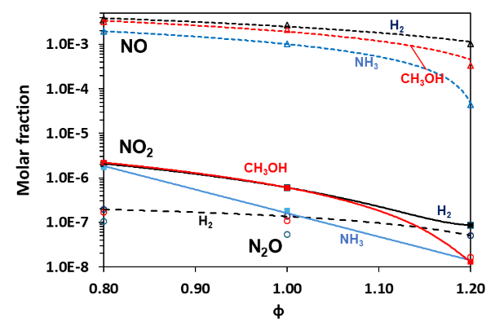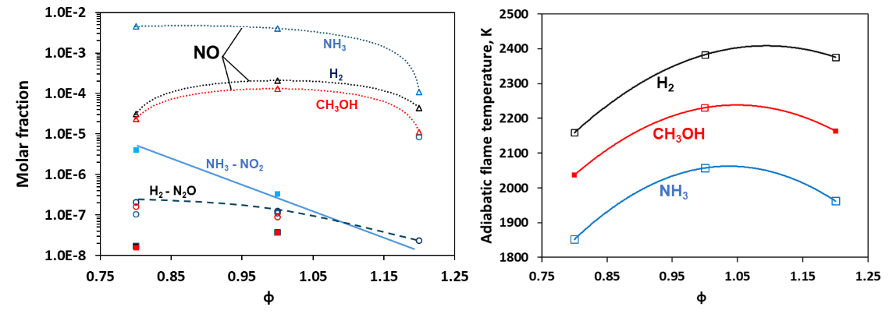

Figure 1. Molar fraction of NOx (NO – Δ, dotted line; N2O – O, dashed line, NO2 – continuous line, square) produced by NH3, H2 and CH3OH by a pure thermodynamic model (left) and by the kinetic model (right) vs equivalence ratio φ as calculated by the KIBO model.

Quite clearly, the molar fraction of nitrogen monoxide NO prevails over the other oxides, even if NO2 shows some relevance in lean conditions. Besides, N2O is almost negligible in all conditions, as expected. Once the Gibbs-free energy model is considered, NH3, H2 and CH3OH produce a comparable amount of NOx, whereas the adoption of the kinetic model results in a significantly larger content of NOx in the case of NH3. This trend can be attributed to the variation in nitrogen content due to the different stoichiometric coefficients, acting as a thermal and kinetic diluent. This aspect can have a significant impact on the overall reactivity, as well. Hence, meaningful considerations can be obtained by comparing the emissions per unit of energy (in kWh) produced by combustion and the consumption rate, i.e. the total amount of fuel required to produce 1 kWh (Figure 2).

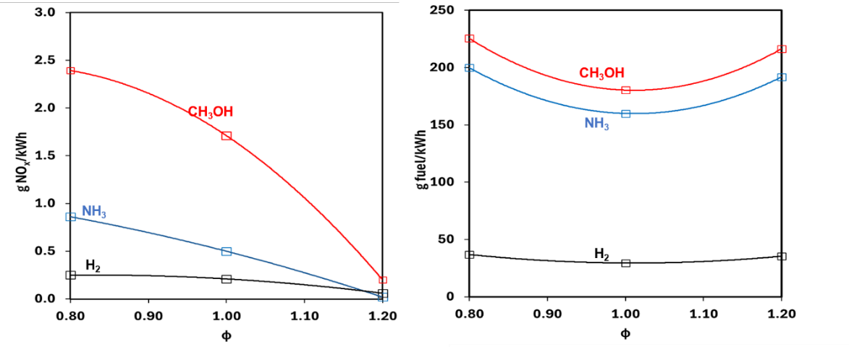

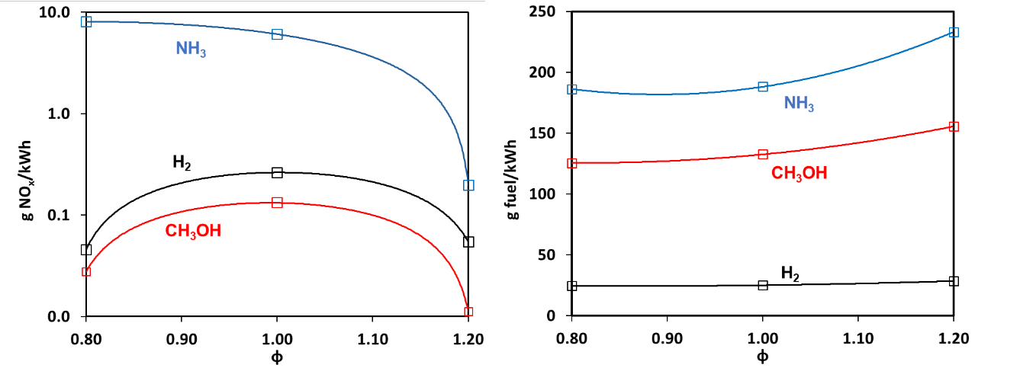

Figure 2. Mass of NOx emitted per unit of energy (left) and mass of fuel required for the production of 1 kWh of energy (right) for the investigated fuels vs the equivalence ratio φ, as calculated by the KIBO code. Top: thermodynamic equilibrium, Bottom: kinetic model.

The figure shows clearly that both the amount of fuel and the amount of NOx per kWh are consistently low in the case of H2  either thermodynamically or kinetically. Besides, the NH3 shows a very high consumption rate and a larger amount of NOx if the detailed chemistry is considered. If considering the kinetic approach, H2 and CH3OH produce less NOx/kWh than Tier III – IMO, at any condition.

The calculated emission index (Eq. 2), based on the grams of fuel and grams of NOx produced per kWh is shown in Figure 3. In the figure, the emission index ${EI}_{{NO}_{x}}$ decreases almost linearly with the equivalence ratio for NH3. That is quite important in the framework of advanced combustion technologies, e.g. the MILD (Moderate or Intense Low oxygen Dilution) combustion or other ultra-lean conditions for Low-NOx energy production, which uses recirculated heat and exhaust gases to reduce the flame temperature, thus reducing the amount of pollutants and increasing thermal efficiency. In this regard, it is worth mentioning that MILD combustion produces a dramatic decrease in NOx emissions but is still far from being adopted for shipping purposes.

As for previous results, the thermodynamic approach shows a large difference with respect to the kinetic model; NH3 seems relevant in terms of NOx emission with a dramatic increase at lean conditions if the kinetic model is considered.

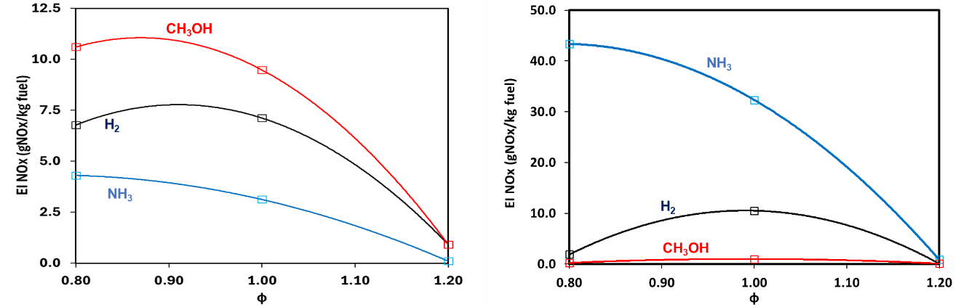

Figure 3. Emission index (Eq. 2) based on NOx produced per kg of fuel vs equivalence ratio φ by using a Gibbs-free energy approach (left) and by using a kinetic approach (right).

The emission index ${EI}_{{NO}_{x}}$ shows that NH3 is the best option if considering a pure thermodynamic analysis based on the Gibbs-free energy approach whereas a dramatic increase in the NOx is shown if a kinetic model is adopted.

4. Conclusions

The NOx emissions are over 95% from anthropogenic (mainly industrial and transportation) sources, so a key performance indicator for environmental sustainability based on these oxides is strongly recommended. Nevertheless, a comprehensive database on the experimental characterization of this parameter is missing. Numerical analyses conducted in this work show the sensitivity to the implemented approach, suggesting the implementation of kinetic models within a simplified layout and geometry of real case scenarios of interest.

Acknowledgements

The authors wish to thank the financial contribution of the EU through the Interreg IPA ADRION program 2021-2027, project: IPA-ADRION073- Sustainability of Alternative Fuels in the ADRION area – SUPERALFUEL”. We also thank Nicoleta Pocitarenco for her useful support.

References

Aneziris, O., Koromila, I.A., Gerbec, M., Nivolianitou, Z., Salzano, E., 2023. A Comparison of Alternative Cryogenic Fuels for Regional Marine Transportation from the Perspective of Safety, Chemical Engineering Transactions, 100, 25-30.

Zanobetti, F., Pio, G., Jafarzadeh, S., Ortiz, M.M., Cozzani, V., 2023. Inherent safety of clean fuels for maritime transport, Process Safety and Environmental Protection, 174, 1044-1055.

Pio, G., Dong, X., Salzano, E., Green, W.H., 2022. Automatically generated model for light alkene combustion. Combust Flame. 241, 112080.

Pio, G., Eckart, S., Richter, A., Krause, H., Salzano, E., 2024. Detailed kinetic analysis of synthetic fuels containing ammonia. Fuel. 362, 130747.

Salzano, E., Pio, G., Ricca, A., Palma, V., 2018. The effect of a hydrogen addition to the premixed flame structure of light alkanes. Fuel. 234, 1064-1070.

Goodwin, D.G., 2009. Cantera: An object-oriented software toolkit for chemical kinetics, thermodynamics, and transport processes, Caltech, Pasadena.

Shaw, S.B., Van Heyst, B., 2022. Nitrogen Oxide (NOx) emissions as an indicator for sustainability. Environmental and Sustainability Indicators. 15, 100188.