|  |  |
| --- | --- |
| cetlogo ***CHEMICAL ENGINEERING TRANSACTIONS***  ***VOL. xxx, 2025*** | A publication of  aidiclogo_grande |
| The Italian Association  of Chemical Engineering  Online at www.cetjournal.it |
| Guest Editors: Bruno Fabiano, Valerio Cozzani  Copyright © 2025, AIDIC Servizi S.r.l. **ISBN** 979-12-81206-xx-y; **ISSN** 2283-9216 | |

Helideck Assessment for Ship using Liquid Hydrogen as Fuel

Olav R. Hansena\*, Eirik S. Hansena and Steven Bosscherb

aHYEX Safety AS, Grindhaugvegen 57, 5259 Hjellestad, Norway

b Royal Van Lent Shipyard B.V., Feadship, Julianalaan 3, 2159 Kaag, The Netherlands

olav@hyexsafe.com

CAP 437 has for decades been the most recognized standard to ensure safe operations at helidecks on offshore installations and ships. CAP 437 defines alert and no-fly criteria for helicopter operations related to environmental effects like structure-induced turbulence, thermal effects from flares, diesel and gas turbine exhausts, and unburnt hydrocarbon gas emission from cold flaring or emergency blowdown systems. For ships using liquid hydrogen (LH2) as fuel, similar assessments are highly relevant. To support the approval process of a superyacht with a 3 MW hydrogen fuel cell power plant and LH2 storage tank installed, a CAP 437 assessment was performed. In addition to a standard directional wind turbulence study above the helideck, both ignited and unignited releases of cryogenic and ambient temperature hydrogen due to possible failures or emergencies were assessed using CFD modelling. Plumes from fuel cell space ventilation exhausts were also studied. Due to the very different properties of hydrogen compared to hydrocarbon fuels it was necessary to modify the CAP 437 criteria to reflect the properties of hydrogen related to both the buoyant (thermal) plume criteria and unignited plumes of hydrogen potentially leading to helicopter engine surge. The main conclusion from the assessment is that while the standard turbulence criteria from CAP 437 should be followed, it is recommended to avoid/limit helicopter operations with winds from aft as a general precaution due to the helideck in the bow area. Hydrogen venting, while highly unlikely, could occur at any time, and represents a major risk for helicopter operations if the vent plume would ignite. In addition to defining a safe operating envelope for helideck operations under normal conditions, simulations were performed to understand selected emergency scenarios, including worst-case hydrogen venting scenarios with/without ignition of plume, and situations with lack of manoeuvrability so that wind direction relative to ship may not be controlled. Recommendations for a safest possible approach for such emergency situations are provided.

* 1. Introduction

The landing and take-off processes during helicopter flights are critical phases as the helicopter is close to taller ship structures and the sea, with high collision risk and limited time to correct errors or deviations. Compared to flat airfields on shore, the wind flow-field directly above a helideck on the bow of a ship will for most wind directions be far from smooth, as sidewinds may scale the bow before flowing above the helideck and winds from aft may form turbulent wakes in the area above the helideck. There may be ship motions due to wave and wind loads. During these operations a sufficient and stable lift is critical for the helicopter. This lift may be reduced if there are significant pockets of air with lower density in the region above the helideck. For traditional ships this would be from hot exhaust plumes from engines or turbines. For a hydrogen ship buoyant plumes could also result from vented hydrogen from the gas mast, whether ignited or not. The only planned hydrogen venting is related to bunkering procedures, with ship at quay and with very limited vent rates. In this situation helicopter operations should, for obvious reasons, not be performed. Unintended hydrogen venting will be rare and could be caused by system deviations/errors while running hydrogen systems. Tank heating to the PRV-setpoint, which could be caused by negligence, loss of vacuum, or fuel storage hold space (FSHS) fire, would also release hydrogen. In these cases, there will be prior warnings that the LH2 tank pressure approaches the PRV-setpoint. In addition, with a very low probability, sudden releases from the tank could happen at any time if there is a mechanical PRV failure. If unignited hydrogen plumes are pulled into the engine air intake of the helicopter, there is a risk for engine surge due to too much fuel, which may be critical during the landing or take-off phases.

* 1. System description and assumptions

The CFD simulation model of the LH2-fuelled ship is shown in Figure 1. The length of the ship is 119 m and the beam 19 m. The helideck in the bow area of the ship is 8 m above sea level and the highest vent mast, from which hydrogen may be vented, is 33 m above sea level and thus 25 m above the helideck. The critical landing region to be monitored for turbulence, buoyant or flammable plumes, is 16 m long and extends upwards from the height of the rotor to a height defined as 30 ft plus wheels-to-rotor plus one rotor diameter. To cover the two planned helicopter types for the helideck, the monitoring height is estimated to range from an elevation of 3.5 m to 28 m above the helideck. The monitoring region thus extends around 3 m higher than the gas mast from which hydrogen may be vented.



*Figure 1: View of ship simulation geometry model from starboard side, helideck is illustrated in the bow area.*

The maximum hydrogen vent rate of around 2 kg/s cryogenic hydrogen is for a dimensioning fire scenario specified by the IGF-code (IMO, 2015) in which the tank is heated by a severe fire inside the FSHS, resulting in loss of vacuum. Due to the type C vacuum insulated tank and the low fire potential and limited access to air inside the FSHS, this scenario is considered to have a remote likelihood and will need a long time to develop. The maximum foreseen vent scenario of ambient temperature hydrogen will release less than 0.2 kg/s and may be caused by a blockage of the vaporizer outlet. In the study, thermal plumes from ventilation outlets and fuel cell exhausts were also assessed and concluded to be of negligible concern.

Hydrogen releases into the gas mast should be detected by gas sensors and all cryogenic releases will lead to visible fog formation due to condensation of air humidity. In a maritime environment it may be expected that all flammable plumes will be visible, possibly down to concentrations of 1-2% hydrogen. Ignited plumes of hydrogen may not necessarily be visible in daylight. The lower flammable limit (LFL) of hydrogen is 4%. In practice, horizontal flame LFL (6%) or downwards flame LFL (8-9%) are more relevant (Coward and Jones, 1952).

The traditional CAP 437 criteria (CAA, 2023) include both alert level criteria and no-fly criteria, see Table 1. A thorough justification of the reasoning and criteria is found in (CAA, 2000). The updated turbulence criteria are discussed in (CAA, 2009), these will be the same for any helideck, and not dependent on the type of gas handled or used as fuel. For conditions exceeding the alert level, experienced pilots may be allowed to perform the operations if prior warning is given as long as the no-fly criterion is not exceeded. For buoyant/thermal plumes no no-fly criterion is defined, instead CAP 437 states that ‘appropriate restrictions may be applied’. Many CAP 437 studies consider +10 °C over ambient as a no-fly criterion, while for helicopter operations to oil and gas facilities on the Norwegian Continental Shelf, operators have developed guidelines allowing operations despite thermal plumes up to +30 to +40 °C over ambient (Sæter et al., 2014).

Table 1: CAP 437 environmental conditions criteria to be considered in monitoring region.

|  |  |  |  |
| --- | --- | --- | --- |
| Parameter | Alert level | No-fly criterion | Comment |
| Vertical turbulence velocity | 1.75 m/s | 2.40 m/s | Experienced pilots may exceed alert level |
| Flammable gas into engine |  | 10%LFL | Engine surge and possible flame-out |
| Buoyant/thermal plume | +2 °C (over 3 s) |  | No-fly: +10 °C used and also +30-40 °C |

To apply these criteria for a hydrogen-fuelled ship, some modifications will be required. To do so, the following considerations are done:

* Vertical turbulence velocity – not related to hydrogen as a fuel – is kept as is.
* Flammable cloud / engine surge: 1.6% H2 plume (40%LFL – 1.44 g/m3 at STP with HHV of 204 kJ/m3) has a similar combustion energy as the hydrocarbon 10%LFL (10%LFL methane – 3.65 g/m3 at STP with HHV 203 kJ/m3) which is considered to be safe. The addition of such limited amounts of hydrogen will have negligible impact on mixture reactivity and flammability limits.
* Buoyant plume: +2 °C air pocket (CAP 437 alert level) has a 0.7% reduced density at ambient temperature (10 °C), corresponding to the buoyancy of 0.75% ambient temperature H2 in air (19%LFL).
* The buoyancy of a cryogenic hydrogen plume will depend on the air humidity. For dry air and at ambient temperatures well below freezing point, the hydrogen plumes from cryogenic releases have a close to neutral buoyancy, and a 2% H2 plume will have a reduced temperature of -4.5 to -5 °C under ambient, depending on release mechanism. At ambient air temperatures above 10 °C, fog formation due to cooling may give a certain buoyancy effect. For the same 2% plume released at 20 °C in 100% relative humidity, a coarse estimate indicates that a fog formation of around 1.5 g/m3 will limit the temperature reduction to less than -2 °C, with a resulting increased plume buoyancy of around 0.7%, similar to the +2 °C buoyant plume alert criterion. As H2 concentration is higher than the 1.6% no-fly engine surge criterion, the buoyant plume criterion for unignited cryogenic releases may not have relevance.
* Ignited vented H2 gives extensive thermal plumes which should not interfere with or be near the helicopter take-off and landing routes. LFL (4%) flame temperature is around 350 °C. Diluted with air, it may be estimated that +2 °C thermal plume criterion could be exceeded where unignited H2 concentrations are 0.02%, or lower, due to the expansion at ignition. Wind conditions for which an ignited thermal plume could interfere with the monitoring region, should thus also be considered.
* For ventilation outlets / fuel cell exhaust the thermal plume +2 °C alert level would be relevant.

Based on this, the following modified criteria are proposed for a hydrogen fueled ship, see Table 2.

Table 2: Recommended assessment criteria CAP 437 study for a hydrogen fueled ship.

|  |  |  |  |
| --- | --- | --- | --- |
| Parameter | Alert level | No-fly criterion | Comment |
| Vertical turbulence velocity | 1.75 m/s | 2.40 m/s | Experienced pilots may exceed alert level |
| Flammable gas into engine | (0.75% H2) | 1.6% H2 | 0.75% H2 corresponds to +2 °C plume |
| Buoyant plume ambient H2 | 0.75% H2 | (1.6% H2) | 1.6% H2 is no-fly engine surge criterion |
| Thermal plume ventilation | +2 °C | (+10 °C) | Consider no-fly limit for experienced pilots |
| Thermal plume ignited H2 release | +2 °C | (+10 °C) | Caution, ensure wind is from bow |
| White smoke / venting | Venting | White smoke | Caution, burning plume may be invisible |

* 1. CAP 437 assessment for a hydrogen-fueled ship

For the turbulence assessment simulations were performed with winds from 13 directions, every 15 degrees from the bow to the aft. Wind speeds 10 m/s, 15 m/s, and higher/lower velocities were simulated, all with a logarithmic profile and stability class Pasquill D, to ensure that scenarios both with lower and higher turbulence velocity than criteria were simulated. This way threshold wind speeds to conclude the operational weather window can be found by interpolation for each wind direction. As the ship is symmetric, wind from port side directions only were simulated and results mirrored across the ship axis to represent winds from starboard.

The FLACS CFD model was used for the study. As FLACS uses the isotropic k-ε turbulence model, the directional turbulence components are not calculated as they would be if using Reynolds stress turbulence models (RSM). Instead, the vertical turbulence velocity is estimated as a fraction of the total turbulence and described by the TURB parameter in FLACS. For atmospheric boundary layers above the sea, and for flat areas on land, the vertical turbulence velocity will generally be lower than horizontal turbulence velocities, and too high turbulence velocities may be estimated using an isotropic turbulence model. To better estimate the vertical turbulence component, some studies, e.g. (Venkatraman and Nyiredy, 2015), suggest that RSM models should be applied for helideck turbulence studies. For flow around offshore petrochemical installations and ships, winds may be diverted to flow above the structures. For such cases, the overestimation of the vertical turbulence velocity will be less, unless helidecks are lifted using air gaps, see (CAA, 2009). Due to its sub-grid turbulence modelling, more efficient solution algorithms and extensive validation, FLACS has advantages relative to most CFD models with RSM for turbulence, in particular for situations with process areas or equipment upwind the helideck. Examples of FLACS validation studies include modelling of atmospheric dispersion experiments (Hanna et al., 2004), the LNG model evaluation protocol (Hansen et al., 2010), and LH2 experiments (Hansen and Hansen, 2023). As CFD models with RSM for turbulence generally leave more flexibility to the user related to parameter settings, validation efforts may be more user dependent, and the quality of the predictions may depend more on the competence of the user than when using FLACS. The proposed helideck operational weather window resulting from the present assessment may be somewhat conservative and restrictive due to the use of k-ε model. In Figure 2a flow patterns are illustrated for diagonal wind onto the bow on port side predicting an upwards flow as wind is climbing the hull before diverting above the helideck, and regions with elevated turbulence velocities are shown. In the 3D illustration, the region with turbulence velocity levels above the alert limit (1.75 m/s) are shown in orange color, and above the no-fly limit (2.40 m/s) in red color.

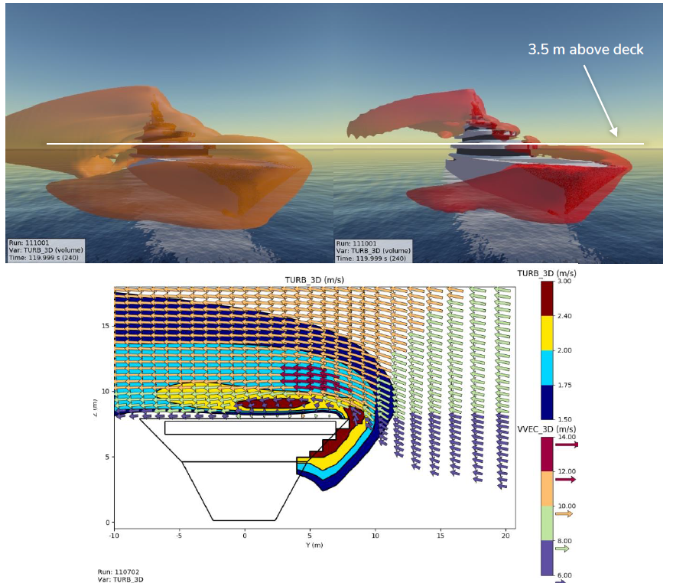 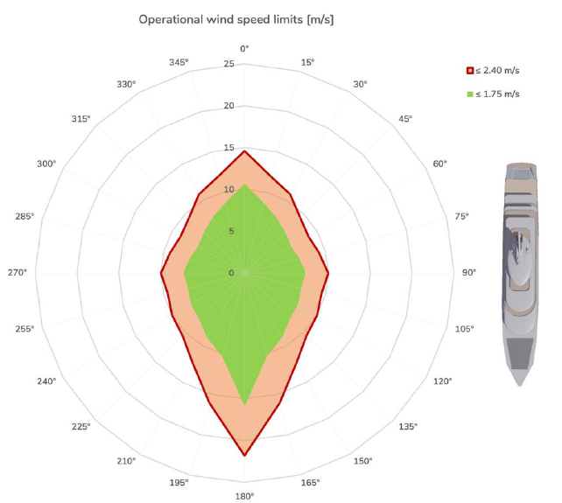

*Figure 2: a) Lower left plot shows predicted flow vectors and turbulence for 10 m/s wind diagonally onto bow from port side, while upper left plots show regions exceeding vertical turbulence criteria for alert (1.75 m/s- orange) and no-fly (2.40 m/s-red). b) Right pilot plot shows the wind conditions below the alert level (green), above the alert level (orange) and the no-fly conditions (red line) for wind from various directions (bow = 180°).*

To assess the possible flammable gas plume exposure of the monitoring region above the helideck, various hydrogen venting scenarios were simulated from the gas mast for different wind speeds and wind from aft. As the release is directed upwards from a location well above other tall structures of the ship, the influence of the ship wakes on the buoyant plume dispersion is concluded negligible. For significant wind speeds the low concentration parts of the hydrogen plumes are predicted to interfere with the top of the helideck monitoring region, as seen in Figure 3 for the maximum tank venting scenario initiated by a dimensioning FSHS fire.

The conclusion of the assessment, which included both cryogenic and ambient temperature hydrogen releases, is that the possible overlap of hydrogen plumes is limited to the top of the helideck monitoring region, and only for concentrations below 1.6% which is the proposed no-fly engine surge criterion. The proposed buoyant plume alert criteria at concentrations of 0.75% (ambient temperature release) and 4-5% (cryogenic release) were not exceeded for any of the simulated cases.

If the vent plumes are ignited, this gives additional buoyancy. The thermal plume is only predicted to interfere with the helideck monitoring region for strong wind from aft. In Figure 4 this is shown for the maximum hydrogen venting scenario caused by the dimensioning FSHS fire. While the predicted steady-state venting simulations indicate that the thermal plumes from ignited vent releases go clear of the helideck monitoring region, the distance to temperatures far exceeding the tolerable range (e.g. 10-40 °C) is short. If larger scale atmospheric turbulence or taller ships or buildings upwind pull the thermal plume to a lower elevation than predicted with the simulated steady wind field, margins may be reduced or disappear. Possible pilot errors would also be of concern. Further, the flashfire or explosion directly after ignition was observed to have potential to push flame pockets downwards which could interfere with the monitoring region for a short period of time. For these reasons, the recommendations from the study are, when possible, to avoid helicopter operations with winds from aft and for situations with ships and buildings nearby which can significantly influence the wind-fields around the ship. For emergency situations, with limited ship maneuverability and wind from sectors aft, possible safe take-off and landing strategies were discussed to remain sufficiently clear of vented hydrogen plumes if venting should start and plumes ignite. Possible impact of hydrogen vent plume ignition, like radiation loads, flame pockets and pressure waves, were also estimated in order to understand possible hazards.

*Figure 3: Predicted hydrogen plumes with wind from aft for ~2 kg/s venting caused by an FSHS dimensioning fire. The helideck monitoring region is illustrated with red rectangle above the bow of the ship.*

*Figure 4: Predicted thermal plumes with wind from aft for the ignited ~2 kg/s hydrogen venting scenario caused by an FSHS dimensioning fire.*

* 1. Conclusions

The use of low/no-carbon, gaseous fuels for ships is increasing to reduce emissions and environmental footprint. In case of technical failures or emergencies, flammable gas may be vented from the gas mast. For ships with helidecks the venting of flammable gases represents a possible major hazard for which special precautions may be required. To ensure safe helideck operations for a ship designed to operate with liquid hydrogen as fuel, a helideck assessment according to the CAP 437 standard was performed. This included numerical CFD assessments of both wind turbulence and vented hydrogen plumes, whether ignited or not, within the critical landing and take-off region above the helideck. As the environmental criteria of the CAP 437 standard are developed with hydrocarbon fuels in focus, revised criteria were proposed for the hydrogen venting assessment, reflecting the different properties of hydrogen. While hydrogen venting operations are expected with a remotely low frequency except during bunkering operations, and the most severe scenarios would develop gradually with possibility to take precautions, the possible consequences if a helicopter would fly into or near a hydrogen plume might be severe. The conclusions from the study are that only a minor overlap between vented hydrogen plumes and the monitoring region above the helideck is predicted. Neither for unignited nor ignited plumes were the proposed CAP 437 no-fly criteria (modified for hydrogen) violated. Still, to ensure sufficient safety margins from unexpected atmospheric conditions, pilot errors, and transient flashfire/explosion consequences if a vent plume would ignite with a helicopter above the helideck, it is recommended to avoid helideck operations with winds from aft when possible. While the current study was performed for a specific ship with a helideck, the CAP 437 plume assessment and proposed criteria are also considered to have relevance for other hydrogen fueled ships for which emergency rescue or evacuation operations with helicopter may be required.

References

CAA. (2000). Research on offshore helideck environmental issues, CAA Paper 99004. London, UK: UK Civil Aviation Authority, Safety Regulation Group.

CAA. (2009). Helideck Design Considerations - Environmental Effects, CAA Paper 2008/03. London, UK: UK Civil Aviation Authority, Safety Regulation Group.

CAA. (2023). Standards for offshore helicopter landing areas - CAP 437, ninth edition February 2023, Civil Aviation Authorities, [www.caa.co.uk/CAP437](http://www.caa.co.uk/CAP437) (last accessed Dec 20, 2024)

Coward, H. F., & Jones, G. W. (1952). Limits of flammability of gases and vapors. US Bureau of Mines. Washington, DC, USA: US Government Printing Office.

IMO (2016), IGF-code – The International Code of Safety for Ships Using Gases or Other Low-flashpoint Fuels

Hanna, S. R., Hansen, O. R., & Dharmavaram, S. (2004). FLACS CFD air quality model performance evaluation with Kit Fox, MUST, Prairie Grass, and EMU observations. Atmospheric Environment, 38(28), 4675-4687.

Hansen, O. R., Gavelli, F., Ichard, M., & Davis, S. G. (2010). Validation of FLACS against experimental data sets from the model evaluation database for LNG vapor dispersion. Journal of Loss Prevention in the Process Industries, 23(6), 857-877.

Hansen, O. R., & Hansen, E. S. (2023). CFD-modelling of large-scale LH2 release and explosion experiments. Process Safety and Environmental Protection, 174, 376-390.

Sæter, O., Hamremoen, E., Lockert, S., & Gilberg, A. (2014). Pro-active approach to control the risk of exposure to hot gas emission during helicopter operations. London, UK: 69th Helicopter Safety Research Management Committee.