Simulation of Decomposition Reactions considering the Residual Cooling Capacity of Industrial Reactors

Adrian Zentel*a), Marc-André Serrera), Steffen Salgb),) Markus Göddec), Johannes Schrödera), Robert John Blancharda

a Safety Assessment & Testing (BASF SE, Carl-Bosch-Straße 38, 67056 Ludwigshafen, Germany)

b Pluriol Plant (BASF SE, Carl-Bosch-Straße 38, 67056 Ludwigshafen, Germany)

c Process Safety (BASF SE, Carl-Bosch-Straße 38, 67056 Ludwigshafen, Germany)

*Corresponding author E-Mail: adrian.zentel@basf.com

1. Introduction

In chemical production plants, process safety is one of the key aspects of process development. A basic scenario within the field of thermal process safety to safeguard exothermal decomposition reactions is the total loss of cooling event with the simplified assumption of adiabatic conditions [1], see Figure 1. Within this scenario the reaction temperature TR, the maximum temperature of the synthesis reaction (MTSR) and the adiabatic decomposition temperature (ADT24) are essential characteristics. Knowing the ADT24, the maximum allowable temperature for the process TExo can be derived. The technical rule for plant safety (German: Technische Regel für Anlagensicherheit (TRAS) 410) suggests limiting the TExo 10 K below the ADT24 [2].

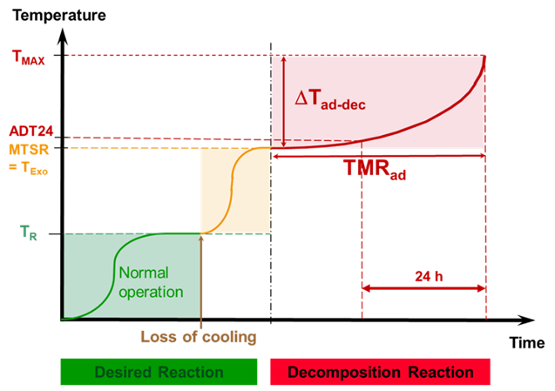

Figure 1: Temperature development in the scenario of a total loss of cooling event with the simplified assumption of adiabatic conditions [1].

The TRAS 410 also emphasizes to consider the heat loss of the system when determining the maximum allowable temperature TExo. Within this frame a study has been performed, investigating the impact of the residual cooling capacity of industrial reactors on the TExo. The residual cooling capacity describes the passive cooling capability of the system after failure of active cooling, particularly due to the heat loss to the environment, i. e. ambient convective cooling.

In this study, alkoxylation reactions were investigated with respect to the scenario of a cooling failure. In alkoxylation processes, a nucleophilic compound like an alcohol or amine is reacted with an alkylene oxide, e. g. ethylene oxide or propylene oxide. The reaction can be catalyzed by Bronsted bases such as sodium hydroxide or potassium hydroxide. Within the alkoxylation process there are significant hazards to be safeguarded: high toxicity of alkylene oxides, gas phase decomposition of ethylene oxide, high reaction enthalpy of - 95 kJ/mol ethylene oxide (l) or - 121 kJ/mol ethylene oxide (g) and exothermal decomposition reactions of educts, intermediates and products [3, 4].

2. Methods

At BASF, a model-based concept is used to safeguard the aforementioned hazards of the alkoxylation processes [4 - 6]. The model calculates the free oxide concentration in the reactor in every moment of the reaction based on temperature, pressure and known substance properties. The oxide dosage is regulated such that in case of a cooling failure the runaway of the synthesis reaction is limited to the maximum allowed temperature TExo. At this temperature, the decomposition of the reaction mixture starts slowly with a rather small heat release rate. In alkoxylation processes, a slightly different definition of the ADT24 is used, which is more conservative than the definition given in TRAS 410. According to TRAS 410, the ADT24 is the temperature at which the time to maximum rate (TMR) at adiabatic conditions equals 24 hours [2]. Following this approach, the T24_TDesign is defined as the temperature, at which it takes at least 24 hours to reach the reactor design temperature. This period is long enough to deploy suitable countermeasures against thermal runaway, i. e. external emergency cooling by the fire department. The maximum rate of the decomposition reaction is usually observed at temperatures larger than 250 °C, which is a common reactor design temperature. Because of this conservative definition and after having conducted sophisticated thermal analyses of the decomposition reaction for each polyether polyol, the T24_TDesign is implemented as maximum allowed temperature TExo.

To investigate the impact of the residual cooling capacity on the alkoxylation process, the process-limiting exothermal decomposition reaction was investigated by calorimetric methods and formal kinetic models were generated describing the decomposition reactions. In addition, for various industrial reactors the specific heat loss due to ambient cooling was determined experimentally and numerical reactor models were developed. The models describing decomposition kinetics and the reactor models were used to perform numerical simulations for the prediction of the thermal behaviour for various product-reactor-combinations. For modelling and simulation, the software code from Cheminform St. Petersburg “Thermal Safety Series-Advanced Reaction Kinetics Simulation (TSS-ARKS)” was used. The concept of simulating the thermal behaviour of a peroxide decomposition reaction under non-adiabatic conditions with the software code and the validating 1:1 experiments were published by our group at Loss Prevention in 2016 [7].

3. Results and discussion

The numerical simulations of the thermal behaviour of the decomposition reactions within the reactor models representing the industrial scale reactors were applied to derive the maximum allowed temperature TExo with an induction time of at least 24 hours under process relevant conditions. Depending on the product-reactor-combination the TExo may be 10 K to 20 K higher when considering ambient cooling than the TExo in the ideal adiabatic case. These benefits of additional temperature increase are strongly dependant on the criticality of the decomposition reaction and the specific heat loss of the reactor. If a decomposition reaction generates heat at a slow rate and the reactor can dissipate heat at a high rate the resulting temperature benefit will be large. For fast decomposition reactions in large reactors with low surface area to volume ratios the benefit will be small, since the system will behave close to the ideal adiabatic case. If additional countermeasures, like independent emergency cooling or drainage/quench systems, are provided, the TExo may be increased by approximately 50 K compared to the ideal adiabatic case, see Figure 2.

Ein Bild, das Text, Diagramm, Reihe, Screenshot enthält.

Figure 2: Simulation of the temperature-time curves of the decomposition reaction of a polyether polyol for 3 cases: ideal adiabatic, residual cooling and active emergency cooling (starting at 180 °C, 190 °C and 245 °C respectively (reactor model: 35 m³ reactor with insulation). The initial temperature of each curve corresponds to the maximum allowed temperature TExo.

4. Conclusions

The findings of these studies show that it can be highly beneficial to consider the process under process relevant conditions when setting up the safeguarding concept. The additional temperature increases of 10 K to 20 K by considering the residual cooling and the up to 50 K temperature increase when active emergency cooling is available can be directly transferred to additional plant capacity while keeping the same safety level as in the conservative worst-case scenario. This highlights that safety engineering and economical production can go hand in hand when the safety assessment is done in a smart way with advanced analytical methods based on high quality and robust caloric data.

Acknowledgments

The authors thank the lab technicians who supported with the ISO17025 accredited caloric measurements of the samples which were the basis for the setup of valid and robust kinetic models and the plant personnel who conducted the cooling down experiments at the reactors. We also thank Arcady Kossoy for the valuable support regarding the ARKS-TSS software code.

References

1. Gygax R., 1988. Chemical reaction engineering for safety. Chemical Engineering Science. 43(8), 1759-1771. https://doi.org/10.1016/0009-2509(88)87040-4
2. Bundesministerium für Umwelt, Naturschutz und Reaktorsicherheit, 2021. Technische Regel für Anlagensicherheit (TRAS) 410. Kommission für Anlagensicherheit, Bundesanzeiger.
3. BG RCI, 2022. R 009 - Reaktionen mit Ethylenoxid und andere Alkoxylierungen. Merkblätter der R-Reihe Anlagensicherheit.
4. Loetgering-Lin O., Salg S., Koenig C., Buchholz H., Goedde M., Odenwald O., Sager W., Brodhagen A., Heitz T., Ries R., 2023. *Knowing and Controlling the Risks of Semi-batch Alkoxylation Reactions*, Chemical Engineering Transactions, 98, 51-56. https://doi.org/10.3303/CET2398009.
5. Reiser M., Salg S., Loetgering-Lin O., Buchholz H., Hohendorf S. Fischer J., Fath W., Odenwald O., Goedde M., 2019. Modellbasierte Absicherungskonzepte für Semi-Batch-Alkoxylierungen. 14. Fachtagung Anlagen-, Arbeits- und Umweltsicherheit. Köthen: Dechema
6. Loetgering-Lin O., Salg S., Buchholz H., Odenwald O., Goedde M., 2020. Modellbasierte Absicherungskonzepte für Semi-Batch-Alkoxylierungen. Chemie Ingenieur Technik. https://doi.org/10.1002/cite.202055061.
7. Duerrstein S. H., Kappler C., Neuhaus I., Malow M., Michael-Schulz H., Goedde M., 2016. Model-Based Prediction of the Adiabatic Induction Period and SADT of Dicumyl Peroxide Solution and Comparison to Large-Scale Experiments Performed Using 216.5-Liter Steel Drums in the UN-Test H.1. Chemical Engineering Transactions, 48, 475-480. DOI:10.3303/CET1648080.