|  |  |
| --- | --- |
| cetlogo ***CHEMICAL ENGINEERING TRANSACTIONS***  ***VOL. xxx, 2025*** | A publication of  aidiclogo_grande |
| The Italian Association  of Chemical Engineering  Online at www.cetjournal.it |
| Guest Editors: Bruno Fabiano, Valerio Cozzani  Copyright © 2025, AIDIC Servizi S.r.l. **ISBN** 979-12-81206-xx-y; **ISSN** 2283-9216 | |

A Novel Index-Based Method for the Risk Assessment of Low-Intensity Natech Events caused by Floods

Di Talia Valentina\*, Giacomo Antonioni, Valerio Cozzani

LISES – Dipartimento di Ingegneria Civile, Chimica, Ambientale e dei Materiali, Alma Mater Studiorum – Università di Bologna, via Terracini 28, 40131 Bologna (Italy).

\*valentina.ditalia2@unibo.it

Natech events (natural events triggering technological accidents) are usually considered high-impact low probability (HILP) events involving the loss of containment of hazardous substances with potentially severe consequences such as fires, explosions, and toxic dispersions. However, in the last decade, environmental contamination due to the interaction of the water receding after a flood event and anthropic activities was reported in several Natech events, raising attention towards the so-called Low-Intensity Natech (LIN) events. Notably, to date, there are no approaches available to identify and assess the risk associated with these occurrences.

This contribution proposes a novel index-based method to estimate the risk associated with LINs for a selected area addressing the environment as a target. The approach involves the characterization of the most relevant anthropogenic activities potentially impacted within the area (i.e., magnitude assessment) and the characterization of the flood hazard level in correspondence with each activity identified (i.e., frequency assessment). These two layers of information – magnitude and frequency assessment - are then integrated by means of GIS software into a LIN Risk Index, which provides a first quantification of the risk associated with LIN events targeting the environment. The proposed method was applied to two river basins with inherently different levels of industrialization in the North of Italy. The analysis of the results obtained confirms that the proposed risk index enables a straightforward assessment, and a comparison of the overall risk associated with LIN events in a river basin.

* 1. Introduction

Technological accidents triggered by natural events, commonly referred to as Natech accidents, are high-impact low probability (HILP) events which present significant risks to human life, infrastructure, and environmental systems. Defined within the scope of Directive 2012/18/EU, these accidental scenarios involve the uncontrolled release of hazardous substances from industrial facilities due to natural hazards (Krausmann et al., 2017). Considerable environmental contamination resulting from post-flood interactions with industrial pollutant has been documented in several cases in the last decade, drawing attention to the so-called Low-Intensity Natech (LIN) events. During these accidental scenarios, floods cause the loss of containment of pollutants stored or processed within industrial activities of various nature into floodwaters, contaminating them. This may further impact the soil and water body quality as a result of migration and stagnation of these floodwaters, endangering both terrestrial and aquatic ecosystems. For example, in May 2023, the municipality of Conselice in Northern Italy experienced significant soil contamination due to floodwaters stagnating for two weeks in an industrial area. The prolonged interaction of the floodwaters with hazardous substances used in food production resulted in widespread environmental damage (Arrighi & Domeneghetti, 2024). Similar accidents have been reported, such as the 2019 flooding in the Saga province, Japan, where floodwaters caused the release of a significant amount of crude oil, which caused the contamination of large tracts of agricultural and residential land (Misuri et al., 2021), and the 2017 flash flood in Livorno, Italy, which resulted in an oil spill that severely impacted local water bodies and soil (eNatech, 2024).

Even though the risks posed by LIN events are becoming more widely acknowledged, their distinctive characteristics are often overlooked by current risk assessment approaches. The efforts of Morra et al. (2012) to estimate the risk associated with Natech events accounting for the target environment can be considered a first step in this direction. However, the complex interactions between floodwaters and the industrial landscape that take place during LIN events are not adequately addressed, as only Seveso establishments are considered. Furthermore, the approach proposed by Di Fluri et al. (2024) to assess the biochemical quality of surface waters in selected river basins affected by industrial discharges represents an interesting starting point for assessing the potential magnitude of these peculiar accidental scenarios.

* 1. Method

An index-based method for assessing the risk associated with LIN events targeting the environment in a given area is defined within this contribution. This approach models the risk as a combination of the magnitudeand the frequency of potential accidental events. Magnitude is assessed by identifying and characterizing relevant pollution sources in the area, and frequency is estimated by accounting for the position of these pollution sources considering flood hazard and land usage.

The pollution sources accounted for in the method are the discharges from industrial activities that can significantly impact surface water and soil quality during LIN events. Specifically, Seveso establishments (sites falling under the obligation of Directive 2012/18/EU) and IPPC-IED activities (sites falling under the obligation of Directive 2010/75/EU) are considered, as they are recognized for storing and processing significant quantities of substances that can be harmful to aquatic environments (Shafiei Moghaddam et al., 2023). Additionally, Contaminated Sites (CSs) are accounted for as they can lead to surface water contamination through run-off from former industrial sites (Chaudhry & Malik, 2017). Waste Water Treatment Plants (WWTPs) - and in particular activated sludge systems – are included in the assessment as they are known to contribute nutrients to receiving water bodies, especially when control systems fail or during critical hydrological conditions (Su et al., 2021).

* + 1. Magnitude assessment

The magnitude of the contamination focuses on characterizing pollution sources potentially impacted by floodwater, through their water discharges within a selected area, using a flooding Biochemical Pressure Index *(BPIflood*). The *BPIflood* for each water discharge is defined as the product of five parameters, as presented in Eq(1):

${BPI}_{flood}=D⋅T⋅F⋅ H⋅S$ (1).

Table 1: Severity scale for LIN magnitude assessment.

|  |  |  |
| --- | --- | --- |
| Parameter | Attribute | Score |
| D | Uncontaminated surface run-off water | 1 |
|  | Domestic wastewater | 2 |
|  | Contaminated surface run-off water and washing wastewater | 3 |
|  | Industrial wastewater | 4 |
| T | No | 1 |
| F | Surface water body | 1 |
| H | Absence | 1 |
|  | Presence, regardless of quantity for IPPC-IED activities and to a lesser extent of the lower-tier requirements for Seveso activities | 1.5 |
|  | Presence in quantities between the lower-tier and upper-tier requirements for Seveso activities | 2 |
|  | Presence exceeding the upper-tier requirements for Seveso activities | 3 |
| S | 0 – 103 m3/year | 0.5 |
|  | 103 – 104 m3/year | 1 |
|  | 104 – 105 m3/year | 1.5 |
|  | 105 – 106 m3/year | 2 |
|  | 106 – 107 m3/year | 2.5 |

The parameters accounted for in the assessment are: the discharge type *D*, the presence or absence of treatment *T*, the fate of the discharge *F*, presence of hazardous substances *H*, and size of the discharge *S*. A higher score indicates a greater potential for environmental contamination. Notably, the *BPIflood* is derived by adapting the method established by Di Fluri et al. (2024) to the context of LIN events by means of a newly defined severity scale presented in Table 1. The values assigned to each parameter were initially determined by Di Fluri et al. (2024) based on expert judgment, and subsequently, they were reviewed and refined through an ex-post analysis. It is also to mention that in that framework, severity scores was validated against water quality monitoring data.

Table 2: Common assumptions for WWTPs and CSs (magnitude assessment).

|  |  |  |  |  |  |
| --- | --- | --- | --- | --- | --- |
| Activity typology | D | T | F | H | S |
| WWTP | 2 | 0.5 | 1 | 1 | [0.5-3] |
| CS | 4 | 0.5 | 1 | [1-1.5] | 0.5 |

It can be observed from Tables 1 and 2 that for WWTPs, the discharge is generally treated as domestic wastewater, and hazardous substances are considered absent. Considering that the Population Equivalents value is typically known, the calculation of parameter *S* can be easily performed based on average flow rates. Conversely, for CSs, the discharge is treated as industrial wastewater, and the assessment of parameter *H* depends on whether the site has undergone remediation or not.

* + 1. Frequency assessment

The frequency assessment involves, for each pollution source, the determination of the expected frequency that a flood event may impact the facility. This can be quantified through a Frequency Index (*IF*) that has been adapted from anindex developed by Morra et al. (2012), which considers expected flooded areas for reference intervals of return periods and land usage and is calculated based on a severity scale that accounts for return period scenarios and land usage presented in Table 3.

Table 3 – Severity scale for LIN frequency assessment.

|  |  |  |  |
| --- | --- | --- | --- |
| Scenario | Return Period interval | Non-urban area score | Urban area score |
| Riverbed | 3÷5 years | 4 | 4 |
| High Probability (HP) | 3÷5 years | 3 | 4 |
| Medium Probability (MP) | 100÷200 years | 3 | 3 |
| Low Probability (LP) | 300÷500 years | 1 | 2 |
| Outside (>500 years) | >500 years | 0.5 | 1 |

The reference return period scenarios and the correspondent time intervals were defined according to Morra et al. (2012). It should be noted that this classification aligns with the Flood Directive (Directive 2007/60/EC) and with the Italian legislation (D.Lgs. 49/2010). Considering land usage, the distinction between urban and non-urban areas is based on different levels of land impermeability that influence water drainage during flooding. Urban areas present more impermeable surfaces and face higher water levels in case of an inundation. Consequently, it is more probable to expect more severe damage to industrial installations in these areas.

* + 1. Risk assessment

Magnitude and frequency assessment are integrated into the LIN Risk Index *RILIN* by summing the products of the flooding Biochemical Pressure Index and the Frequency Indexes calculated for all pollution sources *i* identified within the selected area as presented in Eq(2):

${RI}_{LIN}= \sum_{i}{{BPI}_{flood, i}{ I}_{F,i}}$ (2).

This approach facilitates straightforward comparisons of risk levels associated with LIN events among different study areas, providing a first approach for the assessment of the risk associated with LIN events.

* 1. Case study

Two basins located in the Emilia-Romagna Region (Northern Italy) were selected for the case study application: Navile and Tresinaro, presented in Figures 1 and 2, respectively. The areas were chosen due to their different levels of industrialization, hydro morphological features, flood-proneness, and land usage levels.

An initial investigation aimed at collecting all the information necessary for the identification and characterization of the pollution sources (i.e., the industrial activities) present within the two basins. This involved consulting prefecture websites for detailed information on Seveso establishments, and specific regional portals were employed for IPPC-IED activities (ER1, 2024), WWTPs (ER2, 2024), and CSs (ER3, 2024). For what specifically concerns the frequency assessment, flood hazard maps were examined (ER4, 2024) along with the CORINE Land Cover inventory (Copernicus, 2024). In all cases, official sources available to the public were employed.

Figure 1 presents the features of the Navile basin. The area covers 240 km² and contains 34 industrial activities, including 1 Seveso plant, 12 IPPC-IED activities, 13 CSs, and 8 WWTPs. All activities are located in flood-prone areas: three in high probability area (HP), 30 in medium probability area (MP), and one in low probability area (LP). Considering land usage, 24 plants are situated in urban areas, while 10 are located in non-urban areas.

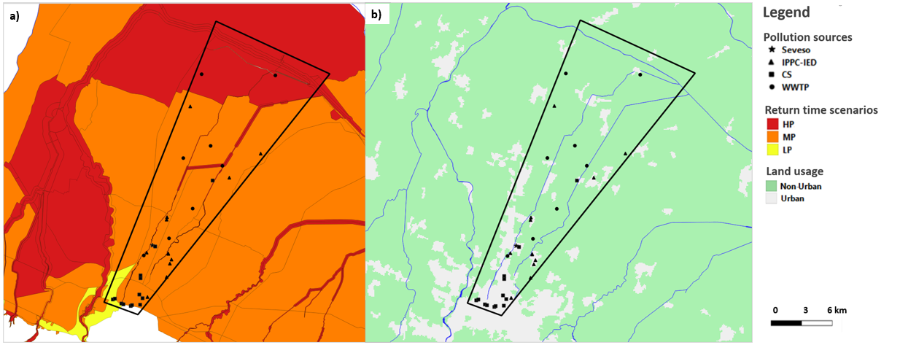

Figure 1 – Navile basin: Panel a) Representation of return time flood scenarios; Panel b) Representation of land usage.

Tresinaro basin’s features are presented in Figure 2. The area covers 206 km² and includes 29 industrial activities: 1 Seveso plant, 13 IPPC-IED activities, 12 CSs, and 3 WWTPs. In the basin, nearly all activities fall outside the return time scenarios, with only one in medium probability area (MP) and 28 outside. Regarding land usage, 15 plants are located in urban areas and 14 in non-urban ones.

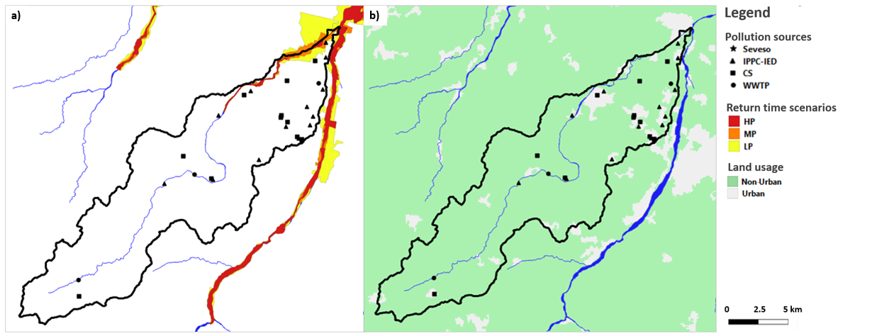

Figure 2 - Tresinaro: Panel a) Representation of return time flood scenarios; Panel b) Representation of land usage.

After defining the two case study areas, the flooding Biochemical Pressure Index (*BPIflood*) and the Frequency Index (*IF*) were calculated for each pollution source identified according to the procedures described in sections 2.1 and 2.2, respectively. The overall LIN Risk Index (*RILIN*) was then computed for each basin according to Eq(2), and the results were eventually analyzed.

* 1. Results

The application of the LIN Risk Index method in the Navile and Tresinaro basins produced risk index values of 410 and 76, respectively. Given that the two areas are comparable in size, with Navile covering 240 km² and Tresinaro 206 km², the higher risk value for Navile indicates a significantly greater risk. To better understand these results, the contribution of the four activity types accounted for in the method (Seveso, IPPC-IED, CS, and WWTP) to LIN Risk Index values obtained were analyzed, as illustrated in Figure 3.

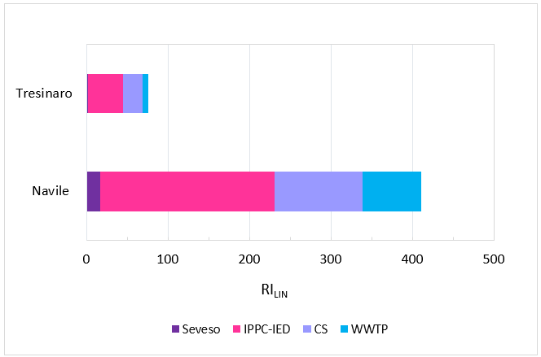

*Figure 3 – Case study results: Contribution of the activity types* to the LIN Risk Index values obtained.

Each contribution reported in the graph represents the sum of the products of the flooding Biochemical Pressure and the Frequency Indexes calculated for pollution sources of the same type. The results indicate that for both basins, the majority of the risk is attributed to IPPC-IED activities, with the Seveso plants contributing minimally.

The analysis then explored how the location of these activities, in relation to return time scenarios and land usage, affects overall risk levels. Figure 4 presents the results obtained.

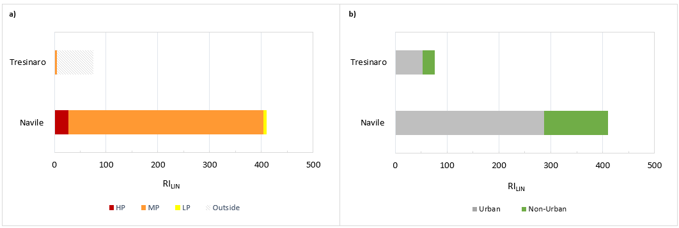

*Figure 4 – Case study results: Contribution* to the LIN Risk Index values obtained of the four return time scenarios (*Panel a)) and of the two land usage classes (Panel b)).*

Figure 4a presents the contributions of activities by return time scenario, revealing that the LIN risk in both Navile and Tresinaro is predominantly influenced by activities in the Medium Probability (MP) return time zone, whereas Tresinaro shows significant risk contributions from areas outside predefined return time scenarios. Regarding land usage, Figure 4b demonstrates that activities located in urban areas contribute more to the LIN risk across all three study areas, as expected.

These findings show that while Seveso plants typically contribute to NaTech risk caused by major accidents, their influence on LIN is not uniform across different areas (as for the other industrial activity types considered). Moreover, it is evident that the location of the pollution sources significantly influences the results. For example, highly urbanized and industrialized regions, particularly those with flat terrain like Navile, exhibit a combination of factors leading to a higher average risk per unit area. Conversely, basins with limited flood zones, such as Tresinaro, have lower risk levels.

* 1. Conclusions

The novel index-based method provides an innovative approach for the assessment of the risks associated with LIN events in areas of concern, taking into account the most significant categories of industrial activities that can lead to environmental contamination, the flood-proneness of territories and land usage. The approach enables regulatory and control bodies to enhance preparedness and to define targeted risk management measures through a straightforward comparison of the risk associated with LIN events considering specific industrial areas.

The results of the case study application confirm that LIN risk assessment requires taking into account not only Seveso plants, as in the case of Natech accidents, but also specific categories of industrial activities (i.e., Seveso., IPPC-IED, WWTPs, and CSs). Moreover, these results corroborated that the extension and location of flood-prone areas and land usage play a significant role in the assessment of LIN risk. The novel method represents a step towards establishing a comprehensive framework for assessing and managing LIN event risks, offering valuable insights for both risk management and environmental protection. However, it should be noted that the methodology currently lacks consideration of local watercourse hydrology, which is crucial for identifying activities most susceptible to flood impacts. To improve risk assessments, further studies using detailed data on water flow and Digital Terrain Models would be beneficial. Moreover, while the severity scale used in the magnitude assessment has been validated, further refinement could be achieved by integrating additional site-specific historical data on pollutant dispersion.

References

Arrighi C., Domeneghetti A., 2024, Brief communication: On the environmental impacts of the 2023 floods in Emilia-Romagna (Italy), Natural Hazards and Earth System Sciences, 24(2), 673–679.

Chaudhry F., Malik M., 2017, Factors Affecting Water Pollution: A Review, Journal of Ecosystem & Ecography, 7(1), Article 225.

Di Fluri P., Di Talia V., Antonioni G., Domeneghetti A., 2024, A short-cut methodology for the spatial assessment of the biochemical river quality, Environmental Monitoring and Assessment, 196(4), 388.

eNatech, 2024, eNatech: Natural hazard-triggered technological accidents database, Eur. Comm. Jt. Res.Cent., <enatech.jrc.ec.europa.eu>, accessed 12.6.24.

ER1, 2024, IPPC portal of Emilia Romagna Region <ippc-aia.arpa.emr.it/ippc-aia/Homepage.aspx>, accessed 2.9.2024.

ER2, 2024, WWTPs database of Emilia Romagna Region, <datacatalog.regione.emilia-romagna.it/catalogCTA/dataset/depuratori-della-regione-emilia-romagna-1506530997461-718>, accessed 2.9.2024.

ER3, 2024, List of contaminated sites in the Emilia-Romagna region, <datacatalog.regione.emilia-romagna.it/catalogCTA/dataset/elenco-dei-siti-contaminati-della-regione-emilia-romagna-1523632340215-121/resource/cf8b31d0-8862-4579-95ef-af2e13bb229d>, accessed 1.9.2024.

ER4, 2024, Flood hazard maps of Emilia Romagna Region, <<https://servizimoka.regione.emilia-romagna.it/mokaApp/apps/DA/index.html>>, accessed 2.9.2024.

Krausmann E., Cruz A., Salzano E., 2017, Natech Risk Assessment and Management—Reducing the Risk of Natural-Hazard Impact on Hazardous Installations, In Natech Risk Assessment and Management: Reducing the Risk of Natural-Hazard Impact on Hazardous Installations, ISBN 978-0-12-803807-9.

Mesa-Gómez A., Casal J., Sánchez-Silva M., Muñoz F., 2020, Advances and Gaps in Natech Quantitative Risk Analysis, Processes, 9(1), 40.

Misuri A., Cruz A. M., Park H., Garnier E., Ohtsu N., Hokugo A., Fujita I., Aoki S., Cozzani V., 2021, Technological accidents caused by floods: The case of the Saga prefecture oil spill, Japan 2019, International Journal of Disaster Risk Reduction, 66, 102634.

Morra P., Antonioni G., Bonvicini S., Spadoni G., Cozzani V., 2012, Valutazione del rischio dovuto ad incidenti rilevanti causati da eventi naturali, VGR 2012 Proceeding, 75–86.

Shafiei Moghaddam P., Jahangiri K., Sohrabizadeh S., Hassani N., Hoseini Moghaddam M., Tehrani G. M., 2023, Foresight of the Consequences of the Hazmat Release From an Oil Refinery on the Surrounding Urban Community Following an Earthquake: A Natech Scenario Analysis, Disaster Medicine and Public Health Preparedness, 17, e79.

Su D., Ben W., Strobel B. W., Qiang Z., 2021, Impacts of Wastewater Treatment Plant Upgrades on the Distribution and Risks of Pharmaceuticals in Receiving Rivers, Journal of Hazardous Materials, 406, 124331.

Suarez-Paba M. C., Perreur M., Munoz F., Cruz A. M., 2019, Systematic literature review and qualitative meta-analysis of Natech research in the past four decades, Safety Science, 116, 58–77.