 CHEMICAL ENGINEERING TRANSACTIONS  VOL. xxx, 2025 | A publication of  
The Italian Association
of Chemical Engineering
Online at www.cetjournal.it
Guest Editors: Bruno Fabiano, Valerio Cozzani
Copyright © 2025, AIDIC Servizi S.r.l.
ISBN 979-12-81206-xx-y; ISSN 2283-9216

Evaluation of the potential impact of wildfires on buried natural gas pipelines
Dylan Bernardª, Clément Chanutª, Vincent Blanchetiere^{b}, Frédéric Heymes^{a*}
ªLaboratoire des Sciences des Risques, IMT Mines Alès, Alès, France
^{b}Research and Innovation Center for Energy, GRTgaz, Villeneuve-La-Garenne, France
frederic.heymes@mines-ales.fr
This study assesses the potential impact of wildfires on buried natural gas pipelines, a key concern as wildfires become more frequent and intense, particularly in regions where gas infrastructure intersects with wildfire-prone areas. The aim is to evaluate the thermal effects of the incident heat flux from wildfires on the soil above pipelines and the soil temperature distribution. A simplified approach is used for rapid analysis based on hypotheses about flame front geometry and soil thermal properties. A parametric study shows that even under worst-case conditions (high incident heat flux and prolonged fire exposure), soil temperatures at the depth of the pipeline remain below critical thresholds. As a result, the current burial depth standards of 0.8 m provide significant protection against hypothetical severe thermal damage from wildfires, reinforcing their continued effectiveness in safeguarding buried gas facilities in wildland fire-prone areas. This conclusion appears to be theoretically validated in scenarios where the maintenance strip is properly maintained. Further studies will be conducted to examine the opposite situation, i.e., where no cleared maintenance strip is present.
  - Introduction
Wildfires are increasingly frequent and severe, posing a threat not only to natural ecosystems but also to critical infrastructure, including gas facilities (Ricci et al., 2021). While much research has focused on the wildland-urban interface to establish safe distances to protect homes and people from wildfires (Billaud et al., 2010; Zarate et al., 2008), relatively little has been done to assess the impacts of wildfires on gas facilities, such as buried pipelines or aboveground structures (Robinson et al., 2018).
In France, the gas network includes more than 37,600 km of buried pipelines and thousands of above-ground natural gas facilities, part of which cross forested areas prone to wildfires. Surfaces above buried pipelines are subject to maintenance strips, where the vegetation is cleared, in accordance with standards, to provide a constant visual check on the location of installations and to avoid any damage caused to the pipeline by plant roots. The frequency of this clearing is always between two and five years, depending on the geographical zone. The width of these strips depends on the diameter of the pipeline ; the larger the diameter, the greater the width. For example, for a nominal diameter between 800 and 1,200 mm, the total width must theoretically be 10 m. Concerning the ground depth of the pipeline, this parameter is maintained to a minimal distance of 0.8 m with a standard that today stands at 1.2 m. This distance is measured from the top of the pipeline to the surface. Thus, the pipeline is protected by a large layer of backfill. The backfill consists of preexisting soil that can be sorted to add fine materials around the pipeline as a priority. In some rare geographical situations, the backfill around the pipeline may be a mixture of sand and clay. However, for any situation, the surface layer (also called topsoil) is always restored to its original state. A typical view of this configuration is shown in Figure 1 with a schematic view and an example of a maintenance strip in the south of France that crosses a forest.
As a common approximation, the assessment of thermal radiation from wildfires is the main parameter that has led these studies. Indeed, the convective heating during a wildfire has an impact on the fire propagation rather than impact on structures (Heymes et al., 2013). However, as highlighted by Butler (2010), after analysis of data collected during the International Crown Fire Modeling Experiment in 1999, convective heating reached 150 kW/m² for short durations (5 to 10 seconds) and a sustained flux of about 40 to 80 kW/m² during and after the passage of the flame front (20 to 40 seconds).These data were collected using a tower equipped with thermocouples and sensors for total and radiative heat flux, which were directly placed in the experimental plot. They show that in the case of wildfires, the previous approximation could not be used when the target is engulfed by the fire. The data collected around the plot on specific targets, as shown in Cohen (2004), indicate that the targets are sufficiently distant and that the likelihood of contact with a convection column or flames is minimal. Therefore, there is general agreement on this hypothesis which suggests a distance from the flame front where thermal radiation is the main source of energy transfer, although an exact measure of this distance is not specified. In this paper, the convective heating will not be considered because other hypotheses will be sufficiently dominant to follow this consensus, and a cleared maintenance strip is considered.

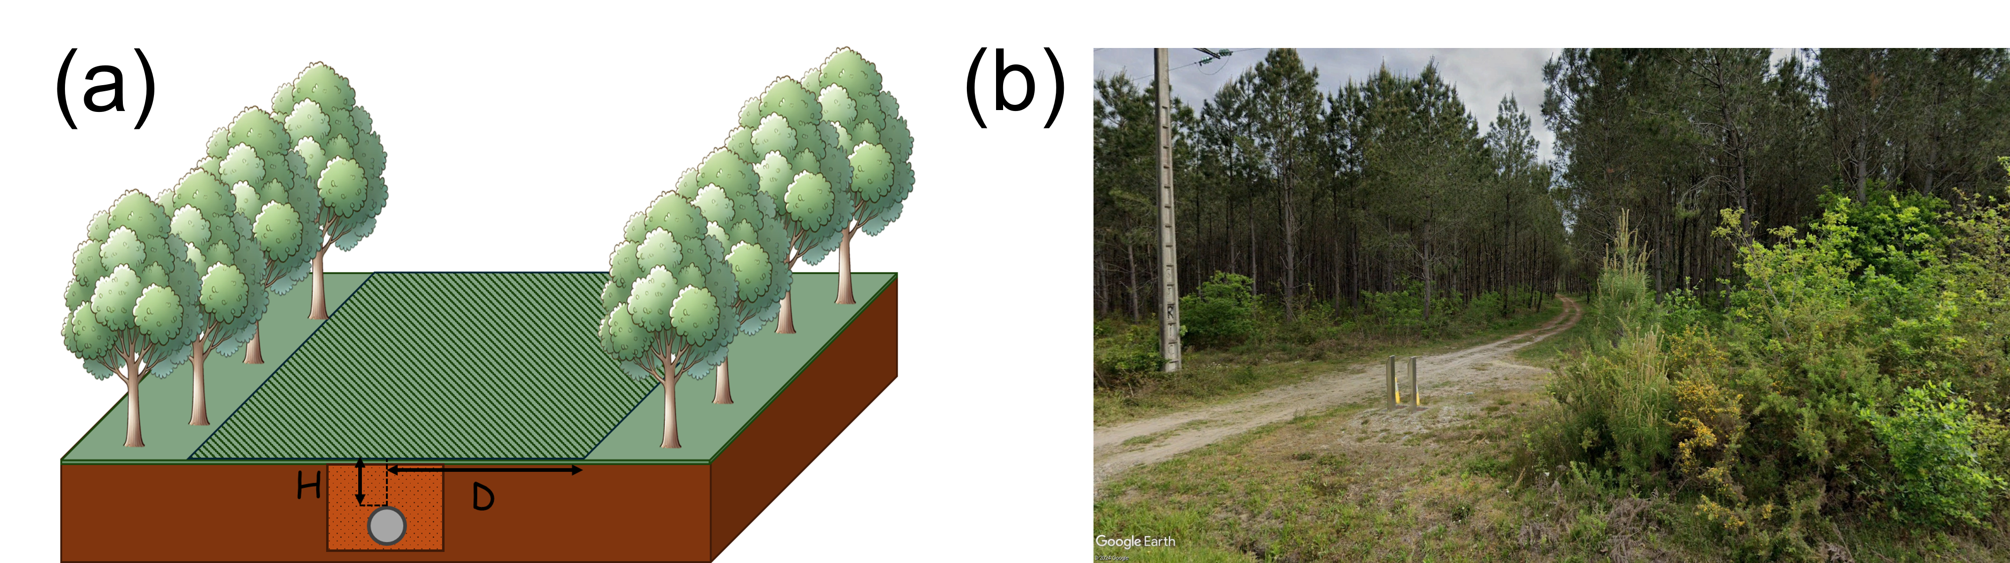

Figure 1: (a) Schematic view of a maintenance strip (hatched zone), (b) Street view of a maintenance strip in the south of France (Google Earth Pro, 2021)
In this paper, an assessment of the thermal response to a wildfire of the soil above the pipeline is proposed. This assessment is based on some geometric and material assumptions regarding the flame front and the composition of the soil. This method provides a rapid evaluation of this thermal response through integral calculations, while remaining conservative. Although this approach may be limited for realistic wildfires scenarios, the results can be used to assess worst-case conditions.
  - Characterization of thermal heat flux impacting the ground surface above pipelines
A large piece of research was performed previously to determine the emitted heat flux of wildfires and especially the emitted radiative heat flux. Moreover, the estimation of the fraction of this energy that can reach a distant target is another aspect of previous research. Often, this part is based on some geometrical considerations using the solid flame model and the estimation of the view factor, which is a dimensionless quantity that describes the fraction of radiation leaving one surface that directly reaches another. This quantity can be determined by using complex analytical equations, abacuses or statistical considerations (such as the Monte Carlo method described in Billaud et al. (2011)).
    - Wildfires radiation flux estimation
The heat flux emitted by a wildfire is the most challenging parameter to assess. Indeed, the diversity of fuel (vegetation), topography and meteorological conditions leads to a variety of methods, as a single universal value would not accurately represent all scenarios. Butler et al. (2004) provided an example of how an emitted heat flux can be assessed with experiments. These experiments, named “International Crown Fire Modeling Experiment”, were established between 1995 and 2001, and the goal was to evaluate a crown fire propagation model through multiple crown fire experiments for a jack pine and black spruce forest. This allowed them to measure the power of this wildfire, with measurements of flame temperatures and radiative heat flux. These data show a pick of temperatures around 1330 °C and a pick of radiant energy flux around 290 kW/m², in the midstory of the canopy. Heymes et al. (2013) provide a list of values from the literature to assess these parameters. The parameter that has a consensus in safety distance studies (studies that aim to determine a distance between a target and the flame front to avoid any damage) is the flame temperature. This flame temperature is commonly estimated to average between 850 °C and 927 °C in many studies involving large fires such as crown fires.
For applying this flame temperature, the popular approach of the solid flame model is used. In this model, the visible flame is idealized as a simple solid geometric shape (usually a parallelepiped) with heat radiation emitted from its surface. The invisible zones of the flame are not considered in the radiative heat flux. Thus, the surface emissive power of the flame E may be calculated as:
$$E=ε \text{·} σ \text{·} T_{f}^{4}$$ | (1)
where ε is the effective emissivity of the flame, σ is the Stefan-Boltzmann constant, and T_{f} is the flame temperature. The present conservative approach led to the selection of ε = 1 (black body hypothesis) and T_{f} = 927 °C, representative of a large crown fire.
    - Incident heat flux on surface above pipelines
With the selected flame model, the radiative heat flux per unit area reaching a target is given by:
$$Q=τ · F ·E$$ | (2)
where $τ$ is the transmissivity of air, F is the view factor and E is the surface emitted power (or emitted flux) previously calculated in Eq(1). The air transmissivity is set to 1, meaning that the air allows all radiation passing through it to be transmitted without any absorption or scattering due to the composition of the environment (humidity, smoke, …).
The view factor represents the fraction of radiation leaving one surface and intercepted by another surface. For determining this value, some authors used geometric considerations for simple cases (Zarate et al., 2008, Rossi et al., 2011) or on the Monte Carlo method for complex cases (Heymes et al., 2013, Billaud et al., 2010). The representation shown in Figure 1 can be simplified by setting certain parameters, as shown in Figure 2.
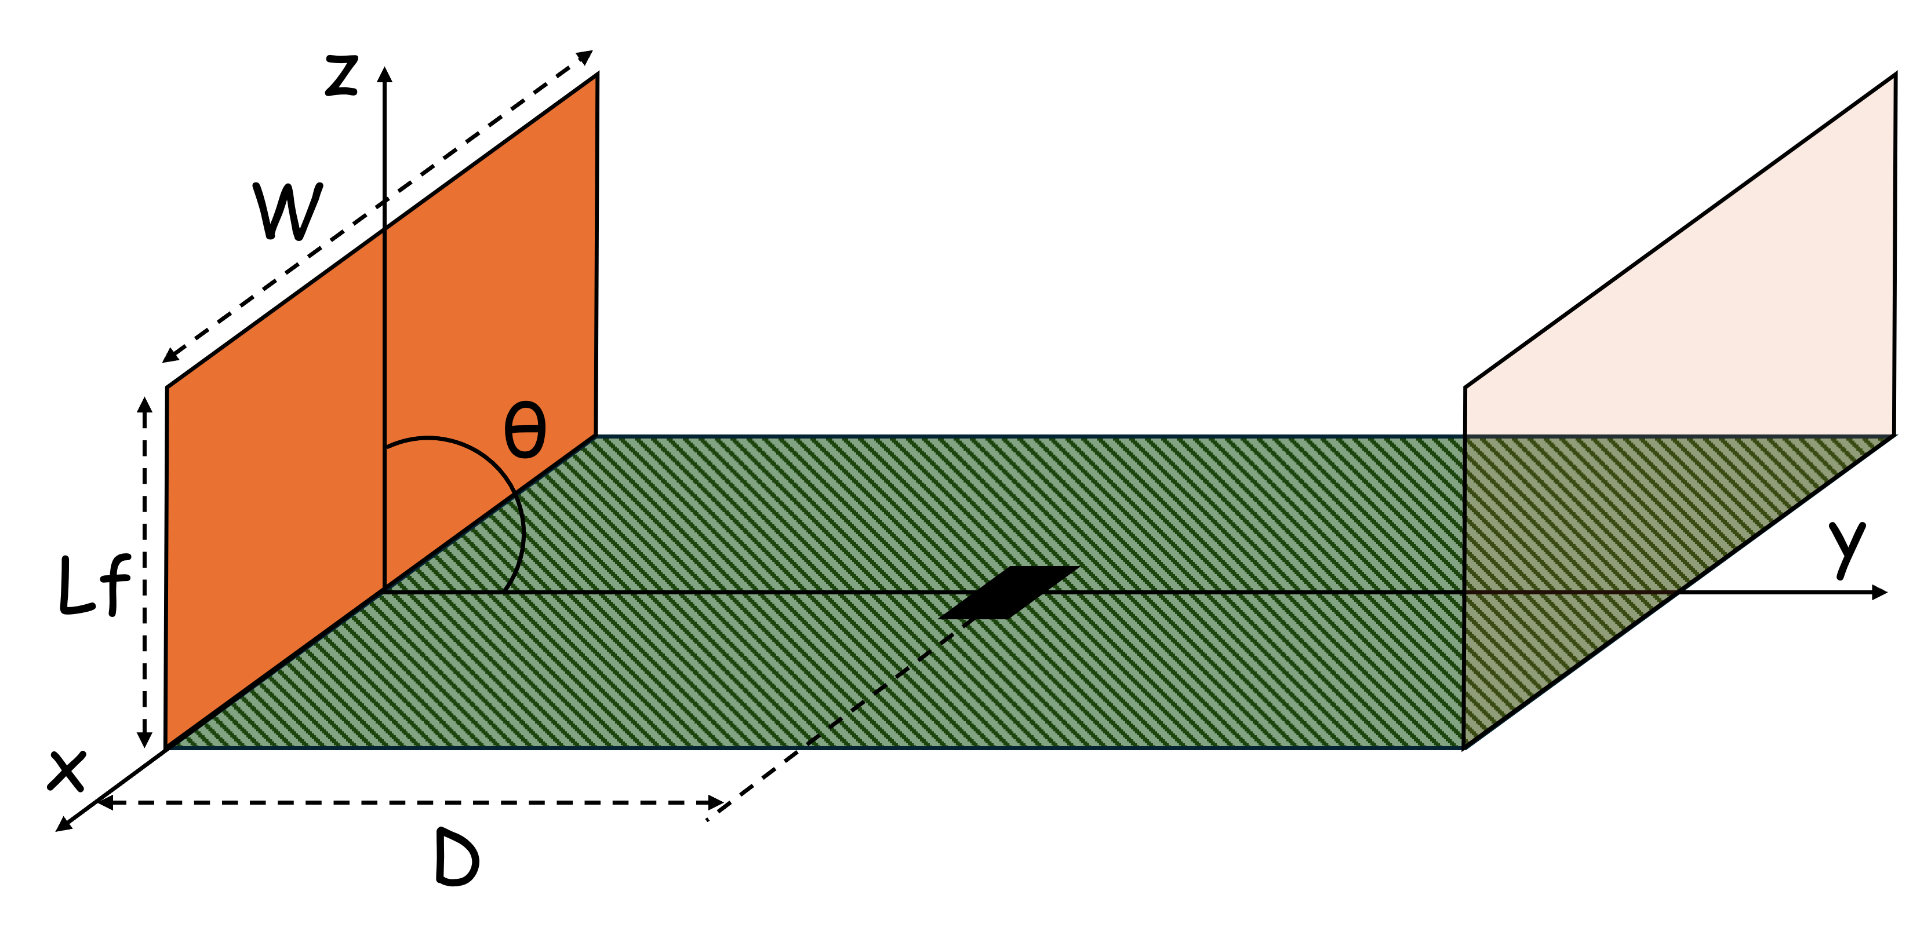

Figure 2: Representation of the geometrical configuration
The view factor of this configuration can be determined by simple geometric considerations using Hamilton and Morgan’s formula, as expressed in equation 15 of Mudan (1987). The choice of this formula was formulated by comparing several formulas available in the literature. In this formulation, the receiver is an element perpendicular to the XY plane, positioned in front of the center of the flame front, which is theoretically the point where the incident heat flux is at its maximum. Thanks to this formula, the angle between the flame front and the ground becomes a variable parameter to perform a parametric study.
With the resolution of Eq(1) and Eq(2), it is therefore possible to evaluate the incident heat flux on a target, the input data for the resolution of the thermal equation in the ground.
  - Soil heat transfer
The problematic of heat transfer in soil is a domain that, like vegetation for forests, is subject to great variation due to the different types of soil that exist. In addition to the variation of mineral and organic composition, the percentage of saturation of air and water is an important aspect for the thermal diffusion. Moreover, in this case, procedures for placing the backfill are also important factors. Indeed, the soil structure is affected by grain size sorting and compaction during operation.
    - Heat equation
A conservative way to estimate the heat transfer in the soil is to solve the transient heat equation in one direction (Richter et al., 2022) as shown in Eq(3).
$$\frac{∂T(z,t)}{∂t}=α \text{·} \frac{∂^{2}T(z,t)}{∂z^{2}}$$ | (3)
Where α is the thermal diffusivity of the soil, T is the soil temperature, and z the depth below ground. To solve this equation, boundary conditions and an initial condition were applied. The temperature at time zero T (z, 0) is assumed equal to 30 °C between the surface and 1 m in depth. Popiel et al. (2000) presented measurements of temperature distribution in the ground from the summer of 1999 to the spring of 2001 in Poland, covering two different ground surfaces (car park and lawn) and various depths. In the summer of 2000, the average ground temperature at depths between 0 and 0.5 m was recorded at 25 °C and 20 °C for the two different soil surfaces, while a temperature close to 20 °C was measured at a depth of 1 m. The selection of 30 °C as a representative value seems to be a reasonable and conservative estimate for the first meter of soil during the dry season in France. While this value is more indicative of surface temperatures during the hot season rather than subsurface ground temperatures, which typically range between 15 °C and 25 °C (as noted in the Météo France database), the difference is negligible for the purposes of this analysis.
At the upper boundary, the surface is continuously exposed to the incident heat flux, which is absorbed by the soil. This is modeled using the Neumann’s boundary condition, as defined as represented in Eq(4), where λ represents the soil’s thermal conductivity.
$$-λ \text{·} \frac{∂T(0,t)}{∂t}=Q$$ | (4)
However, the emissivity of the soil must be considered. Indeed, the emissivity of the previously mentioned type of soil is known and equal to an average value of 0.97 (Zhihao et al., 2006). This condition, close to the black body condition, is integrated to the boundary conditions at the soil surface.
For numerical solution, the equation was discretized using the finite element method and implemented in MATLAB, using the Euler numerical scheme applied for discretization.
    - Parameter selection
In this study, the soil is considered as a homogeneous solid body, without water and air, and where the main parameter that can influence the heat transfer is the choice of the thermal diffusivity of the solid. Realistic models exist such as the model developed by Massmann (2021), where the soil is a heterogeneous body with air and water and where the phenomenon of evaporation is considered. With a conservative approach and a simplified resolution, the homogeneous model is preferred, recognizing its inherent limitations. In addition, the thermal diffusivity is assumed to be constant, despite its inherent dependence on temperature variations. This approach is similarly applied to the thermal conductivity, density, and heat capacity of the soil.
A study was therefore carried out on this parameter in order to be representative of the soils in France that are commonly crossed by the gas network. This soil is mainly composed of limestone, sand, silt, and clay in varying proportions, which, when combined, can form textures such as sandy loam, clay loam, silt loam, … A local study must be performed for any section of the gas network to be representative but in the case of this study, a universal value for thermal diffusivity, found in the literature, was chosen. Ochsner et al. (2001) and Richter et al. (2022) have suggested a thermal diffusivity of 1.8 10⁻⁶ m²/s for a sandy loam soil (with most of the sand). Other values are available in Ochsner et al. (2001) and the literature for a variety of soils but this value is the most appropriate for this study of a worst-case scenario. The thermal conductivity value associated with this thermal diffusivity was chosen to be 3.72 W/m°C, which is relatively high and suggests a material with good thermal conductivity properties.
  - Results
For the following results, the flame front geometry was assumed to have a maximum size in the same way as in Heymes et al. (2013). Thus, a total flame length L_{f} of 40 m and a flame front width W of 100 m were chosen. With these characteristics, the parameters influencing the results are the distance between the flame front and the surface above the pipeline, D, and the flame front tilt, θ, as represented in Figure 2. In order to study these influences, a parametric study was carried out with a single flame front (due to symmetry), the data are shown in Table 1.
Table 1: Results of parametric calculations, for a flame front, with variation of the flame front tilt and the distance between the flame front and the surface above the pipeline
Θ (°) | D = 2  F (-) | Q (kW/m²) | D = 4  F (-) | Q (kW/m²) | D = 5  F (-) | Q (kW/m²)
45 | 0.94 | 110 | 0.94 | 111 | 0.94 | 111
60 | 0.79 | 93 | 0.78 | 92 | 0.77 | 91
75 | 0.63 | 73 | 0.60 | 71 | 0.59 | 69
90 | 0.47 | 55 | 0.44 | 51 | 0.42 | 49
It can be observed that the tilt of the flame front is the main factor influencing the incident heat flux reaching the surface (Q). For these short distances, a variation of a few meters has no effect on the results. In contrast, the variation in the flame front tilt has a significant effect. This observation can be explained from a geometric perspective, i.e., at a small angle θ, the emitted heat flux travels a shorter distance to reach the target. The chosen inclination is hypothetical because with a maximum distance between the two flame fronts of 10 m, the inclination of the flame front cannot be near 45 ° due to total flame height chosen. Thus, the maximum incident heat flux that the surface above the pipeline can receive is 111 kW/m² per flame front, i.e. a maximum of 222 kW/m². Of course, this estimate is only valid for this geometrical configuration with the solid flame model, but it can be interesting to observe the reaction of the soil temperature distribution. In order to study the worst-case scenario, the previously discussed parameters (related to the incident heat flux and the soil properties) were applied. The results, showing the temperature distribution in depth, are shown in Figure 3.

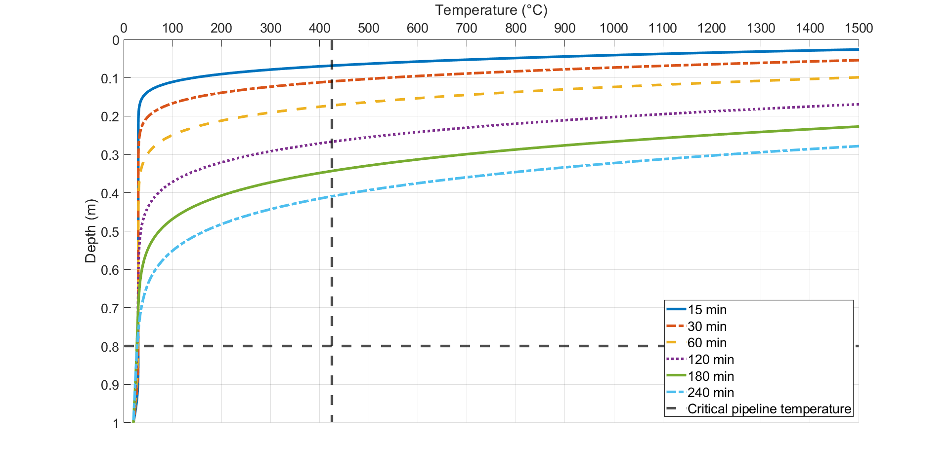

Figure 3: Temperature (°C) profile in the soil for a constant surface heat flux of 222 kW/m² for a flame front inclined at 45° to the ground, with a thermal diffusivity of 1.8 10⁻⁶ m²/s and thermal conductivity of 3.72 W/(m·°C).
Observation of the results showed that at the minimum legal depth of the pipeline (0.8 m), the temperature is far from the critical temperature of the pipeline, which is about 425 °C according to the previous study, even in this worst-case scenario. A hypothetical flame duration was implemented to observe the temperature distribution. Even in a worst-case scenario involving a total incident heat flux of 222 kW/m² sustained for 4 hours (which, in reality, is merely a phenomenon lasting a few minutes), the temperature of the soil in contact with the pipeline remains unaffected and stays at 30 °C. The critical temperature of the pipeline is only reached at 0.4 m for a 4 hour of fire and 0.06 m for a 15 minute of fire. Using this model, it would take 12 to 13 hours of continuous fire exposure to reach the critical temperature of the pipeline.
Another aspect to consider is the possible damage to the anti-corrosion coating. The critical temperature of the coating is assumed at 60 °C in the previous study, but this value is never reached even at a depth of 0.8 m. For 4 hours of maintained heat flux, this value is reached at a depth of 0.6 m. It would take approximately 7 hours of continuous exposure to wildfire to reach this critical temperature.
This shows that the soil layer, even if it has an unfavorable composition, offers effective thermal insulation against external thermal stresses, protecting both the integrity of the pipeline and its coating.
  - Conclusions
This study has focused on a method for estimating the potential impact of wildfires on natural gas pipelines. It has been demonstrated that buried pipelines have a minimum legal depth adapted to the increase in thermal conditions caused by wildfires. Indeed, even in the worst-case scenario, where the incident heat flux reaches 222 kW/m² and sustained for hours, the distribution of temperatures in the ground shows no difference with the depth of the pipeline. This analysis, although simplified, confirms the robustness of current legal depth standards against the risk of wildfire.
However, it is important to be aware of the limitations of these analyses. Here, a hypothetical flame front geometry has been considered, with a uniform repartition of the emissive heat flux due to the solid flame model. It has already been shown in the literature that for wildfires, this model tends to overestimate the results and may be questionable for this application. Then, the model for solving the thermal equation in one dimension in the soil also tends to also overestimate the results. Without the presence of air and water in the soil, where their thermal properties are lower than the solid material of the soil, the distribution of temperature tends to be more important.
Furthermore, to estimate the emitted heat flux of wildfires, a possible way is to use Computational Fluid Dynamics tools as Fire Dynamics Simulator (FDS). This code, developed by the National Institute of Standards and Technology (NIST), is a LES code for low-speed flows, with an emphasis on smoke and heat transport from fires. Several studies have been conducted to simulate vegetation burning under ambient conditions, considering not only the radiative heat flux but also additional factors that affect energy transfer in wildfires. Above ground installations will be investigated with this tool in the future, as these structures are directly impacted by wildfires on the surface. It will be possible to evaluate, with more parameters, the thermal response of equipment. The main limitation of this method is the need for experimental input data, although FDS has already been validated for surface fires, crown fires, and the transition from surface to crown fires in the canopy. Concerning the soil, more realistic models are available to consider a heterogeneous soil, as mentioned previously and solving the heat equation in two dimensions is also an effective way to account for the thermal boundaries at the sides. An approach on the “combustible” soils such as peatlands can also be an interesting topic because of their long burning time (several days or months).
Furthermore, experiments will be conducted to obtain experimental data on buried pipelines and above-ground installations, which will allow for comparison between numerical simulations and real-world conditions.
Nomenclature

D – distance flame front – ground surface above pipeline, m
E – surface emissive power, kW/m²
F – view factor, -
H – distance pipeline – ground surface, m
Q – incident heat flux, kW/m²
Lf – flame length, m
T_{f} – flame temperature, °C
W – flame front width, m
α – thermal diffusivity, m²/s
ε – emissivity of soil, -
θ – flame front tilt, °
λ – thermal conductivity, W/(m·°C)
σ – Stefan-Boltzmann constant, W/(m²·K⁴)
τ – transmissivity of air, -

Acknowledgments
The authors are grateful to GRTgaz, Storengy and Téréga for scientific and financial support to this project.
References
Billaud, Y., Kaiss, A., Consalvi, J.-L., and Porterie, B., 2011, Monte Carlo estimation of thermal radiation from wildland fires. International Journal of Thermal Sciences, 50(1):2–11.
Butler, B. W., 2010, Characterization of convective heating in full scale wildland fires, In Viegas, D. X., ed. Proceedings of the VI International Conference on Forest Fire Research.
Butler, B. W., Cohen, J., Latham, D. J., Schuette, R. D., Sopko, P., Shannon, K. S., Jimenez, D., and Bradshaw, L. S., 2004, Measurements of radiant emissive power and temperatures in crown fires, Canadian Journal of Forest Research, 34(8):1577–1587.
Cohen, J. D., 2004, Relating flame radiation to home ignition using modelling and experimental crown fires, Canadian Journal of Forest Research, 34(8):1616–1626.
Heymes, F., Aprin, L., Forestier, S., Slangen, P., Baptiste Jarry, J., Fran¸cois, H., and Dusserre, G., 2013, Impact of a distant wildland fire on an LPG tank, Fire Safety Journal, 61:100–107.
Massman, W. J., 2021, The challenges of an in-situ validation of a nonequilibrium model of soil heat and moisture dynamics during fires, Hydrology and Earth System Sciences, 25(2):685–709.
Mudan, K. S., 1987, Geometric view factors for thermal radiation hazard assessment, Fire Safety Journal, 12(2):89–96.
Ochsner, T. E., Horton, R., and Ren, T., 2001, A new perspective on soil thermal properties, Soil Science Society of America Journal, 65(6):1641–1647.
Popiel, C., Wojtkowiak, J., and Biernacka, B., 2001, Measurements of temperature distribution in ground, Experimental Thermal and Fluid Science, 25(5):301–309.
Qin, Z., Li, W., Gao, M., and Zhang, H., 2006, Estimation of land surface emissivity for landsat TM6 and its application to lingxian region in north China, In Ehlers, M. and Michel, U., editors, Proc. of SPIE Vol. 6366 636618-1, volume 6366.
Ricci F., Scarponi G.E., Pastor E., Munoz J.A., Planas E., Cozzani V., 2021, Vulnerability of Industrial Storage Tanks to Wildfire: a Case Study, Chemical Engineering Transactions, 86, 235-240.
Richter, E. G., Fischer, E. C., Metz, A., and Wham, B. P., 2022, Simulation of heat transfer through soil for the investigation of wildfire impacts on buried pipelines, Fire Technology, 58(4):1889–1915.
Robinson, C. G., Wattis, Z. E., Dooley, C., and Popovic, S., 2018, Assessment of the threat from wildfires on above ground natural gas facilities, In Volume 2: Pipeline Safety Management Systems; Project Management, Design, Construction, and Environmental Issues; Strain Based Design; Risk and Reliability; Northern Offshore and Production Pipelines, American Society of Mechanical Engineers.
Rossi, J., Simeoni, A., Moretti, B., and Leroy-Cancellieri, V., 2011, An analytical model based on radiative heating for the determination of safety distances for wildland fires, Fire Safety Journal, 46(8):520–527.1
Zarate, L., Arnaldos, J., and Casal, J., 2008, Establishing safety distances for wildland fires, Fire Safety Journal, 43(8):565–575

