|  |  |
| --- | --- |
| cetlogo ***CHEMICAL ENGINEERING TRANSACTIONS***  ***VOL. xxx, 2025*** | A publication of  aidiclogo_grande |
| The Italian Association  of Chemical Engineering  Online at www.cetjournal.it |
| Guest Editors: Bruno Fabiano, Valerio Cozzani  Copyright © 2025, AIDIC Servizi S.r.l. **ISBN** 979-12-81206-xx-y; **ISSN** 2283-9216 | |

Investigation of models for online runaway detection at the esterification of acetic anhydride with methanol

Carsten Schmidta,\*, Jürgen Schmidta, Jens Deneckea, Yongbo Xina

aCSE Center of Safety Excellence (CSE-Institut), Joseph-von-Fraunhofer-Str. 9, 76327 Pfinztal, Germany

bHochschule Karlsruhe – University of Applied Sciences (HKA), Moltkestraße 30, 76133 Karlsruhe, Germany

[carsten.schmidt@cse-institut.de](mailto:carsten.schmidt@cse-institut.de)

Models for the online detection of runaway reactions in chemical plants promise to increase the safe operation of chemical processes. However, a general industrial application has not been achieved for these models. In this publication, three models suitable for online detecting ongoing runaway reactions have been identified from the literature and tested with an RC1 reaction calorimeter for the esterification of acetic anhydride with methanol. In total 16 tests were performed for both, normal operation and runaway reaction, and the usability of the models with the generated data was evaluated.

* 1. Introduction

In the chemical and pharmaceutical industry, runaway reactions of exothermal reactions pose still one of the highest dangers while operating the plants. Runaway reactions are characterized as an uncontrolled reaction in deviation from the normal reaction, potentially exceeding the plants physical thresholds. Recent examples for today’s dangers caused by runaway reactions are the massive styrene release in India in 2020 causing 12 fatalities (Dhara et al., 2021) or the explosion of a waste collection tank in Leverkusen with 7 fatalities (Currenta GmbH & Co. OHG, n.d.). The number of these serious incidents has continued to fall over the last decades, but recent events show that even with today's safety equipment, a full prevention is not in sight in the future. To further reduce this risk, models for the early detection of critical runaway reactions have been developed in the past in addition to primary safety equipment. The early warning models should primarily be used to detect deviations from normal plant operation as early as possible to initiate adequate countermeasures. In the future, these models could be used as an alternative to conventional safety devices if they are sufficiently reliable.

A widespread usage of any of these models in the industry has not been followed since they are usually being validated only for one specific type of reaction and under defined reaction conditions. Additionally, some of the models require input data that is not available as standard in typical industrial systems. The ability to early detect starting runaway reactions and the tendency to produce false alarms during production has not yet been sufficiently investigated.

In this publication, a selection of the models shall be investigated by reactions typically encountered in industry using measurements in a reaction calorimeter (RC1). The well-studied reaction of the esterification of acetic anhydride with methanol with known reaction kinetics was used as a reference in semi-batch operation.

* 1. Runaway detection models

A large number of runaway detection models used for an early detection of a deviation from normal process conditions have been published. In general, they can be divided into three types of models – geometry, stability, and sensitivity-based. Only models suitable for an online application are investigated. The application of these models to batch and semi-batch reactors is given since the required temperature sensors are typically installed in the reactors. A further discussion of available models can be found in (Schmidt et al., 2023).

* + 1. Thomas and Bowes model

|  |  |
| --- | --- |
| $\frac{ⅆT_{R}}{dt}>0$ and $\frac{ⅆ^{2}T_{R}}{ⅆt^{2}}>0$ | (1) |

A geometry based criterion (TB) was proposed by Tomas and Bowes (Thomas, 1961), identifying the loss of control of a reaction by analysing the temperature-time curve. According to this criterion, if the temperature rise of the reactor $T_{R}$ as the first and second derivative over time $t$ accelerates, the reaction is considered to be out of control, potentially leading to a dangerous runaway. It can be expressed with equation (1).

Since the criterion is only based on the internal temperature of the reactor, only the acceleration of the reaction is assumed as a criterion for a runaway. The ability of the system to transfer heat, for example via the cooling system or the environment, is not considered, which according to Semenov (Semenoff, 1928) indicate stable or unstable reaction points.

* + 1. Hub and Jones model

A sensitivity-based model (HJ) developed by Hub and Jones (Hub and Jones, 1986) considers the acceleration of the temperature rise rate of the reactor and the difference between the reactor temperature and the jacket temperature.

|  |  |
| --- | --- |
| $\frac{ⅆ^{2}T_{R}}{dt^{2}}>0$ and $\frac{ⅆ\left(T_{R}{-T_{j}}\right)}{dt}>0$ | (2) |

The difference to the criterion of the earlier developed Thomas and Bowes criterion, which was also suitable for online monitoring of batch and semi-batch reactions, is the consideration of the cooling system temperature which accounts partly for the heat transfer.

* + 1. Divergence model

|  |  |
| --- | --- |
| $$\frac{dV\left(t\right)}{dt}=\int_{t_{0}}^{t_{1}}{div(F\left[x\left(t)\right]\right)dt}>0$$ $$x\left(t\right)=\left[T{}_{R};\frac{dT_{R}}{dt};\frac{d\left(T_{R}-T_{j}\right)}{dt};…\right]$$ | (3) |

The publications of Zaldivar (Zaldívar et al., 2003) and Strozzi (Strozzi et al., 1999) developed the Hub and Jones model further, introducing a time dependent state space variable vector $V\left(t\right)$, which can consist of multiple state space variables as can be seen in equation (3).

The application of the divergence criterion (DIV) to the chosen reaction in this publication has been shown for runaway simulations by (Schmidt et al., 2023), indicating only a short early detection time for an ideal simulation of the reaction. The model will be tested with measurement data of the same reaction in this publication. The measurement data is not smoothed or filtered and therefore a more representative test that ideal simulation data.

* + 1. Test of runaway detection models

Before testing the chosen models with data obtained from the RC1, it is important to check the general performance of the models against reference data. As shown, the TB, HJ, and DIV models from the literature are suitable for the online detection of runaways in plants. For comparison, the temperature data given by (Zaldı́var et al., 2005) were used, where the semi-batch reaction of 40 L of toluene with a dosage of 80 % sulphuric acid in a 100 L reactor was conducted. Only a limited number of points could be depicted from the diagrams in the publication to evaluate the models. Figure 1 (left) shows the temperature of the reactor and the temperature of the jacket over time, the temperature control was able to control the reaction as the so-called “normal operation”. Figure 1 (right) shows the temperature results of the same reaction but with 32 L of toluene, where at a lower toluene volume accumulation of sulphuric acid due to insufficient mixing led to a runaway reaction after approx. 55 minutes. The runaway was stopped with an emergency water injection. Below in Figure 1, the performance of the models for the different operating modes are shown. The divergence model (DIV) does not show false alarms during normal operation and data points can thus not be observed in the diagram (see Figure 1 left). The HJ model produces only false alarms during the start of the dosing, whereas the TB model additionally produces false alarms during cooldown under normal operating conditions. For the runaway initiation (see Figure 1 right), the DIV model leads to valid alarms during the start of the runaway reaction as well as the HJ model. The TB also produces false alarms starting at approx. 75 minutes.

* 1. Experimental setup and test conduction

Figure 1: Left: Comparison of Thomas-Bowes (TB) model, Hub and Jones (HJ) model and divergence model (DIV) for temperature data for normal operation; Right: comparison of the models for runaway reaction; All temperature data obtained from the publication of (Zaldivar et. al., 2005)

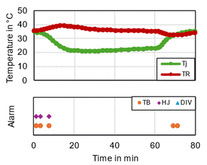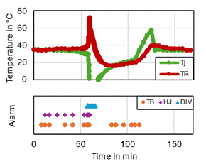

Normal operation

Runaway

For testing the models presented in chapter 2, a reaction calorimeter (RC1) from manufacturer Mettler Toledo has been used. The boundary conditions for the reaction calorimeter are a volume of 1.7 L, a maximum pressure of 60 barg and a maximum temperature of 200 °C which enables runaway reactions. It is equipped with a jacket cooling system using thermal oil, the jacket has a volume of 0,7 L. The system is equipped with a stirrer from manufacturer Büchi AG using an inclined blade stirrer.

* + 1. Experimental setup

In Figure 2 the systems setup in the laboratory is presented. The RC1 reactor is connected to a thermostat from manufacturer Huber using thermal oil. The dosing of components is either possible via a manually opened entry socked or using the pump P010, capable of dosing fluid from a storage vessel with a maximum feed rate of approximately 10 g/min. To sample data on the dosing rate, the storage vessel is located on a scale which is connected to the data acquisition system. Additionally, nitrogen is being used to inert the inside of the RC1. With a sample tube using capillary force, samples can be taken during the conduction of the measurements. To initiate runaway reactions, the thermostat can be deactivated, the stirrer can be turned off or the reaction temperature can be chosen sufficiently low to stop the reaction and accumulate MeOH. After raising the temperature to the reactive zone, a runaway may occur.

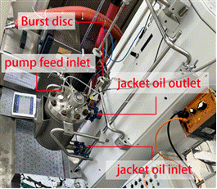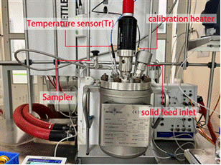

**a)**

**b)**

Figure 2: a) RC1 cooling system; b) RC1 experimental setup

* + 1. Reference reaction

As the reference reaction, the esterification of acetic anhydride (AA) with methanol (MeOH) in semi-batch mode has been selected. AA will be feed first into the RC1, Methanol will be dosed in several dosing steps over time by the feed pump P010. As reaction products, methyl acetate (MA) and acetic acid (AAC) will result, the reaction proceeds without side reactions and is well known from literature (Bohm et al., 2005), the reaction scheme can be seen in equation (8).

|  |  |
| --- | --- |
| $${\left(CH_{3}CO\right)}_{2}O+{CH}_{3}OH→CH_{3}COOCH_{3}+CH_{3}COOH$$ | (4) |

To obtain the maximum reaction conditions, tests using an adiabatic calorimeter (Vent sizing package 2, VSP) were conducted. For stoichiometric ratio AA:MeOH of 2:1 (Figure 3 left) and 1:1 (Figure 3 right) a maximum adiabatic temperature rise of 163,3 °C and a maximum pressure of 17,3 barg was measured. The comparison to literature sources of (Bohm et al., 2005; Leung et al., 1989; Wehmeier, 1994) indicates a similar adiabatic temperature rise but a significant faster reaction, caused by the slightly increased initial temperature (73 °C) compared to the literature experiments (70 °C).

Summarizing, the reaction is exothermal and at temperatures below 100°C sufficiently slow. It stays within the RC1 boundary conditions and is thus suitable to test the runaway detection models.

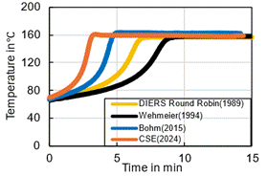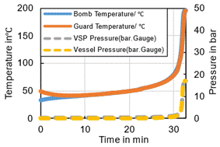

Figure 3: Left: Comparison between VSP2 test for the esterification of AA with MeOH at a stoichiometric ratio of 2:1 with literature data and own measurement data (orange), right: measured temperature and pressure course of a stoichiometric ratio of 1:1.

* 1. Performance tests of runaway detection models with RC1 results

Similar to Figure 1, a comparison of the chosen models with own measurement data from the RC1 for two operational modes of the esterification reaction is shown in Figure 4. In experiment 16, a molar ratio of 1:1 has been dosed to the RC1 at a temperature of 5°C below the onset temperature of the reaction. After the dosing step, the reactor temperature was first controlled to a constant value of 70°C, afterward different temperature jumps replicating permissible temperature adjustments during normal operating conditions were performed. All models produce numerous false alarms during heat-up and cool-down reaction phase. In experiment 9, a molar ratio of 1:1 was dosed at a temperature of 5°C, afterwards, the reaction temperature was increased to 70°C and the thermostat was turned off at 86 minutes. A runaway reaction up to 156°C occurs within 6 minutes (minute 92). The results of the models are almost the same as in experiment 16 indicating a lack of distinguishing between normal operation and runaway reactions. Very small temperature fluctuations during normal operation are the reason causing all models to exceed the critical thresholds from the literature. Without adjustment of these thresholds or further adjustments of the models, an application in industry is not useful.

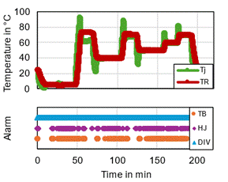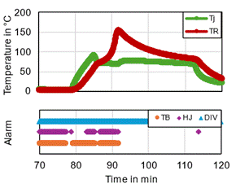

Exp. 16: Heat-up/cool-down

Exp. 9: Runaway

Figure 4: Left: comparison of TB, HJ and DIV models at different temperatures and changes in reaction temperature (heat-up/cool-down) with original publication thresholds; Right: comparison of the models for runaway reaction initiated at 86 minutes

* 1. Improved function of runway detection models

An improved functionality by adjusting the critical thresholds of all models was intended to perform. To evaluate the maximum value $\frac{dV\left(t\right)}{dt}$ for the DIV model as a possible threshold during normal operation, a heating and cooling experiment with water was conducted in the original publication and the obtained value of approximately 0,0005 has been multiplied by 1.5 (Zaldı́var et al., 2005) to set the divergence threshold. This procedure was reproduced with the RC1 calorimeter leading to an increased threshold for the DIV model and improved results. The application of the new threshold can be seen in Figure 5. For the non-runaway experiment 16, the number of false alarms produced decreased from 2921 to 5, for the runaway experiment 9, 11 alarms were triggered with 2 false alarms. However, the new critical threshold delays the sensitivity for detection of the runaway, the detection was achieved 72 s before the maximum temperature occurred correlating to 80 % of the total time to reach the maximum temperature.

For the HJ model, no prior method to determine the critical value has been recommended in the literature. The heating and cooling experiment for the adaption of the DIV model has been used to determine the critical value as well. In contrast to the DIV model, choosing the critical value as maximum values for $\frac{ⅆ^{2}T_{R}}{dt^{2}}$ and $\frac{ⅆ\left(T_{R}{-T_{j}}\right)}{dt}$ lead to overly high thresholds caused by the rapid reduction of the jacket temperature by the thermostat at the end of each reactor’s heating phase. Instead of the maximum, the average of all positive values of the criteria has been chosen leading to increased thresholds. Additionally due to small measurement fluctuations false alarms can be triggered. The application of the new thresholds to the HJ model can be seen in Figure 5. For the non-runaway experiment 16, the number of false alarms was reduced from 824 to 29 with a 96 % reduction rate. For the runaway experiment 9, 99 out of 110 alarms were valid alarms, the first alarm was detected 42 s after the thermostat was turned off correlating to 12 % of the total time to reach the maximum temperature.

For the TB model, the same adjustment of the critical threshold as for the HJ model was chosen with slightly increased thresholds. The application of these thresholds can be seen in Figure 5. For experiment 16, a reduction in false alarms from 935 to 246 was achieved, a reduction of 73 %. For experiment 9, out of 210 alarms, 100 alarms were valid. All other alarms occurred during the heat-up phase.

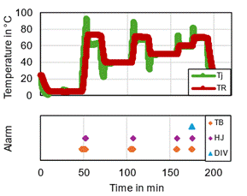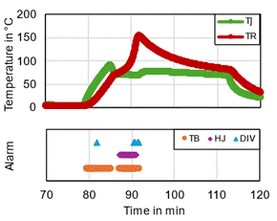

Exp. 16: Heat-up/cool-down

Exp. 9: Runaway

Figure 5: Left: comparison of TB, HJ and DIV models with temperature changes in reaction temperature (heat-up/cool-down) performed with adjusted critical thresholds; Right: comparison of the models for a runaway reaction initiated at 86 minutes

The results of the study are applicable for reactions with a similar reaction speed and only considered tempered reactions. The transfer to other reaction types needs to be evaluated.

* 1. Conclusion

Runaway detection models from the literature were identified according to their applicability for online detection of starting runaway reactions in chemical reactors. Three models, the Hub and Jones model, the divergence model and the Thomas and Bowes models were chosen due to their few parameter requirements, e.g. as reactor temperature and jacket temperature. An elaborate test program with 16 experiments in an RC1 reaction calorimeter for the esterification of acetic anhydride with methanol was conducted to obtain data for normal operation and runaway reactions. All tested models are based on different critical thresholds defined by original publications as zero. However, the application of the models applied with these critical thresholds to the data of the RC1 experiments lead to numerous false alarms during normal operation and runaway reactions, making it impossible to identify a starting runaway reaction. Thus, a new method was presented and evaluated for the models using heat-up and cool-down experiments to adjust all critical thresholds. The adjustments of the critical threshold led to a significant reduction of false alarms during normal operations. However, no model can avoid all false alarms, especially during the heat-up phase, where false alarms can be triggered. For the runaway reaction, the performance of the models was improved, all models were capable of identifying starting runaway reactions. At the same time the adjustment of the critical thresholds led to a delay in detecting the starting runaway reaction. To summarize, the application of online models to detect runaway reactions is a promising approach, further investigation regarding more generic critical thresholds, the application of the models during all reaction phases or data fusion approaches shall be performed.

Nomenclature

t – time, s

TR – reaction temperature, K

Tj – jacket temperature, K

V – state space volume, -

X – conversion, -

References

Adler, J., Zaturska, M.B., 1966. The dependence of flame ignition on transport properties and chemical kinetic parameters. Combust. Flame 10, 273–278. https://doi.org/10.1016/0010-2180(66)90084-8

Bohm, S., Hessel, G., Kryk, H., Prasser, H.-M., Schmitt, W., 2005. Auto-catalytic effect of acetic acid on the kinetics of the methanol/acetic anhydride esterification. Inst. Saf. Res. 53, 53–58.

Currenta GmbH & Co. OHG, n.d. Accident in Leverkusen-Bürrig [WWW Document]. URL https://www.currenta-info-buerrig.de/das-ereignis/

Dhara, Vr., Digumarti, R., Sridhar, G., Gassert, T., 2021. The styrene gas disaster – lessons to learn and the way forward. J. Dr. NTR Univ. Heal. Sci. 10, 117. https://doi.org/10.4103/jdrntruhs.jdrntruhs\_32\_21

Hub, L., Jones, J.D., 1986. Early on-Line Detection of Exothermic Reactions. Plant/operations Prog. 5, 221–224. https://doi.org/10.1002/prsb.720050408

Kummer, A., Varga, T., 2019. Completion of thermal runaway criteria: Two new criteria to define runaway limits. Chem. Eng. Sci. 196, 277–290. https://doi.org/10.1016/j.ces.2018.11.008

Leung, J.C., Creed, M.J., Fisher, H.G., 1989. Round-robin “Vent sizing package” results, in: Int. Symp. Runaway React. pp. 264–280.

Schmidt, C., Schmidt, J., Denecke, J., 2023. Smart overpressure protection devices to protect chemical reactors against exothermal runaway reactions. J. Loss Prev. Process Ind. 82. https://doi.org/10.1016/j.jlp.2023.104996

Semenoff, N., 1928. The theory of the combustion process. Journal of phyiscs. 48, 571–582. https://doi.org/10.1007/BF01340021 (in German)

Strozzi, F., Zaldívar, J.M., Kronberg, A.E., Westerterp, K.R., 1999. On-line runaway detection in batch reactors using chaos theory techniques. AIChE J. 45, 2429–2443. https://doi.org/10.1002/aic.690451116

Thomas, P.H., 1961. Effect of Reactant Consumption on the Induction Period and Critical Condition for a Thermal Explosion. Proc. R. Soc. Lond. A. Math. Phys. Sci. 262, 192–26.

van Welsenaere, R.J., Froment, G.F., 1970. Parametric sensitivity and runaway in fixed bed catalytic reactors. Chem. Eng. Sci. 25, 1503–1516. https://doi.org/10.1016/0009-2509(70)85073-4

Wehmeier, G., 1994. Theoretical and experimental investigation of the processes involved in depressurizing chemical reactors. Fortschr.-Ber. VDI R. 3, 373. (in German)

Zaldívar, J.M., Cano, J., Alós, M.A., Sempere, J., Nomen, R., Lister, D., Maschio, G., Obertopp, T., Gilles, E.D., Bosch, J., Strozzi, F., 2003. A general criterion to define runaway limits in chemical reactors. J. Loss Prev. Process Ind. 16, 187–200. https://doi.org/10.1016/S0950-4230(03)00003-2

Zaldı́var, J.-M., Bosch, J., Strozzi, F., Zbilut, J.P., 2005. Early warning detection of runaway initiation using non-linear approaches. Commun. Nonlinear Sci. Numer. Simul. 10, 299–311. https://doi.org/10.1016/j.cnsns.2003.08.001