 CHEMICAL ENGINEERING TRANSACTIONS  VOL. , 2025 | A publication of  
The Italian Association
of Chemical Engineering
Online at www.cetjournal.it

Guest Editors:
Copyright © 2025, AIDIC Servizi S.r.l.
ISBN; ISSN

Implications for Using Digital Twins to Enhance Safety in Warehouse 4.0 Design
Jing Wu*, Junru Ren, Ole Ravn, Lazaros Nalpantidis
Department of Electrical and Photonics Engineering, Technical University of Denmark, 2800, Kgs. Lyngby, Denmark
jinwu@dtu.dk
Warehouse 4.0 is the digital transformation of traditional warehouse operations by integrating advanced technologies and automation systems. Digital twin (DT) technology is one of the technologies that can be leveraged to enhance safety in warehouse 4.0 design. This paper addresses three research questions: 1. How do these DT technologies affect safety authorities in assessing the quality of designs? 2. How can DT technologies facilitate early consideration of warehouse 4.0 design in the system lifecycle? 3. What are the implications of using DT technologies for risk assessment and the development of safety cases in human-robot collaboration scenarios?
By addressing these research questions, this paper aims to provide a deeper understanding of the role of DT technologies in designing safer intelligent warehouses for the future. Through the integration of DT simulations, early design considerations, and comprehensive risk assessments, stakeholders can leverage DT technologies to proactively enhance safety within Warehouse 4.0 environments, fostering a culture of safety and innovation in the logistics and supply chain industry.

Keywords: Artificial intelligence, Digital twin, Loss prevention, Design for Safety, Warehouse 4.0.
  - Introduction
Intelligent warehouses, often referred to as Warehouse 4.0, are becoming increasingly vital due to the growing digitization and automation of manufacturing processes in supply chain management. The digital transformation and the emergence of new technologies are reshaping Warehouse 4.0, impacting working conditions and altering the associated risks(Ramasubramanian et al. 2022). Ensuring safety has become a shared priority among various stakeholders, including technology providers, system designers, integrators, users, safety experts, and regulatory bodies. During the design phase—the first step in the system lifecycle—addressing safety is critical for preventing hazards and reducing costs(Wu et al. 2024).
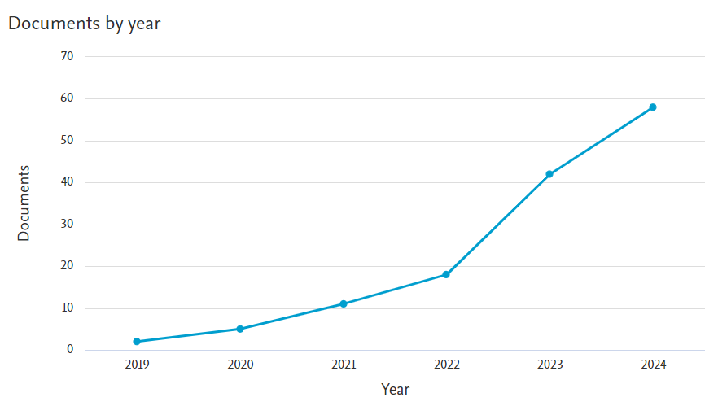
Figure 1: The increasing trend of research in “Warehouse” AND “Safety” AND “Human-Robot Collaboration” AND “Digital Twin” in Scopus.
By searching “Warehouse” AND “Safety” AND “Human-Robot Collaboration” AND “Digital Twin” in Scopus, there are 136 documents are found as shown in Figure 1, which indicates that it is a relatively new research domain since 2019. After 2022, there is a dramatic increase in the trend of carrying out relevant research. Of the 136 documents, 50 have more than 10 citations. The 50 research papers are studied more carefully in the paper. Reviewing these documents is believed to give a baseline for the research in the paper and clarify critical gaps and opportunities within the current digital twin (DT) technology application for safety, helping to align the research objectives with warehouse 4.0 industry needs. This paper explores three key research questions:
- How do these DT technologies affect safety authorities in assessing the quality of designs?
- How can DT technologies facilitate early consideration of warehouse 4.0 design in the system lifecycle?
- What are the implications of using DT technologies for risk assessment and the development of safety cases in human-robot collaboration scenarios?
By addressing these questions, the paper seeks to provide deeper insights into the role of DT technologies in creating safer, more efficient intelligent warehouses, with a particular focus on robotic solutions in Warehouse 4.0 design(Javaid et al. 2021; Huang et al. 2021).
  - Background and Literature Review
    - Warehouse 4.0 and digital transformation
Warehouse 4.0 is driven by the digitization and automation of processes to meet the evolving demands of modern supply chain management. The ultimate goal is to design warehouses that balance human workers with the use of Industry 4.0 technologies. Industry 4.0 technologies transform warehouse operations, enabling more efficient, reliable, flexible, and scalable logistics systems. DT is one of the industry 4.0 technologies(Sharma et al. 2022). DT is a software tool that enables the digital reflection of real-life scenarios. Researchers can conduct lifelike 3D modelling on the studied object and its surrounding environments, simulate the actions of the subject through precise dynamics and kinematics computing, and optimize algorithms based on simulation results. It is a toolkit integrated with modelling, simulation, and visualization functions via the communication between the physical machine and its digital counterpart. In some of the literature(Tao et al. 2019), the data communication infrastructure between the physical and digital components can determine the difference between concepts such as digital twins, digital models, and digital shadows. DT has been applied in many research fields for various purposes. DT is used for safety-related applications(Agnusdei, Elia, and Gnoni 2021; Zio and Miqueles 2024) because there are new safety challenges in warehouse 4.0.

    - Safety challenges in warehouse 4.0
By examining the examples of robot-related fatal accidents in Table 1, the factors that may contribute to accidents can be categorized into unsafe human behavior, unsafe robots, unsafe human-robot collaboration, and failure in management. Human errors, such as entering restricted zones, misinterpreting safety warnings, or failing to adhere to established protocols, are a leading cause of accidents in automated environments. Malfunctions or failures in robotic systems, including hardware defects, software bugs, or unpredictable behaviors, pose a direct risk. As warehouses increasingly implement collaborative robots (cobots) designed to work alongside humans, ensuring safe interaction becomes a critical challenge. Poor management practices, such as inadequate safety training, lack of regular maintenance, or insufficient risk assessments, can manifest hazards. Management failures can also include delays in adopting necessary safety technologies or neglecting to enforce safety protocols rigorously.
To address these challenges, it is widely accepted that hazards should be mitigated or eliminated during the design phase. Incorporating safety measures early on ensures inherent safety by addressing potential risks before they manifest in the operational environment. The next section will explore the role of DT in design for safety(Wu et al. 2024).
Table 1: Robot-related fatal accidents examples (Source: U.S. Occupational Safety and Health Administration)
No. | Date | Accident title | Causes of the accident
1 | 02/22/2024 | Employee Dies From Chest Injuries When Crushed By Robot Arm | Unsafe Entry into the Robotic Area  Failure to Deactivate Machinery  Human error  Lack of adequate safeguards
2 | 08/28/2023 | Employee Is Killed When Head Is Crushed Between Die | The accident was caused by the lack of proper safety protocols, such as lockout/tagout, and the employee's manual interaction with the injection molding machine's drop tray while it was still in operation, which resulted in the mold dies cycling and fatally injuring her.
3 | 11/29/2022 | Employee Is Killed While Lubricating Machine Rollers | The accident was caused by the activation of the robot arm due to the employee inadvertently triggering the photo eye sensor while performing maintenance in an energized robotic cell, compounded by the absence of proper lockout/tagout procedures and safety protocols.
4 | 09/01/2022 | Employee Is Killed When Crushed By Spot Welding Robot | The cause of this accident was the failure to properly lock out the spot welding robot before the employee began working with the welding tip cartridge. Since the robot was not deactivated, it unexpectedly activated while the employee was placing welding tips into the cartridge, resulting in fatal crushing injuries to the employee's upper torso.
5 | 11/03/2021 | Employee Is Killed When Entangled In Machine | The cause of this accident was the failure to properly isolate and lock out the gantry robot while the employee was performing maintenance work on the deenergized machine.
6 | 01/14/2021 | Employee Is Killed When Caught In Between Okura Robotic Pall | The cause of the accident was the employee working inside the robotic cell cage without properly deactivating or locking out the Okura Robotic Palletizer arm. While the employee was servicing the machine, the robotic arm remained energized and active, causing it to strike and trap the employee between the arm and the rollers, resulting in fatal crushing injuries.
7 | 10/16/2019 | Employee Is Struck By Rejected Fiber Concrete Board And Crus | The accident was caused by a combination of human error in bypassing LOTO safety procedures, failure to isolate hazardous energy, and inadequate safety controls (like guarding or machine shutdown mechanisms).
8 | 01/10/2019 | Employee Is Crushed And Killed By Wind-Up Machine | The accident was caused by a combination of failure to lockout the machine, lack of proper safety guarding or interlocks, unsafe positioning, and potentially inadequate training or supervision. These factors created a hazardous situation where the machine's automatic primary arm cycled while the employee's head was in its path, resulting in a fatal injury.
  - Digital Twin Technology and Design for Safety
    - DT in assessing design from safety authorities’ perspective
DT can facilitate digital scene constructions in the design phase, allowing experts from safety authorities to have an intuitive view of the aspect of the designed system, its surroundings, and the objects to interact with. This technology facilitates a more comprehensive evaluation of the design specification, reasonability of application scenarios, and the feasibility of machines and equipment in general. By mathematical modelling and dynamics computing, the designed system is functionalized to mimic jobs in real life, where the experts can zoom into units such as single motors and sensors, checking performance based on data instead of making predictions based on prior knowledge (e.g. domain knowledge) and description in natural language (e.g. operating manuals).
Despite their potential, DTs also present challenges for safety authorities. Discrepancies between the DT and the real system, such as those caused by incomplete modeling of software behavior or environmental interactions, can undermine their reliability. Addressing this gap requires robust methods for synchronizing the DT with the real system, as well as continuous validation to ensure fidelity. This point will be discussed further in the discussion section.
    - DT in early design phases from the designer perspective
Applying digital twins in the early design phase helps with set design, equipment selection, and robot function design. Specifically, by setting locations of cargo and room facilities, designers can make plans on room space, layout, and routes for humans and robots walking. Additionally, there are numerous well-built models of robots and smart sensors to be imported to DTs to test the abilities of task conducting, efficiency, and robustness and select the types with the best values. Eventually, by integrating the designed layout with preferred implementations, the designer can evaluate the overall design quality without early purchase cost.
    - DT for risk assessment from OHS professionals’ perspective
In the case of human-robot collaboration, besides the application in the design phase, DTs can be used as a visualization tool to monitor the real-time movement of robots and humans. This function is also called digital shadow, where the states, such as the positions of each agent, will be sent to the DT, and update the movement of the digital counterparts. The real-time visualization enables quantitative remote monitoring of the warehouse status. Risk assessment methods can be implemented, and data can be collected from the real world. For example, people can assess the collision risk once receiving the position of robots and humans based on trajectory prediction algorithms, and manually interevent robot actions if necessary.
  - Case study
Mobile robots are commonly responsible for logistics tasks, leading to smart warehouses. Safety assessment of the working mobile robots in the design phase enables long-term and efficient system operation. However, hazards and risk management are complicated on mobile robots due to their large working area and necessary interaction with humans and surrounding objects.
The case study carried out by Ren et al.( 2024) from our research group performed function-centric hazard identification (step 1) and verified hazards through DT (step 2). In addition, the study performed a quantitative risk assessment (step 3) using the Kalman filter, taking the collision hazard as an example. In this study, the DT provides a platform for designing and validating the risk estimation module.

In this case study, the simulation is used to verify and complement additional hazards. A Kalman filter-based method is used to estimate the collision risk score of the system, to determine the probability and severity of the risk. More results can be found in PhD thesis by Ren (2024).
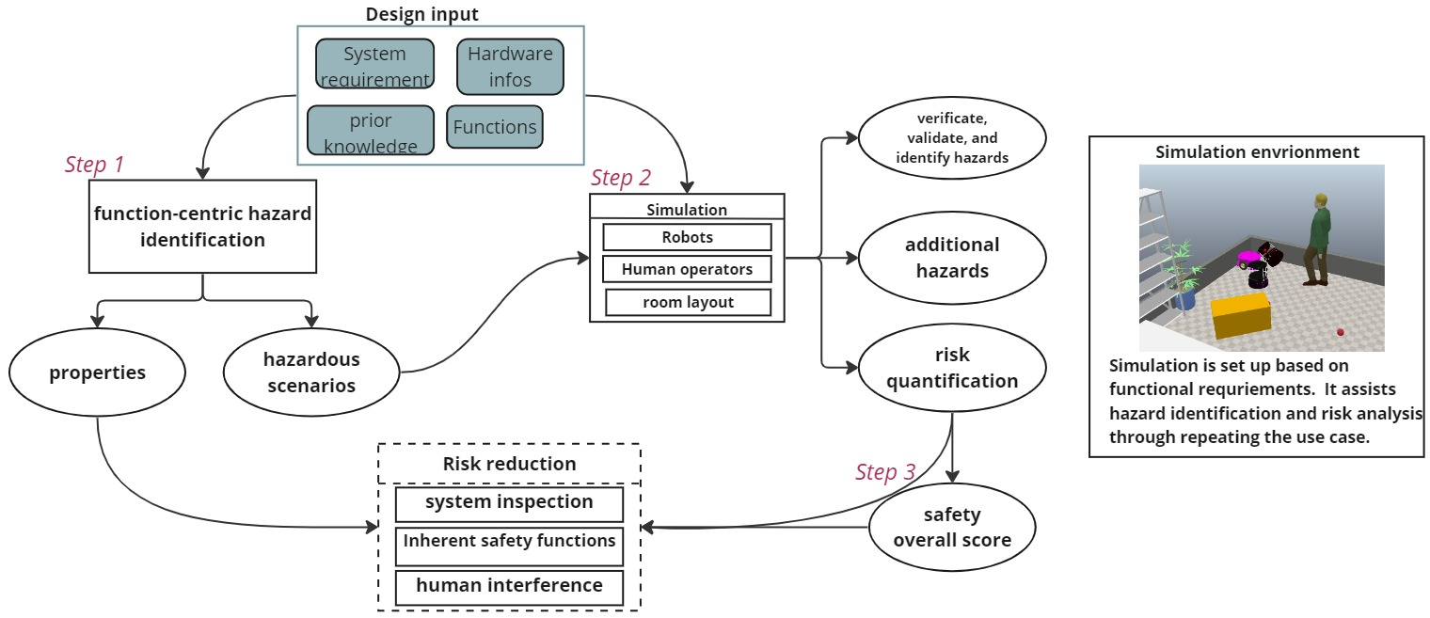
Figure 1: The illustration of implementing simulation in the safety analysis process of a human-robot collaboration autonomous system [adapted from (Ren et al. 2024)].
  - Discussions
    - DT for inherent safety
As the safety requirements for robotics continue to grow, there is a concern that the corresponding robotics risk control measures are not keeping pace. The standardized three-step risk control approach for robotics includes:
- Step 1-Inherently safe design measures
- Step 2-Safeguarding implementation of complementary protective measures
- Step3-Information for use
Functional safety concepts are widely accepted and form an integral part of the three-step risk reduction measures. These concepts aim to reduce risks by implementing safety functions and mechanisms within the robot system.
However, the validation and verification techniques, or testing methods, to assess whether the requirements for risk reduction are met are often insufficient. Contextual understanding is crucial in testing, as it requires considering the specific operating environment, potential interactions with humans, and the range of potential scenarios and risks that the robot may encounter. Effective testing methods should encompass real-world conditions and adequately evaluate the robot's performance and safety features to ensure they meet the desired risk reduction goals. In this context, DT technology can play a pivotal role, particularly in the preliminary design and optimization stages. By simulating and testing machine functionalities early in the development process, DT allows for the integration of safety measures earlier in the system lifecycle, ensuring that risks are addressed from the outset.
    - The gap between the real system and the digital model
One of the fundamental challenges in developing DTs for complex systems like mobile robots lies in accurately replicating both the physical and software components of the real system. While it is relatively straightforward to model geometrical, dynamical, and physical properties, capturing the behavior driven by internal software presents a significant hurdle.

This experience highlights the inherent complexity of bridging the gap between real systems and digital models. Simplifications or assumptions made during modelling can fail to account for the emergent, dynamic nature of real-world operations. This issue is particularly relevant when developing DTs for third-party systems, where full visibility into internal processes and decision-making logic may not be possible. Ultimately, achieving high fidelity in DTs requires a comprehensive approach that integrates not only physical and dynamical accuracy but also the behaviors dictated by software and environmental interactions.
  - Conclusions

The aim of the present work was to provide a deeper understanding of the role of DT technologies in designing safer intelligent warehouses for the future. Through the integration of DT simulations, early design considerations, and comprehensive risk assessments, stakeholders can leverage DT technologies to proactively enhance safety within Warehouse 4.0 environments, fostering a culture of safety and innovation in the logistics and supply chain industry. The case study showed the capability of DT to enhance risk management. The discrepancies between the real system and the digital models are focused in the discussion. It may undermine their trust in digital model performance, which requires a more science-based framework and method to validate the assumptions behind the digital models against the real systems. The goal-oriented modelling approach (Jesus, Manjunath, and Daun 2024) could be the cost-effective option for developing digital twins. Fundamentally, the action theory(Wu et al. 2024) may play an important role in such a goal-oriented modelling approach. The work by Wu et al.(2018) has demonstrated the value of applying action theory for monitoring robotic systems. Future work will explore the opportunities offered by action theory and digital simulation platforms such as Omniverse Isaac Sim to develop safety cases for testing and validation of robotics applications.

References
Agnusdei, G. P., Elia V., and Maria Grazia G., 2021. A Classification Proposal of Digital Twin Applications in the Safety Domain, Computers & Industrial Engineering 154, 107137. https://doi.org/https://doi.org/10.1016/j.cie.2021.107137.
Huang, Z., Shen Y., Li J., Fey M., and Brecher C., 2021. A Survey on AI-Driven Digital Twins in Industry 4.0: Smart Manufacturing and Advanced Robotics, Sensors 21 (19). https://doi.org/10.3390/s21196340.
Javaid, M., Haleem A., Singh R. P., and Suman R, 2021. Substantial Capabilities of Robotics in Enhancing Industry 4.0 Implementation, Cognitive Robotics 1: 58–75. https://doi.org/10.1016/j.cogr.2021.06.001.
Jesus R., Meenakshi Manjunath, J., and Daun M., 2024. Towards a Goal-Oriented Approach for Engineering Digital Twins of Robotic Systems, In Proceedings of the 19th International Conference on Evaluation of Novel Approaches to Software Engineering, 466–73. SCITEPRESS - Science and Technology Publications. https://doi.org/10.5220/0012681500003687.
Ramasubramanian, A. K., Mathew R., Kelly M., Hargaden V., and Papakostas N., 2022. Digital Twin for Human-Robot Collaboration in Manufacturing: Review and Outlook, Applied Sciences (Switzerland) 12 (10). https://doi.org/10.3390/app12104811.
Ren, J., 2024. Digitalizing Autonomous Systems Monitoring, PhD thesis, Technical University of Denmark.
Ren, J., Wu J., Ravn O., and Nalpantidis L., 2024. Safer Human-Robot Collaborative Environments​ through in-Simulation Risk Estimation and Function-Centric Hazard Analysis​, In The 5th International Conference on Supply Chain (5th Olympus ICSC), Katerini, Greece, from May 24th to 26th, 2024.
Sharma, A., Kosasih E., Zhang J., Brintrup A., and Calinescu A., 2022. Digital Twins: State of the Art Theory and Practice, Challenges, and Open Research Questions, Journal of Industrial Information Integration 30. https://doi.org/10.1016/j.jii.2022.100383.
Tao, F., Zhang H., Liu A., and Nee A. Y. C., 2019. Digital Twin in Industry: State-of-the-Art, Ieee Transactions on Industrial Informatics 15 (4): 2405–15. https://doi.org/10.1109/TII.2018.2873186.
Wu, H., Bateman R., Zhang X., and Lind. M., 2018. Functional Modeling for Monitoring of Robotic System, Applied Artificial Intelligence 32 (3): 229–52. https://doi.org/10.1080/08839514.2018.1447431.
Wu, J., Lind M., Li R., and Zhang X., 2024. Chapter Five - Integration of Process Safety Principles in Energy System Design, In Methods in Chemical Process Safety, edited by Faisal I Khan, Efstratios N Pistikopoulos, and Zaman Sajid, 8:133–72. Elsevier. https://doi.org/https://doi.org/10.1016/bs.mcps.2024.07.003.
Wu, J., Ren J., Li R., Zhang X., and Lind M., 2024. Decoding Risk Management: The Crucial Means-End Aspect of Countermeasures and Hazards, In International Workshop on Functional Modeling and Safety Related Issues of Socio-Technical Systems, 13–16.
Zio, E., and Miqueles L., 2024. Digital Twins in Safety Analysis, Risk Assessment and Emergency Management, Reliability Engineering and System Safety, 110040. https://doi.org/10.1016/j.ress.2024.110040.

