|  |  |
| --- | --- |
| cetlogo ***CHEMICAL ENGINEERING TRANSACTIONS***  ***VOL. xxx, 2025*** | A publication of  aidiclogo_grande |
| The Italian Association  of Chemical Engineering  Online at www.cetjournal.it |
| Guest Editors: Bruno Fabiano, Valerio Cozzani  Copyright © 2025, AIDIC Servizi S.r.l. **ISBN** 979-12-81206-xx-y; **ISSN** 2283-9216 | |

LNG Operational and Navigational Risk: An Integrated Risk Assessment for a Resilient LNG Terminal

Tomaso Vairoa, Dario Cangelosib, Alessandro Manfredic, Margherita Pettinatoa, Bruno Fabianoa,\*

a DICCA – Civil, Chemical and Environmental Engineering Department – Polytechnic School - University of Genoa, Via Opera Pia, 15 – 16145 Genova, Italy

b CETENA S.p.A., Via Ippolito d'Aste 5, 16121 Genova, Italy

c GNLMed S.r.l. Via Gabriele d'Annunzio, 2/75, 16121 Genova , Italy

brown@unige.it

Liquefied Natural Gas (LNG) terminals present a complex risk environment due to the inherent hazards associated with LNG handling and the navigational challenges within port areas. A comprehensive risk assessment (RA) framework for LNG terminals, encompassing both LNG operational and navigational risks in the terminal area is presented. Key factors such as LNG transfer operations, storage conditions, and vessel traffic patterns are systematically analysed. The framework incorporates navigational risk elements, including collision, grounding, and environmental conditions, to provide an all-embracing risk profile. Through extensive case studies and scenario analyses, the RA framework demonstrates its efficacy in identifying critical risk contributors and assessing mitigation measures. The results highlight the importance of a dual-focus approach in risk management, considering interdependencies between the components of the sociotechnical infrastructure and systems, e.g. in port areas, combining operational safety protocols for LNG handling with robust navigational safety strategies. The integrated assessment can support informed decision-making and enhance the overall safety and reliability of LNG terminal operations, ultimately contributing to a safer and more resilient energy transport infrastructure and port environment.

* 1. Introduction

The global energy landscape has witnessed a significant shift over the past few decades, driven by the need for cleaner and more sustainable energy sources, coupled with the awareness of novel safety challenges (Pasman et al., 2024) connected to emerging risks to be properly evaluated to ensuring safety, protecting the environment, and sustaining the reliability and resilience of energy systems (Vairo et al., 2023a). Liquefied Natural Gas (LNG) has emerged as a vital component in this shift, serving as a bridge fuel that helps reduce carbon emissions compared to traditional fossil fuels like coal and oil (Vairo et al., 2014). Additionally, it has played a crucial role in enhancing energy security and delivering energy to Europe during crises posed by Covid 19 and the conflict in Ukraine. As a result, LNG imports to Europe grew to a historical peak of 126.6 MT, making the region the second largest in the world in 2022, with a yearly increase in Italy corresponding to 3.6 MT (IGU, 2023). The construction and operation of LNG terminals have expanded rapidly to meet the growing demand. These terminals, which facilitate the import, export, storage, and transfer of LNG, are crucial for ensuring the uninterrupted natural gas supply to various regions. However, the complex nature of LNG operations, combined with navigational activities in and around terminal areas, poses significant safety and risk management challenges (Vairo et al., 2021). Risk management for LNG terminals is a multifaceted endeavour that involves addressing operational risks associated with LNG handling, as well as risks linked to vessel traffic. Operational risks may include potential incidents such as leaks, spills, and equipment failures during LNG transfer and storage, which can have severe consequences, including fires, explosions, and environmental damage and in perspective require advanced preventive solutions e.g. real-time monitoring, predictive capability, and increased emergency response. (Vairo et al. 2023b). Navigational risks are equally critical, as LNG terminals are often located near busy waterways where vessel congestion increases the likelihood of collisions, groundings, or allisions (accidental contact with stationary objects). Environmental factors such as poor visibility, strong currents, and severe weather can exacerbate these navigational risks, adding further uncertainty to the overall complexity of risk management. This study aims to develop a comprehensive Risk Assessment (RA) framework integrating both LNG operational risks and navigational risks in the terminal area, by combining probabilistic risk analysis techniques and advanced simulation tools to evaluate the likelihood and potential consequences of incidents. By analyzing key factors such as LNG transfer operations, storage conditions, vessel traffic patterns, and environmental conditions, this study seeks to provide a detailed and all-encompassing risk profile for LNG terminals. The primary objective of this research is to bridge the gap between operational and navigational risk assessments by creating an integrated model that can support more effective risk management strategies. The here presented framework is intended to serve as a decision-making tool for LNG terminal operators, maritime authorities, and policymakers, facilitating the implementation of targeted risk mitigation strategies. The following sections will outline the RA methodology, discuss the analysis of key risk factors and present the results, including recommendations for enhancing safety and resilience at LNG terminals.

* 1. Methodology

The methodology and procedures to be followed for the evaluation of risk from LNG installation in port areas

can be distinguished into three major phases, as detailed in the following.

a) Hazard assessment and prioritization performed by following activities:

* Hazard identification (HazId);
* Definition of probability and severity classes;
* Definition of the ALARP matrix;
* Definition of priorities.

b) Risk integration based on the following steps:

* Definition of different risks for different types of vessels;
* Definition of barriers;
* Construction of specific Bow-Ties.

c) Residual risk evaluation.

* + 1. HazId and Bow-Tie definition

Hazard prioritization relies on a brainstorming approach that allows, by analysing known hazards, to define potential accident scenarios (OSHA, 2013). The analysis was conducted through the mechanism of expert elicitation, a technique for identifying hazards that is based on the experience and knowledge of experts in the field. In the presence of a scarcity of statistical data, e.g. connected to so-called emerging risks, estimates by expert elicitation can be used as an effective basis to assess the overall risk associated with particular events or situations. The hazards that have been identified are as follows:

* Loss of control - steering and propulsion;
* Loss of buoyancy/stability;
* Unavailability of external manoeuvring gear (tug);
* Electro-instrumental failures;
* Adverse weather conditions;
* Ground incident (fire, release, explosion);
* Pilot unavailability;
* Human error (on board) - incorrect/untimely action/no action;
* Presence of other ships/smaller units;
* Human error (shore) management;
* Electro-instrumental failure ashore management.

The classification of probabilities and consequences was carried out starting from the approach outlined in IALA (2022) and connected reference figures. On these bases, since the focus of this preliminary study was on the possible consequences of collisions and allisions, the risk was considered in an aggregate facet, using the severity classes in Table 1 and the probability classes shown in Table 2.

Table 1: Severity classes.

|  |  |  |  |  |
| --- | --- | --- | --- | --- |
| Minimal | Low | Medium | High | Very High |
| No damage / insignificant injuries | Limited damage / minor injuries | Short-term damage / reversible injuries | Long-term damage / severe injuries | Irreversible damage / irreversible injuries or losses |

To the purpose of presenting the overall methodology, the research considers nautical risk in the applicative context by actual assessing the geometrical compatibility between the LNG carrier and the involved site. A set of reference LNG carriers, to be considered as a benchmark for the analyzed port environment are:

LNG Carrier LOA 180 with 30,000 m3 payload; LNG Carrier LOA 160 with 20,000 m3 payload;

LNG Carrier LOA 120 with 7,500 m3 payload.

Table 2: Probability classes.

|  |  |  |  |  |
| --- | --- | --- | --- | --- |
| Very rare | Rare | Occasional | Frequent | Very frequent |
| No more than once in 20 years | Once in 2 to 20 years | Once in 2 months to 2 years | Once in 1 week to 2 months | At least once a week |

2.2 Residual risk evaluation

Let us consider the risk of an incident, e.g., LNG leakage during transfer operations. The initial risk (𝑅initial) is determined by the product of the incident likelihood (𝑃initial) and its consequence (𝐶initial); in order to reduce the likelihood of the incident, a set of preventive controls is applied, attaining an overall effectiveness (𝐸combined) provided by Eq. (2), where 𝐸𝑖 is the effectiveness of each individual control, and 𝑛 is the total number of designed controls.

𝑅initial = 𝑃initial ∙𝐶initial (1) $E_{combined}= 1-\prod_{i=1}^{n}{(1-Ei)}$ (2)

The residual incident likelihood after applying preventive controls (𝑃residual) is given by Eq. (3), while mitigated consequence resulting from implementation of protective barriers are provided by Eq. (4).

𝑃residual = 𝑃initial ∙ (1 − 𝐸combined) (3) 𝐶residual = 𝐶initial ∙ (1 − 𝑀) (4)

where 𝑀 is the effectiveness of the mitigative measures.

The residual risk (𝑅residual) after applying both preventive and mitigative measures is calculated as:

𝑅residual = 𝑃residual ∙ 𝐶residual  (5)

* 1. Results and discussion

The preliminary HazId based also on expert elicitation allows to define the ranking summarized in Table 3.

Table 3: Hazard ranking.

|  |  |  |  |
| --- | --- | --- | --- |
| Identified hazards | LOA180 | LOA160 | LOA120 |
| Loss of control - steering and propulsion | No action required | No action required | No action required |
| Loss of buoyancy/stability | No action required | No action required | No action required |
| Unavailability of external manoeuvring gear (tug) | ALARP | No action required | No action required |
| Electro-instrumental failures | No action required | ALARP | No action required |
| Adverse weather conditions | Reduction needed | ALARP | ALARP |
| Ground incident (fire, release, explosion) | No action required | No action required | No action required |
| Pilot unavailability | No action required | No action required | No action required |
| Human error (on board) - incorrect / untimely action | Reduction needed | ALARP | No action required |
| Human error (on board) - no action | Reduction needed | ALARP | No action required |
| Presence of other ships / smaller units | ALARP | No action required | No action required |
| Human error (shore) management | No action required | No action required | No action required |
| Electro-instrumental failure ashore mgm. | No action required | No action required | No action required |

The main LNG Carrier safety in the harbour area is connected to the approach, turning and berthing manoeuvre, mooring alongside the unloading terminal, and LNG unloading. It is already evident from the preliminary assessment that the size of the LNG Carrier represents an inherent element of risk reduction. In that, smaller ships are more agile and consequently have improved manoeuvring performance in restricted waters thus determining a lower probability of occurrence of considered events, i.e., impacts and collisions. The relevant parameters affecting structural crashworthiness in the last event include the striking ship speed, impact angle and impact location. The identified risks liable to be reduced by the implementation of preventive and protective barriers, strictly depending on the involved vessel type, are as follows: manoeuvring LNG Carrier colliding with Container Carrier; manoeuvring Container Carrier colliding with LNG Carrier; manoeuvring LNG Carrier colliding with a dock. On these grounds, intending to identify the consequences of vulnerabilities in combination with the ability of the system to face/resist different disturbances, it was possible to develop six specific Bow-Ties accounting for all the given combinations, obtaining the results that for the sake of brevity are summarized in Table 4, including the effectiveness evaluation of passive, active (i.e. strictly including separate elements of “detect-decide-act”, and procedural barriers. The overall results will help the specification of monitoring and decision-making services for effective port area management, surveillance and recovery actions planning.

Preventative Barriers

1. Dock Layout

Barrier type: Passive, Structural (permanently in place, not requiring external activation to perform their safety functions)

Barrier effectiveness: Partial

Figure 1 depicts the layout of the terminal which can be regarded as a partially effective intrinsic safety condition (minimizing the probability of an impact or collision event, and the severity of the consequences). In fact, the configuration makes it possible to exclude the possibility of impacts or collisions with angles of incidence higher than 30° and speeds greater than 3 knots ca. This condition suggests a low probability that any shocks, or collisions could produce damage to the ship's structures liable to compromise its integrity.

1. Use of tugs

Barrier type: Active (fulfilling their role in response to a change or a signal), Procedural / Technological

Barrier effectiveness: Partial

Ship entry into the dock is by tug, at least one is always provided, with simple redundancy when weather conditions suggest it. The presence of the tug constitutes an effective barrier for at least two reasons: firstly, it is an additional maneuvering organ capable of mitigating any error or failures of the ship, secondly, the tugboat captain is an expert aid to conducting maneuvers (as the expert actually provides distance indication, suggests the feasibility of a given choice and represents an additional point of view to the ship's bridge.

1. Pre-entry checks

Barrier type: Active, Procedural

Barrier effectiveness: Partial

Carrying out the pre-entry checks, according to a structured checklist, before entering the dock makes it possible to adapt the manoeuvre to the actual condition of the ship, e.g. by increasing the number or capacity of tugs in case of any fault ship.

1. Instrument systems redundancy

Barrier type: Active, Technological

Barrier effectiveness: Partial

The redundancy of ships' electro-instrumental equipment reduces the probability of unavailability of navigation assistance systems.

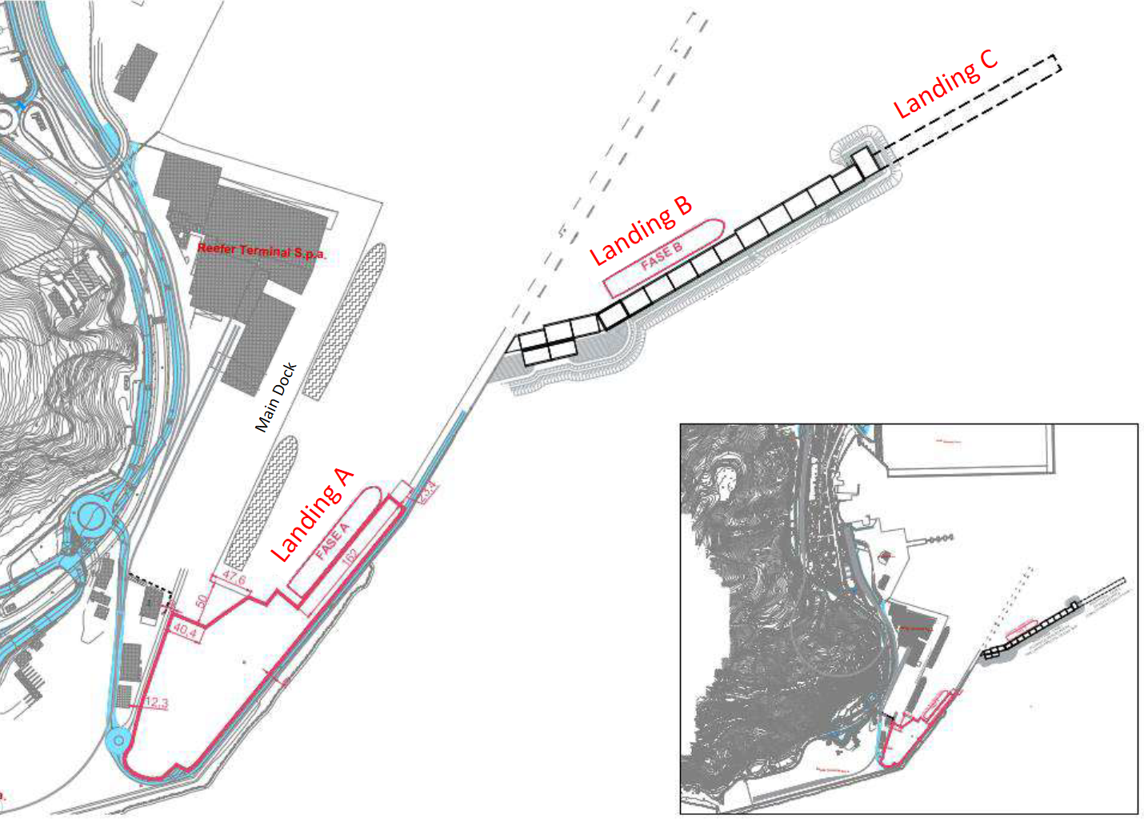

Figure 1: Schematic LNG terminal layout.

Protective Barriers

1. Presence of fender

Barrier type: Passive, Technological

Barrier Effectiveness: Partial

The presence of the fender mitigates the consequences of potential impacts and/or collisions.

1. Landings A, B, C (reference is made to Figure 1)

Barrier type: Passive, Structural

Barrier effectiveness: Partial

The three different landings have different design characteristics connected to their specific location. Moreover, clear safety procedures and periodic inspections are highly recommended to reduce risks.

1. Emergency procedures and port ordinances

Barrier type: Active, Procedural

Barrier effectiveness: Partial.

The presence of emergency procedures and ordinances for managing traffic port minimises both the probability of occurrence and the severity of the consequences of potential collisions and impacts.

Additionally, some devices or systems must be present on the carrier or terminal and contribute to mitigating hazards, e.g., stranding accidents can be prevented by enforcing exclusion zones.

Table 4: Effect of active and passive barriers on risk mitigation.

|  |  |  |  |
| --- | --- | --- | --- |
| Identified hazards | LOA180 | LOA160 | LOA120 |
| Loss of control - steering and propulsion | No action required | No action required | No action required |
| Loss of buoyancy/stability | No action required | No action required | No action required |
| Unavailability of external manoeuvring gear (tug) | No action required | No action required | No action required |
| Electro-instrumental failures | No action required | No action required | No action required |
| Adverse weather conditions | ALARP | No action required | No action required |
| Ground incident (fire, release, explosion) | No action required | No action required | No action required |
| Pilot unavailability | No action required | No action required | No action required |
| Human error (on board) - incorrect / untimely action | ALARP | No action required | No action required |
| Human error (on board) - no action | ALARP | No action required | No action required |
| Presence of other ships / smaller units | No action required | No action required | No action required |
| Human error (shore) management | No action required | No action required | No action required |
| Electro-instrumental failure ashore mgm. | No action required | No action required | No action required |

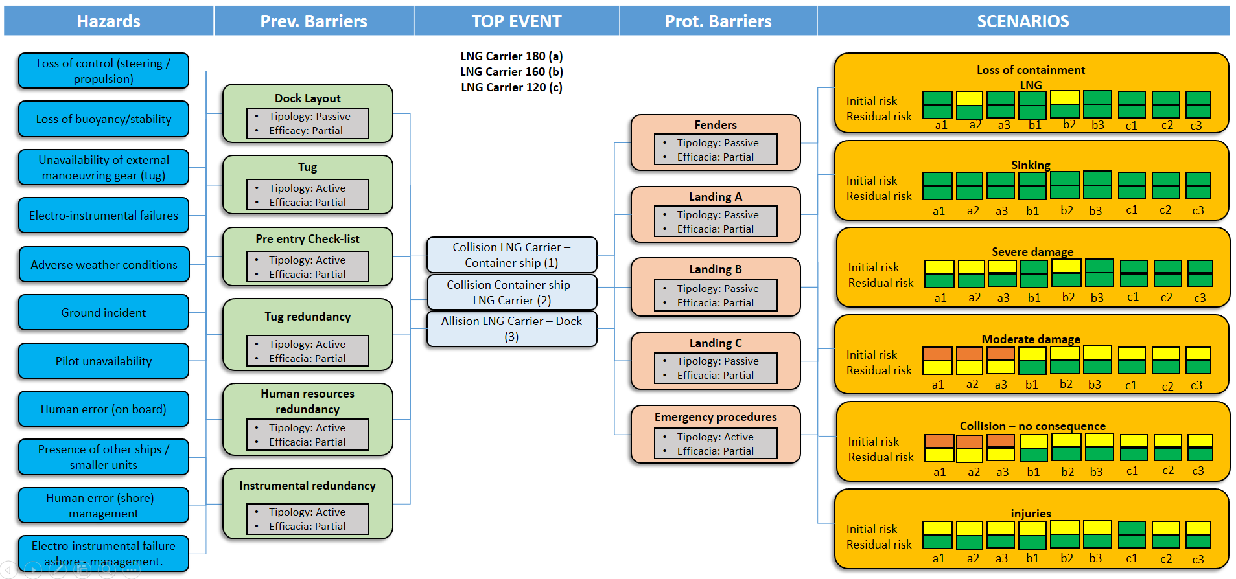

*Figure 2: Bow-Tie analysis integration and residual risk evaluation.*

From the detailed hazard analysis, the positive influence of each identified mitigation measure was assessed to reduce the probability of occurrence of potentially hazardous events, as well as the effect of barriers and contingency measures. The integration of the results attained by six Bow-Tie analyses is shown in a combined complete Bow-Tie depicted in Figure 2, completing phase c) of the framework. Further refinement of the analysis will consider the possibility of integrating the system learning ability from precursors of accidental events, based on sets of field observations, to make predictions about the latent states and enhance system resilience (Vairo et al., 2023). A key finding of this study is that combining operational and navigational risk assessments into a unified framework yields a more holistic understanding of the overall risk landscape, highlighting both individual risk contributors and system interactions. For instance, a crowded terminal with high vessel traffic and challenging weather conditions increases the probability of incidents. A comprehensive risk view enables LNG terminal operators to prioritize investments in technology, training, and infrastructure enhancements representing key elements to enhance the overall safety and resilience of the infrastructure.

* 1. Conclusions

The development of a comprehensive RA framework for LNG terminals by integrating probabilistic risk analysis techniques and advanced simulation tools represents a significant step forward in addressing the multifaceted safety challenges posed by both operational and navigational risks. By systematically analyzing key factors such as LNG transfer operations, storage conditions, vessel traffic patterns, and environmental conditions, the model ensures a comprehensive risk profile that informs better decision-making and enhances the resilience of LNG terminal operations. The navigational risk assessment underscores the complexity of vessel traffic management, especially in high-density areas where collision risks are pronounced. Environmental factors, such as weather and visibility, play a pivotal role in influencing these risks, suggesting that adaptive navigational strategies are essential for maintaining safety. The approach allows terminal operators to systematically evaluate the effectiveness of layered safety measures and prioritize investments in controls attaining the greatest risk reduction and provides stakeholders with a clear, quantifiable path for transitioning from initial risk to residual risk, enhancing safety and operational resilience. Additional work under development aims to explore the incorporation of real-time data feeds into the QRA framework including analysis of interdependencies in the port area and advanced detection and diagnosis, thus enabling continuous risk monitoring and dynamic response strategies. The approach can be refined for use in different types of LNG operations, including floating storage regasification units (FSRUs) and small-scale LNG facilities, to enhance its applicability across diverse contexts.

Acknowledgments

Funded by the European Union - NextGenerationEU and by the Ministry of University and Research (MUR), National Recovery and Resilience Plan (NRRP), Mission 4, Component 2, Investment 1.5, project “RAISE - Robotics and AI for Socio-economic Empowerment” (ECS00000035). Bruno Fabiano is part of RAISE Innovation Ecosystem.

References

Chen C., Yuan H., Bi R., Wang N., Li Y., He Y., Wang F., 2022, A novel conceptual design of LNG-sourced natural gas peak-shaving with gas hydrates as the medium, Energy, 253, Article 124169.

IALA, 2022, G1018 Risk Management Guideline. International Association of Marine Aids to Navigation and Lighthouse Authorities IALA, St Germain en Laye, France.

IGU, 2023, LNG Report, International Gas Union, London, UK.

OSHA, 2013, standard 1910.119, Process safety management of highly hazardous chemicals, Occupational Safety and Health Standards, Subpart:1910-H, U.S. Department of Labor, Washington, DC, U.S.A.

Pasman H.J., Sripaul E., Khan F., Fabiano B., 2024, Energy transition technology comes with new process safety challenges and risks - What does it mean? Process Safety Progress, 43(2), 226–230.

Vairo T., Pettinato M., Setola R., Reverberi A., Fabiano B., 2024, Emerging risks and energy transition in industrial and port environment, Chemical Engineering Transactions, 111, 517–522.

Vairo T., Pettinato M., Reverberi A.P., Milazzo MF., Fabiano B., 2023a, An approach towards the implementation of a reliable resilience model based on machine learning, Process Saf. Environ. Prot. 172, 632-641.

Vairo T., Pettinato M., Taubert E., Tahir A.M., Fabiano B., 2023b, Automation in port areas and industry for safe and effective management of dangerous goods, Computer Aided Chemical Engineering 53, 3049–3054.

Vairo T., Gualeni P., Reverberi A.P., Fabiano B., 2021, Resilience dynamic assessment based on precursor events: Application to ship LNG bunkering operations, Sustainability, 13, 6836.

Vairo T., Curro’ F., Scarselli S., Fabiano B., 2014, Atmospheric emissions from a fossil fuel power station: dispersion modelling and experimental comparison, Chemical Engineering Transactions, 36, 295-300.