|  |  |
| --- | --- |
| cetlogo ***CHEMICAL ENGINEERING TRANSACTIONS***  ***VOL. xxx, 2025*** | A publication of  aidiclogo_grande |
| The Italian Association  of Chemical Engineering  Online at www.cetjournal.it |
| Guest Editors: Bruno Fabiano, Valerio Cozzani  Copyright © 2025, AIDIC Servizi S.r.l. **ISBN** 979-12-81206-xx-y; **ISSN** 2283-9216 | |

Risks from Hydrogen Carriers - Safety Characteristics of the LOHC System Toluene/Methylcyclohexane

Stefan H. Spitzer sen.a,b\*, Arkan Abedc, Alexander Seifertd, Ernesto Salzanoc

aEIfI-Tech, Universitätspark 1/1, Schwäbisch-Gmünd, Germany

bPhysikalisch-Technische Bundesanstalt, Bundesallee 100, Braunschweig, Germany

cUniversity of Bologna, Bologna, Italy

dBundesanstalt für Materialforschung und -prüfung, Unter den Eichen 87, 12205 Berlin, Germany

s.spitzer@eifi-tech.eu

Reversible liquid organic hydrogen carriers (LOHCs) seem to be a promising solution for the transportation of hydrogen. Since no pressure or cooling needs to be applied during the transport, it is considered easier, safer and cheaper compared to pressurized gas tanks or cryogenic hydrogen on long routes and is already applied in large quantities and long distances.

One simple system is methylcyclohexane and toluene. Toluene gets shipped to countries with an excess of (preferably green) energy and is charged with hydrogen to form methylcyclohexane. This is then shipped back to the place with energy and/or hydrogen demand and split into hydrogen and toluene.

For toluene, some safety characteristics are available, whereas methylcyclohexane is loosely analyzed, hence safety characteristics are the basis for an appropriate approach to tackle the hazards and for the risk assessment.

This paper focuses on the safety characteristics of both substances, compares the differences and points out the crucial hazards of this system, especially if the same tanks for transportation are used.

* 1. Introduction

In recent years the production and storage of hydrogen has been an issue that was targeted in several approaches. Beside metals, ammonia and compressed hydrogen, liquid organic hydrogen carriers are a promising solution (Dalebrook et al., 2013). The cost of 1 kg of hydrogen produced by LOHCs calculated to be between 5,5 and 7 US-Dollars and with that comparable to other sources of hydrogen (Zhang et al., 2025). Especially the system methylcyclohexane (MCH, fully saturated with hydrogen or “charged”) and toluene (TOL, aromatic or “uncharged”) is easy to obtain since it is a bulk chemical, easily available and has a high storing capacity with 3 hydrogen molecules per molecule (Figure 1).

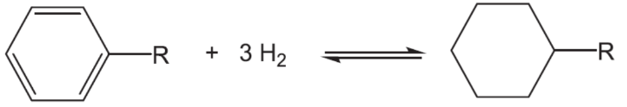

*Figure 1: Reaction of the hydrogen storage using toluene and methylcyclohexane*

MCH and TOL are already shipped between Japan and Brunei (Mitsui 2021), and it is planned to be shipped between Texas and California (Papadias and Ahluwalia, 2021) but once established it can be applied to any other country since it can be shipped via road, rail and ship under ambient pressure and temperature (Carvalho et al., 2021).

Beside all its promising characteristics, both substances are flammable and can form explosive atmospheres when mixed with air: On the 20th of October 1999 a ruptured pipe delivering MCH caused an explosion with an estimated loss of 36.5 million US-Dollar in a plastic production plant in Germany (ZEMA 1999).

Only in Germany a number of 14 accidents that involved toluene occurred over the last 30 years with an overall damage cost of 10 million US-Dollar, one fatality and 21 casualties (ZEMA-Tol).

The known characteristics of both substances alone are stated in Table 1. The upper explosion limit as well as the maximum explosion pressure of Methylcyclohexane seem not to be determined yet. The maximum rate of pressure rise for both substances is also not available in the databases.

Table 1: Known characteristics of Toluene and Methylcyclohexane. If not stated otherwise the values are determined under ambient conditions at 20°C and 1013.25 hPa

|  |  |  |  |  |
| --- | --- | --- | --- | --- |
| Safety characteristic | Toluene |  | Methylcyclohexane |  |
| Molar mass | 92.14 g/mol | - | 98.19 g/mol | - |
| Boiling point | 111 °C | Nabert & Schön (1963) | 101 °C | Nabert & Schön (1963) |
| Density | 0.87 g/cm³ | Nabert & Schön (1963) | 0.77 g/cm³ | Nabert & Schön (1963) |
| Vapor pressure | 29.1 hPa | DGUV-Tol | 48.3 hPa | DGUV-MCH |
| Gravimetric hydrogen capacity | - |  | 7.2 wt% | Hoecke et al., 2021 |
| Volumetric hydrogen capacity | - |  | 55.44 g/L | Hoecke et al., 2021 |
| Flash Point | 4 °C | Hoecke et al., 2021 | -4 °C | Hoecke et al., 2021 |
| Lower Explosion Limit | 1 vol% | PTB (2003) | 1.1 Vol% ± 10 % | Nabert & Schön (1963) |
| Upper Explosion Limit | 7.8 Vol% ± 5 % | Nabert & Schön (1963) | n. d. | - |
| Maximum experimental safe gap | 1.02 mm | PTB (2023) | 0.93 mm | PTB (2023) |
| Maximum explosion pressure | 7.7 bar (=6.7 bar g) | Nabert & Schön (1963) | n. d. | - |
| Stoichiometry with air | 2.3 mol% | PTB (2005) | 2 mol% | PTB (2005) |

Tsai et al. (2023) recently investigated the maximum explosion pressure of toluene-methylcyclohexane mixtures with the admixture of hydrogen. However, since the mixing process was not verified before (liquid injection from a pressurized container) and because the investigation was performed under non-standard turbulent conditions, the data shall be handled with care before applying to industrial facilities since turbulence affects all safety characteristics significantly.

* 1. Materials and Methods

Methylcyclohexane and Toluene with a purity of at least 99 % were used.

The safety characteristics were determined in a metallic 20L-sphere with a temperature-controlled water jacket. On the bottom of the sphere a fan was installed to ensure uniform mixing of the vapor with air. The sphere was evacuated trough valve V2 and vacuum pump P1, valve V1 was then opened to inject the liquid from a syringe and then it was filled with air until equilibrium with the outside pressure. The fan was then stopped, and the mixture was left to settle for at least 180 seconds according to EN 1839 and EN 15967 (see Figure 2). As ignition source, an exploding wire with an energy between 10 J and 20 J was placed in the center of the sphere. After activation of the ignition source the pressure was recorded with two piezo-electric pressure sensors (PR400 and PR500) and a measurement frequency of 5 kHz, and analyzed. An additional piezoresistive pressure sensor was also installed to ensure the beginning pressure to be around 1013 mbar and to validate the explosion pressure (PI 800).

At the concentration with the highest recorded values the tests were repeated five times, around it the tests were repeated at least three times.

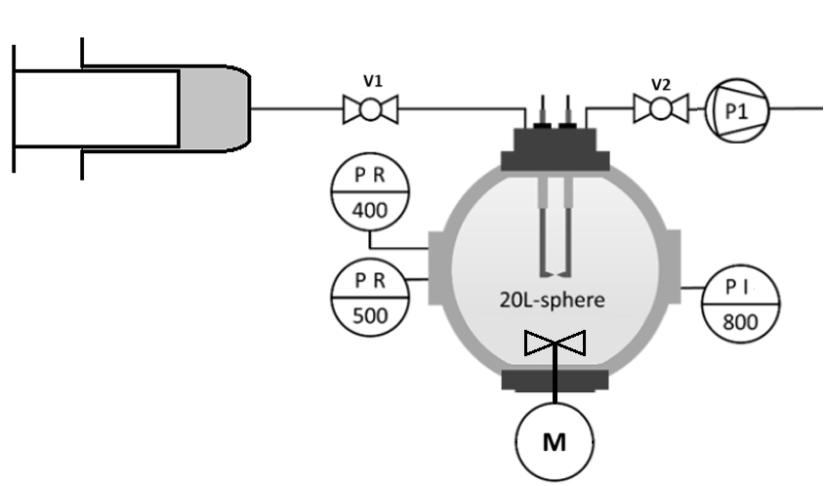

*Figure 2: Schematic of the test vessel with all pressure sensors and connections*

* 1. Results and Discussions

The explosion overpressures of both tested substances can be seen in Figure 3.

Ein Bild, das Text, Screenshot, Schrift, Zahl enthält.

*Figure 3: Explosion pressure of methylcyclohexane and toluene*

The explosion pressure of methylcyclohexane follows the “usual” behavior of gases with a steep rise above the lower explosion limit is exceeded and then a decline once the maximum is reached. However, above 231 g/m³ (6ml) the explosion pressure began to rise a bit, and a lot of soot was found after each test. This means, that the reaction might have taken another path not only reacting to CO2 and H2O this way. This also means, that it does not have an upper explosion limit under ambient conditions.

The behavior of toluene is different since it stays at the maximum of 8.5 bar g once it reached that maximum. The reason for that is, that the vapor pressure is with 29,1 hPa (≙ 2,9 % ≙113,5 g/m³) below the stated upper explosion limit in the literature. This may be a big lack of knowledge since this means, that in any case an explosion will occur once air passes into the container.

Careful researchers might stumble across the statement, that an upper explosion limit is above the vapor pressure but for implementers or for people not having all characteristics of the substance at place this is confusing, puzzling or might simply be overseen and with that leads to unsafe safety measures.

The maximum rate of pressure rise is displayed in figure 4.

Ein Bild, das Text, Screenshot, Schrift, Zahl enthält.

*Figure 4: Rate of pressure rise of methylcyclohexane and toluene*

Two things are remarkable here: First, that methylcyclohexane has a very low rate of pressure rise above the concentration with the maximum. This underlines the theory, that the combustion reaction does take other ways than the simple oxidation of the molecule. The other remarkable thing here is the large scattering of the values. This was first seen as a result of improper mixing or because the measuring frequency was chosen too low. Repeating the tests again very carefully and comparing the actual pressure time-curves for the same concentrations showed that the combustion does look differently at the same concentration for both substances (Figure 5 and Figure 6).

Ein Bild, das Text, Diagramm, Reihe, Screenshot enthält.

*Figure 5: Pressure against time for toluene, both time the same amount of toluene (5 ml) was injected but once a value of 346 bar/s (red line) and once a value of 940 (blue line) was determined*

Ein Bild, das Diagramm, Reihe, Text enthält.

*Figure 6: Pressure against time for methylcyclohexane, both time the same amount of methylcyclohexane (3 ml) was injected but once a value of 538 bar/s (red line) and once a value of 1031 (blue line) was determined*

For both substances it seems, that minor changes in the beginning parameters might have a huge impact on the determined safety characteristics.

It can also be seen, that above a value of 450 bar/s oscillations with a frequency of around 650 Hz (630 Hz (MCH) or rather 670 Hz (TOL)) were recorded. It could have not been fully clarified whether this is the resonance frequency of the inner metal sphere itself or the gas inside of the sphere oscillating.

* 1. Conclusions

The safety characteristics lower explosion limit, upper explosion limit, maximum explosion pressure and maximum rate of pressure rise of methylcyclohexane and toluene were determined. The conclusions are the following:

* The upper explosion limits for both substances are above their vapor pressure under ambient conditions and with that can’t be used for safety measures. That means as soon as air leaks inwards the tank it forms an explosive atmosphere.
* The maximum rate of pressure rise of both substances is very high and has not been determined yet
* The maximum explosion pressure of toluene is almost 2 bars (8.5 bar g instead of 6.7 bar g) higher than the one found in the literature. This may be because it was determined before under different conditions or in a very small test vessel, both causing a lower determined value.
* For both substances the vapor pressure lies around the stoichiometry and with that the concentration with the highest explosion pressure and rate of pressure rise

In their charging/uncharging process some hydrogen might be physically solved in the chemical and with that other safety issues might occur. This will be investigated soon.

**Acknowledgment**

This work has been supported by the European Union’s Horizon Europe Research and Innovation Programme “ENabling FLexibility provision by all Actors and sectors through markets and digital TEchnologies (ENFLATE)” under Grant Agreement No. 101075783.

References

Carvalho M.C.S., Marques J., Matos H.A., Granjo J.F.O., 2021, Long-distance hydrogen delivery using a toluene-based liquid organic hydrogen carrier system, Computer Aided Chemical Engineering, 50. 1647-1652

Dalebrook A. F., Gan W., Grasemann M., Moret, S., Laurenczy G., 2013, Hydrogen storage: beyond conventional methods. Chemical Communications, 49, 8735–8751

DGUV-MCH, taken from the database entry for methylcyclohexane of the German Social Accident Insurance, online, <https://gestis.dguv.de/data?name=030950>, visited on 24th of September 2024

DGUV-Tol, taken from the database entry for toluene of the German Social Accident Insurance, online, <https://gestis.dguv.de/data?name=010070>, visited on 24th of September 2024

EN 1839:2017 - Determination of the explosion limits for flammable gases and vapours, Beuth-Verlag, Berlin, doi: 10.31030/2534064

EN 15967:2022 - Determination of maximum explosion pressure and the maximum rate of pressure rise of gases and vapours, Beuth-Verlag, Berlin, doi: 10.31030/3290404

Van Hoecke, L., Laffineur, L., Campe, R., Perreault, P., Verbruggen, S.W., Lenaerts, S., 2021, Challenges in the use of hydrogen for maritime applications, Energy & Environmental Science, doi: 10.1039/d0ee01545h

Mitsui & Co Ltd (2021) – online: <https://www.mitsui.com/jp/en/topics/2021/1241738_12171.html> visited on the 07th of October 2024

Nabert, K. and Schön, G., 1963, Sicherheitstechnische Kennzahlen brennbarer Gase und Dämpfe (mit 6. Nachtrag), Deutscher Eichverlag, Braunschweig

Papadias, D.D. and Ahluwalia, R.K., 2021, Toluene-Methylcyclohexane as Two-Way Carrier for Hydrogen Transmission and Storage, technical report by Argonne National Laboratory and Chiyoda International Corporation

PTB 2003, from the German Metrology Institute (Physikalisch-Technische Bundesanstalt (PTB)), Sicherheitstechnische Kenngrößen: Messwerte 2003 des PTB-Laboratoriums 3.31, PTB-Lab. 3.31

PTB 2005, from the German Metrology Institute (Physikalisch-Technische Bundesanstalt (PTB)), Berechnete molare stöchiometrische Brenngasanteile in Luft (c\_stoech), Datenbank PTB-Lab. 3.43

PTB 2023, from the German Metrology Institute (Physikalisch-Technische Bundesanstalt (PTB)), Sicherheitstechnische Kenngrößen: Messwerte des Labors, PTB-Lab. 3.71

Tsai, Y., Cai, J., Pan, Y., Jiang, J., 2023, Explosion risk assessment of liquid organic hydrogen carrier system by using toluene-methylcyclohexane on varying hydrogen storage scenarios, Journal of Loss Prevention in the Process Industries, Volume 86, 105206, doi: 10.1016/j.jlp.2023.105206

ZEMA 1999 - Zentrale Melde- und Auswertestelle für Störfälle (Central reporting and evaluation point for incidents in Germany), incident reported for the 20th October 1999, entry number 9933

ZEMA Tol - Zentrale Melde- und Auswertestelle für Störfälle (Central reporting and evaluation point for incidents in Germany), all fourteen incidents reported for toluene simply summed up

Zhang, M., Wei, X., An, Z., Okafor, E.C., Guiberti, T.F., Wang, J., Huang, Z., 2025, Flame stabilization and emission characteristics of ammonia combustion in lab-scale gas turbine combustors: Recent progress and prospects, Progress in Energy and Combustion Science, Volume 106, 101193, ISSN 0360-1285, doi: 10.1016/j.pecs.2024.101193