 CHEMICAL ENGINEERING TRANSACTIONS  VOL. xxx, 2025 | A publication of  
The Italian Association
of Chemical Engineering
Online at www.cetjournal.it
Guest Editors: Bruno Fabiano, Valerio Cozzani
Copyright © 2025, AIDIC Servizi S.r.l.
ISBN 979-12-81206-xx-y; ISSN 2283-9216

Optimizing Pressure Relief and Retainment Systems: Balancing Production, Safety, and Sustainability
Dr. Mondie Kimandi Mutegi^{a,}*, Marc Steinkraussª
ªPELEVEN AG, Sandgrubenstrasse 44,CH-4058 Basel, Switzerland.
corresponding mondie.mutegi@peleven.ch
This paper examines the optimization of pressure relief and retainment systems using the ISO 4126-10:2024 standard, which provides a robust methodology for sizing safety valves and bursting discs in two-phase vapor-liquid flow scenarios. Rather than avoiding two-phase flow entirely, we demonstrate that properly accounting for it enables optimization of filling levels and operating points while maintaining safety. The study reveals that common practices of oversizing pressure relief devices can result in relief loads more than double what's necessary, potentially compromising retainment systems and creating additional safety risks through increased emissions and reaction forces. Using a case study involving solvent substitution and system redesign, we illustrate how ISO 4126-10:2024 facilitates right-sizing of pressure relief and retainment components for multi-purpose plants. The methodology allows for precise determination of critical parameters including sizing pressure, necessary relief capacity, and equipment dimensions across various operating conditions. This approach achieves an optimal balance between production efficiency, safety requirements, and sustainability goals through quantitative analysis of system behaviour. The results demonstrate how proper application of engineering principles can simultaneously improve safety margins and reduce environmental impact in chemical processing facilities.
  - Introduction
The recently published (ISO 4126-10, 2024) standard introduces significant updates for sizing safety valves and bursting discs in two-phase gas/liquid flow systems. Now mandatory in the EU and Switzerland, this harmonized standard brings extensive revisions, including expanded modeling techniques and more accurate assessments of relief areas that consider various system components (STVI, 2024). The standard has doubled in size, incorporating new factors such as vessel swelling assumptions and liquid viscosity corrections, necessitating a re-evaluation of many existing safety valve and bursting disc calculations to ensure compliance. The fine chemicals industry is characterized by small annual production volumes across multi-purpose plants that produce numerous products in campaign-based processes.
To minimize equipment changes between campaigns, especially for overpressure protection, a consistent approach is needed for sizing emergency pressure relief systems (ERS). Previous studies have shown that the required specific relief area remains relatively consistent despite solvent diversity, which simplifies the sizing process (Schmidt, 2011). This paper applies the new standard to a common two-step procedure for sizing pressure relief devices and retainment systems in multi-purpose plants: first by sizing for a representative physical scenario, then by verifying for specific chemical reactions.
The work refers to equations and nomenclature and units per (ISO 4126-10, 2024). Thermophysical fluid properties of substances in this work are determined according to (VDI-Wärmeatlas (12th ed.), 2019), and all pressure values are expressed in bar absolute.

  - Equipment to be protected
The protected equipment consists of three identical semi-batch reactors made of STEM, each with an inner diameter of 1.98 m and a total volume of 8.45 m³ before flooding. They have a maximum allowable pressure of 17 bar and temperature of 523 K, with a heat exchange area A_{heat} of 16.3 m² and a heat transfer coefficient B_{heat} of 450 W/(m²·K). Previously, each reactor was protected by a bursting disc with a burst pressure at 3 bar, sized assuming single-phase vapor flow of dichloromethane (DCM) by limiting the filling level to 50% to avoid two-phase flow (TR EC BCI 157 , 2021). Each reactor contained 5605 kg of DCM, with a heat input of 1123W and a specific heat input of 200 W/kg. While a DN80 bursting disc with a 71.3 mm diameter would have provided adequate relief at 3.2 bar, releasing 3.7 kg/s of DCM, an oversized DN150 disc with 148 mm diameter was installed, unnecessarily increasing the relief capacity to 15.8 kg/s (AD 2000 A2, 2015). This oversizing led to potential issues, including the possibility of losing the entire batch as emissions in a pressure relief incident and increased pipe reaction forces. The pipe reaction forces in a DN150 piping are more than double those of a DN80 pipe, potentially exceeding the design limits of pipe supports (API STD 520 PT II, 2020). The new operator aims to increase efficiency by raising filling levels to operate two reactors instead of three, utilizing existing piping and retention systems with minimal modifications. They also plan to replace DCM with the more sustainable acetonitrile, which has a higher latent heat of vaporization, effectively reducing the vapor generation rate responsible for bubble formation and swelling. To meet compliance standards (CSDD, 2024) with the modified operation, an appropriately sized retention system must be sized and installed, and emissions should be minimized as low as practicable. The first task is to size a new safety valve per ISO 4126-10:2024, optimizing both process safety and sustainability for the intended two-reactor operation.
  - Review of the emergency relief system
The pressure relief system must be designed to safely manage relief over the entire discharge period, as an initial two-phase mixture may discharge if the liquid level exceeds the critical filling limit. The liquid level will decrease over time and vapor is relieved.
    - Step 1 – Identification of the sizing case
The system must be evaluated according to ISO 4126-10:2024, with the first step being the identification of the appropriate sizing scenario. This process requires consideration of all reasonably foreseeable deviations from normal plant operation, as the scenario often carries more weight than the calculation method itself.
In multi-purpose plants where, diverse reactions use different solvents in the same equipment, the sizing must account for this variability. The relief capacity depends on numerous factors, including relief conditions (temperature, pressure), pressure relief device characteristics, pressure losses in the vent-line, filling level, and more. Independent validation of the relief device's capacity is critical when it serves as an independent protective layer in a chemical process scenario. Its capacity requirement depends on quantifiable heat generation, which can be measured via calorimetry. For this specific case, the HAZOP team specified acetonitrile as representative of reaction mass properties. The maximum accumulated relief pressure is specified at 7bar, with a back pressure of 1.1 bar as the system vents to a closed collection system. The reaction mass is non-foaming, and fire cases are excluded from consideration. Two credible sizing scenarios were identified by the HAZOP team, which will form the basis for further analysis and sizing calculations. This approach ensures a comprehensive evaluation of the system's safety requirements, considering the specific characteristics and potential operational variations of the plant.
- Increased external heating due to temperature control failure (ext): The maximum temperature is limited by technical means to T_{heat}=523 K based on the opening pressure of the safety valve protecting the heating jacket. DCM is replaced with acetonitrile. Heat input at sizing temperature T₀ is quantified via Eq.(1).
- Runaway reaction due to cooler shut down (run): Kinetics from calorimetry yield a reference specific heat of q’_{ref}=32 W/kg at T_{ref}=372.4 K. Activation energy is E_{A}=65195 J/mol. Gas constant R=8.314 J/(mol·K) Heat input at sizing temperature T₀ in K is quantified per Eq.(2) (Stössel, 2020).

$Q_{ext}\left(T_{0}\right)=B_{heat}∙A_{heat}∙\left(T_{heat}-T_{0}\right)$ | (1) | $Q_{run}\left(T_{0}\right)={q^{'}}_{ref}∙exp\left[\frac{-E_{A}}{R}∙\left(\frac{1}{T_{0}}-\frac{1}{T_{ref}}\right)\right]∙M_{0}$ | (2)
    - Step 2 – Flow regime at the inlet of the vent line system
The flow behavior in the system, either single-phase vapor (1ph) or two-phase vapor/liquid (2ph), is determined by the gas/vapor velocity through the liquid surface and fill level, which affects liquid swell. This calculation method was developed as part of the DIERS project (CCPS, 2017). For DCM and acetonitrile, the flow regime is determined using the Churn-turbulent (CT) model with C₀=1.53, as the liquid phase dynamic viscosity Ω_{l,0}≤0.1Pa·s, and the medium is non-foaming.
To find the optimum operating point for the pressure relief device, the sizing pressure p₀ is varied in 5 steps (3.2, 4, 5, 6, and 7 bar), while the filling level at 293K is varied in 6 steps (60, 65, 70, 75, 80 and 85%). Additional points were calculated near the (1ph-2ph) limit to ensure consideration of both regimes, resulting in a total of 63 points assessed. Figure 1 and Figure 2 illustrate the dimensionless bubble-rise velocity u* on the x-axis per Eq.(iso-6) (ISO 4126-10, 2024),with the y-axis representing the filling level in percentage. Both systems behave as tempered systems where vapor pressure at sizing pressure p₀ dictates the sizing temperature T₀.

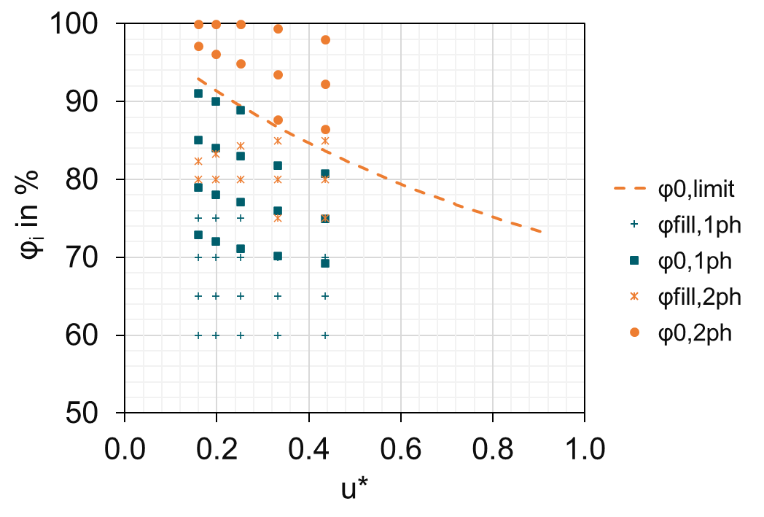  single-phase  two-phase  φ_{fill}=80%  φ_{fill,0}=92%  7.0 bar  3.2 bar  Increase in sizing pressure  Linear decrease in heat input per eq (1) | 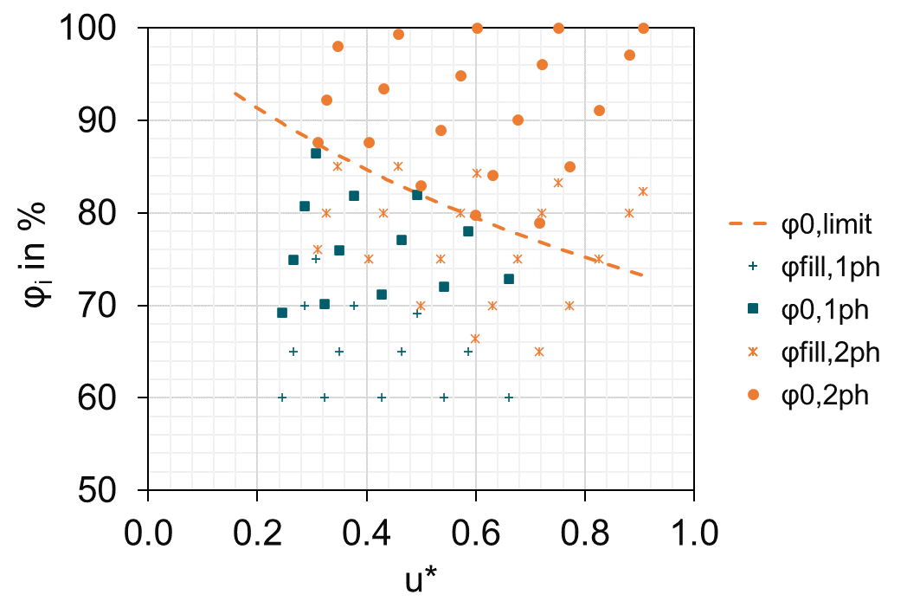  single-phase  two-phase  Increase in sizing pressure  Exponential increase in heat input per eq (2)  7.0 bar  3.2 bar
Figure 1 Flow regime with scenario (ext) | Figure 2 Flow regime with scenario (run)
Looking at Figure 1 for scenario (ext,2ph), a reactor filled to 80% with 5283 kg acetonitrile at 293 K results in a sizing temperature T₀ of 396 K at a sizing pressure p₀ of 3.2 bar, with a total heat input of 787 W per Eq.(1). This leads to u*=0.44 and a filling level of 92% at sizing conditions, exceeding the single-phase limit of 84% and requiring two-phase consideration. Heating the inventory with varying sizing pressure moves the points in Figure 1 to the right for scenario (ext) due to the linear decrease in heat input as sizing temperature increases. For scenario (run) in Figure 2, points move vertically downward to the left, attributable to the exponential increase in heat input as sizing temperature increases with sizing pressure. The flow regime determination depends on the filling level at sizing conditions. Points above the orange dotted line result in (2ph) flow at the vent line inlet for both scenarios, while green points indicate (1ph) flow. Two-phase flow should be considered for 40% of points in scenario (ext) and 61% in scenario (run), making two-phase flow more likely for scenario (run) in this range. Overfilling in closed systems protected by bursting discs requires careful management to avoid compromising disc integrity or causing unintended inventory loss in systems with safety valves. Figure 1 and Figure 2 show that initial filling levels between 82-85% at ambient conditions result in 100% filling at sizing pressure. Therefore, filling levels above 80% at ambient conditions warrant investigation, although they are not recommended. The initial filling level should be adjusted before determining the flow regime at the vent line inlet, with proper documentation and clear communication to operations personnel for effective implementation.
    - Step 3 — Calculation of the mass flow rate required to be discharged
The pressure relief device must be adequately sized to dissipate the total energy supplied under the sizing conditions for both scenarios (ext) and (run) as intended. Figure 3 shows the specific heat input for scenario (ext) reduces with increasing reaction mass as expected. For scenario (run), the specific heat input does not vary with filling level because it is determined per reaction mass and is independent of filling level and reaction mass variations at a reference pressure. Figure 4 and Figure 5 show the total heat input for scenario (run) increases exponentially with increasing over temperature and corresponding sizing pressure. The magnitude increases with higher filling levels.

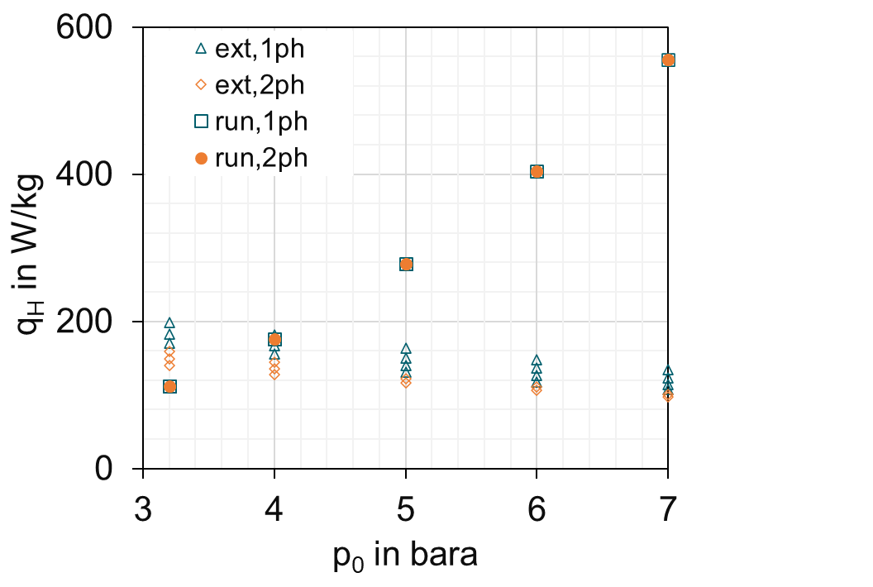  Increasing filling level  (ext) | 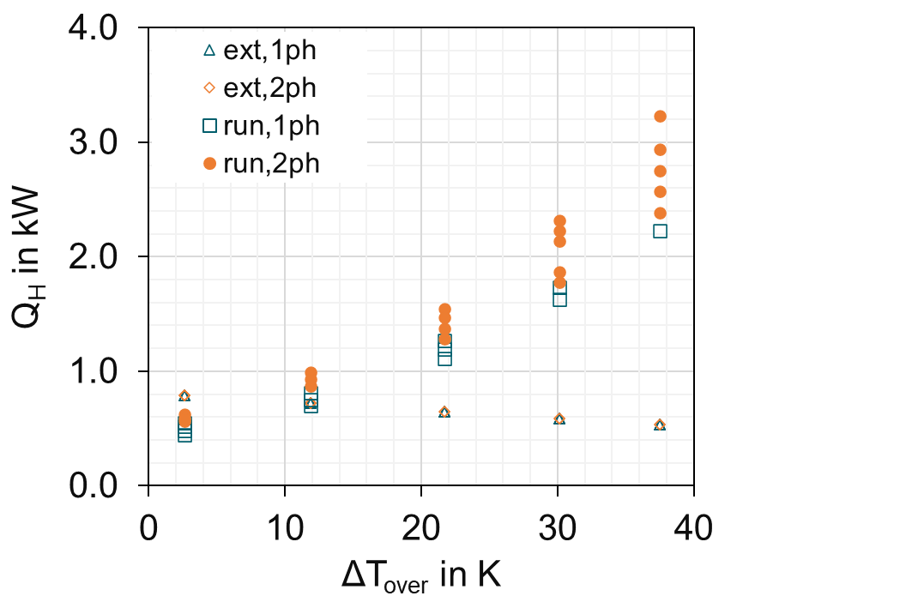  Increase in filling level  (run) | 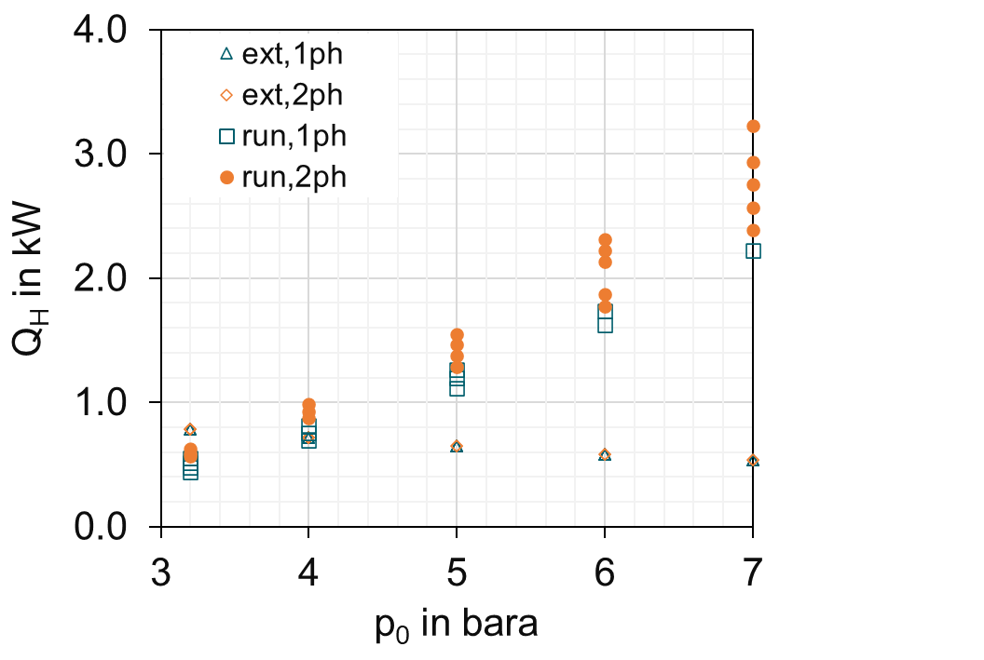  Increase in filling level  (run)
Figure 3 Specific heat input for varying sizing pressure | Figure 4 Total heat input for varying over temperature | Figure 5 Total heat input for varying sizing pressure

The required mass flow rate to be discharged for abnormal external heating in scenario (ext) and scenario (run) is determined iteratively per Eq.(iso-10) and Eq.(iso-32) respectively (ISO 4126-10, 2024). The variables in these equations at sizing conditions are filling level φ₀, density of vapor ρ_{v0}, density of liquid ρ_{l0}, heat capacity of liquid c_{p,l0}, heat of vaporization Δh_{v,0}, saturation pressure difference ΔT_{over}, and heat input into the pressurized system Q_{H} per Eq.(1) for Eq.(iso-10) and Q_{H} per Eq.(2) for Eq.(iso-32) and ΔT_{over}=ΔT₀ – ΔT_{open}. These equations deviate from (Leung, 1986) suggested equations for both scenario (ext) and (run) by less than 1% in the evaluated range.
Figure 6 demonstrates that seemingly small increases in specific heat input for scenario (ext, 2ph) result in significant exponential escalation of relief requirements. This is largely due to the variation of Eq.(iso-10) with over temperature ΔT_{over}. Figure 7 illustrates that an increase of ΔT_{over} from 3 K to 12 K reduces the required mass flow rate by more than 50% for scenario (ext,2ph), from 55 kg/s to 22 kg/s. This corresponds to a marginal sizing pressure increase of 0.8 bar (from 3.2 to 4 bar), as seen in Figure 8. For scenario (run,2ph), the required mass flow rate is also reduced by around 50%, but to a lesser magnitude, from 30 kg/s to 16 kg/s.

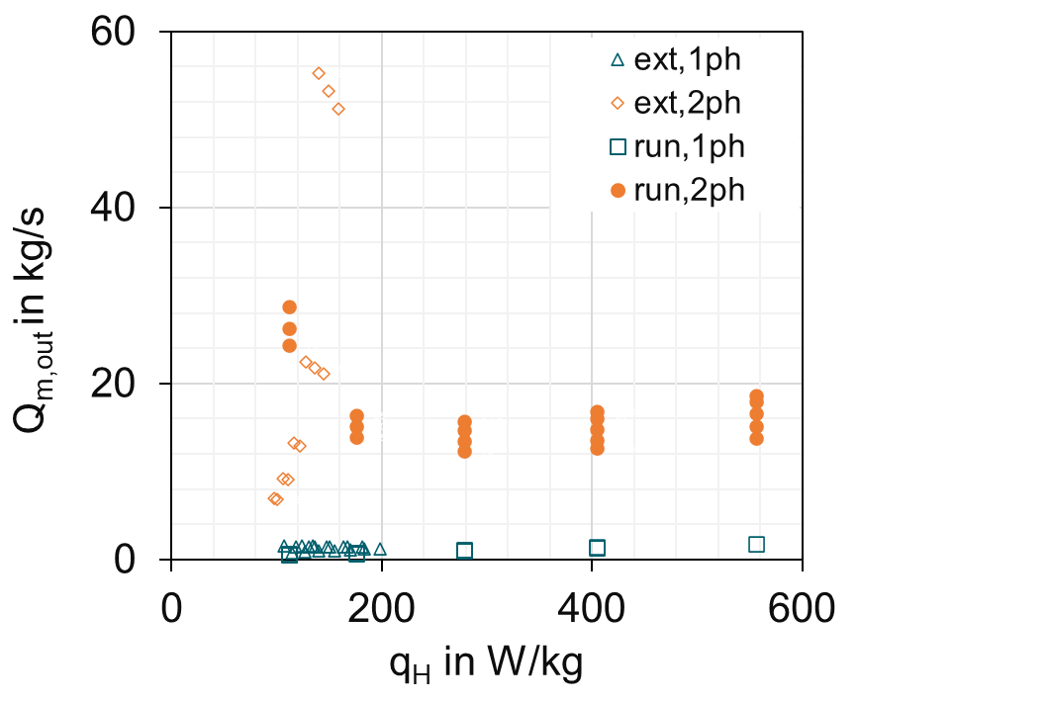  Increase in filling level | 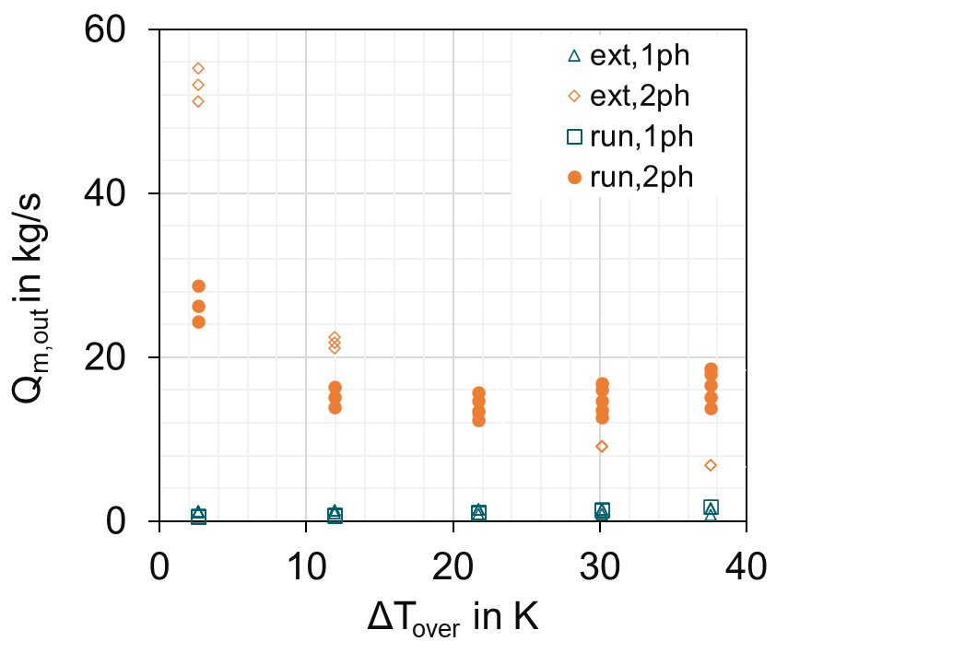  Optimum range  (tentative)  Increase in filling level | 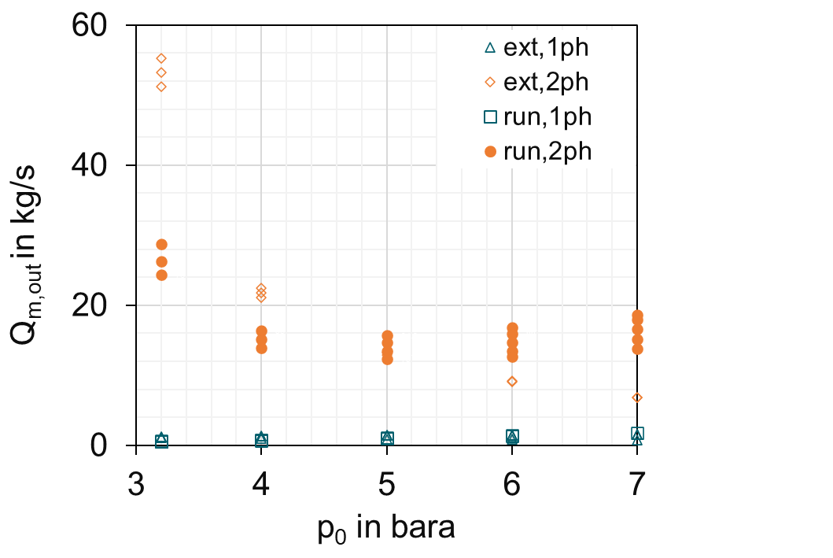  Optimum range  (tentative)  Increase in filling level
Figure 6 Mass flow rate to be discharged for varying specific heat input | Figure 7 Mass flow rate to be discharged for varying over temperature | Figure 8 Mass flow rate to be discharged for varying sizing pressure

The exponential asymptotic increase exhibited by Eq.(iso-10) and Eq.(iso-32) for ΔT_{over} → 0 K explains the strong escalation of relief requirements observed in this range in Figure 7. This exponential relationship defined in the standards' equations (ISO 4126-10, 2024) means that small variations in ΔT_{over} can significantly impact sizing. One requirement was to use the same pressure relief device for scenarios (ext) and (run). Figure 8 shows that the required mass flow rates overlap when 20 K < ΔT_{over} ≤ 22 K. At this point, the specific heat inputs for both scenarios are around 150 W/kg, as shown in Figure 6. The maximum required mass flow rates are 15.7 kg/s and 13.2 kg/s for an initial filling level of 84% at 293K for scenarios (run) and (ext), respectively.
Based on achieving the required mass flow rates, 20 K < ΔT_{over} ≤ 22 K represents the tentative optimum sizing range for the reactor. This range satisfies the single device requirement while allowing the highest filling level and will be used to select an appropriate relief device size in the next step.
    - Step 4 — Calculation of the dischargeable mass flux through and pressure change in the vent line system
For a pressure relief device (bursting disc or safety valve), determining the dischargeable mass flow involves iteratively calculating mass flow and pressure drop in the relief system, consisting of the inlet pipe, relief device, and outlet pipe. This procedure applies generally, not just for two-phase flows. The piping geometry between the reactor and safety valve has the following segments: (i) DN150 entrance nozzle (ζ=0.5), (ii) 1.0 m vertical DN150 pipe, (iii) safety valve modeled as a vertical isentropic nozzle. The pipe roughness Rz is 100μm.
For two-phase vapor/liquid flow (2ph), pressure drop is determined with the HTFS method without slip correction (ISO 4126-10, 2024). For single-phase gas/vapor flow (1ph), pressure drop is determined by applying isentropic or Fanno equations (Levenspiel, 1998), (Mutegi, et al., 2019) conservatively considering compressibility effects at high velocities (Mutegi, 2020). The discharge capacity of each segment is determined per Eq.(iso-53). Mass flow is limited by the first choked flow cross-section, which occurs at the safety valve. The critical seat diameter d_{0,crit} is determined by varying it until choking is detected as the dimensionless mass flow attains a maximum value per Eq.(iso-53).
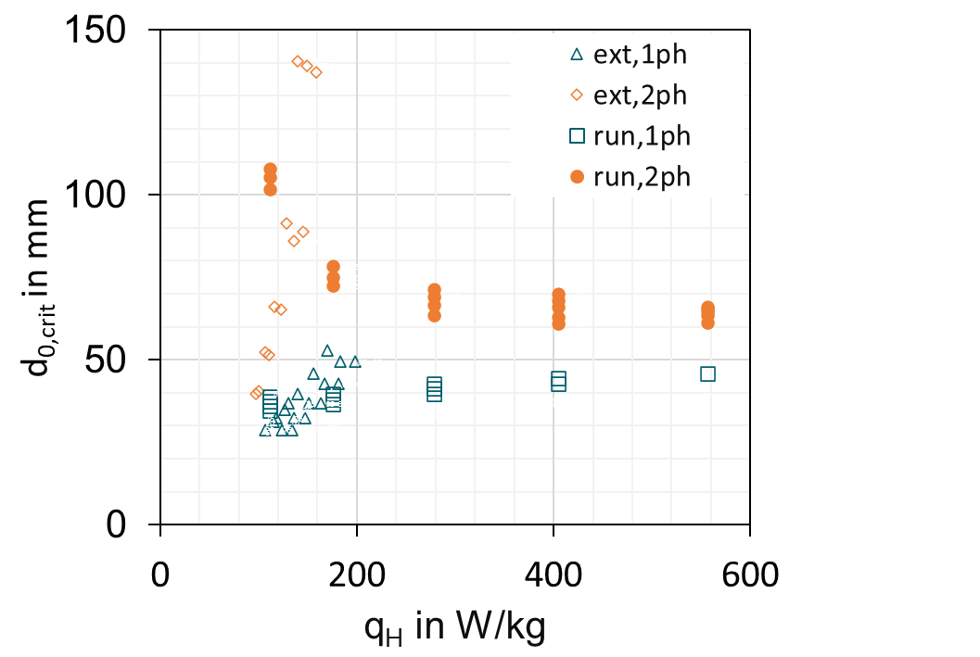  Increase in filling level | 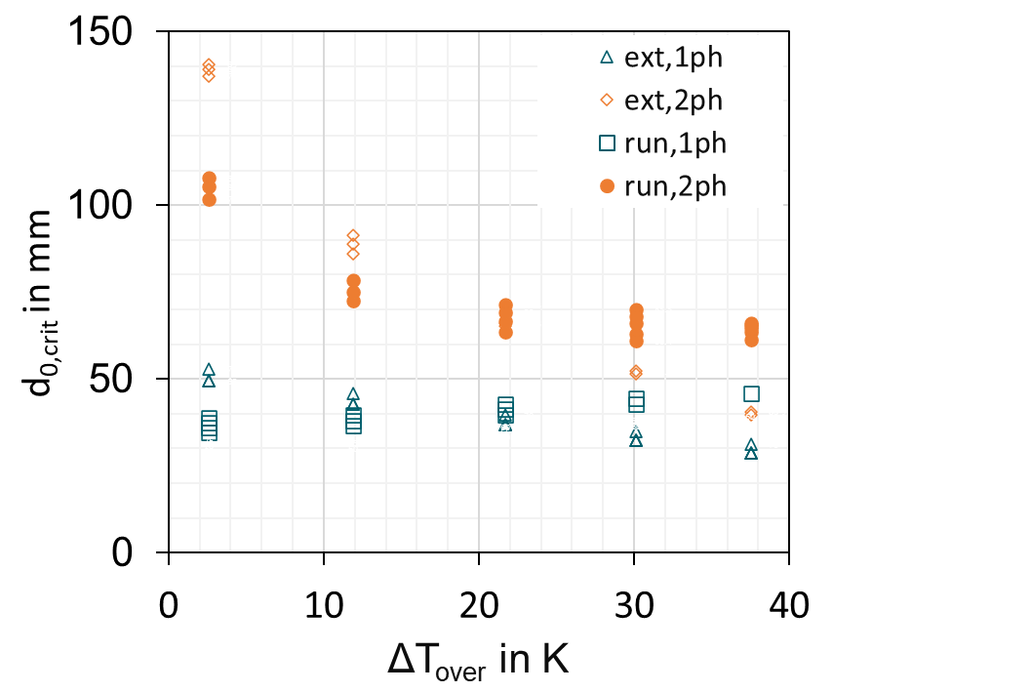  Optimum range  Increase in filling level | 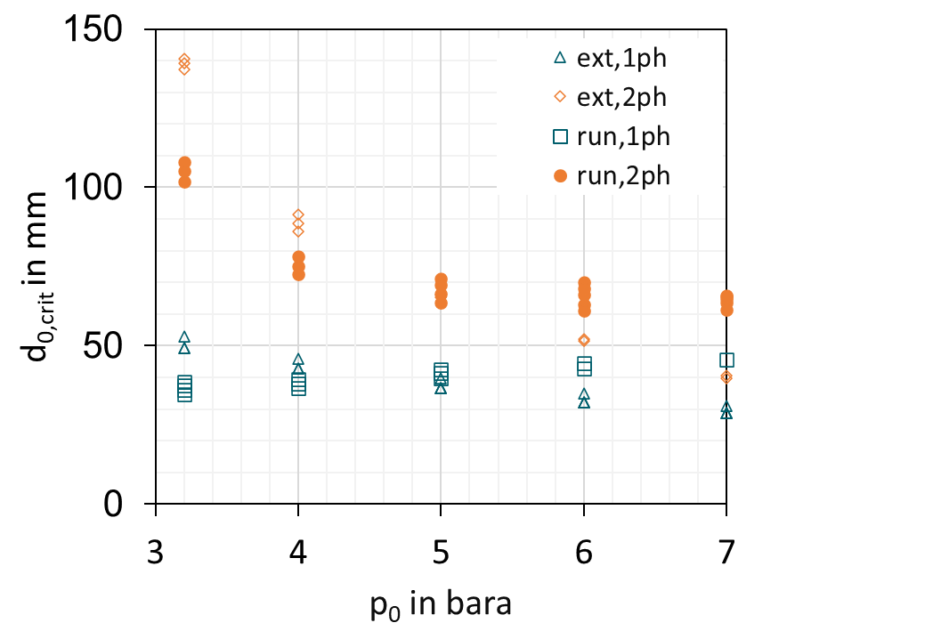  Optimum range  Increase in filling level
Figure 9 Critical seat diameter for varying specific heat input | Figure 10 Critical seat diameter for varying over temperature | Figure 11 Critical seat diameter for varying sizing pressure

Figure 9 to Figure 11 demonstrate that small variations in specific heat input can lead to exponential increases in relief diameter requirements. The largest required critical seat diameters (d_{0,crit}) are 71.3 mm for scenario (run,2ph) and 66.1 mm for scenario (ext,2ph) at an 84% initial filling level. This confirms 20K < ΔT_{over} ≤ 22K as the optimum sizing range based on d_{0,crit} in Figure 10. At this point, the sizing pressure is around 5 bar for both scenarios, as shown in Figure 11. The relief device is sized for the maximum necessary capacity with an adequate safety margin. For the governing scenario (run,2ph), d_{0,crit}=71.3 mm would still be adequately sized even if pressure increased to 7 bar, as seen in Figure 11. Setting the sizing pressure 10% above opening pressure results in ΔT_{over} < 3 K, which increases mass flow rates to 29 kg/s and 52 kg/s for both scenarios, double what is necessary (Figure 8). In this range, scenario (ext,2ph) requires about twice the mass flow of scenario (run,2ph) due to evaporative cooling considerations. This practice is not recommended as it leads to higher-than-needed emissions and unwarranted oversizing. Matching the sizing pressure to relief requirements is preferable to a fixed 10% oversizing approach. A maximum filling level of 80% at ambient conditions is implemented. A DN80 x DN125 safety valve with a seat diameter d₀=72 mm is selected from a manufacturer's catalogue. This selection results in critical flow conditions at a slightly lower sizing pressure of 4.8 bar instead of 5 bar.
For scenario (run,2ph) at 4.8 bar, the relief capacity is 14.56 kg/s. A cyclone separator, located 4.5 m from the safety valve, is optimally sized for the lowest possible discharge capacity. At the cyclone inlet, the static pressure is 1.5 bar. With a conservative gas mass fraction of x_{g}=0.23 and densities of 2 kg/m³ (gas) and 706 kg/m³ (liquid), the cyclone requires a diameter of 635 mm, has a DN150 inlet and DN300 outlet, and experiences forces of 2330 N and a tilt moment of 2314 Nm under optimal conditions. For a higher sizing pressure of 3.2 bar (scenario ext,2ph), the cyclone would need a capacity of 53.2 kg/s, requiring a diameter of 1215 mm, DN300 inlet, and DN700 outlet. Forces would increase to 8900 N and the tilt moment to 16200 Nm (CCPS, 2017). This underscores the importance of right-sizing pressure relief devices, considering practical and cost implications, especially for green-field applications aiming for (near) zero-emissions. If the safety valve differs from the one selected, a new relief capacity calculation would be necessary. The scope of this work covers four of the five steps intended in ISO 4126-10:2024. “Step 5 — Ensure proper operation of safety valve vent line systems under plant conditions”, is omitted in this work for simplicity reasons.
  - Conclusion
The implementation of (ISO 4126-10, 2024) for optimizing pressure relief systems yields significant benefits in sustainability, efficiency, safety, and cost-effectiveness for both greenfield and brownfield applications. While the (ISO 4126-10, 2024) methodology provides more accurate sizing, it requires significantly more computational effort, with the standard doubling in size and complexity. Engineering judgment is crucial in balancing accuracy with feasibility. This case study demonstrates how precise multiphase flow modeling supports sustainability objectives while providing substantial economic and environmental advantages (CSDD, 2024).
The substitution of Dichloromethane with acetonitrile, with its higher latent heat of vaporization, effectively reduces the vapor generation rate responsible for bubble formation and swelling. This change, combined with the optimization process allows for a 60% increase in safe maximum fill level (from 50% to 80%), enabling operation of two reactors instead of three and increasing capacity utilization by 33%. For brownfield applications, it offers retrofit opportunities, including potential material savings of up to 5,605 kg per incident by shifting from bursting discs to safety valves. Equipment optimization benefits also greenfield applications, with significant implications for costs and carbon footprint (CSRD, 2022). The pressure relief device was reduced from DN150 to DN80 (47% diameter reduction), decreasing stationary reaction forces by 75% (from 9.4 kN to 2.41 kN).
The cyclone separator diameter decreased by 48% (from 1,215 mm to 635 mm), reducing parallel forces by 74% (from 8,900 N to 2,330 N) and moment of tilt by 86% (from 16,200 Nm to 2,314 Nm) (CCPS, 2017). These reductions enhance system safety and stability while leading to substantial material savings in equipment, associated piping, and support structures.
While right-sizing reduces material requirements throughout the system, proper sustainability assessment demands rigorous Life Cycle Assessment (LCA) methodology accounting for all plant design choices. The material reductions observed represent environmental improvements, but their true impact must be evaluated through comprehensive LCA that considers raw material extraction, manufacturing, operations, maintenance, and end-of-life scenarios. The resource productivity improvements by up to 30% require verification through this holistic approach, as benefits from individual optimizations may be counterbalanced by other factors in complex chemical processing facilities. Cost implications are far-reaching, with reduced capital expenditure for new facilities and lower replacement costs for existing ones. Improved efficiency and reduced material waste contribute to long-term operational cost savings. This approach leads to more sustainable designs in new projects and improved sustainability within existing infrastructure constraints for brownfield applications, significantly decreasing the facility's embedded carbon and aligning with carbon reduction goals.
This study demonstrates that optimized pressure relief system design, guided by (ISO 4126-10, 2024), can simultaneously advance sustainability objectives, improve operational efficiency, enhance safety, and reduce costs. This approach may not be generalized as it is best suited for multi-purpose plants. As regulatory pressures increase and stakeholders demand greater corporate responsibility, this approach allows companies to demonstrate commitment to sustainability and cost-effectiveness in both new developments and facility upgrades without compromising on safety (CSRD, 2022), (CSDD, 2024).
References
AD 2000 A2, 2015. AD 2000-Merkblatt A 2 Safety devices against excess pressure - Safety valves, s.l.: Verband der TÜV e. V.
API STD 520 PT II, 2020. API Standard 520, Sizing, Selection, and Installation of Pressure-Relieving Devices, Part II - Installation (7th ed.). s.l.:American Petroleum Institute.
CCPS, 2017. Guidelines for pressure relief and effluent handling systems (2nd ed.). s.l.:AIChe, DIERS, CCPS, Wiley.
CSDD, 2024. DIRECTIVE (EU) 2024/1760 OF THE EUROPEAN PARLIAMENT AND OF THE COUNCIL of 13 June 2024 on corporate sustainability due diligence and amending Directive (EU) 2019/1937 and Regulation (EU) 2023/2859. s.l.:European Parliament, Council of the European Union.
CSRD, 2022. Directive (EU) 2022/2464 of the European Parliament and of the Council of 14 December 2022 amending Regulation (EU) No 537/2014, Directive 2004/109/EC, Directive 2006/43/EC and Directive 2013/34/EU, as regards corporate sustainability reporting. s.l.:European Parliament and Council of the European Union.
ISO 4126-10, 2024. Safety devices for protection against excessive pressure — Part 10: Sizing of safety valves and bursting discs for gas/liquid two-phase flow. s.l.: International Organization for Standardization, ISO..
Leung, J. C., 1986. Simplified vent sizing equations for emergency relief requirements in reactors and storage vessels. AIChE Journal, 32(10), pp. 1622-1634.
Levenspiel, O., 1998. Engineering flow and heat exchange (Revised edition). New York: Springer Science & Business Media New York.
Mutegi, M. K., 2020. Experimental Investigation of Mass Flow Rate and Pressure-drop through Rupture Disk Devices with Compressible Two-Phase Flow (Doctoral dissertation, University of Kaiserslautern). 1 ed. Kaiserslautern: KLUEDO Document Server, University of Kaiserslautern, Kaiserslautern.
Mutegi, M. K., Schmidt, J. & Denecke, J., 2019. Sizing rupture disk vent line systems for high-velocity gas flows. Journal of Loss Prevention in the Process Industries, Volume 62.
Schmidt, J., 2011. Sizing of Safety Valves for Multi-Purpose Plants according to ISO 4126-10. Chemie Ingenieur Technik, pp. 796-812.
Stössel, F., 2020. Thermal Safety of Chemical Processes: Risk Assessment and Process Design. s.l.:Wiley‐VCH Verlag GmbH & Co. KGaA.
STVI, 2024. SVTI Swiss Association for Technical Inspections. [Online]
Available at: https://www.svti.ch/en/market-surveillance-authority-pressure-equipment/rules-regulations/legal-basis
TR EC BCI 157 , 2021. TR EC BCI 157 Leitfaden für Druckentlastungssysteme mit Sicherheitsventilen [Guideline for pressure relief systems with safety valves]. s.l.:BCI Engineering Community.
VDI-Wärmeatlas (12th ed.), 2019. Fachlicher Träger VDI-Gesellschaft Verfahrenstechnik und Chemieingenieurwesen. s.l.:Springer-Verlag.

