|  |  |
| --- | --- |
| cetlogo ***CHEMICAL ENGINEERING TRANSACTIONS***  ***VOL. xxx, 2025*** | A publication of  aidiclogo_grande |
| The Italian Association  of Chemical Engineering  Online at www.cetjournal.it |
| Guest Editors: Bruno Fabiano, Valerio Cozzani  Copyright © 2025, AIDIC Servizi S.r.l. **ISBN** 979-12-81206-xx-y; **ISSN** 2283-9216 | |

Hydrogen Safety in Process Industry: Systematization of Past Lessons

Morena Vitale\*, David Javier Castro Rodriguez, Antonello A. Barresi, Micaela Demichela.

Department of Applied Science and Technology, Politecnico di Torino Corso Duca Degli Abruzzi 24, 10129 Torino, Italy

morena.vitale@polito.it

Interest in hydrogen has grown due to its potential as a green fuel, because hydrogen combustion produces only water. However, hydrogen presents two significant challenges: its wide flammability range (4%-75%) and low ignition energy (0.017 mJ), which make leaks highly flammable, and its small molecular size, which easily penetrates materials, altering their microscopic and macroscopic properties and causing leaks that are difficult to detect, increasing the risk of invisible fires. To manage these risks, many studies simulate hydrogen leakage scenarios to establish accurate safety distances. A thorough understanding of hydrogen leakage behaviour and failure mechanisms is crucial for risk assessment. This study addresses a gap in the existing literature on hydrogen-related events. The aim is to identify the most critical equipment in conditions of hydrogen exposure and material degradation in the process industry, to provide support to inspection and monitoring activities for more effective risk management. The analysis identifies the chemical, petrochemical and manufacturing sectors as the most vulnerable to the effects of hydrogen. Corrosion and hydrogen embrittlement are frequent causes of events, mainly affecting pipelines and often resulting in explosions or fires.

**Keywords:** Hydrogen, Hydrogen Embrittlement, Material Degradation, Safety, Process Plant.

* 1. Introduction

Hydrogen is one of the most promising alternatives to reduce environmental pollution and dependence on fossil fuels, thanks to its ability to produce only water as a by-product of combustion.

However, hydrogen presents significant technical challenges. With an extremely low density (0.0899 kg/m³), it is a very light gas. Its wide flammability range, from 4% to 75% by volume, and its very low minimum ignition energy, equal to 0.017 mJ, make it particularly dangerous. In fact, in case of leaks, hydrogen can easily form flammable mixtures with air that can quickly ignite. Furthermore, its molecules, being extremely small, can easily escape through the joints and seals of equipment, causing jet fires that are not visually detectable in sunlight, increasing the risk to operator safety.

In addition, one of the most critical phenomena related to the use of hydrogen is hydrogen embrittlement (HE), a complex process in which the gas penetrates materials compromising their mechanical properties. This phenomenon manifests itself through the physical and chemical absorption of hydrogen within the microstructure of the material, causing a reduction in tensile strength, fatigue and fracture toughness (Dwivedi and Vishwakarma, 2018). HE can lead to significant degradation of the material, increasing the risk of structural failure, cracking, or other mechanical damage.

To ensure the safety and reliability of applications involving hydrogen, it is essential to adopt preventive measures to manage the risk of material embrittlement. This requires a thorough analysis of the potential degradation induced by hydrogen, as well as careful management of containment losses, which could have disastrous consequences for the plant and the surrounding environment. Proper management of these factors is crucial to ensure the operational safety and durability of hydrogen-using equipment and systems. To ensure an accurate risk assessment and effective monitoring of hydrogen leaks, it is essential to identify the critical points within the plant, i.e., those areas where leaks or failures are most likely to occur. This process requires a thorough understanding of the specific failure mechanisms related to hydrogen, such as corrosion and hydrogen embrittlement, which can compromise the integrity of equipment and structures. An effective approach to gaining this knowledge is the analysis of past incidents in the process industry involving hydrogen. These incidents provide valuable data on how and where failures occur, which types of equipment are most at risk, and what operational conditions contributed to the incidents (Vitale et al., 2024). Furthermore, the analysis allows for the evaluation of the effectiveness of current safety measures and to identify areas that need improvement. It facilitates the understanding of the extent of economic and environmental damages associated with incidents, allowing the development of strategies to reduce future losses and mitigate the overall impact. The results of the analysis can also support the formulation of new regulations and standards for hydrogen management, thus contributing to an improvement in safety. Therefore, the aim is to identify the critical factors responsible for leaks, fire or explosions, in order to support the design and maintenance of plants, thus improving operational safety.

* 1. Materials and methods

The analysis is developed in two main phases, following the same procedure described in detail by Castro Rodriguez et al. (2024). The first phase concerns data collection, in which data on industrial events are acquired from different sources, including international databases covering various sectors of the process industry. The aim is to obtain a sufficiently large sample of cases to ensure a meaningful analysis and to provide a global view of the types of events examined. The second phase involves the study of the collected data through graphical analysis. The aim of this analysis is to identify trends and relationships present in the data, to provide an in-depth understanding of the dynamics involved.

* + 1. Data gathering

To conduct the analysis, an in-depth review of the main open-source scientific databases was performed, with the aim of collecting all the reports in which material ageing and degradation played a relevant role, both primary and secondary, in the escalation of events in presence of hydrogen. The following databases have been sorted:

* The ARIA (Analysis, Research, and Information on Accidents) database, managed by the French Ministry of the Environment, is a global resource for collecting information on industrial accidents. Designed to strengthen the prevention of industrial risks, ARIA includes a wide range of reports on accidents, near misses and anomalies, covering different industrial sectors. At the end of 2023, the database had over 59,000 records and continues to expand annually with the addition of approximately 1,200-1,500 new records (BARPI, 2022).
* The eMARS (Major Accident Reporting System) database, managed by the European Commission, is dedicated to collecting information on major accidents in high-risk industries, in compliance with the Seveso Directive. eMARS aims to improve the prevention and management of major industrial accidents by providing a comprehensive resource for the analysis of the causes and consequences of such events. The database contains detailed reports of accidents and near misses, covering a wide range of risky industrial sectors. By the end of 2023, eMARS had collected over 1,200 records, with continuous updates based on reports received from Member States (eMars, 2022).
* The JRC HIAD (Hydrogen Incident and Accident Database) is managed by the Joint Research Centre (JRC) of the European Commission and is dedicated to collecting information on accidents and near misses related to the use of hydrogen. Designed to improve safety and risk management in hydrogen applications, the database contains detailed accident and incident reports, analysing the causes, dynamics and consequences, both human and environmental. The JRC HIAD is a crucial resource for supporting the safe development of hydrogen technologies. By the end of 2023, the database had over 700 records, with regular updates as new incidents were reported internationally (European Commission, Joint Research Centre, 2023).

The search in the indicated databases was performed using the keywords "ageing", "corrosion", "erosion", "vibration", "wear", "brittleness", "degradation" and "fatigue", selecting all the events that occurred in the process industry and that involve the presence of hydrogen; 84 events were collected, constructing a data repository, following a structure similar to the database developed by Castro Rodriguez et al. (2023). Each selected report documents a single event, providing detailed information on the place and date, an in-depth description of the dynamics, the extent of human losses and the environmental impact, reporting any pollution phenomena. The adopted approach allows for a systematic analysis of events related to hydrogen and material ageing phenomena, providing a useful database to identify trends and critical factors related to hydrogen and its influence on industrial risk.

* + 1. Data collection

The classification has been structured as follows:

* Source: Indicates the source of the report.
* Macro-sector: Specifies the type of plant where the event occurred. Process plants are divided into several macro-categories, including Chemical and Petrochemical, Manufacturing, Pipeline, Power Generation, Storage and Warehousing, Transportation and Water Treatment, as reported by Ricci et al. (2021).
* Outcome: Represents the type of industrial event that occurred. The categories are Accident, Incident, Loss of Containment and Near Miss. The definitions of these categories are provided by Ricci et al. (2021), with the addition of the Near Miss category as described by Gnoni et al. (2013).
* Final Scenario: It concerns the impacts generated by the event and includes toxic gas dispersion (TGD), environmental contamination (EC), release without further consequences (R-NFC), fire (F), explosion (E) or multiple scenarios (MS). Multiple scenarios indicate the combination of different types of incidents or the simultaneity of events among those mentioned, according to Ricci et al. (2021).
* Cause: It refers to the most common deterioration mechanisms, as identified by Hansler et al. (2022), such as corrosion, erosion, vibrations, fatigue, and hydrogen embrittlement (Li et al., 2020). A generic category called material degradation has also been introduced for cases where it was not possible to identify a specific type of failure.
* Type of Equipment: It is based on the categories defined by Castro Rodriguez et al. (2024), which include: machinery, electric and electronic equipment, pipework, process equipment, storage equipment and other.
* Classification of Substances Involved: It is based on the Globally Harmonized System of Classification and Labelling of Chemicals (UNECE, 2021). This system categorizes substances based on the physical hazards, health hazards and environmental hazards they pose. In addition, two additional categories have been included: NA for substances that do not pose significant hazards and multiple hazards for those that pose more than one type of hazard.
* Losses: Losses are divided into three main categories: human, economic and environmental. Human losses include injuries and fatalities. Economic losses are classified into four bands based on the extent of damage: i) up to $100,000, ii) between $100,000 and $1 million, iii) between $1 million and $10 million, and iv) above $10 million, following a classification consistent with previous studies. Environmental losses are divided into two main categories: SED (Severe Environmental Damage) and MMD (Minor or Moderate Damages), in accordance with Annex VI of the Seveso III Directive (European Commission, 2015) and the environmental vulnerability criteria of the Ministry of Public Works (Ministero dei Lavori Pubblici, 2001).

It is important to note that the data provided by these reports can often be incomplete or inaccurate. To address this limitation and maintain consistency with previous studies, the category "Unknown" has been introduced. This category allows for cases where the available information is insufficient or not entirely clear, allowing for a more accurate analysis of uncertain situations. Furthermore, during the compilation of the database, special care was taken to avoid duplication of data, thus ensuring the consistency and accuracy of the information collected.

* + 1. Analysis

The analysis uses tables, graphs and charts to visualize data and help identifying relationships between variables. This visual method helps to quickly discover trends, variations, and patterns that may not be apparent through purely numerical analysis. The goal is to gain a preliminary understanding of the data and its interactions, with further steps planned to deepen the knowledge.

* 1. Results and discussion

In this section, a database containing 84 events involving hydrogen use in the process industry, related to material degradation, recorded in the period 1971 to 2022, is analysed. Figure 1a illustrates the annual variations in the number of incidents, showing small fluctuations over time. However, despite these fluctuations, the annual average of incidents showed an increasing trend in the early years. Figure 1b presents the average number of events across different periods. The average is calculated by dividing the total number of incidents recorded during each selected period by the number of years within that period.

The analysis shows that the average number of incidents increased until 2009, followed by a subsequent decrease. This initial increase could be due to several factors, including the introduction of the Internet in industry, which has simplified the reporting of events, and a growing interest in hydrogen as an alternative to fossil fuels, for its potential benefits in reducing dependence on fossil fuels and improving environmental sustainability. The subsequent decrease in the number of events could reflect an improvement in safety practices and prevention measures. This suggests that the strategies implemented to manage risks associated with hydrogen have had a positive impact on reducing events. Indeed, in 2012, Europe introduced Seveso III Directive (2012/18/EU), which regulates the management of major accidents involving dangerous substances. This directive has probably contributed to improve safety practices and reduce the number of accidents through more stringent requirements and more effective prevention measures.

b)

Figure 1: a) Records frequency from 1971 to 2022. b) Average number of events per year in different periods.

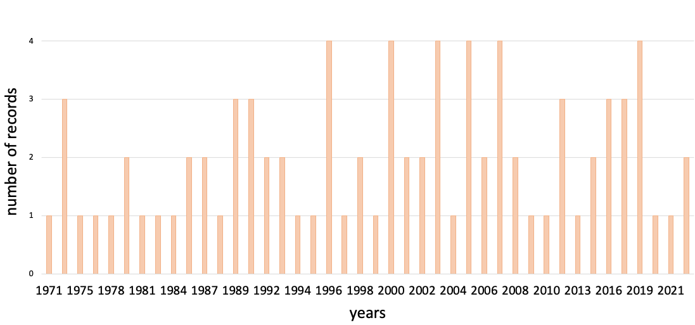

a)

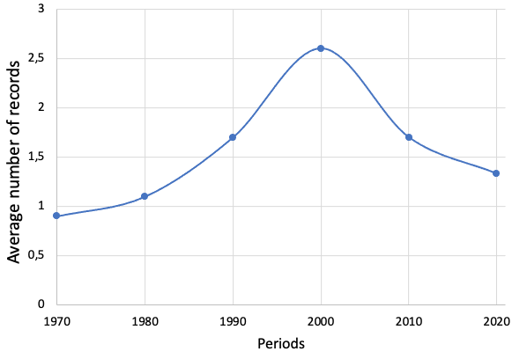

1970-1979 1980-1989 1990-1999 2000-2009 2010-2019 2020-2022

Time periods

The analysed data shows that 77% of the incidents related to material degradation in the presence of hydrogen occurred in the chemical and petrochemical industry, making this the most affected sector. Next, 7% of the incidents occurred in the manufacturing sector and 6% in energy production. These results can be explained by the fact that hydrogen is widely used in these industrial sectors. As for the equipment involved, piping is the most affected category, representing 52%, followed by process equipment (18%), machinery (17%) and storage equipment (10%). Finally, electrical equipment and the category “other” have an equal frequency (1.5%).It is noteworthy that, contrary to initial expectations, storage equipment does not appear to be the most significantly impacted by incidents, despite the assumption that such equipment would be highly vulnerable to hydrogen-related risks due to prolonged exposure, often under pressure, which promotes material embrittlement. This could indicate that more advanced safety systems and more effective prevention measures are applied to this type of equipment, thus reducing the frequency of events compared to other industrial components, such as pipelines or process equipment. Figure 2 shows the results of the analysis of the 84 reports examined, from which the most frequent degradation mechanisms are corrosion, hydrogen embrittlement and vibrations. It is important to note that hydrogen corrosion and embrittlement are closely related to the presence of chemicals in systems. Remarkably, in 12% of reports, hydrogen was not originally present in the system but was formed as a by-product of corrosion processes, caused by factors internal or external to the system, or by welding operations. This highlights the need to consider the risk related to the presence of hydrogen even in systems where it is not initially expected. Hydrogen can form unexpectedly as a by-product of processes such as corrosion or welding. Failure to consider this possibility can significantly increase the risk of events, given the highly flammable and penetrating nature of hydrogen, which can compromise the structural integrity of materials and lead to leaks or explosions. Vibrations, on the other hand, are not related to the chemicals present. However, because hydrogen has very small molecules, it can easily escape from equipment, especially in the presence of vibrations, which increases the risk of leaks and, consequently, gas dispersion.

The data analysis revealed that 36% of the events were classified as accident and 39% as incident, and in all these events an ignition always occurs. In the remaining 25% of cases, there are losses of containment (19%) or events considered near misses, situations in which a potential risk has occurred without consequences. Due to the high flammability of hydrogen, it is essential to limit and control any leak of this gas. Therefore, the management and prevention of hydrogen leaks are essential to ensure the safety of plants and workers, reducing the risk of events. Figure 3 shows the causes of the events in relation to the final scenarios. The main scenarios identified in the incidents analysed include explosions, fires, and multiple scenarios where both fires and explosions are present, which is consistent with the intrinsic characteristics of hydrogen, which is known for its high flammability. However, some significant aspects should be considered. In case of corrosion, it has been observed that hydrogen release occurs without consequences, in a number of cases equivalent to those in which ignitions and explosions have been recorded. This phenomenon, defined as release without further consequences, indicates that not all hydrogen leaks lead to accidents or incidents, despite the potential risk being high. In the context of hydrogen embrittlement, another frequently observed scenario is represented by situations in which nothing happened, i.e., no serious events have occurred, despite the degradation of the material. These aspects highlight a possible insufficiency in the safety measures currently in place. Although no accident or incident have been recorded, the presence of hydrogen leaks or events considered near misses suggests that an improvement in the safety system is necessary.

Finally, reported losses were analysed. 20% of the events reported injuries, 7% reported fatalities, and 40% reported no human losses. In terms of economic losses, only 28% of the reports provide specific data. Among them, 24% reported losses greater than 1 million euros, while 4% reported losses less than 1 million euros. Concerning environmental losses, 88% of the reports reported no environmental pollution. This can be attributed to the fact that hydrogen gas is not considered toxic or harmful to the environment; however, there are facilities where hydrogen is present together with other toxic or harmful substances.

From these results, it clearly emerges that economic losses are the most affected by this type of event.

Figure 3: Degradation mechanisms of the analysed reports, in relation to the fineal scenario.

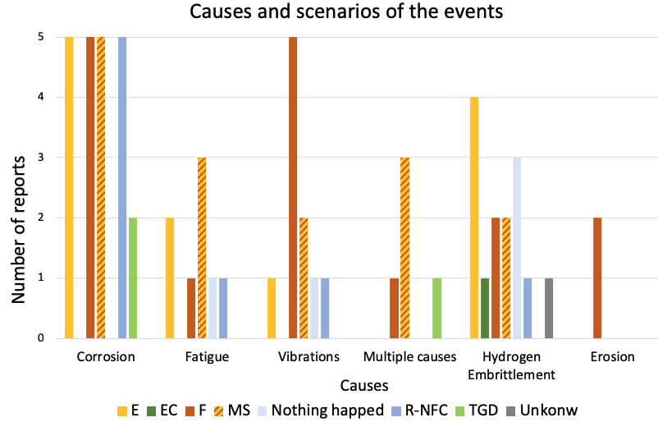

Figure 2: Degradation mechanisms of the analysed reports.

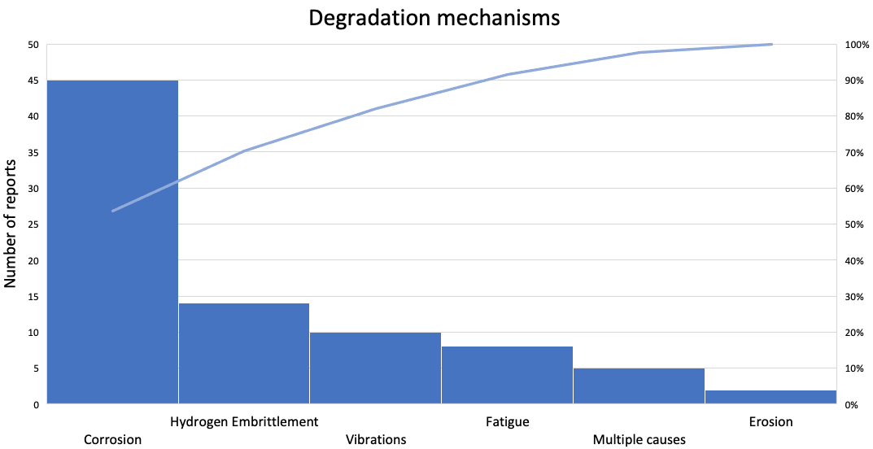

* 1. Conclusions

Hydrogen represents a promising alternative to reduce environmental pollution and dependence on fossil fuels, primarily because its combustion product is water. However, the challenges associated with its use, particularly its flammability and propensity for material degradation, cannot be overlooked. Analysis of 84 incidents, from 1971 to 2022, involving hydrogen and material degradation in the process industry highlights the critical risks posed by hydrogen leaks and the resulting impacts on safety, economic stability, and environmental integrity. The analysis highlights the urgency of adopting safety measures, particularly in the chemical and petrochemical sectors, which are the most vulnerable to hydrogen. This vulnerability stems from their dependence on piping systems and process equipment, which are prone to corrosion and hydrogen embrittlement. The data indicates that the adoption of improved safety standards, such as those required by the Seveso III Directive, contributes to reducing the number of incidents.

It is essential that the risk assessment also considers the potential generation of hydrogen, even in the absence of hydrogen, as it can be produced by phenomena such as corrosion or improperly performed welding. It is necessary to intervene and conduct a thorough risk assessment of corrosion and hydrogen embrittlement, which are the most common causes, with potentially catastrophic outcomes such as fires or explosions. In addition, particular attention must be paid to vibrations, which, despite being the third most common cause, still constitute a significant hazard, since in the event of a release of substances due to vibrations, the probability of ignition and subsequent combustion is extremely high. This study is the first phase of research, aimed at establishing the foundation for future analysis. The main objective is to collect and analyse events that occurred in the past. Subsequently, further investigations will be conducted to deepen the understanding of the consequences associated with the presence of hydrogen and hydrogen releases in industrial plants.

Acknowledgments

Part of this study was carried out within the RETURN Expanded Partnership and received funding from the European Union Next-GenerationEU (National Recovery and Resilience Plan – NRRP, Mission 4, Component 2, Investiment 1.3 – D.D. 1243 2/8/2022, PE0000005).

References

BARPI, 2022, The ARIA database [WWW Document],The French Bureau for Analysis of Industrial Risks and Pollutions (BARPI) https://www.aria. developpement-durable.gouv.fr/the-barpi/the-aria-database/?lang=en < <https://www.aria.developpement-durable.gouv.fr>> accessed 10.23.

Castro Rodriguez, D.J., Tufano, C., Vitale, M., Mietkiewicz, J., Baldissone, G., Barresi, A.A., and Demichela, M., 2023, Dataset of NaTech events triggered by lightning within the Process Industry, Mendeley Data, V2, doi: 10.17632/fff64w3rzn.2.

Castro Rodriguez, D.J., Mietkiewicz, J., Vitale, M., Baldissone, G., Barresi, A.A., and Demichela, M., 2024, NaTech triggered by lightning: Novel insights from past events in the process industry, Heliyon 10, e31610. https://doi.org/10.1016/j.heliyon.2024.e31610

Dwivedi, S.K. and Vishwakarma, M., 2018, Hydrogen embrittlement in different materials: A review, International Journal of Hydrogen Energy 43, 21603–21616. https://doi.org/10.1016/j.ijhydene.2018.09.201.

eMARS, 2022, EUROPA - eMARS Accidents Search - European Commission [WWW Document] <https://emars.jrc.ec.europa.eu/en/emars/accident/search> accessed 10.23.

European Commission, 2015, Directive 2012/18/EU of the European Parliament and of the Council of 4 July 2012 on the control of Major-Accident Hazards involving dangerous substances, amending and subsequently repealing Council Directive 96/82/EC <<https://eur-lex.europa.eu/legal-content/> EN/TXT/PDF/?uri=CELEX:32012L0018> accessed 10.23.

European Commission, Joint Research Centre (JRC), 2023: HIAD 2.1. European Commission, Joint Research Centre (JRC) [Dataset] <<http://data.europa.eu/89h/1d6b06e9-3a89-4ec2-b051-3fb8a28eab9f>> accessed 10.23.

Gnoni, M.G., Andriulo, S., Maggio, G., and Nardone, P., 2013, “Lean occupational” safety: An application for a Near-miss Management System design, Safety Science, 53, 96–104.

Hansler, R.J., Bellamy, L.J., and Akkermans, H.A., 2022, Ageing assets at major hazard chemical sites–The Dutch experience. Safety Science, 153, 105788.

Li X., Ma X., Zhang J., Akiyama E., Wang Y., and Song X., 2020, Review of hydrogen embrittlement in metals: hydrogen diffusion, hydrogen characterization, hydrogen embrittlement mechanism and prevention, Acta Metallurgica Sinica (English Letters), 33, 759–773.

Ministero dei Lavori Pubblici, 2001, Requisiti minimi di sicurezza in materia di pianificazione urbanistica e territoriale per le zone interessate da stabilimenti a rischio di incidente rilevante, Decreto Ministeriale 9 Maggio 2001, Supplemento ordinario Nr 151 alla “Gazzetta Ufficiale” n. 138 del 16 giugno 2001 - Serie generale. Italia.

Ricci, F., Casson Moreno, V., and Cozzani, V., 2021, A comprehensive analysis of the occurrence of Natech events in the process industry, Process Safety and Environmental Protection, 147, 703–713.

UNECE, 2021, Globally harmonized system of classification and labelling of chemicals (GHS), ST/SG/AC.10/30/Rev.9. United Nations Economic Commission for Europe (UNECE).

Vitale, M., Shi, H., Castro Rodriguez, D.J., Barresi, A. and Demichela, M., 2024, Ageing in process industry: Identification of material degradation from past accidents analysis, IFAC-PapersOnLine 58(4), 568-573. <https://doi.org/10.1016/j.ifacol.2024.07.279>.