 CHEMICAL ENGINEERING TRANSACTIONS  VOL. xxx, 2025 | A publication of  
The Italian Association
of Chemical Engineering
Online at www.cetjournal.it
Guest Editors: Bruno Fabiano, Valerio Cozzani
Copyright © 2025, AIDIC Servizi S.r.l.
ISBN 979-12-81206-xx-y; ISSN 2283-9216

Considerations on safety parameters, product quality and process reliability for the usage of microwaves and plasma torch burners in high-temperature processes
Ralph Behendª, Dominik Liebschª, Andreas Pestelª, Hartmut Krauseª, Sven Eckartª
ªInstitute of Thermal Engineering, TU Bergakademie Freiberg, Freiberg, Germany
ralph.behrend@iwtt.tu-freiberg.de

Microwave plasma offers several advantages across various industrial applications. It enables highly efficient and targeted energy transfer to materials, resulting in lower energy consumption compared to conventional high-temperature processes such as liquid and gaseous burners. The controllability of microwave plasmas allows for precise control of high-temperature processes, leading to improved product quality and reproducibility. Nevertheless, the utilization of microwaves and microwave plasmas in industrial process systems presents various potential risks that need to be carefully considered. This manuscript outlines the primary risks and challenges during the implementation and operation in high temperature processes.
Microwave radiation can pose health hazards, particularly if handled improperly or without adequate shielding. Humans exposed to such conditions may suffer from tissue damage, eye irritation, and impairments to the nervous system. Further, microwave generation has the potential to generate electromagnetic interference, which can disrupt or damage sensitive electronic equipment. To safeguard against such interference, effective shielding measures are essential. Additionally, environmental considerations surrounding microwave plasma usage are also significant. Depending on the particular process employed, there is a possibility of releasing pollutants such as large concentration of ozone and nitrogen oxides into the environment.
Microwave plasmas present significant explosion and fire risks, particularly in environments where flammable gases or dust are present. The interaction between the plasma and these combustible materials can lead to dangerous incidents. To mitigate these dangers effectively, it is crucial to implement stringent safety measures, including proper monitoring, containment, and control systems, to ensure a safe operating environment. Some of the available techniques will be summarized.
The high temperatures and reactive species produced in microwave plasmas can lead to significant material degradation. Components directly exposed to the plasma are especially vulnerable, often experiencing corrosion or erosion. This can compromise the integrity and longevity of the materials, necessitating careful selection of materials especially in combination with high wall temperatures.
These risks can be effectively managed through thorough risk assessments, robust safety protocols, adequate protective measures, and regular maintenance. The benefits of using microwaves and microwave plasmas, such as high energy efficiency and precise process control, support their application in many industrial settings.
  - Introduction
To reduce greenhouse gas emissions industry is forced to switch from fossil fuels to renewable energy. One way to achieve this is the electrification of high temperature processes, such as ceramics burning or steel reheating. However, conventional resistive heating is limited in energy density when compared to state-of-the burner technology. Plasma torches can replace burners with relative ease, since the process can stay more or less the same and are therefore under research as a viable retrofit solution for conventional furnaces. Microwave technology has long been seen as an alternative heating method for ceramics and glass and the technology is slowly reaching industrial readiness.
Atmospheric plasma torches have been discussed as heating technology in several forms since decades (Boulos, 2023) but just in recent years have high power microwave plasma torches (MW torches) found wider application and are available from numerous suppliers. Inductively coupled plasma torches (ICP torches) are now in development that might achieve power outputs suitable for large scale industrial use. MW and ICP torches are virtually free of wear and can produce hot gas without trace particles from the electrodes. Both can be used with a wide range of gases and atmospheres. They sustain their plasma by suppling energy to the gas in form of high intensity electromagnetic fields of different frequencies. Since high power MW torches are more widely available, we will focus our discussion on this technology. Most of the considerations can be easily transferred to ICP torches.
Microwaves are electro-magnetic, non-ionizing radiation with a frequency from 300 MHz to 300 GHz. Typically, the ISM radio bands, as defined by ITU Radio Regulations (ITU, 2024), are used for commercially available generators. 915 MHz, 2.45 GHz and 5.8 GHz are the typical frequencies. While microwaves have been in use for food preparation and drying applications for decades (Meredith, 1998), their usage in high temperature applications has been very limited. Research has pushed the limits of application in glass production over the past ten years. Especially when used in retrofitted furnaces some safety consideration beyond normal radiation safety should be taken.
  - Basic operating parameters
    - Microwaves
Common microwave installations make use of magnetrons for microwave generation. In the past years solid state generators (SSG) have become more broadly available for high power applications. However, due to the high investment cost SSGs have not yet become widespread. Magnetron-based systems have several limitations that solid-state generators address effectively. Magnetrons operate at a fixed frequency, making them less versatile and prone to frequency instability, while solid-state systems offer superior frequency control and stability . Magnetrons also have a shorter lifespan (2,000–8,000 hours) compared to up to 15 years offered by solid-state systems. Solid-state generators provide more precise power control. Additionally, solid-state systems are mostly,safer, as they use low-voltage DC power, unlike the high-voltage requirements of magnetrons . These advantages are making solid-state generators increasingly competitive, gradually reducing the dominance of magnetrons in microwave generation (Atuonwu, 2018). Due to the nature of microwaves, the microwave generator can be placed some distance from the application. The microwaves can be transferred via waveguide or coaxial cable with relatively low losses. Microwave generators are commonly available up to 100 kW for 915 MHz and 30 kW for 2.45 GHz. Internally, microwave generators may operate with voltages far exceeding 1 kV, appropriate caution is adviced. Most microwave generators exceeding 1 kW of microwave power are water cooled, which may lead to additional safety consierations for high temperature applications.
Allowable microwave radiation leakage depends on frequency, area of operation and national and international regulations. It has to be monitored for industrial installations.
    - Plasma torches
MW torches usually operate at frequencies of 915 MHz for applications with a power demand exceeding 10 kW and with 2.45 GHz for less power demanding applications. Other frequencies are available but less common. Typically, a MW torch has a turndown ratio of 10:1 in means of power output and even higher in terms of volume flow and temperature. Plasma torches need a plasma gas supply, which is fed directly into the plasma source.
The average hot gas temperature $T_{Gas,hot}$ after recombination can be approximated by
$$T_{Gas,hot}=\frac{P_{MW}}{{\dot{V}}_{Gas}⋅c_{Gas}}+T_{Gas,cold}$$ | (1)
Where $P_{MW}$ is the microwave power absorbed in the gas, ${\dot{V}}_{Gas}$ is the volume flow rate of the gas under standard conditions, $c_{Gas}$ is the specific heat capacity of the used gas under standard conditions and $T_{Gas,cold}$ is the inlet temperature of the used gas. Due to the high differences in specific mass and heat capacity the resulting temperatures for different gases with equal flow rate and microwave power may differ greatly. For a MW power setting of 6 kW and a flow rate of 100 l/min pure Hydrogen will reach 2263°C, while Argon will reach temperatures in excess of 3800°C. Carbon dioxide will only reach 1383°C (Assuming perfect heat transfer to the gas, no thermal losses and a cold gas temperatur of 20°C. Thermophysical data from NIST Chemistry WebBook (NIST, 2024)).
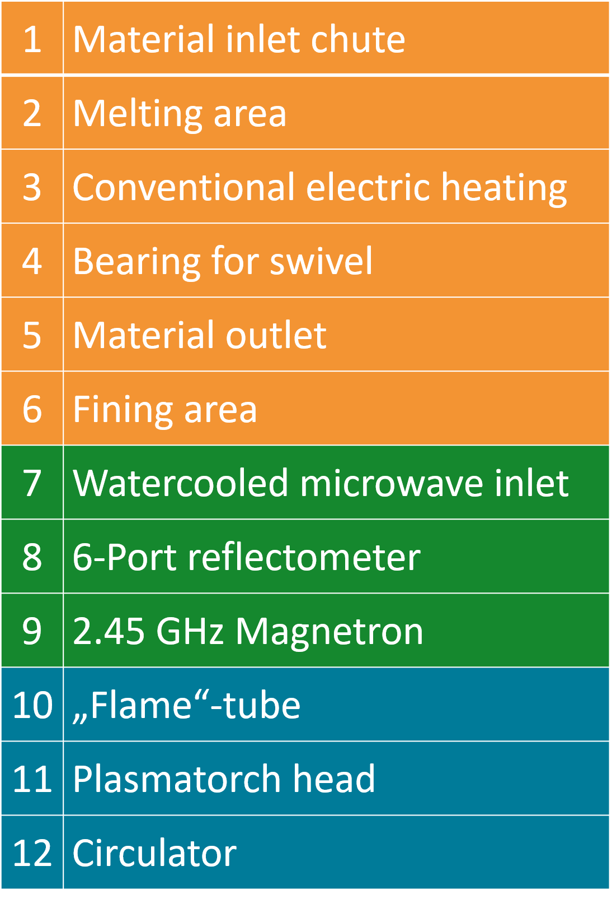
  - General safety considerations
    - Microwaves
Disregarding equipment malfunction and resulting risks for electrocution with high voltage or water damage from cooling water microwave installations are relatively safe. Microwave radiation is non-ionizing radiation. High dose exposure may lead to inner burns. Especially eyes are a sensitive body part and should be shielded under all circumstances. Low dose exposure is with high probability not harmful for the human body, as long as the relevant radiation limits are considered. Microwave radiation levels around an industrial microwave apparatus have to be constantly monitored and the microwave source has to be switched off in case of leakage.
From a technical point of view, even low-level microwave radiation may interfere with other electrical installations in proximity to the source and may interfere with wireless communications. Thermocouples with insufficient shielding may show erroneous temperatures – depending of the field strength the deviation may not be spotted directly, since the measured values are still plausible. Deviations up to several hundred degrees Celsius are, however, possible and pose a direct risk to the safe operation of the furnace. Appropriate shielding with metallic sheaths is advised but may not fully mitigate problem, especially inside of the furnace. Microwave field strength may be increased close to a thermos couple and induction effects at the thermo couple sheath may influence the measurement. Furthermore, microwave heating may not be considered homogeneous in a process in all circumstances. Temperature differences in excess of several hundred degree Celsius may occur in high temperature microwave heated processes over very little distances (see comments on thermal runaways in further down) and a suitable temperature control has to be foreseen to mitigate potential damage to the system or the materials.
Microwave heated processes may achieve heating rates far in excess of 100 K/min and ceramic materials may exhibit violent thermal shock reactions with spalling. Flying shards from such spalling may interfere with other furnace components or even damage them.
Waveguides with damages to the inner surface or with inner material layers deposited on the surface (e.g., deposited from the process) may exhibit strong heating or arcing up to the point of failure and consequent microwave leakage. Even if no critical failure occurs waveguide surfaces may become very hot and pose a risk to its surroundings. Countermeasures include construction from high grade steel and constant purging of the waveguide with dry air or nitrogen. Microwave windows may prevent the sedimentation of material within the waveguide but may be prone to material deposition itself. Furthermore, microwave windows may induce arcing if they are not rated for the used power levels and may therefor damage the system.
Microwave interaction with materials has to be considered in much detail, when designing a process. Microwaves may interact with the product in the furnace as well as with the refractory materials. Since the governing dielectric properties are highly material and temperature dependent and may change in orders of magnitude within a few hundred degrees C

. See for example (Behrend, 2024)).
The widely changing absorption properties of most materials brings some safety concerns. Increased microwave absorption in only parts of the material might lead to a so called “thermal runaway” or hotspot where temperature increases faster than in the surrounding material thus increasing microwave absorption and heating even faster. This might potentially lead to the destruction of the material. If the material was intended to guaranty microwave tightness the implications for safety are obvious. Furthermore, since the absorption characteristics of the materials may differ widely a design has to be chosen that ensures microwave absorption in the material that is intended to be heated.
    - Plasma torches
Plasma torches can be operated with a wide array of gases. Some of these gases may be hazardous in itself and pose risks to health and environment. As stated above, plasma torches heat gases to very high temperatures and exhaust a hot gas stream with all the implications to health and safety that are also true for conventional burners. Most of the health and safety risks can be minimized, if the torches are used in an enclosure, ideally with a gas and EM-radiation tight metallic encasing
Depending on the used plasma gas the plasma torch may generate harmful emissions, such as CO, NOx and O₃ in high amounts. The exhaust gases have to be removed via a suitable exhaust gas system to prevent risks to health and environment, but should be measure to ensure staying inside of the national regulations.
In addition, a plasma torch typically emits strong UV radiation and strong visible light. Suitable measurements to ensure eye protection is advised.
Microwave plasma torches emit a small amount of microwave radiation. This is due to the properties of plasma, which is electrically conductive and in combination with the metallic enclosure of the microwave head forms a “coaxial cable”. The same considerations as stated for microwaves above hold true. However, countermeasures can greatly reduce the effect. If the plasma gas is guided through a metallic tube with a diameter smaller ¼ of the cut-off wavelength of the exiting microwaves over a length greater than the length where the gas electrically conductive the tube will act as a filter. Alterantivly absorbing structures may be placed around the exhaust of the plasma torch. In addition to microwave radiation in the excitation frequency plasma torches may emit electromagnetic radiation in a wide frequency range. Measurements were performed for a 6 kW Muegge plasma torch with 100 l/min air with a tinySA Ultra spectrum analyser for a qualitative analysis of the frequency spectrum over a frequency range from 0 GHz to 5.3 GHz. Beside the expected peak at 2.45 GHz two smaller peaks are registered at 508 MHz and 4.41 GHz.
The influence of the electromagnetic field can be shown without a spectrum analyser. An unshielded thermocouple can be used to qualitatively describe the influence by registering the deviation from room temperature as measured by a conventional thermometer. The influence of the electromagnetic field can reach several meters. Effects on other hardware and safe operation should be considered. If the torch is operated within a metallic enclosure the effects can be contained.
  - Material interaction with plasma
In this series of tests, the primary focus was to investigate how different materials (see table 1) interact with plasma under high-temperature conditions within a furnace. The study was divided into two main test series: the Burn-Through Test and the Scorch Test, see table 2. These tests are crucial for understanding how these materials behave under extreme conditions, providing valuable data for their application in industrial furnaces and similar high-temperature environments.
Table 1: Investigated High-Temperature Materials
Material |  | Usage
AZS (Aluminum Zirconium Silicate Compound mostly used in glass industry): | Used for the burn-through test due to its known high-temperature resistance and structural properties
KVS 184 (High-Temperature Wool Based on Aluminum Oxide used in industrial furnaces) (Rath, 2017): | Selected for the scorch test, this material is known for its insulation properties and ability to withstand high temperatures (up to 1800°C) without significant thermal degradation.
Promasil 1000 (Calcium Silicate Thermal Insulation Board used in industrial furnaces) (Promat, 2024): | Also used for the scorch test, Promasil is valued for its excellent thermal insulation properties and its ability to maintain structural integrity under high temperatures (up to 1000°C).
Table 2: Parameters for Microwave Plasma Material burn-through and scorch test
Burn-Through Test  This test involved integrating the plasma torch into a wall, simulating a scenario similar to that of a burner. The objective was to observe the material's response to prolonged and direct exposure to plasma, assessing its resilience and structural integrity. |  | Scorch Test  This test examined the interaction between the plasma torch and the wall. The aim was to evaluate the immediate effects of plasma contact on the surface of the material, focusing on its ability to withstand scorching without significant degradation.
Parameter | Value |  | Value
Power: | 10 kW |  | 10 kW
Duration: | 40 min |  | Each time 5 min
Volume flow: | 290 Slpm (Dry compressed air, 25°C) |  | 140-290 Slpm (Dry compressed air, 25°C)
Material: | AZS |  | KVS, Promasil
Hole size: | Diameter: 15mm, Length: 85mm |  | Each time angled and orthogonal to the torch

Burn-Through Test: This issue is relevant when retrofitting a furnace. Gas burners are often either embedded in a burner block or equipped with a recuperator that is built into the furnace wall. In both scenarios, it is conceivable to send a plasma torch through a thicker furnace wall while keeping the applicator in the cold zone. Alternatively, targeted cooling of the area is also possible, though this would lead to efficiency losses. In the investigations, no damage was observed either during operation in quartz glass tubes of varying lengths (10-50 cm) or in the AZS block. The AZS block reached a maximum temperature of <170°C after 40 min of torch operation.
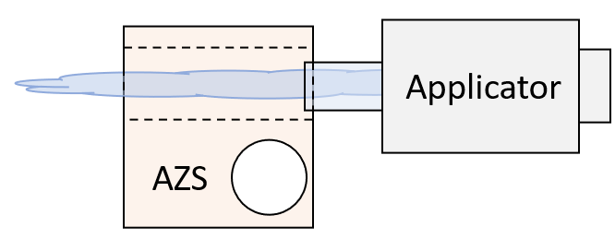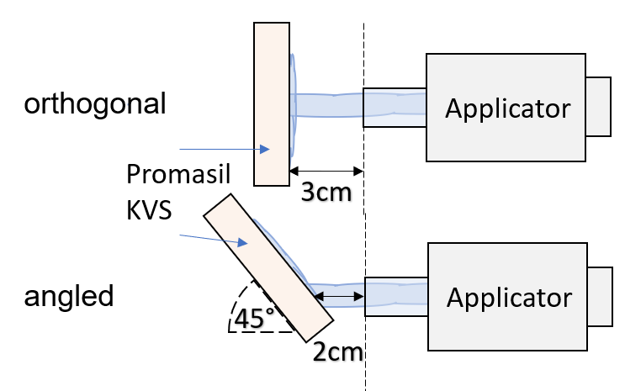
Figure 1 Left scamatic material burn-through testing, right scorch testing both wit microwave plasma
Scorch Test: During a retrofit of a furnace, it can happen that the flame length and the plasma torch length differ, leading to direct contact with built-in components. Furthermore, it was necessary to determine the extent to which parts could be damaged by direct contact. After the exposure, the effects were examined. Significant impacts were observed when a closer distance was chosen and direct contact was tested. Two different volumetric flow rates were investigated. In Table 2, the tested parameters are shown, and Figure 2 provides a detailed illustration of the setup.
On the rigth side of the preceding Figure 3 for Promasil, it can be observed that the deformation of the orthogonally positioned sample occurred in a circular manner. Due to the impact of the plasma, a crater has formed in the material, with its edges slightly raised. The high temperatures are responsible for the softening of the material, and the volumetric flow subsequently caused the deformation. On the left side of the figure, deformation can also be observed. In contrast to the orthogonal positioning, the deformation in the angled positioning is not symmetrical but directed downward. This behavior seems to be attributed to the swirl of the gas flow. Upon impact with the sample, the volumetric flow causes downward-directed flow conditions of the plasma torch. This also results in a crater-like deformation with an elevated edge region. Unlike the Promasil only slight surface deformation is observed for KVS. Small elevations and depressions formed in the marked area of the material. This is due to the high temperature resistance (up to 1800°C [6]) and the subsequent later softening of the material.
 | Material | Angled to the torch | Orthogonal to the torch
 | Promasil | 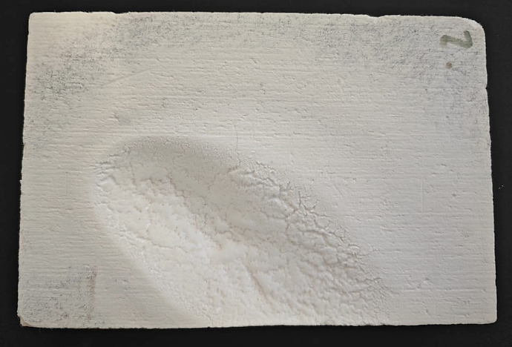 | 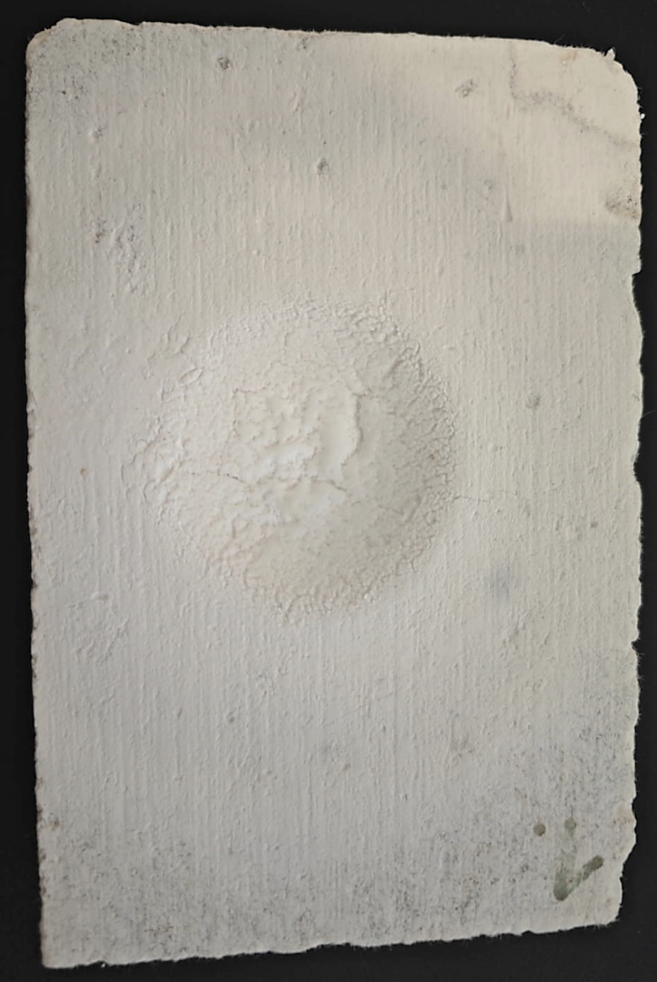
 | KVS | 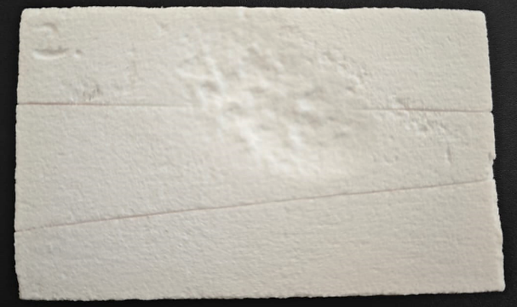 | 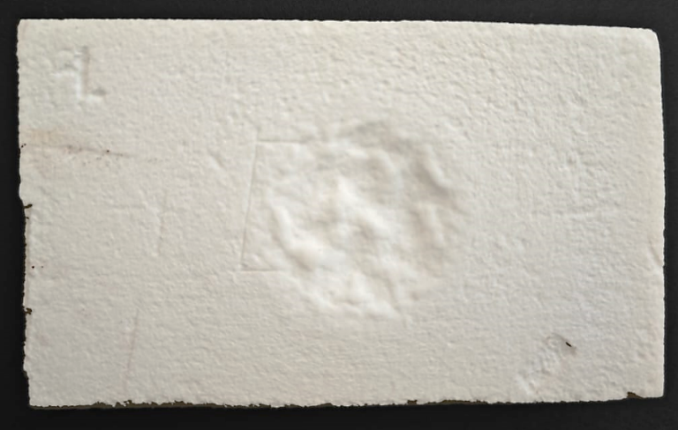
Figure 2 Pictures of the material after Microwave Plasma scorch test, damaged and deformed area in red
After the scorch test, all samples were examined under a light microscope KEYENCE CORPORATION VHX-7000 Mikroskop (LIMI) at a magnification range of 100 µm to 2000 µm. The main focus was on the defect areas and their composition, which were analyzed using Laser Induced Breakdown Spectroscopy (LIBS). For the surface investigations, 9 pulses were used, while two locations also underwent depth investigations with 15 pulses on the same spot. The results of these analyses for KVS are shown in Figure 4. It is evident that there were occasional changes in the surface properties. The analysis (indicated by an orange lightning bolt) shows that the composition of aluminum silicon oxide remains relatively constant. However, in the upper layers, there is an increase in oxygen concentration and a decrease in aluminum content. Observing the identifiable areas in the image on the left (indicated by a blue lightning bolt), it is apparent that in these regions, almost no silicon is present in the structure. Typically, KVS contains about 18-20% silicon. Furthermore, aluminum oxide (AlO) has separated, which remains fairly stable even in the deeper layers.
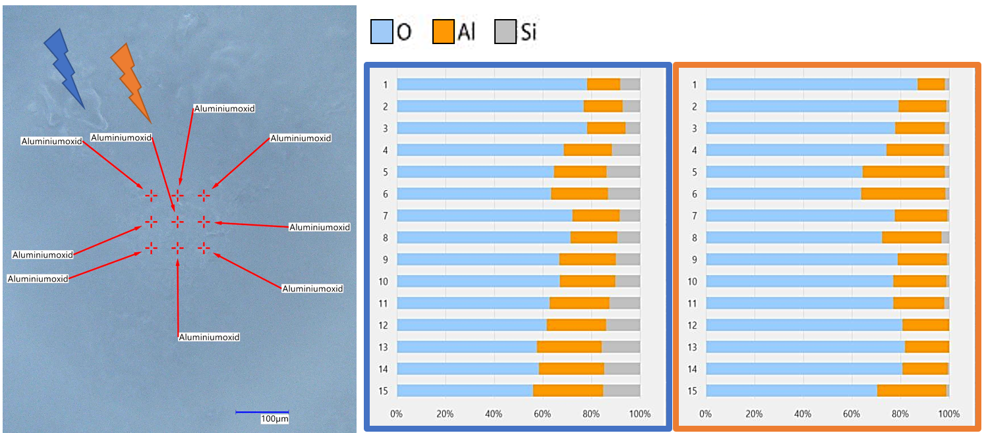
Figure 3 KVS after Microwave Plasma Material scorch testing with 10kW, Analysis using LIBS
  - Conclusions
Microwaves and plasma torches are a promising technology for high temperature furnaces. Beyond safety considerations as indicated by regulation regarding human safety, interactions of microwaves and plasma with furnace materials and components have to be considered. This holds especially true if those technologies are considered for retrofitting of furnaces and thermo process plants.
Due to their potentially very high energy density and non-linear absorption in dependence of materials and temperature microwaves can easily damage existing installations. Furthermore, microwaves may interact with other furnace components, especially thermocouples and might lead to false readings and reduced process controls.
Microwave plasma torches are, on a first glance, very similar to conventional burners in operation and hazard assessment. However, since they emit non negligible amounts of microwave radiation on several wave lengths a suitable encasement has to be considered. Otherwise, damage to surrounding equipment or adverse health effects may follow. The emission of high levels of NOx and Ozon has also to be taken into consideration, if the torch is operated with air or oxygen-rich atmospheres. Furthermore, since the operation characteristics of plasma torches are significantly different in terms of peak temperatures.
Future research areas for microwave plasma torches in thermoprocesses focus on improving energy efficiency, material processing, and environmental technology, with an emphasis on optimizing plasma formation, waste treatment, and process integration. Additional priorities include scalability for industrial applications, the development of precise modeling techniques, and the automation of plasma torches across various industries.
Ackknowledgement:
Parts of this research were co-funded by European Union and the State of Saxony under SAB 100688991.
References:
Atuonwu, J.C. and Tassou, S.A., 2018, Quality assurance in microwave food processing and the enabling potentials of solid-state power generators: A review, Journal of Food Engineering, 234, 1–15.
Behrend, R., Grimm, V., Krause, H., 2024, High temperature dielectric properties measurement for refractories, in Caillat, S. et. al. Proceedings of the 14th European Conference on Industrial Furnaces and Boilers (INFUB-14). 2-5 April 2024. Algarve, Portugal.
Boulos, M., Fauchais, P.L., Pfender, E., 2023, Handbook of Thermal Plasmas, Springer Cham, Switzerland
ITU-International Telecommunication Union, 2024 ITU Radio Regulations Edition of 2024, <handle.itu.int/11.1002/pub/8229633e-en> accessed 03.02.2025
Meredith, R.; 1998, Engineers' Handbook of Industrial Microwave Heating, IET, United Kingdom

NIST, 2024, NIST Standard Reference Database Number 69, accessed 03.02.2025

Rath Feuerfest, 2017, Vakuumformteile, Individuelle Formen aus Hochtemperaturwolle, <rath-group.com/fileadmin/content/Rath-Group/Downloads/Broschueren_Produkte/RATH_ VacuumFormedShapes_201710_DE.pdf> accessed 03.02.2025

Promat, 2017, Promasil 1000, Technical data sheet, <media.promat.com/pd36059/original/-90849477/promasil-1000-1000p-1100_tds_en.pdf> accessed 03.02.2025

