|  |  |
| --- | --- |
| cetlogo ***CHEMICAL ENGINEERING TRANSACTIONS***  ***VOL. xxx, 2025*** | A publication of  aidiclogo_grande |
| The Italian Association  of Chemical Engineering  Online at www.cetjournal.it |
| Guest Editors: Bruno Fabiano, Valerio Cozzani  Copyright © 2025, AIDIC Servizi S.r.l. **ISBN** 979-12-81206-xx-y; **ISSN** 2283-9216 | |

Quantitative Risk Assessment of Mitigated Natech Scenarios Triggered by Wildfires in the Chemical and Process Industry

Federica Ricci\*, Giordano Emrys Scarponi, Valerio Cozzani

LISES – Laboratory of Industrial Safety and Environmental Sustainability, Department of Civil, Chemical, Environmental and Material Engineering, University of Bologna, via Terracini 28, 40131, Bologna, Italy

federica.ricci18@unibo.it

Wildfires, exacerbated by climate change and global temperature rising, increasingly threaten human settlements and industrial facilities near wildlands. Wildland-industrial interfaces face heightened risks due to hazardous materials, where equipment failure can lead to cascading events. Current mitigation strategies, such as clearance areas, may be insufficient, as recent studies highlight inadequacies in prescribed safety distances for preventing wildfire-induced Natech events. This study presents a novel quantitative methodology for assessing the risk of industrial sites exposed to wildfires including safety systems in the evaluation. By integrating the dynamic nature of wildfires, the methodology captures primary Natech events and cascading scenarios through dynamic event trees, accounting for multiple ignition sources and temporal variability. It incorporates safety systems into the evaluation to better address the risk posed by wildfires for process industries. A case study demonstrates the application of the methodology and addresses the risk reduction effects thanks to the presence of safety systems. This approach fills a crucial gap in the evaluation of wildfire-induced Natech scenarios, offering a systematic tool for a more realistic quantification of risk.

* 1. Introduction

The interaction between natural hazards and industrial facilities has become increasingly concerning in recent decades. When natural events impact sites storing hazardous substances, such as chemical or oil and gas facilities, severe Natech (natural-hazard-triggered technological) accidents can occur (Ricci et al., 2021a). The frequency of Natech accidents is rising, driven by climate change which is intensifying extreme weather events (CRED, 2020). In this framework, wildfires pose a serious threat to human-populated areas. Driven by climate change and global temperature rising, wildfires are becoming a growing concern (Williams and Abatzoglou, 2016). This trend is evidenced by the recent surge of catastrophic wildfires, including those in Mediterranean Europe (2017, 2018), Australia (2019, 2024), California (2020), and South America (2024).

Wildfires pose a growing threat to anthropic settlements as residential areas and industrial facilities near wildlands (Manzello et al., 2018). The presence of hazardous materials in Wildland-Industrial Interfaces raises significant concerns for governments and industry professionals. The integrity of equipment items should be ensured to avoid the spread of wildfires within the plant causing major accidents (Planas et al., 2023).

Current practices, like the provision of clearance areas, might not be enough to prevent wildfires from breaching industrial sites and triggering technological scenarios and cascading events (Ricci et al., 2021b). While general frameworks exist for Natech quantitative risk assessment including the assessment of safety barrier performance (Misuri et al., 2023), they have not been applied to cascading accidents triggered by wildfires. This study proposes a novel methodology for quantitative risk assessment of industrial sites facing wildfires accounting for the inclusion of safety barriers in the evaluation. It incorporates the dynamic nature of wildfires, including primary Natech events and cascading domino effects as well as the functioning and the effects of safety systems aimed at protecting tanks. An innovative approach utilizing dynamic event trees identifies potential failure chains considering all possible configurations of the safety systems. A case study was defined to demonstrate the applicability of the novel methodology, highlighting the relevance of including safety systems in the evaluation to obtain a realistic quantification of the risk posed by wildfire-induced Natech accidents and related domino effects.

* 1. Methodology

The present study provides a methodology for the evaluation of the risk related to wildfire-induced Natech and escalation scenarios that account for safety barriers protecting equipment items and their possible failure. The flowchart of the novel methodology is presented in Figure 1. For the sake of brevity, the reader is referred to Ricci et al. (2024, 2021c) for the characterization of the wildfire scenario (i.e. the first step of the methodology).

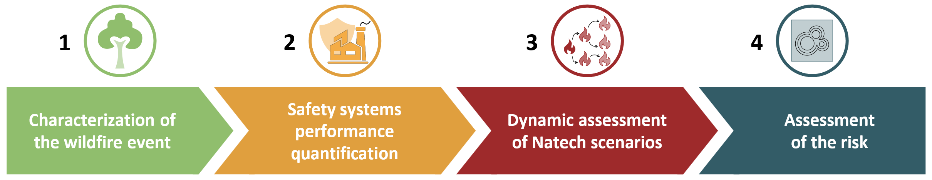

Figure 1. Flowchart of the novel methodology developed in the present study.

* + 1. Safety systems performance quantification

The methodology requires the identification and assessment of the performance of the safety systems implemented to protect the tanks. This can be performed considering both the availability (i.e., probability of failure on demand, *PFD*) and the probability of success in preventing the escalation (i.e., the effectiveness, *η*). The outcomes of the safety system are evaluated based on their characteristics following the method proposed by Landucci et al. (2015) and reported in Figure 2-a. Subsequently, configurations (i.e., pairs equipment item/safety systems outcome) for each equipment item have to be defined. This is performed following the approach illustrated in Figures 2-b and 2-c, which report two examples considering different types and numbers of safety systems. The number of configurations of a piece of equipment is determined by the product of the possible outcomes for each barrier it is equipped with.

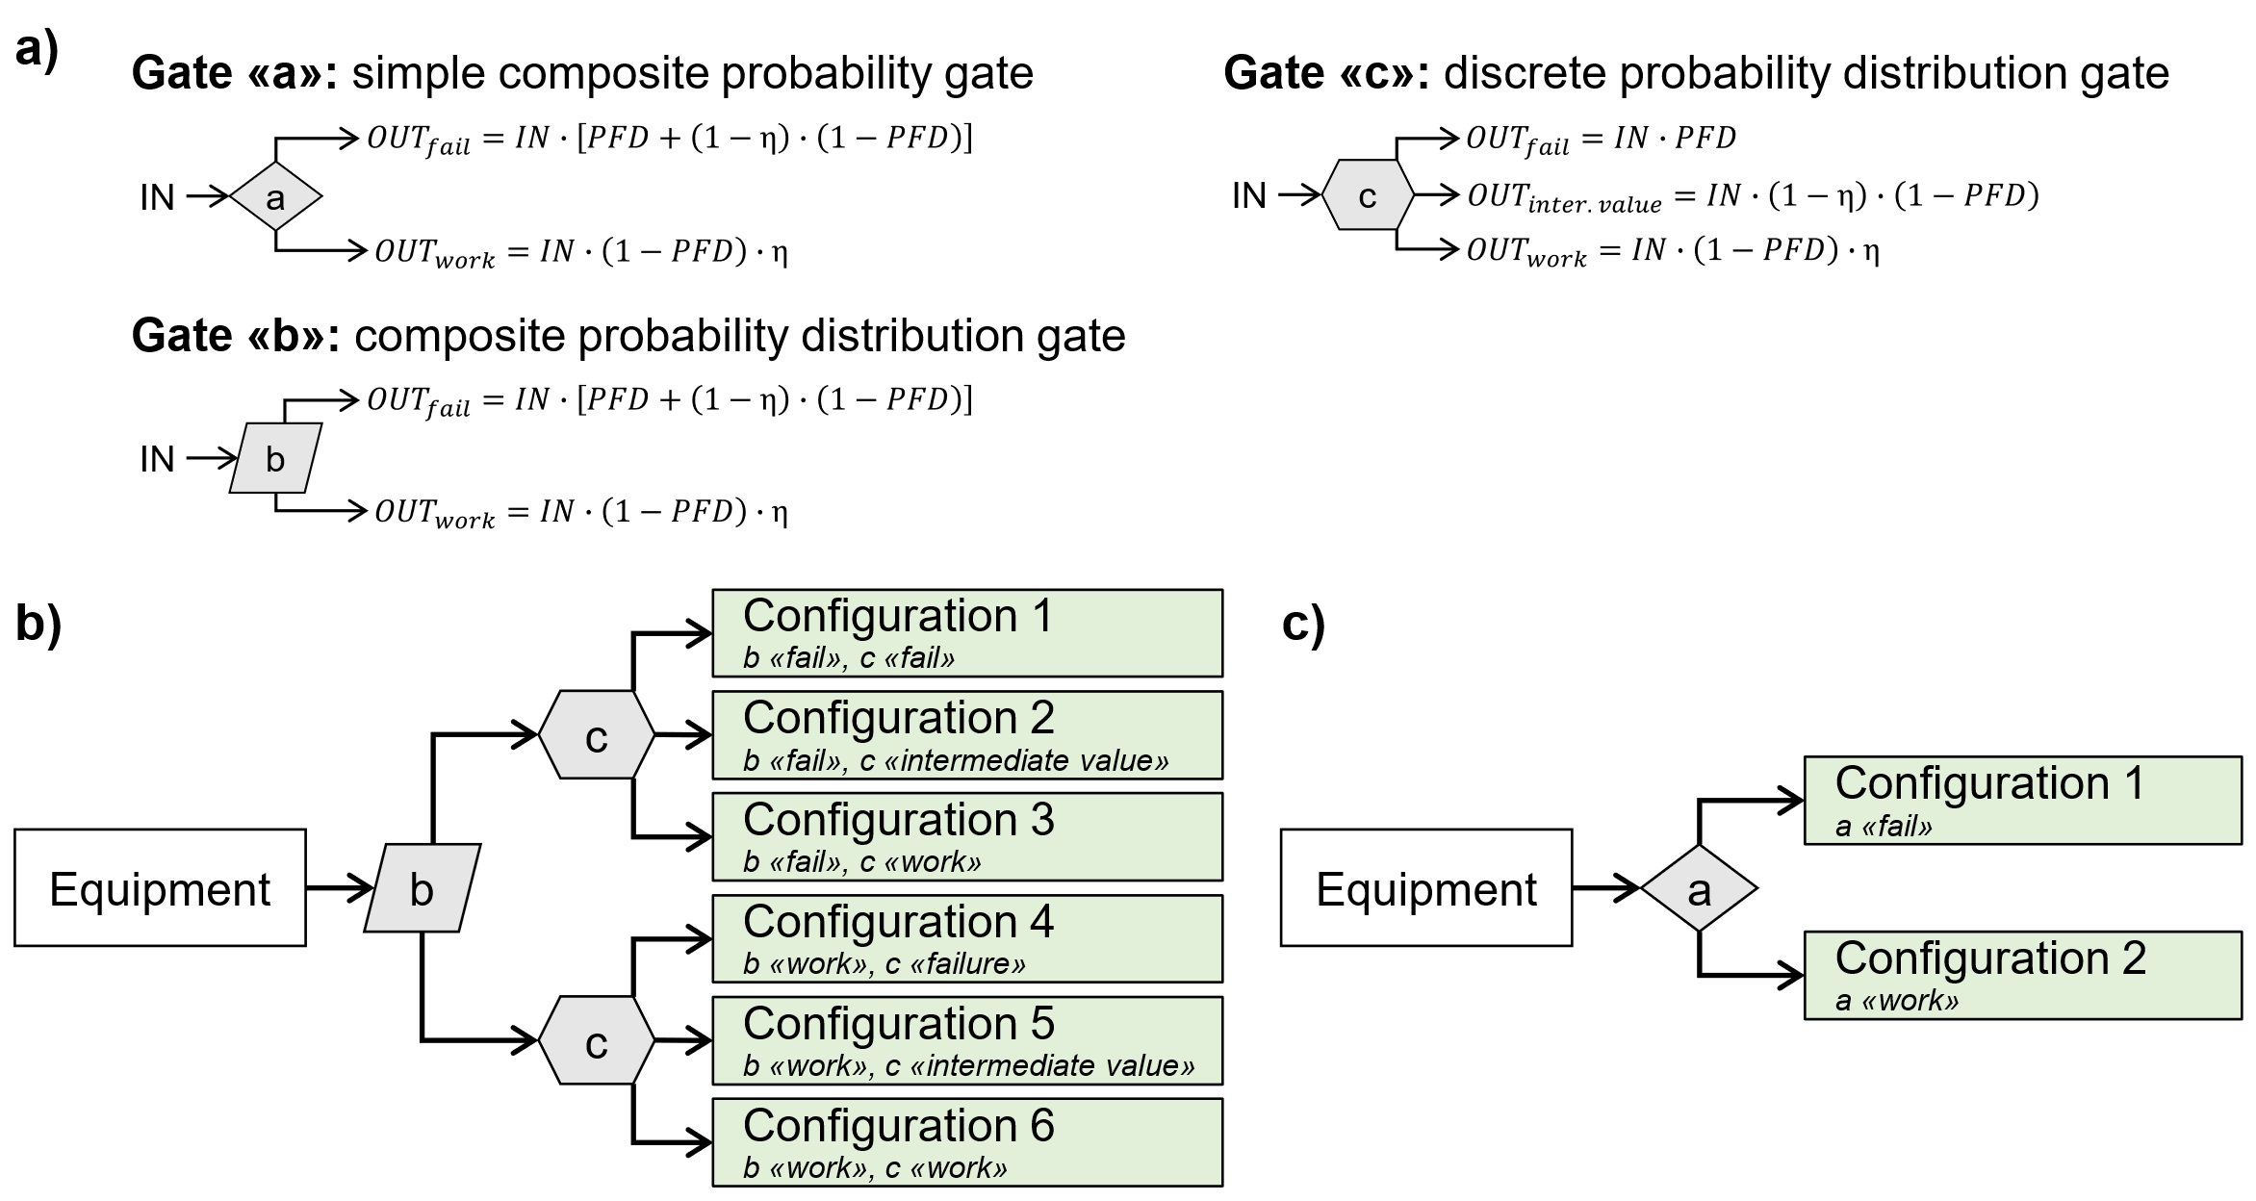

Figure 2. (a) Definition of gate types and associated operators for the evaluation of safety systems outcomes from Landucci et al. (2015). (b) Configurations definition for an equipment item protected by two safety systems. (c) Configurations definition for an equipment item protected by a single safety system.

Then, all possible combinations of tanks equipped with safety systems can be identified. The total number of combinations *Ncomb* can be calculated as reported in Eq. (2), where *n* is the total number of equipment items and *mi* is the number of configurations of the *i*-th tank.

|  |  |
| --- | --- |
| $$N_{comb}=\prod_{i=1}^{n}{m_{i}}$$ | (2) |

Hence, each combination can be represented by a vector ***Nn*** of *n* elements representing the configuration of the equipment items. Thus, *Ncomb* different ***Nn*** vectors are possible and each *i*-th element *Nni* represents the configuration of the *i*-th equipment item. The overall probability of a generic combination *P(****Nn****)* can be calculated by Eq. (3) under the hypothesis of independent event, where *P(Nni)* is the probability of the configuration of the *i*-th item in the ***Nn*** combination.

|  |  |
| --- | --- |
|  | (3) |

* + 1. Dynamic assessment of primary Natech and Escalation scenarios

The methodology developed by Ricci et al. (2024) is applied for the definition and quantification of dynamic event trees which capture the time-dependence of atmospheric tank failures induced by thermal radiation from wildfires and/or nearby tanks. Details on the application of the methodology can be found in the original source.

Given the inclusion of safety systems aimed at protecting tanks, the approach is tailored to account for the modification of the impact vector on tanks when barriers work effectively. Specifically, the thermal radiation received by each target is evaluated by considering the safety system acting on it. The thermal radiation *TRi (Nni)* on the *i*-th target considering the configuration of safety systems *Nni* is calculated as:

|  |  |
| --- | --- |
| $${TR}_{i}\left(N_{i}^{n}\right)=\left({IR}_{wf→i}∙δ_{wf}+\sum_{j=1}^{n}{{IR}_{j→i}∙δ_{j}}\right)∙γ_{sb}\left(N_{i}^{n}\right)$$ | (4) |

where *IRwf→i* is the thermal radiation on the *i*-th target from the wildfire, *IRj→i* is the thermal radiation on the *i*-th target from the *j*-th item, *n* is the total number of equipment item considered, and *δ* is a parameter set to 1 if the status of the fire is active, and to 0 otherwise. The effect of the safety system is accounted for through the factor *γsb (Nni)*, which represents the attenuation parameter for the radiation on the *i*-th tank considering the outcome of the safety system in the ***Nn*** combination.

As an outcome of the methodology, the event tree related to a specific ***Nn*** combination is developed. Then, the probability of the *k*-th generic branch of the event tree *Pk (****Nn****)* is evaluated as:

|  |  |
| --- | --- |
| $$P_{k}\left(N^{n}\right)=P\left(N^{n}\right)∙\prod_{i=1}^{n}{\left(1-p_{f,i,k}\left(N^{n}\right)+β_{i,k}\left(N^{n}\right)∙\left(2∙p_{f,i,k}\left(N^{n}\right)-1\right)\right)}$$ | (5) |

where *P(****Nn****)* is the probability of the ***Nn*** combination of tank and safety system, *pf,I,k (****Nn****)* is the failure probability of the *i*-th target in the *k*-th branch of the ***Nn*** combination, and *βi,k* *(****Nn****)* is a factor equal to 1 when the i-th target fails, 0 otherwise. The procedure for the development of the dynamic event tree is repeated for each of the *Ncomb* combinations defined in Section 2.1 to perform a complete evaluation of all possible primary Natech and escalation scenarios that account also for safety systems protecting tanks.

* + 1. Consequence assessment of overall scenarios and calculation of vulnerability and risk indexes

After generating all possible scenarios, the consequences of these combined scenarios are evaluated. The overall fatality probability for each *k*-th combined scenario is determined using Eq. 6 (Misuri et al., 2023):

|  |  |
| --- | --- |
| $$C_{k}\left(N^{n}\right)=min\left(1,\sum_{i=1}^{n}{δ_{i}∙}C_{i}\left(N^{n}\right)\right)$$ | (6) |

where *Ck* *(****Nn****)* is the fatality probability in the position of interest calculated for the overall *k*-th scenario in the ***Nn*** combination, *Ci* *(****Nn****)* is the fatality probability in the same position associated with the *i*-th equipment item, and *δi* assumes a value of 1 if the corresponding fire is ongoing, 0 otherwise. The fatality probability associated with each failed piece of equipment *Ci* is evaluated using the probit model for radiation-induced fatalities provided in Van Den Bosh (1992). Eventually, vulnerability and risk indices can be calculated. Among others, the overall failure probability of tanks (Ricci et al., 2024), the local-specific individual risk LSIR, and societal risk indicators such as F/N curves, Potential Life Loss PLL, and Expectation Value EV (Uijt de Haag and Ale, 2005).

* 1. Case study

A case study was defined to demonstrate the applicability of the proposed methodology and the influence of safety systems on risk figures. A tank farm was considered, and the main features of atmospheric tanks included in the case study are reported in Table 1.

Table 1: Features of the atmospheric storage tanks considered in the case study

|  |  |  |  |  |
| --- | --- | --- | --- | --- |
| Parameters | Unit | T1 | T2-T3 | T4-T5 |
| Nominal volume | m3 | 9975 | 9161 | 12367 |
| Diameter | m | 42 | 36 | 54 |
| Height | m | 7.2 | 9 | 5.4 |
| Filling level | - | 0.75 | 0.75 | 0.75 |
| Substance | - | Gasoline | Gasoline | Crude oil |
| Physical state | - | Liquid | Liquid | Liquid |
| Inventory | ton | 5612 | 5153 | 8812 |
| Catch basin area | m2 | 3847 | 3577 | 4899 |

The layout considered in the case study is provided in Figure 3-a. A forest lies along the northern border of the storage site, represented as a green area in Figure 3. The average vegetation height is assumed to be 10 meters. The wildfire is modeled according to Ricci et al. (2024, 2021c), with the following input parameters: a flame blackbody temperature of 1200 K, a flame length set to 3.5 times the vegetation height (i.e., 35 m), and a maximum wildfire scenario duration of 15 minutes. A realistic wildfire return period was estimated using data from Guyette et al. (2012), leading to a wildfire frequency of 0.167 y-1. The analysis considers the catastrophic rupture of tanks followed by immediate ignition leading to a pool fire confined in the catch basin, the areas of which are reported in Table 1. Established literature models (Van Den Bosh and Weterings, 2005) were used for the consequence analysis. Figure 3-b illustrates the consequence assessment for the three tank types in the layout, also including the incident radiation from the wildfire.

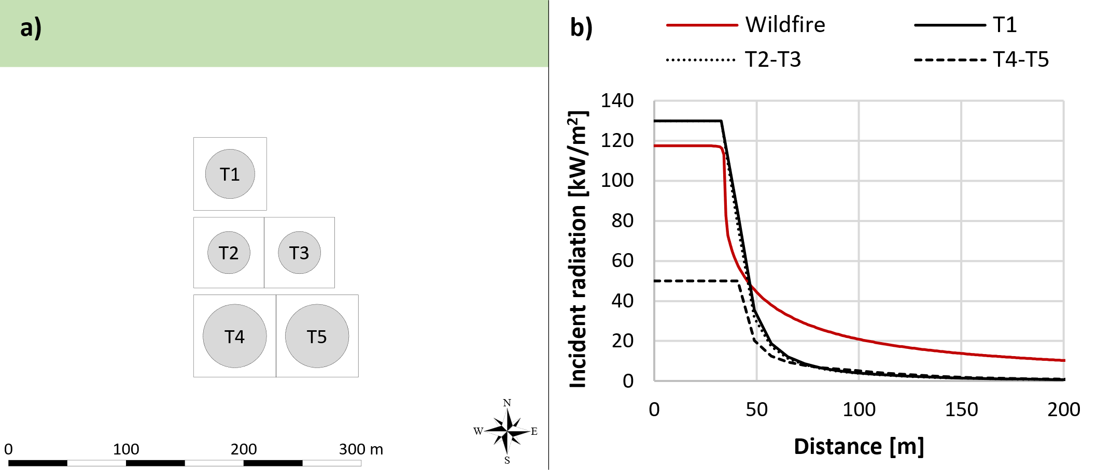

Figure 3. Layout considered in the case study (a) and incident radiation as a function of the distance for wildfires and tank fires considered in the present contribution (b).

Water deluge sprinkler systems (WDS) are the safety barrier considered in the case study. These can be characterized according to the gate “a” in Figure 2-a, and the failure probability is then evaluated as equal to 7.2∙10-2 y-1, assuming a *PFD* value of 2∙10-3 y-1 and the *η* equal to 0.93 obtained from Mannan (2005). The possible configurations of equipment items are represented in Figure 2-c. In the case of WDS effectively working, it reduces the incident radiation reaching the tank on which it is implemented. This can be described through an attenuation parameter, that is considered equal to 0.5 in the present study following other literature applications (Ricci et al., 2022).

To evaluate the influence of safety systems on the risk related to wildfire-induced primary Natech accidents and related escalation scenarios, two cases are analyzed:

* **Absence of WDS**. The case considers unprotected tanks and the evaluation is performed following the procedure described in Ricci et al. (2024).
* **Presence of WDS**. The case includes the water deluge sprinkler systems on each tank, and the methodology described in the present study is applied to evaluate the risk.
  1. Results and Discussion

Figure 4 reports the overall failure probability of each tank in the absence and the presence of WDS.

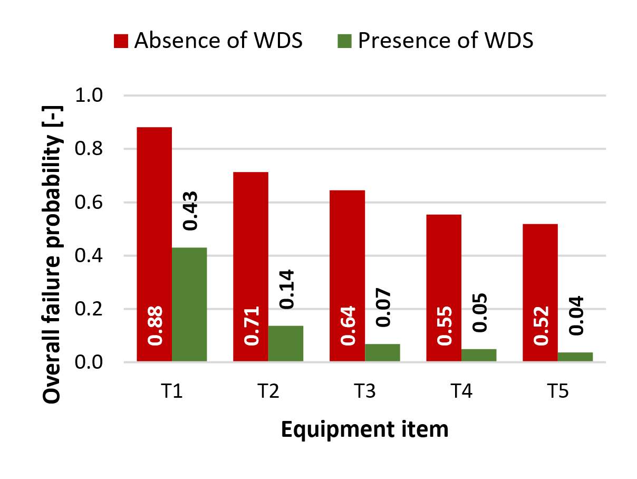

Figure 4. *Overall failure probability of each tank* *for the two cases defined in Section 3.*

The overall failure probability is a vulnerability measure that accounts for all possible branches of the dynamic event tree in which the tank fails. As can be observed from the figure, the overall failure probability decreases considerably when including safety systems in the assessment. Indeed, the value is halved when considering T1, and the reduction is even greater concerning the other tanks, reaching very low values for the tanks furthest from the wildfire.

This trend is reflected in the risk indices, such as the LISR shown in Figure 5. Comparing the case in the absence of WDS (panel a) and the presence of WDS (panel b), it can be seen that the area related to LSIR values less than 1∙10-5 y-1 is comparable. On the contrary, for high-risk values, the area in the case of the presence of WDS is significantly smaller, emphasizing the risk reduction achieved by implementing safety systems. However, it is important to note that the maximum order of magnitude of the LSIR is the same for the two cases.

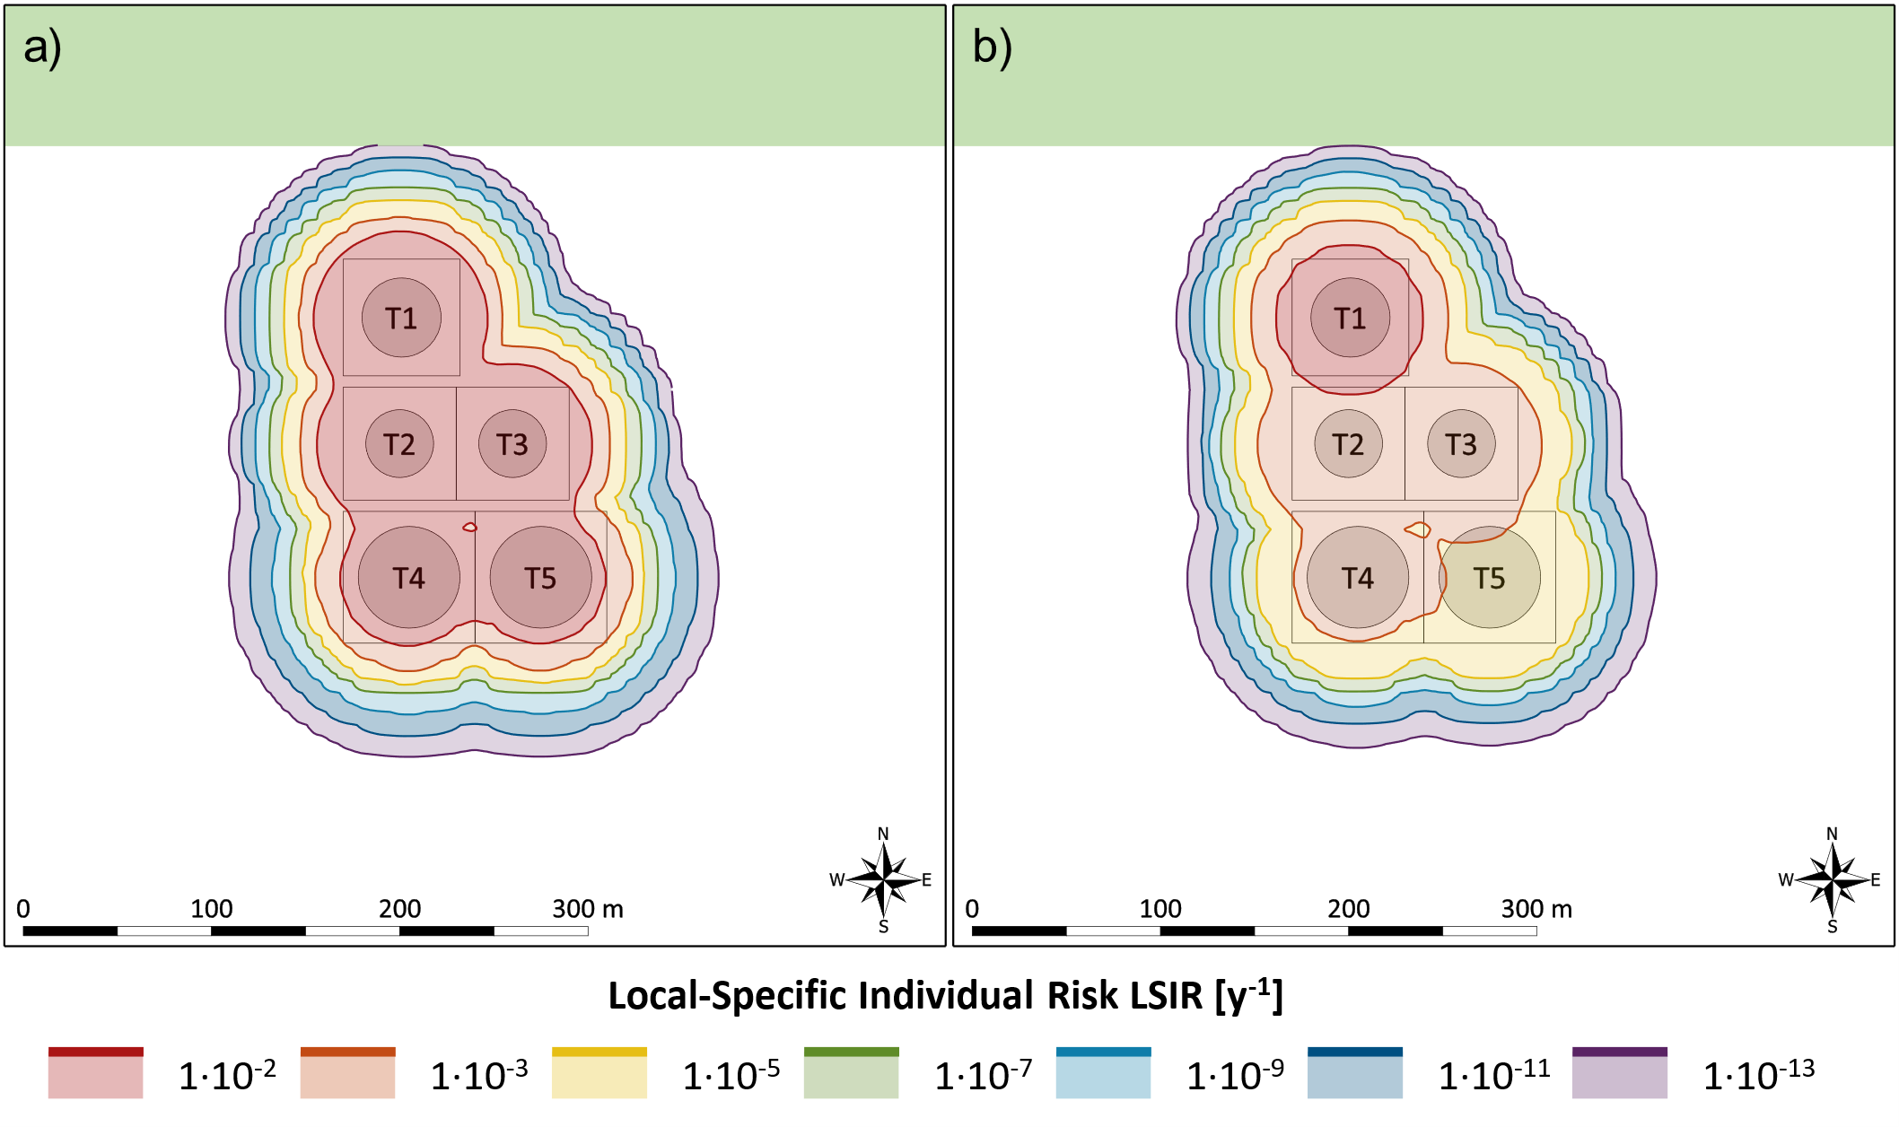

Figure 5. *Local-Specific Individual Risk (LSIR) of the wildfire-induced primary Natech scenarios and the related domino effects considering the absence (a) and the presence (b) of water deluge systems protecting tanks.*

A similar conclusion can be derived by observing societal risk figures reported in Figure 6, namely the F/N curves (panel a) and the risk indexes (panel b). A reduction of more than an order of magnitude is achieved when accounting for the presence of WDS on the tanks. The most significant effect is observed in the risk values associated with a high number of fatalities, as illustrated in Figure 6-a. This is also reflected in the difference between the Expectation Value metrics, an indicator that assigns greater weight to scenarios involving a high number of fatalities. This result is in line with the previous considerations. Indeed, the modest failure probability of tanks located away from the wildfire, when the WDS is present, significantly reduces the likelihood of scenarios involving multiple tanks, which are typically associated with a high number of fatalities. Eventually, the population density considered in the analysis represents a worst-case scenario without the evacuation of the site. Indeed, evacuation procedures, especially in interface fires, may not always be effective, as was also demonstrated by the Black Saturday bushfires in Victoria (Australia, 2009) (Haynes et al. 2010).

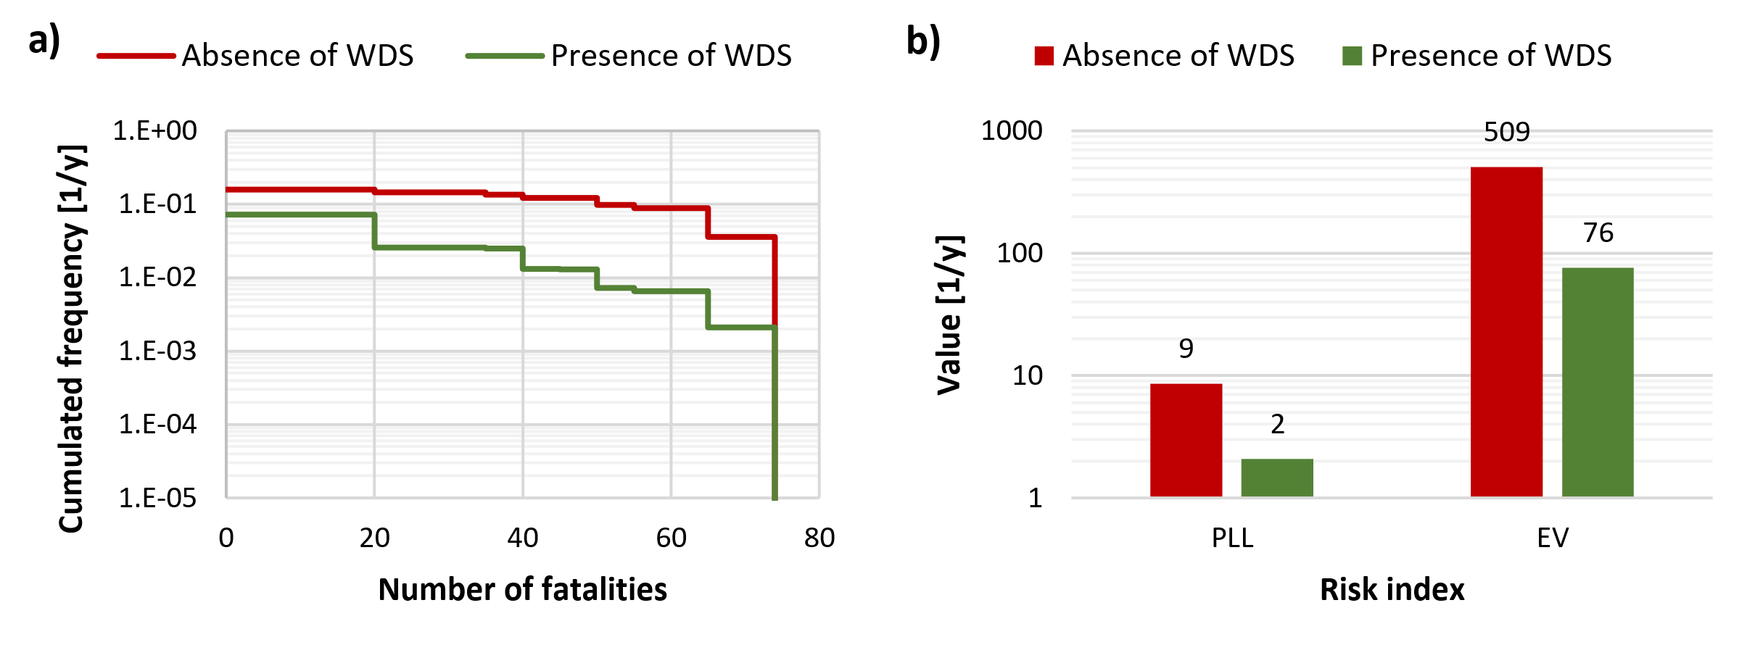

Figure 6. *Societal risk (a) and risk indices (b) for the two cases defined in Section 3. A uniform population density of 50 people/ha and a presence probability of 60 % were assumed for societal risk calculations.*

It is important to emphasize that the two cases considered in this study represent worst-case (absence of WDS) and best-case (presence of WDS) risk scenarios. Indeed, the developed methodology considers the action of safety barriers as independent. This assumption is certainly valid when considering passive systems, such as fireproofing. However, in the case of active barriers, interconnections can be present among the systems. As an example, the water demand to properly operate for a prolonged period of time may not be available. Finally, the possible barrier performance depletion due to wildfire, as demonstrated in the case of other natural events (Misuri et al., 2020), has not been accounted for. Even considering the limitations discussed, the present methodology provides a method for considering safety systems in the evaluation of Natech wildfire accidents, taking a step towards a more realistic quantification of risk.

* 1. Conclusions

Climate change and global temperatures rising have increased the frequency and intensity of wildfires, amplifying the risk for human settlements and industrial facilities. The presence of hazardous substances in industrial sites intensifies the problem with the possible occurrence of technological cascading scenarios. Existing clearance areas and safety barriers are often insufficient to prevent them. Thus, a methodology to evaluate industrial risk from wildfires was developed, considering safety measures and capturing the dynamic behavior of wildfires. The methodology was tested on a case study, including a benchmark scenario without safety barriers. Results show that safety barriers significantly reduce risk by lowering the probability of tank failures, especially for those away from the facility, and by decreasing the likelihood of simultaneous failures. This, in turn, limits the extent of high local-specific individual risk areas. Despite the simplifying assumption of considering optimal barrier performance without accounting for potential failures during wildfires, this study can be considered a step towards more realistic risk assessments for Natech accidents triggered by wildfires. It highlights the critical role of safety barriers and provides a foundation for improving industrial resilience and risk management strategies.

References

CRED, 2020, EM-DAT: The Emergency Events Database. Centre for Research on the Epidemiology of Disasters, Université Catholique de Louvain, www.emdat.be

Guyette R.P., Stambaugh M.C., Dey D.C., Muzika R.M., 2012, Predicting Fire Frequency with Chemistry and Climate. Ecosystems, 15, 2, 322–335.

Haynes K., Handmer J., McAneney J., Tibbits A., Coates L., 2010, Australian bushfire fatalities 1900–2008: exploring trends in relation to the ‘Prepare, stay and defend or leave early’ policy. Environmental Science & Policy, 13(3), 185–194.

Landucci G., Argenti F., Tugnoli A., Cozzani V., 2015, Quantitative assessment of safety barrier performance in the prevention of domino scenarios triggered by fire, Reliability Engineering & System Safety, 143, 30–43.

Mannan S., 2005. Lees’ loss prevention in the process industries, Elsevier Butterworth-Heinemann, Oxford, UK.

Manzello S.L., Blanchi R., Gollner M.J., Gorham D., McAllister S., Pastor E., Planas E., Reszka P., Suzuki S., 2018, Summary of workshop large outdoor fires and the built environment, Fire Safety Journal, 100, 76–92.

Misuri A., Landucci G., Cozzani V., 2020, Assessment of safety barrier performance in Natech scenarios, Reliability Engineering & System Safety, 193, 106597.

Misuri A., Ricci F., Sorichetti R., Cozzani V., 2023, The Effect of Safety Barrier Degradation on the Severity of Primary Natech Scenarios, Reliability Engineering & System Safety, 235, 109272.

Planas E., Paugam R., Àgueda A., Vacca P., Pastor E., 2023, Fires at the wildland-industrial interface. Is there an emerging problem?, Fire Safety Journal, 141, 103906.

Ricci F., Casson Moreno V., Cozzani V., 2021a, A comprehensive analysis of the occurrence of Natech events in the process industry, Process Safety and Environmental Protection, 147, 703–713.

Ricci F., Misuri A., Scarponi G.E., Cozzani V., Demichela M., 2024, Vulnerability Assessment of Industrial Sites to Interface Fires and Wildfires, Reliability Engineering & System Safety, 243, 109895.

Ricci F., Scarponi G.E., Pastor E., Muñoz J. A., Planas E., Cozzani V., 2021b, Vulnerability of Industrial Storage Tanks to Wildfire: a Case Study, Chemical Engineering Transactions, 86, 235–240.

Ricci F., Scarponi G. E., Pastor E., Planas E., Cozzani V., 2021c, Safety distances for storage tanks to prevent fire damage in Wildland-Industrial Interface, Process Safety and Environmental Protection, 147, 693–702.

Ricci F., Scarponi G. E., Pastor E., Planas E., Cozzani V., 2022, Asset Integrity in the Case of Wildfires at Wildland-Industrial Interfaces, Chemical Engineering Transactions, 90, 247–252.

Uijt de Haag P.A.M., Ale B.J.M., 2005, Guidelines for Quantitative Risk Assessment, Purple book, Committee for the Prevention of Disasters.

Van Den Bosh C.J.H., 1992, Methods for the Determination of Possible Damage to People and Objects Resulting from Releases of Hazardous Materials, Green Book, Committee for the Prevention of Disasters.

Van Den Bosh C.J.H., Weterings R.A.P.M., 2005, Methods for the calculation of physical effects due to releases of hazardous materials (liquids and gases), Yellow Book, Committee for the Prevention of Disasters.

Williams A.P., Abatzoglou J.T., 2016, Recent Advances and Remaining Uncertainties in Resolving Past and Future Climate Effects on Global Fire Activity, Current Climate Change Reports, 2(1), 1–14.