|  |  |
| --- | --- |
| cetlogo ***CHEMICAL ENGINEERING TRANSACTIONS***  ***VOL. xxx, 2025*** | A publication of  aidiclogo_grande |
| The Italian Association  of Chemical Engineering  Online at www.cetjournal.it |
| Guest Editors: Bruno Fabiano, Valerio Cozzani  Copyright © 2025, AIDIC Servizi S.r.l. **ISBN** 979-12-81206-xx-y; **ISSN** 2283-9216 | |

Considering Sustainability of Explosions Protection Measures: Two Examples

Marc Steinkraussa,\*, Georg Suterb,\*, Alexander Kranza, Andrea A. Bumanna

aPELEVEN AG, Sandgrubenstrasse 44, CH-4058 Basel (Schweiz)

bFireEx Consulting GmbH, Stieracker 20, CH-5070 Frick (Schweiz)

marc.steinkrauss@peleven.ch

Loss Prevention aims to mitigate process risks, yet the growing emphasis on sustainability in industrial operations requires a reassessment of traditional protection concepts. This paper examines how explosion protection measures, particularly nitrogen inerting and ventilation, can be optimized for both safety and sustainability. Nitrogen, commonly used to prevent explosive atmospheres, is resource intensive. By comparing different inerting methods and incorporating reliable technical monitoring, nitrogen consumption and CO2 emissions can be significantly reduced. Similarly, while ventilation is essential for safety, it is energy intensive. The paper discusses how optimizing ventilation systems can lower both energy and heating losses. Through these examples, the paper highlights how companies can enhance resource efficiency without compromising safety, contributing to sustainable operational practices.

* 1. Introduction

Over the decades, many recognized protection concepts have been developed, for example, in explosion protection. In addition, companies subject to the CSRD/CSDD directives are obligated to align themselves with sustainability. This includes resource-efficient production, reducing CO2 emissions, and minimizing pollutants released into the atmosphere. The sustainability of industrial processes means that protection concepts should now be questioned for their sustainability. In some areas, has too much emphasis been placed on safety, thereby neglecting resource efficiency and sustainability?

The authors aim to stimulate a discussion on whether safety must be compromised for sustainability by presenting two examples of explosion protection. Our fundamental understanding is that facilities in explosive areas must be operated safely, or the handling of explosive materials must be secure. Are we too conservative in explosion protection, with the motto "more is better"? Are we using our knowledge and information sources correctly?

* 1. Industrial processes

Processes in the chemical, petrochemical, pharmaceutical, and life sciences industries often involve flammable solvents and powders.

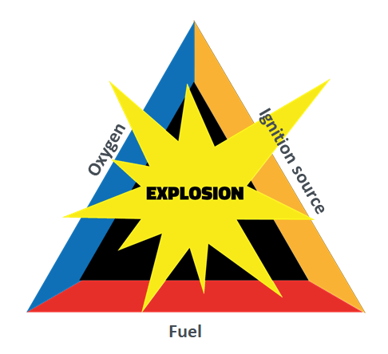  
Figure 1: Explosion Triangle

Despite the continuous development of manufacturing processes, it is only moderately successful in substituting explosive substances. Many ignition sources can be effectively eliminated, such as using approved mechanical and electrical equipment or consistent grounding and potential equalization. However, operational ignition sources, especially brush discharges, can still occur.

If neither can be avoided, it may be necessary to reduce the oxygen content by working with inert gases. Another applicable alternative is to dilute a potentially explosive atmosphere with ventilation measures. Both measures consider the material properties of flammable substances.

* + 1. Nitrogen and Inerting

In explosion protection, nitrogen is extensively used for the inerting of processes. Nitrogen is produced using the globally widespread Linde process. No reliable global data exists on the amount of liquid nitrogen produced. The electricity consumption for producing 1 kg of liquid nitrogen typically ranges between 0.4 and 1.0 kWh, depending on the plant’s efficiency and the technologies used.

Three main methods are used for inerting apparatuses and systems in explosion protection:

* Vacuum inerting
* Flow inerting
* Pressure inerting

Vacuum and flow inerting are the most used methods. In the chemical and pharmaceutical industries, vacuum-tight reactors and equipment undergo vacuum cycles for inerting.

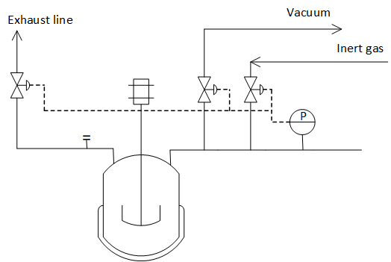  
Figure 2: Vacuum inerting

Table 1: The residual oxygen content as a function of pressure changes and target pressure [5]

|  |  |  |  |
| --- | --- | --- | --- |
| Number of pressure changes | 1013 hPa to 800 hPa  [O2 Vol-%] | 1013 hPa to 500 hPa  [O2 Vol-%] | 1013 hPa to 100 hPa  [O2 Vol-%] |
| 1 | 16,6 | 10,6 | 2,5 |
| 2 | 13,2 | 5,5 | 0,7 |
| 3 | 10,6 | 3,0 | 0,5 |
| 4 | 8,4 | 1,7 | 0,5 |
| 5 | 6,8 | 1,1 | 0,5 |

In the chemical and pharmaceutical industry, it is common practice to carry out inerting up to 100 mbar(a) in 3 cycles. The residual oxygen content is then reduced to 0.5%. In cases where non-pressure and non-vacuum-resistant apparatus, like centrifuges and mobile containers (e.g., IBCs), are used, flow inerting is applied.

Ein Bild, das Diagramm, Entwurf, Text, technische Zeichnung enthält.
Figure 3: Flow inerting

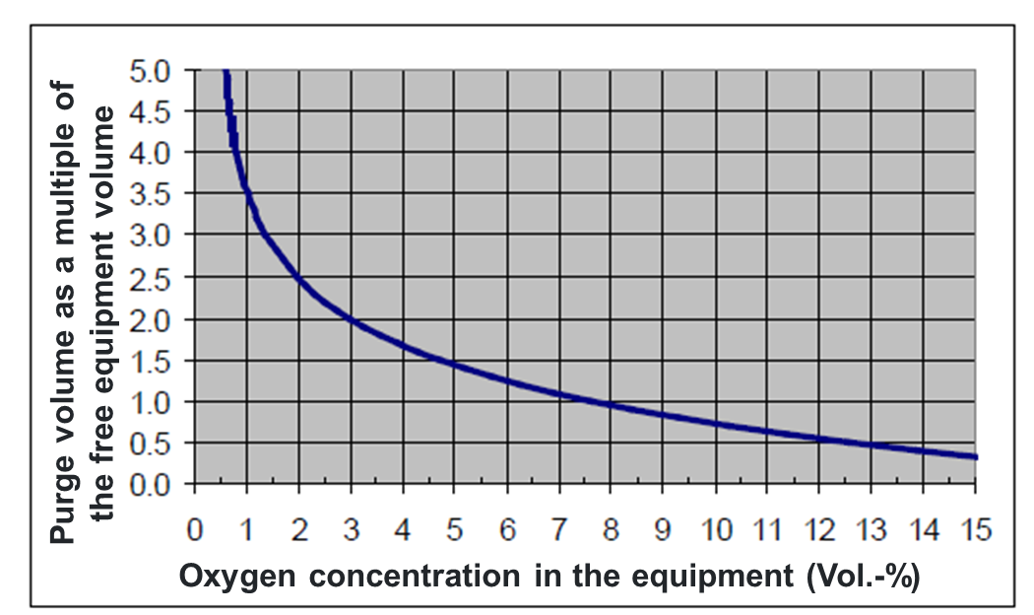  
Figure 4: The oxygen concentration as a function of the N2 amount in the flow. [5]

To achieve a similarly low value during flow inerting, five times the volume of the container in nitrogen is required.

Though inerting is an effective method, it also presents challenges:

* Monitoring oxygen concentration
* Costs for inert gases
* Environmental impact
* Influence of material safety data
  + 1. Influence of safety-related material properties

For the inerting of processes, however, the limiting oxygen concentration is the crucial parameter. The limiting oxygen concentration (also known as the lower oxygen limit, or Limiting Oxygen Concentration, LOC) refers to the maximum oxygen concentration in a gas mixture at which combustion or explosion of a flammable substance is just barely not possible. It is a key parameter in explosion protection, particularly in inerting. The limiting oxygen concentration is a material-specific characteristic and depends on the following factors:

* Type of combustible substance
* Pressure and temperature
* Type of inert gas

The LOC varies depending on the substance and conditions. Typical LOC values at room temperature and normal pressure include:

* Methane: ~12 vol% oxygen
* Hydrogen: ~5 vol% oxygen
* Gasoline vapors: ~10 vol% oxygen
* Coal dust: ~8 vol% oxygen

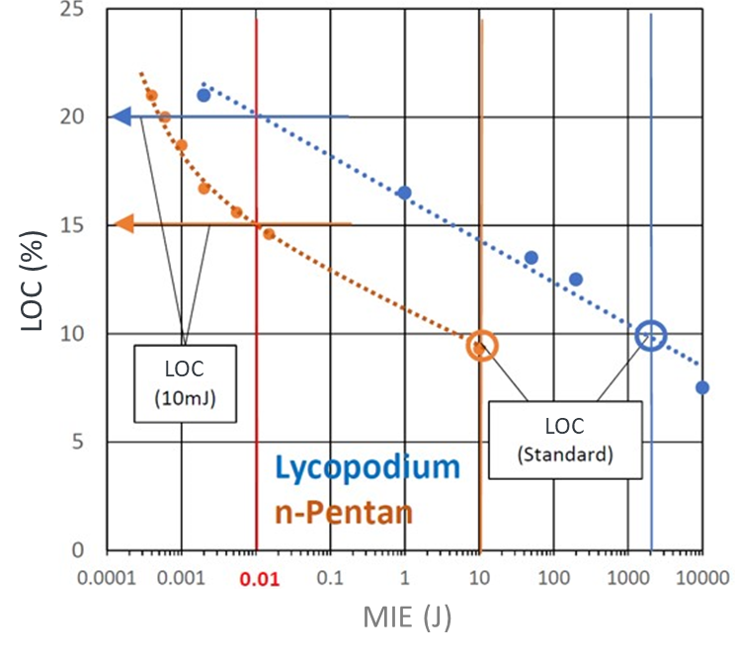

Figure 5: Effect of LOC on the MIE (Minimum Ignition Energy) [6]

* + 1. Impact on ignition sources

Most ignition sources can be prevented through organizational and technical measures. Electrical ignition sources are avoided by using explosion-proof devices. Electrostatic ignition sources like spark discharges are prevented by grounding. Brush discharges, however, cannot be avoided in stirrers, requiring inerting measures.

* 1. Exapmples
     1. Nitrogen consumption example: 10m³ reactor

Inerting today: 3x vacuum inerting at 100 mbar

N2 consumption: 2.7 times the container volume → 27 Nm³ N2

Consumption: 3x vacuum inerting at 100 mbar

N2 consumption: 27 Nm³ N2 → 33.8 kg N2

1 Nm³ of nitrogen corresponds to 1.251 kg of liquid nitrogen (N2fl)

How to define safe operation?

When focusing on the limiting oxygen concentration (LOC), an oxygen content of <6% (see Table 1) is sufficient, provided that hydrogen is excluded.

Required amount for safe operation:

* 2x vacuum inerting at 500 mbar
* N2 consumption: 1.0 times the container volume → 10 Nm³ N2

Resulting savings:

Per reactor inerting, the following savings are achieved:

* Savings of 17 Nm³ N2 ≈ 21.3 kg N2
* Emissions factor for liquid nitrogen (N2) = 0.22 kg CO2 per kg N2 [1,2]
* Nitrogen savings of approx. 63%, or ≈ 4.7 kg CO2

This example demonstrates that nitrogen consumption can be drastically reduced, and as a result, companies can also achieve significant CO2 savings in their Scope 3 emissions.

The work required to evacuate the gas in the reactor is approximately 1.205 MJ (1,205,131 J). The power required for the vacuum pump to perform this evacuation in 5 minutes is approximately 4.02 kW.

This represents the electrical energy that must be supplied to the vacuum pump to achieve the desired evacuation.

* + 1. Energy consumption of a vacuum pump

What amount of electrical energy does a vacuum pump need to evacuate a 10 m³ reactor to 100 mbar at 25°C? It is assumed that one evacuation step takes 5 minutes.

The process is carried out by a vacuum pump. To simplify, it is assumed that the process is adiabatic, meaning that no heat transfer to the outside occurs. The work that a vacuum pump must perform can be roughly calculated by determining the energy required to evacuate the gas.

|  |  |  |  |
| --- | --- | --- | --- |
| |  |  | | --- | --- | |  |  | | (1) |

For an approximate calculation of the work that must be performed, we can use the following formula for the isothermal compression of an ideal gas:

|  |  |
| --- | --- |
| $$W=n*R*T*ln⁡\left(\frac{p_{initial}}{p_{final}}\right)$$ | (2) |

The electrical energy required for a vacuum pump to evacuate a 10 m³ reactor from 1 bar to 100 mbar is approximately 0.64 kWh.

A vacuum pump has an efficiency between 50% and 70%, so an efficiency of 60% is assumed. Therefore, the energy consumption is 1.07 kWh.

Performing the inerting process three times requires an energy consumption of 3.21 kWh.

If the inerting is only carried out until an oxygen content of 5.5% is reached, then only two inerting steps to 500 mbar are necessary.

What electrical energy does a vacuum pump need to evacuate a 10m3 reactor to 500 mbara at 25°C? It is assumed that 1 evacuation step also takes 5 minutes here.

The electrical energy required by a vacuum pump to evacuate a 10 m³ reactor from 1 bar to 100 mbar is approximately 0.19 kWh. At the above-mentioned efficiency of 60%, this is 0.32 kWh.

Inertising twice requires an energy consumption of 0.64 kWh.

The following savings result per inertisation of the reactor:

Energy consumption can be reduced by 2.57 kWh, or around 80 %.

Assuming an electricity emission factor of 0.38 kg CO2 / kWh [2,3], this corresponds to a reduction of 0.98 kg in a company's Scope 2 CO2 emissions. This illustrates the existing efficiency potential.

* + 1. Safeguarding the stirred reactor

Inertisation is a very reliable and proven method of preventing a dangerous explosive atmosphere. However, provided that a higher residual concentration of oxygen is accepted in the stirred reactor, the oxygen concentration must be reliably safeguarded. Various options are available for this purpose, whereby vacuum inertisation is still the basic assumption.

1. use of pressure and flow rate with SIL requirements and without direct oxygen measurement

The oxygen content must be determined before the start of production using a validated measuring method.

2. use of pressure or flow with SIL requirements with a direct oxygen measurement

The two methods are shown schematically in the following figure.

Ein Bild, das Diagramm, technische Zeichnung, Plan, Text enthält.
Figure 6: Influence of oxygen limit concentration on the minimum ignition energy

* + 1. Ventilation

Ventilation is an effective measure for eliminating a hazardous explosive atmosphere, especially when storing hazardous substances such as flammable solvents. How efficient must ventilation measures be? An example using a solvent room:

* Room for storing flammable solvents: 5 m x 6 m x 3 m = 90 m3
* 5-fold air change = 450 m3/h
* Required fan needs 500 W
* Average dT between input and output = 5K (winter)
* Cp (air) = 1.3kJ/m3K
* Energy consumption in the winter half-year (180 days): 180 x 24 x (1.3x5x450/3600 + 0.5) = 2.1 MWh

Assuming an electricity emission factor of 0.38 kg CO2 / kWh[2,3], this corresponds to a reduction in a company's Scope 2 emissions of 798 kg CO2.

In terms of sustainability, these exemplary calculations show that there is in some cases significant potential for savings in the area of explosion protection that require closer consideration than is often the case in the context of overarching sustainability roadmaps.

* 1. Discussion

The CO2 balance of a company is essentially influenced by the fact that

- the CO2 emissions of the raw materials/services sold by companies are directly included in the CO2 balance of customers (Scope 3).

- approx. 80 % of a company's total CO2 emissions come from the upstream value chain

- customers can only achieve their sustainability goals if suppliers become more sustainable.

With these two examples, not only can safety concepts in explosion protection such as inertisation and ventilation measures be maintained, but the sustainability goals of companies can also be positively influenced.

The two examples show that it is possible to save resources, time and energy with a lower nitrogen consumption of approx. 60% and a reduced power consumption of 80% by modifying the operation of the vacuum pump. In order not to undermine the protection concept, important material characteristics such as the oxygen limit concentration can be used, and the processes can be safeguarded by means of process control technology in SIL quality. The same applies to ventilation. The high energy consumption can be significantly reduced if the air changes are reduced to such an extent that the LEL is always significantly undercut, and the evaporation rate is reduced by minimising the surface area of collection trays.

* 1. Conclusion

The CO2 footprint of a company is largely influenced by the sustainability of its supply chain, with approximately 80% of total emissions coming from upstream activities. The responsibility to reduce these emissions, particularly Scope 3, lies not only with end-users but also with suppliers. As regulations like the CSRD [3] and CSDD continue to push for corporate sustainability, it becomes imperative for companies to integrate sustainable practices into every aspect of their operations, including safety measures like explosion protection.

The examples presented in this document demonstrate that maintaining high safety standards in explosion protection does not have to conflict with sustainability goals. By optimizing inerting processes and ventilation measures, companies can significantly reduce resource consumption - saving up to 60% in nitrogen usage and 80% in energy consumption, leading to notable reductions in CO2 emissions. These changes not only ensure continued safety but also enhance operational efficiency, lower costs, and contribute to a company’s overall sustainability targets.

Looking forward, companies must adopt a more integrated approach to safety and sustainability. By leveraging key material data, such as oxygen limiting concentration, and securing processes with advanced control systems (e.g., SIL quality), businesses can strike a balance between minimizing environmental impact and maintaining operational safety. Furthermore, applying these optimizations across various sectors could unlock even greater resource savings, making them scalable solutions for industries beyond chemicals and pharmaceuticals. In conclusion, aligning explosion protection measures with sustainability is not only feasible but essential in the modern industrial landscape. Companies that proactively embrace these innovations will not only strengthen their environmental responsibility but also gain a competitive edge in meeting the sustainability expectations of regulators, customers, and society at large. The path forward requires thoughtful implementation of safety systems that protect both people and the planet, ensuring long-term business resilience in a world increasingly defined by sustainability imperatives.

Nomenclature

a – mesh size, m

Afin – fin surface area, m2

Lex – fin extended length, m

Lc – fin length, m

n – number of mesh elements, -

Pl – longitudinal fin pitch, m

Pt – transversal fin pitch, m

rin – outer radius of a plain tube, m

T – fin surface local temperature, K

Tb – fin base temperature, K

Tcz – ambient temperature, K

w – fin width, m

x, y – cartesian coordinates

α - heat transfer coefficient, W/(m2·K)

λ – thermal conductivity, W/(m·K)

δ – fin thickness, m

η – fin efficiency, -

Acknowledgments

We would like to express our sincere gratitude to [Company Name] for their invaluable support in fostering interdisciplinary collaborations that have significantly contributed to the success of this work. We deeply appreciate the opportunity provided by the company to share our insights through presentations and publications, which has allowed us to contribute to the broader scientific community.

References

[1] BAFA - Bundesamt für Wirtschaft und Ausfuhrkontrolle (2021): Informationsblatt CO2-Faktoren

[2] UBA - Umweltbundesamt (2024): CO2-Emissionen pro Kilowattstunde Strom 2023 gesunken

[3] CSRD - Corporate Sustainability Reporting Directive (EU) 2022/2464

[3] SUVA - Schweizerische Unfallversicherungsanstalt Dokument 2153

[5] BCI 155 - Umsetzung der ATEX 137 in der Basler Chemischen und Pharmazeutischen Industrie

[6] H.Schacke and C.-D. Walther, Proc. Loss Prev. Symp. 1992