|  |  |
| --- | --- |
| cetlogo ***CHEMICAL ENGINEERING TRANSACTIONS***  ***VOL. xxx, 2025*** | A publication of  aidiclogo_grande |
| The Italian Association  of Chemical Engineering  Online at www.cetjournal.it |
| Guest Editors: Bruno Fabiano, Valerio Cozzani  Copyright © 2025, AIDIC Servizi S.r.l. **ISBN** 979-12-81206-xx-y; **ISSN** 2283-9216 | |

Analysis of past Natech Events in a Resilience Perspective

Matteo Valente\*, Federica Ricci, Valerio Cozzani

LISES – Department of Civil, Chemical, Environmental, and Materials Engineering- Alma Mater Studiorum – Università di

Bologna, via Terracini 28, 40131 Bologna (Italy)

matteo.valente6@unibo.it

Natural hazards are able to trigger complex cascading accident scenarios that harm simultaneously individuals, cities, and industries, compromising the ability of the society to withstand and recover from such disasters. In response, the research is going through the development of a holistic safety management framework that integrates Resilience Engineering insights. However, especially in high-risk industries, where natural hazards may trigger technological accidents (Natech events), the development of quantitative resilience assessment tools poses significant challenges due to the complexity of incorporating Natech features as well as the long-term effects of such scenarios. In this study, a systematic analysis of past accidents triggered by the Great East Japan Earthquake was performed. Statistical features of the collected dataset were analyzed to characterize the impact of an extreme natural event on industrial installation. In addition, a detailed analysis of selected reference events revealed valuable insight related to the resilience features. Finally, the results of the analysis were discussed in the current framework of methodologies for the resilience assessment of Natech scenarios to identify open gaps and outline future research directions.

* 1. Introduction

The increasing occurrence of extreme natural events demands a continuous and coordinated effort among communities, governments, and organizations to manage both the immediate impacts and the long-term consequences of such events. In industrial areas where relevant quantities of hazardous materials are handled, natural hazards may trigger severe technological accidents, known as Natech events (Cruz et al., 2006). However, past severe accidents showed that these events may be triggered as well by natural hazards having a moderate intensity, such as lightning (Necci et al., 2014) and extreme temperatures (Ricci et al., 2020). In the last 15 years, the concern of the research on Natech accidents has been primarily dedicated to understanding the mechanisms by which natural hazards may trigger multiple primary events (Krausmann and Cruz, 2013), compromise utility systems (Misuri and Cozzani, 2022) and safety barriers (Misuri et al., 2020), and hindered the emergency response (Ricci et al., 2022). These studies recognized that the risk posed by Natech accidents is typically higher than conventional HILP accidents (Antonioni et al., 2015).

The complexity of these scenarios, where industry, infrastructures, and communities can be simultaneously damaged, requires specific efforts for the development of a framework for the management of Natech scenarios (Suarez-Paba et al., 2020). Even if conventional safety management strategies based on the Quantitative Risk Assessment (QRA) framework (e.g., (Sorichetti et al., 2022)) have a crucial role in preventing and mitigating Natech accidents, a new approach is essential to consider long-term consequences and enhance the resilience of the chemical and process industry concerning complex combined scenarios triggered by natural hazards. In recent years, there has been a growing interest in applying Resilience Engineering (RE) insights (Hollnagel et al., 2013) for the development of a framework for the management of Natural Hazards and Natech scenarios (Valente et al., 2024). RE recognizes that safety management must consider the complex interactions between technical systems, human factors, and organizational components connected with industrial facilities (Hollnagel, 2017a). Specifically, RE applies the Functional Resonance principle to investigate the mechanisms by which coupled variations in the functioning of different systems or environmental conditions may lead to accidents as well as to an extensive delay in the recovery process (Hollnagel, 2017b). Indeed, the assessment of the resilience of an industrial site broadens the scope of the analysis beyond immediate impacts, encompassing post-accident phases (Valente et al., 2025). This wider perspective leads to the identification of critical vulnerabilities and recovery needs, often overlooked in the short-term perspective of the QRA framework.

The present study investigates the fundamental aspects that have to be considered in the development of a comprehensive resilience framework for the management of Natech scenarios in the chemical and process industry. To this aim, a preliminary identification of the specificities of the response of an industrial site exposed to the impact of a natural hazard was performed based on historical data of the Great East Japan Earthquake and Tsunami (GEJET). The results of the analysis provide a clear picture of the critical aspects and knowledge gaps in the assessment of the resilience to Natech scenarios. Finally, a discussion of the future research directions for the development of reliable quantitative resilience assessment is addressed.

* 1. Methodology

To identify relevant resilience features that should be considered in the quantitative resilience assessment of industrial plants in Natech scenarios, the methodology reported in Figure 1 was applied.

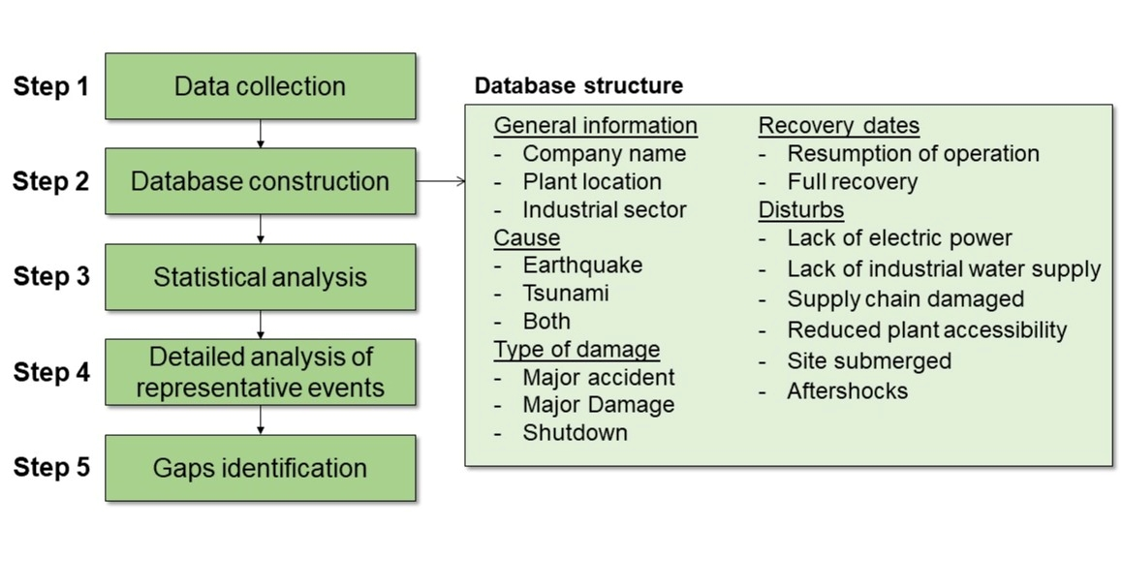

Figure 1: Flow chart of the methodology.

In step 1 the dataset was built starting from the available literature on the Great East Japan Earthquake (i.e., (BARPI, 2013; Krausmann and Cruz, 2013)). Moreover, to retrieve specific information, the ARIA database (BARPI, 2024) was queried. In step 2, a database was built with the retrieved information using the structure reported in Figure 1. In step 3, the collected data were analyzed and used to derive statistical figures. In step 4, a detailed analysis of two representative events was performed to highlight relevant resilience features. Finally, in step 5 relevant gaps existing in the framework of resilience assessment in Natech scenarios were identified and discussed.

* 1. Results

The application of the methodology described in Section 2 led to a dataset of 152 records of companies affected by the GEJET. Specifically, Figure 2a shows the distribution of records among the natural hazards related to the GEJET that damaged the plants: earthquake, tsunami, and simultaneous impact of earthquake and tsunami. Most of the events were caused by the simultaneous impact of the earthquake and tsunami (53%), followed by the earthquake only (41%). In a limited number of events (6%) damages were caused by the impact of the tsunami only, as the earthquake did not cause any significant damage in these cases. Considering the high area of impact of the GEJET, different industrial sectors were affected as can be seen from Figure 2b, which specifies the industrial sector. Especially, where high quantities of hazardous materials are handled (e.g., thermal power plant, chemicals and petrochemicals, and oil and gas) the tsunami had a substantial role in the impact of the GEJET (see light blue and gray bars in Figure 2b), as these plants are frequently located near the coast.

Figure 2c shows the cumulative percentage of plants that resumed operations over time. The trend highlights a rapid increase in the first four months with almost 75% of the affected plants resuming operations. While the remaining plants (25%) restart production in the following nine months. It is worth mentioning that the date of resumption of operations often did not match the date of recovery of the full production capacity of the affected plants. However, the latter information is not always available, and thus reliable statistical figures cannot be elaborated. Clearly, the downtime period of the affected plants strongly depends on the entity of damage caused by the impact of the natural hazard as well as by the consequences of eventual technological accidents potentially triggered. Depending on the consequences of the impact of the GEJET, the collected events were classified as described in Table 1. Notably, the worst classification is always applied when more than one classification fits with the event description.

Table 1: Damage classification of the consequences of the Impact of the GEJET.

|  |  |
| --- | --- |
| Damage classification | Description |
| Major accident (MA) | The natural hazard forced the plant shutdown and triggered a major accident (i.e., fires, explosions, and/or toxic releases) and caused major structural damage to plant equipment and infrastructures. |
| Major damage (MD) | The natural hazard forced the plant shutdown and caused major structural damage to plant equipment and infrastructures. |
| Shutdown (SD) | The natural hazard forced the plant shutdown, without major structural damage to plant equipment and infrastructures. |

Figure 2d reports the distribution of the events categorized by the type of damage caused with respect to the natural hazard responsible for the damage. In all cases in which the tsunami impacted an industrial plant, it provoked MD or MA events. In contrast, the earthquake in some cases caused neither major structural damage to the plant nor major accidents. Indeed, all SD events were caused by the impact of the earthquake only. The majority of MD events (56%) were triggered by the simultaneous impact of the tsunami and the earthquake, whereas only a limited number (7%) were caused by the tsunami alone. Finally, the majority of MA events (65%) were triggered by the simultaneous impact of the tsunami and earthquake, likely due to the proximity of these high-risk industrial facilities to the coast.

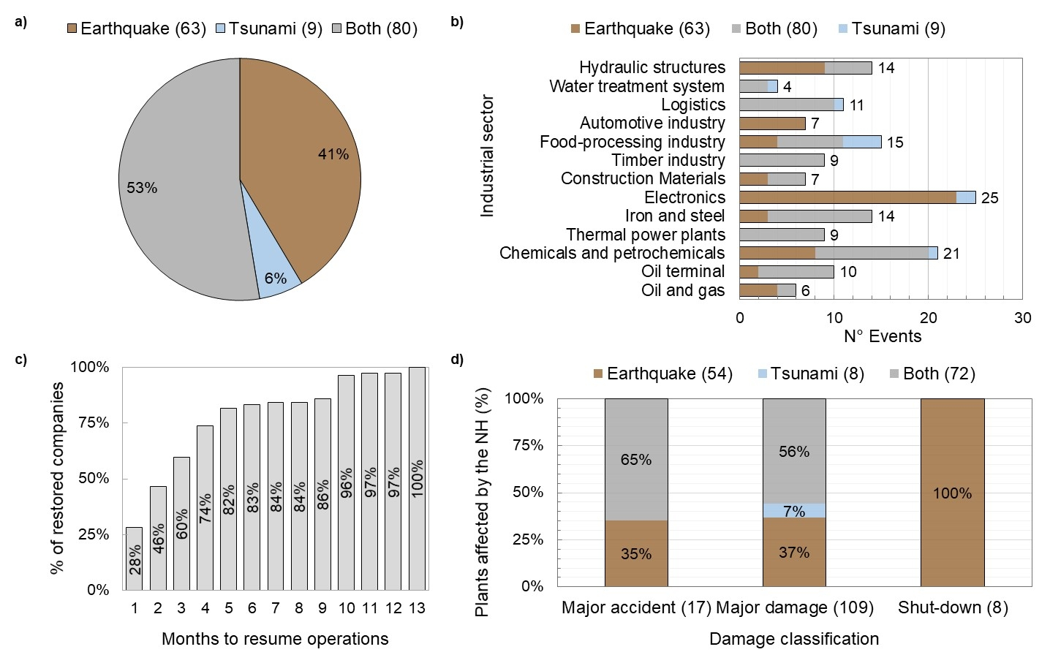

Figure 2: a) Distribution of collected events with respect to natural hazards that damaged the plants. b) Share among industrial sectors and natural hazards that damaged the plants. c) Time trend of resumption of operations for the collected events (excluding hydraulic structures and water treatment systems). d) Percentage distribution of affected company by type of natural hazard (excluding hydraulic structures and water treatment systems).

* + 1. Significant records

A detailed analysis of specific events may reveal meaningful information related to the resilience features of the affected plants. These resilience features regard Natech scenarios (i.e., MA events) as well as SD and MD events. Indeed, even without major accidents, these events were affected by relevant issues typical of Natech scenarios such as lack of electric power and damage to the supply chain. These features affect the resilience of Natech scenarios since they hinder recovery activities, leading to delays in the partial resumption of operations and in the full performance recovery. Unfortunately, the ARIA database (BARPI, 2024) mainly reports detailed descriptions of MA and MD events, therefore a detailed description of a selected reverence MA and MD event is proposed in the following paragraphs to highlight relevant resilience features that are further discussed in Section 4. It is worth mentioning that although detailed information is not available for SD events, the investigation report of BARPI (2013) makes it clear that also industrial installations that were not directly damaged by the GEJET (i.e., SD events) suffered from specific criticalities (e.g., lack of electric power, damage to the supply chain) in the immediate aftermath of the GEJET, delaying the recovery to normal operations.

Reference event 1: major accident (MA), ARIA N° 40258 (BARPI, 2024)

The earthquake (March 11th) and its aftershocks (April 7th) caused severe structural damage to an industrial port refinery in Sendai located 140 km from the epicenter. The damage of the shocks weakened foundations, destroyed concrete bases, and buckled chimneys. Shortly after the tsunami hit the industrial complex, resulting in significant flooding, erosion, and a site subsidence of 40 cm. While most of the refinery employees evacuated to high ground, four workers tragically lost their lives during inspections. The damages caused by the earthquake were exacerbated by the impact of the tsunami that caused the submersion of the control rooms, administrative buildings, and overturned vehicles which in turn damaged catalytic cracking installations. In addition, hydrocarbon transport pipes were twisted, and a 100,000 m³ crude oil tank was destructed, leading to spills and massive pollution in the port and estuary. In addition, a fire broke out in the road/rail loading station and spread to an LPG tank farm, burning for four days. Emergency responses were delayed for 48 hours due to the risk of aftershocks and tsunamis, forcing staff evacuation. The loss of utilities imposed the shutdown of cryogenic cooling systems, leading to the intensive flaring of gases to manage pressure. The event resulted in damages and operational losses amounting to €920 million, with repairs accounting for over €500 million. Recovery operations were initially devoted to restarting transfer and storage operations (2 months after the earthquake). Then, the severely damaged refinery units partially restarted in January 2012, and the full production capacity was reached in March 2012.

Reference event 2: major damage (MD), ARIA N° 42424 (BARPI, 2024)

After the first earthquake foreshocks, production units were placed in a safe state through measures such as the flaring of substances and the shutdown of pipes and equipment. In the meanwhile, almost 2000 workers including employees and subcontractors were evacuated. The tsunami waves inundated the site causing the flooding of facilities and extensive damage. Utility systems were disrupted, pipelines and their insulation were damaged, and large storage tanks experienced roof sinking due to sloshing. Soil liquefaction caused equipment foundations and roads to sink. In addition, the tsunami destroyed wharves, flooded utility buildings, disabled the seawater pumping station, and made the main navigation channel impassable. A chemical tanker was ripped from its moorings, causing additional damage to pipes and wharves. The total damages and production losses for the twenty petrochemical companies in the complex exceeded €1.5 billion. The main navigation channel required over four months of work to restore, and petrochemical units were progressively restarted between one and six months after the disaster, depending on the extent of the damage sustained.

* 1. Discussion

The detailed analysis of the selected reference scenarios provided valuable insights into specific issues that significantly influence the resilience of the affected plants. Table 2 summarizes these issues, underlining the potential effects of such disturbances. As already mentioned, a reference SD event was not included in this table due to the lack of detailed information. However, it is worth mentioning that delays in restarting full operations following SD events were primarily caused by rolling blackouts from the electric company and disruptions in the supply chain.

Figure 3a illustrates a resilience curve of a typical Natech scenarios snapshot. Clearly, different scenarios may be possible depending on the specific features of the accident and the natural hazard-related disturbances. Notably, Figure 3b outlines the characterization of the Resilience Evolution Process (REP) timeline and its phases. As highlighted by Valente et al. (2025), the specific features of Natech scenarios have a substantial effect on the assessment of the loss of performance during the accident phase. However, a specific methodology for taking into account possible indirect Natech pathways triggered by the lack of safety and utility systems is still lacking, although their depleted performance due to natural hazards is well known (Misuri and Cozzani, 2022). Indeed, as can be seen from Table 2, the loss of utility systems was an observed issue of both the reference scenarios analyzed, even if did not lead to indirect Natech. In addition, even if specific methodologies exist to assess multiple primary events (Misuri et al., 2023), domino effects (Antonioni et al., 2015), and the impairment of technical (Misuri et al., 2023) and operational (Ricci et al., 2024) safety barriers, these aspects are not consistently integrated into existing resilience assessment methodology (Valente et al., 2024).

Table 2: List of accident features that characterize the two reference events analyzed. Effects reported in italics are not reported for the analyzed reference scenarios. RE1: reference event 1. RE2: reference event 2.

|  |  |  |  |
| --- | --- | --- | --- |
| Reported accident features | RE1 | RE2 | Observed and potential effects for plant resilience |
| Natural hazard recurrence  (e.g., foreshocks, aftershocks) | ✓ | ✓ | * Cumulative damage. * Damage during the recovery activities. * Hinder the emergency response. * *Interruption of recovery activities.* |
|  |  |  |  |
| Site flooded | ✓ | ✓ | * Hinder the beginning of inspection activities and the clean-up of hazardous materials. * Exacerbate the damage due to corrosion phenomena. |
|  |  |  |  |
| Emergency response hindered | ✓ |  | * Internal and external domino effect. |
|  |  |  |  |
| Loss of utilities | ✓ | ✓ | * Flaring of hazardous substances. * *Indirect Natech accidents.* |
|  |  |  |  |
| Reduced site accessibility |  | ✓ | * *Hinder the emergency response and the beginning of adaptation tasks.* * Delay recovery activities and hinder resumption of operations. |
|  |  |  |  |
| Natural hazard-related debris | ✓ | ✓ | * Clean-up of the site. |
|  |  |  |  |
| Plant infrastructure damage  (e.g., roads, buildings, loading stations) | ✓ | ✓ | * Increase the amount of restoration work and the complexity of the recovery schedule, delaying the restarts of operations. |
|  |  |  |  |
| Natech accidents | ✓ |  | * Damage exacerbated by the consequences of the Natech accident. * Clean-up of hazardous material. |

Beyond the well-known effects of Natech features, the analysis of the reference scenarios highlighted several natural hazard-related issues that significantly challenge system resilience in both MA and MD events. As highlighted in Figure 3a, these issues may directly affect the plant such as in the case of natural hazard recurrence, or they may indirectly affect the system damaging essential external infrastructure such as transportation and energy transmission systems. Although detailed methodologies for the assessment of the post-accident phase have been proposed in the literature (e.g., Caputo et al., (2020) and Kalemi et al., (2024)), they do not rely on a tailored framework addressing the specific activities involved in the adaptation and recovery phases following a Natech event. Thus, the assessment of the causes and mechanisms that may hinder and delay the post-accident phases is still an open issue in the resilience assessment.

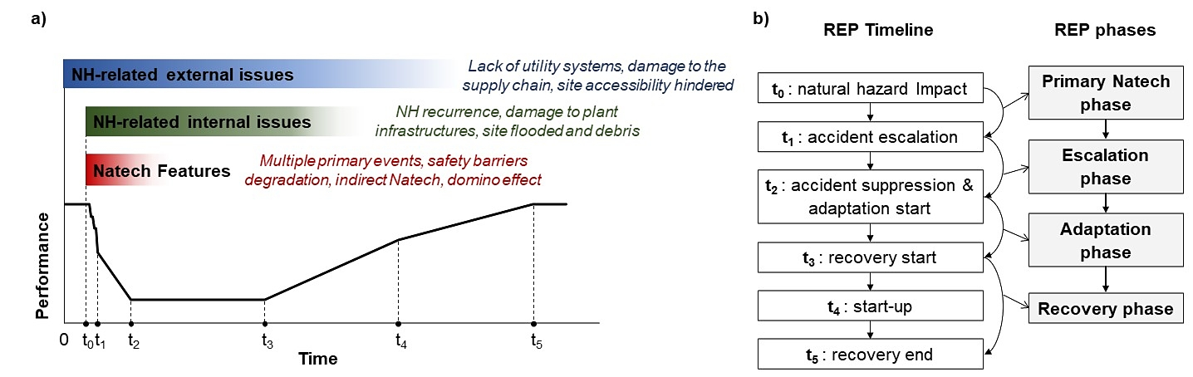

Figure 3: a) Illustrative resilience curve of a typical Natech scenario, representing the integrity-based performance of the system over time. b) Characterization of the timeline and the phases of the Resilience Evolution Process (REP). NH: natural hazard.

Compared to conventional HILP accidents, the resilience curve analysis of Natech scenarios triggered by major natural hazards, such as the GEJET, involves additional layers of complexity due to the simultaneous occurrence of natural hazards and technological failures. The development of specific tools to assess both the accident and post-accident phases is essential for establishing a reliable resilience assessment framework. In addition, it is fundamental to enhance the preparedness of industries to Natech scenarios and to ensure effective emergency response plans.

* 1. Conclusion

The impact of natural hazards on complex heterogeneous industrial facilities possibly leading to Natech accidents demands the development of a comprehensive resilience framework that provides a broader view of events and goes beyond the limits set by safety assessments. This involves the development of reliable assessment tools for the evaluation of the consequences of the immediate impact of natural hazards, as well as holistic approaches that account for the long-term consequences of these scenarios. The availability of a resilience framework is of paramount importance in high-risk industries, where the consequences of Natech accidents may be extremely severe. In this study, a systematic assessment of past accidents triggered by the GEJET highlighted limitations in the current resilience assessment methodologies and revealed open knowledge gaps in the assessment of the post-accident phases of Natech scenarios.

References

Antonioni, G., Landucci, G., Necci, A., Gheorghiu, D., Cozzani, V., 2015. Quantitative assessment of risk due to NaTech scenarios caused by floods. Reliab Eng Syst Saf 142, 334–345.

BARPI, 2024. Analysis, Research and Information on Accidents (ARIA). URL www.aria.developpement-durable.gouv.fr/the-barpi/the-aria-database/?lang=en (accessed 11.27.24).

BARPI, 2013. French Ministry of Ecology, Sustainable Development and Energy. Overview of industrial accidents during the Tohoku earthquake and tsunami. Lyon.

Caputo, A.C., Kalemi, B., Paolacci, F., Corritore, D., 2020. Computing resilience of process plants under Na-Tech events: Methodology and application to sesmic loading scenarios. Reliab Eng Syst Saf 195, 106685.

Cruz, A.M., Steinberg, L.J., Vetere‐Arellano, A.L., 2006. Emerging Issues for Natech Disaster Risk Management in Europe. J Risk Res 9, 483–501.

Hollnagel, E., 2017a. Safety-II in Practice. Routledge.

Hollnagel, E., 2017b. FRAM: The Functional Resonance Analysis Method. CRC Press.

Hollnagel, E., Pariès, J., Woods, D.D., Wreathall, J., 2013. Resilience Engineering in Practice. CRC Press.

Kalemi, B., Caputo, A.C., Corritore, D., Paolacci, F., 2024. A probabilistic framework for the estimation of resilience of process plants under Na-Tech seismic events. Bulletin of Earthquake Engineering 22, 75–106.

Krausmann, E., Cruz, A.M., 2013. Impact of the 11 March 2011, Great East Japan earthquake and tsunami on the chemical industry. Natural Hazards 67, 811–828.

Misuri, A., Cozzani, V., 2022. An Innovative Framework for Chemical and Process Facilities to Support a Comprehensive Natech Risk Assessment. Chem Eng Trans 90, 175–180.

Misuri, A., Landucci, G., Cozzani, V., 2020. Assessing the impact of natural hazards on safety barriers on the basis of expert elicitation. Chem Eng Trans 82, 109–114.

Misuri, A., Ricci, F., Sorichetti, R., Cozzani, V., 2023. The Effect of Safety Barrier Degradation on the Severity of Primary Natech Scenarios. Reliab Eng Syst Saf 235, 109272.

Necci, A., Argenti, F., Landucci, G., Cozzani, V., 2014. Accident scenarios triggered by lightning strike on atmospheric storage tanks. Reliab Eng Syst Saf 127, 30–46.

Ricci, F., Casson Moreno, V., Cozzani, V., 2020. Analysis of natech accidents triggered by extreme temperatures in the chemical and process industry. Chem Eng Trans 82, 79–84.

Ricci, F., Yang, M., Reniers, G., Cozzani, V., 2024. Emergency response in cascading scenarios triggered by natural events. Reliab Eng Syst Saf 243, 109820.

Ricci, F., Yang, M., Reniers, G., Cozzani, V., 2022. The Role of Emergency Response in Risk Management of Cascading Events Caused by Natech Accidents. Chem Eng Trans 91, 361–366.

Sorichetti, R., Misuri, A., Di Padova, A., Miglionico, R., Tallone, F., Cozzani, V., 2022. Multi-risk Approach to the QRA of Natech Scenarios in the Chemical and Process Industry. Chem Eng Trans 91, 493–498.

Suarez-Paba, M.C., Tzioutzios, D., Cruz, A.M., Krausmann, E., 2020. Toward Natech Resilient Industries, in: Disaster Risk Reduction and Resilience. Springer, Singapore, pp. 45–64.

Valente, M., Ricci, F., Cozzani, V., 2025. A systematic review of Resilience Engineering applications to Natech accidents in the chemical and process industry. Reliab Eng Syst Saf 255, 110670.

Valente, M., Ricci, F., Cozzani, V., 2024. Resilience Assessment of Chemical Sites Exposed to Natural Events. Chemical Engineering Transactions 111, 145–150.