|  |  |
| --- | --- |
| cetlogo ***CHEMICAL ENGINEERING TRANSACTIONS***  ***VOL. xxx, 2025*** | A publication of  aidiclogo_grande |
| The Italian Association  of Chemical Engineering  Online at www.cetjournal.it |
| Guest Editors: Bruno Fabiano, Valerio Cozzani  Copyright © 2025, AIDIC Servizi S.r.l. **ISBN** 979-12-81206-xx-y; **ISSN** 2283-9216 | |

Large-Scale Characterization of the Atmospheric Dispersion Velocity and Concentration of Supersonic Underexpanded Jets

Carlo Sanapoa,\*, Sara G. Ruiza , Sebastien Courtiaudb, Delphine Laboureura

a von Karman Institute for Fluid Dynamics, Waterloosesteenweg 72, 1640 Sint-Genesius-Rode, Belgium

b CEA Gramat, D14, 46500 Gramat, France

\* [carlo.sanapo@vki.ac.be](mailto:carlo.sanapo@vki.ac.be)

The present work investigates the velocity and concentration fields of underexpanded jets discharging into quiescent and boundary-layer flow conditions using large-scale planar particle image velocimetry (PIV) and Mie-scattering. Experiments were conducted at the von Karman Institute, employing a high-pressure tank with an orifice nozzle to replicate jet leakage scenarios under two upstream pressure ratios and two boundary layer velocities. The results confirm self-similarity in velocity and concentration profiles for jets in quiescent atmospheres, with normalized profiles collapsing across transition and far-field zones. However, increasing the boundary layer velocity disrupts the jet symmetry, altering the Gaussian tail of the velocity profile and enhancing jet dispersion. The decay rates of centerline velocity and concentration highlight the interplay between upstream jet momentum and external boundary-layer dynamics. Scaling analysis demonstrates the consistency of the results, aligning with theoretical models for fully expanded jets. These findings provide insights into the transport mechanisms of underexpanded jets, underscoring the role of ambient conditions in modifying jet behavior. The outcomes are valuable for applications involving jet dispersion in industrial and environmental contexts, offering a robust experimental framework to model and predict jet flow dynamics.

* 1. Introduction

High-pressure tanks and piping became essential in industries that handle, store, and utilize pressurized substances. Routine inspections of these pressurized vessels frequently reveal damage, which can lead to hazardous leaks or fatal ruptures (OSHA (2023)). Such incidents pose significant health and safety risks, including poisoning, suffocation, fires, and explosions. Statistics on high-pressure device failures underscore the necessity for further safety advancements to mitigate these risks (Zhang and Whang (2022)).

When a high-pressure gas exits through a leak, a supersonic underexpanded jet is generated: a high-speed, turbulent, compressible flow characterized by a broader range of spatiotemporal scales. The resulting mixture can quickly become flammable or explosive if the gas concentration in the air falls within its flammability limits or if the gas temperature exceeds its auto-ignition point. Understanding the behavior of such jets, especially their dispersion into the atmosphere, is crucial for designing effective safety systems and optimizing facility layouts. The interaction with the Atmospheric Boundary Layer (ABL) further complicates this dispersion process, making its characterization a priority (De Visscher (2013)).

Mathematical dispersion modeling is a key tool for predicting how pollutants spread in the atmosphere following a release. Various models exist, each with inherent advantages and limitations (Holmes and Morawska (2006)). However, validating these models remains challenging due to the limited availability of datasets capturing both velocity and concentration fields simultaneously. Using data from actual releases in the atmosphere (government databases or field tests) can often present challenges like identifying the precise location of the emission source, estimating emission rates, or acquiring representative ABL parameters (e.g., shape, height, and wind speed). A significant gap exists in comprehensive experimental datasets that characterize jet dispersion phenomena under conditions resembling a realistic ABL, particularly at ambient and elevated temperatures. To address these challenges, advanced optical measurement techniques such as Particle Image Velocimetry (PIV) combined with the Mie-Scattering theory offer a promising solution (Sanapo et al. (2024), Fouchier (2020)). These techniques enable simultaneous measurement of velocity and concentration fields, providing a detailed understanding of jet behavior, and have demonstrated promising results, particularly in controlled, low-speed, uniform cross-flow conditions (Fouchier (2020)). By solving Maxwell’s equations, the Mie-Scattering theory allows the extrapolation of relative concentration fields (Bohren and Huffman (2008), Hulst (1981)). This non-intrusive, cost-effective technique leverages the same experimental images obtained from PIV measurements to quantify particle distributions within a given volume. However, these techniques have not yet been used in realistic ABL scenarios. Furthermore, much of the existing research focuses on the compressible region near the jet exit, exploring phenomena such as Prandtl-Meyer expansions, Mach disks, and diamond patterns while neglecting far-field dispersion.

Hence, the goal of the present study is manifold: 1 - perform large-scale experimental characterization of high-pressure jet dispersion using PIV and Mie-Scattering theory, 2 - achieve simultaneous descriptions of velocity and concentration fields, 3 - to investigate the influence of the ABL on jet dispersion; in addition, it fills the existing gaps in experimental data and enhances the predictive capability of dispersion models under scaled atmospheric conditions, laying so the foundations for a high-fidelity experimental reference database.

* 1. Methodology
     1. Techniques

To characterize the velocity fields from a region close to the source, i.e $x/D=10,$ up to the far-field zone, e.g. $x/D>100$, large-scale 2-component planar PIV was used. The PIV technique allows the extraction of the velocity fields by tracking the displacement of tracer particles within the flow Scarano (2007). Proper-sized tracer particles were introduced into the flow directly from the source inside the pressurized tank. The axis-symmetric plane, passing through the nozzle orifice, is illuminated twice using a Nd:Yag laser light sheet. Several tests were conducted to optimize the time delay between two laser pulses. This ensured optimal post-processing by achieving particle displacements within the range of 5 to 15 pixels per frame for the varying flow velocities across the FOV. The latter is a natural consequence of employing a large-scale setup in parallel with a wide range of expected velocity magnitudes.

The light scattered by the tracer particles is recorded on two CMOS high-resolution camera sensors on two separate frames. The local displacement vector for the images of the tracer particles between the first and second frame is obtained for each interrogation area using a cross-correlation technique; in contrast to classical PIV, which tracks the average displacement of particles within an interrogation window, the large-scale adaptation, due to its higher FOV and consequently reduced local spatial resolution, tracks the displacement of ensembles (structures) of particles. To conclude, the projection of the vector of the local flow velocity into the FOV is computed considering the previously defined time delay between the two illumination pulses and the scaling factor associated with the camera setting.

The Mie-scattering theory is used to derive a relative concentration field. By leveraging the extinction phenomenon, the theory enables to link the particle concentration within a pixel to the intensity of scattered light recorded by the sensor $I$. Experimentally, it consists of recording a reference image $I_{R}$ having a uniform concentration distribution along with another one of the light distribution $I_{L}$ Sanapo et al. (2024). The derivation of the concentration field is straightforward: $C=((I-I_L ))/((I_R-I_L )$.

To ensure consistency and accuracy in the derived concentration maps, the resulting values are scaled by the maximum recorded intensity by the camera sensor. This peak is typically found near the source, within the potential core of the jet, where particle concentrations and, consequently, the scattering phenomenon is most pronounced (Sanapo et al. (2024)).

* + 1. Experimental setup and conditions

Tests were conducted at the von Karman Institute for Fluid Dynamics in the L1B subsonic wind tunnel. The facility features a rectangular test section measuring $2 m ×3 m × 20$ m (h x w x l), with a roughened floor designed to develop a turbulent boundary layer corresponding to the lower part of the atmospheric neutral boundary layer. The flexible, continuously adjustable ceiling allows precise control of the longitudinal pressure gradient while flow velocities range from $2$ to $50 m/s$. A 100-liter high-pressure stainless-steel tank stores, pressurizes and continuously releases air into the test section. The tank features a manhole that accommodates different nozzle types. To replicate a representative leakage defect, an orifice nozzle having a diameter of $D=0.005 m$ is used. A schematic of the facility and its setup is reported in Figure 1. The degree of jet underexpansion is characterized by the nozzle pressure ratio ($NPR$), defined as $NPR=p_e/p_∞$ ​, where $p_{e}$ ​ is the static pressure at the nozzle exit, and $p_{∞}$ is the ambient static pressure. Two $NPR$ values, corresponding to upstream total pressures of $500,000$ and $900,000 Pa$, are tested. Two ABL conditions are imposed: a quiescent atmosphere $U_∞=0 m/s$ and a crossing boundary layer with a freestream velocity of $U_{∞}=10 m/s$ at $x/D=100$. Tracer particles, made of mineral white oil and produced by a Laskin nozzle seeding generator (SG), are directed into an intermediate seeding tank (ST) pressurized slightly above the main tank (MT) to facilitate particle release. The institute's 40-bar line supplies the air mass flow for the primary and seeding tanks. The facility has pressure regulators, ggates safety, and solenoid valves to control the flow. The nozzle exit is flush with the wind tunnel floor, while two counter-rotating fans generate the desired boundary layer flow. The boundary layer flow speed is monitored using a pitot tube at $x/D=100$ and measured through large-scale PIV with the same settings utilized during a typical tests.

Each test lasts 20 seconds and acquires 300 image pairs per camera. The field of view is illuminated by an ND:YAG laser mounted on the roof of the wind tunnel, with optics, lenses, and prisms shaping the laser into the required light sheet spatial extensions. The two high-resolution cameras have been positioned to extend the covered region up to $x/D=160$. The first is placed in portrait mode to cover the almost vertical path of the resulting flow, while the second is in landscape mode to capture most of the resulting deviated flow caused by the influence of the ABL.

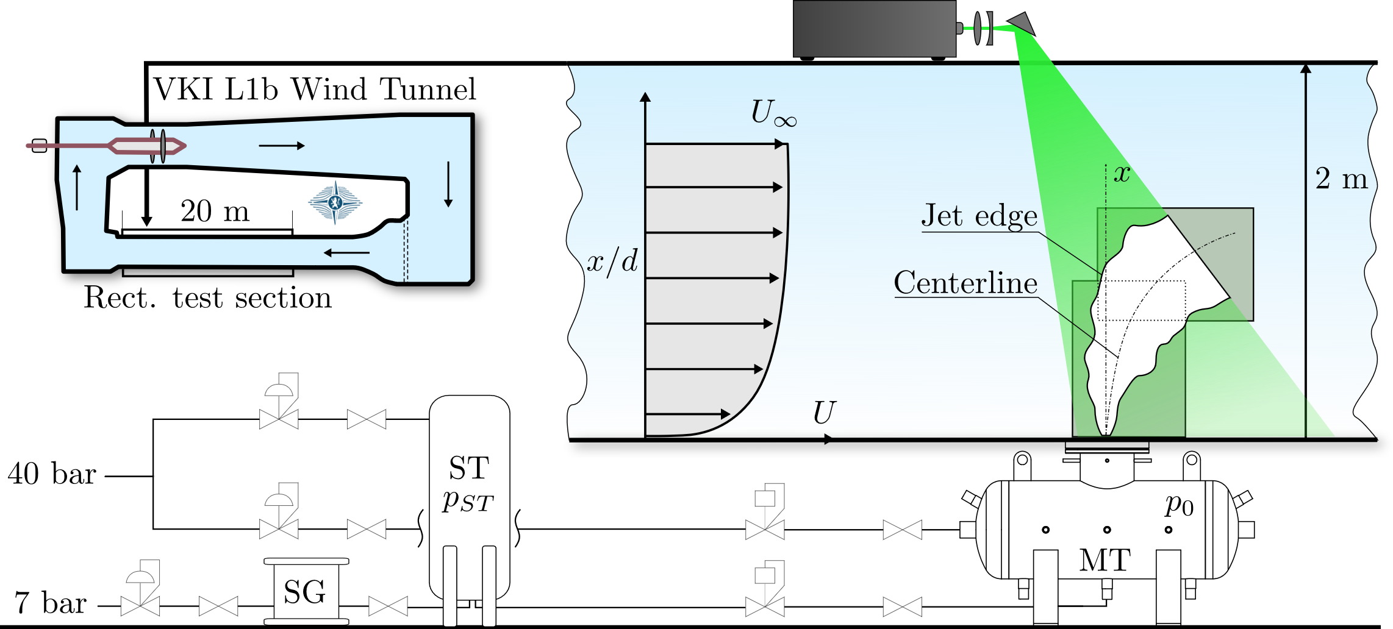

*Figure 1: Experimental facility and large-scale PIV configuration within the VKI L1b subsonic wind tunnel*

* 1. Results and Discussion

Figure 2 reports examples of the averaged velocity $U$ and concentration $C$ fields recorded from camera 1, extending from $10≤x/D≤116$. 300 image pairs (one typical test) proved sufficient to ensure proper convergence of both quantities. Both quantities' mean fields can describe the ABL influence on the atmospheric jet dispersion, with deviations evident in both velocity and concentration fields.

*Figure 2: Mean velocity and concentration field of supersonic underexpanded jets $(p_{0}=500,000 Pa)$ discharging into a quiescent atmosphere and in a crossing boundary layer $U_{∞}=10 m/s$ at $x/D=100$*

The influence of the upstream total pressure $p_{0}$ along with the ABL velocity magnitude $U_{∞}$ on the jet centerline ­­­velocity is highlighted in Figure 3a and Figure 3b. As expected, a higher upstream tank total pressure results in higher jet momentum, which increases the jet centerline velocity magnitude. This relation is consistently observed across all pressure conditions. However, a more detailed analysis reveals characteristic behaviours among different pressure cases. Notably, the $500,000 Pa$ case significantly differs in magnitude from the $900,000 Pa$ cases. This difference arises from the correspondent lower $NPR$; the lower upstream total pressure produces weakly underexpanded conditions.

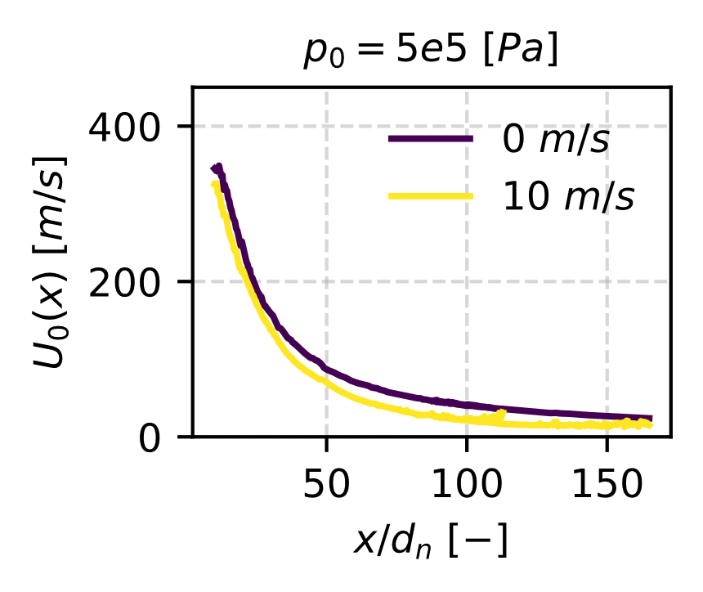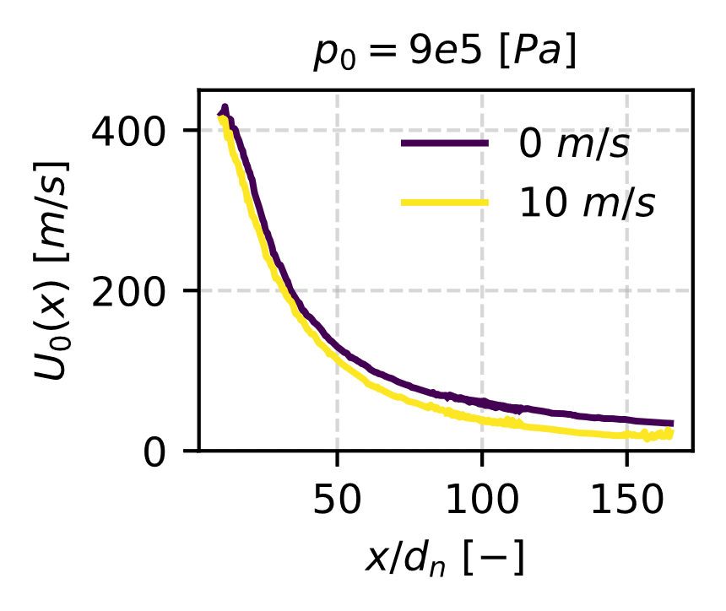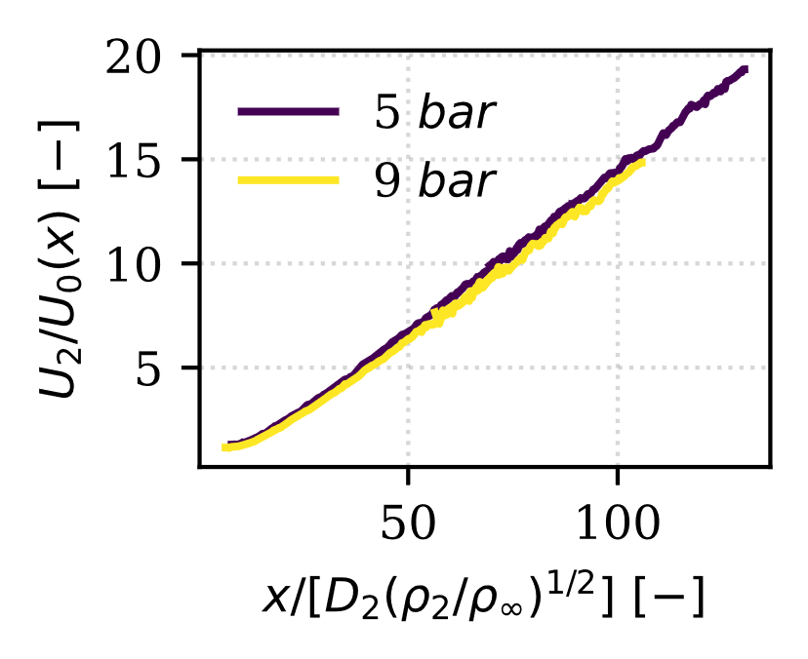

*(a) (b) (c)*

*Figure 3: Centerlines velocity of supersonic underexpanded jets (a) $p_{0}=500,000 Pa$ and (b) $p_{0}=900,000 Pa$ discharging into a quiescent atmosphere and in a crossing boundary layer $U_{∞}=10 m/s$ at $x/D=100$. (c) Nondimensional centerline velocity for both pressures and quiescent atmosphere*

The influence of the ABL becomes increasingly evident as its velocity magnitude rises. At $U_∞=10 m/s$ the effect of the ABL is already evident in the potential core of the lower pressure case ($x/D≈10$). The lower jet momentum resulting from the lowest upstream total pressure condition allows the gradient established by the ABL to modify the centerline profile earlier, even in regions typically dominated by the jet’s inherent momentum. In contrast, the higher-pressure cases remain resistant to ABL disturbances at this velocity, showing negligible differences in the potential core. A necessary remark stands out from the analysis of the far-field zone ( $x/D≈125$). At this height, for the ABL case correspondent to $U_∞=10 m/s$ the centerline velocities for all three underexpanded jets begin to converge towards a plateau. This behavior deviates from lower ABL velocity cases, where the centerline velocity decreases in the same region. The earlier convergence at higher ABL velocities suggests that the increased external momentum rapidly ingests the jet flow, causing it to align with the ambient (i.e., ABL) flow conditions and quickly achieve a uniform velocity profile.

A scaling analysis of the decay rates of supersonic underexpanded jet centerlines is conducted. The analysis is based on the work of Yüceil and Ötügen (2002). For a given test condition, the strategy employed is to retrieve first the initial conditions of an equivalent fully expanded jet at a specific corresponding position, which will later be used to scale the jet centerline previously introduced. The starting conditions are the flow quantities obtained at the nozzle's throat following the jet's discharge. The latter can be obtained via the isentropic relations after imposing the choking condition ($Ma_{e}= 1$). Later, it is assumed that the expansion lasts until the flow reaches the ambient conditions. The latter are considered to be the same as the initial conditions of the equivalent fully expanded jet. After this point, the plane is fully developed and does not go through any further expansion. The detailed math process employed for deriving the quantities can be found in Yüceil and Ötügen (2002). Based on the fully expanded jet conditions identified, the centerline velocity magnitude $U_{0} \left(x\right)$ is scaled by the equivalent fully expanded jet centerline velocity magnitude $U_{2}$ and plotted as a function of the distance from the equivalent nozzle diameter $D_{2}$ also taking into account the density effect as $(ρ_2/ρ_∞ )^(1/2)$. A good overlap of the two resulting nondimensional profiles for has been obtained (Figure 3c), proving that the jet velocity obtained from the large-scale experimental characterization of the phenomenon follows theoretical predictions.

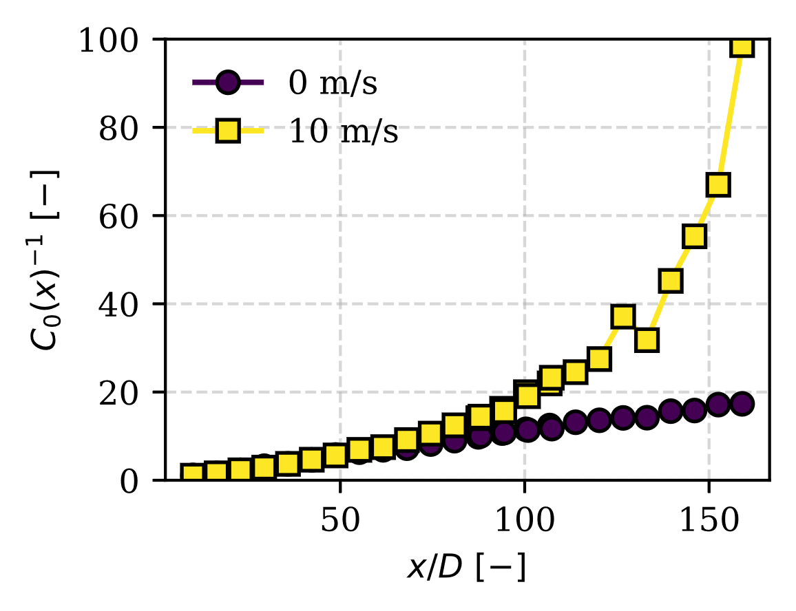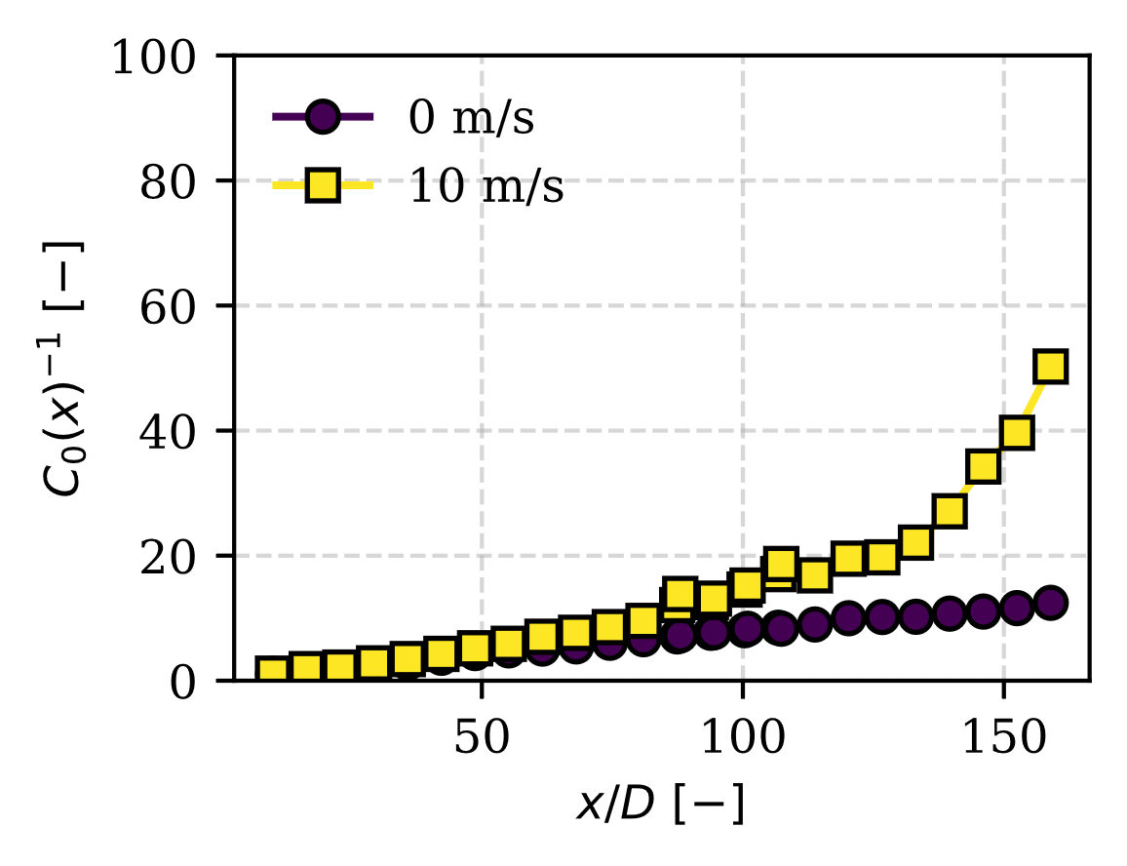

*(a) (b)*

*Figure 4: Centerlines inverse concentration of supersonic underexpanded jets (a) $p_{0}=500,000 Pa$ and (b) $p_{0}=900,000 Pa$ discharging into a quiescent atmosphere and in a crossing boundary layer $U_{∞}=10 m/s$ at $x/D=100$.*

Figure 4 illustrate the relationship between pressure and concentration decay along the centerline. To better visualize the latter, the inverse of the concentration $C^{-1}$ is reported. The data clearly show that at higher pressures Figure 4b, the decay in concentration occurs more gradually, regardless of the ABL magnitude. The latter is evident from the steeper gradient in the inverse of the concentration along the centerline for the quiescent atmosphere case Figure 4a. In addition to this, the concentration exhibits a faster decay trend in the region close to the self-similar zone, resembling an exponential-like behaviour. The increased ABL velocity significantly enhances the substance's dispersion in this region. This underscores the role of ABL dynamics in promoting dispersion and accelerating the decline in concentration downstream. All the previous examples demonstrate the interplay between upstream tank total pressure, ABL velocity, and concentration decay for the underlying transport mechanisms in self-similar regions. Self-similarity is a key feature of turbulent jets, occurring beyond the potential core and transition region. In this state, radial spreading and axial velocity (or concentration) variations follow consistent scaling rules across axial positions. This statistical uniformity allows analysis at one location to represent the entire jet flow Pope (2001)

At a given axial location, the radial velocity (concentration) profiles, normalized by the maximum velocity at that height, are plotted against the radial distance scaled by the half-maximum velocity position. The results confirm that self-similarity is preserved for both velocity and concentration profiles across the transition and far-field zones of jets discharging into quiescent atmospheres (Figure 5a and Figure 6a). Profiles extracted at varying heights under different pressure conditions consistently exhibit this trend.

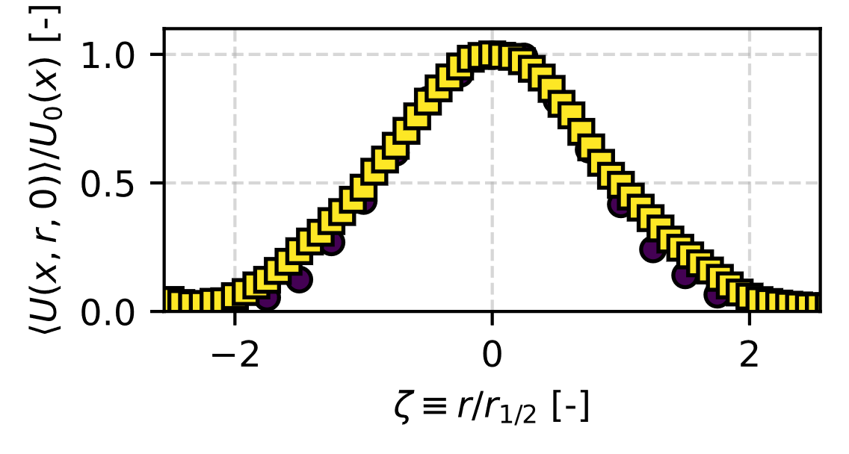`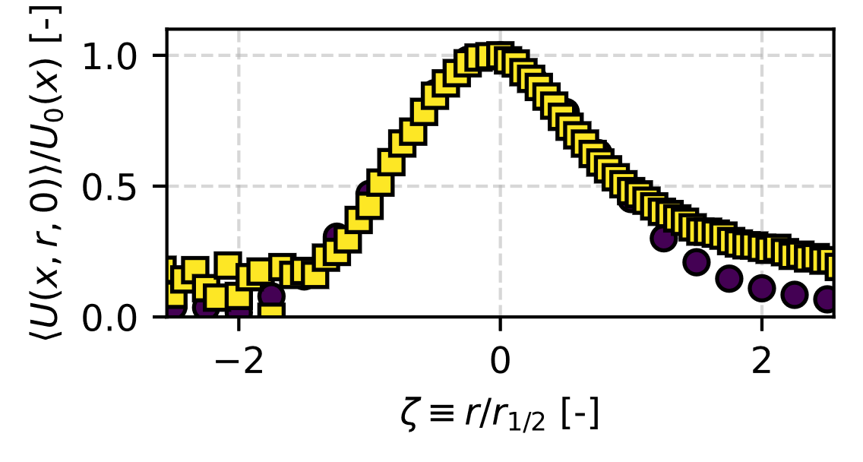

.

*(a) (b)*

*Figure 5: Velocity self-similar profiles at x/D=20 (circle) and x/D=100 (square) for supersonic jets $p_{0}=500,000$ discharging into a quiescent atmosphere (a) and in a crossing boundary layer $U_{∞}=10 m/s$ (b).*

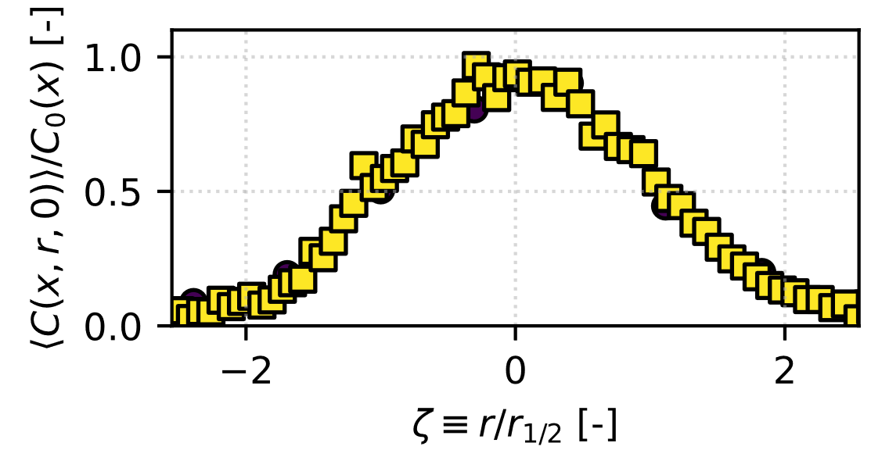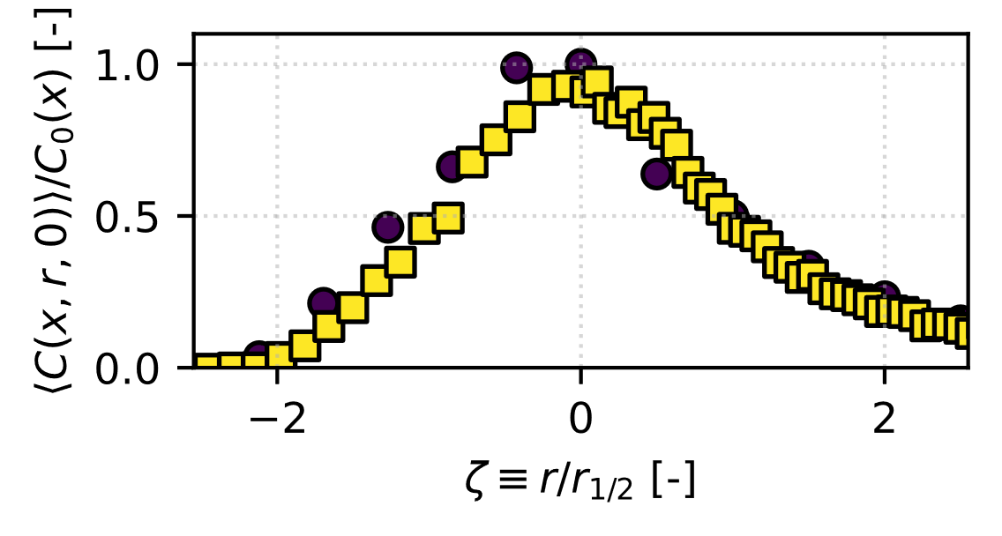

*(a) (b)*

*Figure 6: Concentration self-similar profiles at x/D=20 (circle) and x/D=100 (square) for supersonic jets $p_{0}=500,000$ discharging into a quiescent atmosphere (a) and in a crossing boundary layer $U_{∞}=10 m/s$ (b).*

However, symmetry in the velocity (concentration) profiles is disrupted at the highest boundary layer velocity condition (Figure 5b and Figure 6b). Here, the Gaussian tail remains elevated, reflecting altered dynamics and an unbalanced velocity distribution. The increased momentum from the crossing boundary layer significantly impacts the velocity field, creating a mixed flow behaviour driven by the interaction between the jet and boundary layer flows.

* 1. Conclusions

This study uses large-scale PIV and Mie-Scattering theory to characterize the velocity and concentration fields of underexpanded jets under varying upstream pressure and boundary layer conditions, from the potential core up to the far-field zone $x/D≈160$. The results confirm the preservation of self-similarity in velocity and concentration profiles in quiescent atmospheres, with deviations introduced by the interaction with boundary layer flows. The interplay between upstream total pressure and boundary layer velocity highlights distinct jet dispersion behaviors, particularly in the far-field region.

Nomenclature

$C$– concentration, -

$C_0 (x)$– jet centerline concentration, -

$D$– nozzle orifice diameter, m

$D_2$– equivalent fully expanded jet diameter, m

$p_0$– tank total pressure, Pa

$p_e$– nozzle static exit pressure, Pa

$p_∞$– atmospheric pressure, Pa

$r$– jet radial direction, m

$U$– velocity, m/s

$U_0 (x)$– jet centerline velocity, m/s

$U_∞$– ABL magnitude, m/s

$x$– jet axial direction, m

$ρ_e$– nozzle exit density, [kg/m3]

– ambient density, [kg/m3]

References

Bohren, C.F. and Huffman, D.R., 2008. *Absorption and scattering of light by small particles*. John Wiley & Sons.

De Visscher, A., 2013. *Air dispersion modeling: foundations and applications*. John Wiley & Sons.

Fouchier C., 2020, Investigation of the Pollutant Dispersion Driven by a Condensed-Phase Explosion in an Urban Environment, PhD Thesis, Université libre de Bruxelles, Bruxelles, Belgium.

Holmes, N.S. and Morawska, L., 2006. A review of dispersion modelling and its application to the dispersion of particles: An overview of different dispersion models available. *Atmospheric environment*.

Hulst, H.C. and van de Hulst, H.C., 1981. *Light scattering by small particles*. Courier Corporation.

Yüceil, K.B. and Ötügen, M.V., 2002. Scaling parameters for underexpanded supersonic jets. *Physics of Fluids*, *14*(12), pp.4206-4215.

OSHA: Occupational Safety and Health Administration, 2023. Technical Manual, Instruction TED 01-00-015.

Pope, S.B., 2001. Turbulent flows. *Measurement Science and Technology*, *12*(11), pp.2020-2021.

Sanapo, C., Ruiz, S.G., Fouchier, C., Courtiaud, S. and Laboureur, D., Velocity and Concentration Measurements of Supersonic Underexpanded Jets. *Proceedings of the 21st International Symposium on the Application of Laser and Imaging Techniques to Fluid Mechanics.*

Scarano, F., 2007. Overview of PIV in supersonic flows. *Particle Image Velocimetry: New Developments and Recent Applications*, pp.445-463.

Zhang, X. and Wang, J., 2022. Atmospheric dispersion of chemical, biological, and radiological hazardous pollutants: Informing risk assessment for public safety. *Journal of Safety Science and Resilience*.