 CHEMICAL ENGINEERING TRANSACTIONS  VOL. xxx, 2026 | A publication of  
The Italian Association
of Chemical Engineering
Online at www.cetjournal.it

Guest Editors: Flavio Manenti, Botir Usmonov, Alessandro Di Pretoro
Copyright © 2026, AIDIC Servizi S.r.l.
ISBN 979-12-81206-xx-x; ISSN 2283-9216

CFD-AI Integrated Recovery of Flue-Gas Waste Heat in Chemical Plants
Shodmon A. Abulkhaev ^{a,}*, Gulnoz N. Khakimova ª, Tuychi J. Pirimov ª, Samugjon K. Nigmadjonov ª, Ahmad A. Nurmuhamedov ^{b}
ª Tashkent Institute of Chemical Technology, Tashkent, Uzbekistan
^{b} Gulistan State University, Gulistan, Uzbekistan
shodmon0927@gmail.com

Background: Chemical production facilities remain among the most energy-intensive industrial systems, and a substantial share of their irreversibility is exported through hot flue gases from fired heaters, reformers, boilers, sulfuric acid units, incinerators, and oxidizing furnaces. These streams are simultaneously thermal resources and emission pathways for CO2, NOx, acid precursors, and fine particulates.
Objective: This article evaluates the technical viability of selectively recovering flue-gas waste heat in chemical plants through a workflow that couples computational fluid dynamics (CFD) with AI-based surrogate modeling, optimization, and operational support.
Methods: A research-based framework was developed by integrating thermodynamic analysis, heat-transfer design, equipment selection, flue-gas treatment, and plant retrofit considerations. The approach incorporates CFD-based analysis, AI-assisted optimization, and engineering calculations to estimate heat recovery performance, pressure drop, and emission reduction potential.
Results and technical focus: The analysis shows that effective waste heat recovery requires an exergy- and contamination-aware approach rather than a simple economizer installation. High- and medium-grade heat can be directly reused for steam generation, feedwater heating, combustion-air preheating, and process heating, while deep recovery requires careful control of corrosion, fouling, and condensate management. CFD provides detailed evaluation of flow distribution, wall temperature, and pressure losses beyond conventional calculation methods.
Significance: The proposed CFD-AI framework is judged broadly viable for large, continuous, heat-intensive chemical plants with stable operating envelopes and adequate digital maturity, but only conditionally viable for smaller, highly variable, or severely corrosive services.
1. Introduction
The chemical industry is one of the most energy-intensive sectors and a major source of CO₂ emissions. Therefore, improving energy efficiency and reducing greenhouse gas emissions are essential for sustainable chemical production [International Energy Agency, 2026].
Flue gases from industrial processes contain significant recoverable heat, but efficient utilization remains challenging due to temperature non-uniformity, hydraulic limitations, corrosion risks, and interactions with emission-control systems. Conventional recovery methods, including economizers and pinch analysis, can estimate energy potential but often fail to capture local flow behavior, heat transfer characteristics, and operational constraints [Ononogbo et al., 2023; Nyakuma et al., 2023; Loni R et al., 2021].
Another challenge is the strong coupling between energy recovery and emission control. Reducing flue-gas temperatures can lower fuel consumption and indirect CO₂ emissions, but it may also influence NOx reduction systems, sulfuric acid condensation risks, plume behavior, and CO₂ capture processes. Therefore, thermal management and emission mitigation should be evaluated simultaneously rather than as separate engineering tasks.
Recent advances in computational fluid dynamics (CFD) and artificial intelligence (AI) offer new opportunities to address these challenges. CFD enables detailed analysis of flow behavior, heat transfer, and equipment performance, while AI techniques support optimization, predictive maintenance, and rapid evaluation of design alternatives. However, these methods are rarely combined in a unified framework for flue-gas waste heat recovery in chemical plants.

2. Technologies for Waste Heat Recovery and Harmful Flue Gas Treatment
The selection of waste heat recovery equipment should be based on the characteristics of the flue-gas source rather than on exchanger performance alone. In chemical plants, exhaust streams differ significantly in temperature, composition, flow rate, and operating conditions. Therefore, the goal is not to choose the most efficient device in isolation but to identify the most suitable combination of technologies for a specific process application.
Table 1. Comparison of waste heat recovery devices for chemical plant flue gas appli- cations
Technology | Practical flue-gas window | Principal advantage | Principal limitation | Typical best-fit duty
Waste heat | >650 ⁰ C | High-value | High capex; | Sulfur burners,
boiler |  | steam | thermal stress; | reformers,
 |  | generation | often already | oxidizers
 |  |  | installed
Economizer / | 180-400 ⁰C | Mature, | Fouling, | Fired heaters,
finned-tube |  | effective for | dew-point | reformer stacks
gas-water |  | BFW/process- | corrosion,
exchanger |  | water heating | pressure drop
Recuperator / | 300-900 ⁰C | Reduces burner | Sealing, hot-side | Furnaces,
air preheater |  | fuel by | fouling, thermal | thermal
 |  | preheating | cycling | oxidizers
 |  | combustion air
Heat pipe heat | 150-450 ⁰C | Complete | Cleaning | Corrosive or
exchanger |  | hot/cold fluid | diﬀiculty; | cross-
 |  | separation; | transport limit; | contamination-
 |  | compact layout | cost | sensitive service
Condensing | 40-160 ⁰C outlet | Recovers latent | Severe corro- | Humid
exchanger / | depending chemistry | heat and often | sion/fouling | natural-gas flue
membrane |  | water | risk; condensate | gas, low-sulfur
condenser |  |  | treatment | service
ORC bottoming | 120-350 C, relatively | Generates | Lower eﬀiciency | Remote sites,
cycle | stable/clean source | electricity where | than direct heat | sink-limited
 |  | heat sinks are | reuse; | plants
3. Shell-and-Tube Exchangers, Economizers, Recuperators, and Regenerators
Shell-and-tube heat exchangers remain widely used in flue-gas applications due to their mechanical reliability, scalability, and tolerance to thermal stresses. Because gas-side heat-transfer coefficients are typically lower than liquid-side values, finned tubes and extended surfaces are often employed to improve performance. The primary design objective is to increase heat-transfer area while maintaining an acceptable pressure drop.
Economizers are particularly suitable when the recovered heat can be utilized for boiler feedwater, process water, or other liquid utilities with stable demand. In many chemical plants, they represent one of the most practical retrofit options because the recovered energy can be directly reused. CFD-based studies of finned-tube economizers indicate that improvements in heat transfer are often accompanied by increased flow resistance, making thermal-hydraulic optimization essential [Tang et al., 2022].
Recuperators and air preheaters improve energy efficiency by transferring heat from flue gases to combustion air, thereby reducing fuel consumption. Their main advantage is the direct recovery of energy into a high-value heat sink located close to the source. However, their performance can be affected by leakage, fouling, sealing quality, and operation under varying load conditions. Regenerators can provide efficient high-temperature heat recovery but are less common in continuous chemical processes because dirty gases and cyclic operation increase maintenance complexity.
4. Governing equations
For a first-pass estimate of recoverable sensible heat from flue gas,
$\dot{{ Q}_{sens}}={\dot{m}}_{g}{\overline{c}}_{p,g}\left(T_{g,in}-T_{g,out}\right)$ (1)
where ${\dot{m}}_{g}$ is the flue-gas mass flow rate, ${\overline{c}}_{p,g}$ is its mean specific heat over the relevant temperature interval, and $T_{g,in}$ and $T_{g,out}$ are the inlet and outlet gas temperatures.
The exchanger duty can also be written in standard design form as:
$\dot{Q}=UAFΔT_{lm}$ (2)
where $U$ is the overall heat-transfer coefficient, $A$ is the heat-transfer area, $F$ is the correction factor accounting for the flow arrangement, and $ΔT_{lm}$ is the logarithmic mean temperature difference,
$ΔT_{lm}=\frac{{ΔT}_{1}-ΔT_{2}}{\ln\left({ΔT_{1}}/{ΔT_{2}}\right)}$ (3)
with $ΔT_{1}$ and $ΔT_{2}$ defined from terminal hot- and cold-side temperature differences.
The heat-exchanger effectiveness is
$ε=\frac{\dot{Q}}{C_{min}\left(T_{h,im}-T_{C,in}\right)}$ (4)
where $C=\dot{m}c_{p}$ is the heat-capacity rate and $C_{min}$ is the smaller of the hot- and cold-side values.
Pressure loss is often estimated from a combination of distributed and local resistances,
$∆P ≈ (f\frac{L}{D_{h}}+ \sum{K)\frac{ρϑ^{2}}{2}}$ (5)
where $f$ is the friction factor, $L$ is characteristic flow length, $D_{h}$ is hydraulic diameter, $\sum{K}$ is the sum of local loss coeﬀicients, $ρ$ is gas density, and $ϑ$ is characteristic velocity.
The associated fan or blower penalty is
$P_{in}=\frac{\dot{V}ΔP}{η_{f_{an}}}$ (6)
where $\dot{V}$ is volumetric flow rate and $η_{f_{an}}$ is fan eﬀiciency.
A minimum corrosion constraint may be written as
$T_{w,min}≥T_{ADP}+ΔT_{saf_{e}}$ (7)
where $T_{w,min}$ is the minimum local metal wall temperature, $T_{ADP}$ is the acid dew point, and $ΔT_{saf_{e}}$ is a design safety margin.
For utility displacement, avoided CO₂ can be estimated from the recovered useful heat:
${\dot{m}}_{co_{2}, avoided} = \frac{{\dot{Q}}_{useful}}{ɳ_{disp}}EF_{co_{2}}$ (8)
When exergy is relevant, a useful approximation for heat supplied at mean source temperature $T_{m}$ is $\dot{E}x_{Q}≈\dot{Q}\left(1-\frac{T_{0}}{T_{m}}\right)$ (9)
with $T_{0}$ as the reference environment temperature. The relation is a reminder that low-temperature recovery can be quantitatively large while qualitatively modest in exergy value.
4,1. Illustrative calculation for a representative chemical-plant flue-gas stream
Consider an illustrative, not plant-certified, gas-fired reformer or petrochemical heater stack with the following assumptions:
- flue-gas mass flow rate, ${\dot{m}}_{g}$ = 20 kg s⁻¹
- mean gas specific heat, ${\overline{c}}_{p,g}$ = 1.10 kJ kg⁻¹ K⁻¹
- gas inlet temperature to new economizer, $T_{g,in}$ = 280 ⁰C
- permissible bulk outlet temperature, $T_{g,out}$ = 160 ⁰C
- cold-side utility: boiler feedwater from 105 to 145 ⁰C
- exchanger U = 42 W m⁻² K⁻¹
- correction factor F = 0.95
From the sensible-heat relation,
$\dot{{ Q}_{sens}}$ = 20 × 1.10 × (280 − 160) = 2640 kW
Thus, the economizer can recover about 2.64 MW of sensible heat under the assumed conditions. If that duty heats feedwater from 105 to 145 ⁰C, the required water flow is$${\dot{m}}_{g}=\frac{2640}{4.2 x 40} = 15.7 kg s^{-1}$$
using c_{p,w} = 4.2 kJ kg⁻¹ K⁻¹
The terminal temperature differences are ΔT₁ = 280 − 145 = 135 ⁰C and ΔT₂ = 160 − 105 = 55 ⁰C. Then ΔT_{lm} ≈ 89.2 ⁰C. The required area is therefore$$A=\frac{2.64 x {10}^{6}}{42 x 0.95 x 82.2} ≈742 m^{2}$$
which is a credible order of magnitude for a finned-tube economizer in industrial service.
The heat-capacity rates are C_{g} = 20 × 1.10 = 22.0 kW K⁻¹ and C_{w} = 15.7 × 4.2 = 65.9 kW K⁻¹, so C_{min} = 22.0 kW K⁻¹. The maximum theoretical duty is 22.0 × (280 − 105) = 3850 kW, giving an effectiveness of approximately
$$ε=\frac{2640}{3850} ≈0.69$$
which is neither trivial nor extraordinary; it is an engineeringly plausible target.
Now consider the hydraulic penalty. If the average gas density is about 0.64 kg m⁻³ at the relevant temperature and the exchanger imposes a 2 kPa pressure drop, then the corresponding volumetric flow is about 31.4 m³ s⁻¹. With fan eﬀiciency $η_{f_{an}}$ = 0.65,
$$p_{fan}≈\frac{31.4 x 2000}{0.65} ≈97 kW$$
The net useful thermal recovery remains roughly 2.54 MW, so the pressure-drop penalty is mean- ingful but not dominant.
If that heat displaces a natural-gas-fired utility with 90% efficiency and an emission factor of about 56 kg CO₂ GJ⁻¹ of fuel, the avoided CO₂ rate is approximately 568 kg h⁻¹, or about 4.5 kt y⁻¹ at 8000 operating hours. If the displaced utility would otherwise emit around 80 g NOx GJ⁻¹, the indirect NOx reduction is about 0.8 kg h⁻¹. These values are illustrative, but they show the scale at which modest temperature reductions can matter.
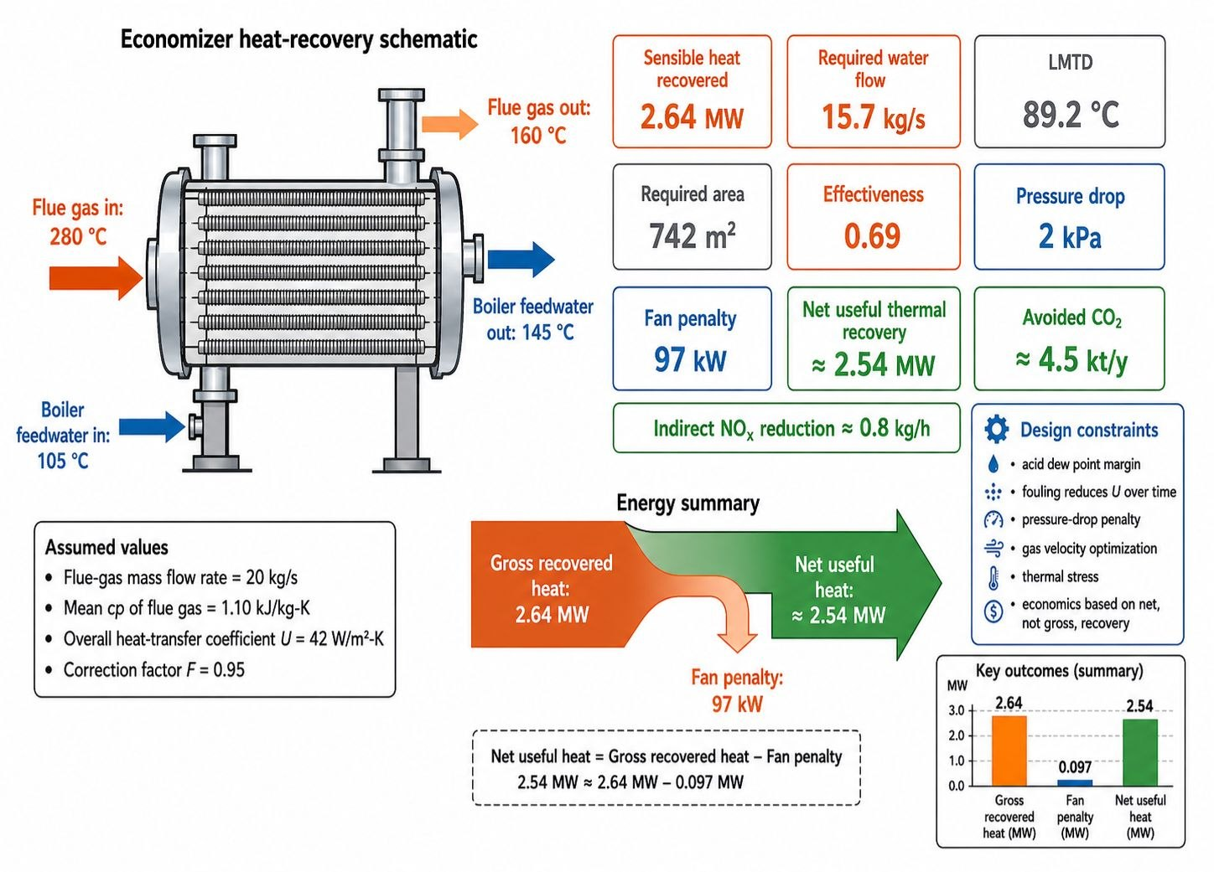
Figure 1. Illustrative engineering summary for a representative chemical- plant flue- gas heat- recovery case
5. Results and Discussion
The first-stage economizer achieved 2.64 MW of gross and approximately 2.54 MW of net heat recovery, demonstrating the technical and economic potential of waste heat recovery systems. However, accurate design requires detailed analysis of gas flow, dew-point limitations, and pressure losses, where CFD provides significant advantages over simple energy balance methods.
Previous studies confirm that optimized flow distribution and proper low-temperature heat integration can improve energy efficiency and reduce CO₂ emissions, while pressure drop and corrosion risks must be considered [Mu et al., 2023a; Mu et al., 2023b].
The analysis shows that direct process heat reuse is generally more efficient than electricity generation because it avoids conversion losses. Power generation technologies such as ORC become attractive when direct heat utilization is limited [Loni R et al., 2021].
The studied case showed a potential CO₂ reduction of approximately 4.5 kt per year. The integration of CFD with AI can further improve design optimization and operational decision-making by combining physical modeling with data-driven prediction.
Nevertheless, uncertainties related to fuel composition, fouling, and operating conditions require robust optimization approaches. The CFD–AI method is most beneficial for complex systems with strict operational and environmental constraints, whereas conventional methods may be sufficient for simple and stable processes.
6. Conclusion
Waste heat recovery from chemical-plant flue gases requires a site-specific approach that considers temperature level, process integration, CO₂ and NOx mitigation, as well as corrosion and fouling limitations. Effective recovery depends on accurate evaluation of local flow behavior and operating conditions.
The proposed framework combines engineering calculations, staged heat recovery, CFD analysis, and AI-based optimization. CFD improves understanding of flow, temperature distribution, and pressure losses, while AI enables faster optimization, prediction, and maintenance support. Their combination provides a more reliable approach for complex industrial systems.
The CFD–AI strategy is particularly suitable for large continuous chemical plants with significant waste heat potential and sufficient digital infrastructure, while conventional methods may remain adequate for simpler systems. Future research should focus on advanced CFD models, reliable AI surrogate models, and integrated techno-economic optimization of heat recovery and emission control systems.

Nomenclature
Symbol | Definition | Symbol | Definition
$$A$$ | Heat-transger area, m² | $$\dot{Q}$$ | Heat-duty rate, kW
C | Heat-capacity rate, kW K⁻¹ | $$T_{ADP}$$ | Acid dew-point temperature
$$c_{p}$$ | Specific heat capacity, kJ kg⁻¹ K⁻¹ | $$T_{0}$$ | Reference environment temperature, K
$$D_{h}$$ | Hydraulic diameter, m | $$T_{w,min}$$ | Minimum local wall temperature
$$EF_{co_{2}}$$ | CO² emission factor of displaced fuel | $$U$$ | Overall heat-transfer coefficient, W m⁻² K⁻¹
$$\dot{E}x_{Q}$$ | Exergy rate associated with recovered heat | $$ϑ$$ | Gas velocity, m s⁻¹
$$f$$ | Darcy friction factor | $$\dot{V}$$ | Volumetric flow rate, m³ s⁻¹
$$F$$ | LMTD correction factor | $$∆P$$ | Pressure drop, Pa
$$L$$ | Characteristic flow length, m | $$ΔT_{lm}$$ | Log-mean temperature difference
$$\dot{m}$$ | Mass flow rate, kg s⁻¹ | $$ε$$ | Heat-exchanger effectiveness
$$P_{fan}$$ | Fan or blower power, kW | $$η$$ | Efficiency

References
International Energy Agency (IEA), 2026, Chemicals, IEA, Paris. Available from: https://www.iea.org/energy- system/industry/chemicals (accessed 13 April 2026).
Loni R., Najafi G., Bellos E., Rajaee F., Said Z., Mazlan M., 2021, A review of industrial waste heat recovery systems for power generation with Organic Rankine Cycle: Recent challenges and future outlook, Journal of Cleaner Production, 287, 125070. DOI: 10.1016/j.jclepro.2020.125070.
Mu L., Wang S., Liu G., Lu J., Lan Y., Zhao L., Liu J., 2023a, On-site experimental study on low-temperature deep waste heat recovery of actual flue gas from the reformer of hydrogen production, Sustainability, 15(12), 9495. DOI: 10.3390/su15129495.
Mu L., Wang S., Lu J., Liu G., Zhao L., Lan Y., 2023b, Effect of flue gas condensing waste heat recovery and its pressure drop on energy saving and carbon reduction for refinery heating furnace, Energy, 283, 128081. DOI: 10.1016/j.energy.2023.128081.
Nyakuma B.B., Mahyon N.I., Chiong M.S., Rajoo S., Pesiridis A., Wong S.L., Martinez-Botas R., 2023, Recovery and utilisation of waste heat from flue/exhaust gases: A bibliometric analysis (2010–2022), Environmental Science and Pollution Research, 30, 90522–90546. DOI: 10.1007/s11356-023-28791-4.
Ononogbo C., Nwosu E.C., Nwakuba N.R., Nwaji G.N., Nwufo O.C., Chukwuezie O.C., Chukwu M.M., Anyanwu E.E., 2023, Opportunities of waste heat recovery from various sources: Review of technologies and implementation, Heliyon, 9(2), e13590. DOI: 10.1016/j.heliyon.2023.e13590.
Tang S., Xie X., Zhao Z., Ding L., 2022, Investigation of thermal-hydraulic characteristics in a novel finned tube heat exchanger for flue gas waste heat recovery, Case Studies in Thermal Engineering, 39, 102392. DOI: 10.1016/j.csite.2022.102392.

