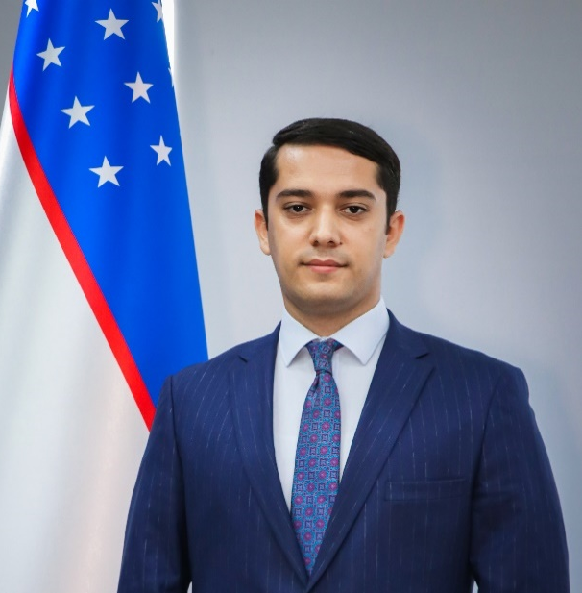
Rector
Turin Polytechnic University in Tashkent
Olimjon Tuychiyev

Education
 | 2010-2015 yy. | Turin Polytechnic University in Tashkent  Bachelor Degree  Faculty of mechanical engineering
 | 2016-2018 yy. | Turin Polytechnic University in Tashkent Masters Degree  Faculty of Mechatronics
 | 2016-2017 yy. | University of Hohenheim, Germany  Student exchange program
 | 2019-2021 yy. | Chirchik state pedagogical university  PhD in pedagogical sciences
 | 2021-2023 yy. | Tashkent state transport university  DSc in technical sciences

Professional experience
 | 2014 - 2014 yy. | Turin Polytechnic University in Tashkent  Assistant of Rector
 | 2014 - 2016 yy. | Turin Polytechnic University in Tashkent  Engineer of Technopark Department
 | 2017 - 2017 yy. | Turin Polytechnic University in Tashkent  Engineer on new projects of Technopark Department
 | 2017 - 2017 yy. | Science and technology agency of the Republic of Uzbekistan  Deputy general director
 | 2018 - 2019 yy. | Ministry of Innovative development of the Republic of Uzbekistan  Director of science, education and production integration department
 | 2019 - 2021 yy. | Ministry of Innovative development of the Republic of Uzbekistan  Deputy Minister
 | 2019 - 2023 yy. | Specialized general education boarding school named after Mirzo Ulugbek  Director
 | 2021 - 2023 yy. | National office for innovation implementation and technology transfer  General Director
 | 2023 - 2024 yy. | Agency of innovative development  Director
 | 2024 - present | Turin Polytechnic University in Tashkent  Rector

Honors
- State Medal of “Shuhrat” (2013 y) for achievements in science and for the popularization of technical science among young people
- Honorary professor of Kyungil University, South Korea

