 CHEMICAL ENGINEERING TRANSACTIONS  VOL. xxx, 2026 | A publication of  
The Italian Association
of Chemical Engineering
Online at www.cetjournal.it

Guest Editors: Leonardo Tognotti, Rubens Maciel Filho, Viatcheslav Kafarov
Copyright © 2026, AIDIC Servizi S.r.l.
ISBN 979-12-81206-xx-x; ISSN 2283-9216

The effect of char loading on biomass fluidized bed pyrolysis
Maurizio Troiano^{a,}*, Renata Migliaccio^{b}, Antonio Cammarota^{b}, Giovanna Ruoppolo^{b}, Massimo Urciuolo^{b}, Roberto Solimene^{b}, Piero Salatinoª
ªDipartimento di Ingegneria Chimica, dei Materiali e della Produzione Industriale, Università degli Studi di Napoli Federico II, Piazzale Vincenzo Tecchio 80, 80125, Napoli, Italy
^{b}Istituto di Scienze e Tecnologie per l’Energia e la Mobilità Sostenibili, Consiglio Nazionale delle Ricerche, Piazzale Vincenzo Tecchio 80, 80125, Napoli, Italy
maurizio.troiano@unina.it
This study deals with fast pyrolysis of giant reed Arundo Donax in a bench scale fluidized bed apparatus. The effect of organic carbon loading onto the pyrolysis process was investigated, as it affects products yield and composition. Steady state pyrolysis experiments have been carried out at 500°C, at fixed gas superficial velocity and solids residence time. The carbon inventory in the bed has been controlled by means of a system that allows partial discharge/charge of solids from the bed, during continuous biomass feeding. Products yield, oil and gas composition have been characterized for different carbon inventories. Semi-quantitative analysis of bio-oil composition has been obtained by GC-MS technique, while gases have been analyzed with micro-GC. Results highlight that organic carbon loading does affect secondary decomposition pathways. Increasing the carbon loading, phenols increase, while ketones and organic acids decrease, together with an increase of CO, H₂ and CH₄. Results confirm that a proper control of char loading during fast pyrolysis is crucial to maximize yield and selectivity in desired chemical compounds.
  - Introduction
Renewables, flexible power sources and negative emissions technologies play an important role toward the decarbonization of energy systems (Sandhaas and Hartmann, 2025). Among the various negative emissions technologies, bioenergy with carbon capture and storage, direct air carbon capture and storage, afforestation and reforestation, and pyrolysis represent the most discussed and viable options. Biomass pyrolysis deserves a special role as it not only enables carbon sequestration but also allows the substitution of fossil feedstocks. In fact, pyrolysis provides multiple valuable products, biochar, pyrolysis gas, and pyrolysis oil, that can further serve diverse applications (Kan et al., 2016). Fast pyrolysis offers a direct route to produce liquid fuels and chemicals, with high feedstock flexibility and energy input efficiencies and it has the potential of converting all carbon in the feedstock. The essential features of a fast pyrolysis process for liquids production are: high heating rates and heat transfer rates; biomass dimension typically less than 3 mm; short hot vapour residence times (less than 2s) and vapor-char contact time to minimise secondary reactions; rapid cooling of the pyrolysis vapours to give the bio-oil product (Bridgwater, 2017). The inherent heterogeneity of biomass raw feedstocks and the complexity of chemical pathways are responsible for the broad variety of chemical compounds in the bio-oil (Brachi et al., 2022), including pyrolytic sugars and oligosaccharides, furans, alkylphenols, acids, ketones, and aldehydes, together with substantial amounts of water. The complex composition and some critical properties (high viscosity, acidic pH, low heating value, and limited stability) of bio-oils may compromise their further processing and use (Czernik and Bridgwater, 2004). A specific concern regards the course of secondary reactions between volatiles and char, whose progress, probably enhanced by prolonged residence times and uncontrolled backmixing, may alter the quantity/quality of the produced bio-oil (Troiano et al., 2022). Zhu et al., (2021) report that secondary reactions are likely to produce low-molecular-weight derivatives, such as molecular acids, as a result of volatile−char interactions and the presence of potassium in the char also increases the rate of demethoxylation and demethylation of guaiacyl-containing structures, leading to the formation of phenols and the increased release of CH₄. It has been demonstrated that alkali and alkaline earth metals catalyze pyranose ring fragmentation in cellulose and hemicellulose that effectively hampered the production of sugars from biomass pyrolysis (Plouffe et al., 2022). The catalytic nature of nascent chars for the pyrolysis heterogeneous secondary reaction is still poorly understood, although it is believed that it may play a major role in the reforming of volatiles to form condensable tars, along reaction pathways that involve oxygen-containing functional groups and the interaction between nascent char and the radicals generated during biomass pyrolysis (Huang et al., 2020). In the present study the effect of char holdup during biomass fast pyrolysis is experimentally investigated. Giant reed Arundo donax is used during steady state experiments carried out at fixed solids residence time, while varying the organic carbon inventory in the bed, which is the result of biomass devolatilization and char formation/accumulation. The effect of carbon loading is investigated on the product yields and on the composition of oil and gas.
  - Experimental
Steady state pyrolysis tests have been carried out to evaluate the effect of char loading at fixed solids residence time.
    - Apparatus
A stainless steel bubbling fluidized bed reactor 40 mm ID and 1 m high was used for the pyrolysis experiments (Figure 1) in continuous biomass feeding mode. The windbox is a 225 mm high stainless steel column filled with ceramic rings aimed at gas flow equalization. High temperature operation is carried out using two semi-cylindrical 2.4 kW ceramic ovens with thermal insulation. Fluidization column temperature is controlled by two PID control units in bed and freeboard sections, while gas flow rate is regulated by high-precision digital mass flowmeters/controllers. Inert bed solids are fed from the top of the reactor, while biomass is continuously fed inside the bed by a system consisting in an electric motor coupled with a screw conveyer, and a pneumatic transport device. The reactor is also equipped with a system for the fast discharge of solids from the bed, composed by a pneumatically activated piston which enables the passage of solids through a vertical tube connected to a nitrogen-flushed pot for collection and cooling of discharged solids. The aperture time of the piston allows to regulate the amount of the discharged solids. Gas, vapors and entrained solids from the reactor are conveyed to a cyclone for solids separation and to a first condensation flask at ambient temperature, then they are condensed by three refrigerated flasks with an eutectic solution of water, ice and NaCl. The stream at the outlet of the condensation flasks train is split into three streams: a stream is sent to a gas sampling bag for the off line measurement of the concentration of light hydrocarbons (C₁–C₆), CO, CO₂, CH₄, and H₂; another stream is sent through a filter to online gas analyzer to continuously monitor the concentration of O₂, CO, CO₂, CH₄, and H₂; the rest is sent to the stack. During the heating up step of the reactor and during the transient steps of the experiments the condensation system, the filter and the analyzer are bypassed and all the gases are directly conveyed to the stack. Pressure and temperature probes are connected to data acquisition modules and signals are acquired on LABVIEW software.

Figure 1: Scheme of the experimental apparatus
    - Materials
Silica sand, double sieved in the size range of 0.212-0.300 mm has used as bed material. Giant reed herbaceous biomass was used in the size range of 0.6-1 mm. The size range of both the inert bed solids and biomass particles has been chosen to allow separation of biomass/char particles from the inert bed solids but also to ensure good mixing in the fluidized bed. Biomass characterization in terms of ultimate, proximate and macro-components analyses is reported in Table 1.
Table 1: Biomass characterization
 | Giant reed
Proximate analysis (as received), %w  Moisture  Volatile matter  Fixed carbon  Ash | 7.4  71.6  17.7  3.3
Ultimate analysis (dry basis), %w  Carbon  Hydrogen  Nitrogen  Ash  Oxygen (by difference) | 46.2  6.0  0.4  3.6  43.8
Component (dry basis), %w  Cellulose  Hemicellulose  Lignin | 27.6  15.5  37.0

    - Experimental procedure and data analysis
Pyrolysis tests have been carried out at a fixed temperature of 500°C, at fixed superficial gas velocity of 0.45 m/s and fixed excess gas velocity with respect to minimum fluidization conditions equal to 0.42 m/s. Nitrogen was used as fluidiziation gas. A part of the gas flow rate is fed at the bottom of the fluidized bed, while a part is used to assist biomass feeding in the fluidized bed. Biomass is continuously fed in the bed and a transient phase occurs, monitored by the pressure signal in the bed. Once a certain increase in the bed pressure is established because of a partial discharge of the solids from the bed at fixed time intervals and the consequent addition of inert solids from the top of the reactor, a steady state conditions can be considered reached. Under these conditions the gases and vapours are sent to on-line analysis and condensation flasks train, respectively. At the end of the test, biomass feeding is stopped, all the gases are directly sent to the stack, the bed is fully discharged and char is separated by sieving from the inert solids to measure char yield. Char is characterized in terms of elemental composition and all the solids are fully oxidized to determine the organic carbon inventory during the test. The bio oil yield is calculated as the amount of collected bio oil divided by the total amount of biomass fed during the steady state, while the gas yield is calculated from the concentration profiles of the gas analyzer. The mean solids residence time in the bed is calculated as the average inventory of the solids in the bed divided by the mass flow rate of solids discharged during the test. Three tests have been carried out at fixed solids residence time of 13 min, while varying the biomass inlet flow rate and, thus, the organic carbon loading in the bed. Biomass mass feeding rates were 0.6, 1.96 and 2.56 g/min and the carbon loading was 1.84, 6.46 and 10.2 g, respectively. The mass fraction of organic carbon in the bed was 1.1%, 3.25% and 5.36%, respectively. Permanent gases from the condensation train were analyzed by a micro gas chromatograph (micro-GC), while the collected pyrolytic liquids were characterized offline using an Agilent 7890A GC equipped with MS 5975C-VLMSD (GC-MS). Chromatographic peaks were identified using the NIST 11 mass spectral data library, whereas a semi-quantitative approach was adopted to determine the relative content of each bio-oil component.
  - Results and discussion
    - Products yield
The char, oil and gas yields obtained from the tests at fixed solids residence time, while varying the carbon loading in the bed are reported in Table 2. Results indicate that there are no significant differences in the gas and char yields while varying the carbon loading. In fact, the yields obtained at different operating conditions differ less than 3%. On the other hand, the oil yield increases with increasing the carbon loading. This result can be due to the fact that experiments at low carbon loading were carried out using small biomass mass flow rate, thus the collection efficiency of the oil could be lower. This speculation is in agreement with the overall mass balance closure, which is lower for lower carbon loading.
Table 2: Products yield
Organic carbon loading (g) | Oil yield (%w) | Char yield (%w) | Gas yield (%w) | Overall mass balance closure (%)
1.8 | 28.8 | 25.8 | 23.3 | 77.9
6.5 | 36.5 | 23.6 | 22.1 | 82.2
10.2 | 43.0 | 23.0 | 22.9 | 88.9

    - Bio oil and gas characterization
Key volatile compounds determined by GC–MS are reported in Table 3 in terms of retention time (RT), and relative abundance area (area of each spectrum peak divided by total area of all peaks) while varying the carbon loading. Compounds in bio-oil identified by GC–MS were acids, aldehydes, ketones, furans, phenols and anhydrosaccharides. Table 3 shows that acetic acid is the dominant acid compound while ketones, phenols, and furans are represented by several compounds. The key functional groups were methoxy, hydroxy, and carbonyl. Most of the compounds identified in bio-oil such as acids, furans, ketones, esters, and anhydrosaccharide are likely the pyrolysis products from celluloses and hemicelluloses (Liu et al., 2012), while phenols are likely derived from lignin (Staš et al., 2020). The compounds shown in Table 3 were typical for bio-oil derived from fast pyrolysis of biomass (Collard and Blin, 2014). A higher concentration of phenolic compounds was detected when increasing the carbon loading. Compounds from primary degradation of lignin such as syringol and trans-isoeugenol were detected in appreciable amounts. Other aromatic compounds, formed through a high degradation of lignin such as cresols and methoxyphenols, were detected in all the tests.
Table 3: Products yield
Compound | RT (min) | Area %  W_{C}=1.84 g | Area (%)  W_{C}=6.46 g | Area (%)  W_{C}=10.19 g
hydroxy-Acetaldehyde | 6.98 | 2.38 | 2.02 | N.D.
Acetic acid | 9.13 | 13.23 | 9.38 | 8.21
1-hydroxy-2-Propanone | 10.88 | 13.01 | 7.59 | 6.59
1,3-Dioxol-2-one | 11.85 | 0.50 | 0.11 | N.D.
Propanoic acid | 14.17 | 0.74 | 0.61 | 0.68
1-Hydroxy-2-butanone | 16.52 | 4.60 | 2.18 | 2.03
Succindialdehyde | 18.07 | 4.35 | 1.33 | 1.03
2-oxo-, methyl ester Propanoic acid | 18.44 | 0.83 | 0.34 | 0.36
Butanoic acid | 19.14 | 0.22 | 0.19 | 0.31
tetrahydro-2-Furanmethanol | 19.32 | 0.32 | 0.21 | 0.22
2-Cyclopenten-1-one | 20.18 | 2.84 | 1.88 | 2.09
2-Furanmethanol | 22.26 | 0.9 | 0.49 | 0.65
1-(acetyloxy)-2-Propanone | 22.67 | 1.87 | 1.1 | 1.17
2-methyl-2-Cyclopenten-1-one | 24.03 | 0.54 | 0.42 | 0.63
2-hydroxy-2-Cyclopenten-1-one | 25.94 | 0.94 | 0.38 | 0.27
Butyrolactone | 27.28 | 0.54 | 0.44 | 0.56
2(5H)-Furanone | 27.50 | 0.60 | 0.41 | 0.41
5-methyl-2-Furancarboxaldehyde | 27.98 | 0.39 | 0.3 | 0.42
3-methyl-2-Cyclopenten-1-one | 28.62 | 0.69 | 0.66 | 0.85
3-methyl-2(5H)-Furanone | 30.56 | 0.26 | 0.16 | 0.19
3-methyl-1,2-Cyclopentanedione | 31.62 | 1.53 | 2.22 | 2.70
Phenol | 32.00 | 1.78 | 1.9 | 2.74
2,3-dimethyl-2-Cyclopenten-1-one | 32.17 | 0.27 | 0.29 | 0.35
Guaiacol | 34.66 | 1.07 | 1.43 | 1.57
2-methyl-Phenol | 34.99 | 0.81 | 0.92 | 1.36
p-Cresol | 36.51 | 2.07 | 2.7 | 3.58
2,5-dimethyl-Phenol | 39.33 | 0.49 | 0.79 | 0.88
Creosol | 39.93 | 0.37 | 0.61 | 0.59
4-ethyl-Phenol | 40.87 | 2.03 | 3.71 | 4.80
1,4:3,6-Dianhydro-.alpha.-d-glucopyranose | 43.15 | N.D. | 0.75 | 0.71
2-ethyl-5-methyl-Phenol | 43.49 | 0.27 | N.D | 0.61
2-methyl-1,4-Benzenedicarboxaldehyde | 43.63 | 0.62 | N.D. | 0.85
4-ethyl-2-methoxy-Phenol, | 44.05 | 0.28 | 0.59 | 0.61
2,3-dihydro-Benzofuran | 44.32 | 6.78 | 7.08 | 6.95
Catechol | 45.60 | 1.89 | 2.57 | 4.86
2-Methoxy-4-vinylphenol | 46.14 | 1.88 | 4.32 | 2.63
2-Allylphenol | 46.85 | 0.34 | 3.27 | 0.47
3-methyl-1,2-Benzenediol | 47.68 | 1.18 | 0.41 | 1.95
Syringol | 47.96 | 1.30 | 1.55 | 2.20
Hydroquinone | 49.15 | N.D. | 2.9 | N.D.
4-methyl-1,2-Benzenediol | 49.19 | 1.96 | 2.79 | 2.89
4-(2-propenyl)-Phenol | 49.48 | 0.44 | 0.86 | 0.83
2-methoxy-6-(1-propenyl)-Phenol | 50.00 | 0.89 | 1.21 | 1.23
4-hydroxy-Benzaldehyde | 50.69 | 0.36 | 0.6 | 0.53
Vanillin | 51.48 | 0.81 | 1.44 | 1.23
trans-Isoeugenol | 52.02 | 1.58 | 3.15 | 2.50
4-Ethylcatechol | 53.02 | N.D. | 1.91 | 2.23
Apocynin | 55.02 | 0.23 | 0.44 | 0.37
5-tert-Butylpyrogallol | 55.27 | 0.23 | N.D | N.D.
4-Methyl-2,5-dimethoxybenzaldehyde | 57.18 | N.D. | 1.51 | 1.03
Levoglucosan | 58.12 | 0.69 | 0.49 | 0.62
2,6-dimethoxy-4-(2-propenyl)-Phenol | 58.26 | 0.76 | 2.4 | 1.63
4-hydroxy-3,5-dimethoxy-Benzaldehyde | 62.17 | 0.16 | 0.36 | 0.27
1-(4-hydroxy-3,5-dimethoxyphenyl)-Ethanone | 64.78 | N.D. | 0.46 | 0.20

Figure 2 reports the semi-quantitative chemical composition of the collected bio-liquids (Figure 2a) and the gas yield obtained from micro-GC (Figure 2b) for different values of organic carbon loading in the bed at fixed solids residence time. At low organic carbon loading W_{C}, the bio-oil is mainly represented by ketones, with an area of around 28%, followed by organic acids, phenols, guaiacols, furans, aldehydes and sugars. Increasing the carbon loading the bio-oil composition changes; in fact, aldehydes, ketones and organic acids decrease while guaiacols and phenols increase to values of around 15% and 31%, respectively. From Figure 2b) at low W_{C} the gas product is mainly represented by CO₂ and CO, followed by CH₄, H₂, C₄H₁₀ (isoC₄) and small amount of C₂H₄ and C₂H₆. For larger values of carbon loading, CO₂ yield decreases while H₂, CH₄ and CO yield increase with increasing carbon loading. These results suggest that the organic carbon loading affects the gas and oil composition due to the presence of secondary heterogeneous reactions between vapours and char. In particular, these outcomes are in agreement with mechanistic chemical pathways (Zhu et al., 2021) which provide that holocellulose in presence of char, undergoes dehydration and fragmentation toward the production of furans, while lignin, after depolymerization, undergoes demethylation and demethoxylation reactions with production of guaiacols and phenols and release of methane and CO (Evans and Milne, 1987).
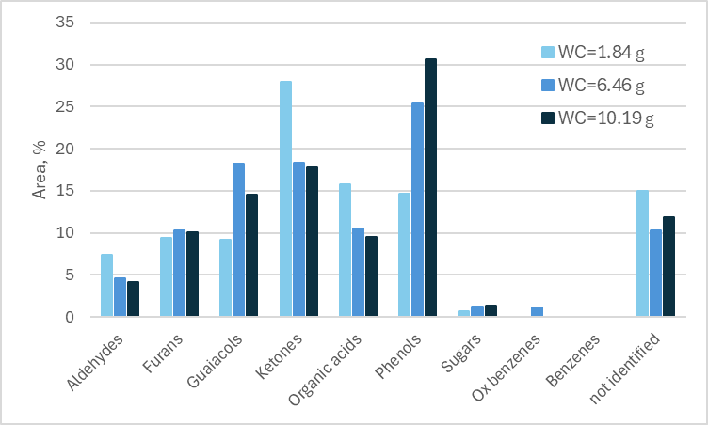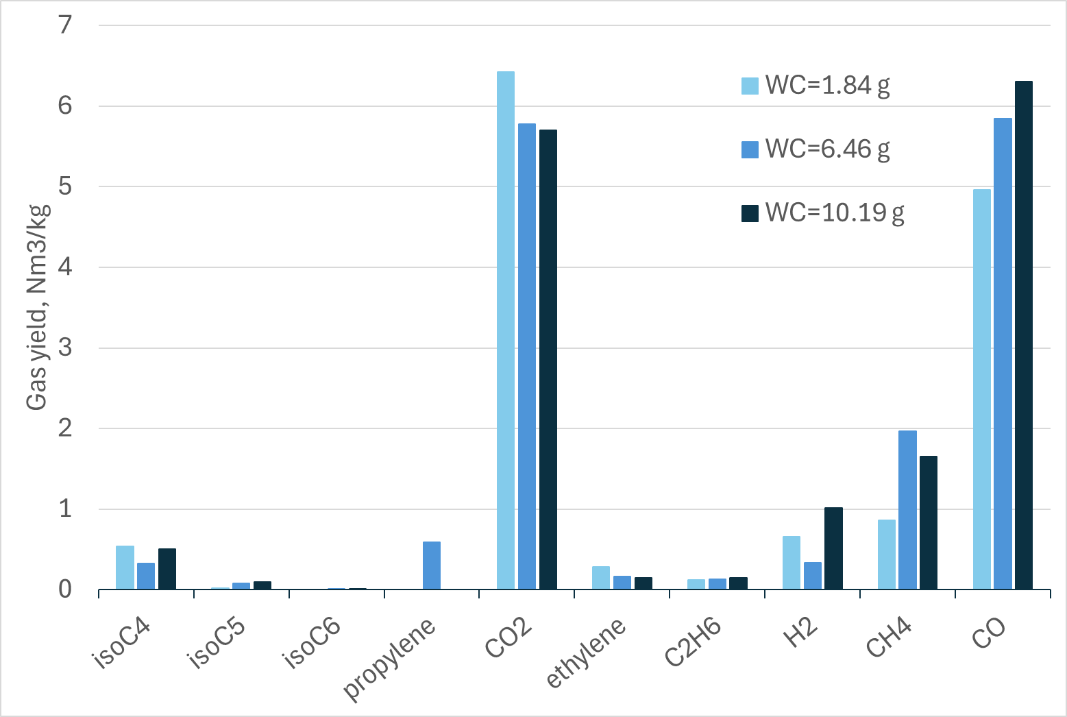
a)
b)
Figure 2: Bio oil composition (a) and gaseous yield distribution (b) as a function of the carbon loading W_{C}
  - Conclusions
Fast pyrolysis of giant reed Arundo Donax has been experimentally investigated in a fluidized bed bench scale reactor. Experiments carried out with continuous biomass feeding at fixed gas superficial velocity and solids residence time allowed to investigate the effect of different organic carbon loadings onto products yield and composition. Experimental results highlight that increasing the carbon loading in the bed the bio-oil, char and gas yield slightly change, while it deeply affects oil and gas composition. In particular, at low carbon loading ketones and organic acids are the main species in the bio oil, followed by phenols, guaiacols, furans, aldehydes and sugars. For larger carbon loading, phenols and guaiacols sharply increase, likely as a consequence of demethylation and demethoxylation of guaiacyl phenols and other secondary heterogeneous reactions, as also suggested by the increasing concentration of CH₄, H₂ and CO in the gas phase. Results pinpoint the relevance of char−vapor secondary reactions and of bed char inventory to bio-oil and gas quality. Altogether, results confirm the need of an improved knowledge of the mechanisms and kinetics of heterogeneous vapor−char reactions for an optimal design of a pyrolytic fluidized bed converter.
Acknowledgments
The authors gratefully acknowledge Mr. Giuseppe Tamburrino and Federico Marrano, University of Naples, for the support during the experimental campaign. The study was funded under the Italian National Recovery and Resilience Plan (NRRP), Mission 4 Component 2 Investment 1.3 - Call for tender No. 1561 of 11.10.2022 of Ministero dell’Università e della Ricerca (MUR) funded by the European Union – NextGeneration EU; Project code PE0000021, Concession Decree No. 1561 of 11.10.2022 adopted by Ministero dell’Università e della Ricerca (MUR), Project title “Network 4 Energy Sustainable Transition – NEST”.
References
Brachi P., Migliaccio R., Ganda E.T., Urciuolo M., Ruoppolo G., Coppola A., Scala F., Salatino P., 2022, Strategies to Improve Quality and Yield of Pyrolysis Bio-oils, Chemical Engineering Transactions, 92, 469 – 474.
Bridgwater A.V., 2017, Pyrolysis of Solid Biomass: Basics, Processes, and Products, in: RA Meyers (Ed.), Encyclopedia of Sustainability Science and Technology, Springer New York: New York, NY., 1 – 30.
Collard F.X., Blin J., 2014, A review on pyrolysis of biomass constituents: Mechanisms and composition of the products obtained from the conversion of cellulose, hemicelluloses and lignin, Renewable and Sustainable Energy Reviews, 38, 594 – 608.
Czernik S., Bridgwater A.V., 2004, Overview of Applications of Biomass Fast Pyrolysis Oil, Energy Fuels 2004, 18 (2), 590−598.
Evans R.J. and Milne T.A., 1987, Molecular characterization of the pyrolysis of biomass, Energy Fuels, 1 (2), 123 – 137.
Huang Y., Liu S., Akhtar M.A., Li B., Zhou J., Zhang S., Zhang H., 2020, Volatile−char Interactions during Biomass Pyrolysis: Understanding the Potential Origin of Char Activity, Bioresource Technology, 316, 123938.
Kan T., Strezov V., Evans T.J., 2016, Lignocellulosic biomass pyrolysis: A review of product properties and effects of pyrolysis parameters, Renewable and Sustainable Energy Reviews, 57, 1126 – 1140.
Liu Y., Shi Q., Zhang Y., He Y., Chung K.H., Zhao S., Xu C., 2012, Characterization of Red Pine Pyrolysis Bio-oil by Gas Chromatography–Mass Spectrometry and Negative-Ion Electrospray Ionization Fourier Transform Ion Cyclotron Resonance Mass Spectrometry, Energy Fuels, 26 (7), 4532 – 4539.
Plouffe C., Peterson C.A., Rollag S.A., Brown R.C., 2022, The Role of Biochar in the Degradation of Sugars during Fast Pyrolysis of Biomass, Journal of Analytical and Applied Pyrolysis, 161, 105416.
Sandhaas A., Hartmann N., 2025, Pyrolysis as a strategic element in energy system transformation to achieve net zero emissions, Energy Conversion and Management: X, 26, 100970.
Staš M., Auersvald M., Kejla L., Vrtiška D., Kroufek J., Kubička D., 2020, Quantitative analysis of pyrolysis bio-oils: A review, Trends in Analytical Chemistry, 126, 115857.
Troiano M., Ianzito V., Solimene R., Ganda E.T., Salatino P., 2022, Fluidized Bed Pyrolysis of Biomass: A Model-Based Assessment of the Relevance of Heterogeneous Secondary Reactions and Char Loading, Energy Fuels, 36, 9660 – 9671.
Zhu H., Yi B., Hu H., Fan Q., Wang H., Yao H., 2021, The Effects of Char and Potassium on the Fast Pyrolysis Behaviors of Biomass in an Infrared-Heating Condition, Energy, 214, 119065.

