 CHEMICAL ENGINEERING TRANSACTIONS  VOL. xxx, 2026 | A publication of  
The Italian Association
of Chemical Engineering
Online at www.cetjournal.it

Guest Editors: Leonardo Tognotti, Rubens Maciel Filho, Viatcheslav Kafarov
Copyright © 2026, AIDIC Servizi S.r.l.
ISBN 979-12-81206-xx-x; ISSN 2283-9216

Hydrothermal carbonization of palm kernel shell: surface area and oxygenated functional groups with performance in sodium adsorption
Jose Mazo^{a,b,}*, Luis Rodríguezª, Cristian Ramírezª, Dora Carmonaª, Zulamita Zapata-Benabitheª
ªEscuela de Ingeniería, Universidad Pontificia Bolivariana, Sede central – Medellín. Circular 1a # 70-01, Medellín, Colombia
^{b}Programa de Ingeniería Agroindustrial, Universidad Popular del Cesar, Sede Sabanas Diagonal 21 No. 29-56, Colombia
jose.mazo@upb.edu.co
In this work, we explore the use of oil palm kernel shells (PKS) to produce hydrochar (HC), which promotes sodium adsorption in saline soils. The aim was to identify a PKS-derived hydrochar with a high specific surface area and presence of oxygenated functional groups for sodium adsorption. We applied a 2² factorial design, varying temperature and time, with a randomized center point. The hydrochar were porous and superficially characterized by gas physisorption of nitrogen at 77 K to obtain the specific surface area (A_{BET}), XPS for elemental composition, FTIR for functional groups, elemental analysis, and TGA for weight changes, and DTG for rate of weight change. Simple ANOVA results showed that temperature has a significant effect on A_{BET}: A_{BET,180 °C} < A_{BET,205 °C} ≈ A_{BET,230 °C}. Time did not have a significant effect, as the A_{BET} ranges (4 h, 22 h, 40 h) overlapped. Thus, 205 °C and 22 h were selected as the operational conditions to produce the hydrochar (HC-205-22) for sodium adsorption analysis, due to the high A_{BET} and oxygen/carbon ratio of 39.1 m² g⁻¹ and 0.35, respectively. The surface contained oxygenated groups of HC-205-22, showing mainly ether oxygen in anhydrides and lactones (C-O-C), alcohol-phenol bonds (C–OH), carbonyl (C=O), and carboxyl (O=C–O) groups. The Langmuir isotherm estimated a maximum sodium adsorption capacity of 62.57 mg g⁻¹ and an adsorption intensity (n) of 1.292, indicating that this material is suitable for sodium adsorption.
1. Introduction
Soil salinity (saline and alkaline soils) negatively affects crop development because it increases the osmotic pressure around plant roots, making it more difficult for plants to absorb water. As a result, even though water is present in the soil, the roots are unable to take it up effectively, leading to physiological dehydration in plants (He et al., 2020). Water-soluble salts such as sodium (Na⁺), potassium (K⁺), chloride (Cl⁻), and sulfate (SO₄²⁻) contribute to soil salinity, which can lead to plant dehydration by making it harder for them to absorb water from the soil. These salts depend on natural conditions such as the mineralogy (origin) of the material, topography, and groundwater levels, as well as on anthropogenic activities attributed to irrigation without water leaching and poor drainage. These factors allow dissolved salts such as chloride ions, sodium ions, and calcium carbonate to accumulate in the soil profile or on the surface (Stavi et al., 2021). Notably, soil salinity focuses mainly on the presence of Na⁺ and Cl⁻, which are not considered plant nutrients and negatively affect the soil by altering its pH, reducing nutritional quality, and decreasing microbial activity (Ma et al., 2024). This degrades agricultural soil, causes poor crop growth, and reduces plant productivity (Abbas et al., 2022). It also affects 1.03 billion hectares globally under saline conditions (Shahid et al., 2018). Currently, to mitigate soil salinity, various treatments have been used, including physical procedures (leaching-draining, scraping), chemical procedures (application of gypsum, silica, synthetic fertilisers, and other materials), and organic procedures (manure, compost, cover crops, sludge). The implementation of rotation of plants tolerant to saline conditions (halophytes), the use of solutions based on halotolerant microorganisms (bacteria) and conditioners such as biochar, including pyrochar (PC) and hydrochar (HC).
PC is a high-carbon byproduct obtained by pyrolysis of plant or animal raw materials in the absence of oxygen, while the HC is synthesized by hydrothermal treatment (water as solvent) at atmospheric or higher pressures. PC is generally more thermally stable than HC (Suarez et al., 2023). These carbonaceous materials have high carbon (C) content and functional groups such as carboxylic (O-C=O), hydroxyl (-OH) and carbonyl (C=O) that improve the physical and chemical properties of the soil such as pH, electrical conductivity (EC), porosity, cation exchange capacity (CEC), fertility, plant development and reactivation of enzymatic activity of soil microorganisms, and an impact effect is the adsorption of soluble salts from the soil. Both materials are prepared from diverse raw material sources, depending on their availability in sufficient quantities and at low cost—such as agro-industrial, forestry, gardening, and food-waste streams; livestock manure; sewage sludge; and aquatic organisms (B. Wu et al., 2024). However, review articles indicate that few studies specifically target hydrochar for saline soils, so most results focus on pyrochar. Furthermore, the reviews do not distinguish between these materials when specifying amendments for saline soils (Ma et al., 2024). Given these gaps, this study aimed to identify optimal process conditions, using surface area and oxygen-containing functional groups as parameters, to select those suitable for sodium adsorption.
2. Materials and methods
2.1 Hydrothermal carbonization treatment of palm kernel shell
The palm kernel shell (PKS) (1.0 - 2.0 mm) was introduced in a 200 mL polypropylene (PPL)- lined hydrothermal carbonization (HTC) synthesis autoclave reactor. The PKS:distilled water ratio was maintained at 1:4 g:mL, and the vessel was filled to 50 % of its volume. The vessel was introduced into a stainless-steel autoclave for the chemical reaction and placed in a convection oven (NN55 Memmert). In this study, a 2² multivariable factorial with a completely randomised centre-point design was selected to perform an exploratory evaluation of the main effects of the selected factors on the properties of the materials and its future application in saline soil. The factors examined were temperature (180 - 230 °C) and residence time (4 - 40 h), both with two levels and three central points. The yield, specific surface area and oxygen/carbon functional groups ratio were selected as response variables.
2.2 Hydrochar Characterization
The specific surface area (A_{BET}) and pore size were calculated from N₂ adsorption isotherms at 77 K using Brunauer-Emmett-Teller equation on an ASAP 2020 PLUS instrument (Micromeritics). Pore-size distribution was determined from the same data using the BJH model. Thermogravimetric analysis (TGA) was performed on a TGA/SDTA852e instrument (Mettler Toledo), and the resulting curves were analyzed with STARe software (SW 10.00). Each sample (11.5 mg) was heated from 25 °C to 1000 °C at 10 °C min⁻¹ under a nitrogen atmosphere. Functional groups in the hydrochar were identified using Fourier transform infrared spectroscopy (FTIR, Nicolet iS50R) over 4000–400 cm⁻¹, with a 4 cm⁻¹ resolution, H₂O and CO₂ corrections, and 128 scans per spectrum. Elemental composition of the hydrochars surface was determined by X-ray photoelectron spectroscopy (XPS, PHOIBOS 150 1D-DLD analyzer, NAP-XPS, SPECS Group, Berlin, Germany) with a monochromatic Al-Kα source (1486.7 eV, 13 kV), and the spectra were calibrated using the C1s signal at 284.5 eV as a reference. Elemental analysis of the hydrochars was determined using the UNE-EN-15407 standard method and technique, with a Thermo Scientific™ FLASH 2000 CHNS/O Analyser. The morphology and topography of the hydrochar were determined by scanning electron microscopy (Apreo 2S) using a field-emission scanning electron microscope (FESEM) in high vacuum, with the ETD (secondary electrons) and T1 (backscattered electrons) detectors at 1.0 kV, in different inspection zones. The pH of hydrochar (HC-205-22) was measured using a pH meter (SI Analytics™ Laboratorio 855) and the electrical conductivity (EC) of HC-205-22 was determined using a conductivity meter (Thermo Scientific, STARA2220 Orion), both were measurement in a ratio of HC to water of 1:20 (w:v), with agitation for 1 hour, then at rest for 20 minutes.
2.3 Sodium isothermal adsorption
Isothermal adsorption was carried out as described by Nguyen et al. (2022) with some modifications. Thirty (30) mL of each saline solution (0.1 %, 0.25 %, 0.5 %, 1 % and 2 %) were placed into 50 mL tubes and 1.5 g of HC-205-22 was added to each solution. The tubes were shaken at 120 rpm for 24 h at room temperature. Then, the tubes were centrifuged, and the supernatants were collected and filtered using Whatman filter paper. Adsorption isotherms were tested with Langmuir’s and the Freundlich’s models.
3. Results and discussion
Figure 1a shows that the A_{BET} increases markedly with temperature for both residence times, confirming that temperature is the main factor governing pore development during HTC, and the effect of time is limited, indicating that no significant interaction between temperature and time exists. In Figure 1b, two groups are shown: letter A corresponds to 180 °C, letter B to 205 °C and 230 °C, suggesting a significant difference between 180 °C and 205 °C. However, Figure 1c shows a single group, suggesting overlap without a significant effect of residence time. ANOVA was used to evaluate the influence of temperature and residence time on A_{BET}. As shown in Table 1, temperature exhibited a statistically significant effect (p= 0.0147), whereas time and the temperature–time interaction were not statistically significant within the evaluated range (p > 0.05). The A_{BET} values for samples synthesised at temperatures above 205 °C ranged around 40 m² g⁻¹, which are higher than those reported for biomass with similar treatments (2.8–30 m² g⁻¹) (Cavali et al., 2023), possibly because longer contact times were used. The HTC process mainly promotes polymerisation, dehydration, and aromatisation reactions, resulting in dense carbonaceous structures with lower A_{BET} values. Therefore, for this study, the promising exploratory condition of 205 °C for 22 hours was selected, as this represents an intermediate operating condition that achieves a high A_{BET} percentage and a high yield (60 %), while avoiding the highest temperature and the longest residence time. This is relevant from both a practical and an energy-efficiency perspective.
(a) | (b) | (c)
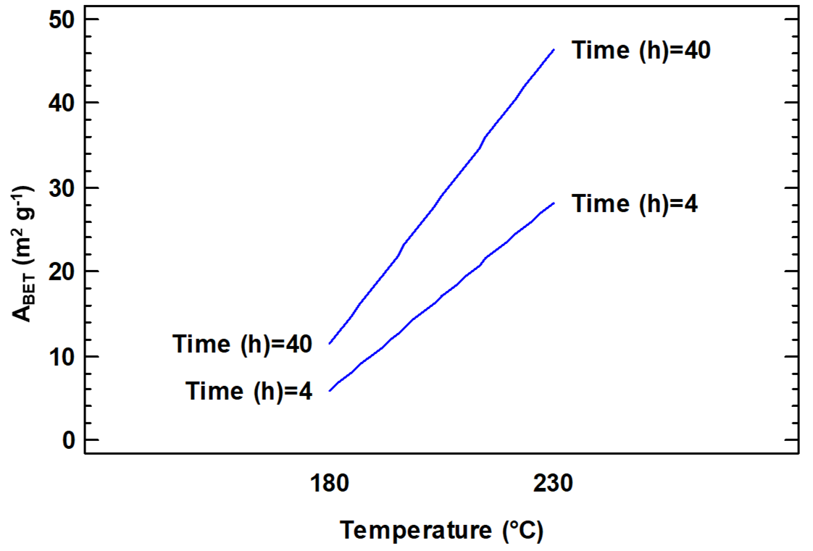 | 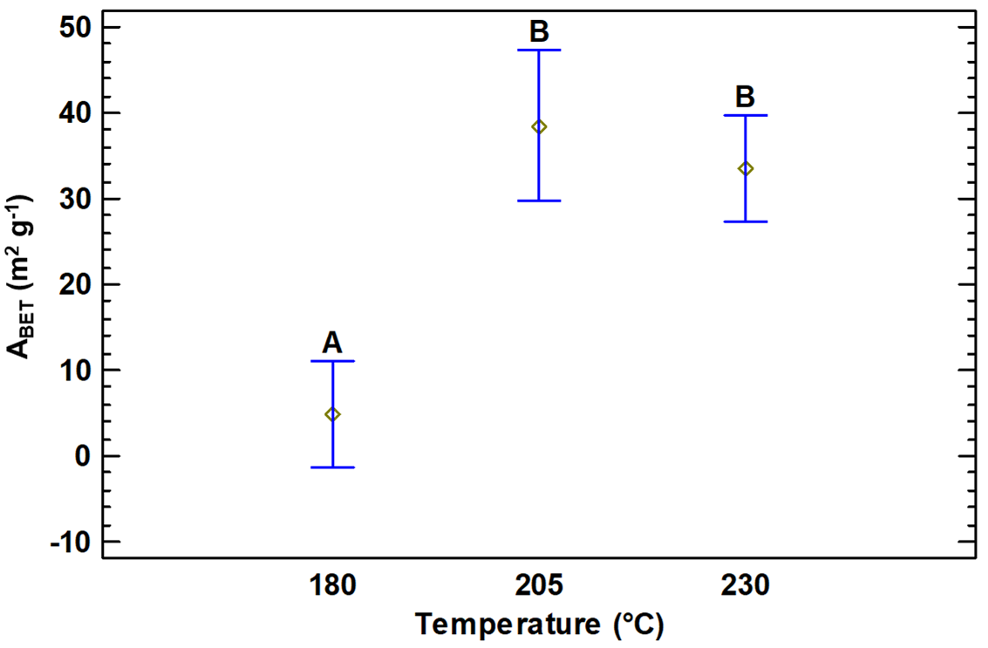 | 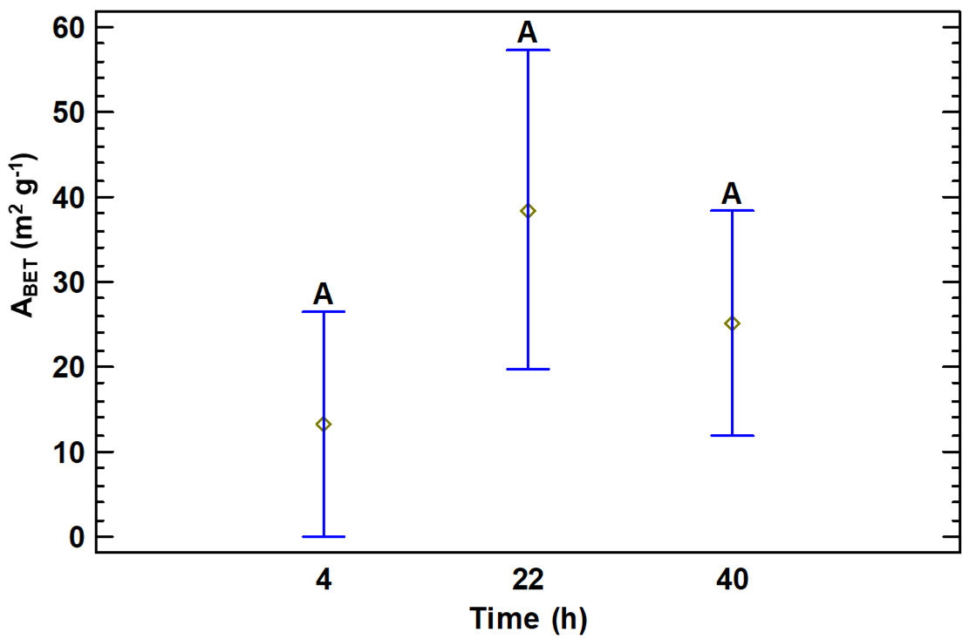
Figure 1 Effect of temperature and residence time on the A_{BET}: (a) interaction plot between temperature and time, (b) main effect of temperature, and (c) main effect of residence time.
Table 1. Analysis of variance of temperature and time on specific surface area.
Source | Sum of Squares | Degrees of freedom | Middle Square | Reason-F | P-value
A: Temperature | 1638.78 | 1 | 1638.78 | 13.36 | 0.0147
B: Time | 282.031 | 1 | 282031 | 2.3 | 0.1899
AB | 81.2813 | 1 | 812813 | 0.66 | 0.4526
Blocks | 11.664 | 1 | 11664 | 0.1 | 0.7702
Total, error | 613.338 | 5 | 122.668
Total (cor) | 2627.1 | 9
Figures 2a shows the N₂ adsorption-desorption isotherms, and the inserted figures show the pore size distributions and surface morphologies for HC-205-22. The isotherms showed a Type IV(a) (IUPAC) due to their multilayer adsorption, with hysteresis loops type H3 caused by mesopore filling (Rahman et al., 2019). The A_{BET} and pore volume of PKS were null and exhibited a closed and compact morphology. The A_{BET} for HC-205-22 increased up to 38.8 ± 2.4 m² g⁻¹ with a micropore diameter of 3.6 ± 0.2 nm and the pore size distribution from the BJH model showed an average pore diameter ~12.3 nm. The surface of HC-205-22 showed the formation of many spheres, this may be due to the degradation of saccharides and cellulose components during hydrothermal carbonization (Ilić et al., 2022). Figure 2b shows the thermogravimetric (TGA) and differential thermogravimetric (DTG) curves corresponding to HC-205-22. The TGA showed reductions of 3.7 % in the temperature range of 28 °C to 150 °C and 48.7 % in the temperature range of 150 °C to 1000 °C. The DTG curve shows a single endothermic peak at 355 °C, which is associated with the degradation of cellulose and hemicellulose (Wen et al., 2025).
The Figure 2c shows the FTIR spectra of PKS and hydrochars, where an O-H stretching vibration around 3433 cm⁻¹ is attributed to the alcohol groups in the cellulose, hydroxyl groups contained in the water and the phenol in the lignin of the PKS sample, which indicates that the O-H groups were not completely degraded during the different treatments (Yang et al., 2025). A decrease in the O-H band and an increase in the C-H band are observed, with the peak defined at 2851 cm⁻¹, caused by the dehydration reaction that destroys hydroxyl groups (S. Wu et al., 2023). The peaks from 2921 cm⁻¹ to 2851 cm⁻¹ are stretching vibrations of the aliphatic groups (C-H_{n}), which indicates that the different hydrochars retain the aliphatic structure, this occurred during the dehydrogenation of cyclic compounds (Yang et al., 2025). The carbonyl group (C=O) was identified in HC-205-22 as the vibrations corresponding to 1791 cm⁻¹, 1705 cm⁻¹ and 1605 cm⁻¹, which are attributed to the formation of bonds in cellulose and lignin. Vibrations of 1513 cm⁻¹, 1463 cm⁻¹, 1468 cm⁻¹, 1384 cm⁻¹ and 1270 cm⁻¹ corresponding to the C=C groups that are related to aromatic lignin rings (Bkangmo Kontchouo et al., 2025). The C-O-C stretching vibrations (1215 cm⁻¹, 1159 cm⁻¹, 1111 cm⁻¹, 1059 cm⁻¹ and 1031 cm⁻¹) are assigned to cellulose. In comparison with the PKS spectrum, it is observed that the region between 1164 cm⁻¹ and 1044 cm⁻¹ disappears, is attributed to the cleavage of C–O–C bonds associated to the hydrolysis of glycosidic linkages and the decomposition of polysaccharide structures during hydrothermal carbonization (Danso-Boateng et al., 2022). The wavelength ranges from 874 cm⁻¹ to 750 cm⁻¹ are asigned to out-of-plane stretching vibration of the C-H in the aromatic core (S. Wu et al., 2023).
(a) | (b) | (c)
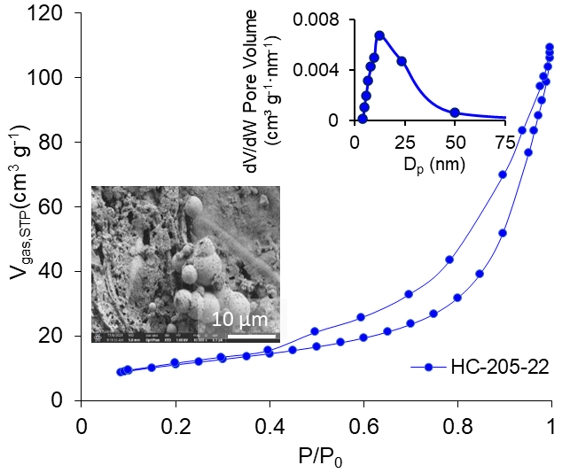 | 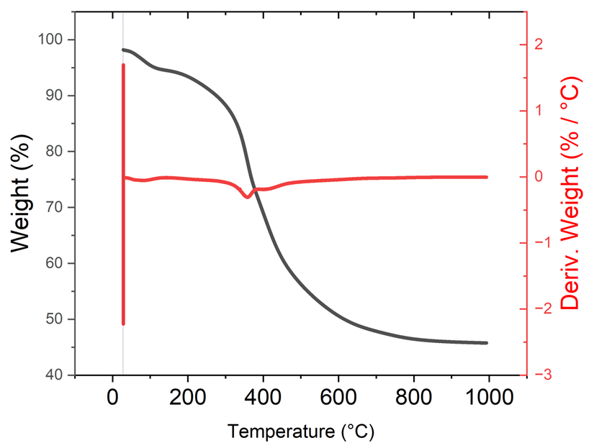 | 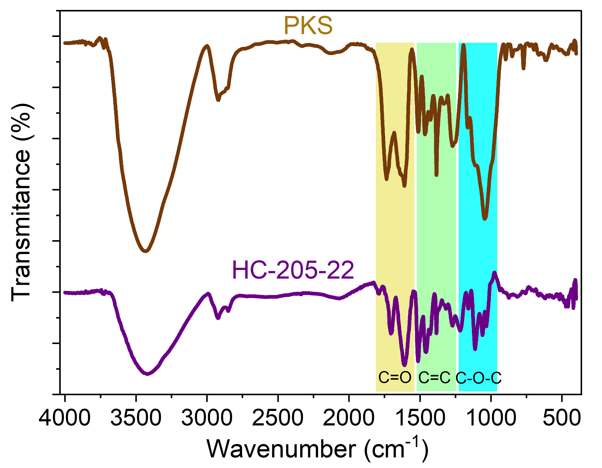
Figure 2: (a) N₂ isotherms at 77 K, BJH pore size distribution and SEM microphotographs are inserted for HC-205-22 PKS; (b) Thermogravimetric analysis for HC-205-22, and (c) FTIR spectrum of PKS and HC-205-22.
The surface functional groups of hydrochars were analyzed by XPS. Three main peaks were deconvolutionated in the general XPS spectra: C_{1s} at ~284.6 eV, O_{1s} at ~532.5 eV and N_{1s} at ~400 eV. The C=O content reached 28.8%, particularly in treatments at 230 °C for 4 hours, indicating greater oxidation. The O/C_{XPS} ratio varied from 0.23 to 0.45, increasing with longer residence times. Figure 3 shows the deconvolution of C_{1s} and O_{1s} peaks and the distribution of functional groups for HC-205-22 as an example, which showed an O/C_{XPS} ratio of 0.36. The highest percentage of functional groups in C_{1s} was attributed to the presence of graphitic carbon (C=C) sp2, C-C and C-H bonds, followed by aliphatic carbon (C-C) sp³ (21 %). The high-resolution O_{1s} spectra reveal that oxygenated functional groups, such as esters, epoxides and carboxylic acids, are dominant (36.83%). Furthermore, deconvolution of the high-resolution N_{1s} spectrum revealed two peaks at ~398.8 eV (N-6) and ~399.8 eV (N-5). This suggests that there is no significant substitution of nitrogen in the graphitic network or of strongly oxidised nitrogen. Furthermore, Table 2 shows the elemental composition of HC-205-22 by ultimate analysis and XPS. The carbon content of HC-205-22 increased compared to PKS, while the H and O content decreased with increasing temperature, which is attributed to deoxygenation reactions such as dehydration and decarboxylation during the HTC process. In agreement with the FTIR analysis, where the weakening or disappearance of bands associated with C–O stretching (∼1040–1160 cm⁻¹), XPS analysis shows a decrease in C–O contributions (~532–533 eV), confirming the progressive deoxygenation of the surface. Moreover, the O/C ratio obtained from elemental analysis (bulk) is higher than that determined by XPS (surface), suggesting that the surface is more carbonized and less oxygenated than the core, likely due to secondary reactions such as aromatization and condensation (Sevilla and Fuertes, 2009).
(a) | (b)
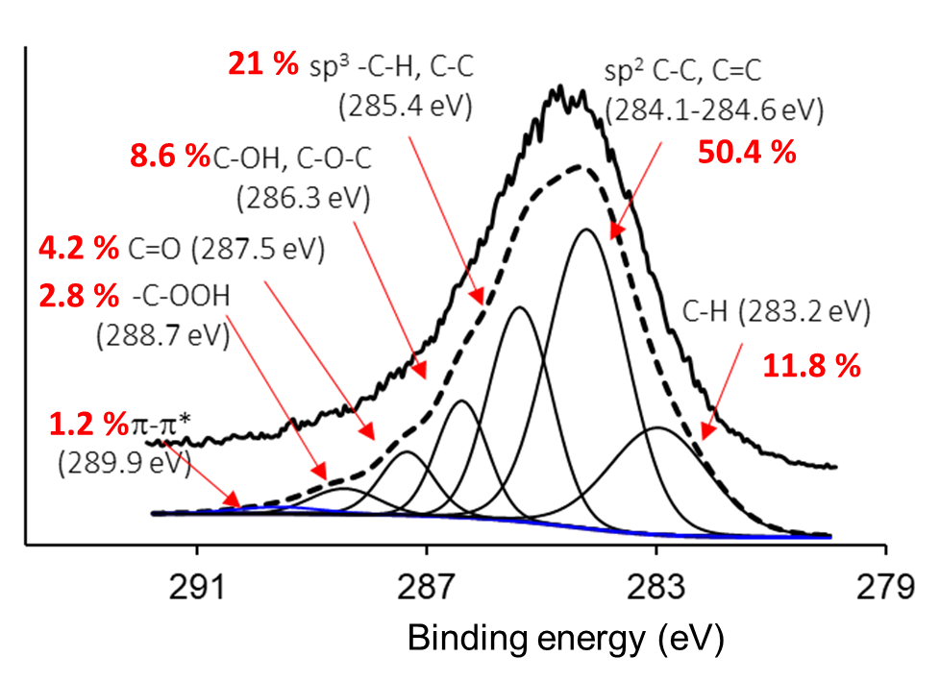 | 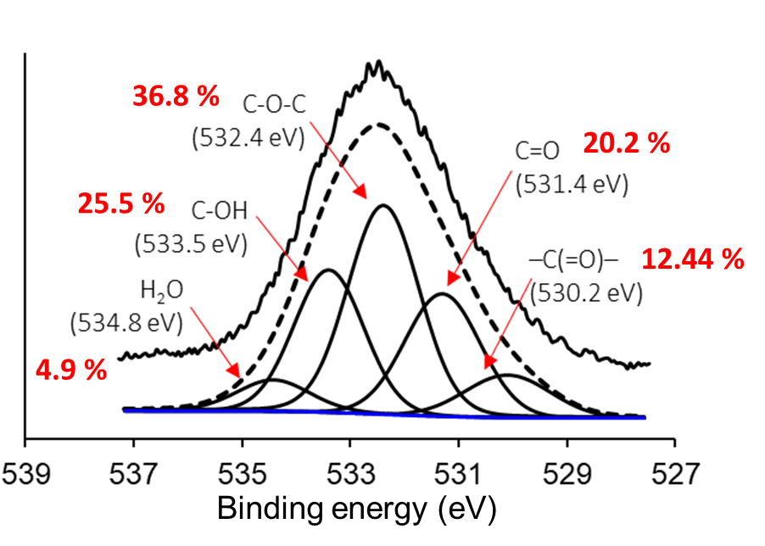
Figure 3: High resolution of C_{1s} spectra and distribution of carbon-containing functional groups (a) and high resolution of O_{1s} spectra and distribution of oxygen-containing functional groups (b) of HC-205-22.
Table 2: Elemental composition by ultimate analysis and X-ray photoelectron spectroscopy for HC-205-22.
Sample | Ultimate analysis (%wt) |  |  |  |  |  |  | XPS (%wt)
Sample | C | H | O | N | S | Total fixed solids | C_{1s} |  | O_{1s} | N_{1s}
PKS | 50.58 | 8.11 | 38.55 | 1.1 | 0 | 1.66 | - |  | - | -
HC-205-22 | 62.61 | 5.75 | 29.55 | 0.57 | 0 | 1.52 | 72.97 |  | 25.77 | 0.62
Table 3 and Figure 4 show the Langmuir and Freundlich isotherm model. The R² isotherm model demonstrated a satisfactory fit with both isotherm models for Na⁺ adsorption. However, the Freundlich isotherm model was found to be a less suitable fit than the Langmuir isotherm model.
Table 3: Estimated parameters of the Langmuir isotherm model and the Freundlich isotherm model for Na⁺ and Cl⁻ adsorption with HC-205-22.
Langmuir isotherm model |  |  |  |  |  |  | Freundlich isotherm model
Intercept | Slope | Q₀  (mg g⁻¹) | K_{L}  (L mg⁻¹) | R_{L} | R² |  | Intercept | Slope | 1/n | K_{f} | R² | n
0.00140 | 35.483 | 712.303 | 0.0000396 | 0.9847 | 0.965 |  | -2.4087 | 1.303 | 1.303 | 0.00390 | 0.9127 | 0.7672
(a) | (b)
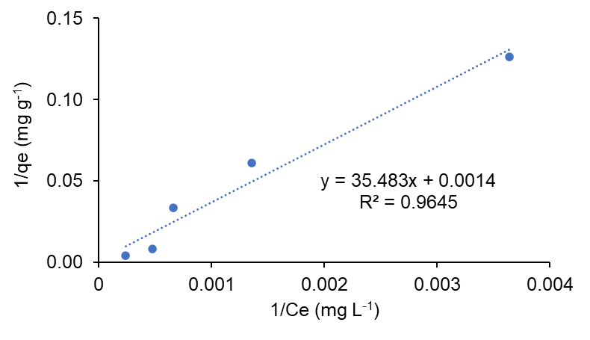 | 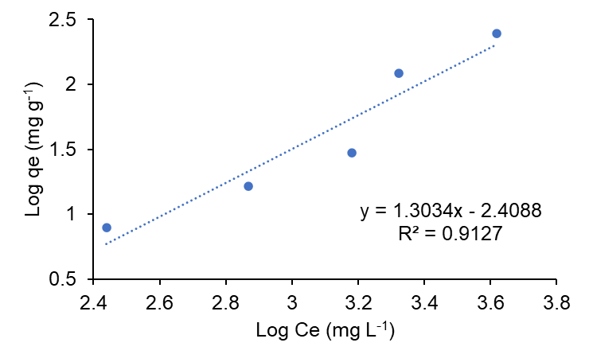
Figure 5: Adsorption isotherm models of (a) Langmuir and (b) Freundlich from HC-205-22.

The experimental results for sodium adsorption fitted the Langmuir and Freundlich isotherm models. The Langmuir adsorption model showing a better R² value and an RL value between 0 and 1, indicating favorable adsorption with a maximum adsorption capacity (Q0) of 712.303 mg g⁻¹ indicates a strong ability to retain Na⁺ and to lower concentrations lead to improved absorption, which is essential for reducing soil sodicity and improving soil structure, these results are a first approximation of this application, and these values are also found within other investigations carried out by Medyńska-Juraszek et al. (2021) with 214.33 to 308.86 mg g⁻¹ of non-activated biochar and 1029.30 to 3449.54 mg g-1 of activated biochar and above those of Nguyen et al. (2022) with 15.5 to 33.9 mg g⁻¹. The moderate electrical conductivity (95.2 µS cm⁻¹) indicates that the material does not significantly increase the salinity of the system, while the slightly acidic pH (4.72) may promote ion exchange processes and enhance Na⁺ immobilization. Overall, these characteristics suggest that the material is a promising amendment for mitigating salinity and sodicity in affected soils.
4. Conclusions
An exploratory experimental design was used to evaluate the production of hydrochar from palm kernel shell (PKS) via hydrothermal carbonization. This revealed that temperature has a greater influence than reaction time on the development of material properties. The hydrochar obtained at 205 °C for 22 hours exhibited a relatively high specific surface area (39.05 m² g⁻¹) and a notable of oxygen functional groups (25.7 %wt) for this type of material. The oxygen-containing functional groups were generated through dehydration and decarboxylation reactions, accompanied by structural rearrangement toward more aromatic and carbonized domains. The adsorption behaviour was well described by the Langmuir model, indicating predominantly monolayer adsorption on relatively homogeneous sites. Overall, these results highlight the potential of PKS-derived hydrochar as an effective bioadsorbent for sodium removal, with promising applications in saline soil remediation.
References
Abbas, G., Abrar, M. M., Naeem, M. A., Siddiqui, M. H., Ali, H. M., Li, Y., Ahmed, K., Sun, N., and Xu, M., 2022, Biochar increases salt tolerance and grain yield of quinoa on saline-sodic soil: multivariate comparison of physiological and oxidative stress attributes, Journal of Soils and Sediments, 22, 1446–1459.
Bkangmo Kontchouo, F. M., Xu, H., Ganmo Koutchouo, M., Ding, K., Kositanont, C., Dokkhan, C., Lampang, T. N., Thanachayanont, C., Hu, X., Xu, C., and Zhang, S., 2025, Hydrothermal carbonization of cola nut shell: Impact of deep eutectic pretreatment on the property of hydrochar, Industrial Crops and Products, 227, 120792.
Cavali, M., Libardi Junior, N., de Sena, J. D., Woiciechowski, A. L., Soccol, C. R., Belli Filho, P., Bayard, R., Benbelkacem, H., and de Castilhos Junior, A. B., 2023, A review on hydrothermal carbonization of potential biomass wastes, characterization and environmental applications of hydrochar, and biorefinery perspectives of the process. Science of the Total Environment, 857, 159627.
Danso-Boateng, E., Ross, A. B., Mariner, T., Hammerton, J., and Fitzsimmons, M., 2022, Hydrochars produced by hydrothermal carbonisation of seaweed, coconut shell and oak: effect of processing temperature on physicochemical adsorbent characteristics, SN Applied Sciences, 4, 203.
He, K., He, G., Wang, C., Zhang, H., Xu, Y., Wang, S., Kong, Y., Zhou, G., and Hu, R., 2020, Biochar amendment ameliorates soil properties and promotes Miscanthus growth in a coastal saline-alkali soil, Applied Soil Ecology, 155, 103674.
Ilić, M., Haegel, F. H., Lolić, A., Nedić, Z., Tosti, T., Ignjatović, I. S., Linden, A., Jablonowski, N. D., and Hartmann, H, 2022, Surface functional groups and degree of carbonization of selected chars from different processes and feedstock, PLoS ONE.
Ma, Y., Xie, W., Yao, R., Feng, Y., Wang, X., Xie, H., Feng, Y., and Yang, J., 2024, Biochar and hydrochar application influence soil ammonia volatilization and the dissolved organic matter in salt-affected soils, Science of the Total Environment, 926, 171845.
Medyńska-Juraszek, A., Álvarez, M. L., Białowiec, A., and Jerzykiewicz, M., 2021, Characterization and sodium cations sorption capacity of chemically modified biochars produced from agricultural and forestry wastes, Materials, 14, 4714.
Meysami, M., Rabie, A., Najafabadi, R. A., Meysami, A., and Isfahani, T., 2025, Comparative thermal and structural analysis of biochar from rapeseed meal and Fraxinus excelsior sawdust, Results in Engineering, 27, 106397.
Nguyen, B. T., Dinh, G. D., Dong, H. P., and Le, L. B., 2022, Sodium adsorption isotherm and characterization of biochars produced from various agricultural biomass wastes, Journal of Cleaner Production, 346, 131250.
Phan, K. A., Phihusut, D., and Tuntiwiwattanapun, N., 2022, Preparation of rice husk hydrochar as an atrazine adsorbent: Optimization, characterization, and adsorption mechanisms, Journal of Environmental Chemical Engineering, 10, 107575.
Rahman, M. M., Muttakin, M., Pal, A., Shafiullah, A. Z., and Saha, B. B., 2019, A statistical approach to determine optimal models for IUPAC-classified adsorption isotherms, Energies, 12, 4565.
Sevilla, M., and Fuertes, A. B., 2009, Chemical and structural properties of carbonaceous products obtained by hydrothermal carbonization of saccharides, Chemistry - A European Journal, 15, 4195–4203.
Shahid, S. A., Zaman, M., and Heng, L., 2018, Soil Salinity: Historical Perspectives and a World Overview of the Problem, Chapter In: M. Zaman, S. A. Shahid, & L. Heng (Eds.), Guideline for Salinity Assessment, Mitigation and Adaptation Using Nuclear and Related Techniques, Springer International Publishing, 43–53.
Stavi, I., Thevs, N., and Priori, S., 2021, Soil Salinity and Sodicity in Drylands: A Review of Causes, Effects, Monitoring, and Restoration Measures, In Frontiers in Environmental Science, Frontiers Media S.A, 9, 712831.
Suarez, E., Tobajas, M., Mohedano, A. F., Reguera, M., Esteban, E., and de la Rubia, A., 2023, Effect of garden and park waste hydrochar and biochar in soil application: a comparative study, Biomass Conversion and Biorefinery, 13, 16479–16493.
Wen, H., Li, J., Wang, X., Mao, W., He, Y., Cao, X., Yang, H., Zhang, J., Xu, S., and Gu, L., 2025, Comparative study on combustion characteristics of biomass digestate-derived pyrochar and hydrochar: Insights from structural composition and oxygen-containing groups. Fuel, 389, 134627.
Wu, B., Yang, H., Li, S., and Tao, J., 2024, The effect of biochar on crop productivity and soil salinity and its dependence on experimental conditions in salt-affected soils: a meta-analysis, Carbon Research, 3, 56.
Wu, S., Wang, Q., Cui, D., Wu, D., Bai, J., Qin, H., Xu, F., and Wang, Z., 2023, Insights into the chemical structure evolution and carbonisation mechanism of biomass during hydrothermal treatment, Journal of the Energy Institute, 108, 101257.
Yang, M., Lu, R., Wei, Y., Guo, Y., Lan, L., Lu, J., Liao, Y., Li, H., Lan, P., and Kou, Z., 2025, Preparation of highly functionalised biochar from hydrochloric acid activated bagasse for the efficient removal of metal ions, Process Safety and Environmental Protection, 195, 106736.

