 CHEMICAL ENGINEERING TRANSACTIONS  VOL. xxx, 2026 | A publication of  
The Italian Association
of Chemical Engineering
Online at www.cetjournal.it

Guest Editors: Leonardo Tognotti, Rubens Maciel Filho, Viatcheslav Kafarov
Copyright © 2026, AIDIC Servizi S.r.l.
ISBN 979-12-81206-xx-x; ISSN 2283-9216

Mapping of Digestate Originating from Norwegian Biogas Plants Using Feedstocks from the Food System
Cansu Birgen*, Tom Ståle Nordtvedt
Department of Fisheries and New Biomarine Industry, SINTEF Ocean, 7010 Trondheim, Norway
cansu.birgen@sintef.no
Biogas production in Norway is expected to increase substantially, driven mainly by expanded use of livestock manure, food waste, fish sludge, and fish ensilage. While this supports climate mitigation and circular bioeconomy objectives, it will also lead to a significant rise in digestate generation, requiring efficient management. This study quantifies current and future digestate volumes, nutrient content, and energy requirements for downstream processing within the Norwegian food system. Results show that feedstock and digestate volumes are projected to increase more than fourteenfold, with nitrogen and phosphorus contents rising by approximately nineteen times. Future digestate could supply up to 40 % of Norway’s agricultural phosphorus demand and about 25 % of nitrogen demand, highlighting its potential as a key nutrient recycling resource. However, energy analysis reveals that digestate drying dominates processing energy demand, accounting for over 99 % of total energy use. These findings underline the need for integrated digestate management strategies that prioritize nutrient recovery while minimizing energy use through enhanced dewatering, partial drying, direct land application, and utilization of surplus heat.

  - Introduction
Norwegian biogas production is expected to increase considerably in near future. According to the Biogas Statistics (2024), approximately 828 GWh of energy was produced from biogas at 66 facilities, with planned expansion to 2,565 GWh from 36 new or expanded facilities 26 of which are livestock manure plants with 2,075 GWh and 3 of which are food waste plants with 71 GWh. These include plants in building, planning and development phases; therefore, the biogas production potential will be realized in different time horizons and “future” refers to all of them in this article. Increased attention to improved utilization of livestock manure aims to reduce the climate footprint of land use by diverting manure to biogas production. Direct application of manure as fertilizer is associated with significant environmental impacts, including ammonia volatilization, nutrient leaching to soil and water systems, and emissions of greenhouse gases such as methane (CH₄) and nitrous oxide (N₂O) (Kadam et al., 2024). Table 1 shows current and future biogas production using feedstocks from Norwegian food system (Norwaste, 2024).
Table 1: Current and potential biogas production using feedstocks from Norwegian food system.
Feedstock | Current biogas (2024) (GWh) | Future biogas (GWh)
Livestock manure | 26 | 2,101
Food waste | 254 | 325
Fish sludge | 17 | 164
Fish ensilage | 88 | 143
Total | 385 | 2,733
Household food waste in Norway has long been utilized in biogas production as means of waste management and it will remain significant due to increasing population and improved sorting at the consumer level (Birgen et al., 2025). Fish sludge consisting of uneaten feed and faecal solids from aquaculture is another valuable feedstock. In Norway, most sludge collection occurs in land‑based salmonid farms which is called smolt sludge, where solids are required to be collected and managed. Even though there is no requirement, there is increasing interest for collection beneath sea cages that is called food fish sludge and treatment for nutrient recovery to reduce nutrient discharges and support circular value chain (Böpple et al., 2025). Similar to fish sludge, fish ensilage that is acidified fish processing waste has high biogas potential and is forecasted to play an important role in Norwegian biogas production (Sarker, 2020). Therefore, these biogas feedstocks are chosen as the scope of this study being significant for the Norwegian food system.
Table 1 shows that biogas production using feedstocks from Norwegian food system will increase 7 times with livestock being the largest contributor by increasing about 80 times. This development in biogas production will result in an increased amount of digestate, a byproduct that requires management and further utilization or disposal. Currently, digestate originating mostly from municipal waste treatment plants is used as fertilizer in Norwegian agriculture. These plants are relatively close to agricultural areas, helping to lower storage and transport costs (Kvakkestad et al., 2023). However, new plants using manure and fish sludge do not have the same advantage, as these feedstocks are generated farther away from agricultural areas. This underscores the need for increased knowledge about digestate composition to enable more efficient use as fertilizer (Skrzypczak et al., 2024), prevent nutrient hotspots, reduce transport and storage costs (Pandit et al., 2024), and support the development of alternative nutrient-recycling methods. Therefore, this study maps the quality and quantity of digestate originating from feedstocks of the Norwegian food system.
  - Methodology
Estimation of biogas feedstock and digestate volumes in both wet and dry basis and properties of dry matter (DM), nitrogen (N) and phosphorus (P) contents are given in sections below for current and future biogas production. Estimation is done when the numbers are reported directly as shown in Figure 1.
    - Biogas feedstock volume and properties
Dry matter (DM) volumes (kt) for the current situation (2024) were obtained from Carbon Limits (2019). Potential DM volumes were calculated from wet weight and DM content for all feedstocks except smolt sludge, which was estimated by extrapolating fish numbers (Bjørndal et al., 2018) and applying a production factor of 0.0000306 t DM per fish (Carbon Limits, 2019). Wet weight volumes were derived from DM volumes and DM content.
Future wet weight volumes for food waste, livestock manure, and smolt sludge were calculated from DM volumes and DM content. Fish ensilage was estimated using extrapolated 2017 slaughtered food fish data, assuming 5 % K2-type by-products sent to biogas (Carbon Limits, 2019). Livestock manure volumes were derived by dividing reported biogas potential (assuming availability factors are included; Norwaste, 2024) by biogas yield. Food fish sludge was estimated from smolt sludge wet weight using the smolt-to-food fish sludge ratio (Bjørndal et al., 2018) and an assumed 5 % collection rate. A weighted sum of smolt and food fish sludge is used in this study and referred to as fish sludge throughout the article.

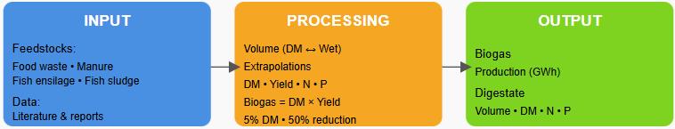
Figure 1: Illustration of the methodology followed in this study.
Biogas yields (MWh CH₄ t⁻¹ DM) for food waste and fish ensilage were taken from Carbon Limits (2019). Livestock manure yields were estimated based on manure composition and animal-specific parameters. Yields for smolt sludge were taken from Biogass Oslofjord and Avfall Norge (2021) and assumed identical for food fish sludge. DM contents were obtained from Carbon Limits (2021) for food waste, EY (2024) for fish ensilage, Bjørndal et al. (2018) for fish sludges, and are listed for livestock manure in (Birgen, 2026).
Current biogas production (GWh) was calculated from DM volumes and biogas yields. Biogas potential for food waste and livestock manure was obtained from Norwaste (2024), while potentials for fish ensilage and fish sludges were calculated from DM volumes and yields.
Nitrogen and phosphorus contents are the properties estimated in this study since the biogeochemical flows of nitrogen and phosphorus currently exceed the Earth’s safe operating limits are defined to be critical to track and recover (Azote, 2023). The nitrogen concentration (kg/t DM) and phosphorus concentration (kg/t DM) on a dry matter basis were obtained for food waste from (Morken et al., 2015), for fish ensilage from (Brod, 2024) and (Blytt et al., 2017), for livestock manure from (Birgen, 2026), for smolt sludge from (Brod and Øgaard, 2023), and for food fish sludge were estimated by multiplying the nitrogen-to-phosphorus ratio (N/P) of smolt sludge by the phosphorus concentration of food fish sludge (Blytt et al., 2017).
    - Digestate volume and properties
Digestate properties are estimated theoretically using the associated biogas feedstock volume and properties as explained in section 2.1. Digesters in biogas production typically operate at a DM content of approximately 5 % in Norwegian biogas plants (Ivar, 2025), which is regulated by adding water to the reactor. In addition, a 50 % reduction in DM during the anaerobic digestion process can be assumed based on a typical range of 50-90 % of volatile solids reduction during anaerobic digestion (University of Maryland, 2014). Furthermore, it was assumed that all components constituting the total solids were reduced by 50 %. Digestate volume both in wet and dry basis as well as N and P contents are calculated based on these assumptions.
  - Results
Volume and properties of biogas feedstocks and corresponding digestates as well as energy requirement for downstream processing of digestate are given in sections below.
    - Volumes and properties of biogas feedstocks originated from Norwegian food system
Table 2 shows volumes of current and future biogas feedstocks originated from Norwegian food system.
Table 2: Current and future biogas feedstock volumes in wet and dry basis in kilotonnes.
Feedstock | Current wet (kt) | Future wet (kt) | Current dry (kt) | Future dry (kt)
Livestock manure | 199 | 15,776 | 15 | 1,215
Food waste | 205 | 262 | 61 | 79
Fish sludge | 38 | 368 | 4 | 37
Fish ensilage | 59 | 96 | 18 | 29
Total | 500 | 16,501 | 98 | 1,359
Table 2 shows a substantial increase in the volume of feedstock, particularly driven by livestock manure. Total wet feedstock increases from 500 kt currently to 16,501 kt in the future, while total dry matter rises from 98 kt to 1,359 kt. Livestock manure dominates this growth, increasing from 199 kt to 15,776 kt on a wet basis and from 15 kt to 1,215 kt on a dry basis as a result of initiatives to decrease GHG emissions occurring due to direct land application (Kadam et al., 2024). Food waste shows a modest increase in both wet and dry quantities as forecasted in previous studies (Birgen et al., 2025), whereas fish sludge and fish ensilage increase notably, especially on a wet basis as a result of the initiatives for circular bioeconomy. Overall, future feedstock amount is expected to be significantly higher than current levels, with livestock manure as the main contributor. Currently 1,462 kt process water is used to dilute the DM content from approx. 20 % (500 kt of which 98 kt is DM) to 5 % that is the operating concentration of the anaerobic digester. In future, necessary process water is estimated to be 10,675 kt to dilute the DM from approx. 8 % (16,501 kt of which 1,359 kt is DM) to 5 %. During anaerobic digestion, 50 % of DM will be consumed (converted into biogas and used for microbial metabolism) and the remaining mass in the digester (wet feedstock and added process water) constitutes digestate volume.
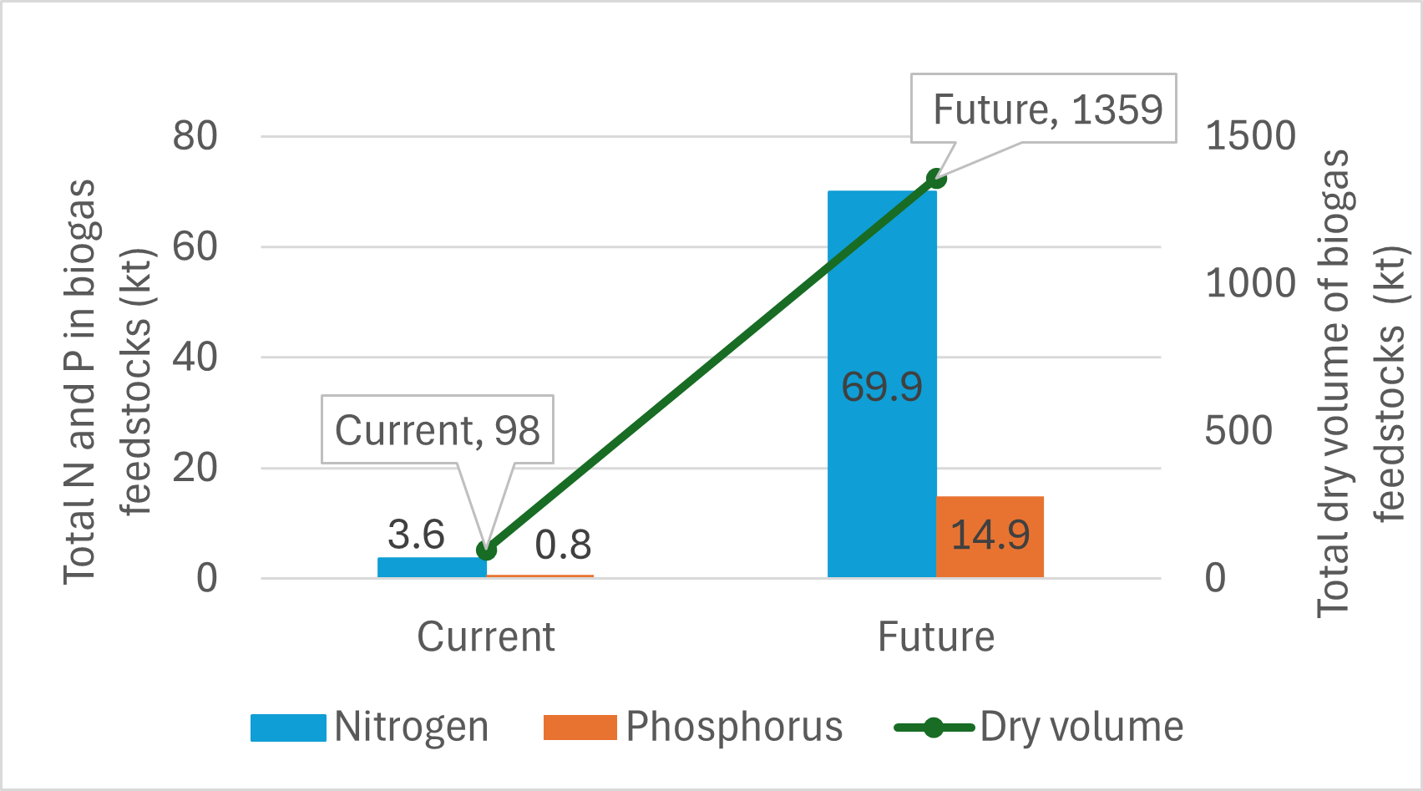
Figure 2: Total volume in dry basis, total nitrogen and phosphorus content of biogas feedstocks in kilotonnes.
Figure 2 shows that volume of feedstocks utilized in biogas will be about 14 times higher than current level while nitrogen and phosphorus levels will be approximately 19 times higher due to increased contributions of feedstocks containing these valuable minerals. This makes it even more important to map the flows of these to enable possible recovery methods.
    - Volumes and properties of digestate originated from Norwegian food system
Table 3 shows current and future digestate volume in wet and dry basis in kilotonnes as well as total nitrogen and phosphorus contents in tonnes.
Table 3: Volumes and properties of current and future digestate.
 | Wet volume (kt) | Dry volume (kt) | Total nitrogen (t) | Total phosphorus (t)
Current | 1,913 | 49 | 1,806 | 384
Future | 26,496 | 679 | 34,971 | 7,472
Table 3 shows a substantial increase in both the volume and nutrient content of digestate in the future scenario compared to current conditions. The wet volume of digestate increases 14 times (from 1,913 kt to 26,496 kt), while dry matter rises from 49 kt to 679 kt, reflecting the significantly higher input of feedstock to anaerobic digestion systems. This expansion is accompanied by a pronounced increase in nutrient loads, with total nitrogen rising from 1,806 t to 34,971 t and total phosphorus increasing from 384 t to 7,472 t. These results indicate that future biogas production could generate large quantities of nutrient-rich digestate, representing both an opportunity and a challenge. On one hand, the increased nitrogen and phosphorus content highlights the potential of digestate as a valuable fertilizer and nutrient recycling resource. On the other hand, the substantially higher nutrient concentrations underline the need for careful digestate management, storage, and application strategies to avoid nutrient losses and environmental impacts, particularly in relation to eutrophication and planetary boundary constraints. For comparison, 136,900 tonnes of nitrogen and 18,400 tonnes of phosphorus from mineral fertilizer and livestock manure were available from Norwegian agriculture in 2023 (Statistisk sentralbyrå, 2024). Therefore, the phosphorus content in future digestate from Norwegian food system (7,472 tonnes) could cover 40 % Norway’s phosphorus demand while nitrogen could cover 25 % of Norway’s demand. This will be an important factor for achieving circularity in food system of the country. Figure 3 shows the contributions of digestates from different biogas feedstocks to total nitrogen and phosphorus content for current situation and future in percentages.
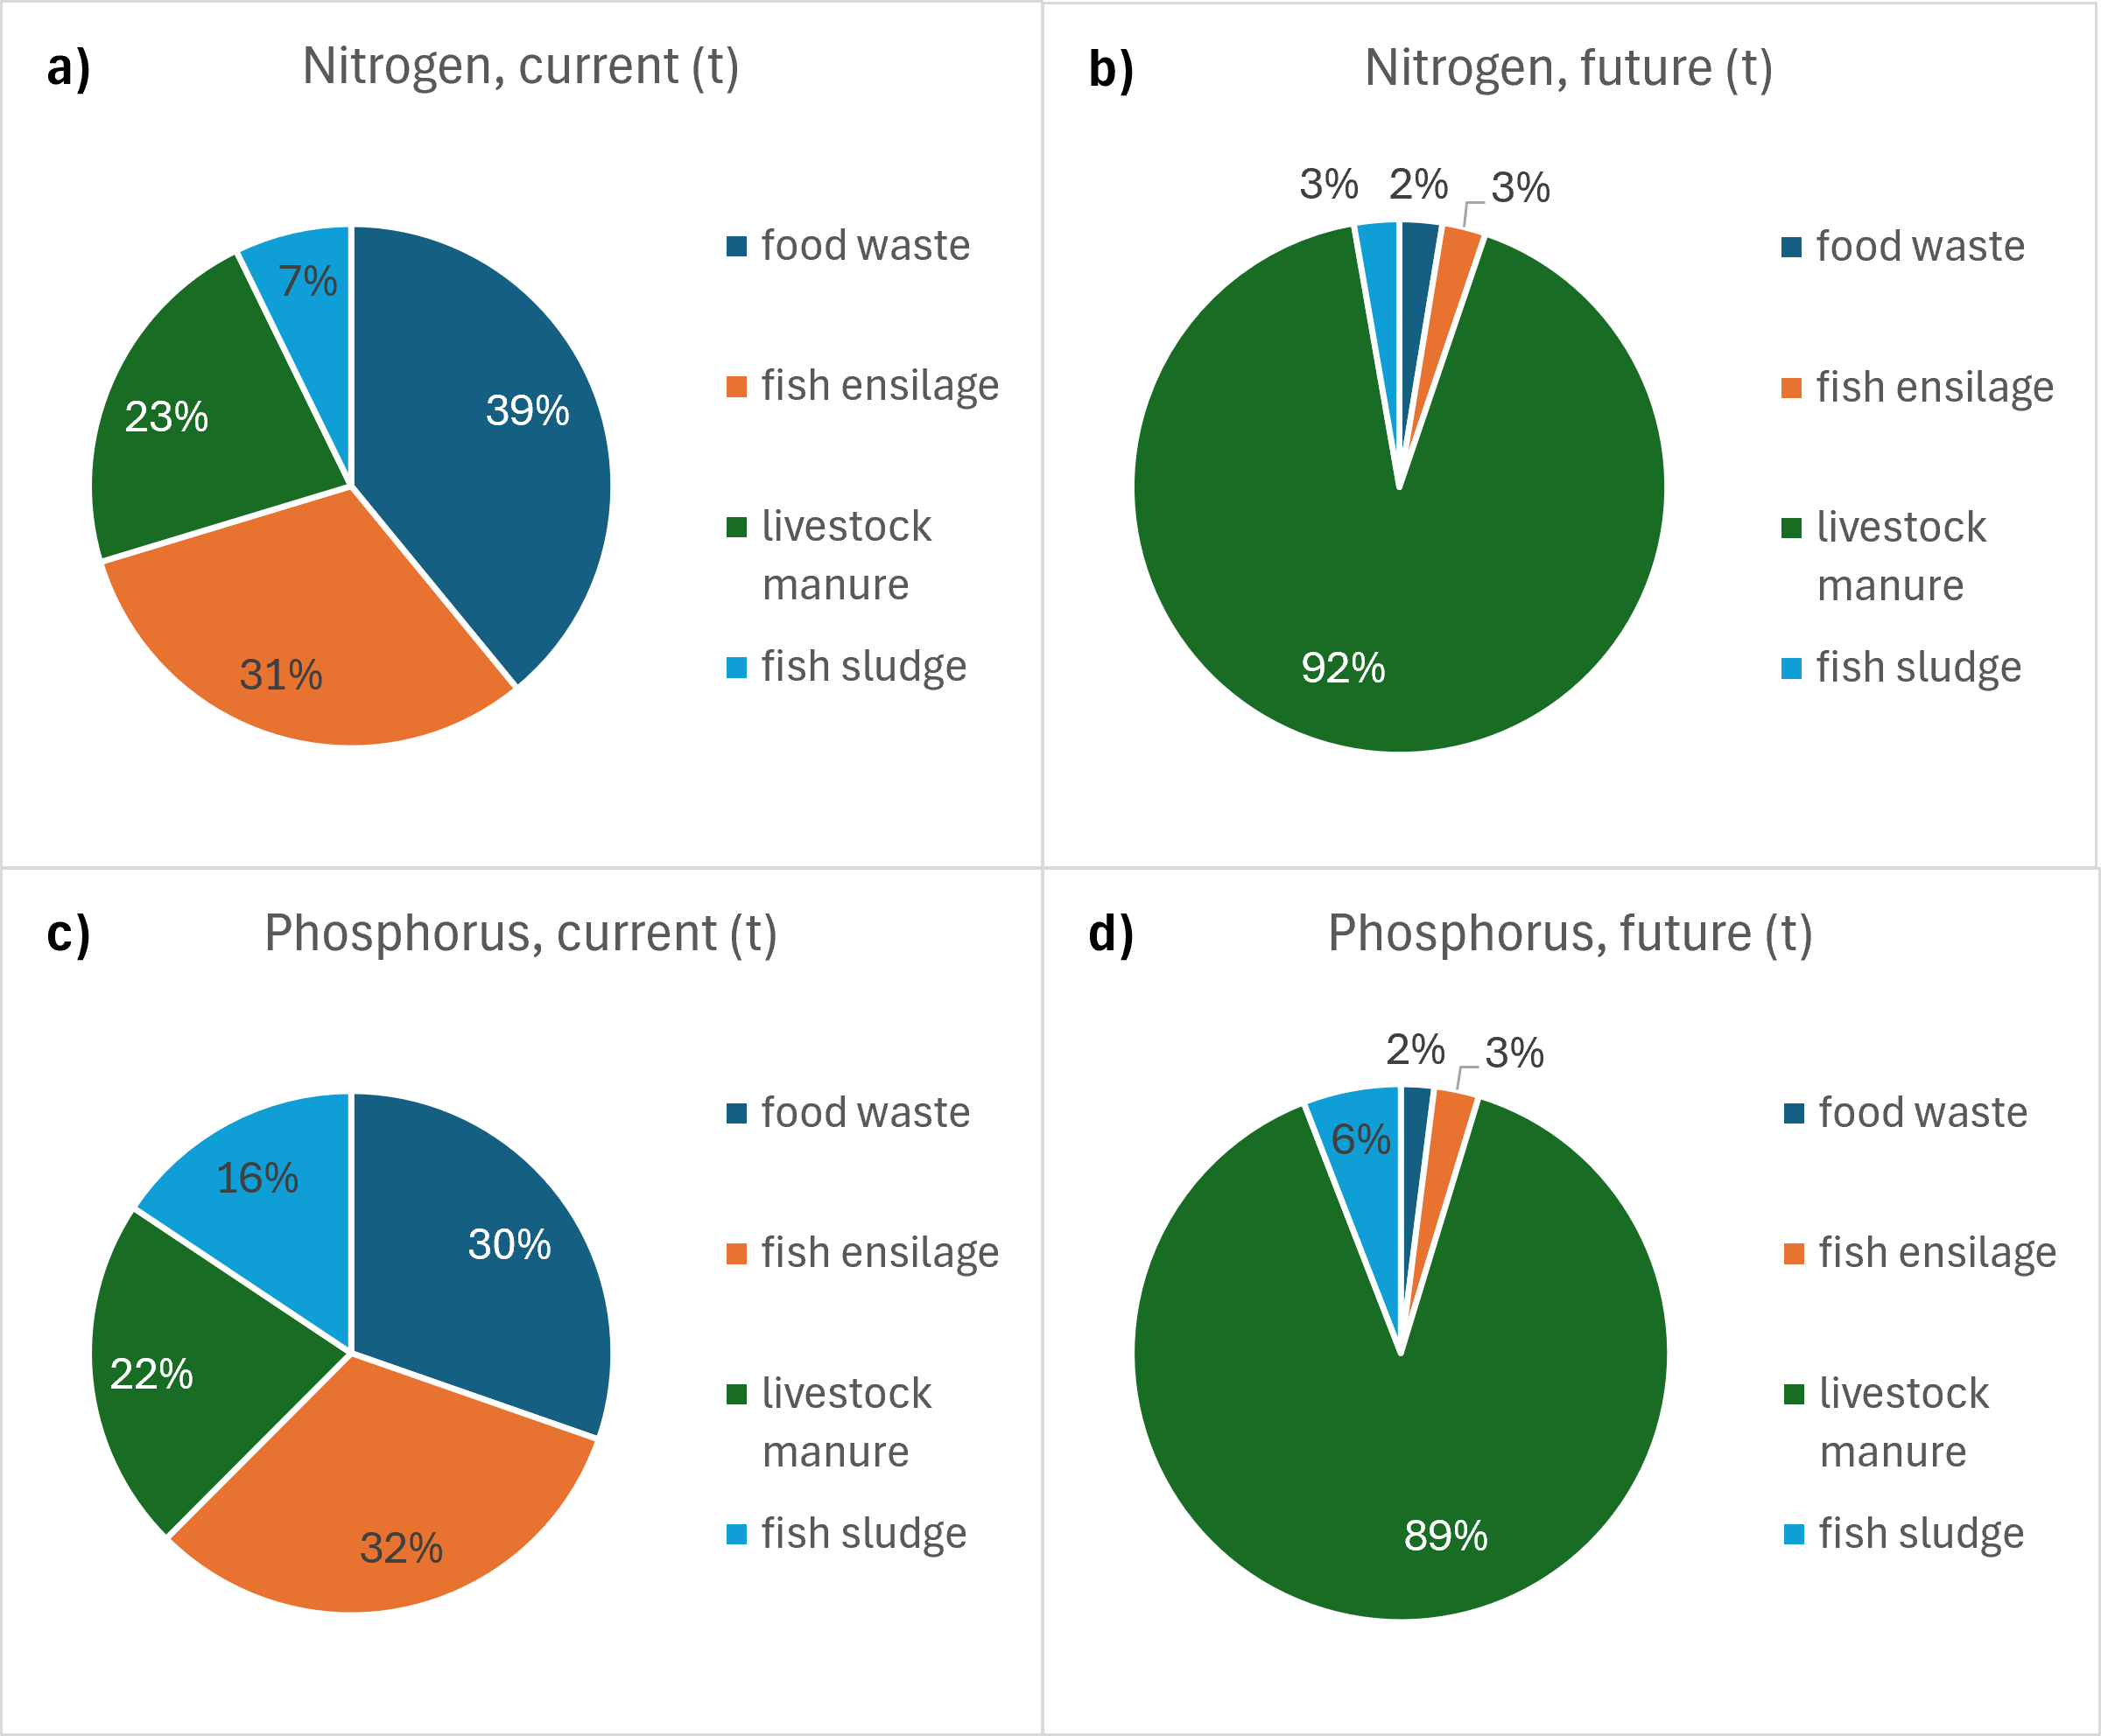
Figure 3: Contributions of digestates from different biogas feedstocks to total nitrogen and phosphorus content for current situation and future in percentages.

Currently food waste (for nitrogen) and fish ensilage (for phosphorus) are important contributors to total amounts of these valuable nutrients. This will be changed in the future due to large amounts of livestock manure entering the biogas market.
    - Energy use for downstream processing of digestate
Digestate has around 2.6 % DM concentration and it is often dewatered for easy transport and storage before use as fertilizer in agricultural lands. Therefore, it is important to consider energy requirement of the downstream processing of digestate even if there is enough market for its utilization. The digestate is usually dewatered to a DM content of 15–25 % using centrifuges, screw presses, filter presses, or other dewatering technologies (Miljødirektoratet, 2020). The energy demand of centrifuges is 50–60 kWh per tonne of DM, whereas screw presses require less energy, approximately 20 kWh per tonne of DM (including pumping and polymer dosing), with an estimated polymer consumption of 6 kg per tonne of DM to produce dewatered digestate with 25 % DM (Esteves and Vik, 2020). Dry digestate (90–95 % TS) can be produced by applying heat after dewatering, which offers advantages such as easier application on agricultural land and lower storage and transportation costs due to reduced volume. However, this is an energy-intensive process (Miljødirektoratet, 2020). Theoretically, 2,257 kJ are required to evaporate 1 kg of water (Bjørndal et al., 2018). Energy requirements of dewatering from 2.6 % to 25 % DM and drying from 25 % to 90 % DM are estimated for current and future digestate volumes and given in Table 4.
Table 4: Thermal energy requirement for processing of current and future digestate.
 | Dewatering (GWh) | Drying (GWh) | Total (GWh)
Current | 0.98 | 88.84 | 89.82
Future | 13.58 | 1230.48 | 1244.06
Drying dominates the total energy demand in both scenarios, accounting for more than 99 % of the total processing energy. In the future scenario, the energy required for drying rises sharply. Table 4 shows that total energy requirement for digestate will be 1244.06 GWh if it is entirely dried. Even though it is not realistic to assume all digestate would be dried as a national strategy. Norway’s electricity use was 136000 GWh in 2023 as comparison. These results highlight drying as the main energy bottleneck in digestate management, particularly under scenarios with large increases in digestate volumes even though it is not realistic to assume all digestate would be dried as a national strategy. Although drying offers logistical and agronomic benefits, the very high energy demand may significantly reduce the net energy efficiency of the biogas system unless low-grade waste heat or renewable energy sources are utilized. Consequently, alternative management strategies such as partial drying, enhanced dewatering, or direct land application of liquid digestate or utilization of surplus/waste energy to meet the energy requirement may be more energy-efficient options in future large-scale biogas deployment.
  - Conclusions
This study mapped quantity, composition, and assessed processing implications of digestate originating from biogas feedstocks within the Norwegian food system. The results demonstrate that the planned expansion of biogas production will lead to a substantial increase in both feedstock use and digestate generation, primarily driven by livestock manure. Total feedstock volumes are projected to increase more than fourteenfold, resulting in a corresponding rise in digestate volumes and nutrient content. This development positions digestate as an increasingly important carrier of recycled nutrients within Norwegian agriculture. The future digestate contains significant amounts of nitrogen and phosphorus, with the potential to supply approximately 25 % of Norway’s nitrogen demand and 40 % of its phosphorus demand. This highlights digestate’s strong potential to contribute to nutrient circularity, reduce reliance on mineral fertilizers, and mitigate pressures on planetary boundaries related to biogeochemical flows. However, realizing this potential requires careful nutrient management to avoid environmental risks such as eutrophication, ammonia emissions, and nutrient hotspots, particularly as digestate production becomes more geographically decoupled from agricultural land. Energy analysis shows that downstream processing of digestate, especially drying, represents a major challenge. Drying dominates total energy demand and could significantly reduce the net energy benefits of biogas systems if applied at scale without access to surplus heat or renewable energy sources. Consequently, full drying of digestate may not be a viable strategy in all cases. Overall, the findings underline the need for integrated digestate management strategies that balance nutrient recovery, energy efficiency, and environmental protection. Enhanced dewatering, partial drying, direct land application of liquid digestate, and utilization of waste heat emerge as promising pathways to support sustainable large-scale biogas deployment in Norway’s evolving food and energy system. Future work should include a comprehensive economic feasibility analysis of the proposed digestate management and processing pathways. This analysis should compare the costs of treatment, transport, and energy use—particularly for drying and dewatering—with the market value of the recovered nutrients as fertilizers. Such an assessment would help determine whether the recovery and utilization of nitrogen and phosphorus from digestate can be economically competitive with conventional mineral fertilizers, and under which conditions these strategies are financially viable.
References
Azote for Stockholm Resilience Centre, 2023 <https://www.stockholmresilience.org/research/planetary-boundaries.html> accessed 01.07.2025.
Birgen C., 2026, Kartlegging av biorest i Norge: Volum, kvalitet, behandling og regelverk.
Birgen C., Wang L., Becidan M., 2025, Forecasting End Products in Food Waste Management System for a Circular Future, European biomass conference and exhibition proceedings, 9-12 June 2025, 188-192.
Bjørndal T., Holte E. A., Hilmarsen Ø., Tusvik A., 2018, Analyse av landbasert oppdrett av laks landbasert og i sjø: Produksjon, økonomi og risiko.
Blytt L.D, Brod E., Øgaard A.F., Johannessen E., Estevez E.M.E., Paulsrud B., Bedre Utnyttelse av Fosfor, 2017, COWI.
Böpple H., Brussino G., Engel A., Breuhaus P., Dopffel N., An-Stepec B.A., Kleinegris D.M., Slegers P.M., 2025, Utilization of fish sludge and aquaculture effluent water from Norway for nutrient and energy recovery. Resources, Conservation & Recycling Advances, 200256.
Brod E., 2024, Biorest fra marine råstoffer. Jord-og Plantekultur, 151.
Brod E., Øgaard A.F., 2023, Fiskeslam fra smolt- og postsmoltproduksjon som gjødsel, Norsk Institutt for Bioøkonomi.
Carbon Limits, 2019, Ressursgrunnlaget for produksjon av biogass i Norge i 2030.
Estevez M.M., Vik E.A., 2020, Grønn slamhåndtering for mindre landbrukskommuner, COWI Aquateam.
EY, NIBIO, House G., ReSourcer, 2024, Restråstoff i Trøndelag.
Ivar, 2025, Slam blir til verdifulle ressurser < https://www.ivar.no/slambehandling/> accessed 01.07.2025.
Kadam R., Jo S., Lee J., Khanthong K., Jang H., Park J., 2024, A review on the anaerobic co-digestion of livestock manures in the context of sustainable waste management, Energies, 17(3), 546.
Kristiansen T. K., Hetland T., 2021, Sommeroppgave: Undersøkelse av økende mengde fiskeavfall til biogassproduksjon, Biogass Oslofjord og Avfall Norge.
Kvakkestad V., Brod E., Flø B.E., Hanserud O., Helgesen H., 2023, Circulation of nutrients through bio-based fertilizer products: perspectives from farmers, suppliers, and civil society. Frontiers in Sustainable Food Systems, 7, 1239353.
Miljødirektoratet, 2020, Virkemidler for økt bruk og produksjon av biogass <https://www.miljodirektoratet.no/publikasjoner/2020/mars-2020/virkemidler-for-okt-bruk-og-produksjon-av-biogass/> accessed 01.07.2025.
Morken T.B., Hanssen O.J., Sørby I., 2015, Biogassproduksjon fra matavfall og møkk fra ku, gris og fjørfe.
Norwaste, 2024, Bransjestatistikk for biogassbransjen <https://biogassnorge.no/statistikk> accessed 01.07.2025.
Sarker S., 2020, By-products of fish-oil refinery as potential substrates for biogas production in Norway: A preliminary study, Results in Engineering, 6, 100137.
Skrzypczak D., Trzaska K., Mironiuk M., Mikula K., Izydorczyk G., Polomska X., Wiśniewski J., Mielko K., Moustakas K., Chojnacka, K., 2024, Recent innovations in fertilization with treated digestate from food waste to recover nutrients for arid agricultural fields. Environmental Science and Pollution Research, 31(29), 41563-41585.
Statistisk sentralbyrå, 2024, Bruk av gjødsel i jordbruket <https://www.ssb.no/jord-skog-jakt-og-fiskeri/jordbruk/artikler/bruk-av-gjodsel-i-jordbruket> accessed 01.07.2025.
Pandit A.V., Dittrich N., Strand A.V., Lozach L., Las Heras Hernández M., Reitan K.I., Müller, D.B., 2023, Circular economy for aquatic food systems: insights from a multiscale phosphorus flow analysis in Norway. Frontiers in Sustainable Food Systems, 7, 1248984.
University of Maryland, 2014, Anaerobic Digestion: Basic Processes for Biogas < https://enst.umd.edu/sites/enst.umd.edu/files/files/documents/Extension/Anaerobic-Digest_Basic-Processes.pdf> accessed 01.07.2025.
Ålund I., Gentile V., Morken J., Sogn T. A., 2021, Behandling og disponering av avløpsslam og annet organisk avfall i Norge,» Carbon Limits.

