 CHEMICAL ENGINEERING TRANSACTIONS  VOL. xxx, 2026 | A publication of  
The Italian Association
of Chemical Engineering
Online at www.cetjournal.it

Guest Editors: Leonardo Tognotti, Rubens Maciel Filho, Viatcheslav Kafarov
Copyright © 2026, AIDIC Servizi S.r.l.
ISBN 979-12-81206-xx-x; ISSN 2283-9216

Consequential Life Cycle Analysis of a Multi-Product Biorefinery from Hass Avocado Seeds in the Colombian Amazon Region: System Expansion Assessment, Monte Carlo, and Sensitivity Analysis
Anibal Alviz-Meza* and Ángel Darío González-Delgado
Chemical Engineering Department, Nanomaterials and Computer-Aided Process Engineering Research Group (NIPAC), Universidad de Cartagena, Cartagena 130014, Bolívar, Colombia
aalvizm1@unicartagena.edu.co

This study assesses a cascade biorefinery that converts Hass avocado seeds from the Colombian Amazon into three co-products: starch, biodegradable biofilms, and a bioinsecticide, employing a gate-to-gate consequential life cycle assessment. The functional unit is defined as 1000 kg of processed seed, supported by Aspen Plus v12.0 simulations for the life-cycle inventory. System expansion, in accordance with ISO 14044, accounts for the avoided production of market substitutes and addresses the multifunctionality of co-products. Findings suggest that the biorefinery can provide net benefits relative to the sanitary landfill baseline across climate change (−474 kg CO₂-eq/t; P5–P95: −3510 to -778 kg CO₂-eq/t) and other midpoint categories; however, a Monte Carlo uncertainty analysis indicates sensitivity in the climate change results, particularly with respect to pesticide substitution levels. Hotspot and scenario analyses identify materials, energy consumption, and waste management as critical factors for environmental enhancements. Overall, this research provides a quantitative, uncertainty-aware foundation for benchmarking avocado seed valorization against conventional disposal and alternative waste management strategies.
  - Introduction
The rapid expansion of avocado consumption and industrialization is creating opportunities to add value to the avocado production chain. Global production more than tripled between 2000 and 2021, while the Hass avocado has become the preferred variety among consumers (Hammami et al., 2024). This growth exacerbates a typical problem in the bioeconomy: it generates more biomass waste. In avocados, the seed can account for approximately 20% of the fruit's weight and, together with the peel, up to 30% of the total weight, generating considerable solid waste streams that, if not valorized, end up in sanitary landfills, thereby contributing to pollution (Nascimento et al., 2025). Within a circular bioeconomy framework, cascade biorefineries are attractive because they seek to extract multiple valuable products from the same resource; however, precisely because of this multi-productivity and the interdependencies between processes, environmental assessment requires robust life cycle assessment (LCA) frameworks that allow for the evaluation of scenarios or technological alternatives with a lower environmental impact. Current research on avocado waste LCA primarily focuses on exploring valorization options across the entire value chain and comparing different transformation methods, such as producing guacamole, oil, and bioactive compounds, as well as management strategies, including fertilizers and biogas. These studies aim to identify hotspots and optimal routes using common midpoint methodologies. A key example is García-Vallejo et al. (2023), which proposes various waste valorization options across different stages of the supply chain and employs LCA to compare scenarios, highlighting the main contributions in supply and processing. Additionally, innovative proposals on avocado-based biorefineries, co-products, and waste management have attracted attention. For instance, Solarte-Toro et al. (2022) examined two small-scale biorefinery setups in Colombia, emphasizing the importance of agricultural inputs and comparing the carbon and water footprints. Similarly, research on integrated biorefineries indicates that heat and steam requirements often dominate environmental impacts, particularly in new designs, where hotspots often involve energy utilities and process materials (Meramo et al., 2026). Based on this, it is evident that while there is existing literature on LCAs of avocado value chains and related biorefineries, none specifically examines a multi-product cascade biorefinery based solely on Hass avocado seeds. Additionally, this study avoids system partitioning by using simplified allocations when the design makes it difficult to isolate individual resources. Instead, it uses simulated data from Aspen Plus V12.0 and adopts a consequential approach to system expansion to account for product substitutions in the market, in accordance with ISO 14044. The findings are supported by sensitivity analyses, deterministic scenario analyses, and Monte Carlo simulations, which identify key areas for improvement and offer recommendations for future research.
  - Materials and methods
This study examines a new biorefinery utilizing Hass avocado seeds from the Colombian Amazon. The environmental performance evaluation considers Colombia's geographical features.
    - Processes description
Aguilar-Vásquez et al. (2025) propose a cascade biorefinery to valorize Hass avocado seeds and produce starch, biofilms, and a biocontrol agent, which is studied in this paper and described as follows (see block diagram in this paper for a better understanding). The biorefinery has three primary sections: pretreatment, starch and starch-derived bioplastic production, and polylactic acid bioplastic manufacturing. Approximately 27.4 kg/h of waste is diverted to this process, selected based on a segment of Amazon's total Hass avocado output and a mass-balance computation. Initially, the waste is washed with water to remove impurities, then dried in an oven at 50°C. Subsequently, the waste is crushed to a maximum dimension of 3 cm. The ground waste is then segregated into raw material and output streams. 60% of the ground hard waste undergoes processing by mixing with a water solution containing 0.3% (v/v) sodium metabisulfite to facilitate starch extraction. This mixture is liquefied and filtered, yielding a starch-rich liquid and a bioactive compound-enriched hard-waste fraction. The starch-rich liquid is then decanted to eliminate residual water and traces of solvents. The solid starch fraction is subsequently washed to remove impurities, immediately dried at 60°C using hot air, and divided into three fractions: pure starch (2.8 kg/h), starch intended for bioplastic production (2.4 kg/h), and a starch film former (0.3 kg/h). The pure starch is further dried to reduce its moisture content to below 0.01%. The starch designated for bioplastic manufacturing is gelatinized in cellulose and glycerol solutions at 5% and 4% (w/w), respectively, and then dried at 110°C to remove residual moisture. 40% of the ground hard waste is processed to produce polylactic acid bioplastic. The waste material is subjected to hydrolysis with a 5% acid solution (sulfuric acid) to extract fermentable substrates for Lactobacillus fermentation, which yields lactic acid. A stream of pure calcium hydroxide (20 kg/h) is maintained to regulate the fermentation pH. After fermentation, the lactic acid suspension containing residual calcium hydroxide is neutralized with sulfuric acid (20 kg/h). The resulting salts are separated via filtration, and water is evaporated. The lactic acid then undergoes pre-polymerization to produce low-molecular-weight polylactic acid, which is subsequently converted into lactides. These lactides are separated from water and residual acids by flash separation and distillation, with the light fractions recirculated to the pre-polymerization reactor. In contrast, the purified lactides are polymerized via ring-opening polymerization. The final polylactic acid is blended with a starch fraction from the starch production section to produce a bioplastic film.
    - Life Cycle Assessment
The LCA conducted in this study aligns with ISO 14040 and 14044 standards (2006). These standards define the structure of the LCA, covering the objective and scope, life cycle inventory, impact assessment (LCIA), and result interpretation. OpenLCA 2.6 software was utilized to perform the LCA calculations.
Goal and scope
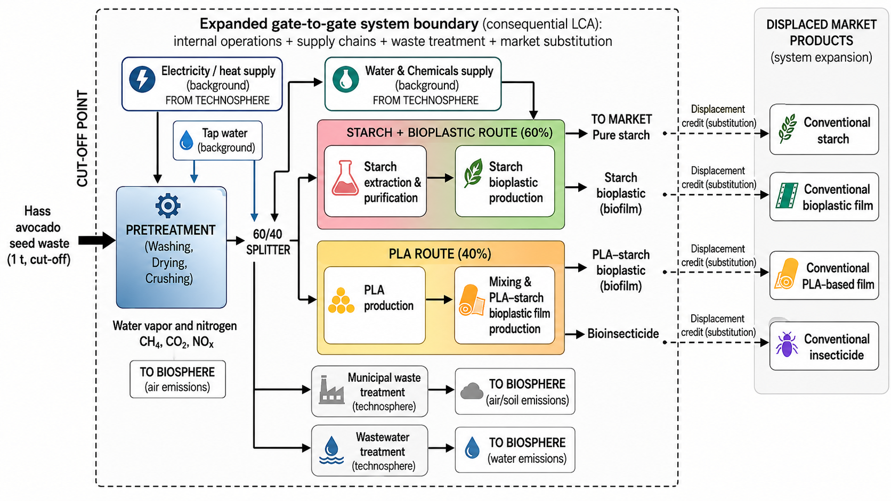
This investigation evaluates the environmental performance —mainly climate change؅— of a cascade biorefinery that transforms Hass avocado seed waste into starch, biofilms, and an insecticide. It emphasizes identifying key impact hotspots and assessing the robustness of findings through uncertainty and sensitivity analyses. The objective is to understand not only the average environmental impact but also the variability of results under different assumptions, and to determine whether the biorefinery provides environmental benefits relative to conventional waste management practices. The scope of this consequential LCA of the multi-product system addresses inquiries into the environmental impacts associated with the multi-product biorefinery, the implications of diverting waste from its customary destination, and the extent to which co-products may partially substitute for market products. The functional unit (FU) is defined as 1,000 kg (1 t) of processed Hass avocado seeds (Cut-off), consistent with industrial scenarios in which displaced products are produced (it implies that the 27.4 kg/h of avocado seed flow, and all the process streams, were multiplied by a factor of $\sim$36.5). Specifically, the comparative scenario involves the current disposal of avocado seeds in a sanitary landfill, contrasted with 100% replacement of market products. The system boundary encompasses an expanded gate-to-gate scope (see Figure 1), including upstream inputs such as internal process operations, supply chains for materials and energy, treatment of municipal waste streams and wastewater, and the substitution of market products based on replacement percentages used in the sensitivity analysis. A cradle-to-gate scenario is avoided due to uncertainty about the new biorefinery's potential location. Finally, in accordance with standard practice, contributions deemed marginal —infrastructure, capital goods, and labor— were excluded because relevant data were unavailable. To address multifunctionality, the study emphasizes avoiding allocation through system expansion or displacement credits, consistent with a consequentialist framework for analyzing a cascade biorefinery.
Figure 1: System boundary of the Cascade biorefinery
Life Cycle Inventory modeling
Data sources were compiled based on process modeling and simulation of the Hass avocado seed biorefinery. Aspen Plus v12.0 was used to model the production process (steady-state), and energy and mass balances were employed to quantify the life-cycle inventory (see Table 1).
Table 1: Summary of inputs, outputs, and emissions of the biorefinery
Flow type | Flow | Amount | Unit
Input | Avocado seed (Feedstock) — Functional Unit | 1000 | kg
Input | Carboxymethyl cellulose, powder - GLO | 22.74 | kg
Input | Ethanol (99.7% w/w, anhydrous) - GLO | 620.44 | kg
Input | Glucose - RoW | 52.09 | kg
Input | Glycerine (proxy used for glycerol) - RoW | 36.5 | kg
Input | Nitrogen - RoW | 8.98 | kg
Input | Lime, hydrated (proxy used for calcium hydroxide) - RoW | 735.04 | kg
Input | Sodium sulfite (proxy used for sodium metabisulfite) - RoW | 5.35 | kg
Input | Sulfuric acid - RoW | 953.63 | kg
Input | Tap water - CO | 11432.6 | kg
Input | Electricity, medium voltage - CO | 7384.77 | kWh
Input | Natural gas, high pressure - CO | 791.77 | m³
Output | Biofilm 1 (Product) | 137.34 | kg
Output | Biofilm 2 (Product) | 125.54 | kg
Output | Bioinsecticide (Product) | 450.25 | kg
Output | Starch (Product) | 70.24 | kg
Output | Municipal solid waste (same as comparison scenario) - RoW | 1816.96 | kg
Output | Wastewater - RoW | 5.99 | m³
Output | Nitrogen (air emission) | 8.98 | kg
Output | Water vapour (air emission) | 3841.79 | kg
Output | Carbon dioxide (air emission) | 1590.18 | kg
Output | Methane (air emission) | 0.02835 | kg
Output | Dinitrogen monoxide (air emission) | 0.00283 | kg
Reference data were sourced from Ecoinvent 3.10, including models of waste treatment, raw material production, electricity supply, and other processes. Electricity, natural gas, and water supply are regionalized in Colombia, whereas market materials and products are sourced from the GLO and RoW categories, with RoW prioritized in the database when possible. In the expanded product system, starch was replaced with maize starch, the biofilms with packaging films made of low-density polyethylene, and the bioinsecticide with an unspecified pesticide (no background dataset was available for a functionally equivalent biobased insecticide or for a specific fossil pesticide consistently matching the intended substitution context), all of which were market-for-designated (GLO). As part of the sensitivity analysis, various scenarios of product substitution or displacement from the market, as well as optimization of energy and material use in the process, were explored. Since certain inputs were not available in the OpenLCA LCI databases, they were represented using proxy flows to maintain inventory consistency and traceability. Hydrated lime was used as a substitute for calcium hydroxide, as it consists mainly of Ca(OH)₂ and is widely used as a low-cost alkali in aqueous neutralization systems. Sodium sulfite was used as a proxy for sodium metabisulfite because both generate sulfite species in solution and fulfill the same role of inhibiting oxidation. Finally, because of its influence on the LCIA, hydrated lime was included in the sensitivity analysis.
Life Cycle Impact Assessment
The impact assessment employs the ReCiPe 2016 Midpoint (H) method (v1.13), with uncertainties expressed as percentiles (P5–P95) and probabilistic metrics, such as P(biorefinery < sanitary landfill), across various categories. Sensitivity analysis focuses on parameters identified as process-dominating. Although ReCiPe offers a comprehensive range of midpoint categories encompassing diverse environmental aspects pertinent to biorefineries, the analysis concentrates on a selected subset to facilitate interpretation and emphasize key system outcomes: climate change, fossil resource utilization, water consumption, land utilization, freshwater eutrophication, terrestrial acidification, human toxicity (carcinogenicity), and terrestrial ecotoxicity. This selection is justified by their significance in systems that are heavily dependent on chemical inputs, energy, and effluent management, as well as by their alignment with the sensitivity and uncertainty analyses performed in the study.
Interpretation of results
The LCIA results are employed to assess the environmental sustainability of the Hass avocado seed cascade biorefinery. A hotspot analysis identifies the primary factors influencing each impact category and highlights opportunities to enhance the system's eco-efficiency. Building upon these hotspots, a sensitivity analysis assesses the model's robustness by varying key input parameters and observing the resulting changes in environmental impacts. Furthermore, an uncertainty analysis, conducted via 2000 Monte Carlo (MC) simulations, propagates uncertainties in foreground inputs through the Pedigree approach and accounts for background data uncertainties derived from the selection made in the Ecoinvent datasets. This approach facilitates a statistical evaluation of the impact distribution. The MC outcomes enable a probabilistic comparison, estimating the probability that the biorefinery yields lower impacts than the sanitary landfill scenario.
  - Results and discussion
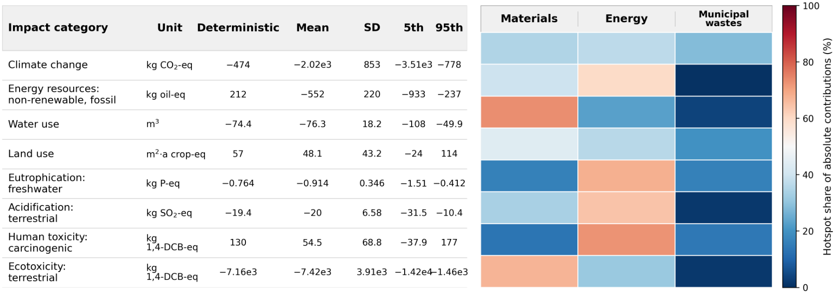
The results of the cascade biorefinery using Hass avocado seeds indicate generally positive environmental impacts across multiple categories when substituting for market products on a one-to-one basis (see Figure 2).
Figure 2: LCIA results for 1000 kg of Hass avocado seeds (deterministic), including 5th and 95th percentile values based on MC simulations
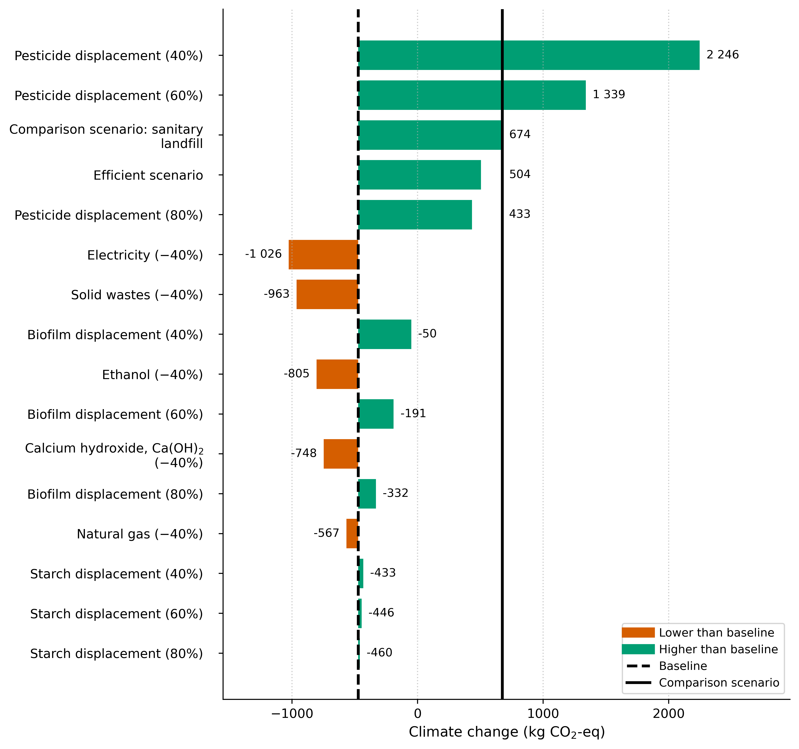
Although climate change exhibits a negative deterministic value (−474 kg CO₂-eq/t), the extensive Monte Carlo interval in Figure 2 (P5–P95: −3510 to -778 kg CO₂-eq/t) and sensitivity scenarios of Figure 3 suggest that the sign of the outcome depends on key assumptions regarding yields, substitution factors, end-of-life options, and background data. This indicates a tendency towards an overall “net benefit”—as the probability MC results show when compared with the sanitary landfill disposition scenario— even though such an outcome cannot be assured, as sensitivity analysis suggests. Uncertainty analysis indicates that, under certain parameter configurations, the system could become environmentally detrimental even when bioplastics and fossil-based pesticides are entirely replaced for impact categories such as land use and human toxicity (carcinogenic). Compared with avocado biorefineries reported in the literature, none of which focus exclusively on waste valorization or system expansion, the main difference lies not only in the numerical values but also in the mechanisms governing the results. In Solarte-Toro et al. (2022), impacts per 1 kg of avocado are positive (0.72–8.99 kg CO₂-eq/kg), indicating that avoiding energy-intensive processes reduces impacts but does not necessarily reverse the balance — electricity needs are a hotspot in small-scale setups. Similarly, Meramo et al. (2026) highlight energy, mainly electricity and steam (77%) and cooling (15%), as the main impact in avocado oil-focused biorefineries. In this study, the hotspots appear in materials, waste, and energy, which is perhaps more similar to the work of García-Vallejo et al. (2023), who report a carbon footprint of 3.71 kg CO₂-eq/kg, highly dependent on materials, with ethanol accounting for 67% of the climate impact.
Figure 3: Deterministic sensitivity analysis results using the same FU. The Efficient scenario combines input reductions with a 40% reduction in pesticide use. Seed disposal in a sanitary landfill is the comparison scenario
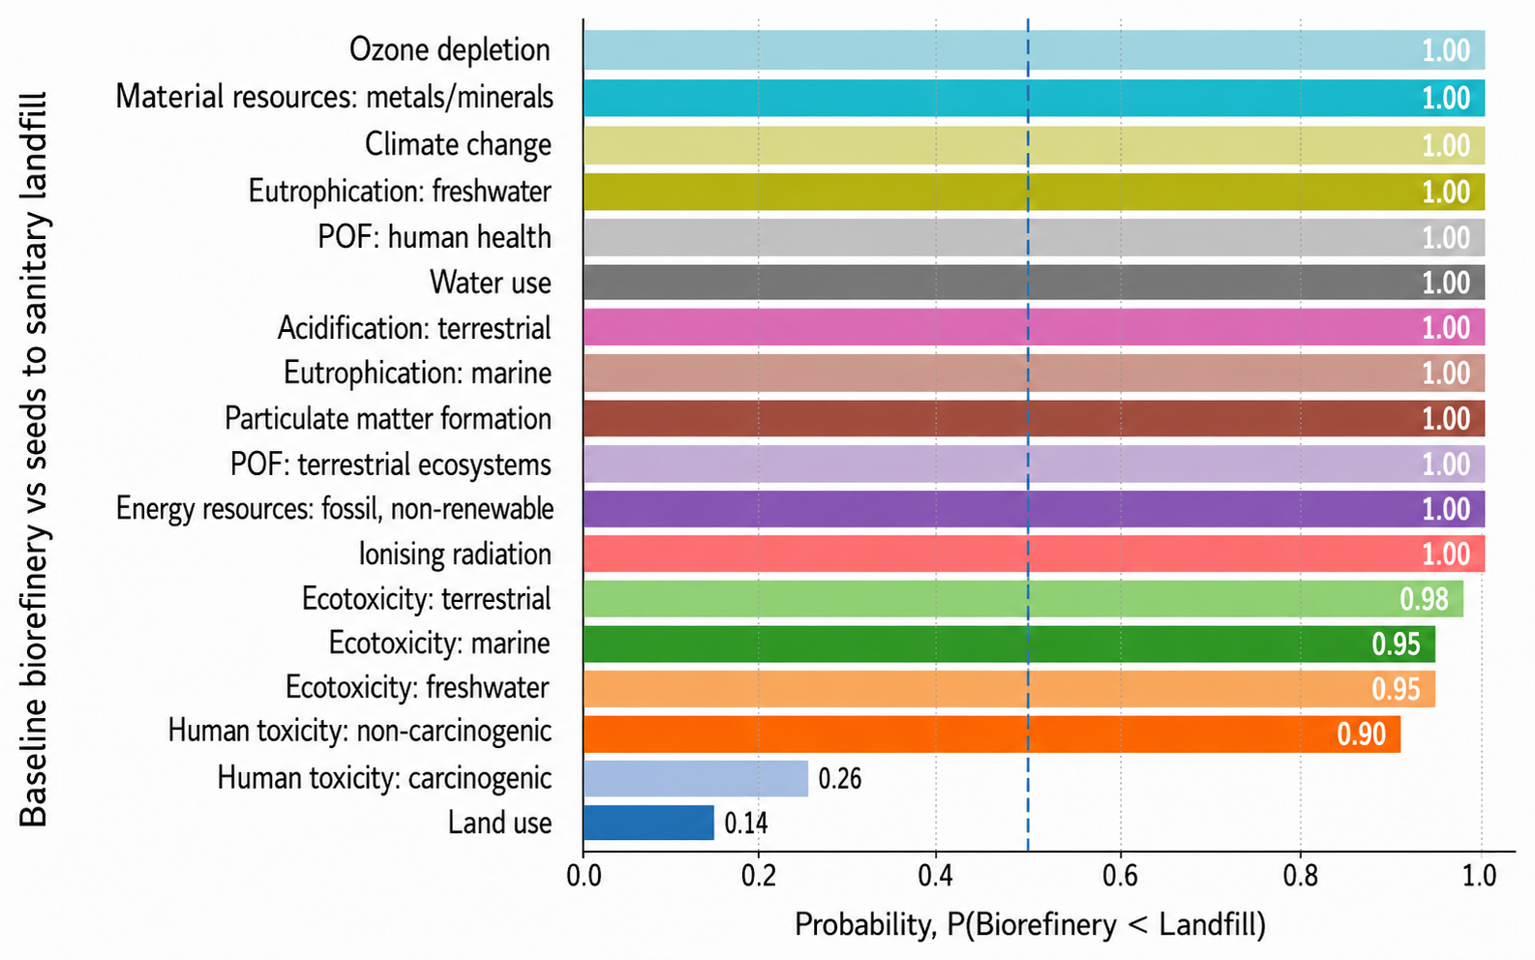
The deterministic analysis revealed that electricity and natural gas are the drivers in the energy category, whereas ethanol and hydrated lime are the drivers in the materials category: one derived from the phenol extraction process for bioinsecticide production and the other used in bioplastics manufacturing via fermentation, respectively. Moreover, most solid waste is produced through the same biofilm production pathway. In essence, restricting biofilm production to the non-fermentation route could substantially mitigate the biorefinery's environmental impacts. Therefore, a sensitivity analysis was conducted to assess the impact of not fully replacing equivalent products in the market and to develop scenarios in which the aforementioned environmental impact drivers can be reduced. The results shown in Figure 3 demonstrate that reducing consumption of electricity, natural gas, ethanol, and calcium hydroxide (hydrated lime), and minimizing solid-waste generation, create a more resilient scenario against the impacts of these inputs on climate change and enable the substitution of equivalent products in the market. The pesticide replacement factor has the greatest impact on the studied product system—displacements below 80% could be environmentally detrimental to the proposed biorefinery. When comparing the results with the sanitary landfill disposal scenario, the probability plot obtained from an MC analysis for both scenarios (see Figure 4) indicates a statistically significant “superiority” of the biorefinery in almost all categories. Even so, environmental impacts such as land use and human toxicity (carcinogenic) remain categories in which the biorefinery would negatively affect surrounding ecosystems, which points to structural trade-offs associated with inputs and operations that the sanitary landfill lacks —production of auxiliary chemicals, water treatment, waste/effluent management, and background datasets with toxic profiles.
Figure 4: Probability of Biorefinery impacts lower than in the comparison scenario through MC analysis
  - Conclusions
This research demonstrates that a cascade biorefinery utilizing Hass avocado seeds (FU = 1,000 kg) and evaluated through consequential LCA with system expansion has the potential to yield environmental benefits over sanitary landfilling, particularly when byproducts such as bioinsecticides, biofilms, and starch effectively substitute market products. Although the analysis indicates a positive impact on climate change within the deterministic framework, this outcome is not guaranteed and may be reversed under alternative assumptions, as evidenced by Monte Carlo simulations. Key hotspots and sensitivity analyses indicate that efforts should focus on reducing material inputs, energy consumption, and solid waste, with the pesticide replacement factor identified as the most influential parameter affecting the system's climate outcomes.
References
Aguilar-Vázquez E.A., Rojas-Flores S., González-Delgado Á.D., 2025, Inherent Safety Analysis of a Cascade Biorefinery for the Utilization of Avocado Hard Waste from the South Colombian Region, Sustainability, 17, 8103
García-Vallejo M.C., Agudelo Patiño T., Poveda-Giraldo J.A., Piedrahita-Rodríguez S., Cardona Alzate C.A., 2023, Alternatives for the Valorization of Avocado Waste Generated in the Different Links of the Value Chain Based on a Life-Cycle Analysis Approach, Agronomy, 13, 2229
Hammami A.M., Kuan-Ming H., Guan Z., 2024, An Overview of the Avocado Market in the United States, EDIS, 1
Hurme M., Rahman M., 2005, Implementing inherent safety throughout process lifecycle, Journal of Loss Prevention in the Process Industries, 18, 238–244
Khan F.I., Amyotte P.R., 2005, I2SI: A comprehensive quantitative tool for inherent safety and cost evaluation, Journal of Loss Prevention in the Process Industries, 18, 310–326
Meramo S., Herrera-Rodríguez T.C., González-Delgado A.D., 2026, Economic and environmental hotspots of new thermal-extractive avocado biorefinery, Biomass and Bioenergy, 207, 108724
Nascimento A.P.S., Duarte M.E.M., Rocha A.P.T., Barros A.N., 2025, Valorization of Avocado (Persea americana) Peel and Seed: Functional Potential for Food and Health Applications, Antioxidants, 14, 1032
Solarte-Toro J.C., Ortiz-Sánchez M., Cardona Alzate C.A., 2022, Environmental life cycle assessment (E-LCA) and social impact assessment (SIA) of small-scale biorefineries implemented in rural zones: the avocado (Persea Americana var. Americana) case in Colombia, Environmental Science and Pollution Research, 30, 8790–8808

