 CHEMICAL ENGINEERING TRANSACTIONS  VOL. xxx, 2026 | A publication of  
The Italian Association
of Chemical Engineering
Online at www.cetjournal.it

Guest Editors: Leonardo Tognotti, Rubens Maciel Filho, Viatcheslav Kafarov
Copyright © 2026, AIDIC Servizi S.r.l.
ISBN 979-12-81206-xx-x; ISSN 2283-9216

Inherent Safety Analysis of Large-Scale Production of Magnetic Hydrogel from Native Peruvian Yellow Potato Peel Starch
Anibal Alviz-Meza^{a,*}, María V. Carranza-Oropeza^{b,c}, Angel D. Gonzalez-Delgadoª
ªChemical Engineering Department, Nanomaterials and Computer-Aided Process Engineering Research Group (NIPAC), Universidad de Cartagena, Cartagena 130014, Bolívar, Colombia
^{b}Centro de Investigaciones Tecnológicas, Biomédicas y Medioambientales (CITBM), laboratorio de síntesis y caracterización de materiales (SyCAM), Universidad Nacional Mayor de San Marcos, Lima, Peru
aalvizm1@unicartagena.edu.co

Agro-industrial waste, such as the peel of native Peruvian potatoes, offers a scalable opportunity to produce functional hydrogels, although the intrinsic safety of these new bioprocesses remains unknown. This work applies the Inherent Safety Index methodology to the production of a magnetic hydrogel synthesized from native Peruvian potato peel starch. The necessary process data were obtained from an Aspen Plus simulation in previously published work. Physicochemical, toxicological, and reactivity data for the compounds involved were obtained from safety data sheets to develop chemical-hazard subindices. As a result, the most significant risks were associated with the exothermic nature of graft polymerization, potential oxidizer-fuel interactions between ammonium persulfate and ethanol, and the toxicity and corrosiveness of acrylic acid and iron salts. Therefore, special safeguards must be considered to avoid risky operations. The process achieved an overall ISI of 27 by adding the chemical index of 16 and a process safety index of 11. These results indicate that producing a magnetic hydrogel from native potato peel is potentially hazardous and highlight areas for improvement in industrial-scale-up.
  - Introduction
The valorization of agro-industrial waste through process expansion or the creation of new product-system pathways is a well-established approach within the circular economy, especially when this waste contains biopolymers such as starch. In this context, starch-based hydrogels have garnered attention due to their availability, relatively low cost, and versatility for contaminant adsorption and controlled-release applications (Bhuyan et al., 2016). This study focuses on starch derived from the peel of a native Peruvian potato, which has demonstrated promising economic performance at large scale when functionalized with magnetite for easy recovery and reuse (Alviz-Meza et al., 2025). However, when scaling up the production of these biomaterials from laboratory synthesis to industry, a frequently overlooked component emerges —the safety of the processes.
The manufacture of hydrogels involves various reagents and conditions that can directly and indirectly affect process safety and the well-being of personnel involved. For example, the use of acrylic acid and radical polymerization introduces hazards associated with reactivity and exothermicity, potential self-acceleration, heat generation, fire, and/or explosion (Jeong et al., 2025). Furthermore, magnetization of Fe₃O₄-containing hydrogels typically requires iron salts (Fe⁺²/Fe⁺³) and strong bases, which pose additional hazards, including corrosiveness and heat generation. Within this framework of industrial process engineering, one of the most proactive approaches is the Inherent Safety Index (ISI), whose quantitative methodology enables comparison of process design and scaling alternatives. The ISI separates chemical contributions—intrinsic hazards of substances and reactivity—from process contributions—inventories, operating conditions, equipment, and complexity—thereby enabling the comparison of process alternatives using preliminary information (Gao et al., 2021). In parallel, computational tools and frameworks have applied and extended the inherent safety logic to industrial cases, reinforcing the conceptual maturity of the approach (Palaniappan et al., 2002).
In this regard, the scientific literature includes ISI analyses of biomaterials, such as chitosan and chitosan microbead production, identifying risks related to toxicity and flammability (Meramo-Hurtado et al., 2021), and to acids/bases, solvents, inventories, and operating conditions (Zuorro et al., 2021), respectively. Other industrial polymerization processes require special care due to exothermic reactions, temperature control, inventory management, operating pressures, and solvent handling (González-Delgado et al., 2023). However, a critical gap remains regarding the integrated assessment of magnetized hydrogel production. Consequently, the novelty of this research lies in addressing this gap by determining the ISI for the synthesis route of magnetic hydrogels using the peel of a native Peruvian potato. This enables, for the first time, the quantification of chemical or process risks associated with incorporating magnetic functionality into a biopolymer matrix. This, in turn, enables recommendations to ensure that this emerging process leads to intrinsically safe scenarios. Finally, given the length of this format, the discussion of the results and their implications is addressed succinctly.
  - Materials and methods
This section comprises the process description and parameter definitions for the ISI analysis.
    - Process description
The described process is based on the work of Alviz-Meza et al. (2025) for the synthesis and magnetization of hydrogels from native Peruvian potato starch (Amarilla Reyna) and its simulation in Aspen Plus V12.0 at an industrial scale. The starch is pretreated with NaOH in water to disrupt its semicrystalline structure and to expose and/or ionize hydroxyl groups under standard conditions. Polyacrylic acid (PAA) is then grafted onto the starch using acrylic acid (AA) as the monomer and ammonium persulfate (APS) as the initiator, under an inert N₂ atmosphere at 65 °C. Subsequently, crosslinking is performed using MBA (N, N′-Methylenebisacrylamide) to form the 3D network at 65 °C. The mixture is then thermally conditioned at 70 °C. To facilitate purification, distilled water is added to remove impurities, and the mixture is then filtered. Ethanol is then added, and the mixture is dried (50 °C + filtration), yielding the non-magnetized hydrogel. In situ magnetization is achieved by magnetite coprecipitation: the dry hydrogel is mixed with FeCl₃·6H₂O and FeSO₄·7H₂O (2:1) in N₂-saturated water at a precursor-to-hydrogel ratio of 4:1 in a reactor at 80 °C and 1 atm. Then, 25% NH₃ is added. The magnetized hydrogel is then separated from the supernatant magnetite and impurities by filtration with magnetic assistance, and finally dried (see Figure 1).

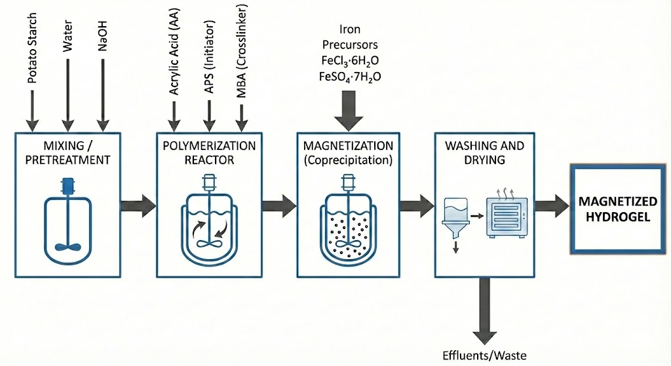
Figure 1: Scheme of the magnetic hydrogel production process
    - Inherent Safety Analysis
This metric enables an objective comparison of design alternatives in the early stages of development. The ISI is calculated using Eq(1), where 𝐼_{𝑐ℎ} represents the index associated with the chemical properties of the materials, including factors such as heat of reaction, toxicity, flammability, explosivity, and the possibility of unwanted reactions, while 𝐼_{𝑝𝑠} evaluates the risks related to the design and operation of the process, considering parameters such as maximum temperature and pressure, the inventory of hazardous substances, the complexity of the system, and the degree of integration between operations. The Chemical Inherent Safety index (𝐼_{𝑐ℎ}) is determined from Eq(2) while the Process Safety Index (𝐼_{𝑝𝑠}) is determined from Eq. (3). In Eq(2), 𝐼𝑟s𝑚𝑎𝑥 represents the main chemical reaction indicator, 𝐼𝑟s𝑚𝑎𝑥 secondary chemical reaction, 𝐼𝑖𝑛𝑡𝑚𝑎𝑥 chemical interaction, (𝐼𝑓𝑙 + 𝐼𝑒𝑥 + 𝐼𝑡𝑜𝑥)𝑚𝑎𝑥 the maximum sum of flammability, explosiveness and toxicity of the substances and 𝐼𝑐𝑜𝑟𝑚𝑎𝑥 represents corrosivity. In Eq(3), 𝐼_{𝐼} represents the inventory indicator, 𝐼_{𝑇}𝑚𝑎𝑥 maximum process temperature, 𝐼_{𝑝}𝑚𝑎𝑥 maximum process pressure, 𝐼_{𝐸𝑄}𝑚𝑎𝑥 equipment risk factor, and 𝐼_{𝑆𝑇}𝑚𝑎𝑥 safe process structure. Each sub-index's value is assigned based on the specific weights outlined in Table 1.

𝐼𝑆𝐼 = 𝐼_{𝑐ℎ} + 𝐼_{𝑝𝑠} | (1)
𝐼_{𝑐ℎ =} 𝐼𝑟𝑚𝑚𝑎𝑥 + 𝐼𝑟𝑠𝑚𝑎𝑥 + 𝐼𝑖𝑛𝑡𝑚𝑎𝑥 + (𝐼𝑓𝑙 + 𝐼𝑒𝑥 + 𝐼𝑡𝑜𝑥)𝑚𝑎𝑥 + 𝐼𝑐𝑜𝑟𝑚𝑎𝑥 | (2)
𝐼_{ps =} 𝐼_{𝐼} + 𝐼_{𝑇}𝑚𝑎𝑥 + 𝐼_{𝑝}𝑚𝑎𝑥 + 𝐼_{𝐸𝑄}𝑚𝑎𝑥 + 𝐼_{𝑆𝑇}𝑚𝑎𝑥 | (3)
Table 1: Summary of the inherent safety sub-indices and their score ranges
Subindex | Symbol | Score
Heat of primary reaction | 𝐼𝑟𝑚 | 0-4
Heat of secondary reaction | 𝐼𝑟𝑠 | 0-4
Chemical interaction | 𝐼𝑖𝑛𝑡 | 0-4
Flammability | 𝐼𝑓𝑙 | 0-4
Explosiveness | 𝐼𝑒𝑥 | 0-4
Toxic exposure | 𝐼𝑡𝑜𝑥 | 0-6
Corrosivity | 𝐼𝑐𝑜𝑟 | 0-2
Inventory | 𝐼_{𝐼} | 0-5
Process temperature | 𝐼_{𝑇} | 0-4
Process pressure | 𝐼_{𝑃} | 0-4
Equipment safety | 𝐼𝐸𝑄 | 0-4 (ISBL); 0-3 (OSBL)
Safe structure | 𝐼𝑆𝑇 | 0-5

Chemical reactivity is assessed based on the enthalpy of reaction (∆𝐻_{𝑓}), using the highest values observed in both the primary (main product formation) and secondary reactions (not involved in the main product). These sub-indicators evaluate how exothermic a reaction is, with scores ranging from 0 for endothermic reactions (∆𝐻_{𝑓}$≈$0 𝑗/𝑔) to 4 for highly exothermic reactions (∆𝐻_{𝑓}≤−3000 𝑗/𝑔). Chemical interactions describe unintended reactions among chemicals outside the reactors; the score depends on the severity of possible interactions such as fire (score 4), formation of flammable or toxic gases (score 2 or 3), explosions (score 4), rapid polymerization (score 2 or 3), and heat release (score 1 or 3). Flammability assesses how easily a substance can ignite, based on its flash point or boiling point (°C), from nonflammable (score 0) to very flammable (score 4, flash point below 0°C). Explosiveness gauges a gas’s propensity to create explosive air mixtures, measured by the difference between upper and lower explosion limits (UEL-LEL %) — from 0 for nonexplosive to 4 for highly explosive, with a 70–100% difference. Toxicity is assessed using the threshold limit value (TLV), expressed in ppm; lower TLV values indicate greater hazard, ranging from 0 for TLV ≥10,000 ppm to 6 for TLV ≤0.1 ppm. Corrosivity reflects the risk of material degradation in equipment, with higher-resistance materials scoring higher (0 for carbon steel to 2 for specialized materials).
The inventory subindex assesses risks associated with maintaining specific quantities of substances, applicable within the internal or inside battery limit (ISBL) and the external or outside battery limit (OSBL). These geographical zones define the boundaries of particular processes. The ISBL covers core operations that convert raw materials into products, characterized by dense equipment and piping in a confined space. Conversely, the OSBL includes auxiliary systems, such as storage and utilities, which typically occupy larger open areas. It is based on equipment capacities or flow rates over time (t/h), with the ISBL score ranging from 0 for flows under 1 t/h to 5 for flows of 500 t/h or more. Temperature indicates the system's thermal energy and is classified by the highest process temperature: 0 for 0–70°C, 1 for 70-150 °C, and so forth until reaching 4 for temperatures above 600°C. Pressure assesses potential leakage risks, with scores based on vacuum or process pressure: 0 for pressures between 0.5 and 5 bar, and 4 for pressures exceeding 200 bar. The equipment safety subindex assesses risk by equipment type. Values range from 0 for handling nonflammable, non-toxic materials, up to 4 for furnaces and air heaters. The safe process structure subindex evaluates operational risks from a system engineering perspective, focusing on how well the system functions as a whole. This complex score depends on historical data like safety audits, inspection reports, maintenance records, and accident reports. It ranges from 0 for standard/recommended processes to 5 for setups with confirmed major accidents.
The ISI estimates are conducted using a worst-case scenario approach, which assumes the most hazardous possible conditions. A lower index indicates an inherently safer process. Calculations account for the maximum values of the flammability, explosivity, and toxicity sub-indices, as well as the highest expected inventory, process temperature, and pressure. The worst interaction between chemicals or equipment and the most severe process structure determines these sub-indices. Finally, an 𝐼𝑆𝐼 value below 24 indicates an intrinsically safer process, while a higher value indicates an unsafe operation (Heikkilä, 1999).
  - Results and discussion
    - Chemical Inherent Safety
𝐼𝑟𝑚 = 2 and 𝐼𝑟s=1 were achieved in the heat-of-reaction subindex for the main and secondary reactions of the process, respectively (see Table 2). Score 2 stands for a modest reaction for the grafting process, while score 1 is a slightly exothermic reaction, as in the in situ coprecipitation of magnetite. Jacketed reactors with improved heat removal, distributed temperature monitoring, and tighter control of operating conditions are recommended. Additionally, semi-batch dosing of reactive species would also be beneficial.

Table 2: Reactions and heat of reactions of the process
Reaction | Type of Reaction | ΔH_{r}​ (J/g)
Grafting | Main  $$Starch-O^{-}+n\left({CH}_{2}​=CHCOOH\right)⟶Starch-g-{PAA}^{-}$$ | -1075.5
Co-precipitation | Secundary  $$Fe{SO}_{4}+2Fe{Cl}_{3}+8{NH}_{3}+4H_{2}​O⟶{Fe}_{3}O_{4}+6{NH}_{4}Cl+{{(NH}_{4})}_{2}{SO}_{4}$$ | -466.5

The inherent safety assessment considers the worst-case scenario of contact between Ammonium Persulfate and Ethanol, as this mixture increases the potential for fire and explosion (𝐼𝑛𝑡 = 4). While engineering controls can prevent this mixing, the inherent safety index assesses hazard based on the chemical characteristics of substances in the plant inventory. Regarding the hazardous substances subindex, toxicity, explosiveness, and flammability indicators were scored using updated safety data sheets from sources such as NOAA's Chemical Effects Research Information System, INCHEM (World Health Organization), and the National Institute for Occupational Safety and Health. Table 3 highlights some high-risk substances and their inherent properties. Notably, acrylic acid is identified as the most hazardous with a total score of 7.

Table 3: Subindex for hazardous substances
Substance | Physicochemical data | 𝐼𝑓𝑙 | 𝐼𝑒𝑥​ | 𝐼𝑡𝑜𝑥​
Acrylic Acid | Flash Point: 54°C, Explosiveness: 2.4% - 8.0%  Toxicity (TLV): 2 ppm | 2 | 1 | 4
Ethanol | Flash Point: 13°C, Explosiveness: 3.3% - 19.0%  Toxicity (TLV): 1000 ppm | 3 | 1 | 2
Ammonia | Flash Point: NA, Explosiveness: 15.0% - 28.0%  Toxicity (TLV): 25 ppm | 0 | 2 | 3
Ammonium Persulfate | Flash Point: NA, Explosiveness: NA  Toxicity (TLV): 0.01 ppm | 0 | 0 | 6
Sodium Hydroxide | Flash Point: NA, Explosiveness: NA  Toxicity (TLV): 1.2 ppm | 0 | 0 | 4
MBA | Flash Point: 138°C, Explosiveness: NA  Toxicity (TLV): NA | 1 | 0 | 0
Ferrous sulfate | Flash Point: NA, Explosiveness: NA  Toxicity (TLV): 0.3 ppm | 0 | 0 | 5
Ferric Chloride | Flash Point: 160°C, Explosiveness: NA  Toxicity (TLV): 0.2 ppm | 1 | 0 | 5

Regarding the Subindex of corrosivity, ferric chloride was found to be the compound requiring the most caution, as it is a strong oxidizer that induces localized corrosion in common stainless steels; therefore, it is not recommended to store it in carbon steel, and 304/316 stainless steels are generally a poor choice, leading to special materials —score 2 in I_{cor}— for its storage (Otero et al., 1995). Finally, as shown in Figure 2, the chemical safety index shows that chemical interactions and the hazardous substances subindex are the main concerns.
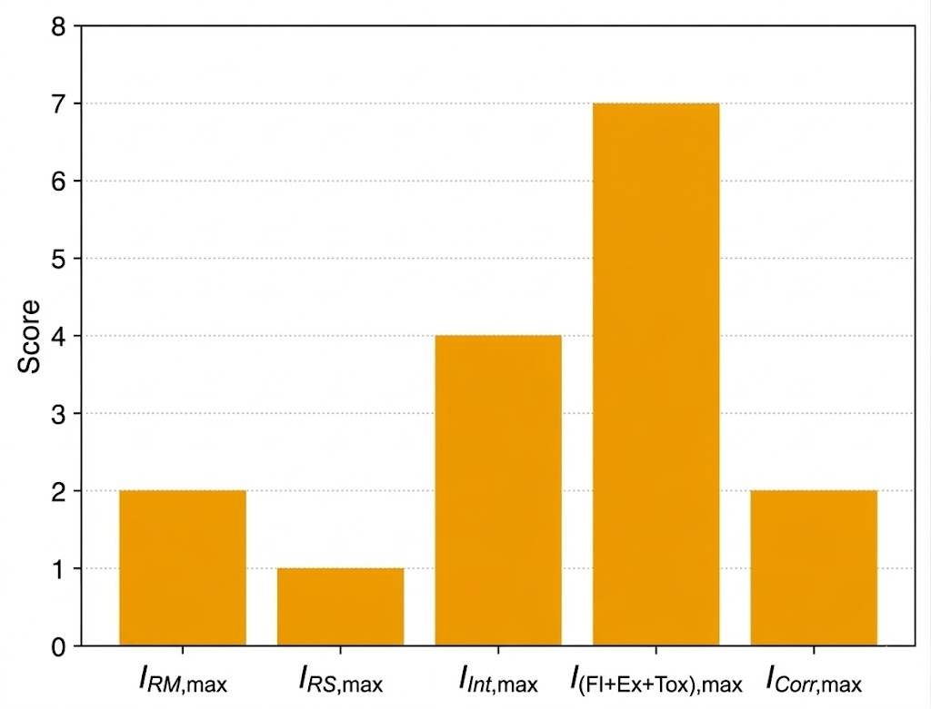
Figure 2: Chemical safety indicators for the production of magnetic hydrogel
    - Process Inherent Safety
For the inventory sub-indicator, only the internal battery of the process (ISBL) was included, as OSBL was not defined; that process area is addressed in later design stages, such as detailed engineering. In this analysis, the mass within each piece of process equipment was measured over a hydraulic retention time of 1 h. As described in section 2.1, the highest pressure and temperature of the study process are 1 atm and 80°C. While the total mass inventory of the process was 316.17 t, as detailed in the supplementary material of our previous study (Alviz-Meza et al., 2025). As a consequence, 𝐼_{𝐼} = 4, 𝐼_{T, max}= 1, and 𝐼_{P,max}=0.
Furthermore, regarding the process equipment safety sub-indicator, it is considered that, although the grafting and crosslinking reactions of acrylic acid are highly exothermic —runaway polymerization risk—, the reactors can be considered high-risk because once runaway polymerization begins, restoring normal conditions is difficult because the gel effect auto-accelerates the reaction due to the viscous medium and high heat rate production (Fujita et al., 2019). Therefore, despite the low pressure and high dilution of these processes, their exothermic nature justifies classification in the high-risk reactor category (𝐼𝐸𝑄=3).
Finally, the score assigned to the process safety sub-index is I_{ST} = 3, indicating that the overall plant configuration is based on a likely unsafe process. Even with inherently safe alternatives to mitigate risks, the possibility of a runaway polymerization reaction demands a less conservative approach to evaluating this index. Particularly during the radical polymerization stage —AA + APS + MBA— in a gelling medium, the reaction can self-accelerate, making it difficult to return to normal conditions if a runaway occurs. The process flow —alkaline pretreatment, grafting, crosslinking, and coprecipitation— comprises a sequence of unit operations sensitive to temperature control, dosing, and inerting. Furthermore, some industrial accidents associated with AA polymerization processes have been reported (Kalfas et al., 2009). As shown in Figure 3, for the process safety index, inventory, equipment safety, and structural safety are the primary concerns.
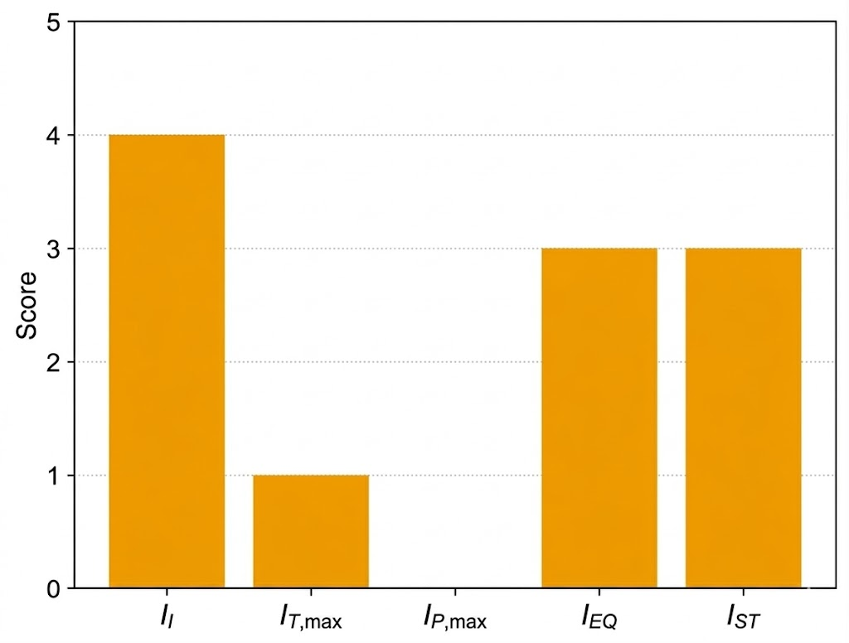
Figure 3: Process safety indicators for the production of magnetic hydrogel
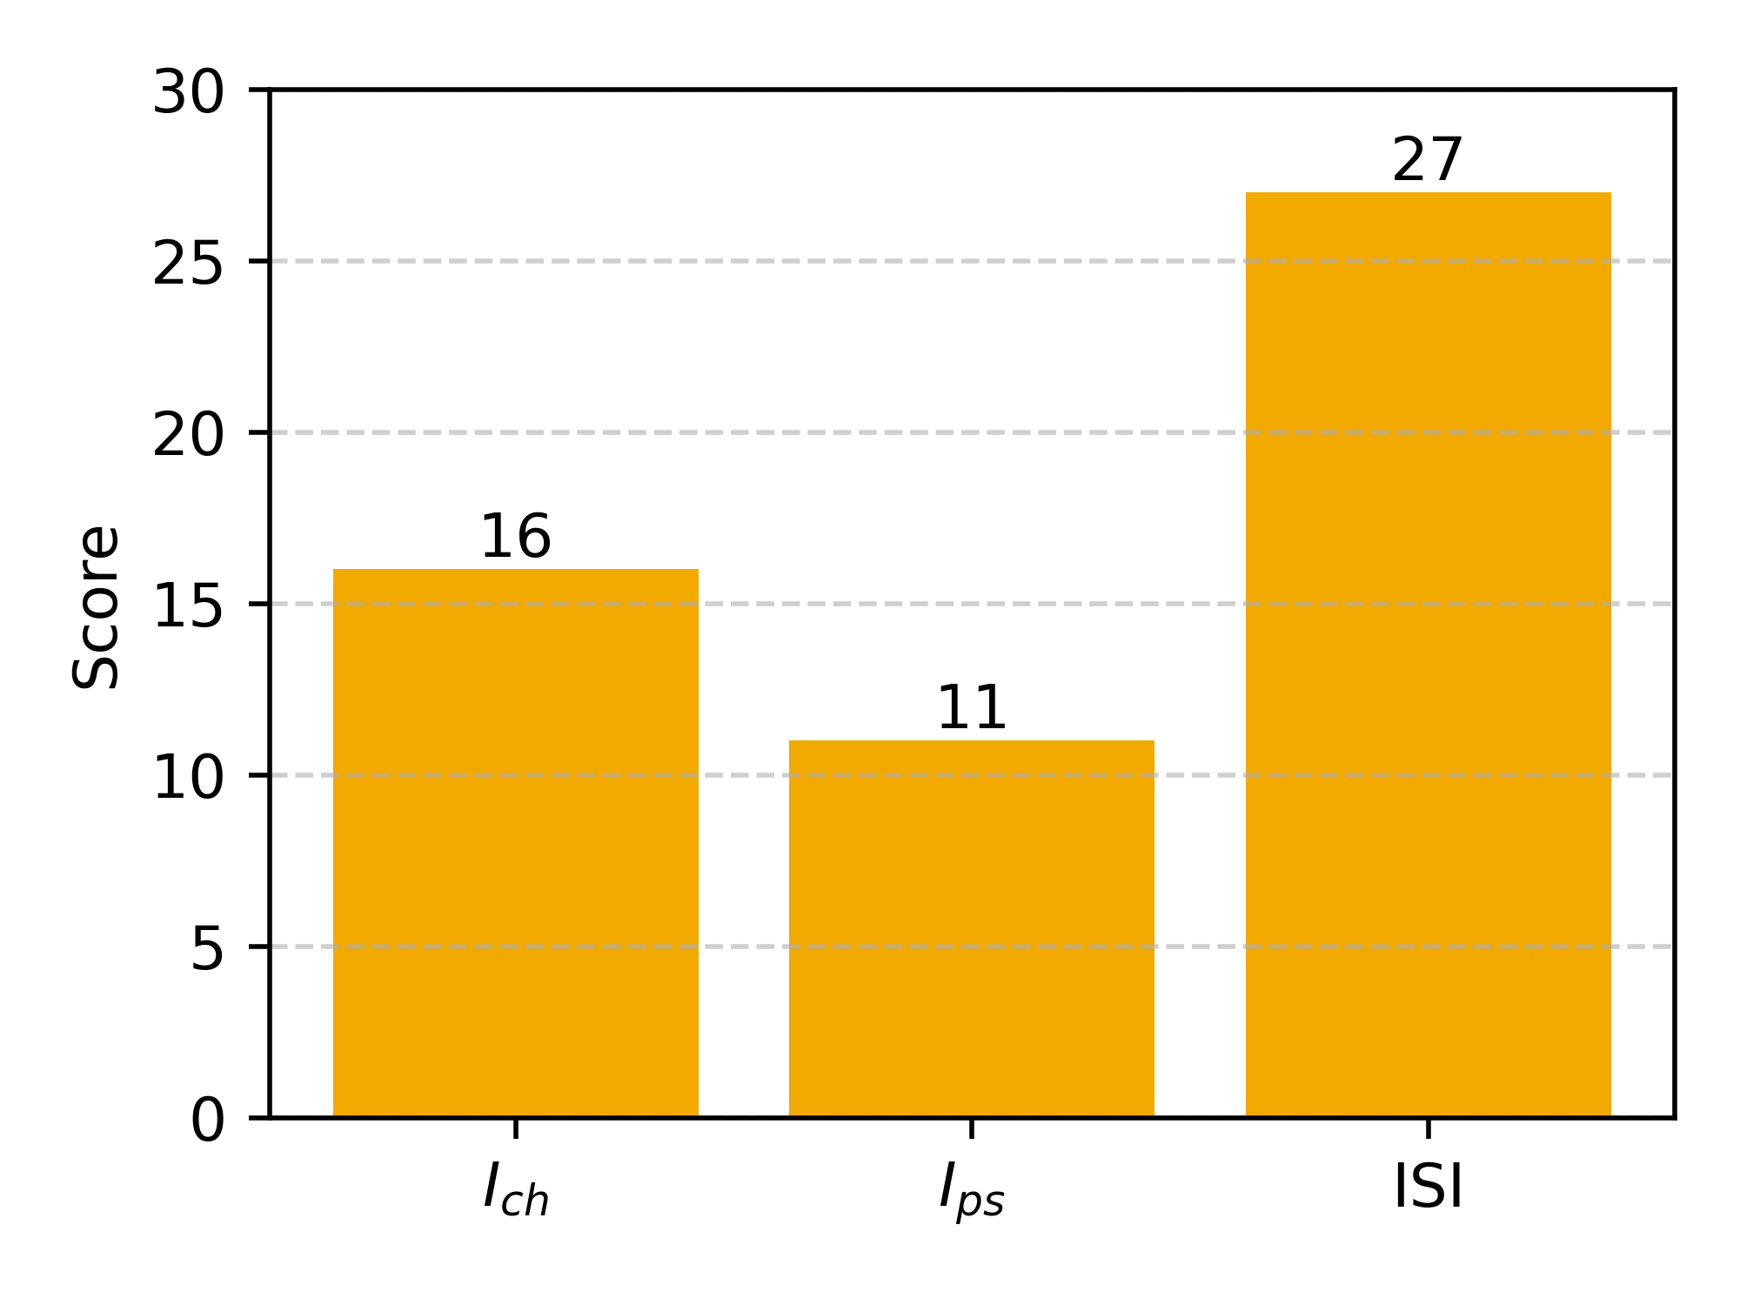
The analysis yields 𝐼_{𝑐ℎ} = 16 for chemical inherent safety and 𝐼_{𝑝𝑠} = 11 for process inherent safety, for a total of 27 (see Figure 4), indicating that the process of producing magnetic hydrogels from native Peruvian potato peel starch is intrinsically unsafe. In bioprocesses for the manufacture of hydrogels or comparable polymers, the industrial production of TiO₂-modified chitosan microspheres has been evaluated with an ISI of 28 (I_{ch} = 16; I_{ps} = 12), indicating a risk level comparable to handling titanium isopropoxide (Meramo-Hurtado et al., 2021). In industrial polymerization processes, higher scores are expected. For instance, PVC suspension production reports an ISI of 30 (I_{ch} = 19; I_{ps} = 15), driven by inventories, critical equipment, and the hazards of vinyl chloride (González-Delgado et al., 2023). All of these processes would be classified as inherently unsafe due to the potentially hazardous reagents used in polymerization. Finally, since the data in this study are based on simulations, this risk estimate is only an approximation that provides a partial risk profile for extrapolating to the industry as a whole.
Figure 4: ISI for the production of magnetic hydrogel
  - Conclusions
This study presents a safety profile for the large-scale production of magnetized hydrogels from Peruvian yellow potato peel waste. Using process simulation and the Inherent Safety Index (ISI) methodology, the proposed technological route was found to operate at a potentially hazardous risk level, with a score of 27, primarily due to the use of acrylic acid. Even so, this process is presented as a viable alternative for preparing magnetic hydrogels for use as adsorbents for contaminants in aqueous media.
References
Alviz-Meza A., Carranza-Oropeza M.V., Gonzalez-Delgado A.D., 2025, Techno-Economic Assessment and FP2O Technical–Economic Resilience Study of Peruvian Starch-Based Magnetized Hydrogels at Large Scale, Sci, 7, 181
Bhuyan M.M., Dafader N.C., Hara K., Okabe H., Hidaka Y., Rahman M.M., Khan M.M.R., Rahman N., 2016, Synthesis of Potato Starch-Acrylic-Acid Hydrogels by Gamma Radiation and Their Application in Dye Adsorption, International Journal of Polymer Science, 2016, 9867859
Fujita M., Izato Y., Iizuka Y., Miyake A., 2019, Thermal hazard evaluation of runaway polymerization of acrylic acid, Process Safety and Environmental Protection, 129, 339–347
Gao X., Abdul Raman A.A., Hizaddin H.F., Bello M.M., Buthiyappan A., 2021, Review on the Inherently Safer Design for Chemical Processes: Past, present and future, Journal of Cleaner Production, 305, 127154
Gonzalez-Delgado A.D., Aguilar-Vásquez E., Ramos-Olmos M., 2023, Chemical and Process Inherent Safety Analysis of Large-Scale Suspension Poly(Vinyl Chloride) Production, ChemEngineering, 7, 76
Heikkilä A. M., 1999, Inherent Safety in Process Plant Design: An Index-Based Approach, VTT Publications, Vol 384, Espoo, Finland
Jeong G., Nam M., Kim J., Yoo B.T., 2025, Study on Risk Mitigation Measures for Atmospheric Storage Tank of Acrylic Acid Due to Abnormal Weather Conditions, Processes, 13, 1607
Kalfas G., Krieger T., Wilcox R., 2009, Improvements in the Safety Screening of Resin Manufacturing Processes, Process Safety Progress, 28, 275–281
Meramo-Hurtado S., Ceballos-Arrieta N., Cortes-Caballero J., Leon-Pulido J., Gonzalez-Quiroga A., Gonzalez-Delgado Á.D., 2021, Inherent Safety Assessment of Industrial-Scale Production of Chitosan Microbeads Modified with TiO₂ Nanoparticles, Biomolecules, 11, 568
Otero E., Pardo A., Utrilla M.V., Saenz E., Perez F.J., 1995, Influence of Microstructure on the Corrosion Resistance of AISI Type 304L and Type 316L Sintered Stainless Steels Exposed to Ferric Chloride Solution, Materials Characterization, 35, 145–151
Palaniappan C., Srinivasan R., Tan R.B., 2002, Expert System for the Design of Inherently Safer Processes. 2. Flowsheet Development Stage, Industrial and Engineering Chemistry Research, 41, 6711–6722
Zuorro A., Moreno-Sader K.A., Gonzalez-Delgado A.D., 2021, Inherent Safety Analysis and Sustainability Evaluation of Chitosan Production from Shrimp Exoskeleton in Colombia, Water, 13, 5

