 CHEMICAL ENGINEERING TRANSACTIONS  VOL. xxx, 2026 | A publication of  
The Italian Association
of Chemical Engineering
Online at www.cetjournal.it

Guest Editors: Leonardo Tognotti, Rubens Maciel Filho, Viatcheslav Kafarov
Copyright © 2026, AIDIC Servizi S.r.l.
ISBN 979-12-81206-xx-x; ISSN 2283-9216
Experimental Investigation of Gas-Liquid Hydrodynamics in a Pilot-Scale Stirred Vessel with Non-Newtonian Fluids for biomethane production applications
Federico Alberini*, Giuseppina Montante, Alessandro Paglianti

Department of Industrial Chemistry ‘Toso Montanari’, University of Bologna, Via Piero Gobetti 85, 40129, Bologna, Italy.
Corresponding author: federico.alberini@unibo.it
Accurate understanding of gas–liquid systems involving non-Newtonian fluids is essential for the design and optimization of processes such as biomethane production. In this work, a pilot-scale stirred tank was experimentally investigated to assess the influence of non-Newtonian rheology on power consumption and bubble dynamics under gassed conditions. The system consisted of a baffled cylindrical vessel (T = 0.48 m) equipped with a Rushton turbine, using air as the dispersed phase. Carboxymethyl cellulose (CMC) solutions at concentrations of 0.25% and 0.5% w/w were employed to simulate shear-thinning fluids representative of anaerobic digestion media. Rheological measurements confirmed pronounced shear-thinning behavior, with increasing consistency index and decreasing flow behavior index at higher polymer concentrations. Power consumption was significantly affected by fluid rheology, while gas injection led to a reduction in power number for both solutions. Surface tension values remained close to those of water, indicating a limited contribution of interfacial effects. Bubble size distributions, obtained through optical imaging and image analysis, showed a clear shift toward smaller and more uniform bubbles in CMC solutions compared to water. This behavior suggests that bubble breakup and coalescence are primarily governed by rheological properties rather than surface tension variations.
  - Introduction
Multiphase gas-liquid systems are widely encountered in industrial applications such as biomethane production, where mass transfer, mixing, and reaction rates strongly depend on hydrodynamic conditions (Jensen et al., 2021). The description of these systems is therefore essential for process design and optimization. In recent years, computational fluid dynamics (CFD) has become a valuable tool for analyzing and predicting the behavior of such systems (Wu, 2013). However, its predictive capability is closely linked to the availability of reliable experimental data for model development and validation. The situation becomes more complex when the liquid phase exhibits non-Newtonian behavior, as commonly observed in slurries, fermentation broths, and other process fluids. In these cases, the apparent viscosity depends on the local shear rate, which varies significantly within the reactor. This introduces additional challenges in both experimental characterization and numerical modelling. In particular, the coupling between flow field and rheology leads to strongly non-linear system behavior, which is difficult to capture using conventional modelling approaches. Most CFD models for gas-liquid systems rely on closure relations originally developed for Newtonian fluids (Li et al., 2025). Therefore, they often fail to properly describe key phenomena such as shear-dependent viscosity, viscoelastic effects, and their influence on bubble breakup, coalescence, and size distribution. This limitation highlights the need for new modelling strategies supported by experimental data specifically obtained for non-Newtonian systems. Relevant quantities typically include gas holdup, bubble size distribution, local void fraction, and power consumption (Niño, 2022; Shiue et al., 2025). In this context, pilot-scale experiments play an important role by providing data under conditions closer to industrial operation compared to laboratory-scale studies. They allow for a more realistic representation of flow regimes, turbulence levels, and bubble interactions, which are influenced by both Reynolds number and fluid rheology. This is particularly relevant for understanding the interplay between turbulence, bubble dynamics, and non-Newtonian properties in gas–liquid systems. In the present work, experimental measurements were carried out in a pilot-scale stirred vessel with a tank diameter of 0.48 m, equipped with a Rushton turbine installed at a clearance ratio C/T = 0.5. Shear-thinning fluids were reproduced using CMC solutions, which are commonly adopted as model fluids for anaerobic digestion processes (Singh et al., 2020). The experimental campaign included power consumption measurements over a range of operating conditions, both in single-phase and gas-liquid regimes. In addition, bubble size distributions were determined through optical imaging techniques, providing further insight into the effect of rheology on gas dispersion.
  - Material and methods
In this work, a representative stirred configuration commonly adopted in the literature was selected. The system consists of a cylindrical vessel with a tank diameter T=0.48 m, equipped with four vertical baffles of width equal to T/10 and a flat bottom. Mixing is provided by a Rushton turbine driven by an electric motor (M). The impeller diameter is D=T/3; both the disk and blade thickness are equal to 0.0029 m. The impeller is positioned at a clearance, C, such that C/T=1/2. For all experiments, the liquid filling height was fixed at H/T=1.4, corresponding to a liquid volume V=122 L. A schematic of the system is shown in Fig. 1. As illustrated, a gas sparger is located below the impeller to supply air to the liquid. The sparger outlet is positioned at 0.18 T from the bottom tank. The sparger has a diameter of approximately 0.2 T and is equipped with 36 evenly distributed holes.
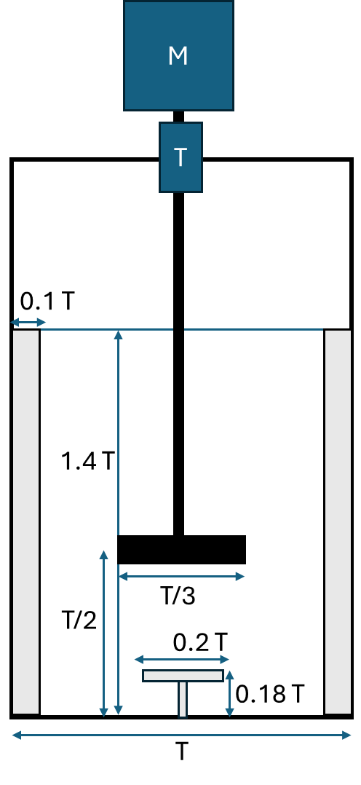
Figure 1: Experimental rig set-up: vessel configuration.
To perform the BSD analysis, a digital camera was used and positioned at a suitable distance from the vessel wall to ensure a sufficiently wide field of view. The distance between the camera and the vessel surface was 0.207 m. The analyzed area includes a section (interrogation zone) of the vessel wall located between 0.41 m and 0.49 m from the bottom of the vessel, with a width of 0.08 m and a radial position relative to tank center of 0.24 m. The camera was focused on the vessel wall to capture only the bubbles near the inner wall, while excluding those present in the bulk of the system. The images are obtained using the principle of backlighting, by positioning the light source opposite the camera, with the vessel placed between them. The acquisition procedure is based on capturing images of bubbles within the interrogation zone. The first step in the image analysis was the calibration obtaining a scale factor relating pixel dimensions to the actual system dimensions. For this purpose, a ruler was placed inside the vessel, and a single image was acquired and used as the calibration image. The bubble size distribution (BSD) was obtained by post-processing the acquired images using the DynamicStudio 7.6 software and the Adaptive Shadow Tracking (AST) algorithm (Maluta et al., 2023). The bubble detection principle is based on isolating and measuring the bubble boundaries produced by the bubbles under back-illumination. Prior to shadow segmentation, a filter was applied to remove random Gaussian noise. Out-of-focus bubbles were excluded from the analysis, and a minimum allowable bubble eccentricity of 0.5 was imposed. The eccentricity was defined as the ratio of the bubble minor axis to its major axis. More details about the methodology can be found in previous work (Alberini et al, 2024). The mimic continuous phase fluids used in this work were Carboxy methyl cellulose (CMC) dispersions, precisely 0.25% and 0.5% w/w. The range of the impeller speeds investigated, was between 3 to 7 rps and the gas flow rate was between 10 to 60 L min⁻¹. The CMC solutions rheology was determined by an Anton Paar Physica MCR301 rotational rheometer, using a stainless-steel hollow bob B-DG26 and cup C-DG26/SS according to DIN 54453. For each solution of CMC, the shear rate was varied between 0.1 s⁻¹ and 500 s⁻¹ and a flow ramp was obtained. The measurements were carried out in triplicates at T=22°C. Moreover, the surface tension of the CMC solutions was measured using a Krüss K10ST tensiometer equipped with a Du Noüy ring. Measurements were carried out to determine the surface tension under equilibrium conditions for the different CMC concentrations. Surface tension measurements were repeated three times at 22°C to assess repeatability. Finally, power measurements were obtained using an in-line Kistler 4502.020RAU torque sensor (20 Nm range), which provided instantaneous torque (Γ) and rotational speed (N) (Mandolini et al., 2023).
  - Results and discussion

The mimic fluids, exhibiting non-Newtonian rheology with shear-thinning behaviour, representative of feed characteristics typically encountered in biomethane anaerobic digestion processes, are often described by a power law rheological model as showed in eq.1.
$$τ=K γ^{n}$$ | (1)
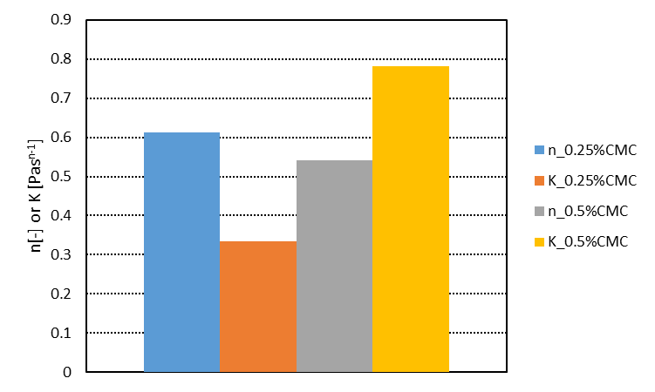
Fluid | n [-] | K [Pa s^{n-1}] | % error
0.25% w/w CMC in water | 0.61 | 0.33 | 8.89
0.5% w/w CMC in water | 0.54 | 0.78 | 4.23
Figure 2: Rheological power law parameters for mimic fluids obtained using CMC solutions.

Figure 2 reports the values of the power-law rheological parameters, namely the flow behavior index (n) and the consistency index (K), obtained for CMC solutions at concentrations of 0.25% and 0.5% w/w. For both concentrations, the flow behavior index is lower than unity, confirming the shear-thinning (pseudoplastic) nature of the fluids. Increasing the CMC concentration from 0.25% to 0.5% leads to a decrease in n, indicating a more pronounced shear-thinning behavior at higher polymer content. At the same time, the consistency index K increases significantly with concentration, reflecting the increase in apparent viscosity and resistance to flow. Overall, these results are consistent with the expected rheological behavior of CMC solutions, where higher polymer concentrations enhance fluid consistency while intensifying non-Newtonian effects.

a) | b)
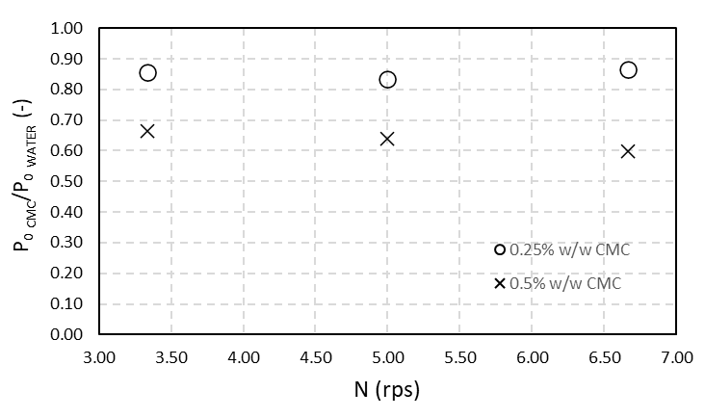 | 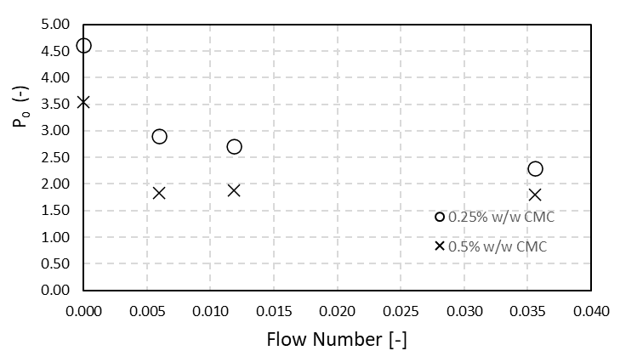
Figure 3: Power consumption (P): a) ratio between Power number for the CMC solution over the power number for only water without gas, where the Po is defined as $Po=\frac{P}{ρN^{3}D^{5}}$; effect of gas flow rate at fixed impeller speed at N=3 rps , flow numbers ($Fl=\frac{Q_{g}}{ND^{3}}$) versus the power number.

Figure 3a shows the trend of the power number ratio, between CMC solutions and water, as a function of the impeller rotational speed N, with the gas flow rate set to zero.
For both CMC concentrations (0.25% and 0.5% w/w), the power number ratio remains relatively constant over the investigated range of rotational speeds, indicating a weak dependence on N, as previously observed is similar system by Shiue et al. (2025). However, the ratio is consistently lower for the 0.5% w/w CMC solution compared to the 0.25% w/w solution, reflecting the stronger non-Newtonian effects and higher apparent viscosity at the higher polymer concentration, which reduces the power number relative to water, which is an indication that the regime in the vessel is shifted in the transitional regime. Shiue et al. (2025) observed a similar trend; particularly larger impeller speeds were required as the viscosity rises due to shear-thinning characteristics. Figure 3b presents the power number as a function of gas flow rate at a constant rotational speed of N=3 rps. For both CMC solutions, the power number decreases as the gas flow rate increases, demonstrating the typical gas-induced power reduction due to gas holdup, gas accumulation on the rear of the impeller blades and reduced effective liquid density around the impeller. Moreover, this suggests that the rheology affects the power, gas hold-up, and most likely the mass transfer as observed previously by throughout the Shiue et al. (2025). At all gas flow rates, the 0.25% w/w CMC solution exhibits higher power numbers than the 0.5% w/w solution, again indicating that increasing CMC concentration leads to lower power number under gassed conditions. Overall, the results highlight that CMC concentration has a stronger influence on power number than impeller speed in un-gassed conditions, while gas flow rate significantly affects the power number for both solutions at fixed rotational speed.
The recorded averaged values of the surface tension (Table 1) show a small but noticeable variation, which is only slightly lower than that of pure water at the same temperature. This indicates that, at this concentration, CMC exhibits a limited surface-tension-reducing effect. The observed variability is consistent with the known sensitivity of the Du Noüy ring method and the time-dependent surface adsorption behavior of polymer solutions. Repeating the measurement three times improves confidence in the result and highlights the importance of consistent equilibration time, careful ring cleaning, and stable temperature control were used to minimize experimental uncertainty.
Table 1: Surface tension for the CMC solutions
 | 0.25%w/w CMC | 0.5%w/w CMC
Surface tension  [mN/m] | 71.2 | 68.6
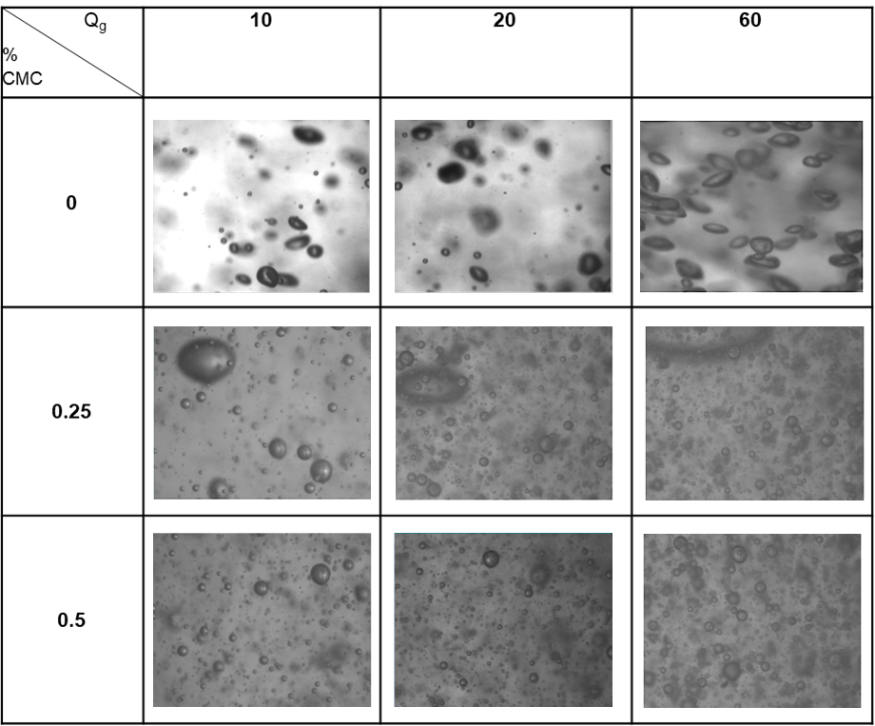
Figure 4: Selected images for different flow numbers with N=5 rps varying gas flow rate (Q_{g}, in L/min) and the percentage of CMC on the continuous phase.
Figure 4 presents selected images acquired at a constant rotational speed of N = 5 rps, illustrating the effect of gas flow rate (Q_{g}) and CMC concentration in the continuous phase on bubble size and morphology. At 0 CMC content (hence water as continuous phase) and for the different gas flow rates, the system is characterized by larger, more irregular bubbles and frequent bubble interactions, indicating active breakup and coalescence processes. As the gas flow rate increases, bubble density increases and deformation becomes more pronounced due to enhanced hydrodynamic stresses. Conversely, increasing the CMC percentage in the continuous phase leads to a clear transition toward smaller, more uniformly distributed bubbles, with reduced evidence of coalescence even at higher gas flow rates. This behavior is consistent with the rheological properties of CMC solutions, where increased viscosity and viscoelastic effects damp interfacial motion and stabilize bubbles against coalescence. The qualitatively visual observations are supported by the quantitative cumulative density function (CDF) analysis, showed in Figure 5.
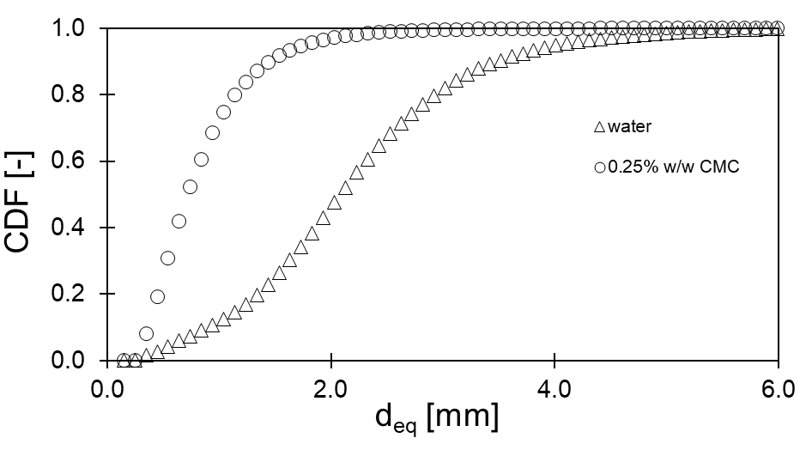
Figure 5: Selected results for a gas flowrate of 60 L/min and N=5 rps. Comparison of CDF distributions for the equivalent diameters using water and 0.25% w/w CMC solution as continuous phases.

Figure 5 compares the cumulative density function (CDF) of equivalent bubble diameters obtained using water and a 0.25% w/w CMC solution as continuous phases at a gas flow rate of 60 L/min and a rotational speed of N = 5 rps. The CDF for the CMC solution is clearly shifted toward smaller equivalent diameters compared with water, indicating the presence of different dynamics in the system and the formation of smaller bubbles. This behavior is not explained only with the surface tension measurements, which showed only a slight reduction in surface tension for the 0.25% w/w CMC solution (≈70 mN/m) relative to pure water at 22 °C. Since the surface tension remains close to that of water, interfacial tension reduction alone cannot account for the observed shift in bubble size. Instead, the results suggest that the increased viscosity and elastic effects of the polymer solution play a dominant role in suppressing bubble coalescence. Together, the surface tension and CDF results indicate that, at this concentration, CMC influences bubble dynamics primarily through rheological effects rather than interfacial tension reduction. Similar results were observed also with the other CMC solution.
These findings are especially important for numerical simulation purposes, as they highlight the limitations of models that rely solely on surface tension-based correlations for bubble breakup and coalescence when non-Newtonian fluids are involved. For CMC solutions, accurate simulations must account for non-Newtonian rheology, viscoelastic stresses, and their influence on interfacial dynamics, which directly affect bubble size distributions. Neglecting these effects may lead to significant discrepancies between predicted and experimental results, even when surface tension values are like those of water. Therefore, the present results emphasize the need for rheology-aware multiphase models when simulating gas–liquid systems involving polymer solutions. Similar trends were also observed for the other CMC solutions investigated, confirming the robustness of this conclusion.
  - Conclusions
This study provides a comprehensive experimental analysis of gas-liquid hydrodynamics in a pilot-scale stirred vessel operating with non-Newtonian, shear-thinning continuous phases. Using CMC solutions as representative mimic fluids, the results demonstrate that fluid rheology plays a dominant role in determining power consumption, bubble morphology, and bubble size distribution under both un-gassed and gassed conditions. While increasing CMC concentration significantly affected apparent viscosity and power number, surface tension measurements showed only minor deviations from that of water, indicating that interfacial tension reduction alone cannot explain the observed changes in bubble dynamics. High-speed imaging and quantitative bubble size distribution analysis revealed a clear transition toward smaller and more uniformly distributed bubbles in CMC solutions, accompanied by a marked suppression of bubble coalescence. These effects are attributed to the shear-dependent viscosity and viscoelastic stresses of the polymeric solutions, which modify local hydrodynamics and interfacial behaviour. Importantly, these findings were consistent across operating conditions and CMC concentrations, confirming the robustness of the observed trends. From a modelling perspective, the results emphasize that conventional multiphase approaches based on Newtonian assumptions and surface tension-driven closures are insufficient to accurately describe gas-non-Newtonian liquid systems. The experimental data presented here provide valuable pilot-scale benchmarks for the development and validation of rheology-aware CFD models that explicitly account for non-Newtonian viscosity and elastic effects. Such models are essential for reliable scale-up and optimization of industrial processes, particularly in applications such as anaerobic digestion and biomethane production, where complex fluid behaviour strongly influences reactor performance.

Nomenclature
C Impeller clearance from the tank bottom (m)
D Impeller diameter (m)
H Liquid height in the vessel (m)
Fl Flow Number (–)
K Consistency index (Pa·s^{n})
n Flow behavior index (–)
N Impeller rotational speed (rps)
P Power consumption (W)
Po Power number (–)
Q_{g} Gas flow rate (L·min⁻¹)
Re Reynolds number (–)
T Tank diameter (m)
V Liquid volume (m³)
ρ density (kg m⁻³)
τ Shear stress (Pa)
γ Shear rate (s⁻¹)

Abbreviations

AST Adaptive Shadow Tracking
BSD Bubble Size Distribution
CDF Cumulative Density Function
CFD Computational Fluid Dynamics
CMC Carboxymethyl Cellulose
rps Revolutions per second (s⁻¹)
w/w weight/weight

Acknowledgments
The contribution of Hélèn Jacquier in carrying out the experimental program is gratefully acknowledged.

References
Alberini, F., Nerini, F., Mandolini, N., Maluta, F., Paglianti, A., Di Pasquale, N.D., Montante, G., 2024, On the reliability of image analysis for bubble size distribution measurements in electrolyte solutions in stirred reactors, Chemical Engineering Journal Advances, 20, art. no. 100658.
Jensen, M.B., Ottosen, L.D.M., Kofoed, M.V.W., 2021, H2 gas-liquid mass transfer: A key element in biological Power-to-Gas methanation, Renewable and Sustainable Energy Reviews, 147.
Li, X., Hu, Q., Zhang, R., Chen, J., Wang, L., Jiang, Z., Hong, C., Liu, H., Ren, L., Li, G., Li, H., & Chen, K. (2025). Enhanced mixing and mass transfer of non-Newtonian fluids for DHA production via Schizochytrium sp. fermentation. Bioresource Technology, 438.
Maluta, F., Alberini, F., Paglianti, A., Montante, G., 2023, Hydrodynamics, power consumption and bubble size distribution in gas-liquid stirred tanks, Chemical Engineering Research and Design, 194, 582 – 596.
Mandolini, N.,Alberini, F.,Maluta, F.,Montante, G.,Paglianti A., 2024, Chemical Engineering Transactions, 110, pp. 289–294.
Niño, L., Gelves-Zambrano, R., Ali, H., Solsvik, J., Jakobsen, H. , 2022, Numerical determination of bubble size distribution in Newtonian and non-Newtonian fluid flows based on the complete turbulence spectrum, Chemical Engineering Science, 253, art. no. 117543.
Singh, B., Szamosi, Z., Siménfalvi, Z., 2020, Impact of mixing intensity and duration on biogas production in an anaerobic digester: a review Critical Reviews in Biotechnology, 40, 508 – 521.
Shiue, A., Hu, Q., Ye, Y. J., Jeng, J. C., Leggett, G. (2025). Gas-liquid mixing performance of a non-Newtonian fluid in a multiple-impeller agitated tank. Journal of Chemical Technology and Biotechnology, 100(1), 104-120.
Wu, B. Advances in the use of CFD to characterize, design and optimize bioenergy systems, 2013, Computers and Electronics in Agriculture, 93, 195 – 208.

