 CHEMICAL ENGINEERING TRANSACTIONS  VOL. xxx, 2026 | A publication of  
The Italian Association
of Chemical Engineering
Online at www.cetjournal.it

Guest Editors: Leonardo Tognotti, Rubens Maciel Filho, Viatcheslav Kafarov
Copyright © 2026, AIDIC Servizi S.r.l.
ISBN 979-12-81206-xx-x; ISSN 2283-9216

GENERATION OF SOLID AND LIQUID BIOFUELS BY PYROLYSIS OF SUGARCANE BAGASSE
Marina C. Fernandes*, Éricles V. Nascimento, Gustavo P. Valença, Telma T. Franco
Process Engineering Department, School of Chemical Engineering – University of Campinas (UNICAMP), Campinas, São Paulo, Brazil
mcampanerfernandes@gmail.com
Several environmental impacts are associated with the intensive use of energy from non-renewable sources, such as fossil fuels. To reduce this dependence, the global demand for renewable alternatives has been increasing. In this context, the Brazilian energy matrix stands out for being predominantly composed of clean sources, a result of favourable climatic and edaphic conditions. Brazil is the world’s largest producer of sugarcane, which makes the biomass from this crop a particularly promising alternative for energy generation. Among its residues, sugarcane bagasse has high energetic potential, as it can be converted into valuable products such as biofuels. The pyrolysis of this residue generates biofuels with lower environmental impact compared to fossil resources, producing three main fractions: biochar, bio-oil (acid extract and bio-oil), and gas. Therefore, the aim of this study was to evaluate the yield of these products from the pyrolysis of sugarcane bagasse, varying the processing time and applied temperature. It was observed that the lowest temperature (400 °C) favoured the formation of solids (biochar), while the intermediate temperature (500 °C) resulted in the highest liquid production. The highest temperature (600 °C), in turn, provided the greatest gas yield. The highest higher heating value (HHV) of the biochar, 31.0 MJ/kg, was obtained at 600 °C. For the bio-oil, the highest HHV, 25.2 MJ/kg, occurred at the intermediate temperature of 500 °C.
  - Introduction
Climate change associated with the intensified use of fossil fuels has raised global concerns. The increased consumption of these non-renewable sources, the depletion of global reserves, and the rise in atmospheric concentrations of pollutant gases, known as greenhouse gases (GHGs), have driven the search for alternative energy sources with lower climatic impact. In this context, the use of biomass as a renewable energy source stands out as a promising strategy for mitigating GHG emissions (Fardhyanti et al., 2022)
Brazil is the world’s largest producer of sugarcane (Nachiluk, K, 2021) and the processing of this raw material generates a significant amount of by-products and residues with high potential for reuse, either for agricultural soil application or for energy purposes. It is estimated that the processing of one metric ton of sugarcane generates approximately 280 kg of bagasse and 170 kg of straw (Embrapa, 2022).
Sugarcane bagasse is a fibrous residue resulting from the milling process used to extract the juice. This material presents favorable physicochemical characteristics for industrial applications, such as low sulfur and ash contents, which, when compared to conventional fuels, contribute to reduced emissions of atmospheric pollutants. In addition, its high cellulose and volatile matter content enhances its performance in energy generation processes (Toscano Miranda et al., 2021).
Among the thermochemical routes for converting biomass into higher value-added products, pyrolysis stands out as a thermal decomposition process carried out in the absence of oxygen, capable of converting biomass into three main products: biochar, bio-oil, and gas (Fardhyanti et al., 2022). Variations in operational conditions allow the formation of each of these fractions to be directed and maximized (Toscano Miranda et al., 2021).
Several studies reported in the literature have investigated the pyrolysis of sugarcane bagasse, evaluating the influence of operational conditions on product yields and properties (Fardhyanti et al., 2022). In general, temperatures around 500 °C favor bio-oil production, while higher temperatures promote an increase in the gas fraction (Sohaib et al., 2017).
However, the combined evaluation of operational parameters, especially temperature and residence time, in relation to product distribution and their energy properties, such as the higher heating value (HHV), is still limited in the literature, highlighting the need for studies that consider the simultaneous effect of these variables on the determination of the energetic potential of the products.
Thus, this study proposes to evaluate the production of biochar, bio-oil, and gas from sugarcane bagasse through the pyrolysis process, as well as their potential use as clean energy sources, based on physicochemical analyses.
  - Methodology
The methodology used in this study is described below.
    - Biomass Characterization
Sugarcane bagasse was obtained from a sugar mill located in the Campinas region, Brazil. The biomass was milled using a CARVOMILL 300 hammer mill to ensure sample homogeneity, followed by particle size distribution analysis. Physicochemical characterization included the determination of moisture content, volatile matter, ash, and fixed carbon, performed in triplicate according to ASTM D1762-8.
    - Pyrolysis process
The pyrolysis process was conducted in a fixed-bed reactor operating in batch mode (Figure 1), under a closed system configuration to minimize the presence of oxygen during the experiments. The reactor was fed with 150 g of sugarcane bagasse, and two independent variables were evaluated: temperature and residence time. The experiments were carried out at temperatures of 400, 500, and 600 °C. The heating time corresponded to the period required for the reactor to reach the desired temperature. The residence time was defined as the time during which the reactor was maintained at the target temperature, with values of 0, 15, and 30 minutes. The time count was initiated once the reactor reached the set temperature. A residence time of 0 minutes indicates that the reactor was turned off immediately after reaching the target temperature, without any holding time. The same procedure was applied for all evaluated temperatures. The yields of the solid (char) and liquid (bio-oil and acidic extract) products were calculated based on Equation 1.
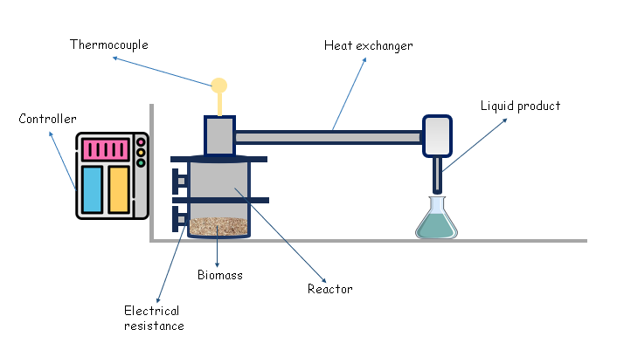
Figure 1: Pyrolysis process of sugarcane bagasse

$$Y_{i} \left(\%\right)=\frac{m_{i}}{{150 }_{g}} x 100 \%$$ | (1)

    - Characterization of Solid and Liquid Products
The obtained char was characterized in terms of moisture, volatile matter, ash, and fixed carbon, according to ASTM D1762-84. This procedure was performed in triplicate. Based on the results of the proximate analysis, it was observed that temperature was the most relevant factor affecting the results when compared to time. Therefore, the char samples obtained at the same temperature were grouped for the determination of the higher heating value, in accordance with ASTM D5865-13. For the liquid product, the phases were separated by decantation, allowing the separation of the acidic extract and the bio-oil. Subsequently, the bio-oils obtained at the same temperatures were grouped, and their higher heating value (HHV) was determined in accordance with ASTM D5865-13. Further details on the experimental procedures can be found in Fernandes (2024).
  - Results and discussions
The results and discussion are presented below.
    - Characterization of Sugarcane Bagasse
The particle size distribution of sugarcane bagasse is presented in Figure 2. The calculated Sauter mean diameter was 0.32 mm, indicating a fine and relatively homogeneous particle profile. The particle size of sugarcane bagasse directly influences product yields in the pyrolysis process. In the study by Sohaib et al. (2017), different particle sizes (0.1, 0.3, and 0.5 mm) were evaluated, and it was observed that larger particle sizes (0.5 mm) favour an increase in biochar and gas yields. Comparable particle sizes for milled sugarcane bagasse have been reported in previous studies, such as that of El-Sayed and Mostafa (2014). Differences in particle size values reported in the literature are commonly related to the milling process.
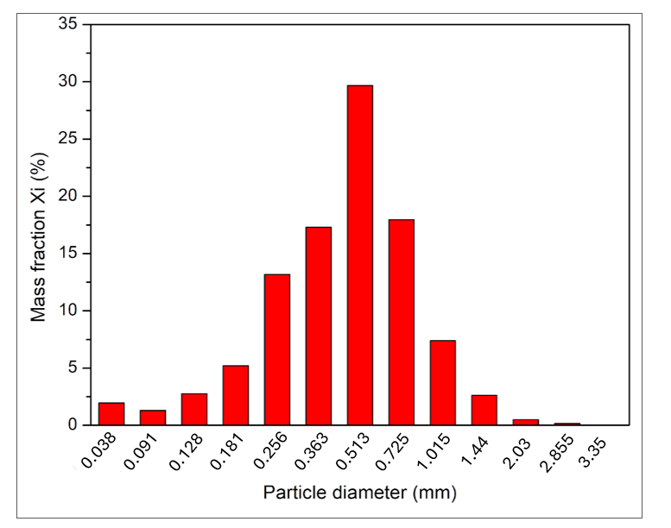
Figure 2: Particle size distribution of sugarcane bagasse

The proximate analysis results of sugarcane bagasse, obtained in triplicate, are summarized in Table 1. The biomass presented a high volatile matter content (approximately 83 %), which is a favourable characteristic for thermochemical conversion processes targeting liquid fuel production. Comparable proximate composition values for sugarcane bagasse have been reported in the literature, including the studies by Sohaib et al. (2017) and Montoya et al. (2015), supporting the consistency of the results obtained in this work.
Table 1: Proximate analysis results of sugarcane bagasse
Sample | Moisture (%) | Volatile matter (%) | Ash (%) | Fixed carbon (%)
1 | 7.7 | 82.2 | 3.0 | 14.8
2 | 7.8 | 84.1 | 2.3 | 13.7
3 | 7.6 | 83.8 | 2.3 | 13.9
Average | 7.7 ± 0.0 | 83.4 ± 0.6 | 2.5 ± 0.2 | 14.1 ± 0.3

    - Pyrolysis Product Yields
The yields of the solid (biochar) and liquid (acid extract + bio-oil) fractions obtained from sugarcane bagasse pyrolysis were calculated using Equation 1, while the yield of non-condensable gases was determined by mass balance. Since the processing time showed no significant effect when compared to temperature, the results are presented as average values for each temperature, as shown in Table 2.
Table 2: Average product yields
Temperature (°C) | Solid (%) | Liquid (%) | Gas (%)
400 | 33 ± 1 | 41 ± 1 | 25 ± 1
500 | 28 ± 0 | 42 ± 2 | 31 ± 2
600 | 25 ± 0 | 35 ± 1 | 40 ± 1

As observed in Table 2, increasing temperature led to a progressive increase in gas yield, accompanied by a reduction in solid product formation. Liquid production was favored at intermediate temperatures, reaching a maximum average yield of 42 % at 500 °C. This behavior can be explained by the thermal degradation mechanism of the main biomass components, namely cellulose, hemicellulose, and lignin, whose decomposition occurs over different temperature ranges.
This trend is consistent with previous studies on sugarcane bagasse pyrolysis, such as that reported by Sohaib et al. (2017), who observed the highest bio-oil yield at 500 °C in a bench-scale reactor.
    - Physicochemical Analysis of Biochar and Bio-oil
The proximate analysis of the biochar produced by pyrolysis indicated that the material obtained at the highest temperature (600 °C) exhibited a lower moisture content, a behavior expected due to the greater removal of water promoted by elevated temperatures. It was also observed that the volatile matter content progressively decreased with increasing temperature, varying from 39.3 % at 400 °C to 12.4 % at 600 °C, reflecting the intensification of thermal degradation of the biomass, with a consequent increase in ash and fixed carbon contents. In comparison with the original biomass, which presented an ash content of 2.50 %, the biochar exhibited higher values, predominantly above 3.4 %, associated with the concentration of mineral material remaining after carbonization (Toscano Miranda et al., 2021). The Table 3 presents the higher heating value results of the char produced by pyrolysis.
Table 3: Results of the higher heating value of the biochar obtained by pyrolysis
Sample | 400°C | 500°C | 600°C
A (MJ/kg) | 28.5 | 29.7 | 31.0
B (MJ/kg) | 28.2 | 30.4 | 31.0
Average | 28.4 ± 0.2 | 30.1 ± 0.4 | 31.0 ± 0.0

The biochar produced by pyrolysis at 600 °C exhibited the highest higher heating value, reaching 31 MJ/kg, whereas the lowest value, 28.4 MJ/kg, was observed for the material obtained at the lowest temperature. The increase in the higher heating value is related to the fixed carbon content of the material, which tends to increase with rising pyrolysis temperature. Different heating value results were reported by Warma and Mondal (2017), who obtained a value of 24.31 MJ/kg for the char generated from biomass pyrolysis. Additionally, the higher heating value of the bio-oil was also determined, and the corresponding results are presented in Table 4.
Table 4: Results of the higher heating value of the bio-oil obtained by pyrolysis
Sample | 400°C | 500°C | 600°C
A (MJ/kg) | 23.4 | 25.2 | 24.6
B (MJ/kg) | 23.3 | 24.9 | 23.9
Average | 23.4 ± 0.0 | 25.1 ± 0.2 | 24.3 ± 0.3

The higher heating value of the bio-oil ranged from 23.4 to 25.1 MJ/kg, values higher than the 4.1 MJ/kg reported by Fardhyanti et al. (2022). This difference may be associated with the moisture content of the bagasse used as the feedstock. It was observed that the bio-oil obtained at 500 °C exhibited the highest HHV, possibly due to the higher concentration of volatile matter and fixed carbon compared to the products generated at 400 °C and 600 °C. Overall, the bio-oil produced in this study presents a lower HHV than fossil fuels, whose typical values range from 42 to 45 MJ/kg (Varma & Mondal, 2017). However, the evaluation of its application as a liquid fuel should consider other physicochemical properties, such as viscosity, flash point, acidity, density, and elemental composition (C, H, N, and S). Nevertheless, bio-oil can be used for the production of chemicals or as a fuel in engines, boilers, and turbines (Toscano Miranda et al., 2021)
  - Conclusions
The results of this study indicate that sugarcane bagasse is a promising feedstock for thermochemical conversion into value-added products, mainly due to its high volatile matter content (83.4%) and low moisture content (7.7%). The pyrolysis experiments showed that temperature was the dominant operational parameter, presenting a stronger influence on product distribution than residence time. Within the evaluated temperature range (400–600 °C), distinct trends in product yields were observed. Liquid production reached its maximum at 500 °C, whereas higher temperatures favoured the formation of gaseous products, with the highest gas yield occurring at 600 °C. These results highlight the role of temperature in controlling the distribution of pyrolysis products. Regarding fuel properties, the biochar obtained at 600 °C exhibited the highest higher heating value, reaching 31 MJ/kg, while the maximum higher heating value of the bio-oil (25.1 MJ/kg) was obtained at 500 °C. Although the energy content of the bio-oil remains lower than that of conventional fossil fuels, the generated products, biochar, bio-oil, and gas, demonstrate potential for application as alternative and more sustainable energy sources.
Nomenclature
ºC – degrees Celsius
MJ/kg – megajoule per kilogram
mm – millimetres
% - percentage
Y_{i} – yield fraction, %
M_{i} – mass obtained of component i
g – grams
C – Carbon
H – Hydrogen
N – Nitrogen
S – Sulfur
Acknowledgments
The authors would like to thank the State University of Campinas (UNICAMP), the Chemical Engineering School, the Coordination for the Improvement of Higher Education (CAPES) – Finance Code 001 and São Paulo Research Foundation (Grant #2024/04660-0) (FAPESP).
References
Bridgwater A.V., 2012, Review of fast pyrolysis of biomass and product upgrading, Biomass and Bioenergy, 38, 68–94.
El-Sayed S.A., Mostafa M.E., 2014, Analysis of grain size statistic and particle size distribution of biomass powders, Waste and Biomass Valorization, 5, 1005–1018.
Embrapa, 2022, Cana, Embrapa <embrapa.br/agencia-de-informacao-tecnologica/cultivos/cana/pos-producao/processamento-da-cana-de-acucar/outros-produtos> accessed 06.02.2024.
Fardhyanti D.S., Megawati, Chafidz A., Prasetlawan H., Raharjo P.T., Hablbah U., Abasaeed A.E., 2022, Production of bio-oil from sugarcane bagasse by fast pyrolysis and removal of phenolic compounds, Biomass Conversion and Biorefinery, 12, 1–11.
Fernandes M.C., 2024, Evaluation of bio-oil and biochar production through pyrolysis of sugarcane bagasse, MSc Thesis, Universidade Estadual de Campinas, Campinas, Brazil <repositorio.unicamp.br/Acervo/Detalhe/1500309>.
Fernandes M.C., Nascimento E.V., Figueiró C.G., Valença G.P., Franco T.T., 2024, Evaluation of the potential of sugarcane bagasse for obtaining charcoal, bio-oil, and gas through fast pyrolysis process under different operational conditions, Proceedings of the I Congresso Brasileiro de Biotecnologia Industrial (COBBIND 2024), Florianópolis, Brazil, Paper ID: 19359 <attitudepromo.iweventos.com.br/evento/cobbind2024/trabalhosaprovados/naintegra/19359>.
Fernandes M.C., Nascimento É.V., Valença G.P., Franco T.T., 2025, Sugarcane bagasse as a renewable energy source: Life cycle assessment, Proceedings of the 9th European Process Intensification Conference (EPIC 2025), Athens, Greece, 4–6 June 2025.
Montoya J.I., Valdés C., Chejne F., Gómez C.A., Blanco A., Marrugo G., Osorio J., Castilho E., Aristóbulo J., Acero J., 2015, Bio-oil production from Colombian bagasse by fast pyrolysis in a fluidized bed: An experimental study, Journal of Analytical and Applied Pyrolysis, 112, 379–387.
Nachiluk K., 2021, Increase in sugar production and exports mark the 2020/21 sugarcane harvest, Análises e Indicadores do Agronegócio, 16, 1–5, São Paulo, Brazil <iea.sp.gov.br/out/TerTexto.php?codTexto=15925> accessed 06.02.2024 (in Portuguese).
Sohaib Q., Muhammad A., Younas M., 2017, Fast pyrolysis of sugarcane bagasse: Effect of pyrolysis conditions on final product distribution and properties, Energy Sources Part A: Recovery, Utilization, and Environmental Effects, 39, 184–190.
Toscano Miranda N., Motta I.L., Maciel Filho R., Maciel M.R.W., 2021, Sugarcane bagasse pyrolysis: A review of operating conditions and product properties, Renewable and Sustainable Energy Reviews, 149, 111394.
Varma A.K., Mondal P., 2017, Pyrolysis of sugarcane bagasse in semi batch reactor: Effects of process parameters on product yields and characterization of products, Industrial Crops and Products, 95, 704–717.

