 CHEMICAL ENGINEERING TRANSACTIONS  VOL. xxx, 2026 | A publication of  
The Italian Association
of Chemical Engineering
Online at www.cetjournal.it

Guest Editors: Leonardo Tognotti, Rubens Maciel Filho, Viatcheslav Kafarov
Copyright © 2026, AIDIC Servizi S.r.l.
ISBN 979-12-81206-xx-x; ISSN 2283-9216

Assessing the Impact of the National Program for Rational and Efficient Use of Energy on the Design of a Biomass Gasifier Integrated with a Photovoltaic-Wind Energy System. Case Study: Silos, Colombia
Nicolas Cabrera^{a,}*, A.M. Rosso-Cerón^{b}, Viatcheslav Kafarovª, Andrés F. León Esteban^{c}
ªDepartment of Chemical Engineering, Carrera 27 Calle 9, Universidad Industrial de Santander, Bucaramanga, Colombia
^{b}Department of Chemical Engineering, Cl. 5 No. 3-93, Kilometro 1 Vía Bucaramanga, Universidad de Pamplona, Pamplona, Norte de Santander, Colombia
^{c}Department of Electrical, Electronic and Telecommunications Engineering, Carrera 27 Calle 9, Universidad Industrial de Santander, Bucaramanga, Colombia
nicolas2238039@correo.uis.edu.co
This study evaluates the impact of the public policy known as the Programme for the Rational and Efficient Use of Energy (PROURE) on electricity demand forecasting and the resulting energy matrix for the municipality of Silos, Colombia. The proposed energy matrices are obtained using a multi-objective mixed-integer linear programming (MOMILP) model that simultaneously minimises the net present value (NPV) and total CO₂ emissions. The technologies considered include solar photovoltaic panels and wind turbines integrated with biomass gasifiers, aiming to mitigate the environmental impacts associated with biomass waste while promoting the circular economy. The results indicate that compliance with the strategies established in the PROURE policy effectively reduces electricity demand by approximately 19%. This reduction leads to decreases in system financial costs ranging from 9.79% to 11.65% and reductions in total CO₂ emissions between 32.02% and 36.09%. These findings highlight the importance of implementing the PROURE policy, supported by government economic incentives or the adoption of dynamic tariff schemes in the electricity market, as key mechanisms for promoting a sustainable energy transition and mitigating potential congestion in transmission lines. Furthermore, the proposed methodology provides a robust decision-support tool for stakeholders and policymakers, enabling the assessment of the financial and environmental feasibility of PROURE implementation in energy planning projects across different geographical contexts.
  - Introduction
The growing need to move towards decarbonisation in response to climate change has driven the adoption of various international laws and agreements, including the Paris Agreement, the Conferences of the Parties (COP) and the Sustainable Development Goals. In this context, the share of renewable energy in the global energy matrix has increased significantly in recent years, reaching approximately 41% of global electricity generation (Low-Carbon Power, 2024). This fast deployment of unconventional technologies has increased the importance of the electricity grid. The grid is the fundamental component for transmitting energy from generation systems to the end consumer. However, a considerable part of the electricity infrastructure is old, and given the rapid growth of new technologies, this creates the risk that electricity grids will become a bottleneck for the energy transition and affect the security of electricity supply, potentially causing congestion in the electricity grid. Consequently, it is estimated that an investment of around 584 billion EUR is needed to modernise electricity grids. This amount represents a significant fraction of the total investment cost required to achieve the energy transition in the electricity sector (Messias R. et al., 2025). Due to these high costs, as well as the associated risks and regulatory and permitting barriers, among others, various public policies have been developed to prolong the modernisation and maintenance processes and guarantee the security of the electricity supply. These policies include demand management, the integration of energy storage systems, building modernisation, digitalisation and increased energy efficiency (UPME, 2022). However, increased energy efficiency stands out among these strategies, as in many cases it can be implemented progressively, with relatively low investment costs and without requiring abrupt changes in end-user behaviour.
Tajudeen (2015) analysed the role of energy efficiency and consumer behaviour in shaping energy demand and CO₂ emissions in Nigeria using a structural time series model. The results demonstrated that consumer behaviour is a significant determinant of demand projections and, consequently, of CO₂ emissions. These findings underscore the importance of implementing policies that promote investment in energy-efficient technologies, the application of CO₂ taxation, and the reduction of import tariffs on energy-efficient machinery.
Pappis et al. (2021) employed the Open-Source Energy Modelling System (OSeMOSYS) to assess the impacts of three scenarios, public policy, slow development, and big business, on energy planning in Ethiopia. Their results indicated that the public policy scenario facilitates greater penetration of renewable energy technologies, improves access to energy for a large share of the population, and promotes an increase in energy exports.
Similarly, Messias et al. (2025) developed a mathematical model incorporating the effects of public policies aimed at enabling active consumer participation in the electricity market through energy production, storage, and sales. The results showed that such policies can significantly contribute to the decarbonisation of the electricity, thermal, and transport sectors, serving as a complementary approach for the design of energy-efficient hybrid systems.
In the Colombian context, Villamizar-Villamizar et al. (2024) estimated energy demand in the municipality of Pamplona under three scenarios, energy efficiency, trend, and post-COVID, using the LEAP modelling tool. Their findings emphasised the need for strategic energy planning and the integration of energy efficiency measures to support a sustainable energy transition.
In accordance with the above and an additional literature review, there is a lack of international literature and an absence of studies in the Colombian context that explicitly quantify the direct impact of public energy efficiency policies on regional energy planning outcomes. In particular, existing studies rarely assess how a specific public policy, such as the PROURE policy in Colombia, modifies electricity demand trajectories and, through a cascading effect, alters the optimal configuration of energy systems in terms of installed capacities, total system costs, and CO₂ emissions over the planning horizon.
To address this gap, this study assesses the impact of implementing the PROURE policy on electricity demand and, consequently, the change in the optimal solution to an energy planning problem, compared to a scenario based on trends (business as usual). To this end, a multi-objective mixed-integer linear programming (MOMILP) model is developed to assess policy and trend scenarios, aiming to minimise the net present value (NPV) and total CO₂ emissions, while accounting for operational, regulatory, and budgetary constraints. The model considers photovoltaic solar panels, wind turbines, and biomass gasifiers, supported by diesel power plants. Among these technologies, biomass gasifiers play a strategic role, as they enable the valorisation of locally available biomass resources, promote circular economy principles, and contribute to reducing environmental impacts in regions characterised by high volumes of surplus agricultural waste.
  - Public policy
Public energy policy considered is the third version of PROURE for the 2022–2030 period, prepared by the UPME. This version was formally adopted by the Ministry of Mines and Energy through Resolution 40156 of April 29, 2022. The plan establishes guidelines and indicative targets aimed at reducing final energy consumption, improving energy efficiency, and mitigating greenhouse gas emissions. The policy prioritises efficiency measures in residential end uses, including the replacement of household appliances, efficient lighting, improving the energy performance of buildings, fuel substitution and the promotion of good energy use practices. PROURE also incorporates regulatory and economic instruments, such as energy labelling, incentive schemes, and consumer information mechanisms, to encourage the adoption of efficient technologies and reduce barriers to implementation. These measures aim to progressively lower residential electricity demand and ease pressure on the electricity infrastructure, supporting national energy transition and sustainability objectives. Although PROURE covers additional strategies, such as energy storage, sustainable buildings, electric mobility, and grid digitalisation, these are not considered in this study due to their limited short- to medium-term economic viability, as indicated by cost–benefit ratios below unity (UPME, 2022).
  - Methodology
The proposed methodology is divided into two sections: demand forecasting and the structuring of the MOMILP optimisation model.
    - Electricity demand
Electricity demand is projected under the trend and PROURE public policy implementation scenarios for the case study of Silos, Colombia.
3.1.1 Case study
The municipality of Silos, Colombia, was selected as a case study because 64.6% of its area is located within the Santurbán Páramo, a strategic ecosystem responsible for supplying potable water to approximately 2.5 million people. In addition, the local economy is based mainly on agriculture. The region consists of a municipal capital connected to the National Interconnected System and decentralised areas that depend mainly on diesel-powered electricity generation plants. Considering 2018 as the baseline, the municipality has a population of 7,046 inhabitants and an annual electricity demand of 2,861.13 kWh. Solar radiation and wind speed data were obtained from the NASA POWER tool. Information associated with biomass availability in the region was extracted from the AGRONET database, while the other input parameters necessary for model implementation were collected from official sources, including IRENA, the Single Information System (SUI), the Mining and Energy Planning Unit (UPME), and the Ministry of Mines and Energy. Among the different agricultural residues identified, potatoes were selected as the primary source for the biomass gasifier, as they have a moisture content of less than 40%, which favours their efficient use in electricity generation.
3.1.2 Scenarios
The scenarios analysed correspond to the trend scenario and the scenario of 100% compliance with Colombia's PROURE public policy. The trend scenario is based on the projection of electricity demand using growth rates obtained from historical data from the Single Information System (SUI) and information reported by Becerra J. (2024). The policy scenario, meanwhile, considers the electricity demand projection incorporating the increases in energy efficiency established by the PROURE policy. The electricity demand projections for both scenarios were obtained using the time series analysis tool in the LEAP software.
3.2 Optimisation model
The structured optimisation model used in this study is described in Cabrera N. et al. (2025) and corresponds to a MOMILP model. This mathematical model seeks to minimise the NPV, and total CO₂ emissions generated, while considering operational, design and budget constraints. The technologies evaluated include photovoltaic solar panels, wind turbines and biomass gasifiers, with diesel power plants as backup systems to ensure the reliability of the electricity supply. The planning horizon was set at 20 years.
Biomass gasifiers are included in the model as a strategic technology due to their potential to valorise the large volumes of locally available residual biomass, mitigate the environmental impacts associated with its inadequate disposal, support the transition towards cleaner fuels promoted by the PROURE public policy, and contribute to the development of a circular economy. However, under purely economic optimisation criteria, the model tends to exclude this technology, as its investment and operating costs, as well as its associated CO₂ emissions, are higher than those of other available alternatives, particularly in a context of relatively low electricity demand. For this reason, the constraint defined in Eq(1) was introduced as a deliberate modelling decision to ensure the representation of biomass gasifiers in the optimal energy matrix. This constraint imposes a minimum contribution of 2% of the total energy generated ($En{G_Total}_{p,t}$) by all plants p over time periods t, supplied by biomass gasifiers ($EnG_{p=bg, t}$). The selected threshold does not aim to artificially favour this technology, but rather to guarantee its inclusion at a realistic and limited scale, consistent with the territorial conditions and with the maximum feasible contribution identified by the model across the analysed scenarios. This methodological choice allows the assessment of the systemic impacts of incorporating a strategically relevant but economically disadvantaged technology, without distorting the overall optimisation results.
$\sum_{t}{EnG_{p=bg, t}}≥ 0.02*\sum_{t}{[\sum_{p}{En{G_Total}_{p,t}}]}$ | (1)
  - Results and analysis
This section presents the results of the electricity demand projection in the scenarios considered, as well as its influence on the design of energy planning projects.
4.1 Electricity demand forecast
Figure 1 shows the projected electricity demand for the residential sector in the municipality of Silos under the scenarios analysed. In the trend scenario, an annual growth rate of 1.7% is observed, while under the PROURE policy, this rate is reduced to 0.72%. As a result, the implementation of the PROURE policy allows for a reduction in electricity consumption in 2040 compared to the trend scenario, reaching a final electricity demand of 3,350 kWh, which represents an approximate decrease of 19% compared to the projected demand of 4,145 kWh in the trend scenario. Therefore, these results show that replacing technological equipment, adopting good energy use practices, implementing efficient lighting systems, changing fuels, and improving the energy performance of buildings constitute an effective strategy that should be implemented in communities. These measures significantly reduce electricity demand and, consequently, decrease CO₂ emissions, installed generation capacity associated with the national energy matrix, as well as the costs of modernising and maintaining existing electricity grids, while also helping to prevent possible congestion in transmission lines.
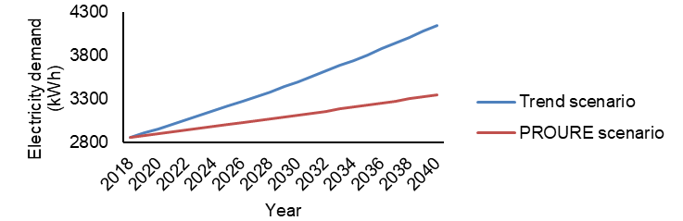
Figure 1: Forecast of electricity demand in the trend and PROURE scenarios.
4.2 Proposed energy planning project
This section presents the resulting energy matrices proposed to meet electricity demand under the trend and PROURE scenarios, as well as their subsequent comparison.
4.2.1 Energy matrix – trend scenario
The alternatives obtained from the Pareto diagram between NPV and CO₂ emissions for the trend scenario are shown in Figure 2. Negative NPV values represent gains associated with the sale of surplus electricity. The Pareto diagram shows an inverse relationship between the two objective functions, indicating that prioritising the environmental factor increases the financial cost of the system, and vice versa. The cash flow analysis shows gains ranging from 714.57 USD to 694.41 USD, while total CO₂ emissions vary between 169 kgCO₂-eq and 153 kgCO₂-eq, respectively. Additionally, the Pareto diagram shows non-convex behaviour, characterised by an abrupt decrease in NPV between alternatives A7 and A8, while the reduction in emissions occurs gradually. This behaviour can be associated with a significant decrease in the energy generated by one of the power plants.
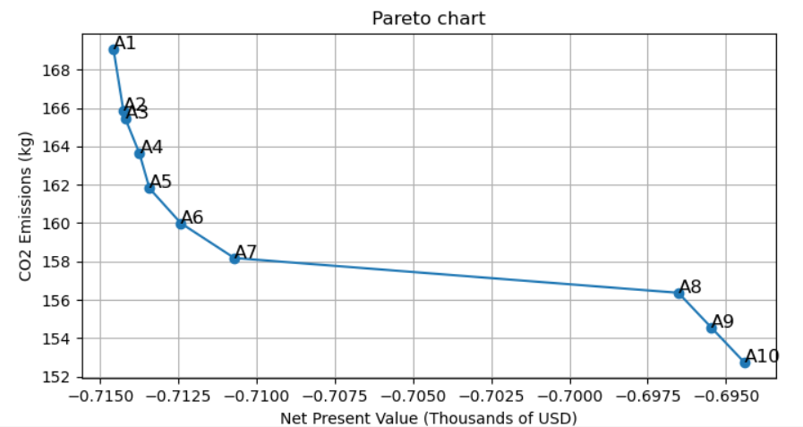
Figure 2: Pareto diagram in the trend scenario.
The total energy generated and the total installed capacities of each technology considered throughout the planning horizon is provided in Table 1. The biomass gasifier maintains an installed capacity of 0.015 kW and a total annual generation of 29.83 kWh, as a result of the restriction incorporated in Eq(1). Additionally, there is a reduction in the installed capacities and energy generated by wind turbines and diesel plants. In the case of diesel plants, this decrease is due to their high CO₂ emissions, while for wind turbines it is explained by the low wind speeds in the case study and their higher costs compared to photovoltaic solar panels, which limits their share in the energy matrix. Consequently, the most favoured technology for installation is photovoltaic solar panels, which account for 58% of the total energy generated in alternative A10.
Table 1: Total energy generated and total installed capacity of the energy matrix in the trend scenario.
Total energy generated (kWh) – Total installed capacity (kW)
Alternative | Biomass gasifier | Diesel plants | Wind turbines | Photovoltaic solar panels
A1 | 29.83 - 0.015 | 188.52 - 0.036 | 791.76 - 0.025 | 481.73 - 0.060
A2 | 29.83 - 0.015 | 184.44 - 0.036 | 800.75 - 0.025 | 476.82 - 0.060
A3 | 29.83 - 0.015 | 183.92 - 0.036 | 785.99 - 0.025 | 492.10 - 0.060
A4 | 29.83 - 0.015 | 181.62 - 0.036 | 798.73 - 0.025 | 481.66 - 0.060
A5 | 29.83 - 0.015 | 179.32 - 0.036 | 818.72 - 0.025 | 463.98 - 0.060
A6 | 29.83 - 0.015 | 177.02 - 0.036 | 818.53 - 0.025 | 466.46 - 0.060
A7 | 29.83 - 0.015 | 174.72 - 0.036 | 797.20 - 0.027 | 490.10 - 0.060
A8 | 29.83 - 0.015 | 172.42 - 0.035 | 521.37 - 0.020 | 768.23 - 0.092
A9 | 29.83 - 0.015 | 170.12 - 0.035 | 469.18 - 0.020 | 822.71 - 0.093
A10 | 29.83 - 0.015 | 167.81 - 0.035 | 427.08 - 0.020 | 867.12 - 0.095
4.2.2 Energy matrix – PROURE scenario
The Pareto-optimal alternatives obtained for the PROURE scenario are illustrated in Figure 3, highlighting a clear trade-off between the financial and environmental performance of the system. The results indicate that the NPV varies between 633.33 USD and 626.41 USD, while total CO₂ emissions range between 108 kgCO₂-eq and 104 kgCO₂-eq. Likewise, the Pareto diagram exhibits convex behaviour, characterised by low gradual variations between the different alternatives, which allows for the identification of a curve with a well-defined slope.
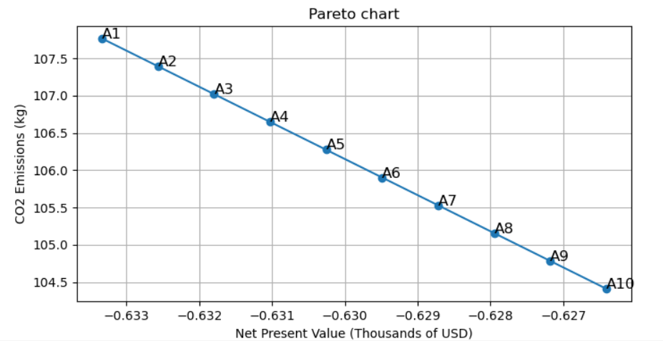
Figure 3: Pareto diagram in the PROURE scenarios.
As in the trend scenario, the total energy generated and the installed capacity of each technology over the planning horizon are reported in Table 2. The energy generated and installed capacities of biomass gasifiers remain constant in all alternatives as a result of the restriction defined in Eq(1). In this scenario, there is a decrease in the share of diesel plants, while the installation of photovoltaic solar panels is favoured as environmental criteria are prioritised. Additionally, the proposed energy matrices do not recommend the installation of wind turbines, as the low wind speeds in the case study, together with the incorporation of the restriction in Eq(1), make the installation of other technologies more viable from both a financial and environmental point of view.
Table 2: Total energy generated and total installed capacity of the energy matrix in the PROURE scenario.
Total energy generated (kWh) – Total installed capacity (kW)
Alternative | Biomass gasifier | Diesel plants | Wind turbines | Photovoltaic solar panels
A1 | 13.13 - 0.015 | 125.25 - 0.029 | 0.0 - 0.0 | 518.30 - 0.086
A2 | 13.13 - 0.015 | 124.77 - 0.029 | 0.0 - 0.0 | 518.77 - 0.087
A3 | 13.13 - 0.015 | 124.30 - 0.029 | 0.0 - 0.0 | 519.24 - 0.088
A4 | 13.13 - 0.015 | 123.82 - 0.029 | 0.0 - 0.0 | 519.72 - 0.089
A5 | 13.13 - 0.015 | 123.35 - 0.029 | 0.0 - 0.0 | 520.19 - 0.090
A6 | 13.13 - 0.015 | 122.88 - 0.029 | 0.0 - 0.0 | 520.66 - 0.091
A7 | 13.13 - 0.015 | 122.41 - 0.029 | 0.0 - 0.0 | 521.13 - 0.092
A8 | 13.13 - 0.015 | 121.94 - 0.028 | 0.0 - 0.0 | 521.60 - 0.093
A9 | 13.13 - 0.015 | 121.46 - 0.028 | 0.0 - 0.0 | 522.08 - 0.094
A10 | 13.13 - 0.015 | 120.99 - 0.028 | 0.0 - 0.0 | 522.55 - 0.095
4.2.3 Comparison of energy matrices and public policies
According to the results obtained in the previous sections, the implementation of the PROURE public policy generates multiple advantages in energy planning designs. Among the main benefits is the achievement of convex behaviour in the Pareto diagram, which facilitates the interpretation of results, ensures consistency in the inverse behaviour of the objective functions, and simplifies the selection of the most sustainable alternative for decision-makers and stakeholders in accordance with their interests. In this context, the NPV shows a reduction of between 11.65% and 9.79% in the different alternatives analysed, which represents a significant economic decrease. Similarly, total CO₂ emissions are reduced by between 36.09% and 32.02%, demonstrating a highly favourable environmental impact and confirming that the main objective of public policy, aimed at mitigating CO₂ emissions, is being satisfactorily achieved.
Additionally, as a result of the reduction in electricity demand induced by the policy, the total installed capacity of the system decreases. In particular, there is an approximate 20% reduction in the installed capacity of diesel plants, which favours the incorporation of photovoltaic solar panels and rules out the installation of wind turbines. Consistently, the energy generated by each technology is also reduced, leading to lower variable operating and maintenance (O&M) costs and decreasing the likelihood of congestion on transmission lines. Likewise, biomass gasifiers, due to the restriction established in the model, maintain their installed capacities constant. However, there is a decrease in the energy generated under the PROURE scenario. These results show that the implementation of the PROURE policy is a key strategy for moving towards a sustainable energy transition, with greater financial and environmental benefits. However, despite its relevance, its effective implementation faces various barriers, including the costs to be borne by end consumers, as well as a lack of information and disinterest in adopting energy efficiency measures.
From the consumer’s perspective, the expected long-term savings frequently fail to compensate for the initial investments required, particularly in low- and middle-income households. Under these conditions, voluntary adoption of efficiency measures remains limited, reducing the actual impact of the policy on electricity demand. Therefore, achieving a comprehensive energy transition aligned with PROURE requires active and targeted economic support from government and decision-makers, explicitly designed to engage end users through subsidies, incentives, or financing mechanisms that lower entry barriers.
In this context, the implementation of dynamic electricity tariff schemes emerges as a concrete and complementary policy recommendation rather than a marginal consideration. By establishing higher tariffs during peak demand periods and lower tariffs during off-peak hours, dynamic pricing provides direct and transparent price signals that influence consumer behaviour, promote shifts in consumption patterns, and encourage the adoption of more efficient technologies and practices. When combined with PROURE, such tariff structures can enhance the real effectiveness of energy efficiency policies, leading to sustained reductions in electricity demand and reinforcing the long-term viability of the energy transition.
  - Conclusions
The results of this work demonstrate that the implementation of the PROURE public policy has a measurable impact on electricity demand in the municipality of Silos, Colombia. By reducing the annual demand growth rate from 1.7% to 0.72%, the policy leads to a substantial decrease in projected electricity consumption, which directly influences the optimal design of the local energy system through lower installed capacities, reduced reliance on diesel-based generation, and increased penetration of photovoltaic technologies.
In economic and environmental terms, the incorporation of PROURE yields significant benefits. The system’s NPV decreases by approximately 10 – 12%, while total CO₂ emissions are reduced by more than 30%, confirming that demand-side efficiency policies can deliver considerable environmental gains without compromising the financial viability of local energy systems.
These findings have important implications for local energy policy. Although PROURE proves effective in reducing demand, costs, and emissions, its long-term impact depends on overcoming barriers to end-user adoption. Accordingly, complementary policy instruments, such as targeted economic incentives and dynamic electricity tariff schemes, are required to provide clear price signals, encourage behavioural change, and strengthen the effective implementation of energy efficiency strategies at the local level.
Finally, this proposed methodology can be applied in other geographical contexts to assess the real impact of national policies and analyse their financial and environmental viability in different energy matrix configurations.
Acknowledgments
The authors would like to acknowledge the financial support from the Ministry of Science, Technology, and Innovation of Colombia for the project "Development of a computational tool and renewable energy technologies for energy transition in high mountain areas post-pandemic," CD 82605 CT ICETEX 2022-0644.
References
Becerra J., 2024, Estimation of renewable energy resource potential and energy requirements with projections for 2040 for electricity and heat for three case studies in the Santurbán páramo, using LEAP software, bachelor’s thesis, University of Pamplona, Santander, Colombia (In Spanish).
Cabrera N., Rosso-Ceron A.M., Leon Esteban A.F., Kafarov V., 2025, A Multi-objective Optimization Model for Integrating Renewable Energy in Distribution System Expansion: a Case Study of Pamplona, Colombia, Chemical Engineering Transactions, 117, 1045-1050.
Low-Carbon Power, 2024, Electricity in the World 2024,<https://lowcarbonpower.org/es/> accessed 05.01.2026.
Messias, R., Carvalho, P. M., & Sousa, J., 2025, Hybrid distribution network planning to incorporate virtual capacity from distributed flexibility resources. Utilities Policy, 93, https://doi.org/10.1016/j.jup.2025.101892
Mining and Energy Planning Unit - UPME, 2022, Programme for the Rational and Efficient Use of Energy – PROURE, <www1.upme.gov.co/DemandayEficiencia/Paginas/PROURE.aspx> accessed 05.01.2026.
Pappis, I., Sahlberg, A., Walle, T., Broad, O., Eludoyin, E., Howells, M., & Usher, W., 2021, Influence of Electrification Pathways in the Electricity Sector of Ethiopia—Policy Implications Linking Spatial Electrification Analysis and Medium to Long-Term Energy Planning. Energies, 14(4).
Tajudeen, I. A., 2015, Examining the role of energy efficiency and non-economic factors in energy demand and CO2 emissions in Nigeria: Policy implications. Energy Policy, 86, 338-350.
Villamizar-Villamizar A.E., Rosso-Cerón A.M., Becerra-Rodriguez J., 2024, Post-pandemic Long-term Energy Demand Forecasting Using Leap Software in the Páramo De Santurbán: the Case of Pamplona North De Santander, Chemical Engineering Transactions, 109, 481-486.

