 CHEMICAL ENGINEERING TRANSACTIONS  VOL. xxx, 2026 | A publication of  
The Italian Association
of Chemical Engineering
Online at www.cetjournal.it

Guest Editors: Leonardo Tognotti, Rubens Maciel Filho, Viatcheslav Kafarov
Copyright © 2026, AIDIC Servizi S.r.l.
ISBN 979-12-81206-xx-x; ISSN 2283-9216

Green Hydrogen Production from Biomass Gasification: Energy Integration and Environmental Assessment of Sugarcane Bagasse and Oil Palm Empty Fruit Bunches in Colombia
Rosalba Cabrera-Mercado, Edwin Yépez-Ospino, Karina A. Ojeda-Delgado*, Eduardo Sánchez-Tuiránª, Yurley P. Villabona-Durán^{b}
ªProcess Design and Biomass Utilization Research Group (IDAB). Faculty of Engineering, Universidad de Cartagena, Av. El Consulado Street 30 #48-150. Cartagena, Colombia.
^{b}Facultad de Ingeniería Ambiental, División de Ingenierías y Arquitectura, Universidad Santo Tomás, Cra. 18 Nº 9-27, Bucaramanga, Colombia.
kojedad@unicartagena.edu.co

The increasing demand for cleaner energy sources has intensified the need to diversify the global energy mix and reduce dependence on fossil fuels. In Colombia, although hydropower remains the dominant generation source, climate variability and the growing energy demand have highlighted the urgency of exploring alternative, renewable pathways. Agroindustrial residues derived from crops such as oil palm and sugarcane represent a promising yet underutilized resource. In regions like Santander and Norte de Santander, where agricultural activity generates large quantities of residual biomass, inadequate waste management has led to environmental challenges, including soil and water contamination, pest proliferation, and greenhouse gas emissions. This situation highlights the need to improve current waste management practices and explore the potential of these residues as valuable energy carriers. In this context, biomass gasification emerges as a relevant thermochemical route to convert these residues into synthesis gas and green hydrogen, aligning with Colombia’s Hydrogen Roadmap and the broader goals of sustainable energy transition. Considering the above, this project proposed a way to obtain green hydrogen as an alternative for bioenergy generation from potential biomass in the departments of Santander and Norte de Santander. The article evaluated the energy demand of the process and its variation depending on the biomass used, comparing sugarcane bagasse and oil palm empty fruit bunches (EFB), showing that sugarcane bagasse had the highest energy requirements among the alternatives analyzed, which led to the proposal of a heat exchanger network (HEN) as a strategy to improve the energy performance of the system. Similarly, through the application of the waste reduction algorithm (WAR GUI®), it was identified that the use of sugarcane bagasse has higher environmental impacts compared to oil palm EFB, predominantly those associated with toxicological and atmospheric categories, which provides technical criteria for environmental analysis and decision making in process design.
  - Introduction
The growing global commitment toward sustainable energy systems has intensified research into alternative hydrogen production pathways that reduce dependency on fossil fuels and minimize greenhouse gas emissions (International Energy Agency, 2023). Among renewable options, biomass gasification has emerged as a compelling route for converting organic waste into synthesis gas (syngas), which can be further processed to produce green hydrogen, defined as hydrogen generated from renewable feedstocks with low net carbon emissions (Siwal et al., 2020). Biomass gasification involves heating organic matter with controlled amounts of oxidizing agents such as steam or oxygen to form a gaseous mixture primarily composed of hydrogen (H₂), carbon monoxide (CO), and carbon dioxide (CO₂), avoiding complete combustion and enabling subsequent water gas shift reactions and separation stages that enhance hydrogen concentration (U.S. Department of Energy, 2026).The potential of biomass gasification for hydrogen production has been widely reviewed, demonstrating its capability for high energy recovery and versatile product outputs under optimized conditions, especially when steam is used as the gasifying agent and catalysts are applied to enhance hydrogen yield (Sharma et al., 2023). Moreover, comprehensive assessments highlight how advancements in reactor design, feedstock pretreatment, and gas cleaning technologies continue to improve process performance and economic feasibility (Bartoli et al., 2026). Green hydrogen production through biomass gasification not only offers an avenue for renewable energy generation but also aligns with circular economy principles, valorizing agricultural residues that would otherwise contribute to environmental burdens (Mishra et al., 2023). In many developing regions, including Latin America, agricultural industries generate large volumes of lignocellulosic waste, creating both management challenges and opportunities for energy recovery. Colombia, for example, possesses significant sugarcane and oil palm sectors, particularly in departments such as Santander and Norte de Santander, resulting in abundant residues such as sugarcane bagasse and oil palm empty fruit bunches (EFB) that remain largely underutilized. The accumulation of these residues contributes to localized environmental impacts, including methane emissions during decomposition, soil degradation, and contamination of water bodies through leachate generation (Mishra et al., 2023). Several studies have underscored the dual benefit of converting agro-industrial residues into hydrogen, as this approach simultaneously reduces waste accumulation and enables the production of a low-carbon energy carrier suitable for integration into sustainable energy strategies (Jeje et al., 2024). In addition, techno-economic analysis conducted in different geographic contexts have shown that biomass gasification pathways can achieve competitive hydrogen production costs when compared to other low-carbon alternatives, reinforcing their potential role in emerging hydrogen markets. In this study, an environmental assessment is carried out using the Waste Reduction Algorithm (WAR GUI®) to quantify the potential environmental impacts associated with the production of green hydrogen using biomass gasification. Additionally, process energy integration is evaluated to reduce external energy requirements. The analysis focuses on the gasification of sugarcane bagasse and oil palm empty fruit bunches as representative agro-industrial residues, to evaluate the environmental and energetic performance of the proposed hydrogen production pathway and to support its potential implementation within sustainable energy systems.
  - Methodology
This study proposes a simulation approach to analyze green hydrogen production from biomass gasification, using sugarcane bagasse and oil palm EFB, both feedstocks evaluated through the process represented in figure 1, developed under the same assumptions. Firstly, energy integration was carried out for each route through pinch point analysis, leading to the synthesis of a heat exchanger network (HEN) and limited to examining energy performance. Secondly, environmental evaluation was performed through WAR GUI® methodology, aiming to understand how energy use and product streams influence the potential environmental impact (PEI) of the gasification route.
    - Process description
An entering stream of raw biomass calculated in 20ton/h according to availability is reported in stream 1. Then, biomass drying process was carried out in a RStoich (Y-101) module to reduce its moisture content to 15%, using hot air as the drying medium. The vapor generated during this stage was separated from the dried biomass using a FLASH unit. Subsequently, the biomass was subjected to a pyrolysis process in an RYield reactor (R-101) at 600 °C and atmospheric pressure, decomposing it into its elemental components (C, H, O, N, S, and ash). Ash was considered inert, and tar formation was not considered (Saufishan et al., 2024). The gaseous products then reacted with the gasifying agent (stream 8) in an RGibbs unit (R-102), using an agent-to-biomass ratio (EBR) of 1.2. This stage was carried out at 650 °C under atmospheric conditions, modeling the conversion to synthesis gas (Bakhtiar, 2025). Finally, the produced syngas, composed of CO, H₂, CO₂, N₂, CH₂, H₂O, H₂S, COS, and ash, was treated in a Cyclone unit to separate the ash from the gas stream. Subsequently, the gas stream was fed to a desulfurization reactor (R-103) operating at 450 °C, where zinc oxide was used to reduce the H₂S content. This was followed by the implementation of a water–gas shift (WGS) reactor (R-104) to promote the conversion of CO. Following the previous stage, the stream was gradually cooled to allow the separation of water vapor. Finally, the gas mixture was subjected to a purification step using pressure swing adsorption (PSA), represented in the model by a SEP unit operating at 2 MPa, in order to estimate a hydrogen recovery of 99% relative to the other gaseous components (Zafanelli et al., 2025). Under these conditions, an average hydrogen production of 1.4 t/h was obtained in stream 25.

Figure 1. Process flow diagram for the proposed route.
    - Energy integration
The energy integration of the biomass gasification process was developed with the objectives of optimizing the use of the system's thermal energy and reducing external energy requirements, based on the identification and characterization of the hot and cold streams in the process. These streams were strategically coupled to meet internal energy demands, adopting a minimum temperature difference of 10 °C between the ends of the heat exchangers, selected based on technical and economic feasibility considerations. In addition, the heat exchange network was designed using Aspen Energy Analyzer v11 (AspenTech) software, applying the pinch analysis methodology as the main tool. Process stream data, including flow rates, physicochemical properties, and temperature ranges, were obtained from the previously developed process simulation. Based on this information, heat recovery opportunities were identified and the minimum and maximum energy utility requirements of the system were estimated.
    - Environmental assessment
The environmental assessment was based on the WAR GUI® methodology, which evaluates PEI of chemical processes through a set of impact categories associated with human health and ecological effects: human toxicity by ingestion (HTPI), human toxicity by exposure (HTPE), aquatic toxicity potential (ATP), terrestrial toxicity potential (TTP), global warming potential (GWP), ozone depletion potential (ODP), photochemical ozone creation potential (PCOP), and acidification potential (AP). For each biomass, four scenarios were defined: exclusion of both energy and product streams, inclusion of energy impacts only, inclusion of product stream impacts only, and inclusion of both contributions. This structure allowed a clearer interpretation of how energy and subproducts influence the overall environmental performance. Based on the results obtained, potential improvement options are briefly discussed as a basis for further evaluation to enhance the environmental performance of the proposed route.
  - Results and discussion
    - Energy Integration of the process
Based on the process energy integration analysis, the thermal behavior of the scenarios was evaluated using pinch analysis tools. As shown in Figure 2, the pinch point is located in the final temperature interval for both case studies, indicating the absence of minimum cooling requirements in the biomass gasification process. This behavior suggests that the heat available in the hot process streams can be efficiently utilized to satisfy the cooling demands of the system, without the need for external cooling utilities. From a thermodynamic perspective, the location of the pinch point reflects an adequate matching between hot and cold streams, favoring the internal utilization of process heat. Nevertheless, the analysis reveals the presence of minimum heating requirements that cannot be entirely met through internal heat recovery, making the supply of additional energy via external utilities necessary to achieve the required operating conditions. In the case of oil palm residues, the minimum heating requirement was estimated at approximately 6,700 MJ/h, while the maximum potential for thermal energy integration reached values close to 23,600 MJ/h. In contrast, the scenario involving sugarcane bagasse exhibited minimum heating requirements on the order of 21,000 MJ/h, with a maximum integrated thermal energy of approximately 39,000 MJ/h. It should be noted that both scenarios were evaluated under equivalent simulation conditions, considering an identical biomass feed rate. Under these conditions, sugarcane bagasse exhibits a higher energy demand to complete the process and achieve hydrogen production. The observed differences between the two cases suggest distinct energy behaviors, which may be associated with the characteristics and inherent composition of each biomass.
Max. integrated heat load
~39000MJ/h
Min.
heating utilities
~21000MJ/h
PP
Heat load
[MJ/h]
T
[°C]
(a)
Max. integrated heat load
~23600MJ/h
Min.
heating utilities
~6700MJ/h
PP
Heat load
[MJ/h]
T
[°C]
(b)

Figure 2. Pinch analysis of cold and hot streams: (a) sugarcane bagasse biomass, (b) palm EFB biomass.
In order to meet the objectives of integration, and further use of heat within the system, a proposal for HEN was studied. The result of this analysis for sugarcane bagasse is shown in figure 3, where connections between streams were represented. The arrangement developed used seven heat exchangers, one more unit than non-integrated route, and effectively obtained minimum heating utilities for both biomass scenarios. There is ongoing investigation on further economic implications for this proposal, as well as design specifications for each heat exchanger. However, these results illustrate the extent of energy integration within the process and allow for the characterization of the system’s thermal behavior under the operating conditions considered for hydrogen production from biomass.

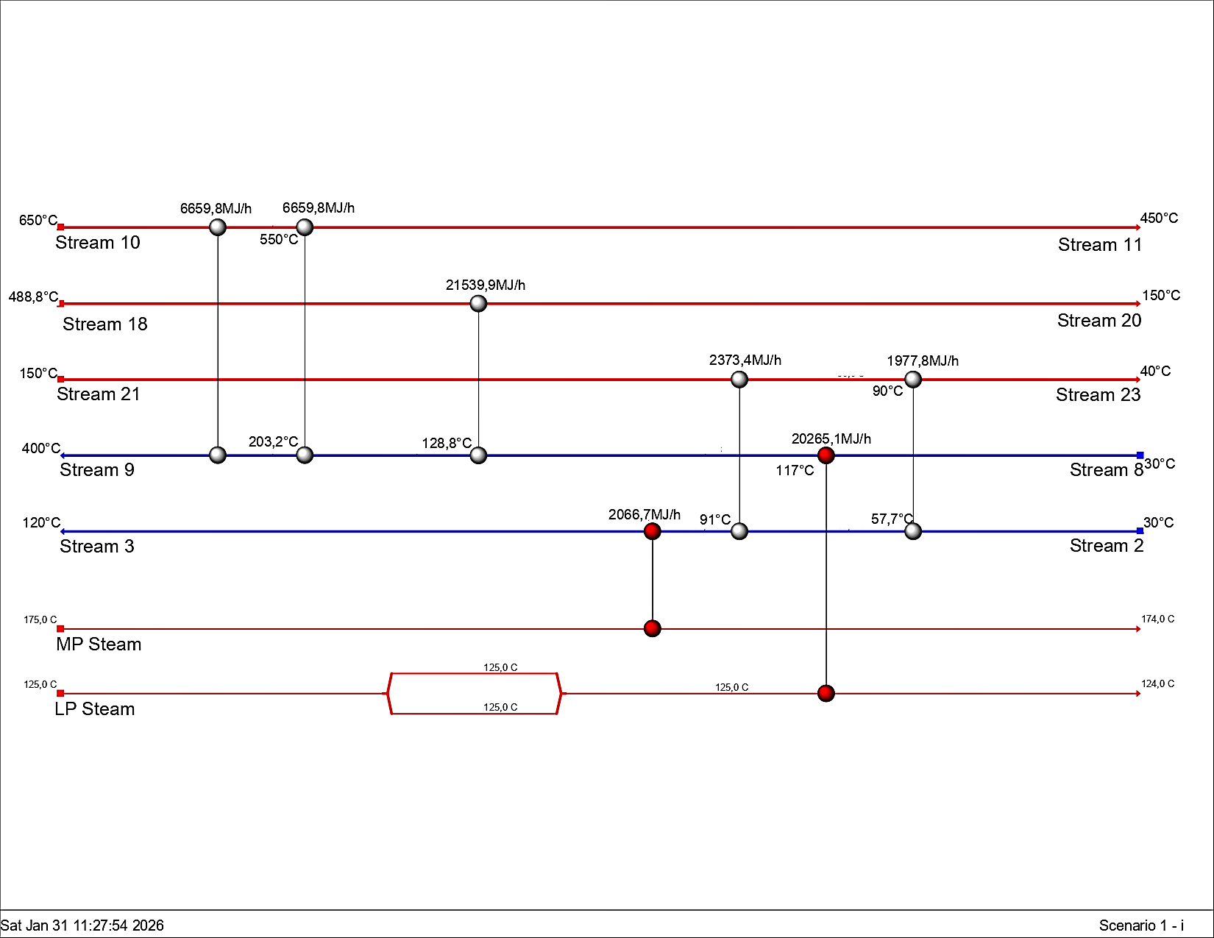
Figure 3. Heat exchangers network proposed for sugarcane bagasse biomass gasification.
    - Environmental analysis using WAR GUI® algorithm
In order to evaluate the environmental performance of the process, the Waste Reduction Algorithm was applied for the estimation of potential environmental impacts associated with the system's output streams, considering both the type of substances emitted and their relative contribution to different impact factors. For this purpose, four case studies were defined: Case A corresponds to a base scenario in which neither products nor energy are considered, only the impacts inherent to the process streams. Case B incorporates the products of the system, while excluding the effects associated with energy consumption. Case C considers only the energy requirements of the process, without including the product. Finally, Case D considers both products and energy simultaneously, representing the most complete scenario from an environmental point of view.
The results obtained for sugarcane and palm residues are presented in Figures 4 and 5, respectively, and allow for a comparative analysis of the toxicological and atmospheric impact categories. Firstly, figure 4, the case (a) of sugarcane bagasse, the toxicological impact categories have the highest relative contributions within the environmental profile of the process. In particular, the impact categories associated with human toxicity by ingestion, human toxicity by inhalation/dermal exposure, and terrestrial toxicity have higher contributions compared to the categories associated with aquatic toxicity. The inclusion of products and/or energy does not generate substantial changes in the overall behavior of these categories, indicating that the toxicological impacts in cane processing are mainly determined by the process streams and not by the scope defined in each scenario. In contrast, the case (b) for palm, the toxicological impact categories show a significantly lower contribution compared to sugarcane, with a notable difference in the impacts associated with human toxicity through ingestion and terrestrial toxicity. However, regardless of the case study considered. In all the scenarios evaluated, these categories maintain low values and limited variations, evidencing a less relevant toxicological profile within the environmental impact of the process when palm is used as a raw material. This behavior is attributed to a sulfur composition for sugarcane bagasse residues higher than those considered (according to the literature) for EFB residues.
(b)
(a)

Figure 4. Results for potential environmental impacts in toxicological categories for: (a) sugarcane bagasse, (b) oil palm EFB.
In terms of atmospheric impact categories, figure 5 shows that sugarcane residues (a) presented moderate behaviour, with photochemical oxidation potential standing out compared to other atmospheric categories, although without significant variations between the different case studies. In contrast, for oil palm EFB (b) there was a clear predominance of photochemical oxidation potential in all the scenarios analyzed, which far exceeds the other atmospheric impacts considered. This behaviour remained constant both when the products and energy requirements of the process are excluded and when they are included.

(a)
(a)

Figure 5. Results for potential environmental impacts in atmospheric categories for: (a) sugarcane bagasse, (b) oil palm EFB.
The comparison between the two biomasses showed clear differences in their environmental impact profiles: while sugarcane had a greater relative contribution in the toxicological impact categories, oil palm was characterized by a higher atmospheric impact, dominated by photochemical oxidation potential. These trends were consistent across the four case studies, suggesting that the observed behaviour is strongly influenced by the nature of the biomass and the streams generated during its processing.
  - Conclusion
This study explored how energy integration potential and environmental assessment in biomass gasification for hydrogen production are strongly governed by feedstock characteristics. Pinch analysis showed that both scenarios operate without minimum cooling requirements, allowing significant internal heat recovery. Moreover, for oil palm EFB, the energy recovered from hot streams satisfies approximately 89 % of the total heating demand, reducing the minimum external heating requirements. In contrast, sugarcane bagasse requires higher usage of external utilities, with internal heat recovery covering around 79 % of total heating demand. Environmental assessment using WAR GUI® methodology revealed that sugarcane bagasse showed higher contributions in toxicological categories, while oil palm EFB was dominated by atmospheric impacts, particularly photochemical oxidation potential. Altogether, these results confirm that effective heat integration can substantially reduce energy requirements, while the environmental performance was found to be highly dependent on biomass composition.
  - Acknowledgment
The authors would like to express their sincere gratitude to the University of Cartagena and Santo Tomás University, via project N.°2025_CREANDOFUTURO_16_IP_DCB (Convocatoria Interna de Investigación, Innovación, Creación y Desarrollo – Creando Tu Futuro 2025), for providing the computational resources and software essential for the execution of the simulations presented in this study.
  - References
Bakhtiar, M., Shahbaz, M., Ayub, H. M. U., Ali, U., 2025, Steam gasification of plastic and woody biomass for hydrogen-rich syngas production with CO2 reduction, emission and energy analysis, Energy, 334, 1–11.
Bartoli M., Pirri C.F., Bocchini S., 2026, A comprehensive review on hydrogen production from biomass gasification, Molecules, 31, 99, 1–20.
Chelvam, K., Hanafiah, M. M., al Ali, K., al Blooshi, A., 2023, Gate-to-gate life cycle analysis of a pilot-scale solar driven two-step thermochemical hydrogen sulfide decomposition for hydrogen production, Journal of Cleaner Production, 428, 139369, 1–11.
International Energy Agency, 2023, Global hydrogen review 2023, Paris, France.
Jeje, S. O., Marazani, T., Obiko, J. O., & Shongwe, M. B., 2024, Advancing the hydrogen production economy: A comprehensive review of technologies, sustainability, and future prospects, International Journal of Hydrogen Energy, 78, 642–661.
Mishra, B., Mohanta, Y. K., Reddy, C. N., Reddy, S. D. M., Mandal, S. K., Yadavalli, R., y Sarma, H., 2023, Valorization of agro-industrial biowaste to biomaterials: An innovative circular bioeconomy approach, Circular Economy, 2(3), 100050, 1–14.
Saufishan, T., Rafey, A., Siddiqui, F., 2024, Hydrogen production via gasification of corn stover: modeling and simulation using Aspen Plus®, Biofuels, 15, 723–733.
Sharma R.K., Nazari M.A., Haydary J., Singh T.P., Mandal S., 2023, A review on advanced processes of biohydrogen generation from lignocellulosic biomass, Energies, 16, 6349, 1–27.
Siwal S.S., Zhang Q., Sun C., Thakur S., Thakur V.K., 2020, Energy production from steam gasification processes and parameters: a review, Renewable and Sustainable Energy Reviews, 115, 109426,1–11.
Wen Q., Chen X., Peng X., Qiu Y., Wu K., Lin Y., Liang P., Xu D, 2025, Integrated Environmental–Economic Assessment of Small-Scale Natural Gas Sweetening Processes, Processes, 13, 2473, 1–19.
Zafanelli, L. F. A. S., Aly, E., Henrique, A., Rodrigues, A. E., Silva, J. A. C., 2025, Dual-stage vacuum pressure swing adsorption for green hydrogen recovery from natural gas grids, Separation and Purification Technology, 360, 1–10.

