 CHEMICAL ENGINEERING TRANSACTIONS  VOL. xxx, 2026 | A publication of  
The Italian Association
of Chemical Engineering
Online at www.cetjournal.it

Guest Editors: Leonardo Tognotti, Rubens Maciel Filho, Viatcheslav Kafarov
Copyright © 2026, AIDIC Servizi S.r.l.
ISBN 979-12-81206-xx-x; ISSN 2283-9216

Study on self-heating of biocarbon at different surrounding temperatures
Liang Wang*, Jørn Bakken, Øyvind Skreiberg
SINTEF Energy Research, Sem Sælands vei 11, NO-7034 Trondheim, Norway
liang.wang@sintef.no
Metal production is a highly energy- and resource-intensive industry that relies heavily on carbon as both a reducing agent and an energy source. Biocarbon has been considered as a promising material to replace the conventional fossil carbon for metal production to reduce CO₂ footprints of metallurgical industry. However, in comparison to fossil carbon, the biocarbon has relatively high potential regarding self-heating and self-heating during storage, transportation and handling. The aim of this study is to investigate self-heating and self-ignition of biocarbon upon contact with synthetic air at low temperatures in the range of 140-250°C. The test self-heating and self-ignition of biocarbon powder was tested using a fixed bed reactor with controlling the surrounding temperature and adjusting flow of supplied air. Along one test, the emission of CO₂ and CO was monitored continuously. The self-heating and self-ignition of one biocarbon sample was tested under different temperatures at 180, 190, 200 and 250 °C with supplying of varied flow with 0.5 L/min, 1 L/min and 2 L/min. The results showed that temperature is a key factor that leading to self-heating of the studied material. For the test conducted at the temperatures below 200°C, no evident increase of temperature measured in the core of sample bed was detected. And no release of CO₂ and CO was monitored. For the test conducted at 200°C, the reactions started as the temperature is approaching this desired temperature, with slow release of CO₂ and CO and decrease of O₂. More intensive reactions took place and measured temperature increased dramatically during the first 15 minutes holding of the sample at 200°C, which was accompanied with intensive release of CO₂ and decrease of O₂. Afterwards, even with continuous supplying the synthetic air, only a slow increase of temperature measured from in core of sample bed was detected. During this stage, only the release of CO₂ and CO is rather stable, indicating smoldering combustion of the material. The findings for from this work indicate combination of temperature measurement and monitoring of gas emissions can be an important measure to identify self-heating and self-ignition of biocarbon. Alarm thresholds for biocarbon can be established based on such measurements, which helps to prevent and reduce risks related to self-heating and self-ignition of biocarbon along the value chain from production to final application.
  - Introduction
The metallurgical industry, particularly steel and silicon production, is currently responsible for approximately 7–9% of global anthropogenic CO₂ emissions. Traditionally, this sector relies on fossil-based reductants like coal and coke, which serve a dual purpose: providing the thermal energy required for smelting and acting as a chemical reducing agent to strip oxygen from metal ores (Venna et al., 2019). To increase sustainability and reduce greenhouse gas emissions, biocarbon (or charcoal) has emerged as a promising renewable alternative. Produced through the pyrolysis or carbonization of biomass, biocarbon participates in a biogenic carbon cycle where CO₂ emitted during metal production is sequestered by regrowing plants (Wang et al., 2023). Despite its environmental benefits, biocarbon's physical properties—such as high porosity and surface area—make it a reactive porous medium highly permeable to air and moisture.
Handling, transportation, and storage of large volumes of biocarbon present significant challenges due to its susceptibility to self-heating and spontaneous ignition. Self-heating occurs when spontaneous exothermic reactions within the material raise its internal temperature (Wang et al., 2023). This phenomenon is primarily driven by the chemisorption of oxygen onto the biocarbon surface, which forms carbon-oxygen complexes and releases heat (Phounglamcheik et al., 2022). If this heat generation exceeds the rate of heat dissipation to the surroundings, the material can undergo thermal runaway, leading to smoldering or flaming fires. Oxygen chemisorption is considered as the primary heat-generation mechanism responsible for the self-heating of biocarbon, particularly at low temperatures (Restuccia et al., 2019). This process involves the physical and chemical adsorption of oxygen onto the biocarbon's surface, leading to a series of exothermic reactions that can eventually result in thermal runaway and spontaneous ignition. A distinct indicator of chemisorption is a slight increase in the mass of the biocarbon sample as it adsorbs oxygen molecules. This mass gain is most observable at isothermal temperatures where the loss of carbon due to surface reactions is still negligible (e.g., 50–175 °C) (Phounglamcheik et al., 2022). The interaction between oxygen and biocarbon also produces indicator gases like carbon monoxide (CO) and carbon dioxide (CO₂). Monitoring these gases is a recognized method for the early detection of the self-heating process (Wang et al., 2018). Other contributing factor to self-heating of biocarbon is condensation of water vapor. The interaction between biocarbon and water vapor is either exothermic or endothermic, depending on whether the water condenses or evaporates. When stored in moist air, biocarbon grains and fines adsorb water vapor; this condensation process results in a release of heat. In addition, biological degradation from fungal growth under humid conditions can also cause temperature increase and degradation of biocarbon upon long term storage and transportation.

Current research methodologies have utilized oven and fixed-bed experiments to quantify risks related to self-heating and self-ignition of biocarbon. Fixed-bed tests allow for the continuous measurement of temperature history within a sample bed compared to ambient conditions, identifying points of temperature runaway (Restuccia et al., 2019, Dzonzi-Undi et al., 2014., Van Blijderveen., 2013). Furthermore, the "oven basket method", based on the Frank-Kamenetskii theory of criticality, is widely used to determine the minimum ambient temperature at which a specific volume of biocarbon will spontaneously ignite (Restuccia et al., 2019). As reported by Restuccia et al., pyrolysis temperature significantly influences the physical and chemical properties of biocarbon, making its self-ignition risk a non-monotonic function of production temperature. Research across multiple feedstocks indicates that the risk of spontaneous ignition typically peaks at intermediate temperatures before decreasing as production temperatures rise further. Traditional monitoring relies on thermocouples (thermal sensors). However, biocarbon is an excellent insulator; a fire can be raging just two meters away from a sensor, and the temperature reading may remain normal until it is too late (Garcia et al., 2015). Studies have also focused on the emission of indicator gases, particularly carbon monoxide (CO) and carbon dioxide (CO₂), as a method for early detection (Lohrer et al., 2005). These gases are released at the earliest stages of self-heating as chemical bonds begin to break, offering a potentially cheaper and more efficient monitoring solution than traditional thermal sensors. Using gas detectors is often considered an easier and cheaper way to monitor bulk materials. Many industrial facilities already have gas detectors installed to comply with environmental policies. Utilizing this existing infrastructure is significantly less expensive than installing the dense network of thermal sensors required to monitor the internal temperatures of large material piles. Gas detectors can sense indicator gases as they reach the surface of a material mass, potentially identifying a problem before it affects a large portion of the storage. In contrast, thermal sensors can only detect heat localized near the sensor itself, meaning a "hot spot" could develop some distance away from a sensor and go undetected until it reaches a critical stage (Garcia et al., 2015, Carras et al., 1994). Further work is required to study the complex effects of surrounding humidity, as water vapor can both generate heat and catalyze surface reactions (Garcia et al., 2015). There is also a need for more detailed characterizations of biocarbon sampled from storage tests to link ignition tendencies directly to physical properties altered during production. Future research should also involve testing a wider variety of feedstocks and production conditions, utilizing more robust transient modeling to predict the exact time and location of ignition in deep fuel beds.

In this work, preliminary work has been done to study self-heating and self-ignition of biocarbon produced from the wood waste. In addition to measurement of temperature in the biocarbon mass stored under given conditions, monitoring of gas emissions were conducted as complementary to thermal analysis to provide an early indication of chemical reactions of the studied biocarbon. Conducting of both temperature measurement and detection of gas provides a more comprehensive view of the self-heating and self-ignition of the biocarbon.
  - Materials and method
    - Biocarbon
In this work, biocarbon chips were generated from waste wood dust utilizing a continuous pyrolysis reactor at temperatures ranging between 600-650°C. The biocarbon is mixture of chips and particles with different sizes. To test sample with more homogeneous properties, the biocarbon was first ground to size in the range of 0.5-1 mm. Prior to experimentation, the ground biocarbon was dried at 105 °C until a constant mass was attained, ensuring the removal of moisture for standardized testing.
    - Fixed bed test
The self-heating and self-ignition tests were conducted using a laboratory-scale fixed-bed reactor system, as illustrated in the schematic in Figure 1. The system consists of a cylindrical reactor positioned within a tubular electrical furnace equipped with integrated heating elements and a digital temperature control system. To manage volatiles and gas composition, the assembly is integrated with a gas-purging system and a condenser unit. The reactor tube is fabricated from Kanthal APM™ (a FeCrAl alloy), selected for its structural integrity at high temperatures. For each test, the pre-dried biocarbon sample was loaded into a cylindrical basket and positioned in the middle section of the reactor tube. The reactor was then hermetically sealed and connected to the auxiliary gas and cooling systems. The furnace temperature was regulated using three thermocouples positioned at varying heights. Additionally, a central thermocouple was inserted into the core of the biocarbon bed to record the sample's thermal history continuously. During testing, air entered from the bottom of the reactor tube and flowed upward through the sample. A metal mesh was placed at the base of the basket to support the biocarbon particles and ensure uniform air distribution. The reactor was heated at a rate of 10K/min to a target temperature (180, 190, 200, 250°C) and held for a specified duration. As temperatures increased, the emitted gases passed through a condenser and dual-stage filters to remove particulates and tar vapours. The cleaned gas stream was then metered and analyzed using a Varian CP-4900 Micro-Gas Chromatograph (GC) to monitor CO, CO₂, and O₂ concentrations. After each test, the basket was taken out of the reactor carefully for visual observation and taking photo on the appearance of the residual material.
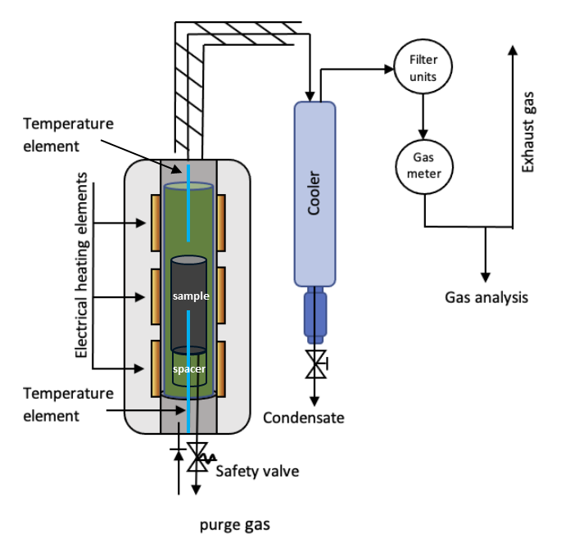
Figure 1: Schematic illustration of the fixed-bed reactor
  - Results and discussion
    - Preliminary test of biocarbon sample
Figure 2 shows a control scenario where the biocarbon is thermally stable under test condition. The sample temperature (T_{sample}) increases gradually to approach the furnace temperature (T_{furnace}) 180°C. The sample temperature levels off and does not exceed the furnace temperature during the 3-hour holding period. There was no "evident increase" or runaway is observed at this tested temperature.

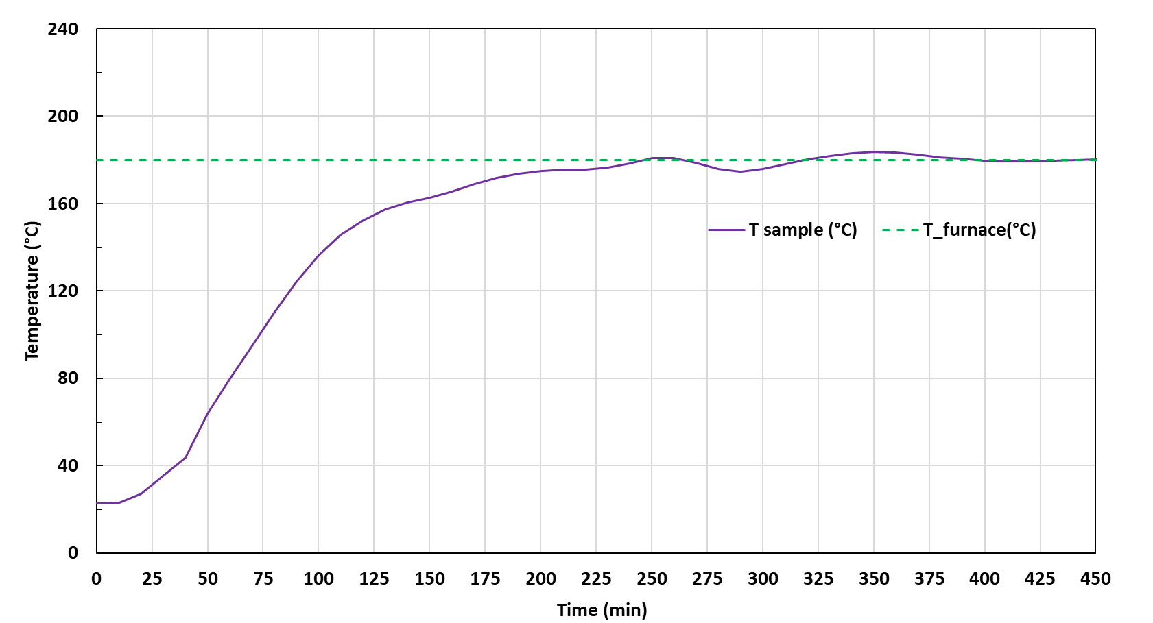
Figure 2: Temperature history of heating up the sample to 180 °C with further holding of 3 hours

The test was conducted with same procedures but with the furnace temperature (Tfurnace) 190°C, again there was increase of sample temperature, even the sample was held at the temperature fore 3 hours. Notably, at 180°C and 190°C, there is no detectable release of CO or CO2, nor any significant depletion of O2.
    - Effect of preset temperature on self-ignition and gas release of biocarbon
Figure 3 shows temperature and gas release profile obtained from the test at furnace temperature (T_{furnace}) 200°C with air supply of the 1L/min throughout the test period. As indicated on the figure, the tested sample passed through different stage from stable heating to smoldering combustion. As the sample temperature gradually reaches 200C°C at about 20 minutes, the concentration of O₂ in the gas emitted from the furnace slightly decreases, while the concentration of CO₂ increases simultaneously. As the sample hits 200°C, the CO and CO₂ as "indicator gases" appear, which marks the breakdown of chemical bonds and the transition from simple adsorption to active oxidation.

The measured sample temperature further increases to 250 °C after 50 minutes test time. Afterwards, the sample temperature spikes dramatically to approximately 330 °C within about 10 minutes. This is accompanied by a sharp concentration decrease of O₂. This confirms that the internal chemical reactions have become intensive as the porous biocarbon greedily consumes available O₂ to fuel the internal reaction. After the initial runaway, the sample temperature increases continuously up to 450 °C after 3 hours after it reached furnace temperature (T_{furnace}) 200°C. During this stage, emission CO₂ and CO from the reactor remain at a high but stable plateau, indicating a steady state of smoldering combustion.
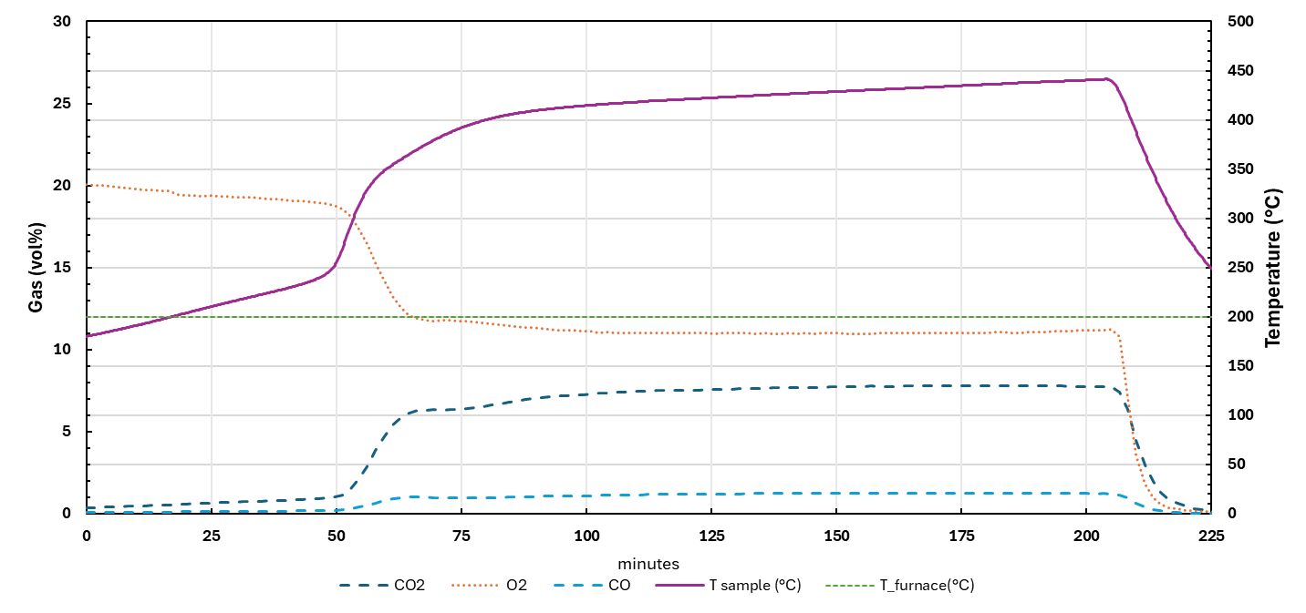
Finish of experiment
Thermal runaway
smoldering combustion
Start of reaction
Figure 3: Temperature history of heating up the sample to 200 °C with further holding of 3 hours
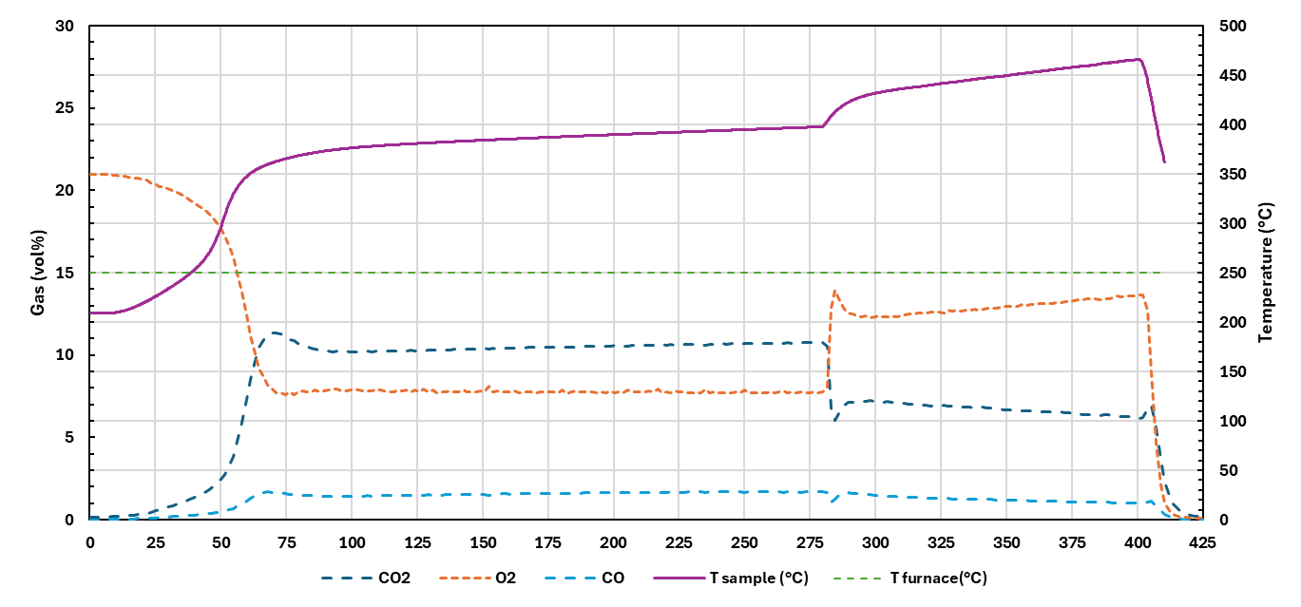
Smoldering combustion with supply of 2L/min air
Thermal runaway
Smoldering combustion with supply of 0.5L/min air
Figure 4: Temperature history of heating up the sample to 250 °C with further holding of 3 hours and change of supply of air
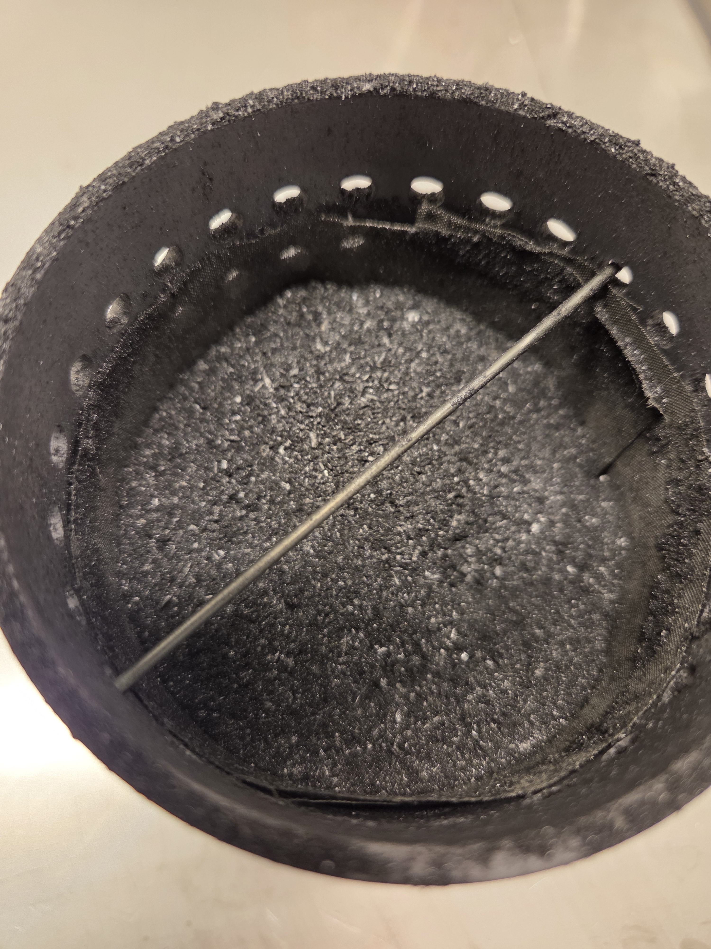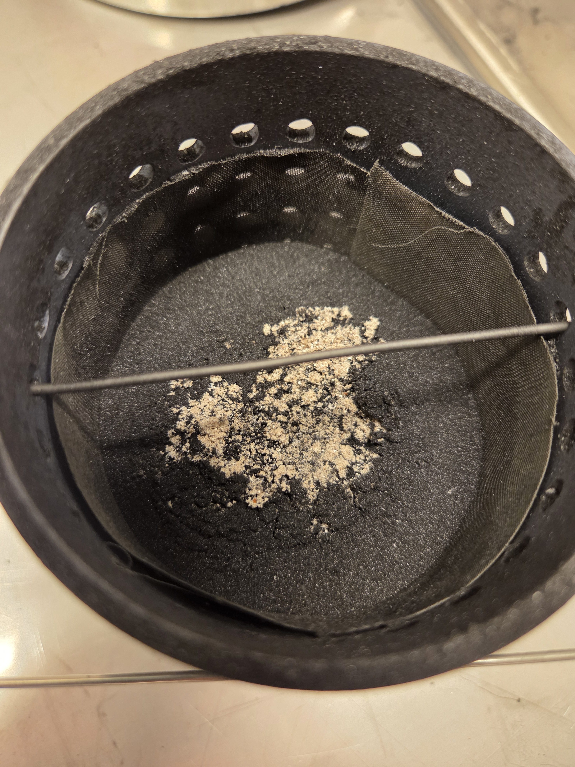
Figure 4: Residues of biocarbon after tests at temperature of 180 and 250 °C

Figure 4 shows temperature and gas release profile obtained from the test with furnace temperature (T_{furnace}) set at 250°C. This shows a more aggressive reaction than the 250°C test. It specifically tracks the effects of changing the air supply flow. Spikes in the gas concentration and temperature occur as the air supply is adjusted, demonstrating how oxygen availability alter the reaction rate. Different than the test at furnace temperature (T_{furnace}) 200°C, the test was conducted with changes of supply of air to the furnace during the test. From the start of the test to about 4 hours holding time, an air flow 0.5L/min was supplied. As shown in the figure 4, the measured sample temperature increases to 250°C, which further goes up to a temperature about 370 °C. Same as monitored from test conducted at 200 °C, the concentration of CO₂ decreases drastically with sharp increase of CO₂ and CO. It is interesting to note that, for the test conducted at 250 °C, the concentration of O₂ decreases from 20 vol% down to about 8 vol% in the flue gas, which keeps stable at this level during the further 3 hours testing time when the air supply is restricted to 0.5 L/min.

This monitored value is lower than detected from test conducted at 200 °C, which is about 11 vol% during smoldering combustion stage with supply of air of 1 L/min. In addition, the monitored CO₂ level from the test conducted at 250 °C during the first smoldering combustion stage is about 11 vol%, which is higher than that detected from the test conducted at 200 °C, even the latter with two times higher flow air supply. More intense consumption of O₂ and generation of CO₂ detected from the test conducted at 250 °C indicate that even with limited air, the reaction is more intense than the 200°C test because the higher ambient energy accelerates the initial oxidation kinetics. As shown in figure 4, with increase of air supply from the 0.5L/min to 2L/min, the sample temperature increases evidently from 400 °C to 450 °C. Such increase of temperature implies more intensive reaction of biocarbon with better availability of oxygen in the system, which is clearly indicated as increase of O₂ concentration shown in the figure 4. It is interesting to note that, while the reaction of biocarbon becomes more intense, the concentration of decrease CO₂ from about 11 vol% to 6 vol%. it is partially because the higher volume of air dilutes the produced gas.

Figure 5 shows the photo of residues to compare the physical state of biocarbon after the 180°C and 250°C tests. The 180°C residue (left) appears mostly intact and major fraction of the biocarbon particles are still black, reflecting the lack of reaction seen in Figure 2. The 250°C residue (right), in comparison to the initially loaded biocarbon, become more compact with decrease of height. In addition, yellowish particles and grains can be clearly seen on the top of the residue, which are ash after combustion of biocarbon. Observation of ash particles and grains provides visual evidence of the intensive smoldering combustion described in the 250°C.
  - Conclusions
The research specifically focuses on the risks of self-heating and spontaneous ignition during storage and transport. A fixed-bed reactor where a ground sample (0.5–1 mm) was subjected to controlled temperatures (180°C to 250°C) and varying air-flow rates (0.5 to 2 L/min). Simultaneous tracking of internal core temperature and gas emissions CO, CO₂, O₂ via Micro-Gas Chromatography. The experimental data reveals a clear progression of thermal behavior as the furnace temperature increases, moving from a state of stability to active combustion. At these lower temperatures, the biocarbon remains thermally stable. While the sample temperature rises to meet the furnace's heat, it levels off and stays consistent throughout the 3-hour holding period. Crucially, there is no detectable release of indicator gases like CO₂ and CO, and oxygen levels remain unchanged, suggesting that any chemical reactions at this stage are negligible. This temperature acts as the critical tipping point. Once the furnace reaches 200°C, the biocarbon undergoes thermal runaway. This is accompanied by the first measurable appearance of CO₂ and CO, signaling the breakdown of chemical bonds and a rapid consumption of available oxygen. At this elevated temperature, the material enters a state of active smoldering combustion. The reaction is far more aggressive than the 200°C test, with internal temperatures climbing as high as 450°C. The process is characterized by intense oxygen depletion and high levels of gas emissions. The study identifies that CO and CO₂, utility as early-warning markers. In addition, increasing air flow from 0.5 to 2 L/min accelerated the reaction and raised the internal temperature, though it diluted the concentration of emitted gases in the flue stream. Post-test analysis showed that while 180°C samples remained black and intact, 250°C samples were significantly reduced in volume and covered in yellowish ash particles. The research concludes that a dual-monitoring approach—combining temperature sensors with gas detection—is essential for the safe handling of biocarbon. Establishing alarm thresholds based on CO₂ and CO levels can prevent industrial fires before they reach a critical "thermal runaway" stage.
Acknowledgments
The authors acknowledge support from the project Upgrading biocarbon for sustainable metallurgical industries (BioCarbUpgrade). The supports are through the funding from the Research Council of Norway (grant no: 336309) and financial support from the BioCarbUpgrade project industry partner.
References
Venna S., Samane M. Geoffrey B., Philip B., Isabella D.B., 2019, Alternative sustainable carbon sources as substitutes for metallurgical coal,IEA report
Wang L, Skreiberg Ø., 2023. B., A Critical Review on Self-Heating and Self-Ignition of Biocarbon. Chemical Engineering Transactions 105, 271–276.
Phounglamcheik, A., Johnson, N., Kienzl, N., Strasser, C., Umeki, K., 2022. Self-Heating of Biochar during Postproduction Storage by O2 Chemisorption at Low Temperatures. Energies 15.
Restuccia, F., Mašek, O., Hadden, R.M., Rein, G., 2019. Quantifying self-heating ignition of biochar as a function of feedstock and the pyrolysis reactor temperature. Fuel 236, 201–213.
Wang, L., Barta-Rajnai, E., Hu, K., Higashi, C., Skreiberg, Ø., Grønli, M., Czégény, Z., Jakab, E., Myrvågnes, V., Várhegyi, G., Antal, M.J., 2017. Biomass Charcoal Properties Changes During Storage. Energy Procedia. 105, 830 – 835
Dzonzi-Undi, J., Masek, O., 2014. Determination of Spontaneous Ignition Behaviour of Biochar Accumulations. International Journal of Science and Research (IJSR) 3, 656–661.
Van Blijderveen, M., Bramer, E.A., Brem, G., 2013. Modelling spontaneous ignition of wood, char and RDF in a lab-scale packed bed. Fuel 108, 190–196.
Garcia Torrent, J., Fernandez Anez, N., Medic Pejic, L., Montenegro Mateos, L., 2015. Assessment of self-ignition risks of solid biofuels by thermal analysis. Fuel 143, 484–491.
Lohrer, C., Krause, U., Steinbach, J., 2005. Self-Ignition of Combustible Bulk Materials Under Various Ambient Conditions. Process Safety and Environmental Protection 83, 145–150.
Carras, John N., and Brian C. Young. 1994. Self-Heating of Coal and Related Materials: Models, Application and Test Methods. Progress in Energy and Combustion Science 20 (1): 1–15.

