 CHEMICAL ENGINEERING TRANSACTIONS  VOL. xx, 2026 | A publication of  
The Italian Association
of Chemical Engineering
Online at www.cetjournal.it

Guest Editors: Leonardo Tognotti, Rubens Maciel Filho, Viatcheslav Kafarov
Copyright © 2026, AIDIC Servizi S.r.l.
ISBN 979-12-91206-xx-x; ISSN 2283-9216

Characterisation of Biocarbon Produced from Untreated and Water-Leached Pine Bark
Liang Wangª*, Zsuzsanna Czégény^{b}, Yusuf Tolunay Kilic^{c}, Bence Babinszki^{b}, Robert L. Johnson^{d}, Kentaro Umeki^{c}, Øyvind Skreibergª, Scott Q. Turn^{d}
ª SINTEF Energy Research, Trondheim, Norway
^{b} HUN-REN Research Centre for Natural Sciences, Institute of Materials and Environmental Chemistry, Budapest, Hungary
^{c} Division of Energy Science, Luleå University of Technology, SE-97187, Luleå, Sweden
^{d} Hawaii Natural Energy Institute, University of Hawaii at Mānoa

liang.wang@sintef.no

Leaching pine bark with deionized water effectively reduced its total ash content by removing a portion of the inorganic elements, particularly the water-soluble potassium (K) and sodium (Na). As a result, biocarbon derived from leached pine bark contained lower levels of both ash and carbon, compared to biocarbon derived from untreated pine bark. Inductively coupled plasma atomic emission spectroscopy (ICP-AES) confirmed that the content of total and individual inorganic elements in the leached bark biocarbon was considerably reduced relative to the untreated counterpart. X-ray diffraction (XRD) analysis identified calcium carbonate as the dominant mineral phase in both biocarbons; however, its peak intensity was notably weaker in the leached bark biocarbon, indicating a lower content of this mineral phase. Scanning electron microscopy coupled with energy-dispersive X-ray spectroscopy (SEM-EDS) revealed calcium-rich grains on the surface of the untreated bark biocarbon, which were largely absent in the leached bark biocarbon. Fourier transform infrared (FTIR) spectroscopy showed similar spectral profiles for both biocarbons, though the leached bark biocarbon exhibited reduced peak intensities corresponding to C=O and C–O–C stretching vibrations. This reduction is likely due to the removal of water-soluble extractives and polysaccharides during leaching, resulting in the formation of fewer oxygenated functional groups during carbonization and a reduced carbon content.
  - Introduction
Interest is growing in replacing fossil-based metallurgical reductants with sustainable biocarbon derived from lignocellulosic biomass via pyrolysis. However, its adoption is often limited by high inorganic impurities (ash) and poor mechanical strength, particularly when using low-grade or unconventional feedstocks. Pre-treatment to reduce ash content is essential to improve the quality and performance of biocarbon for metallurgical applications. Biomass naturally contains mineral matter derived from both intrinsic physiological processes and external contamination during growth or handling (Wang and Skreiberg, 2023). Among the inherent minerals, alkali and alkaline earth metals (AAEMs), together with phosphorus, are predominant, as they serve essential nutritional roles in plant development. To address the detrimental impact of these inorganic constituents on biocarbon quality, various demineralization strategies have been investigated, with washing and leaching emerging as the most effective (Singhal et al., 2023). Of these, water and acid leaching have been studied most extensively. Water leaching, in particular, has been widely recognized for its simplicity, cost-effectiveness, rapid operation and efficiency in eliminating water-soluble inorganic species such as sodium (Na), potassium (K) and sulphur (S). Washing pretreatments have been widely investigated as a strategy to improve the quality of biomass for thermochemical conversion. Studies on agricultural residues, grasses and aquatic biomass have shown that water washing effectively removes over 90% of potassium (K), chlorine (Cl) and sodium (Na), while also reducing 10–70% of calcium (Ca), magnesium (Mg), phosphorus (P) and silicon (Si) (Singhal et al., 2023). In addition to reducing ash-forming elements, leaching significantly influences pyrolysis behaviour by altering decomposition kinetics, product distributions and the physicochemical properties of the resulting fractions. Water-leached biomass exhibited slower decomposition and released volatiles at higher temperatures, confirming the catalytic role of AAEMs in lowering pyrolysis activation energy (Branca and Di Blasi, 2024). Although significant progress has been made in this field, most studies have primarily concentrated on liquid-phase products, leaving the effects of leaching of biomass on properties of the produced biocarbon largely underexplored. This is a critical gap, as biocarbon characteristics directly affect its effectiveness as a carbonaceous reductant in metallurgical applications. Currently, large-scale biocarbon production relies mainly on stem wood, a feedstock that also holds substantial value for manufacturing higher-value products. To secure a sustainable biocarbon supply for energy- and material-intensive metal industries, it is essential to shift more focus toward utilizing low-grade biomass as alternative feedstocks (Wang and Skreiberg, 2023). Bark, which represents approximately 9–21% of a tree’s dry mass depending on the species, is produced in vast quantities as a by-product of forestry, sawmilling and pulp and paper industries (Şen and Pereira, 2021). Globally, millions of tons of bark are generated each year, yet its utilization remains limited, with much of it ending up in landfills, being openly burned, or used as a low-grade fuel (Feng et al., 2013). Given its lignocellulosic structure and relatively high carbon content, bark has strong potential as a renewable feedstock for biocarbon production. Its effective utilization could provide a sustainable carbon source, reduce waste, improve resource efficiency within the forestry sector and help to mitigate greenhouse gas emissions (Şen and Pereira, 2021). However, compared to stem wood, bark generally contains higher levels of inorganics and has greater compositional variability. These differences are influenced by factors such as species, geographic origin, plant tissue type, harvesting season and growth conditions. To address this, washing, particularly water leaching, has been investigated as a pretreatment to lower inorganic content. For example, Liu and Bi (2011) found that water washing of pine bark removed less than 10% of total ash, while acid washing achieved reductions of 36 –54%. Likewise, Singhal et al. (2023) showed that water leaching of spruce bark for 180 minutes reduced total ash content by up to 18%, with removal efficiencies of 85% for Na, 57% for K, 48% for Mg and 20% for P. Despite these encouraging outcomes, research examining how such pretreatments influence the properties of bark-derived biocarbon remains scarce.
The aim of the present study is to characterize properties of biocarbon produced from water-leached pine bark. The pine bark was first leached with deionized water. The untreated and water-leached barks were then pyrolyzed to produce biocarbon at a temperature of 500 °C, applying a slow heating rate of 10 °C/min with purging of N₂. The biocarbons were characterized via a combination of analytical techniques. The effects of leaching parental bark on biocarbon properties were investigated, including general properties, element composition, content of ash and major inorganic elements, presence of crystalline phases, surface functional groups and microstructure and chemistry.
  - Materials and methods
    - Sample preparation and leaching treatment
This study investigated the bark of Scots pine (Pinus sylvestris). A pine tree was collected from a forest in southern Norway (Hobøl, 59°35′35″N 10°56′45″E) and the bark was removed and cut into small chips about 3–4 cm long. The chips were first air-dried at room temperature to about 15% moisture, then oven-dried at 105 °C for 16 hours. Leaching tests were performed in triplicate under identical conditions. In each test, 100 g of bark chips were placed in 1 L of deionized Milli-Q water (conductivity < 1 μS cm⁻¹) at 60 °C for 60 minutes. Afterward, the bark was filtered out, oven-dried again at 105 °C for 24 hours and stored. In total, 300 g of bark was prepared for later analysis and for making biocarbon.
Biocarbon was produced using a laboratory-scale fixed bed reactor system. The system comprises a cylindrical fixed bed reactor housed within a tubular electrical furnace, which is connected to a temperature and heating control unit. The reactor tube is constructed from Kanthal APM™ (a FeCrAl alloy) capable of withstanding temperatures up to 1250 °C. A gas purging system and a condenser are integrated with the reactor. For each experiment, the dried bark, either unleached or water-leached was loaded into the sealed tubular reactor, which was then connected to the gas purge system and condenser. The reactor was purged with nitrogen at 2 Normal Litter (NL)/min for 1 hour to remove residual air. Subsequently, the reactor was heated to 500 °C at a rate of 10 °C/min and maintained at this temperature for 1 hour. Temperatures at the centre of the biomass bed and at the reactor outlet were continuously monitored to ensure precise control during the process. After holding at 500 °C for 1 hour, the power supply of the furnace was cut off and the reactor cooled down to room temperature with continuous purging of N₂. As the temperature reached 50 °C, the reactor was opened for unloading solid biocarbon.
    - Biocarbon characterization
Proximate analysis of the untreated dried bark and produced biocarbon was performed following ASTM 872, ASTM D1102 and ASTM D1762-84. The ultimate composition and inorganic element content of the dried bark sample and biocarbon were determined using an element analyser (Eurovector EA 3000 CHNS-O) and an inductively coupled plasma-atomic emission spectrometer (ICP-AES). A Fourier transform infrared spectroscope (FTIR) was used to identify functional groups on surface of the produced biocarbon. The produced biocarbon was characterized for its morphology, microstructure and elemental composition using a scanning electron microscope (SEM, Zeiss Ultra 55 Limited Edition) combined with Energy Dispersive Spectroscopy (EDS, Bruker XFlash).
  - Results and discussions
    - Solid yield of leached bark
The volatile matter (VM), fixed carbon (FC) and ash contents and the main element composition in the untreated and water-leached pine bark are summarized in Table 1. Upon leaching, the C and H content of the pine bark respectively decreased and increased slightly. This change can be related to the leaching of some organic compounds such as sugars, organic acids and phenols (Şen and Pereira, 2021). The proximate analysis results showed that water leaching reduced the ash content of the pine bark from 1.45% to 1.21%. Table 2 shows that the content of all detected inorganic elements in the water-leached bark are lower than those in the untreated bark. It can be seen that K and Na in the water-leached bark are significantly lower, respectively about 48 and 69% lower compared to the untreated bark. For biomass materials, the K and Na are often present as ions in the intracellular fluid, which are water-soluble and can be effectively leached away. For elements like Ca, Mg, Si and P, significant fractions of them are covalently bonded to the organic matrix or present as water-insoluble compounds such as Ca- and Mg-oxalates and carbonates (Singhal et al., 2023). Water leaching is less effective in removing these elements, their contents being respectively about 3, 11, 17 and 15% lower. For Ca this is negligible and falls within the standard error range of ICP-AES analysis for heterogeneous solid fuels.
Table 1: Proximate and ultimate composition of the untreated and water-leached pine bark
 | Volatile matterª | Ashª | Fixed carbon^{a,c} | C^{b} | H^{b} | N^{b} | S^{b} | O^{b,c}
Pine bark | 79.84 | 1.45 | 18.71 | 50.37 | 6.01 | 0.45 | 0.03 | 43.15
Leached pine bark | 81.35 | 1.21 | 17.44 | 49.68 | 6.12 | 0.47 | 0.01 | 43.72
ª: wt%, dry basis, ^{b}: wt%, dry ash free basis, ^{c}: by difference
Table 2: Content of inorganic elements in the untreated and water-leached pine bark (mg/kg)
 |  | Ca | K | Na | P | S | Mg | Si | Al | Mn | Zn | Fe
 | Pine bark | 5130 | 1394 | 62 | 360 | 380 | 416 | 360 | 109 | 259 | 87 | 22
 | Leached pine bark | 4997 | 724 | 19 | 306 | 353 | 369 | 298 | 106 | 243 | 84 | 20
    - Characterization of biocarbon
Table 3 summarizes the proximate analysis and ultimate analysis of biocarbon produced from the untreated and water-leached pine bark. The volatile matter content of the biocarbon produced from water-leached bark is slightly higher than the biocarbon produced from untreated bark. Also, water leaching of pine bark had some impact on the element composition of the produced biocarbon. The biocarbon produced from water-leached bark has slightly lower carbon content compared to that from untreated bark. It can be related to loss of certain organic fractions of the pine bark upon leaching treatment. In contrast to volatile matter, water leaching had evident impact on the biocarbon ash content. The ash content of biocarbon from water leached bark is 3.98%, whereas the ash content of biocarbon from untreated bark is 5.88%.
Table 3: Proximate and ultimate composition in the biocarbon produced from untreated and water-leached pine bark
 | Volatile matterª | Ashª | Fixed carbon^{a,c} | C^{b} | H^{b} | N^{b} | S^{b} | O^{b,c}
Pine bark biocarbon | 16.74 | 5.88 | 77.38 | 80.55 | 2.95 | 0.86 | 0.02 | 15.63
Leached pine bark biocarbon | 17.98 | 3.98 | 78.04 | 78.31 | 3.01 | 0.88 | 0.01 | 17.78
ª: wt%, dry basis, ^{b}: wt%, dry ash free basis, ^{c}: by difference
Table 4 summarizes the major inorganic elements and the total amount of them determined by ICP-AES. The total amount of inorganic elements of biocarbon produced from the untreated pine bark is 22402 mg kg⁻¹, which is close to the value reported in previous studies. For the biocarbon produced from water-leached bark, this value is considerably reduced, to 16864 mg/kg. As shown in Table 4, Ca and K are two dominant inorganic elements in the biocarbon, followed by various amounts of Mg, Mn, P, Si and Al. Among these elements, in comparison to the biocarbon produced from the untreated bark, K, Na and P in the biocarbon produced from leached bark are significantly lower, while contents of Ca, Mg and Mn remain high. The ICP-AES analyses conducted on biocarbon produced from the untreated and water leached pine bark imply that water leaching is more efficient to reduce content of alkali metals K and Na that have high solubility towards water. For reducing content of other less water-soluble elements such Ca, Mg and Mn, more severe leaching treatment is needed.
Table 4: Content of inorganic elements in biocarbon produced from the untreated and water-leached pine bark (mg/kg)
 |  | Ca | K | Na | P | S | Mg | Si | Al | Mn | Zn | Fe | Total
 | Pine bark biocarbon | 12980 | 4470 | 93 | 580 | 190 | 1962 | 480 | 148 | 1295 | 99 | 53 | 22350
 | Leached pine bark biocarbon | 11358 | 2030 | 29 | 353 | 142 | 1755 | 318 | 156 | 1251 | 89 | 44 | 17525

In addition to the content of the inorganic elements, it is also necessary to examine presence of the inorganic elements in the biocarbon. X-ray diffraction (XRD) analyses of biocarbon from untreated and leached pine bark are shown in Figure 1. A broad peak between 22° and 26°can be seen for both samples. This broad peak suggests presence of amorphous carbon structure. The peaks at 29.55°, 36.0°, 39.43°, 47.5° and 48.5° indicate the presence of crystalline calcite structures. Calcium carbonate has been observed in biocarbons produced from different woody biomass materials with calcium as a dominant inorganic element (Phounglamcheik et al., 2021). In lignocellulose biomasses, calcium is normally present as water-soluble forms (e.g., Ca²⁺ ions, CaCl₂ ) and in less soluble forms (e.g., Ca oxalate). During a pyrolysis process, the calcium oxalate will decompose in a temperature range between 400–700 °C with calcium carbonate and CO as main products (Wang and Skreiberg, 2023). The formed calcium carbonate normally tends to crystallize within the biocarbon structure and can migrate from the internal structure to the external surface. The calcium carbonate can further decompose into calcium oxide and CO₂ as the temperature rises above 700 °C. The formation, migration and decomposition of calcium carbonate can promote pore formation and increase surface area of the biocarbon structure. In addition, the calcium oxide generated from the decomposition of calcium carbonate has catalytic activities, enhancing conversion of carbon through different reactions. Therefore, as used for metallurgical applications, biocarbon with high content of calcium and calcium containing mineral phases are normally not wanted. Figure 1 shows that, for the biocarbon produced from the water-leached pine bark, the intensity of peaks corresponding to calcium carbonate are lower in comparison to those identified from the biocarbon produced from the untreated pine bark. The XRD peak intensity is normally proportional to amount and crystallinity of the mineral phase in the biocarbon. Therefore, the XRD spectrum in Figure 1 confirms that water leaching of bark can reduce the content of calcium in the raw feedstock, which further reduces the amount of calcium carbonate formed upon pyrolysis at the studied temperature.
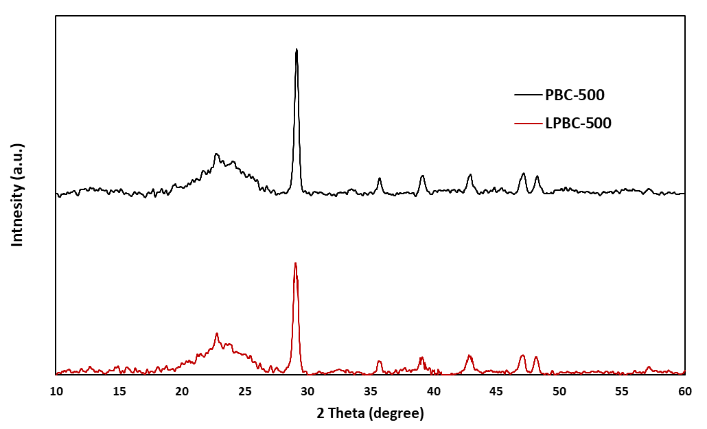
CaCO3
v
v
v
v
v
v
v
Figure 1: XRD diffractograms of biocarbon from untreated (PBC) and water-leached (LPBC) pine bark produced at 500 °C
Figure 2 shows microstructure and distribution of ash-forming elements on the biocarbon samples, analysed by SEM−EDS. For both biocarbons, they generally have a compact surface and dense structure as shown in Figure 2 (a) and (c). As shown in Figure 2(a), there are many areas with brighter colour on the surface of biocarbon produced from the untreated pine bark. Figure 2(b) shows a zoom-in view of the area highlighted with a rectangle in Figure 2(a). In the scanned area, there are small white particles aggregated together. EDS analyses (Figure 3(a)) revealed that Ca and C are two main elements in these particles. The high content of Ca and C indicate presence of calcium carbonate, which agrees with the XRD analysis. The presence of these Ca rich particles on the biocarbon surface implies migration and accumulation of Ca during pyrolysis of pine bark, which has been identified and reported by other work (Phounglamcheik et al., 2021). On the other hand, for the biocarbon produced from the leached pine bark, only a few large bright grains can be observed as shown in Figure 2 (c). The difference regarding presence of Ca rich particles on the surface of the studied biocarbon, together with the ICP and XRD analyses results, confirms that water leaching treatment can reduce the content of inorganic elements in the raw pine bark and the produced biocarbon as well. Figure 3 (a) also shows EDS analysis on spot 4 of untreated sample as indicated in Figure 2(b). The analysis results show that the C content of the detected spot is about 90 mol% with presence of Ca, K, Mn, Mg and P. From the biocarbon produced from the leached pine bark, even higher content of C was detected (spot 3 and 4, Figure 2(d)), above 90 mol%. In addition, contents of Ca, K, Mn, Mg and P detected from the same spot are quite low. Comparison of EDS analyses on the carbon-rich spots and regions implies that leaching treatment might affect the amount of these inorganic elements retained in the biocarbon matrix.

Figure 2. SEM images of biocarbon from untreated ((a) and (b)) and water-leached pine bark ((c) and (d)) produced at 500 °C
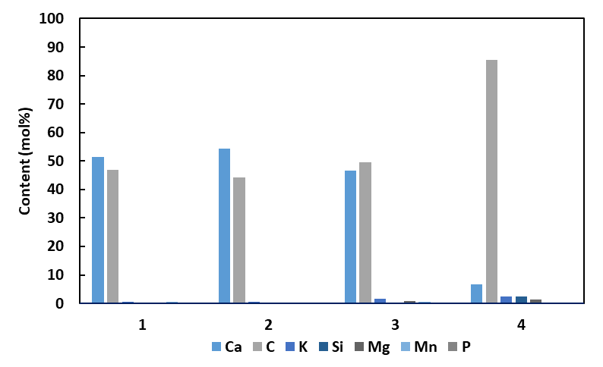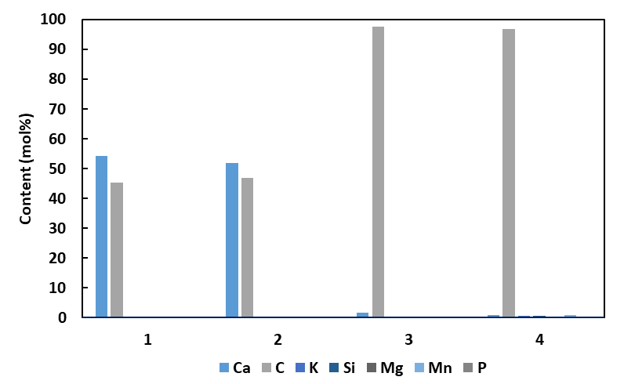
a
b
Figure 3. EDS analysis on biocarbon from untreated (a) and water-leached pine bark (b) produced at 500 °C

As used for metal production applications, volatile matter content of the biocarbon is an important property. Content and composition of the volatile matter are partially related to functional group composition in the biocarbon, which can be elucidated through Fourier-transform infrared spectroscopy (FTIR) analysis. The FTIR analysis is based on the principle that one functional group of organic matter corresponds to a specific peak at a certain wavelength in the infrared spectrum (Şen et al., 2023). As shown in Figure 4, the FTIR pine bark biocarbon exhibits noticeable adsorption bonds with peaks at 1100–1000 cm⁻¹ corresponding to C–O stretching vibrations, peaks at 1200–1100 cm⁻¹ corresponding to C–O–C stretching vibrations, peaks at 1600–1500 cm⁻¹ corresponding to aromatic C=C stretching vibrations and lignin-derived skeletal vibrations, peaks at 2100–2050 cm⁻¹ corresponding to C≡C stretching and broad absorption peaks at 3600–3100 cm⁻¹ corresponding to O-H stretching vibration (Vilakazi et al., 2023). The FTIR spectra detected from biocarbons produced from untreated and leached pine are rather similar. However, the intensity of the peaks corresponding to different functional groups are different. The 1100–1000 cm⁻¹ and 1200–1100 cm⁻¹ peaks are corresponding to C–O and C–O–C stretching vibrations from functional groups (i.e., polysaccharides) derived from the decomposition of cellulose and hemicellulose (Vilakazi et al., 2023). For the bark produced from the leached pine bark, the peaks in these two wavelength regions are considerably lower or even diminished. It is mainly due to removal of water-soluble parts of hemicellulose and extractives in the pine bark upon leaching treatment. There is a peak between 1600–1500 cm⁻¹ in the FTIR spectra, which corresponds to C=C stretching vibrations and lignin-derived skeletal vibrations (Şen et al., 2023). It indicates abundance of functional groups derived from the lignin contained in the bark. For the biocarbon from untreated pine bark, the intensity of this peak is evidently higher, indicating presence of more condensed aromatic structures.
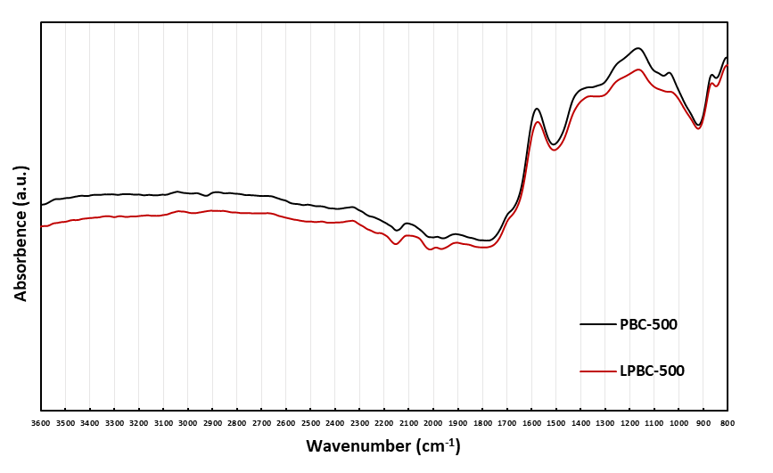
Figure 4. FTIR spectra biocarbon from untreated (PBC-500) and water-leached (LPBC-500) pine bark produced at 500 °C
  - Conclusions
Leaching treatment with deionized water reduced the content of total ash and certain inorganic elements in the studied pine bark, especially for the water-soluble K and Na. The biocarbon produced from the leached pine bark has lower content of ash and carbon as well. ICP-AES results showed that total amount and amount of individual inorganic elements contained in the biocarbon from the leached pine bark are evidently lower than in the biocarbon produced from untreated pine bark. XRD analyses showed that calcium carbonate is the main mineral phase detected in the biocarbon from both untreated and leached biocarbon. However, the intensity of the calcium carbonate in the biocarbon from leached pine bark is lower, indicating lower content of this mineral phase. SEM-EDS analyses revealed presence and accumulation of calcium rich grains on the surface of the biocarbon produced from the untreated pine bark, which is hardly observed from the biocarbon produced from the leached pine bark. FTIR analysis results showed that biocarbon produced from both untreated and water-leached pine bark are similar. For the biocarbon produced from the water-leached pine bark, lower intensity of peaks corresponding to C=O and C–O–C stretching vibrations were observed. This is partially related to reduced hemicellulose and extractives content in the water-leached pine bark, modified decomposition and carbonization mechanism due to decreased alkali and alkali earth metal content, therefore limiting formation of oxygenated functional groups during the biocarbon production process.
Acknowledgments
The authors acknowledge support from the project Upgrading biocarbon for sustainable metallurgical industries (BioCarbUpgrade). The supports are through the funding from the Research Council of Norway (grant no: 336309) and financial support from the BioCarbUpgrade project industry partners.
References
Branca, C. and Di Blasi, C., 2024. Demineralization Pretreatments for Reducing Biomass Variability in Pyrolysis. ACS Omega, 9(8), pp. 9536–9546.
Feng, S., Cheng, S., Yuan, Z., Leitch, M. and Xu, C., 2013. Valorization of bark for chemicals and materials: A review. Renewable and Sustainable Energy Reviews, 26, pp. 560–578.
Liu, X. and Bi, X.T., 2011. Removal of inorganic constituents from pine barks and switchgrass. Fuel Processing Technology, 92(7), pp. 1273–1279.
Phounglamcheik, A., Vila, R., Kienzl, N., Wang, L., Hedayati, A., Broström, M., Ramser, K., Engvall, K., Skreiberg, Ø., Robinson, R. and Umeki, K., 2021. CO2 Gasification Reactivity of Char from High-Ash Biomass. ACS Omega, 6(49), pp. 34115–34128.
Şen, A.U. and Pereira, H., 2021. State-of-the-Art Char Production with a Focus on Bark Feedstocks: Processes, Design, and Applications. Processes, 9(1), p. 87.
Sen, U., Martins, M., Santos, E., Lemos, M.A., Lemos, F. and Pereira, H., 2023. Slow Pyrolysis of Quercus cerris Cork: Characterization of Biochars and Pyrolysis Volatiles. Environments, 10(1), p. 4.
Singhal, A., Goel, A., Bhatnagar, A., Roslander, C., Wallberg, O., Konttinen, J. and Joronen, T., 2023. Improving inorganic composition and ash fusion behavior of spruce bark by leaching with water, acetic acid, and steam pre-treatment condensate. Chemical Engineering Journal, 452, p. 139351.
Vilakazi, S.P., Muchaonyerwa, P. and Buthelezi-Dube, N.N., 2023. Characteristics and liming potential of biochar types from potato waste and pine-bark. PLOS ONE, 18(2), p. e0282011.
Wang, L. and Skreiberg, Ø., 2023. Evaluation of Water Leaching on Properties of Woody Biomass for Biocarbon Production. Chemical Engineering Transactions, 105, pp. 277-282.

