 CHEMICAL ENGINEERING TRANSACTIONS  VOL. , 2025 | A publication of  
The Italian Association
of Chemical Engineering
Online at www.cetjournal.it

Guest Editors:
Copyright © 2025, AIDIC Servizi S.r.l.
ISBN 979-12-81206-XX-X; ISSN 2283-9216

Kinetic Parameter Sensitivity in Microbial Electrolysis Cell Performance Modeling
Gabriela S. Demarqui^{a,}*, Marcos P. Felizardo, Loyse Tussolini, Laiane A. Andrade, Júlio C.C. Miranda
ªChemical Engineering Department, Engineering School, Universidade Federal de Mato Grosso,
Avenida Fernando Corrêa da costa 2367, Cuiabá 78060900, Brasil
gabriela.demarqui@sou.ufmt.br
Microbial Electrolysis Cells (MEC) represent a promising technology for hydrogen production from wastewater, requiring low applied voltages compared to conventional water electrolysis. However, system performance remains limited due to complex microbial interactions, making mathematical modeling essential for process optimization. This work replicates and analyzes the multi-population dynamic model proposed by Pinto et al. (2011), focusing on sensitivity analysis of maximum substrate consumption rates (q_{max}) for electrogenic, fermentative, and acetoclastic methanogenic microorganisms. Fifteen simulations were conducted, varying each parameter within its respective uncertainty intervals, and sensitivity was quantified using normalized indices. Results revealed a clear hierarchical importance: q_{max,e} (electrogenic) showed the highest impact with sensitivity indices (S_{mean}) ranging from 3.8 to 6.2 for competitive microbial populations; q_{max,f} (fermentative) demonstrated transient influence primarily during reactor startup (S_{mean} ranging from 0.65 to 0.78); while q_{max,m} (methanogenic) affected only anodic methane production (S_{mean} of approximately 0.96). Notably, electrochemical performance variables (current, H₂ production) proved robust to all three parameters at steady state, indicating that once the electrogenic biofilm is established, the system exhibits significant operational stability. These findings provide practical guidance for MEC design and operation, identifying q_{max,e} as the critical parameter requiring precise estimation for accurate prediction of microbial competition dynamics.
  - Introduction
In response to the ongoing climate crisis, wastewater treatment plants are transitioning into resource recovery facilities, with a focus on mitigating carbon footprints and enhancing energy efficiency (Fathima et al., 2024). In this context, hydrogen is widely recognized as a clean energy vector with an energy potential of 122 kJ/g, exceeding gasoline by 2.75 times (Palanivel and Mohamed, 2025). Microbial Electrolysis Cells (MECs) are a type of microbial electrochemical system (MES) operated for hydrogen production from biomass, such as wastewater or organic waste, while simultaneously treating these effluents (Yahya et al., 2013).
The operating mechanism of MECs relies on principles analogous to water electrolysis (Zou and He, 2018), yet with a key distinction: the employment of electroactive microorganisms at the anode (Asrul et al., 2021). These microbes oxidize organic matter, releasing electrons, protons, and CO₂ (Zeppilli et al., 2015). A major advantage of this process lies in its favorable thermodynamics; unlike water electrolysis, which demands a theoretical minimum voltage of 1.23 V, MECs can function with a substantially lower external applied voltage, approximately 0.2 V, as the chemical energy stored in the organic substrate facilitates the reaction (Asrul et al., 2025b).
Despite this potential, optimizing MECs presents challenges arising from the complexity of microbial interactions (Hasany et al., 2016). Mathematical modeling has emerged as an effective approach to addressing these challenges, enabling the analysis of dynamic phenomena at the microbial level and supporting the design of process monitoring and control for optimal biohydrogen production (Asrul et al., 2021). In this context, the multi-population dynamic model developed by Pinto et al. (2011) provides a structured framework for simulating the competing metabolic activities of bacteria. While Dudley et al. (2019) performed sensitivity analysis of a reduced version of this model, focusing on current density response to exoelectrogenic parameters in acetate-fed batch MECs, a systematic quantification of the relative influence of the maximum substrate consumption rates for all three microbial groups on both biofilm competition dynamics and electrochemical performance variables remains unreported. More recent sensitivity studies have either focused on operational and reactor design parameters (Pedroza-Medina et al., 2024) or on electrochemical kinetic structures for electroactive bacteria alone (Asrul et al., 2025a), leaving the parametric sensitivity of the full model under startup conditions unaddressed. The present work fills this specific gap by replicating the model under reactor inoculation conditions and applying normalized sensitivity indices across the full set of state variables, providing practical guidance on which kinetic parameters require precise estimation for reliable model-based MEC design.
  - Methodology
    - Continuous Model
The dynamic model developed by Pinto et al. (2011) serves as a tool to simulate hydrogen production in MECs fed with complex organic substrates, such as wastewater. Designed for process control and optimization, the model employs specific assumptions to ensure computational efficiency. Specifically, the anaerobic digestion process at the anode is streamlined into a single hydrolysis and fermentation step where acetate acts as a proxy for all volatile fatty acids. The biological framework integrates four distinct microbial populations, accounting for the anodic competition for acetate between exoelectrogens and acetoclastic methanogens, alongside the cathodic consumption of H₂ by hydrogenotrophic methanogens.
Instead of using a complex distributed parameter approach, the authors adopted a simplified layered biofilm structure governed by biomass retention constants. This structure distinguishes between an outer anodic layer (fermentative and acetoclastic bacteria), an inner anodic layer (exoelectrogens and acetoclastic bacteria), and a separate cathodic biofilm layer populated by hydrogenotrophic methanogens. Further operational assumptions include a perfectly mixed anodic chamber, a fixed pool of intracellular mediators for electron transfer, and negligible biomass growth in the bulk liquid. Finally, the system assumes that environmental parameters, specifically pH and temperature, are strictly regulated.
    - Simulation Validation
Reproduction of the reference experimental scenario (MEC-3 Cell), necessary to validate the model before sensitivity analysis, presented challenges due to the absence of explicit values in the original literature (Pinto et al., 2011) for the initial concentrations of state variables, such as substrate (S_{u}), acetate (A), redox mediator in oxidized form (M_{ox}), and initial biomass fractions. Additionally, the reference study presents the cathodic yield (Y_{h}) coupled with the maximum capacity of biofilm layer 3 (X_{max,3}) through the relationship described in Equation 1, without discriminating the independent values for each parameter.
$${\text{Y}}_{\text{h}}\text{⋅}{\text{X}}_{\text{max,3}}\text{=1680}$$ | (1)
Therefore, to enable numerical simulation, the parameter Y_{h} was decoupled and fixed at 0.5 mL-H₂/mg-X, allowing determination of the corresponding X_{max,3} value; similarly, the applied potential was fixed at 1 V. Initial conditions were then heuristically estimated to minimize deviation from the graphically reported MEC-3 trajectories of Pinto et al. (2011). It is worth noting that full quantitative validation was not achieved with the current parameterization. The large transient discrepancies observed arise from phase misalignments between the simulated dynamic response and reference data digitized from figures and reflect the inherent limitations of heuristic parameter estimation in the absence of explicitly reported initial conditions. The relative errors remained mostly below 30 %, 100 %, 80 %, and 60 % for soluble dynamics of chemical oxygen demand, acetate, current, and hydrogen production, respectively, indicating that the model adequately reproduces the equilibrium behavior of the system. Nevertheless, the uncertainty introduced during the transient phase must be considered when interpreting the sensitivity indices computed during startup, as presented in Section 3.
    - Computational Implementation and Parameterization
The system of ordinary differential equations governing the process was implemented in the MATLAB/Simulink platform using the ode15s solver. For numerical integration, kinetic and physical parameters were adopted directly from the original study. The focus of the analysis was the simulation of reactor startup, representing the biomass inoculation scenario in a clean medium. For this simulation, initial concentrations of S_{u} and A were defined as 0 mg/L. Initial biomass concentrations were distributed as follows: 22 mg/L for both fermentative (x_{f}) and acetoclastic methanogenic microorganisms of the external layer (x_{m,1}); 13 mg/L for both electrogenic (x_{e}) and acetoclastic methanogenic microorganisms of the internal layer (x_{m,2}); and 168 mg/L for hydrogenotrophic methanogenic biomass (x_{h}). Additionally, the initial concentration of M_{ox} was established at 0.05 mol/L, and the reactor receives a constant feed of 550 mg/L of substrate.
To evaluate the impact of parametric uncertainties on model behavior, a sensitivity analysis was performed. Fifteen simulations were conducted exploring the uncertainty interval of maximum substrate consumption rates for fermentative (q_{max,f}), electrogenic (q_{max,e}), and acetoclastic methanogenic (q_{max,m}) microorganisms. The adopted uncertainty intervals (Table 1) correspond to the 95 % confidence intervals statistically reported by Pinto et al. (2011), ensuring that the analysis reflects the real uncertainty of parametric estimation.
Table 1 - Uncertainty intervals
Parameter | Value (mg-S/mg-X) | Uncertainty
qmax,e  qmax,m | 14  14.12 | ± 9.7 %  ± 11.8 %
qmax,f | 16.28 | ± 35.4 %
The sensitivity of variables to variations was quantified using a normalized index, S, which measures the relative variation of a model output variable (F) in response to a relative variation in an input parameter (ξ), according to Equation 2. Values of S close to 0 indicate that the model is insensitive to the parameter, while values greater than 1 suggest high sensitivity, thus allowing identification of which kinetic parameters exert greater influence on the simulation results.
$$\text{S}\left(\text{F;ξ}\right)\text{=}\left|\left(\frac{\text{∂F}}{\text{∂ξ}}\right)\text{⋅}\left(\frac{\text{ξ}}{\text{F}}\right)\right|$$ | (2)
  - Results and Discussion
    - Variation of q_{max,e}
The maximum substrate consumption rate by electrogenic microorganisms proved to be the most critical parameter for internal biofilm competition dynamics. Figures 1a and 1b illustrate the evolution of populations in layer 2, where electrogenic and acetoclastic methanogens microorganisms compete directly for space and substrate. It is observed that for all simulated scenarios, the electrogenic population shows rapid growth, reaching saturation of the biofilm support capacity in less than 20 days. This dominance imposes a severe spatial and nutritional restriction on the cohabiting methanogenic population, leading to its rapid decline between days 15 and 60, demonstrating that a small increase in q_{max,e} efficiency is sufficient to cause rapid population washout and indicating that the competitive equilibrium predicted by the model is dependent on the precision of this parameter.
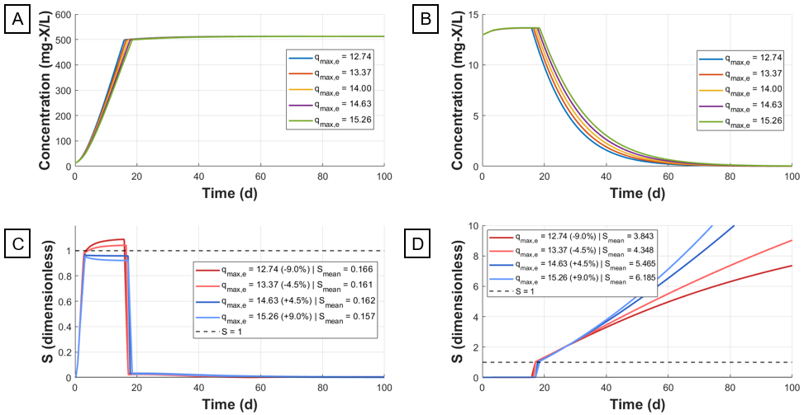
Figure 1: Temporal evolution of variables and its sensitivity (A) electrogenic microorganisms (B) acetoclastic methanogenic microorganisms (C) sensitivity of electrogenic microorganisms (D) sensitivity of acetoclastic methanogenic microorganisms.
Sensitivity analysis mathematically quantifies this competitive exclusion phenomenon. Methanogens in the internal layer showed the highest sensitivity indices of the entire study, with mean values (S_{mean}) ranging between 3.8 and 6.2. Figure 1d details the temporal profile of this sensitivity, which exhibits exponential growth even after day 60. It should be noted that this asymptotic behavior of S is partly a mathematical artifact of the normalization in Eq (2). As x_{m,2} concentration tends to zero due to competitive exclusion, small absolute variations result in mathematically amplified relative variations, not necessarily indicating operational instability but rather confirming the suppression of this population. Meanwhile, the behavior of S for x_{e} (Figure 1c) demonstrates that the electrogenic microorganism population shows transient sensitivity to the q_{max,e} parameter, which directly influenced how quickly this population was able to saturate layer 2 of the biofilm.
Beyond the direct competition in layer 2, simulations revealed a long-term indirect competitive effect on methanogens in the external layer (x_{m1}). Although this population shows low mean sensitivity (S_{mean}), continuous divergence in concentration curves was noted throughout the 100-day simulation, indicating that higher acetate consumption efficiency by electrogens in the internal layer progressively reduces substrate availability for the external layer, slowly suppressing its growth.
In contrast to population dynamics, electrochemical performance variables demonstrated robustness. Electric Current (I_{MEC}), Hydrogen Production (Q_{H2}), and M_{ox} showed practically null sensitivity at steady state, indicating that once electrogenic biofilm dominance is established, variations of up to 9 % in maximum consumption kinetics do not compromise final energy production. This insensitivity suggests that the final level of current and hydrogen production is not limited by q_{max,e}, but rather by another limiting factor in the model, such as maximum biomass concentration. Similarly, acetate concentrations and anodic methane production suffered only transient impacts during the startup phase, quickly converging to stable values regardless of the magnitude of q_{max,e}.
    - Variation of q_{max,f}
While electrogenic consumption kinetics dictate the structural competition of the biofilm, the maximum consumption rate of fermentative microorganisms acts predominantly as a modulator of the system's transient response. Figure 2a presents the acetate concentration profiles, the central intermediate product of the process. It is observed that variations in the rate significantly alter the magnitude of the acetate accumulation peak during the startup phase. Higher fermentative rates accelerate the hydrolysis of complex substrates, generating immediate acetate availability, driving initial growth of methanogenic populations in the external layer (x_{m1}).
After the initial stabilization period (beyond day 20), the acetate concentration curves converge to the same equilibrium value, regardless of the applied fermentative rate. Sensitivity analysis, presented in Figure 2c, corroborates this observation: the sensitivity index (S) exhibits high peaks coinciding with startup perturbations but rapidly decays to values close to zero at steady state. It is worth noting that the fluctuations observed in the sensitivity curve during the steady-state regime do not represent physical process instability but rather numerical noise, which occurs because the differential term of the sensitivity equation approaches machine precision of the solver. These infinitesimal variations, when processed by finite difference calculation, result in residual mathematical oscillations without physical meaning, confirming the nullity of the parameter's impact in this phase.
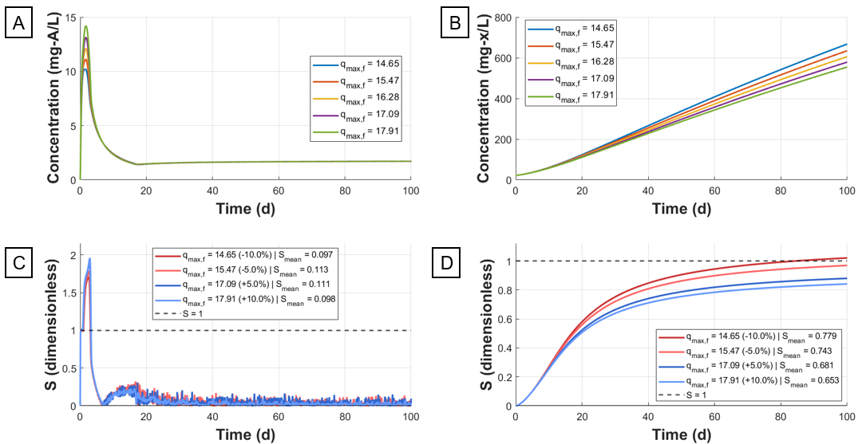
Figure 2: Temporal evolution of variables and their sensitivity (A) acetate (B) fermenting microorganisms (C) acetate sensitivity (D) sensitivity of fermenting microorganisms.
The fermentative microorganism population had a direct and significant impact (S_{mean} of 0.7), such that higher q_{max,f} values resulted in smaller populations. Meanwhile, the layer 1 methanogenic population presents complex behavior, as it cohabits this layer with fermenters and therefore competes with them for space. Despite this spatial competition, q_{max,f} has a positive correlation with x_{m1}, although sensitivity is low (S_{mean} of 0.05). A high q_{max,f} generates a more pronounced transient acetate peak, and the initial acetate excess serves as food and drives initial growth of x_{m1}. It is worth noting that neither population reached a steady state within the simulation period, much less fill layer 1 of the biofilm.
However, this population variation did not propagate to energy performance variables. Electric current, hydrogen production, and electrogenic population proved insensitive to q_{max,f} after reaching steady state. This demonstrates that, given a minimum fermentation rate capable of supplying electrogenic consumption, increasing fermentative efficiency does not translate into energy gain, with the process limited by subsequent electrogenic steps.
    - Variation of q_{max,m}
Finally, analysis of the maximum methanogenic consumption rate revealed behavior distinct from the previous ones: an isolated impact, linearly decoupled from the reactor's global dynamics. This parameter exclusively influenced methane production in the anodic compartment, presenting a mean sensitivity index of approximately 0.96. This value close to unity indicates a direct proportionality relationship: an increase in methanogenic kinetic efficiency translates almost integrally into increased methane production, without saturation effects or complex feedback observed in other populations. Crucially, the sensitivity of all other state variables, including electric current, hydrogen production, and competing electrogenic biomass, remained close to 0. This result confirms that under the simulated operating conditions (continuous feeding and applied voltage), the electrogenic pathway exerts robust competitive dominance. Variations of up to 30 % in methanogenic kinetic capacity were not sufficient to shift competitive equilibrium or reduce coulombic efficiency of the system, suggesting that methanogenesis suppression is governed primarily by thermodynamic and operational factors, rather than by small fluctuations in its intrinsic kinetic parameters.
  - Conclusions
This work aimed to replicate and analyze the multi-population dynamic model proposed by Pinto et al. (2011) for Microbial Electrolysis Cells (MECs), focusing on sensitivity evaluation of the system in response to variations in maximum substrate consumption rate parameters for the main microbial groups: electrogenic (q_{max,e}), fermentative (q_{max,f}), and acetoclastic methanogenic (q_{max,m}). A clear kinetic parameter hierarchy was established: q_{max,e} governs biofilm competition and requires precise estimation; q_{max,f} modulates startup transients with no significant steady-state effect; and q_{max,m} exerts a near-proportional, isolated influence on anodic methane production only. Electrochemical outputs (current and H₂ production) proved robust to all three parameters at steady state, indicating that once electrogenic dominance is established, the system tolerates substantial parametric uncertainty. These findings must be qualified by the limitation that full quantitative validation was not achieved against the reference data, so sensitivity indices during the startup phase should be interpreted with caution. At steady state, however, the results provide actionable guidance: precise characterization of q_{max,e} is critical for predicting competitive dynamics; controlled organic loading strategies are more effective during startup than at steady state; and methanogenic suppression under sufficient applied voltage renders complex chemical inhibition strategies unnecessary.
Nomenclature

A – acetate concentration, mg-A/L
F – output variable of the model (sensitivity index), –
I_{MEC} – electric current generated by the MEC, mA
M_{ox} – concentration of oxidized intracellular mediator, mg-M/mg-X
Q_{H2} – volumetric hydrogen production rate, mL-H₂/d
q_{max} – maximum specific substrate consumption rate, mg-S/mg-X/d
q_{max,e} – maximum specific substrate consumption rate, electrogenic bacteria, mg-S/mg-X/d
q_{max,f} – maximum specific substrate consumption rate, fermentative bacteria, mg-S/mg-X/d
q_{max,m} – maximum specific substrate consumption rate, acetoclastic methanogenic bacteria, mg-S/mg-X/d
S_{u} – substrate (sCOD) concentration, mg-S/L
S – normalized sensitivity index, –
S_{mean} – time-averaged normalized sensitivity index, –
X_{max} – maximum biomass concentration in a biofilm layer, mg-X/L
X_{max,3} – maximum biomass concentration in biofilm layer 3 (cathodic), mg-X/L
x_{e} – electrogenic biomass concentration, mg-X/L
x_{f} – fermentative biomass concentration, mg-X/L
x_{h} – hydrogenotrophic methanogenic biomass concentration, mg-X/L
x_{m,1} – acetoclastic methanogenic biomass concentration, outer anodic layer, mg-X/L
x_{m,2} – acetoclastic methanogenic biomass concentration, inner anodic layer, mg-X/L
Y_{h} – cathodic hydrogen yield, mL-H₂/mg-X
Y_{H2} – cathodic efficiency, –
α₁ – biofilm retention constant, outer anodic layer, –
α₂ – biofilm retention constant, inner anodic layer, –
ξ – input parameter of the model (sensitivity index), –

Acknowledgments
This work was supported by the Conselho Nacional de Desenvolvimento Científico e Tecnológico (CNPq). Project 443958/2024-6.
References
Asrul M.A.M., Atan M.F., Yun H.A.H., Lai J.C.H., 2021, Mathematical model of biohydrogen production in microbial electrolysis cell: a review, International Journal of Hydrogen Energy, 46, 37174–37191.
Asrul M.A.M., Atan M.F., Yun H.A.H., Tan I.A.W., Wahi R., Abdullah R., Elciana A.D., 2025a, Influence of Butler-Volmer and Haldane kinetic structure on the consumption rate and growth rate of electroactive bacteria based on Nernst-Monod model, International Journal of Hydrogen Energy, 155, 150346.
Asrul M.A.M., Atan M.F., Yun H.A.H., Tan I.A.W., Wahi R., Abdullah R., Elciana A.D., 2025b, Performance assessment through comprehensive analysis of mathematical model assumptions for biohydrogen production from various substrates in microbial electrolysis cell, International Journal of Hydrogen Energy, 106, 896–920.
Dudley H. J., Lu L., Ren Z. J., Bortz, D. M., 2019, Sensitivity and bifurcation analysis of a differential-algebraic equation model for a microbial electrolysis cell. SIAM Journal on Applied Dynamical Systems, 18(2), 709-728.
Fathima A., Ilankoon I.M.S.K., Zhang Y., Chong M.N., 2024, Scaling up of dual-chamber microbial electrochemical systems–An appraisal using systems design approach, Science of The Total Environment, 912, 169186.
Hasany M., Mardanpour M.M., Yaghmaei S., 2016, Biocatalysts in microbial electrolysis cells: A review, International Journal of Hydrogen Energy, 41, 1477–1493.
Palanivel P.D., Mohamed S.N., 2025, Valorization of agro-waste into graphene oxide for enhanced biohydrogen recovery in microbial electrolysis cell, Electrochimica Acta, 147277.
Pedroza-Medina U. R., Cházaro-Ruiz L. F., Femat R., Román-Martínez A., 2024, Intensification of a microbial electrolysis cell for biohydrogen production. Chemical Engineering and Processing-Process Intensification, 197, 109707.
Pinto R.P., Srinivasan B., Escapa A., Tartakovsky B., 2011, Multi-population model of a microbial electrolysis cell, Environmental Science & Technology, 45, 5039–5046.
Yahya A., Abdul Wahab A.K., Hussain M.A., 2013, Optimal production of biohydrogen gas via microbial electrolysis cells (mec) in a controlled batch reactor system, Chemical Engineering Transactions, 32, 727-732 DOI: 10.3303/CET1332122
Zeppilli M., Villano M., Majone M., 2015, Microbial electrolysis cell to enhance energy recovery from wastewater treatment, 43, 2341-2346 DOI: 10.3303/CET1543391
Zou S., He Z., 2018, Efficiently “pumping out” value-added resources from wastewater by bioelectrochemical systems: a review from energy perspectives, Water Research, 131, 62–73.

