 CHEMICAL ENGINEERING TRANSACTIONS  VOL. xxx, 2026 | A publication of  
The Italian Association
of Chemical Engineering
Online at www.cetjournal.it

Guest Editors: Leonardo Tognotti, Rubens Maciel Filho, Viatcheslav Kafarov
Copyright © 2026, AIDIC Servizi S.r.l.
ISBN 979-12-81206-xx-x; ISSN 2283-9216

Role of the Oxide Support on the CO₂ hydrogenation over supported Ni Catalysts
Kathlen C. E. S. Yokoo*, Maria E. V. Almeida, Aulus R. R. Bineli, Rubens Maciel Filho
VALPET, School of Chemical Engineering, University of Campinas, R. Josiah Willard Gibbs, s/n, Cidade Universitária, Campinas, SP, 13417-780, Brazil
kathlen@unicamp.br
In Brazil, CO₂ generated during sugarcane ethanol fermentation offers a biogenic CO₂ providing an excellent opportunity for carbon recycling and reduction of the overall ethanol carbon footprint. The hydrogenation of CO₂ into value added C₁ products, such as CH₄, remains challenging due to its thermodynamic stability of CO₂ and the difficulty in controlling product selectivity. The influence of support on the performance of Ni-based catalysts in CO₂ hydrogenation was investigated by comparing Ni/Al₂O₃ and Ni/HAP (hydroxyapatite). Commercial Al₂O₃ was used as a conventional acidic support, while HAP was synthesized by chemical precipitation as a bifunctional material exhibiting both acid and basic surface sites. The catalysts were characterized by XRD, BET, TPD–NH₃, and TPD–CO₂ to determine crystallinity, surface area, and the distribution of acidic and basic sites. Catalytic tests were carried out in a fixed-bed reactor at temperatures ranging from 250 to 550 °C and a WHSV of 6,000 mL h⁻¹ g⁻¹, using a H₂/CO₂ ratio of 7. The Ni/HAP showed higher CO₂ conversion than Ni/ Al₂O₃ due to higher density of weak and medium basic sites in the catalyst surface.
  - Introduction
The catalytic hydrogenation of CO₂ into value-added C₁ products has attracted considerable attention as an approach that simultaneously addresses climate change mitigation and renewable energy storage. The CO₂ hydrogenation enables the conversion of a thermodynamically stable greenhouse gas into fuels and chemicals such as carbon monoxide, methane, and methanol (Ye et al., 2025). When coupled with hydrogen produced from renewable sources, such as water electrolysis, CO₂ hydrogenation represents an environmentally favorable route for the production of fuels and chemicals. In this context, industrial sources of biogenic CO₂ offer particularly attractive opportunities for carbon recycling. Brazil is the second-largest producer of ethanol after the United States (U.S.), with a production of 7.40 billion gallons in 2022 and representing 28% of worldwide ethanol production (Alternative Fuels Data Center, 2024). In Brazil, the CO₂ released during sugarcane ethanol fermentation constitutes a concentrated and renewable carbon source, providing an opportunity to reduce the overall carbon footprint of the ethanol industry through catalytic conversion into value-added products (Silva et al., 2024).
Upgrading biogas to biomethane enables its direct use or injection into the natural gas grid, taking advantage of the existing infrastructure for methane distribution and its application as a fuel and chemical feedstock for heat and power generation (Tommasi et al., 2024). However, achieving high activity and selectivity toward CH₄ remains challenging because CO₂ activation competes with the reverse water–gas shift (RWGS) reaction (Becka et al., 2025). Consequently, the rational design of catalysts that favor methanation while maintaining stability and resistance to deactivation remains a key challenge in catalysis research.
Nickel-based catalysts are widely used as one of the most promising catalysts for CO₂ hydrogenation to methane due to their high selectivity to methane (Tommasi et al., 2024). Several oxide supports have been investigated for Ni catalysts in CO₂ hydrogenation, such as Al₂O₃, CeO₂, ZrO₂-CeO₂, TiO₂ (González-Rangulan et al., 2023). Conventional supports such as Al₂O₃ are widely used due to their high surface area and mechanical stability, but their predominantly acidic character can affect CO₂ adsorption and promote side reactions or carbon deposition (Yi et al., 2022). Cerium oxide (CeO₂) has shown superior activity due to the presence of medium-strength basic sites and the formation of interfacial sites capable of stabilizing reaction intermediates such as formates (e.g., hydrogen carbonates) during methanation (González-Rangulan et al., 2023). Hydroxyapatite (HAP, Ca₁₀(PO₄)₆(OH)₂) has gained attention as a catalytic support due to its tunable acid–base properties, thermal stability, and ability to host metal nanoparticles with strong interfacial interactions (Kharissova et al., 2025). Previous studies have proposed bifunctional catalysts to enhance CO₂ activation through the formation of surface carbonates and bicarbonates, potentially favoring methanation over RWGS (Meng et al., 2021).
The present study aims to elucidate the influence of Ni-based catalysts support properties for CO₂ hydrogenation, with emphasis on hydroxyapatite (HAP) as a promising support. However, the strength of the acid-basic sites on methanation selectivity remains unclear. To address these gaps, Ni catalysts supported on HAP and Al₂O₃ were prepared and the materials were characterized by XRD, BET, TPD–NH₃, and TPD–CO₂ to determine their crystallinity, surface area, and the distribution of acidic and basic sites. Catalytic tests were carried out in a fixed-bed reactor at temperatures ranging from 250 to 550 °C and a WHSV of 6,000 mL h⁻¹ g⁻¹, using a H₂/CO₂ ratio of 7. The study focuses to elucidate the role of the support in tuning the activity and selectivity of Ni-based catalysts for CO₂ hydrogenation and to contribute to the rational design of efficient and sustainable catalytic systems for CO₂ valorization.
  - Methodology
    - Materials
The alumina (γ-Al₂O₃) support used in this study was obtained from Alcoa. The HAP was synthesized using diammonium phosphate ((NH₄)₂HPO₄, 99.4%), calcium nitrate tetrahydrate (Ca (NO₃)₂·4H₂O, 99.9%) and ammonium hydroxide (NH₄OH, 25%) obtained from Merck. The metal precursor used was nickel (II) nitrate hexahydrate (Ni (NO₃)₂.6H₂O, Dinâmica, ≥98%). The gases used for reactivity tests were CO₂, H₂ (99.999%) and N₂ (99.999%). All gases were purchased from White Martins Gases Industriais Ltda.
    - Catalysts preparation
HAP was prepared by chemical precipitation according to the previous literature (Lovon-Quintana et al., 2015). Supported nickel catalysts with a metal loading of 20 wt % were prepared by incipient wet impregnation method using Al₂O₃ and HAP as supports. The required amount of Ni (NO₃)₂.6H₂O was dissolved in distilled water and then impregnated into the supports. The obtained materials were dried overnight at 120 °C and calcined at 500 °C (10 °C min⁻¹) for 3h.
    - Catalyst characterization
A powder X-ray diffraction (XRD) pattern was obtained using a Philips Analytical X'Pert PW3050 diffractometer, equipped with Cu-Kα radiation (λ = 0.15406 nm). Textural properties were determined from N₂ adsorption-desorption isotherms at –196 °C in a Micromeritics ASAP 2020 analyzer. Temperature-programmed reduction (TPR) was carried out under H₂ using a Micromeritics AutoChem II 2920 instrument. As-prepared catalyst was heated from room temperature to 800 °C (10 °C min⁻¹) under a flowing gas mixture of 10% vol. H₂/N₂ (50 cm³ min⁻¹). The acid and basic site densities were determined by NH₃ and CO₂ temperature-programmed desorption (TPD) using a Micromeritics AutoChem II 2920 instrument. Before the TPD analysis, approximately 0.2 g of the reduced sample was pretreated at 400 °C for 2 h and cooled to analysis temperature. The sample was then saturated with the probe molecule at 35 °C (CO₂) or 50 °C (NH₃). After the sample was purged for 30 min, the temperature was raised to 650 ºC at 10 ºC min⁻¹.
    - Catalytic reactions
The CO₂ hydrogenation tests were carried out in a single-step gas-phase reaction at atmospheric pressure using a tube reactor (ID ≈ 10 mm). Usually, 500 mg of catalyst was loaded into the reactor which was placed inside a vertical muffle furnace. Reactions were carried out at temperatures from 250 to 550 °C, under a total flow rate of 50 mL/min and H₂/CO₂ ratio of 7/1. Before testing, the catalysts were reduced in situ upon heating from RT to 500 °C at a constant rate of 10 °C min⁻¹ under a ﬂow of 10% vol. H₂/N₂ (60 mL min⁻¹). After reaching 500 °C, the temperature was maintained constant for 3 h, and then the sample was cooled to RT. The reactor outflow gases were collected using gas sample bags and analyzed in gas chromatography (Agilent Technologies, 7890A) equipped with HP-PlotU (30m x 0.530 mm x 40 μm) and HP-Plot Molesieve (30m x 0.530 mm x 25 μm)) columns, a methanizer and a flame ionization detector (FID). Compound identification and calibration were performed with calibration gas mixtures (5.0098% vol H₂, 14.9941 vol % CO₂,16.0003%vol. CO, 0.4999 vol% C₂H₆, 0.5017 vol % C₂H₄,14.8967vol% CH₄, 48.0975 %vol N₂). The peak areas were integrated with the software Open Lab. Argon was used as a carrier gas. The CO₂ conversion, X (%), and product selectivity, Si (%) were determined according to Eq(1) and Eq(2), respectively.
$$X= \left(1-\frac{{F_{CO2}}^{out}}{{F_{CO2}}^{in}}\right)×100$$ | (1)
$$S= \left(1-\frac{{F_{i}}^{out}}{{F_{total}}^{in}}\right)×100$$ | (2)

where F_{CO2}^{in} and F_{CO2}^{out} (mmol h⁻¹) are the input and exit molar flow rates of CO₂, F_{i}^{out} (mmol h⁻¹) is the exit molar flow rate of product i, F_{total}^{out} (mmol h⁻¹) is the total exit molar flow rate of the products.
  - Results and discussion
    - Catalysts characterization
Figure 1 shows the XRD patterns of the as-prepared Ni catalysts synthesized in this study. For the Ni/HAP, the diffraction peaks characteristic of the hydroxyapatite phase (JCPDS: 01-074-0566) are observed at 2θ = 25.9°, 31.8°, 32.1°, 32.9°, 34.0°, 40.0°, 46.8°, and 49.5°(Meng et al., 2021). No impurity phases were detected, indicating the formation of HAP. The peak with the highest intensity, located at 2θ = 31.8°, corresponds to the main diffraction peak of the hexagonal HAP structure, which corresponds to the P6₃/m space group (Rincon-Lopez et al., 2018).
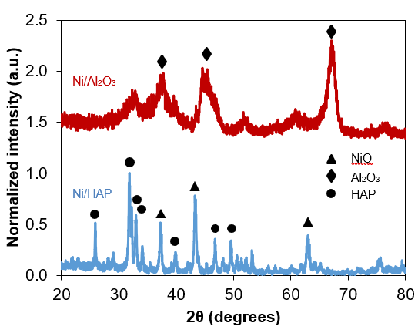
Figure 1: X-ray diffraction patterns of as-made Ni/HAP and Ni/Al₂O₃
The as-prepared Ni/HAP catalyst exhibits additional reflections at 2θ = 37.3° and 43.4°, which are assigned to the NiO phase (JCPDS: 01-075-0197) (Meng et al., 2021). The positions of the characteristic HAP peaks are not affected by the incorporation of Ni and/or Ca, suggesting that the crystal structure of HAP is preserved after metal addition. Moreover, no diffraction peaks associated with crystalline Ca-containing surface species, such as CaO, Ca (OH)₂ or CaCO₃ were detected (Diputra et al., 2025), indicating that calcium species are highly dispersed on the HAP surface. For the Ni/Al₂O₃, diffraction peaks located at 2θ = 37.2°, 45.6°, and 66.9° are observed, which are consistent with the γ-Al₂O₃ reference pattern (JCPDS: 00-010-0425) (Rozita et al., 2010). Notably, no distinct diffraction peaks associated with NiO are detected for the as-prepared Ni/ Al₂O₃, which is attributed to the overlap of NiO reflections with the intense γ- Al₂O₃ peaks.
Table 1 shows the textural properties of the materials investigated in this study. Both Al₂O₃ and HAP exhibit mesoporous characteristics, with pores diameter ranging from 7 to 34 nm. Alumina exhibits a significantly higher surface area, while HAP shows an average pore diameter four times larger (8 vs 32 nm), which are particularly advantageous for minimizing internal diffusion limitations and ensuring effective accessibility of the active sites. A large pore volume presented by HAP may be beneficial for the deposition of NiO particles within mesopores, contributing to stronger metal–support interactions (Yi et al., 2022). Nickel incorporation (20 wt% Ni) did not modify the mesoporous structure of both supports, as pore volume and pore diameter remained essentially the same after impregnation. For Al₂O₃, the moderate decrease in BET surface area (78 to 68 m² g⁻¹) is consistent with partial surface coverage by NiO species. In contrast, HAP exhibited nearly unchanged surface area (30 to 32 m² g⁻¹), suggesting that Ni deposition did not reduce pore accessibility, and the slight increase is negligible and may reflect experimental variability of the equipment. Pore structure plays a key role in metal dispersion, as larger pore diameters facilitate the penetration of nickel species into the pore network (Li et al., 2021).
Table 1: Textural properties of the materials
Sample | S_{BET} (m² g⁻¹) | Vp (cm³ g⁻¹) | Dp (nm)
HAP | 30.4195 | 0.2804 | 34.1486
20%Ni/HAP | 32.2490 | 0.2973 | 32.4022
Al₂O₃ | 78.4463 | 0.2038 | 7.8266
20%Ni/Al₂O₃ | 68.9384 | 0.1944 | 7.8732

Figure 2a) shows ammonia temperature programmed desorption (NH₃-TPD) profiles for the catalysts. Sites that desorb up to 230 °C were classified as weak sites, medium sites from 230 to 400 °C, and strong sites above 400 °C (Nguyen et al., 2015). The Ni/HAP and Ni/Al₂O₃ samples present a strong peak with a maximum located at 120 and 130 °C, respectively. These low temperature peaks indicate the presence of a large amount of weak acid sites. In addition, low-intensity desorption peaks centered around 200 °C suggest the presence of a small fraction of medium-strength acid sites. No desorption features associated with strong acid sites were observed for Ni/HAP. Figure 2b) shows carbon dioxide temperature programmed desorption (CO₂-TPD) profiles for the catalysts. The Ni/HAP shows a high intensity peak at 120 °C, indicating a high concentration of weak basic sites. Less intense peaks observed at around 230 and 370 °C are attributed to medium-strength basic sites, while a minor desorption feature at 570 °C suggests the presence of a small amount of strong basic sites. In contrast, Ni/ Al₂O₃ shows a small peak at 100 °C and a large peak at 500 °C indicating a high concentration of strong basic sites.
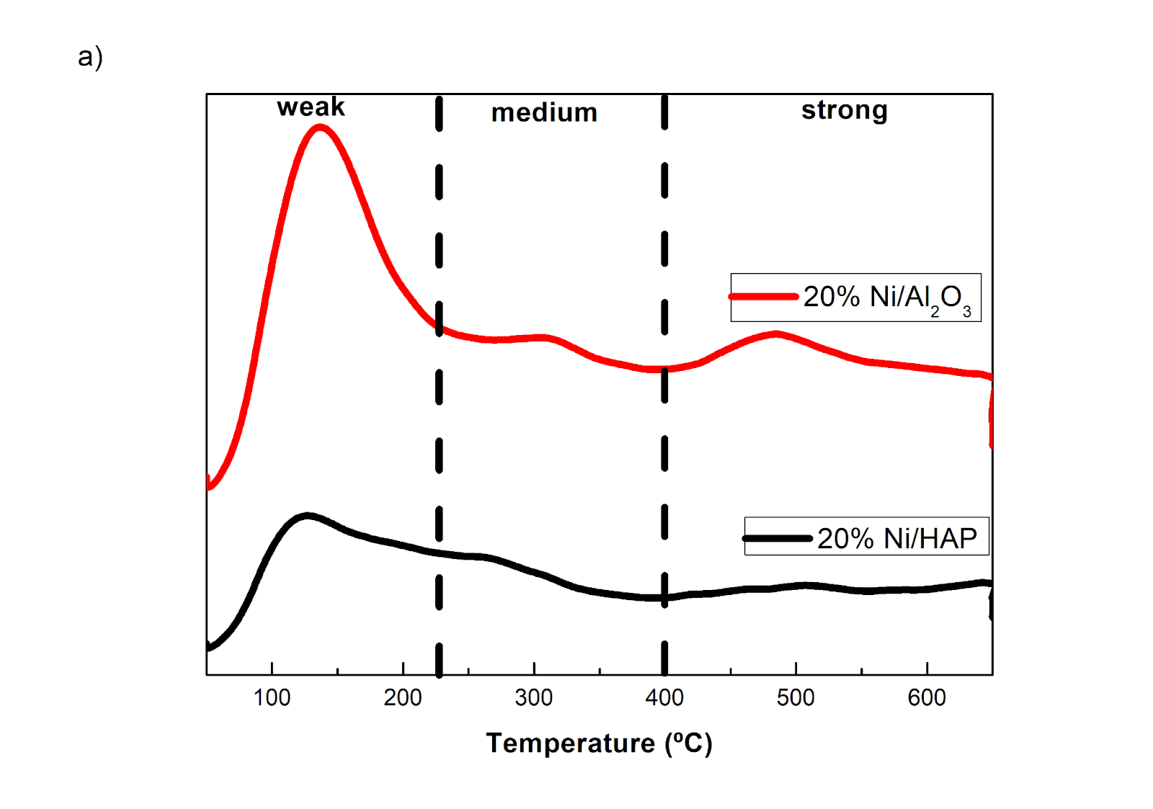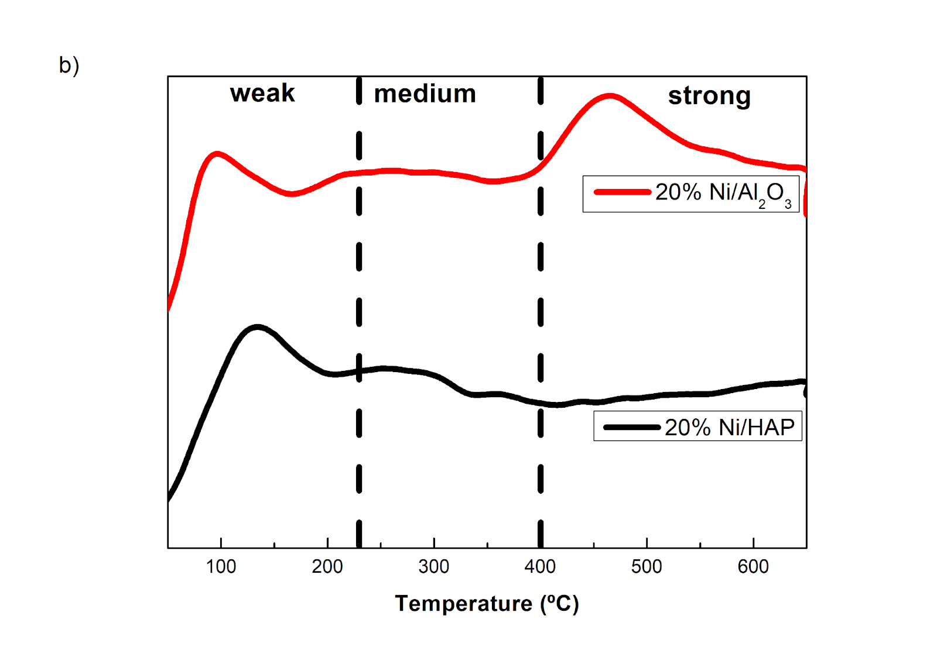
Figure 2: Temperature desorption profiles a) NH₃ and b) CO₂
The Ni/HAP exhibits a better distribution of weak to moderate basic sites, which favors the adsorption of CO₂, considered an acidic molecule. The Ni/Al₂O₃ exhibited the highest number of total basic sites (302 mmol g⁻¹), with more than 50% of these sites classified as strong basic sites. This behaviour is consistent with the intense high-temperature desorption peak observed at approximately 570 °C in the CO₂-TPD profile (Figure 2b). As will be shown later the strong basicity is correlated with reactivity results, indicating that basic sites play a role in the reaction.
    - Catalysts activity
Figure 3 shows the CO₂ conversion and CH₄ selectivity with temperature for Ni/HAP and Ni/Al₂O₃. No conversion was observed at 250 °C at the reaction conditions tested in this study.
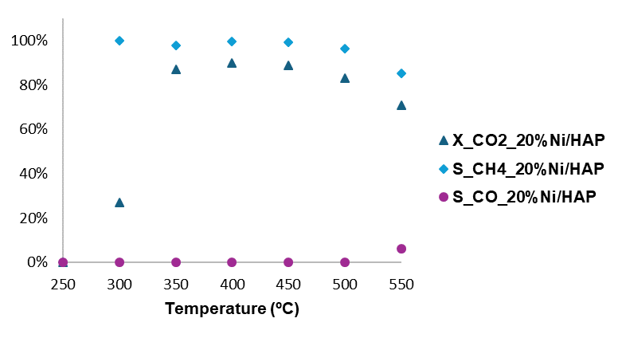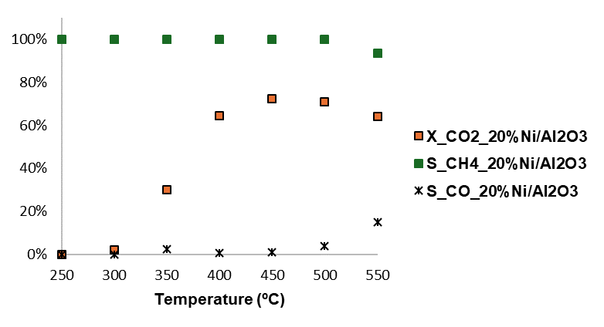
Figure 3: CO₂ conversion and CH₄ selectivity with temperature for Ni/HAP and Ni/Al₂O₃
For the Ni/HAP catalyst, CO₂ conversion increased sharply from 27% at 300 °C to 87% at 350 °C, reaching a maximum of 90% conversion at 400 °C. From 300 to 500 °C, Ni/HAP exhibited 100 % selectivity toward CH₄, indicating that methanation is the main reaction pathway. At 550 °C, CH₄ selectivity was 94%, with CO formation becoming detectable only at this temperature. In contrast, Ni/Al₂O₃ showed significantly lower CO₂ conversion, increasing from 2% at 300 °C to 30% at 350 °C and reaching a maximum conversion of 73% at 450 °C. Unlike Ni/HAP, CO formation over Ni/Al₂O₃ was observed at temperatures above 350 °C, with CH₄ selectivity decreasing from 98% at 350 °C to 85% at 550 °C. At higher temperatures, both catalysts exhibited a decrease in CO₂ conversion, which agrees with thermodynamic equilibrium for exothermic reactions, which is particularly pronounced at 550 °C (Floriam et al., 2025; Veloso Almeida et al., 2025). Also, the lower CO₂ conversion observed for Ni/Al₂O₃ in this study is associated with the predominance of strong basic sites, as indicated by the intense desorption peak at 500°C (Figure 2b). Strong basic sites promote strong CO₂ adsorption to the support surface, which may hinder its activation and subsequent hydrogenation. In contrast, weak and medium-strength basic sites facilitate more CO₂ activation (Gac et al., 2020).
Table 2 summarizes the catalytic performance of Ni-based systems reported in the literature and highlights hydroxyapatite (HAP) as a promising catalyst support for CO₂ methanation.
Table 2: Comparative studies of Ni-based catalysts for CO₂ methanation
Catalyst | Temperature  (°C) | H₂/CO₂ | CO₂ conversion (%) | CH₄ selectivity (%) | Reference
20%Ni/Al₂O₃ | 400 | 4 | 70 | 80 | Ma et al. (2020)
36%Ni/SiO₂ | 425 | 4 | 69 | 94 | Tommasi et al. (2025)
20%Ni/HAP | 400 | 7 | 90 | 100 | This work
20%Ni/Al₂O₃ | 450 | 7 | 73 | 99 | This work

Beyond acid–base properties, previous studies have demonstrated that metal particle size plays a key role in determining selectivity toward CH₄ or CO (Simons et al., 2023). Smaller Ni particles and higher metal dispersion generally favor methanation due to the higher availability of active surface sites for hydrogen activation, whereas larger particles may promote the reverse water–gas shift (RWGS) reaction (Wu et al., 2015). In this context, further investigations are currently being carried out to evaluate the influence of Ni particle size and metal dispersion on catalytic performance.
  - Conclusions
The hydrogenation of CO₂ over Ni catalysts supported on HAP and Al₂O₃ was evaluated under atmospheric pressure from 250 to 550 °C. Despite its lower surface area, Ni/HAP exhibited higher CO₂ conversion, superior CH₄ selectivity, and reduced coke formation compared to Ni/ Al₂O₃. This enhanced performance is attributed to the higher density and balanced distribution of weak acid and basic sites on HAP, which promote efficient CO₂ activation while suppressing RWGS and secondary reactions. These results demonstrate that support surface chemistry plays a more critical role in controlling activity, selectivity, and stability in CO₂ methanation. Tailoring the acid–base properties of the support emerge as an effective strategy for improving methane selectivity and catalyst stability. Hydroxyapatite is therefore highlighted as a promising bifunctional support for the design of efficient Ni-based catalysts for CO₂ valorisation.
Acknowledgments
This study was financed by the São Paulo Research Foundation (FAPESP), Brasil. Process Number #2022/16379-8 and by the Coordination for the Improvement of Higher Level Personnel (CAPES) (Grant No 88887.990754/2024-00).
References
Alternative Fuels Data Center, 2024, Global Ethanol Production by Country or Region, Renewable Fuels Association <afdc.energy.gov/data> accessed 22.01.2026.
Becka R., Bajohr S., Kolb T., 2025, Review on CO2 Activation via Catalytic Reverse Water-Gas Shift Reaction, Chemie Ingenieur Technik, 97, 860-881.
Diputra A.H., Dinatha I.K.H., Yusuf Y., 2025, A comparative X-ray diffraction analysis of Sr2+ substituted hydroxyapatite from sand lobster shell waste using various methods, Heliyon, 11, e41781.
Floriam, B.G., Barros, L.M.S., Bineli, A.R.R., Filho, R.M., 2025, CO2 Methanation: Thermodynamic Simulations for Enhanced Methane Production and Hydrogen Source Evaluation. Chemical Engineering Transactions, 117, 61–66.
Gac, W., Zawadzki, W., Rotko, M., Greluk, M., Słowik, G., Kolb, G., 2020. Effects of support composition on the performance of nickel catalysts in CO2 methanation reaction. Catal. Today 357, 468–482.
Kharissova O. V., Méndez Y.P., Kharisov B.I., González L.T., Dorozhkin S. V., 2025, Hydroxyapatite-based materials as catalysts: A review, Particuology, 11, 203-127.
Li X., Shao Y., Zhang S., Wang Y., Xiang J., Hu S., Xu L.L., Hu X., 2021, Pore diameters of Ni/ZrO2 catalysts affect properties of the coke in steam reforming of acetic acid, International Journal of Hydrogen Energy, 46, 23642–23657.
Lovon-Quintana J.J., Rodrigues-Guerrero J.K., Valença G.P., 2015, Process for producing hydrocarbon fuels from ethanol over apatite-type catalysts, process for obtaining said catalysts, catalysts thus obtained, and uses thereof, INPI, Rio de Janeiro, Brazil: BR-10-2015-009832-4 and PCT: 2015-000200 (in Portuguese).
Ma, Y., Liu, J., Chu, M., Yue, J., Cui, Y., Xu, G., 2020. Cooperation Between Active Metal and Basic Support in Ni-Based Catalyst for Low-Temperature CO2 Methanation. Catalysis Letters, 150, 1418–1426.
Meng J., Pan W., Gu T., Bu C., Zhang J., Wang X., Liu C., Xie H., Piao G., 2021, One-Pot Synthesis of a Highly Active and Stable Ni-Embedded Hydroxyapatite Catalyst for Syngas Production via Dry Reforming of Methane, Energy and Fuels, 35, 19568–19580.
Nguyen, T.T.N., Ruaux, V., Massin, L., Lorentz, C., Afanasiev, P., Maugé, F., Bellière-Baca, V., Rey, P., Millet, J.M.M., 2015, Synthesis, characterization and study of lanthanum phosphates as light alcohols dehydration catalysts. Applied Catalysis B, 166–167, 432–444.
Rincon-Lopez J.A., Hermann-Muñoz J.A., Giraldo-Betancur A.L., De Vizcaya-Ruiz A., Alvarado-Orozco J.M., Muñoz-Saldaña J., 2018, Synthetic and Bovine-Derived Hydroxyapatite Ceramics: A Comparison, Materials, 11, 333.
Rozita Y., Brydson R., Scott A.J., 2010, An investigation of commercial gamma-Al2O3 nanoparticles, Journal of Physics: Conference Series, 241, 012096.
Silva J.F.L., Souza G.M., Filho R.M., Yang Y., Li F., 2024, Case studies of CO2 utilization in the production of ethanol, IEA Bioenergy,<www.ieabioenergy.com/wp-content/uploads/2025/02/Case-studies-of-CO2-utilization-in-the-production-of-ethanol.pdf> accessed 24.03.2026.
Simons J.F.M., De Heer T.J., Van de Poll R.C.J., Muravev V., Kosinov N., Hensen E.J.M., 2023, Structure Sensitivity of CO2 Hydrogenation on Ni Revisited, Journal of the American Chemical Society, 145, 20289–20301.
Tommasi M., Degerli S.N., Ramis G., Rossetti I., 2024, Advancements in CO2 methanation: A comprehensive review of catalysis, reactor design and process optimization, Chemical Engineering Research and Design, 201, 457–482.
Veloso Almeida M.E.., Ramos V.H.S., Silva J.F.L., Bineli A.R.R., Filho R.M., 2025, Thermodynamic assessment of CO₂ methanation, in: Proceedings of the Brazilian Congress of Chemical Engineering and Brazilian Meeting on Chemical Engineering Education, Vol 5, Galoá, Belo Horizonte, Brazil, <proceedings.science/cobeq-2025/trabalhos/avaliacao-termodinamica-da-metanacao-do-co2?lang=pt-br> accessed 24.03.2026 (in Portuguese).
Wu, H.C., Chang, Y.C., Wu, J.H., Lin, J.H., Lin, I.K., Chen, C.S., 2015. Methanation of CO2 and reverse water gas shift reactions on Ni/SiO2 catalysts: the influence of particle size on selectivity and reaction pathway. Catalysis Science Technol. 5, 4154–4163.
Ye, J., Dimitratos, N., Rossi, L.M., Thonemann, N., Beale, A.M., Wojcieszak, R., 2025, Hydrogenation of CO2 for sustainable fuel and chemical production. Science, 387, 943.
Yi, H., Xue, Q., Lu, S., Wu, J., Wang, Y., Luo, G., 2022, Effect of pore structure on Ni/Al2O3 microsphere catalysts for enhanced CO2 methanation. Fuel, 3151 123262.

