 CHEMICAL ENGINEERING TRANSACTIONS  VOL. , 2026 | A publication of  
The Italian Association
of Chemical Engineering
Online at www.cetjournal.it

Guest Editors:
Copyright © 2025, AIDIC Servizi S.r.l.
ISBN 979-12-81206-XX-X; ISSN 2283-9216

Effect of Acid Concentration on the Yield, Surface Functionality, and Adsorption Capacity of Activated Hydrochars from Apple Tree Pruning
Ameni Ben-Salah, María Gonzalez-Alriols, M. Mirari Antxustegi*
Biorefinery Processes Research Group (BioRP), Chemical and Environmental Engineering Department, University of the Basque Country (UPV/EHU), Avda. Otaola 29, 20600, Eibar, Spain
mirari.antxustegi@ehu.eus
Hydrothermal carbonisation (HTC) is an efficient route to convert lignocellulosic residues into carbon‑rich materials for environmental applications. This work evaluates the influence of phosphoric acid (H₃PO₄) concentration (2.5 and 5 M) on the yield, surface properties, and methylene blue (MB) adsorption capacity of activated hydrochars (AHCs) produced from apple tree pruning. HTC was conducted at 200 °C for 24 h followed by activation at 450 °C. The AHC obtained using 2.5 M H₃PO₄ developed a markedly higher specific surface area (1,343 m²/g) and micropore volume (0.591 cm³/g) compared with the 5 M sample (468 m²/g and 0.346 cm³/g, respectively), while also exhibiting a narrower average pore width (1.76 vs. 2.95 nm). These structural differences translated into significantly enhanced MB adsorption performance, with the 2.5 M material achieving the highest adsorption ratio and removal efficiency under the tested conditions. Ultimate analysis further confirmed stronger deoxygenation and carbon enrichment at 2.5 M (C = 76.7 wt%, O/C = 0.26) relative to 5 M (C = 53.4 wt%, O/C = 0.78). Overall, the results demonstrate that moderate H₃PO₄ loading optimises microporosity and functionalisation, yielding superior adsorbents for wastewater treatment.
  - Introduction
The growing global energy demand and environmental concerns have intensified the search for sustainable technologies capable of valorising biomass into high-value products (Petrović et al., 2024). Lignocellulosic biomass, abundant and renewable, represents a promising feedstock for producing carbon-rich materials that can serve as biofuels, adsorbents, and precursors for advanced applications in energy and environmental remediation (Ighalo et al., 2025). Among the thermochemical conversion processes, HTC has emerged as an efficient and eco-friendly method for transforming wet biomass under subcritical water conditions (180–260 °C, 2–10 MPa), eliminating the need for energy-intensive drying steps (Khandelwal et al., 2024). HTC mimics natural coalification but accelerates the process, producing HC with tailored physicochemical properties through dehydration, decarboxylation, and polymerization reactions (Sathish & Saraswat, 2024). Recent studies have demonstrated that chemical activation and surface modification of HCs significantly enhance their adsorption capacity for organic pollutants and heavy metals, expanding their applicability in wastewater treatment and environmental remediation (Sivaranjanee et al., 2023). Acid activation, particularly with phosphoric acid (H₃PO₄), has proven effective in developing porous structures and introducing oxygen-containing functional groups, which improve adsorption performance for dyes such as methylene blue (Supee & Zaini, 2024). Furthermore, HTC-derived HCs exhibit potential for integration into energy systems, either as solid biofuels or as feedstock for gasification, contributing to cleaner energy generation (Prifti et al., 2021). Despite these advantages, the influence of process parameters—such as acid concentration, temperature, and residence time—on HC properties remains a critical research area. Understanding these relationships is essential for designing application-specific materials that meet the requirements of energy storage, pollutant removal, and carbon sequestration (Vásquez Llanosa et al., 2024). This study addresses this gap by investigating the effect of H₃PO₄ concentration on the yield, surface characteristics, and adsorption performance of HCs derived from AP, aiming to optimize HTC conditions for environmental-related applications.
  - Materials and methods
In this work, AP was used as waste lignocellulosic biomass to prepare P-rich AHCs, by mixing 1 g of substrate with 4 g of a solution of H₃PO₄ with different concentrations (2.5 and 5M) in a 50 mL stainless steel reactor, at 200ºC for 24h. Then, an activation stage was performed in a horizontal tube furnace under N₂ atmosphere with a heating rate of 20 K/min up to 450 ºC. Samples were kept at 450 ºC for 2h before cooling down under N₂. After the chemical activation, samples were washed with deionized water until neutral pH and dried at 105 ºC for 12 h (Figure 1). Two samples were produced and characterized, one treated with a 2.5 M H₃PO₄ solution (AP-AHC-P2.5) and the other one treated with a 5 M H₃PO₄ solution (AP-AHC-P5).

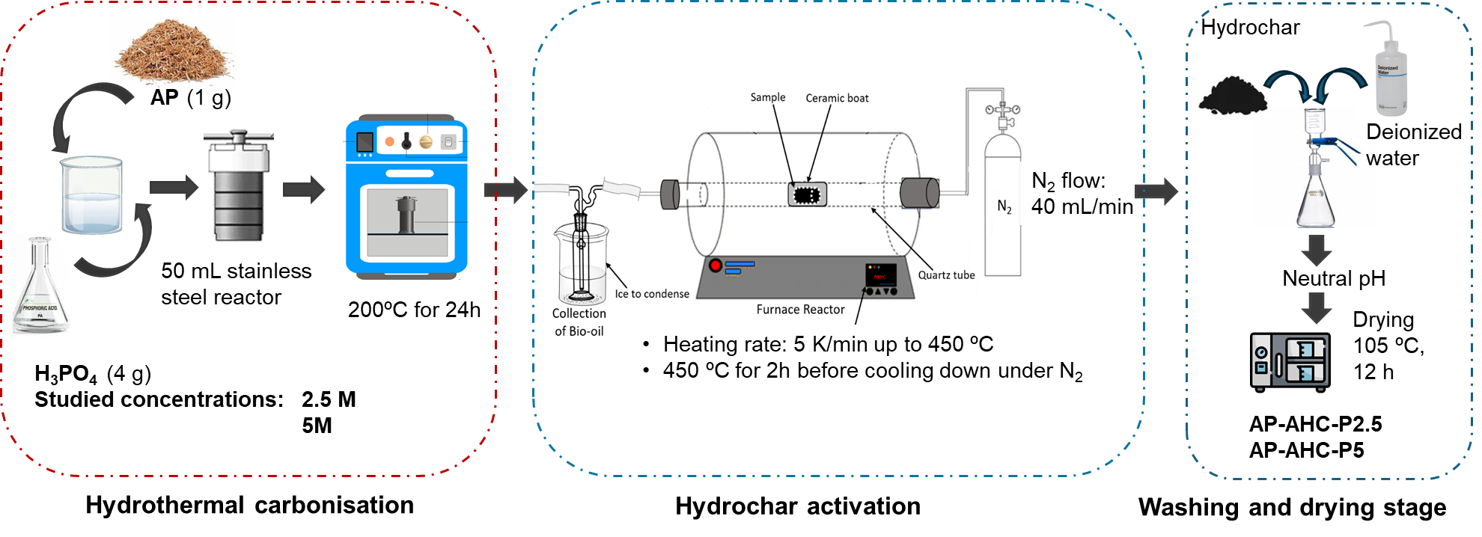
Figure 1: Experimental procedure for the production of activated hydrochar.
    - Adsorption experiments
Adsorption tests were carried out under previously optimised conditions (Antxustegi et al., 2022). The absorbance and concentration values of MB were related with a calibration curve and results expressed as:
$Q_{e}= \frac{\left(C_{0}-C_{eq}\right)}{m·V}$ Adsorption-ratio (mg_{MB} adsorbed/g_{bio-char}) Eq. 1
$E= \frac{\left(C_{0}-C_{eq}\right)}{mC_{0}·100}$ MB removal (%) Eq. 2
C₀: initial conc. (mg MB/L); C_{eq}: final or equilibrium conc. (mg MB/L); m: BC mass (g); V: solution bulk (L).
  - Results
    - Ultimate analysis
The ultimate analysis of the AHC samples is presented in Table 1. Raw AP has the typical lignocellulosic signature (moderate C, relatively high O and H). After AHTC, both samples are more carbon‑rich and dehydrogenated than the raw biomass. AP‑AHC‑P2.5 is markedly enriched in C (76.7 wt.%) and depleted in O (19.8 wt.%) and H (0.38 wt.%), yielding very low O/C (0.26) and H/C (0.005). In contrast, AP‑AHC‑P5 shows lower C (53.4 wt.%) and higher O (41.5 wt.%) and H (2.33 wt.%), with higher O/C (0.78) and H/C (0.04).
Table 1: Ultimate analysis
 |  | AP | AP-AHC-P2.5 | AP-AHC-P5
Ultimate analysis  (wt.%) | C (%)  H (%)  N (%)  S (%)  O (%)* | 45.1 ± 0.3  5.71 ± 0.1  0.73 ± 0.1  0.72 ± 0.1  47.7 ± 0.3 | 76.7± 0.2  0.38 ± 0.05  0.56 ± 0.03  2.60 ± 0.3  19.8 ± 0.2 | 53.4 ± 0.2  2.33 ± 0.1  0.30 ± 0.03  2.50 ± 0.3  41.5 ± 0.2
 | O/C | 0.94 ± 0.04 | 0.26 ± 0.05 | 0.78± 0.05
 | H/C | 0.13 ± 0.04 | 0.005 ± 0.001 | 0.04± 0.01

Phosphoric acid activation forms stable phosphate and polyphosphate species covalently bound to the carbon matrix (e.g., C–O–P, P–O–P). Numerous studies report significant residual P (often several wt.%, even >10 wt.%) in H₃PO₄‑activated carbons/HCs after washing. These P‑species carry multiple oxygen atoms and acidic –P–OH groups. If O is calculated by difference (common in ultimate analysis), unmeasured residual P can spuriously appear as “oxygen,” lowering the apparent C%. This effect becomes stronger at higher H₃PO₄ loading, explaining why AP‑AHC‑P5 shows higher O and lower C than AP‑AHC‑P2.5. Phosphorus‑containing carbons with exclusively phosphate/polyphosphate environments and up to ~13 wt.% P were identified by XPS/³¹P MAS NMR after H₃PO₄ activation, underscoring the persistence of P‑species after heat treatment and washing (Puziy et al., 2022). H₃PO₄ interacts with phenolic/carbonyl groups to form C–O–P linkages that survive to 450–500 °C. The thermal decomposition of phosph(on)ates occurs around ~450 °C, so at 450 °C a substantial fraction can remain in the solid (Luo et al., 2019). Phosphate incorporation (C–O–P, P=O, P–O–P) is intrinsic to H₃PO₄ activation and increases acidity and O‑content of the surface (Ge et al., 2024).
    - FATR-FTIR spectra
The FATR‑FTIR spectra (Figure 2) reveal that HTC induces extensive dehydration, evidenced by the strong reduction of O–H stretching bands and the consequent increase in hydrophobicity, while persistent aliphatic C–H signals indicate that part of the original lignocellulosic aliphatic structures remains after HTC. Simultaneously, prominent C=O and C–O–C absorptions confirm the formation of oxygenated intermediates arising from cellulose and hemicellulose degradation through dehydration, fragmentation, and re‑polymerization reactions, and the emergence of olefinic and aromatic C=C bands highlight partial aromatization enhanced during activation at 450 °C under N₂. The bands corresponding to P‑containing groups (C–O–P, P=O, P–OOH) demonstrate successful H₃PO₄ functionalization, consistent with phosphate ester formation and condensation reactions documented during acid‑assisted carbonization, which create acidic surface sites and increase the density of adsorption functionalities. Their higher intensity in AP‑AHC‑P5 suggests more extensive phosphorylation at higher acid concentration. Altogether, the coexistence of dehydrogenated aromatic domains, residual aliphatic structures, and abundant P‑oxygenated moieties yields a heterogeneous, chemically rich surface that enhances the adsorption potential of the AHCs, particularly toward cationic species such as MB.

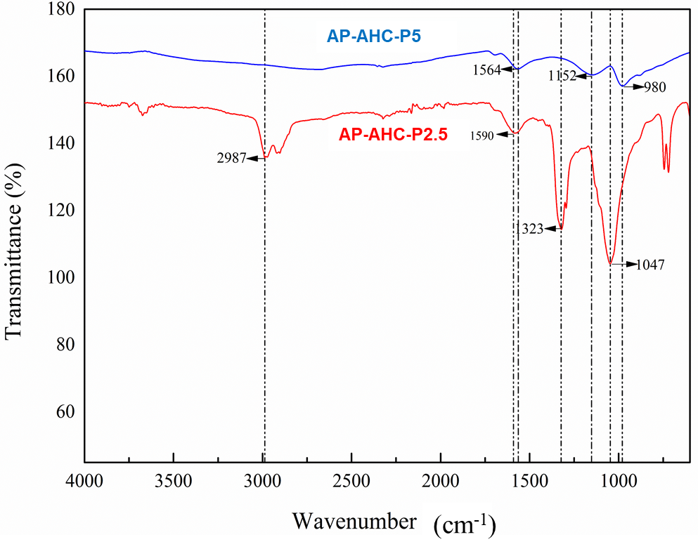
Figure 2: ATR-FTIR spectra of the different activated hydrochar samples.
    - Scanning Electron Microscopy (SEM)
The SEM micrographs of the activated hydrochars AP‑AHC‑P2.5 and AP‑AHC‑P5 (Figure 3) show that, in both samples, the original block‑like features of the biomass are no longer visible, indicating extensive decomposition and reorganization of biopolymer fractions under HTC followed by activation. A highly disrupted carbon structure is shown in both AP-AHC-P2.5 and AP-AHC-P5, characterised by fragmented surfaces, open cavities, and a network of newly formed pores. This morphology indicates that H₃PO₄ promotes extensive matrix swelling, which enlarges mesopores, while the breakdown of C–O–C linkages contributes to the formation of finer microporous features. The presence of stabilized pore walls is consistent with the formation of polyphosphate species during activation, preventing collapse during carbonization. Although both acid concentrations produce similarly porous frameworks, the more pronounced fragmentation observed in AP-AHC-P5 suggests that higher H₃PO₄ loading intensifies structural decomposition and pore development.

AP-AHC-P2.5 | AP-AHC-P5
Figure 3: SEM images of the ACH samples.
    - Porosity and surface properties
The N₂ adsorption/desorption isotherms and calculated (NDFT) pore size distribution curves of ACH samples are presented in Figure 4, whereas the porosity and surface properties are included in Table 2.

AP-AHC-P2.5 | AP-AHC-P5
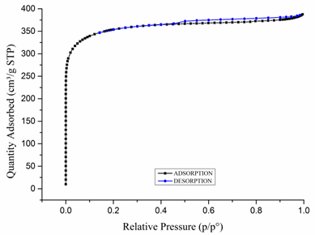 | 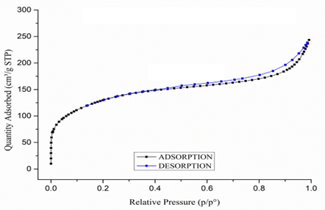
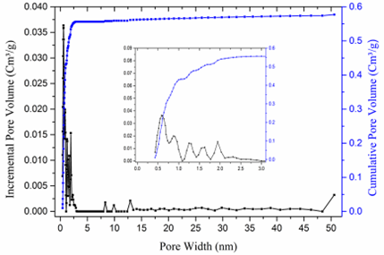 | 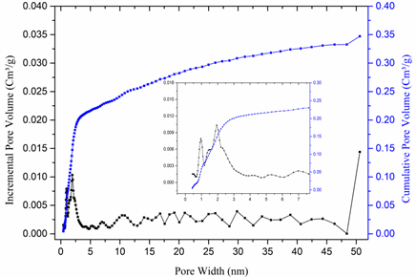
Figure 4: N₂ adsorption/desorption isotherms (77,3 K) and calculated (NDFT) pore size distribution curves of AP-AHC-P2.5 (left) and of AP-AHC-P5 (right).

Table 2: Porosity and surface properties (Dubinin-Radushkevich).
Sample | Specific surface (m²/g) | Micropore volume  (cm³/g) | Average pore width  (nm)
AP-AHC-P2.5 | 1,342.8 ± 5 | 0.591 | 1.761
AP-AHC-P5 | 468.4 ± 3 | 0.346 | 2.951

Figure 4 shows that the porosity of the activated hydrochars is strongly influenced by the concentration of phosphoric acid used during activation, with AP‑AHC‑P2.5 exhibiting a distinctly microporous structure while AP‑AHC‑P5 shifts toward mesoporosity, a trend consistent with the values in Table 2, where the surface area decreases from 1,342.8 to 468.4 m²/g and the micropore volume drops from 0.591 to 0.346 cm³/g as the average pore width increases from 1.76 to 2.95 nm. These differences arise from the stronger chemical action of 5 M H₃PO₄, which induces more extensive hydrolysis of lignocellulosic linkages and deeper matrix swelling, widening originally narrow micropores into larger mesopores; at the same time, higher acid loading promotes the formation of abundant phosphate and polyphosphate species (C–O–P, P–O–P) that act as swelling templates but can also block or collapse the smallest pores, thus reducing micropore density after carbonization and washing, as indicated by the greater intensity of P–O functional groups and the more fragmented morphology observed for AP‑AHC‑P5 in FTIR and SEM analyses. Consequently, the higher H₃PO₄ concentration accelerates structural decomposition and broadens the pore network at the expense of microporosity, while the milder 2.5 M activation preserves a more compact carbon framework, favouring the development of a high surface area dominated by narrow micropores; this explains the contrasting porosity distributions observed in Figure 4 and highlights the critical role of phosphoric acid concentration in tailoring the micro‑/mesopore balance of activated hydrochars.
    - MB adsorption
The adsorption performance of AP-AHC-P2.5 and AP-AHC-P5 samples, expressed as adsorption ratio and MB removal percentage, is presented in Figure 5.
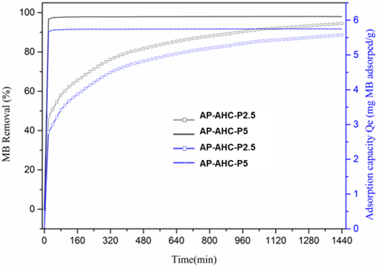
Figure 5: MB adsorption results for AP-AHC-P2.5 and AP-AHC-P5 samples.
Figure 5 shows that AP‑AHC‑P2.5 exhibits a substantially higher adsorption ratio and MB removal efficiency than AP‑AHC‑P5, a behaviour directly linked to its much larger specific surface area and higher micropore volume, which provide a greater density of high‑affinity adsorption sites for rapid MB uptake, whereas the more mesoporous and lower‑surface‑area structure of AP‑AHC‑P5 limits both adsorption rate and total removal capacity. These trends are fully consistent with the porosity and surface chemistry differences previously discussed, where the milder 2.5 M H₃PO₄ activation promotes a microporous structure favourable for fast dye diffusion into narrow pores, while the stronger 5 M activation widens pores and reduces micropore density, thereby diminishing adsorption performance. When compared with phosphoric acid activated hydrochars reported in the literature, the behaviour of APA-HCP-2.5 is consistent with studies showing that moderate H₃PO₄ concentrations maximise MB uptake due to dominant microporosity. H₃PO₄activated bamboo hydrochar achieved ~260–300 mg/g MB adsorption at moderate impregnation ratios, whereas stronger acid loadings (similar to 5 M conditions) reduced performance to ~150–180 mg/g as mesoporosity increased and micropore volume decreased (Supee & Zaini, 2024). Similarly, phosphorus rich activated carbons produced from rice husk showed MB capacities of ~250 mg/g at moderate H₃PO₄ concentration, dropping to ~120 mg/g at higher acid doses due to over etching and structural collapse (Luo et al., 2019). These reported trends confirm that optimal MB adsorption is obtained when activation conditions favour a microporous framework with abundant phosphate derived surface functionalities—conditions best met by the 2.5 M treatment—explaining the clear superiority of APAHCP2.5 over APAHCP5 in both adsorption rate and total MB removal.
  - Conclusions
This study demonstrates that phosphoric acid concentration plays a decisive role in tailoring the physicochemical properties, porosity, and adsorption performance of activated hydrochars derived from apple tree pruning. Moderate activation with 2.5 M H₃PO₄ produced a highly microporous material with superior surface area and functionalization, resulting in significantly enhanced methylene blue adsorption compared to the more mesoporous and less efficient hydrochar obtained with 5 M acid. Overall, these findings highlight the importance of controlled chemical activation to optimize pore architecture and surface chemistry for effective environmental applications. Future work should focus on evaluating the long‑term stability and regeneration potential of these materials, as well as exploring their performance against a broader spectrum of pollutants under realistic operating conditions. Additionally, understanding the scalability and economic viability of the activation process remains an important challenge for advancing these bio‑derived adsorbents toward industrial implementation.
Acknowledgments
This research has been founded by the Gipuzkoa’s Provincial Government under the program “Etorkizuna Eraikiz” 2024/2025. Ameni Ben Salah acknowledges the funding by the University of the Basque Country, EHU (PIF24-262).
References
Antxustegi M., Corro E., Baloch M., Volpe R., Gonzalez‑Alriols M., 2022, Production of Activated Bio‑chars for Wastewater Treatment: Characterization, Activation and Evaluation of the Adsorption Capacity, Chemical Engineering Transactions, 92, 547–552.
Ge, Q., Dong, Ch.J., Wang G.Y., Zhang J., Hou R. 2024. Production, characterization and environmental remediation application of emerging phosphorus-rich biochar/hydrochar: a comprehensive review. RSC Adv., 14, 33649-33665. https://doi.org/10.1039/D4RA03333G.
Ighalo, J.O., Adeniyi, A.G., 2025, Biomass hydrochar: A critical review of process chemistry, synthesis methodology, and applications, Sustainability, 17(4), 1660. DOI: 10.3390/su17041660
Khandelwal, A., Singh, R., 2024, Recent developments in hydrothermal carbonization for bioenergy and material applications, Bioresource Technology, 389, 129–140. DOI: 10.1016/j.biortech.2024.129140.
Luo, Y., Li, D., Chen, Y., Sun, X., Cao, Q., Liu, X. 2019. The performance of phosphoric acid in the preparation of activated carbon-containing phosphorus species from rice husk residue. Journal of Materials Science 54, 5008–5021. https://doi.org/10.1007/s10853-018-03220-x.
Petrović, J., Vuković, G., Stojanović, M., 2024, Advances in hydrothermal carbonization for sustainable biomass valorisation, Renewable Energy, 223, 1198–1212. DOI: 10.1016/j.renene.2024.02.045
Prifti K., Basso D., Pavanetto R., Manenti F., 2021, Improving Hydrothermal Carbonization (HTC) Processes by Hydrochar Gasification, Chemical Engineering Transactions, 86, 925–930. DOI: 10.3303/CET2186155
Puziy, A.M., Poddubnaya, O.I., Gawdzik, B., Sobiesiak, M., Sprynskyy, M., 2022. Structural Evolution of Polyimide-Derived Carbon during Phosphoric Acid Activation. Journal of Carbon Research 8(3) 47. https://doi.org/10.3390/c8030047.
Sathish, A., Saraswat, S.K., 2024, Hydrothermal carbonization: Emerging trends and applications in environmental remediation, Journal of Cleaner Production, 412, 137–150. DOI: 10.1016/j.jclepro.2024.137150
Sivaranjanee R., Senthil Kumar P., Rangasamy G., 2023, A recent advancement on hydrothermal carbonization of biomass to produce hydrochar for pollution control, Carbon Letters, 33(7), 1909–1933. DOI: 10.1007/s42823-023-00576-2.
Supee A.H., Zaini M.A.A., 2024, Phosphoric acid-activated bamboo hydrochar for methylene blue adsorption: isotherm and kinetic studies, Biomass Conversion and Biorefinery, 14, 8563–8577. DOI: 10.1007/s13399-022-03465-2.
Vásquez Llanosa S.A., García M., Torres J., 2024, Energy Transformation: Assessment of Urban Lignocellulosic Biomass Biofuels via Hydrothermal Carbonization, Chemical Engineering Transactions, 110, 487–492. DOI: 10.3303/CET24110070.

