CHEMICAL ENGINEERING TRANSACTIONS  VOL.xxx, 2026 | A publication of  
The Italian Association
of Chemical Engineering
Online at www.cetjournal.it

Guest Editors: Leonardo Tognotti, Rubens Maciel Filho, Viatcheslav Kafarov
Copyright © 2026, AIDIC Servizi S.r.l.
ISBN979-12-81206-xx-x;ISSN 2283-9216

Biotechnological Valorization of Colombian and Peruvian Apicultural Products by Lactic Fermentation of Honey and Bee Pollen
Jalelys Liceth Leones-Cerpa^{a,b,d*}, Martha Cuenca Quicazán^{b}, Karina A. Ojeda Delgado^{b}, Waldir D. Estela-Escalante^{c}
ªTenured Professor, Chemical Engineering Program, , Research group in Process design and biomass utilization (IDAB), Universidad de Cartagena, Cartagena, Colombia
^{b}Associated Professor, Chemical Engineering Program, Research group in applied transformation to industrial and agro-industrial matrices (ITMIA), Universidad de Cartagena, Cartagena, Colombia
^{c}Chemistry and Chemical Engineering Faculty, Bioprocesses and Fermentation Technology Laboratory, Universidad Nacional Mayor de San Marcos, Lima, Perú
^{d}Doctorate in Engineering candidate, Faculty of Engineering, Universidad de Cartagena, Cartagena, Colombia
jleonesc@unicartagena.edu.co

Abstract
The aim of this research was to evaluate the impact of the use of honey and bee pollen in fermentations with lactic acid bacteria with the purpose of predicting their importance in the production of a fermented beverage. Colombian and Peruvian apicultural products such as honey and pollen were utilized in the experiments. A consortium of lactic bacteria composed by homo- and heterofermentative ones were used in the study. Fermentation experiments were conducted in Erlenmeyer flasks and monitored through pH variation. Additionally, the effect of Colombian honey and pollen proportions on lactic acid production was assessed using a 2² full factorial design. Results showed that the supply of pollen to the culture medium enhances the fermentation activity of lactic bacteria accelerating the decrease in pH. Furthermore, the experimental design revealed that the higher pollen addition the higher production of lactic acid and consequently the lower pH value. Conversely, the increase of proportion of honey to the medium did not provoke a substantial effect of lactic acid production. The findings are important for predicting the fermentative behavior of lactic acid bacteria in honey and pollen-based beverages. From a technological perspective, a higher lactic acid concentration is advantageous, as it ensures a greater stability in the final product.
  - Introduction
The changes in the life style of the people have led to an increased interest for the consumption of healthy foods based on natural products to enhance the consumer well-being. Fermented foods are primarily an interesting vehicle for delivering nutrients and probiotics, which promotes a healthy gut microbiome (Leeuwendaal et al., 2022). Fermentation is a good strategy for increasing the shelft life of raw materials. In the fermentation process of foods, microorganisms metabolize carbohydrates—mainly sugars—to produce a diversity of metabolites such as carbon dioxide, alcohols, and organic acids (Chilton et al., 2015). Lactic fermentation is one of the most important alternatives to produce foods of high nutritional and nutraceutical value. Lactic bacteria (LAB) use the carbon source and other nutrients of the culture medium to produce energy necessary for the growth (Zhao et al., 2015). According to the World Health Organization (WHO), many lactic bacteria are classified as probiotics since they provide health benefits to the people (Viana de Souza and Silva Dias, 2017). Recent studies have reported that LAB play a fundamental role in strengthening immunity and potentially prevent some kinds of cancer (Riaz Rajoka et al., 2017). Optimization of the culture conditions such as medium composition, growth temperature, pH and agitation is necessary for reaching the maximum growth rates (Qiu et al., 2023). The chemical behavior of lactic acid (LA) is determined by its physicochemical characteristics such as acidity in aqueous media, bifunctional reactivity, and optical activity at the C2 asymmetric carbon (Castillo Martinez et al., 2013). LA is non-volatile, odorless, and regarded as Generally Recognized as Safe (GRAS) (Albuquerque et al., 2015). In addition, it contains a chiral carbon and exists in two (2) distinct isomeric forms: L(+) and D(-) (Liu et al., 2018). The lactic acid bacteria is widely used in food fermentations, for instance, fruits, and vegetables are fermented to produce fermented beverages, adding value to these raw materials (Tang et al., 2022).
However, few studies have explored the use of bee pollen as a raw material for lactic fermentation (Mora-Adames et al., 2021). Other important foodstuff such as bee honey is also fermented to produce honey mead (Cuenca et al., 2022). Honey and pollen are natural products of bees (Apis mellifera), widely used in the cosmetic, pharmaceutical, and food industries. Pollen is identified as a "superfood" due to its rich content of fatty acids, phenolic compounds, minerals, amino acids, proteins, vitamins, and antioxidants (Laaroussi et al., 2023). Its chemical composition varies significantly based on its geographical origin and the floral sources visited by the bees (Xue and Li, 2023). In addition, honey bee is composed by sugars (mainly glucose and fructose), enzymes, minerals, vitamins, and phytochemicals, and its composition is strongly influenced by the harvest location and predominant flora (Golmakani et al., 2025).
The beekeeping in Colombia and Peru is an important economic activity for many rural families that lives in the countryside. They sell bee products (mainly honey and pollen) in local markets. In Colombia for instance, 163,215 beehives were reported in 2023, with an estimated production of 6,599 tons of honey and over 300 tons of pollen. The main producers included the states of Cundinamarca, Boyacá, and Antioquia (Ministry of Agriculture and Rural Development - MADR, 2023). The production of honey and pollen is determined by the geography, climate and floral diversity, thus, honey production is mainly observed in warm-climate areas, whereas the production of pollen is mainly in temperate climates and cold regions. On the other side, in Peru, over 252,000 beehives were reported in 2023, yielding 2,314 tons of honey (Ministry of Agrarian Development and Irrigation - Midagri, 2024). In both countries, honey and pollen are primarily sold as raw hive products, and the production of value-added derivatives remains limited. The aim of this research was to use honey and bee pollen from different origin (Colombia and Peru) in lactic acid fermentation with the potential production of a fermented beverage. Primarily it was evaluated the impact of these components in the kinetics of lactic fermentation and monitored the pH variation and lactic acid production.
  - Materials and methods
    - Material and microorganisms
Samples of honey and pollen were provided by the Cooperative of organic beekeepers Montes de María (COOAPOMIEL; El Carmen de Bolívar, Bolivar, Colombia) and samples from Peru (“La Reyna Oxapampa” from Oxapampa–Pasco) were acquired from a local supermarket in Lima, Peru. Fermentations were carried out with a commercial freeze-dried mixed culture of lactic acid bacteria (LAB) (Danisco), composed by Streptococcus thermophilus, Lactobacillus delbrueckii ssp. lactis, and Lactobacillus delbrueckii ssp. bulgaricus.
    - Fermentative activity of lactic acid bacteria in honey- and pollen based media
Fermentations were conducted in 500 mL Erlenmeyer flasks containing 300 mL of culture medium composed by honey (10 °Bx) and bee pollen (1% w/v). The culture media were treated at 105 °C for 5 minutes. After treatment and cooling, the media were inoculated with 0,0225 g of freeze-dried mixed lactic acid bacteria, according to the manufacturer’s instructions. Experiments were performed by triplicate at 42 °C and 80 rpm, with an initial pH of 6.2. Samples were collected each two (2) h during the first 10 h, followed by a final sampling at 44 h. At the end of experiments, the samples were centrifuged for 10 minutes at 10,000 rpm to separate the cell biomass and the resulting supernatant was then used for pH measurement and further quantification of lactic acid.
    - Impact of the proportion of honey and bee pollen in the production of lactic acid
Experiments were conducted in 250ml Erlenmeyer flasks containing 100ml of culture medium of the following composition: honey (10 or 20 °Bx) and bee pollen (1% or 5% w/v). Honey bee was diluted with distilled water to the corresponding concentration as indicated and pasteurized at 110 °C for 8 minutes, meanwhile, the bee pollen was sterilized at 121 °C and 15 psi for 15 minutes. The media were adjusted to pH 6.2 and then inoculated with equal amounts of freeze-dried lactic acid bacteria (0,0045 g). Experiments were carried out for 20 hours at 42 °C and 80 rpm. To evaluate the impact of the proportion of honey and bee pollen a 2² full factorial design with three replicates and four central points was implemented using the software Design-Expert (version 13.0). Finally, the sample of each experiment was centrifuged at 10,000 rpm for 10 minutes and the supernatant used in the determination of lactic acid.
    - Chemical Analyses
The content of lactic acid in the fermented solution was determined by High-Performance Liquid Chromatography (HPLC) and the variation of pH values was measured with a Milwaukee MW15 pH-meter. It was used a HPLC AZURA® analytical system equipped with an autosampler, a diode-array detector (DAD), and a NUCLEODUR® C18 Pyramid column (150 × 4 mm, 5 μm). Samples before injecting to the equipment were filtered through a 0.2 μm pore-size membrane. The HPLC was set as follows: column temperature 25 °C, mobile phase 0.2% H₃PO₄, flow rate 0.7 mL/min, detection at 210 nm. Quantification was done by the method of the external standard calibration curve.
  - Results and Discussion
    - Lactic acid fermentation in honey- and pollen based media
In lactic acid fermentations the decrease of pH is regarded to the accumulation of lactic acid in the culture medium. The amount of lactic acid produced by a specific strain of lactic bacteria depends of the availability of fermentable sugar and essential nutrients. Figure 1 shows the pH variation of fermentation trials carried out with medium containing honey from Peru or Colombia, and with or without pollen. It was observed that, the supply of pollen to the medium resulted in higher decrease of pH compared to the medium containing only honey bee. It indicates that the pollen exerts an important impact promoting a higher synthesis of lactic acid. It is suggested that the pollen provides essential nutrients useful for the lactic acid, thereby accelerating the acidification process. The positive effect of the pollen may also be partially attributed to the incorporation of nutrients that enhance the metabolic activity of lactic acid bacteria, providing supplementary nutrients for their growth. Furthermore, the fermentative behavior of the inoculum was similar in experiments with both types of honey and pollen, suggesting no relevant differences in their suitability as substrates. Notably, the higher decrease of the pH is associated with higher lactic acid production.
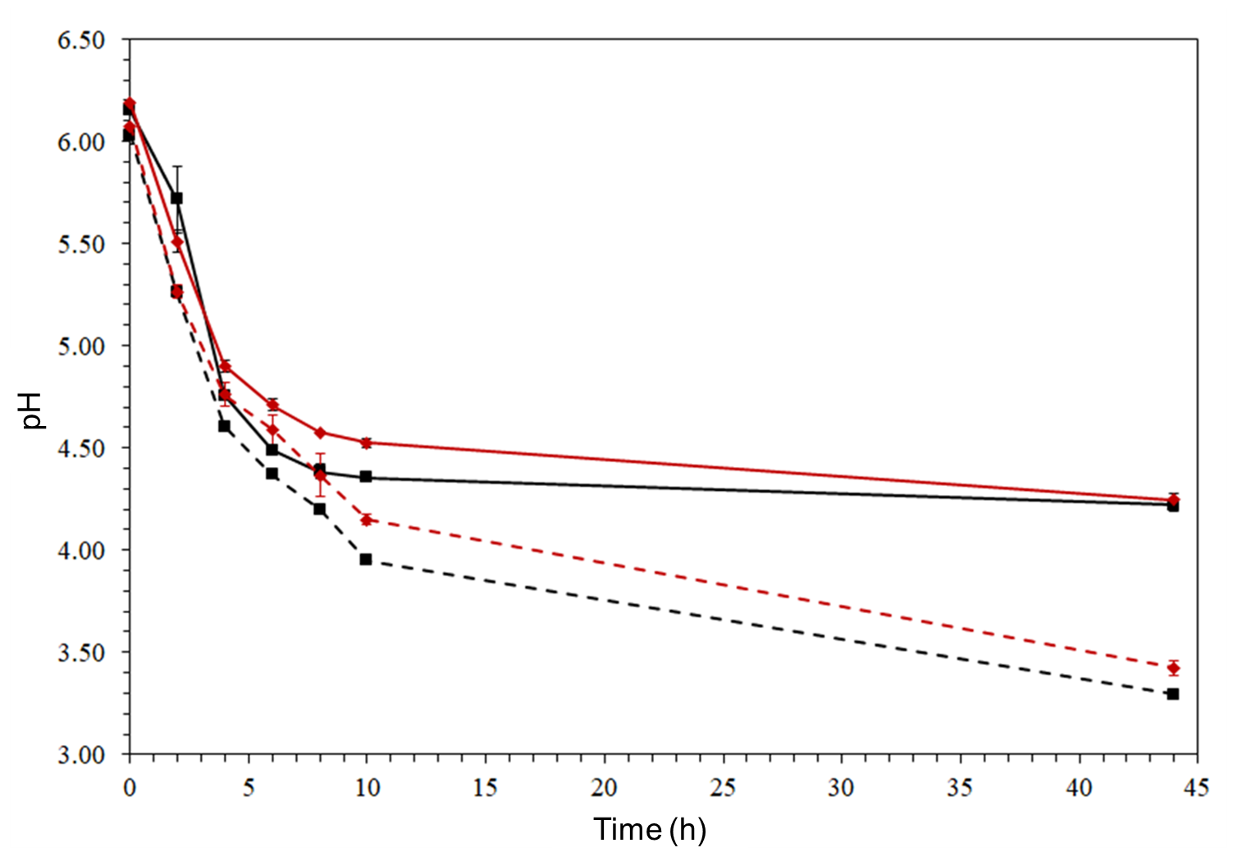
Figure 1: Kinetics of pH variation during lactic fermentation of media composed by honey with bee pollen (dotted lines) or without pollen (solid lines), using honey from Colombia (red line) and Peru (black line).
    - Impact of the proportion of honey and bee pollen in the production of lactic acid
Lactic acid bacteria are classified in homofermentative, heterofermentative and facultative heterofermentative groups. The classification is related to the metabolites that they produce during the fermentation (Nuzzo et al., 2019). Previous findings showed no relevant differences on pH decrease during fermentation of media containing honey alone of different origin or media composed by honey and bee pollen. In the following experiments the optimal proportion of both components (honey and pollen) of Colombian origin was searched with the aim to maximize the production of lactic acid. It is important to note that a higher concentration of lactic acid has a positive influence on a longer shelf life of the final product, as it has a preservative effect. Figure 2 shows a Response Surface Methodology of a 22 full factorial design. It shows a positive effect of the addition of pollen on the production of lactic acid as also evidenced in previous experiments (Figure 1). However, the increase of honey bee in the medium results in a mild effect. The results demonstrated the important role of pollen in the metabolic activity of lactic acid bacteria. It suggests that pollen can be used to improve the nutrition value of many other culture media.
.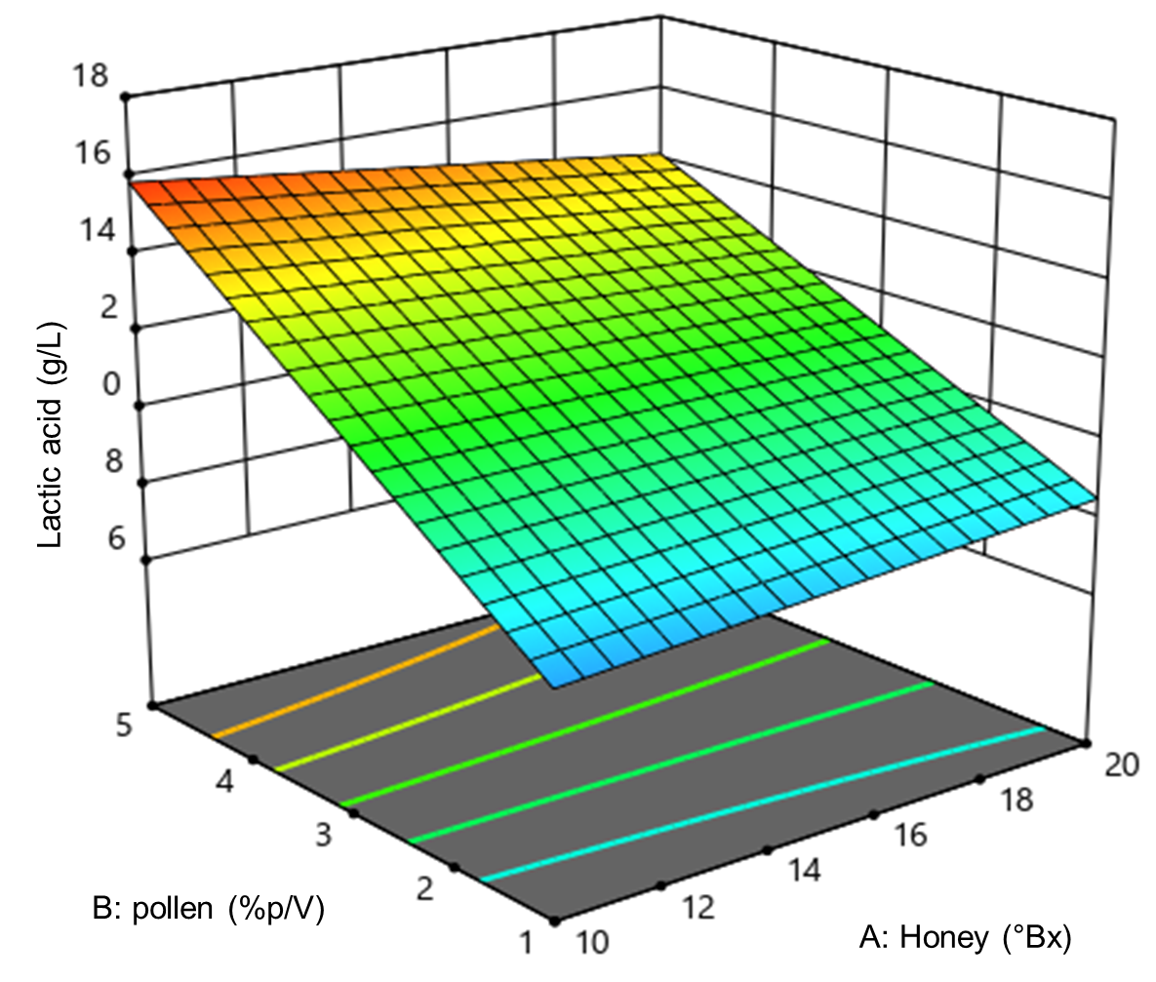
Figure 2: Response Surface Methodology of the effect of honey and pollen of Colombian origin in the production of lactic acid.
The supplement with bee pollen to the fermentation medium would provide with essential nutrients required for the activity of lactic acid bacteria. From a technological point of view, a higher lactic acid concentration is desirable as it contributes with better stability to the final product. The mild positive effect observed by the addition of honey can be partially attributed to the osmotic stress induced by a high concentration of soluble solids which diminish the water activity (Golmakani et al., 2025). Thus, a low concentration of soluble solid favors the metabolic activity of the bacteria and movement of nutrients, enabling a rapid assimilation of honey sugars (Cuenca et al., 2021). The highest positive effect on lactic acid production was achieved with addition of 5% (w/v) of pollen and 10 °Bx of bee honey. Similar positive effect of the pollen was observed in experiments of alcoholic fermentation carried out using honey as main source of sugar (Leones-Cerpa et al., 2024). Most lactic acid bacteria are nutritionally exigent; besides fermentable sugars, they require amino acids, vitamins, minerals, and peptides, which are found in the bee pollen (Mora-Adames et al., 2021). Table 1 shows the Analysis of Variance (ANOVA) of the 2² factorial design. It shows that the presence of pollen is strongly significant (p=0.0012).
Table 1: ANOVA of the Experimental Design for Lactic Acid in Fermentations with Honey and Pollen from Colombia
Source | DF | Sum of Squares | F-Value | P-Value
Model | 4 | 26.490 | 30.980 | <0,0001
A-Honey | 1 | 0.2647 | 0.3096 | 0.5915
B-Pollen | 1 | 18.67 | 21.830 | 0.0012
AB | 1 | 2.020 | 2.360 | 0.1590
A² | 1 | 0.1884 | 0.2203 | 0.6499
R²: 0.9323, Adequate Precision: 13.5709, CV (%): 7.96, DF: degrees of freedom

In addition, it is observed that the model is statistically significant (p< 0.0001), with a good fit, demonstrating an adequate response variability. Furthermore, the coefficient of variation (CV) indicates high precision and experimental reproducibility. The value of the determination coefficient (R2) is high (0.9323) and acceptable for experiments carried out with living cells. In addition, a mathematic model was generated from the data obtained experimentally and it is expressed in terms of actual values as Eq(1):
$$LA=3.60000+0.375833A+2.33333B-0.045833AB-0.010333A^{2}$$ | (1)
The value of R² also indicates that the mathematical model is explained with a 93.23% of accuracy and 5% of level of significance, considering the behavior of lactic bacteria within the limits of the tested variables. The influence of pollen is highly significant (P < 0.05) and confirms the positive impact of the lactic acid production. The effect of pollen may be regarded to its composition—comprising of carbohydrates, vitamins, minerals, and amino acids—which enhance the LAB metabolisms, growth and lactic acid production (Mora-Adames et al., 2021). Some studies reported that the pollen can be pretreated using ultrasounic, themal and/or enzymatic methods to disrupt the recalcitrant exine layer and provoke the release the bioactive compounds (Sharma et al., 2025). Thus, the pretreatment could be an interesting alternative for improving the availability of compounds and optimizing the production of lactic acid by lactic bacteria.

From an economic sustainability perspective, the lactic fermentation process investigated in this study offers several advantages. First, the use of honey and pollen provides a strategy for valorizing beekeeping products. This is particularly relevant for pollen, which is often underutilized despite its high nutritional value, as both inputs are sourced directly from beekeepers. Second, the process operates under low-energy conditions, thereby reducing both energy consumption and associated operational costs. Third, the implementation of this fermentation process has the potential to significantly enhance the value of the final product, helping to offset production costs in regions such as Colombia and Peru. Overall, the proposed approach not only contributes to the technological development of fermented products but also represents a potentially viable alternative for improving the economic sustainability of the apicultural sector.

It is important to note that scaling up this fermentation process to large-scale bioreactors requires careful control of key operational parameters. In particular, substrate concentration, pH variation, temperature, and biomass distribution must be closely monitored, as they can significantly influence fermentation kinetics. Despite these challenges, the process is safe and shows favorable potential for scale-up, provided that the aforementioned parameters are properly controlled.
  - Conclusions
Apicultural products such as honey and bee pollen were successfully used in fermentations with lactic acid bacteria. It was evidenced no substantial differences in the fermentation behavior when used Colombian or Peruvian apicultural products. Thus, fermentation kinetics of diluted honey or diluted honey plus bee pollen of both countries were similar. Furthermore, it was observed a favorable effect of the addition of pollen in the acidification of the medium verified with the decrease of pH, which is linked to a higher production of lactic acid. Results of experimental design showed a strong and confirmative effect of the addition of pollen in the production of lactic acid by lactic bacteria. Conversely, the increase of the proportion of honey in the medium did not provoke an important effect on the production of lactic acid indicating that the honey is deficient in some nutrients necessary for supporting the fermentative activity of lactic bacteria as compared to that observed in experiments with addition of pollen. Thus, its addition enhanced the fermentation provoking a fast acidification of the medium. The maximum production of lactic acid has been reached adding honey (10°Bx) and bee pollen (5% w/v). Our findings demonstrate the potential of bee pollen as a key ingredient for honey-based fermented beverages. Additionally, this research is economically sustainable and can be safely and controllably scaled up to bioreactors.
Acknowledgments
The authors The authors express their gratitude to the Universidad de Cartagena (Colombia), particularly to the Vice-Rectorate for Research, as Resolution No. 01889 of July 31, 2024 authorized the initiation of strengthening plans to allocate funding to research groups classified by the Ministry of Science, Technology and Innovation (Minciencias) that support the main research line of a doctoral program at the University of Cartagena for the year 2024. Furthermore, the authors acknowledge the strengthening plan of the Doctoral Program in Engineering at the University of Cartagena (Act No. 056-2024) for supporting participation in the academic event International Conference on BIOMASS (IConBM2026), the strengthening plan of the IDAB Research Group (Act No. 002-2023) for supporting the research internship at the Universidad Nacional Mayor de San Marcos (Lima, Peru), and the research projects (Acts No. 081-2023 and 008-2024) for supporting the experimental development of the results presented in this study. Additionally, the authors thank the Universidad Nacional Mayor de San Marcos (Peru) for its valuable support during the development of this research.
References
Castillo Martinez, F. A., Balciunas, E. M., Salgado, J. M., Domínguez González, J. M., Converti, A., Oliveira, R. P. de S., 2013, Lactic acid properties, applications and production: A review, Trends in Food Science and Technology, 30(1), 70–83, DOI: 10.1016/j.tifs.2012.11.007
Chilton, S. N., Burton, J. P., Reid, G., 2015, Inclusion of fermented foods in food guides around the world, Nutrients, 7(1), 390–404, DOI: 10.3390/nu7010390
Cuenca, M., Blanco, A., Quicazán, M., Zuluaga-Domínguez, C., 2022, Optimization and Kinetic Modeling of Honey Fermentation for Laboratory and Pilot-Scale Mead Production, Journal of the American Society of Brewing Chemists, 80(3), 248–257, DOI: 10.1080/03610470.2021.1966590
Golmakani, M. T., Sasani, M., Sahraeian, S., Khalesi, M., 2025, Evaluating the impact of thermal processing on physicochemical properties of monofloral and multifloral honey, Journal of Food Composition and Analysis, 137, 1–8, DOI: 10.1016/j.jfca.2024.106940
Laaroussi, H., Ferreira-Santos, P., Genisheva, Z., Bakour, M., Ousaaid, D., El Ghouizi, A., Teixeira, J. A., Lyoussi, B., 2023, Unveiling the techno-functional and bioactive properties of bee pollen as an added-value food ingredient, Food Chemistry, 405 (July 2022), 1–12, DOI: /10.1016/j.foodchem.2022.134958
Leeuwendaal, N. K., Stanton, C., O’toole, P. W., Beresford, T. P., 2022, Fermented Foods, Health and the Gut Microbiome, Nutrients, 14(7), 1–26, DOI: 10.3390/nu14071527
Leones-Cerpa, J. L., Mason, M., Cuenca Quicazán, M. M., 2024, Technical Feasibility of Mead Production as a Contribution to Generate Value to Beekeepers in Montes de María, Colombia, Chemical Engineering Transactions, 110, 31–36, DOI: 10.3303/CET24110006
Liu, P., Zheng, Z., Xu, Q., Qian, Z., Liu, J., Ouyang, J., 2018, Valorization of dairy waste for enhanced D-lactic acid production at low cost, Process Biochemistry, 71, 18–22, DOI: 10.1016/j.procbio.2018.05.014
Ministry of Agrarian Development and Irrigation (Midagri) , 2024, Honey production reaches 2,314 tons per year in 2024 (in Spanish) <gob.pe/midagri> accessed 14.03.2025.
Ministry of Agriculture and Rural Development - MADR (Colombia), 2023, Regulations in beekeeping (in Spanish). <minagricultura.gov.co/> accessed 13.03.2025.
Mora-Adames, W. I., Fuenmayor, C. A., Benavides-Martín, M. A., Algecira-Enciso, N. A., Quicazán, M. C., 2021, Bee pollen as a novel substrate in pilot-scale probiotic-mediated lactic fermentation processes, Lwt, 141, 1–9, DOI: 10.1016/j.lwt.2021.110868
Nuzzo, G., Landi, S., Esercizio, N., Manzo, E., Fontana, A., D’Ippolito, G., 2019, Capnophilic lactic fermentation from Thermotoganeapolitana: A resourceful pathway to obtain almost enantiopure L-lactic acid, Fermentation, 5(2), 3–9, DOI: 10.3390/fermentation5020034
Qiu, Z., Han, X., Fu, A., Jiang, Y., Zhang, W., Jin, C., Li, D., Xia, J., He, J., Deng, Y., Xu, N., Liu, X., He, A., Gu, H., Xu, J., 2023, Enhanced cellulosic D-lactic acid production from sugarcane bagasse by pre-fermentation of water-soluble carbohydrates before acid pretreatment, Bioresource Technology, 368, 1–8, DOI: 10.1016/j.biortech.2022.128324
Riaz Rajoka, M. S., Shi, J., Zhu, J., Shao, D., Huang, Q., Yang, H., Jin, M., 2017, Capacity of lactic acid bacteria in immunity enhancement and cancer prevention, Applied Microbiology and Biotechnology, 101(1), 35–45, DOI: 10.1007/s00253-016-8005-7
Sharma, A., Thakur, A., Nanda, V., 2025, Impact of bee pollen cell-wall disrupting techniques on the structural integrity, functional attributes, and nutritional quality of bee pollen protein isolates for food application, International Journal of Biological Macromolecules, 305, 1–13, DOI: 10.1016/j.ijbiomac.2025.141179
Tang, Z., Zhao, Z., Wu, X., Lin, W., Qin, Y., Chen, H., Xiao, Y., 2022, A Review on Fruit and Vegetable Fermented Beverage-Benefits of Microbes and Beneficial Effects, Food Reviews International, 39(8), 4835–4872, DOI: 10.1080/87559129.2021.2024222
Viana de Souza, J., Silva Dias, F., 2017, Protective, technological, and functional properties of select autochthonous lactic acid bacteria from goat dairy products, Current Opinion in Food Science, 13, 1–9, DOI: 10.1016/j.cofs.2017.01.003
Xue, F., Li, C., 2023, Effects of ultrasound assisted cell wall disruption on physicochemical properties of camellia bee pollen protein isolates, Ultrasonics Sonochemistry, 92, 1–9, DOI: 10.1016/j.ultsonch.2022.106249
Zhao, W., Huang, J., Lv, C., Hu, S., Yao, S., Mei, L., Lei, Y., 2015, pH stabilization of lactic acid fermentation via the glutamate decarboxylation reaction: Simultaneous production of lactic acid and γ-aminobutyric acid, Process Biochemistry, 50(10), 1523–1527, DOI: 10.1016/j.procbio.2015.06.019

