 CHEMICAL ENGINEERING TRANSACTIONS  VOL. xxx, 2026 | A publication of  
The Italian Association
of Chemical Engineering
Online at www.cetjournal.it

Guest Editors: Leonardo Tognotti, Rubens Maciel Filho, Viatcheslav Kafarov
Copyright © 2026, AIDIC Servizi S.r.l.
ISBN 979-12-81206-xx-x; ISSN 2283-9216

Bioethanol Production from Potato Peels (Solanum Tuberosum) as Sustainable Alternative for Urban Eco-Communities
Sofia Baquero^{a*}, German A. Castroª, Bernay Cifuentesª, Zahira Gómez^{a,b}, Ana Vásquez^{c}
ª Faculty of Engineering, Universidad de La Salle Bogotá, Bogotá, Colombia.
^{b} Energy, Materials and Environment Laboratory, Faculty of Engineering, Campus Universitario Puente del Común, Universidad de La Sabana, km. 7 Autopista Norte de Bogotá, Chía, Colombia.
^{c} Asociación de Familias, Hombres y Mujeres de Colombia (ASOFAHIMCO), Bogotá, Colombia lbaquero59@unisalle.edu.co*

Potato cultivation in Colombia accounts for 1.4 % of the agricultural GDP, with potato peel waste (PPW) being the main byproduct. The valorization of agro-industrial waste has gained particular interest as a strategy for transitioning to a circular and sustainable economy. Eco-communities play an important role in utilizing this available residual biomass (collecting 126 kg of PPW per week). This study explored the development of a biotechnological process for obtaining bioethanol from PPW at a laboratory scale. The process began with the application of thermochemical (HCl 0.1 %v/v and NaOH 0.1 %v/v) and hydrothermal pretreatments to the PPW. Enzymatic hydrolysis was evaluated using Celluclast 1.5 L (700 EGU/g) and Amylase AG 300 L (260 AGU/g). The product was then fermented with Saccharomyces cerevisiae and subsequently distilled under reduced pressure. The hydrolysate with HCl 0.1 %v/v showed a higher sugar release (29.08 ± 0.04 g/L) and lower bioconversion (11.23 ± 0.37 g ethanol / 100 g dry peel) with an 8 %w/v PPW, compared to the hydrolysate with 0.1 %v/v NaOH under the same conditions (24.10 ± 0.07 g sugar/L), but the ethanol bioconversion was higher (12.14 ± 0.45 g ethanol / 100 g dry peel). This represents a transformation process applicable in eco-communities, where an estimated 3.15 L of alcohol al 70 – 80 % is projected to be produced per week.
  - Introduction
Contemporary lifestyles have driven a growing energy demand, underscoring a critical dependence on fossil fuels. The intensive use of these fuels is the primary precursor of greenhouse gas emissions (Chauhan et al., 2023). In this scenario, biofuels have emerged as a renewable and viable alternative for diversifying the energy matrix (Atitallah et al., 2019). In Colombia, bioethanol plays a fundamental role as it partially replaces fossil-derived gasoline (10 %), thereby reducing the environmental impact of the transportation sector (Congress of the Republic of Colombia 2001). However, the sustainability of first-generation bioethanol is debated due to its competition with food security, which drives the transition towards second-generation processes that valorize residual biomass and agro-industrial byproducts (Ijaz et al., 2024).
Potato (Solanum tuberosum) cultivation is a cornerstone of the Colombian agricultural sector, with a production of 2.57 million tons, accounting for 1.4 % of the national agrarian Gross Domestic Product (PIB by Spanish acronyms) (DANE, 2023). In turn, the industrial processing and consumption of this tuber generate potato peel waste (PPW) as the primary residue, which can range from 15 % to 40 % depending on the peeling method used (Ijaz et al., 2024). Inadequate management of PPW leads to the generation of leachate and methane gas in landfills, and it is estimated that by 2030, global PPW production could result in the release of 5 million tons of CO₂ into the environment (Khanal et al., 2024). Despite its abundance, PPW use in Colombia is limited by logistical collection barriers and a lack of technical protocols adapted to local varieties. This presents an opportunity to strengthen energy sovereignty by creating circular value chains and increasing eco-communities' economic capacity to collect waste based on their consumption levels.
PPW is classified as a secondary plant biomass with high biotechnological potential due to its composition of residual starch (up to 44.80 %), along with cellulose (34.30 %), hemicellulose (5.90 %), and lignin (4.3 %) (Atitallah et al., 2019). This biopolymeric structure enables the production of fermentable sugars via biochemical routes. Previous research (Khawla et al., 2014), shows that enzymatic hydrolysis offers advantages over conventional acid hydrolysis by operating under moderate conditions and minimizing the formation of inhibitory compounds, such as hydroxymethylfurfural (HMF), thereby optimizing yield in the subsequent alcoholic fermentation with Saccharomyces cerevisiae. Within this framework, this research focuses on developing a biotechnological process for producing bioethanol from potato (Solanum tuberosum) peel waste at a laboratory scale, aiming to represent a transformation process applicable in eco-communities that generate 126 kg of PPW per week.
  - Materials and methods
    - Raw Material
Potato peel waste (Solanum tuberosum) was used. The peel was obtained by mechanical peeling of fresh potatoes, followed by washing and disinfection with a TIMSEM solution (400 ppm). The material was dried at 50 °C for 4 h, ground using a pin mill, and sieved.
    - Pretreatment
PPW was evaluated with a hydrothermal pretreatment (using distilled water) and two thermochemical pretreatments employing HCl (0.1 %v/v) and NaOH (0.1 %v/v) at a substrate of 5 %w/v for a particle size of 335 µm. A 3x2x2 factorial design was applied in triplicate, varying the type of pretreatment, time (1 h and 1.5 h), and temperature (80 °C and 121 °C). In each case, the release of reducing sugars was evaluated using the DNS technique described by Miller (1959) as the response variable.
    - Enzymatic Hydrolysis
Enzymatic hydrolysis was carried out at 50 °C and pH 4.8 (0.1 M sodium acetate buffer) with constant agitation at 300 rpm for 48 h. The particle size of PPW ranged from 250 µm to 500 µm in a working volume of 150 ml. A 3x2x2 factorial design was used, analyzing the type of pretreatment (HCl 0.1 %v/v and NaOH 0.1 %v/v), the type of enzyme—Celluclast 1.5 L (700 EGU/g) and the combination of Celluclast 1.5 L with Amylase AG 300 L (260 AGU/g)—and the substrate concentration (2 %, 5 %, and 8 %w/v). The enzyme dosage was set at 23.58 µL/g of cellulose for Celluclast 1.5 L and 2.72 µL/g of starch for Amylase AG. Enzyme inactivation was achieved using a water bath at 95 °C for 10 minutes with thermal shock, and the release of reducing sugars was evaluated using the DNS technique described by (Miller, 1959).
    - Fermentation and Distillation
The hydrolysate was fermented with Saccharomyces cerevisiae (Angel Thermal Tolerance) at an inoculum rate of 0.3 g/L (5 million cells/mL). The process was conducted under conditions of 30 °C, pH 5.0, and 100 rpm for 72 h. The fermented broth underwent simple distillation using a rotary evaporator at 50 °C and 150 mBar. The quantity of ethanol produced was determined by gas chromatography (working volume of 2 µL, the run time was 12 min, and a HP-PLOT Q column at 150°C to 210 °C (rate 20 °C/min) with gas flow of 5 ml/min of N₂ and FID detector at 275 °C). The fermentation yield was estimated according to equations (1) and the overall ethanol yield according to the equations (2), where: Ce is the ethanol concentration (g/L); M is Potato peel waste (g); V is solution volume (L).
$$\% Ethanol yield=\frac{g Ethanol produced}{g Ethanol theorist}*100$$ | (1)
$Overall Ethanol yield (gEthanol/100g dry peel)=\frac{Ce*V}{M}*100$ | (2)
    - Statistical Analysis
The data presented in this document are the average of at least three replicates with a standard error of less than 5 %. Data were analyzed using Minitab16 software through Tukey tests (α 0.05) to determine significant differences between treatments, following analysis of variance (ANOVA).
    - Work with Eco-Community
A 3-hour technical workshop was conducted with the community of ASOFAHIMCO (Association of Families, Men and Women of Colombia), located in El Regalo neighborhood, Bosa locality, Bogotá D.C., Colombia, which consists of 26 families and 80 urban gardens. The workshop consisted of two phases, one theoretical and one practical, introducing the community to laboratory equipment and visualizing the fermentation process to strengthen their knowledge regarding the utilization of organic waste and the production of ethanol (not suitable for human consumption), to diversify waste valorization pathways.
  - Results and discussion
    - Raw Material and Effect of Pretreatment
The conditioning process for potato peel (Solanum tuberosum) resulted in a dehydrated material with an average moisture content of 8.7 % and a final yield of 11.56 % relative to the initial fresh mass. Pretreatment involves rupturing cellulose and lignin microfibrils to increase the biomass's susceptibility to enzymatic hydrolysis (Sharma et al., 2019).
Figure 1 shows that the evaluation of pretreatments revealed that conditions at 80 °C were ineffective for structural rupture of the biomass, with reducing sugar release below 1 g/L. According to Atitallah et al. (2019), the composition of thermally pretreated PPW (80 °C for 24 h) only slightly modified the cellulose, hemicellulose, and lignin composition compared to untreated PPW. In contrast, autoclave processing at 121 °C for 1 h and 1.5 h significantly increased sugar yield when using HCl 0.1 %v/v, with the highest yield of 7.88 ± 0.09 g/L at 1.5 h. This significantly exceeded the NaOH 0.1% v/v treatment (0.656 ± 0.01 g/L) and the hydrothermal treatment (0.611 ± 0.01 g/L). This aligns with the findings of Atitallah et al. (2019), who reported that adding chemical agents under the same conditions as hydrothermal pretreatment results in a significant decrease in PPW recovery. Furthermore, the Tukey test indicated that the type of agent, time, temperature, and their interactions significantly affect reducing sugar yield.

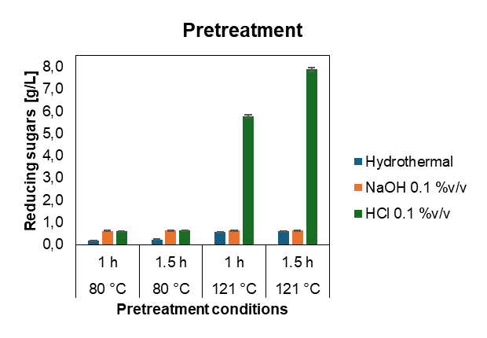
Figure 1: Comparative analysis between Pretreatment (Hydrothermal, NaOH 0.1 %v/v y HCl 0.1 %v/v) with PPW in 5 %w/v y 355 µm particle size.
According to Atitallah et al. (2019), pretreatment with NaOH 0.1 %v/v on PPW reduces lignin content by up to 48.8 % (from 4.3 g/100g Total Solids to 2.2 g/100g Total Solids). In this regard, Ben Taher et al. (2017) and Zoghlami & Paës (2019) highlight that alkaline treatment, besides reducing lignin, also facilitates the entry of hydrolytic enzymes by promoting material swelling, which decreases crystallinity and increases surface area. In contrast, acid pretreatment is not efficient for lignin removal, as it primarily focuses on hemicellulose solubilization, in addition to hydrolyzing cellulose and starch (Atitallah et al., 2019). Therefore, pretreatments with HCl 0.1 %v/v and NaOH 0.1 %v/v were selected for enzymatic evaluation at 121 °C for 1.5 h, aiming to visualize the effects of both pretreatments during hydrolysis.
    - Enzymatic Hydrolysis
Figures 2a and 2b show that the combined action of Celluclast 1.5 L and Amylase AG 300 L (CEL+AMI) is significantly superior to the individual use of Celluclast 1.5 L (CEL). This aligns with the findings of Arapoglou et al. (2010), who reported that the combined use of amylases and cellulases produces a multifocal effect on PPW, enabling synergistic degradation of cellulose and residual starch. ANOVA analysis confirmed that enzyme type, substrate, and the type of previous pretreatment significantly influence sugar concentration. In this case, the hydrolysate with the highest sugar concentration was obtained from PPW hydrolyzed with the enzyme conjugate (Celluclast 1.5 L and Amylase AG 300 L) and pretreated with HCl 0.1 %v/v at an 8 %w/v substrate, at this condition a sugar concentration of 29.08 ± 0.04 g/L was reached, followed by PPW pretreated with NaOH 0.1 %v/v, which yielded 24.10 ± 0.07 g/L of reducing sugars under the same substrate and enzyme conjugate conditions.
The heterogeneous nature of biomass and the diversity of enzymes complicate the understanding of enzyme-substrate interactions. However, it is known that biomass is influenced by structural characteristics inherent to its type, such as crystallinity, degree of polymerization, viscosity, accessible surface area, pore volume, among other factors that affect the dynamic behavior and mass transfer of the biomass in solution (Zoghlami & Paës, 2019). In this case, it was observed that the use of NaOH 0.1 %v/v during pretreatment promoted material swelling, which altered the solution's viscosity and hindered medium agitation during the hydrolytic phase. This effect diminished over time, but it may have impaired the initial enzyme-substrate interaction due to mass transfer limitations, resulting in a lower sugar yield (Zoghlami & Paës, 2019).
In contrast, pretreatment with HCl 0.1 %v/v partially hydrolyzed the starch in the PPW, preventing swelling and reducing the viscosity of the medium (Atitallah et al., 2019). The hydrolysis curve shown in Figure 2a and Figure 2b exhibited a growth trend up to approximately 45 h, which aligns with the results described by Atitallah et al. (2019). This trend was independent of the substrate concentration (2 %, 5 %, 8 %w/v), as the availability of PPW influences the quantity of sugars released but does not alter the direct action of the enzymes on the substrate (Ben Taher et al., 2017).

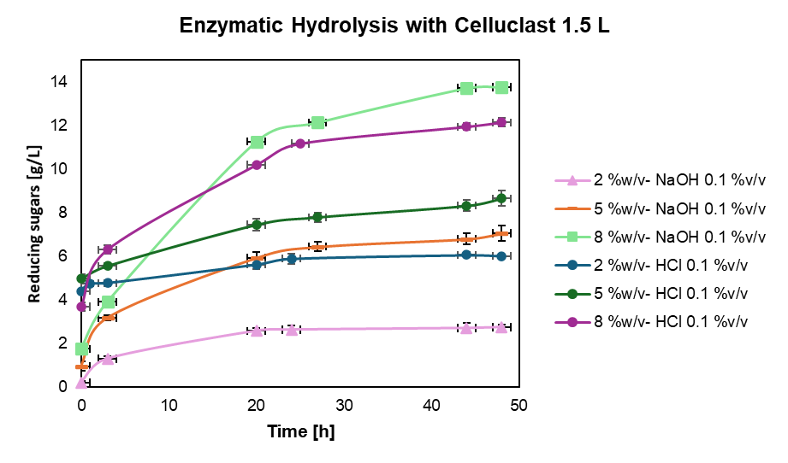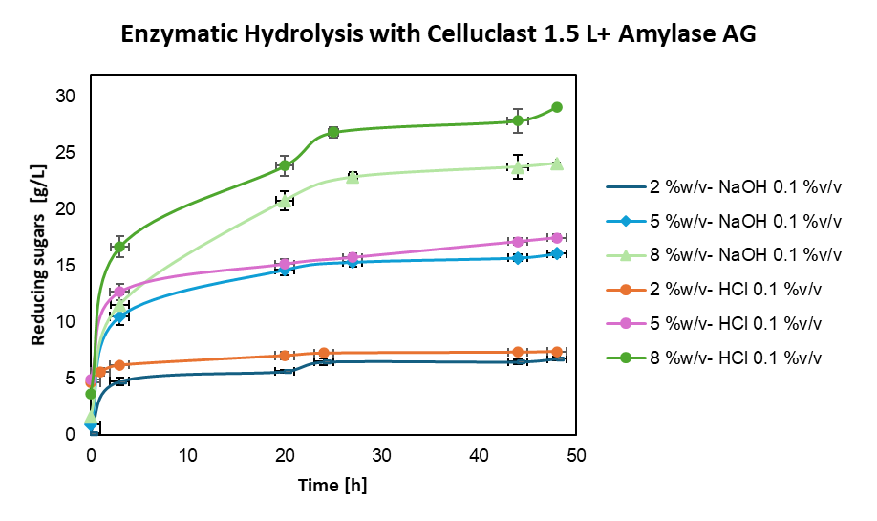
b)
a)
Figure 2: Comparative Analysis of Enzymatic Hydrolysis on PPW with Particle Size Ranging from 250 µm to 500 µm, in Relation to PPW Pretreated with Solutions (NaOH 0.1 %v/v and HCl 0.1 %v/v). (a) Hydrolysis with Celluclast 1.5 L. (b) Hydrolysis with Celluclast 1.5 L + Amylase AG 300 L.
    - Fermentation and Distillation
Table 1 shows that for the assay with NaOH 0.1 %v/v CEL+AMI, the ethanol concentration was 9.71 ± 0.36 g/L (yield, 89.6%). The treatment with HCl 0.1 %v/v CEL+AMI produced 9.29 ± 0.31 g/L (yield, 87.8%). Despite this, no statistically significant differences in alcohol production were observed among the evaluated hydrolysates. These values exceed those reported by Khawla et al. (2014) for the use of HCl as a chemical agent in acid hydrolysis (6.45 g Ethanol/L). Narisetty et al. (2022) reported values of 24.9 g ethanol/L from an initial glucose concentration of 50 g/L and 50.2 g ethanol/L from a glucose concentration of 100 g/L. They evaluated how glucose concentration in the medium (50 g/L to 200 g/L) affected outcomes, using the S. cerevisiae Z75578 strain. These results suggest that more fermentable sugars lead to greater ethanol production. Improved cell growth and complete glucose depletion were seen between 24 and 36 hours, depending on the initial substrate concentration. The hydrolysate for this study started from a concentration of 21.19 ± 0.05 g/L for the hydrolysate pretreated with NaOH 0.1 %v/v and 20.69 ± 0.02 g/L for the hydrolysate pretreated with HCl 0.1 %v/v.
Table 1: Results Fermentation and Distillation.
Rehearsal | Ethanol (g/L) | Yield (%) | Overall yield  (g Ethanol/100 g dry peel)
HCL 0.1% CEL+AMI | 9.29 ± 0.31 | 87.8 ± 0.03 | 11.23 ± 0.37
NaOH 0.1% CEL+AMI | 9.71 ± 0.36 | 89.6 ± 0.11 | 12.14 ± 0.45
Abbreviations: CEL: Celluclast 1.5 L; CEL+AMI: Celluclast 1.5 L con Amylase AG 300 L.
According to Walker & Stewart (2016), S. cerevisiae requires low concentrations of O₂ during an initial growth phase for the biosynthesis of fatty acids and sterols; subsequently, in the absence of O₂, it promotes ethanol production. In Figure 3, the highest ethanol production was recorded during the first 23 h, during which the sugar concentration also decreased significantly over the same period. Narisetty et al. (2022) similarly reported the depletion of carbon present in the medium within the first 24 h of fermentation. This suggests that the fermentable reducing sugars (glucose, fructose, maltose, etc.) were exhausted due to the yeast's high metabolic activity, as the determination of reducing sugars using the DNS technique quantifies all sugars containing a free aldehyde or ketone group in their chemical structure, which can donate electrons in the presence of an oxidizing agent (Miller, 1959).
Consequently, the DNS technique also identifies other types of reducing sugars that are non-fermentable, such as oligosaccharides and xylose (common during hemicellulose hydrolysis), which are not assimilable by yeasts (Arapoglou et al., 2010). Finally, distillation using a rotary evaporator yielded a distillate with an ethanol concentration of 80.01 ± 0.19 %v/v, and the overall process yield was estimated at 12.14 ± 0.45 g of ethanol / 100 g of dry peel for the hydrolysate with NaOH 0.1 % / CEL+AMI and 11.23 ± 0.37 g / 100 g for the hydrolysate with HCl 0.1 % / CEL+AMI.

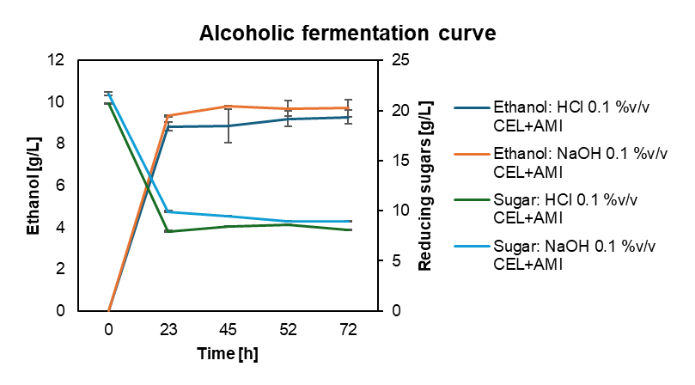
Figure 3: Fermentation curve with Celluclast 1.5 L hydrolysates and Amylase AG 300 L for pretreatment NaOH 0.1 %v/v y HCl 0.1 %v/v. Abbreviations: CEL: Celluclast 1.5 L; CEL+AMI: Celluclast 1.5 L con Amylase AG 300 L.
    - Work with Eco-Community ASOFAHIMCO
Figure 4 illustrates the collaborative work process with the ASOFAHIMCO eco-community, which is based on training in topics related to enzymatic hydrolysis, alcoholic fermentation, and the basic handling of laboratory instruments as an initial approach to analytical techniques. It was established that the community generates a weekly accumulation of 126 kg of PPW. An ethanol production of 3.15 L of ethanol at a concentration of 70 - 80 % v/v was reached. This represents an alternative income source for the community and promotes the circular economy.
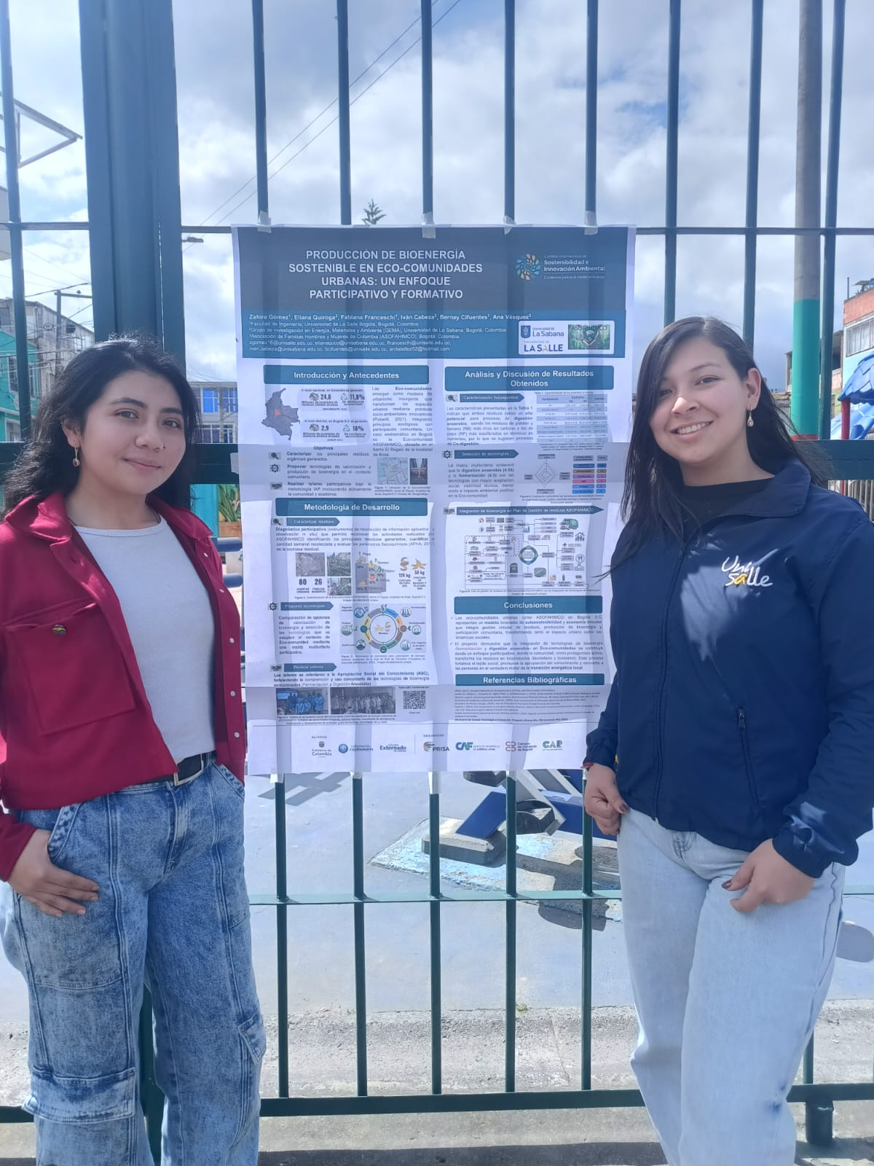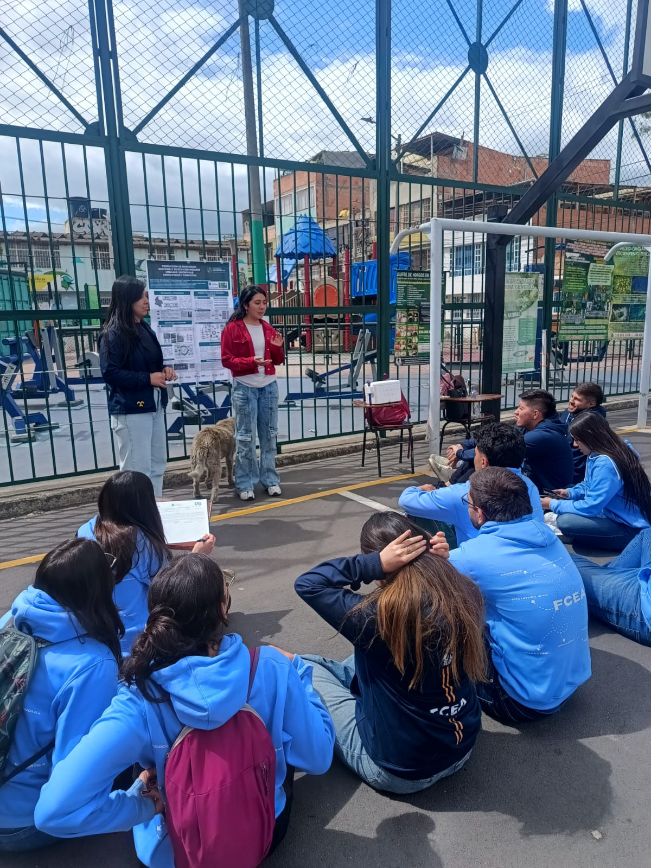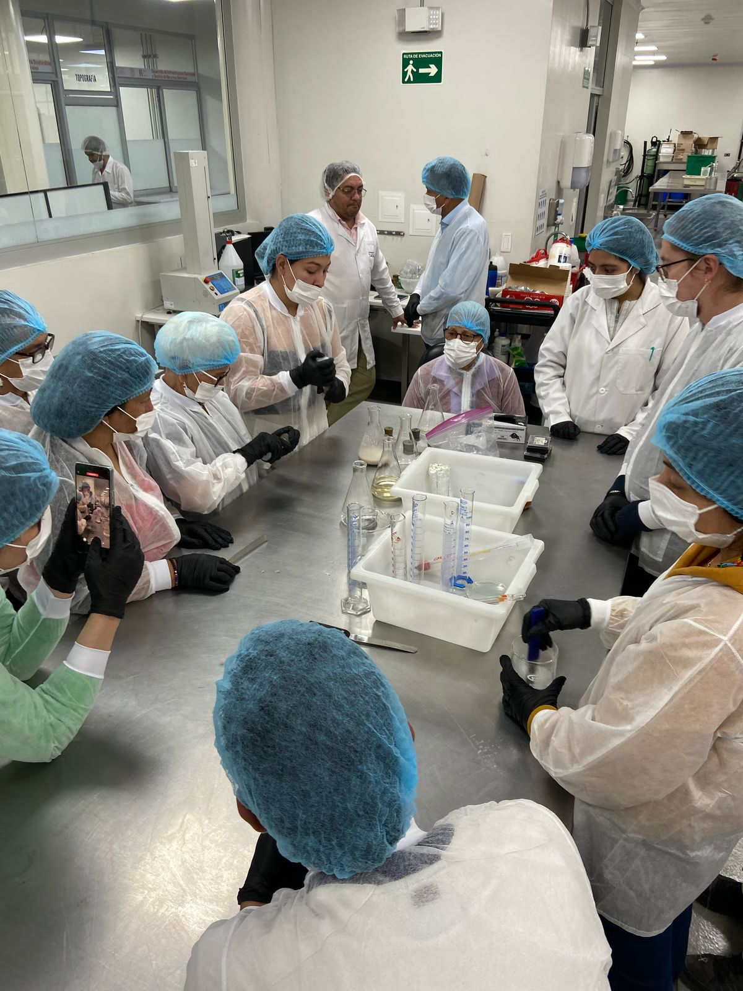
Figure 4: Photographic record of workshop with ASOFAHIMCO eco-community
The approximate investment cost within the community is $11,095.80 USD, covering the acquisition of basic equipment and utensils for the production process. Operating costs amount to $14.4 USD per liter of ethanol, and the selling price, considering a 15% profit margin, would be $17.12 USD per liter. This constitutes a reference baseline experimental process; it is recommended to optimize the hydrolysis and fermentation stages to reduce operating costs and improve the product's market competitiveness. Notably, these stages account for 77% of operating costs, mainly due to energy and input consumption. By contrast, distillation projects an energy consumption of 1.53 kWh. However, since its operation time is short compared to the duration of fermentation and hydrolysis, distillation represents only 8% of the process's energy cost.
  - Conclusion
Potato peel (Solanum tuberosum) has a high-potential raw material for second-generation bioethanol production. Overall, thermochemical pretreatment at 121 °C for 1.5 h was the operating condition that resulted in the highest degree of biomass disruption. The hydrolysate from pretreatment with HCl 0.1 %v/v reported a higher sugar release (29.08 ± 0.04 g/L) but a lower bioconversion yield (11.23 ± 0.37 g ethanol / 100 g dry peel). In contrast, the hydrolysate from pretreatment with NaOH 0.1 %v/v yielded 24.10 ± 0.07 g sugar/L but fostered a more favorable environment for ethanol bioconversion (12.14 ± 0.45 g ethanol / 100 g dry peel). This suggests that the degradation of lignin and swelling of cellulose fibers caused by the alkaline agent compensate for the lower sugar release during pretreatment, as it promotes enzymatic accessibility and the metabolic efficiency of S. cerevisiae.
Furthermore, the enzymatic synergy between cellulases (Celluclast 1.5 L) and amylases (Amylase AG 300 L) maximizes the saccharification of the wort, given the substrate's nature (lignocellulosic and starchy). The distillate obtained had an alcohol concentration of 80.01 ± 0.19 %v/v, indicating its potential as a biofuel. However, raising the concentration of anhydrous ethanol (>99 %). The collaborative work with the ASOFAHIMCO eco-community not only provided technical training but also demonstrated that utilizing PPW represents an alternative to strengthen the neighborhood's circular economy. It can serve as a source of income through the commercialization of alcohol in local markets.

Acknowledgments

The authors gratefully acknowledge the financial support provided by the Ministerio de Ciencia, Tecnología e Innovación de Colombia (MinCiencias, Francisco José de Caldas Fund, Contract 441-2023, Code 106724), and Zahira Gómez is grateful to the Universidad de La Sabana for the funding his PhD studies through the Carlos Jordana distinction (2025-II) and the Carlos Jordana Doctoral Scholarship.
References
Arapoglou, D., Varzakas, T., Vlyssides, A., & Israilides, C. (2010). Ethanol production from potato peel waste (PPW). Waste Management, 30(10), 1898–1902. doi.org/https://doi.org/10.1016/j.wasman.2010.04.017
Atitallah, B., Antonopoulou, G., Ntaikou, I., Alexandropoulou, M., Nasri, M., Mechichi, T., & Lyberatos, G. (2019). On the evaluation of different saccharification schemes for enhanced bioethanol production from potato peels waste via a newly isolated yeast strain of Wickerhamomyces anomalus. Bioresource Technology, 289, 2–8. doi.org/https://doi.org/10.1016/j.biortech.2019.121614
Ben Taher, I., Fickers, P., Chniti, S., & Hassouna, M. (2017). Optimization of enzymatic hydrolysis and fermentation conditions for improved bioethanol production from potato peel residues. Biotechnology Progress, 33(2), 397–406. doi.org/10.1002/btpr.2427
Chauhan, A., Islam, F., Imran, A., Ikram, A., Zahoor, T., Khurshid, S., & Shah, M. (2023). A review on waste valorization, biotechnological utilization, and management of potato. Food Science and Nutrition, 11(10), 5773–5785. doi.org/10.1002/fsn3.3546
Congress of the Republic of Colombia. (2001, July 19). Ley 693 del 2001. www.funcionpublica.gov.co/eva/gestornormativo/norma.php?i=19114 Translation of Spanish.
DANE. (2023). DANE - PIB Technical information. Gross Domestic Product - PIB. www.dane.gov.co/index.php/estadisticas-por-tema/cuentas-nacionales/cuentas-nacionales-trimestrales/pib-informacion-tecnica. Translation of Spanish.
Ijaz, N., Bashir, S., Ikram, A., Zafar, A., Bader, H., Ambreen, S., Ahmad, M., Almalki, R., Khalid, M., Khalid, W., & Madilo, F. (2024). Valorization of potato peel: a sustainable eco-friendly approach. CYTA - Journal of Food, 22(1), 2–8. doi.org/https://doi.org/10.1080/19476337.2024.2306951
Khanal, S., Karimi, K., Majumdar, S., Kumar, V., Verma, R., Bhatia, S., Kuca, K., Esteban, J., & Kumar, D. (2024). Sustainable utilization and valorization of potato waste: state of the art, challenges, and perspectives. Biomass Conversion and Biorefinery, 14(19), 23335–23360. doi.org/https://doi.org/10.1007/s13399-023-04521-1
Khawla, B., Sameh, M., Imen, G., Donyes, F., Dhouha, G., Raoudha, E., & Oumèma, N.-E. (2014). Potato peel as feedstock for bioethanol production: A comparison of acidic and enzymatic hydrolysis. Industrial Crops and Products, 52, 144–149. doi.org/10.1016/j.indcrop.2013.10.025
Miller, G. (1959). Use of Dinitrosalicylic Acid Reagent for Determination of Reducing Sugar. Analytical Chemistry, 31(3), 426–428. doi.org/10.1021/AC60147A030
Narisetty, V., Nagarajan, S., Gadkari, S., Ranade, V. V., Zhang, J., Patchigolla, K., Bhatnagar, A., Kumar Awasthi, M., Pandey, A., & Kumar, V. (2022). Process optimization for recycling of bread waste into bioethanol and biomethane: A circular economy approach. Energy Conversion and Management, 266, 115784. doi.org/10.1016/J.ENCONMAN.2022.115784
Sharma, H. K., Xu, C., & Qin, W. (2019). Biological Pretreatment of Lignocellulosic Biomass for Biofuels and Bioproducts: An Overview. Waste and Biomass Valorization, 10(2), 235–251. doi.org/10.1007/S12649-017-0059-Y/TABLES/3
Walker, G. M., & Stewart, G. G. (2016). Saccharomyces cerevisiae in the Production of Fermented Beverages. Beverages 2016, Vol. 2, Page 30, 2(4), 30. doi.org/10.3390/BEVERAGES2040030
Zoghlami, A., & Paës, G. (2019). Lignocellulosic Biomass: Understanding Recalcitrance and Predicting Hydrolysis. Frontiers in Chemistry, 7, 874. doi.org/10.3389/FCHEM.2019.00874/FULL
Bogotá D.C., April 2026
Organizing Committee
Editor in Chief
Chemical Engineering Transactions
Subject: Revisions of paper #47

Please accept my warm regards.
We have received the comments from the reviewers of the article entitled: " Bioethanol Production from Potato Peels (Solanum Tuberosum) as Sustainable Alternative for Urban Eco-Communities", and we appreciate the observations that allow us to improve our manuscript for publication. Below is the detail of the corrections made.
Reviewer #1:
Please clarify the energy requirements for the reduced-pressure distillation stage, as this is a critical factor for the feasibility of the process within the community. | First of all, I appreciate the observation regarding the impact of the distillation stage on the process. Based on this, the operating cost was estimated for the processing of 126 kg of potato peel waste managed weekly by the community. It was identified that the stages with the highest energy consumption are hydrolysis and fermentation, as they remain in operation for 48 h and 72 h, respectively.
In Figure 2, ensure that the error bars are clearly visible for all data points to support the stated standard error of less than 5% | Thank you for your valuable observation. We carefully reviewed Figure 2 and confirm that the error bars corresponding to the standard error (less than 5%) are included for all data points. However, due to the relatively small magnitude of the error, the bars may appear less prominent at the current scale of the figure.
Reviewer #2:
The authors should provide, if possible, an analysis of the operating costs. | We appreciate the suggestion and will take it into account when analyzing the operating and initial investment costs required for implementing the Project in the ASOFAHIMCO community. Based on this analysis, an operating cost of $14.4 USD per liter of ethanol produced is documented, with an investment cost of $11,095.80 USD. It is noteworthy that the experimental process was carried out at laboratory scale and requires the establishment of an optimization process for the hydrolysis and fermentation stages, in order to increase yield and reduce costs associated with energy and input consumption, which account for approximately 77% of production costs.

We will be following the process closely.
Sincerely,
Authors

