 CHEMICAL ENGINEERING TRANSACTIONS  VOL. xxx, 2026 | A publication of  
The Italian Association
of Chemical Engineering
Online at www.cetjournal.it

Guest Editors: Leonardo Tognotti, Rubens Maciel Filho, Viatcheslav Kafarov
Copyright © 2026, AIDIC Servizi S.r.l.
ISBN 979-12-81206-xx-x; ISSN 2283-9216

Syngas Production from Biomass in a Fixed Bed Gasifier Using Aspen PlusTM: Modelling and Simulation
Yurany Camacho Ardilaª*; Jaiver Efren Jaimes Figueroa^{b}, Pablo Miguel Coha Vesga^{c}
ª School of Environmental Engineering, Universidad Pedagógica y Tecnológica de Colombia, 150003, Tunja, Boyacá
^{b} School of Chemical Engineering, Federal University of Maranhão, Av. do Portugueses, 1966. Cidade Universitária “Dom Delgado”, CEP 65080-805.São Luís-M, Brazil.
^{c}School of Metallurgical Engineering, Universidad Pedagógica y Tecnológica de Colombia, 150003 Tunja, Boyacá, Colombia
*yurany.camacho01@uptc.edu.co
The production of biofuels from biomass offers an alternative to supply the limited reserves of petroleum. Currently, biomass is utilized in various thermochemical processes, with gasification being a notable example. Gasification produces synthesis gas, a mixture mainly composed of CO, H₂, and CO₂. This gas is utilized to generate energy, various chemical products, and biofuels such as bioethanol. Using mathematical models and their computational simulation can help to evaluate the feasibility of this technology regarding operational conditions. This work aims to simulate a fixed-bed gasifier (FB) using elemental and proximate analysis, considering steady state, and employing the Aspen Plus™ simulator. The model accounts for several processes relevant to converting biomass into synthesis gas, including drying, pyrolysis, oxidation, reduction of CO₂, H₂O, and H₂ with char, and tar cracking. The gasifier model is based on yields and chemical kinetics, using data from studies on char produced from sugarcane bagasse. Fourteen reactions were considered to represent the gasification process. The effects of the equivalence ratio (ER), steam injection, and air preheating on the composition of synthesis gas were examined. It was observed that the gasification temperature increases nearly linearly with the air temperature and that increasing the ER reduces the amount of CH₄. Low ER lead to higher CO levels compared to CO₂. For ER values of 0.29-0.38, CO₂ dominates the composition, with only slight changes in H₂, unlike the other gases (CO, CO₂, and CH₄). High H₂ levels are observed when the SB ratio for the LF reactor is varied; as this ratio increases, H₂ and CO₂ concentrations also rise, while CO levels decrease (SB values ≥ 1.75).

Keywords: biomass, Aspen Plus, biofuels, Syngas, Gasification

  - Introduction
The production of clean and sustainable fuels is the main challenge in facing future energy crises and global warming. Among all renewable energy sources, biomass stands out as a potential alternative to increase energy independence from fossil fuels and minimize environmental pollution. The use of biomass such as sugarcane bagasse to produce energy, biofuels, or chemicals can be achieved through thermochemical routes. Thermochemical conversion technologies (pyrolysis, gasification, and combustion) are promising options for transforming biomass raw materials into liquid oils and gases that, in turn, through other processes, can generate energy, biofuels, and chemicals (Hu and Chen, 2025). Gasification, combustion, and pyrolysis are distinguished both by the amount of oxidant used and by the products of interest generated. As pyrolysis is carried out without oxidation and combustion with excess product (O₂), gasification uses quantities below the stoichiometrically necessary quantities based on the amount of carbon present in the reactions. As products of interest, pyrolysis at low temperatures and short times of reaction produced mainly liquid compounds (Figueroa et al., 2013). Combustion is carried out to harness heat, generating gaseous by-products, essentially carbon dioxide (CO₂) and steam (H₂O), while gasification aims to obtain gaseous energy vectors, mainly H₂, CO, and CO₂. Gasification and pyrolysis are integrated by pyrolysis, which represents the initial stage of the gasification process, known as the initial decomposition of biomass (or pyrolysis), and which also plays an important role in the subsequent chemical and physical changes (Castro et al., 2009). The gasification of sugarcane bagasse offers the advantage of producing synthesis gas, allowing the entire sugarcane plant, from its origin to its destination, to be utilized in the process. In addition to steam turbines, the clean synthesis gas from bagasse can also be used in stationary gas turbines (Ahmed and Gupta, 2012). Furthermore, gasification offers the flexibility of using the produced synthesis gas to convert it into liquid fuels. Therefore, this work presents the simulation of a fixed-bed reactor for the production of synthesis gas from the gasification of sugarcane bagasse. The influence of temperature, gas composition, product yields, and the effectiveness of the gasifying agent were evaluated.

  - Simulation
The following stages were considered for the simulation development:

The characterization of the biomass for the proximate and elemental non-conventional components was developed using the data shown in Table 1 and following the methodology proposed by Camacho-Ardila et al. (2025). For the higher heating value (HHV) data, the correlations of Camacho-Ardila et al. (2024) were used in Fortran.
Table 1: Proximate and ultimate analysis of sugarcane bagasse used in the simulation
Proximate (w/w%)ª |  | Ultimate (dry basis-w/w%)ª |  | Average particle diameter (mm)^{b} |  | Mass fraction  Retained^{b}
Moisture (air) | 7.8 | C | 44.52 | 0.00 | 0.60 | 0.21
Fixed carbon-FC-(dry basis) | 10.81 | H | 5.90 | 0.60 | 0.85 | 0.18
Volatile material-VM-(dry basis) | 83.97 | N | 0.32 | 0.85 | 1.18 | 0.22
Ash(dry basis) | 5.22 | Cl | 0.29 | 1.18 | 2.00 | 0.11
 |  | S | 0.10 | 2.00 | 2.36 | 0.05
 |  | O | 43.65 | 2.36 | 4.75 | 0.06
 |  |  |  | 4.75 | 6.30 | 0.01
 |  |  |  | 6.30 | 9.00 | 0.16
a: Figueroa et al. 2014 b: Taken from Camacho-Ardila et al. (2025)

-The model was developed in a steady state.
-The empirical formula for char is CH_{0.2909}O_{0.0507}N_{0.032}S_{0.0044}Cl_{0.0116,} and for tar is CH_{1.3558}O_{0.5098}. These values were obtained from the elemental analysis generated by Camacho-Ardila et al. (2025) for the pyrolysis of sugarcane bagasse at a temperature of 600 °C.
-A fixed-bed reactor with a diameter of 15 cm and a height of 2 m was considered (Akay and Jordan, 2006). The total volume of the reactor was divided into two parts with the same volume.
-Conventional components used during the simulation are CO, CO₂, H₂, CH₄, ethane, ethylene, HCl, H₂S, NO and NH₃.
- Air or steam water was considered as the gasifying agent.
-Variations were made in the main operating parameters such as equivalence ratio (ER), steam-biomass ratio (SB), gasification temperature, and air preheating temperature.
- Figure 1 represents the flowsheet for fixed-bed gasification of sugarcane bagasse.

    - Drying and pyrolysis
To define the compositions of tar, gases, and char generated during the initial stage of gasification, the methodology presented in Camacho-Ardila et al. (2025) (blocks SEC-1, SEC-2, PIROLPRI Figure 1) was used, thus defining the drying and devolatilization of sugarcane bagasse. For this case study, the correlations proposed for the fixed bed were considered as a basis. The pyrolysis temperature was fixed at 600 °C.

    - Gasification
The reactions used to represent the behavior of the fixed bed reactor and the kinetic parameters were taken according to the methodology proposed by Ardila (2015) on page 140. Fourteen reactions are considered to represent the char, tar, and gases. The reactions consider the char in the form of CH_{x}O_{y}N_{w} S_{z}Cl_{p} and tar in the form of CHaOb, derived from the pyrolysis of sugarcane bagasse. Homogeneous and heterogeneous reactions were applied to the CSTR reactor block COMBS (Figure 1), using kinetics through a FORTRAN code. In the reactions of the GAF block, only homogeneous reactions were considered. The Z0-0 mixing block simulates the distributor of the gasifier.

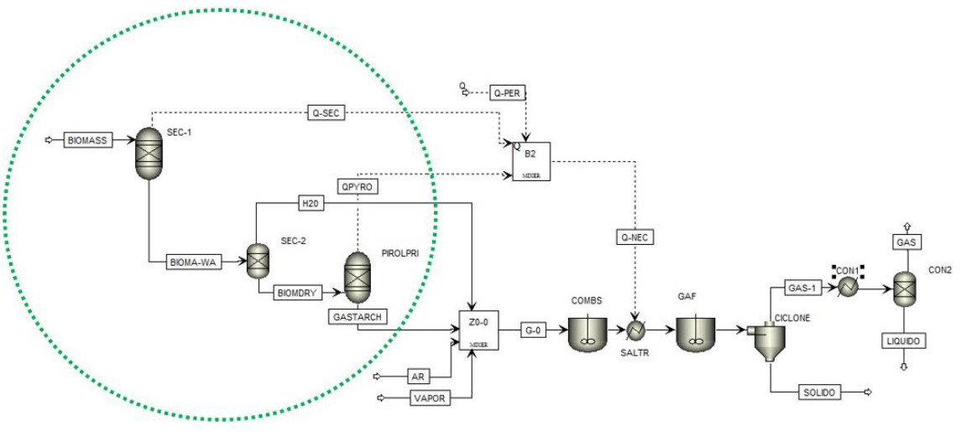
Figure 1. Flowsheet of a fixed-bed reactor simulation for sugarcane bagasse gasification in Aspen Plus™. Pyrolysis stage, according to Camacho-Ardila et al. (2025).

    - Gas Cleaning
The gas outlet from the gasifier contains impurities of particulate matter, carbon, and ash, as well as tar, which are considerable and must be separated in order to use this gas for future chemical processes. The CYCLONE block simulates the cyclone separator, which is commonly used for the separation of solid particles dispersed in the gas phase. The streams corresponding to SOLIDS represent the separation of carbon and ash. The blocks, CON1 and CON2 represent the condensation of tar. Finally, the GAS stream represents the synthesis gas obtained during gasification, no other cleaning methods besides cyclones and condensers having been used.
    - Simulation validation
To validate the developed model, experimental data from the literature for the fixed-bed gasifier were used. The differences between the experimental and predicted values are estimated using the root mean square (RMS) value for each dataset (Eq. 1).
(1)
Where n is the number of points studied.
  - Results and Discussions
The gasification model was validated with experimental data obtained by Akay and Jordan (2011) and Figueroa et al. (2013). Akay and Jordan (2011) used air as a gasifying agent in their experiments, while Figueroa et al. (2013) used water steam in a biomass ratio (SB) of 2 and a temperature of 900 °C (Table 2).

The largest deviations between simulated and experimental data were obtained for CO composition, and the smallest deviations for CO₂, H₂, and CH₄ (Table 2). Specifically, deviations the CO at ER = 0.26 are attributed to the difference between the kinetic model and experimental conditions. While the simulation is based on the kinetic subroutine, which assumes an optimized conversion of the char into gaseous products, the experimental setup by Akay and Jordan (2011) is subject to physical constraints. At low ER values (0.26), heat losses and shorter residence times in the physical reactor reduce the efficiency of the gasification reactions, resulting in a higher accumulation of residual char and a consequently lower CO yield compared to the simulated predictions. Furthermore, the impact of this deviation on the overall energy balance is minimal. Since the model accurately predicts the concentrations of H₂ and CH₄, the slight overestimation of CO does not significantly shift the total higher heating value (HHV) trends. However, the overall deviation for CO is low, without significantly altering a gasification study. The RMS in the fixed-bed gasification process shows good agreement between experimental and simulated data. These RMS values indicate that the proposed simulation adequately represents the process and, therefore, can be applied to gasification studies.

Table 2: Comparison between simulated and experimental data of the gasification process using an FB gasifier
ER |  | COª | CO^{b} | CO₂ª |  | CO₂^{b} | H₂ª | H₂^{b} | CH₄ª | CH₄^{b}
0.26 | 18 |  | 11 |  | 12.2 | 14.3 | 7.9 | 8.9 | 2.3 | 1.8
0.3 | 13.2 |  | 10.8 |  | 14.9 | 15.2 | 6.8 | 5.8 | 2.6 | 2.5
0.32 | 11.8 |  | 11.9 |  | 15.6 | 14.9 | 6.5 | 8.5 | 2.5 | 1.6
0.38 | 13.2 |  | 13.1 |  | 14.9 | 13.7 | 7.2 | 6.5 | 0.6 | 0
RMS | 4.3 |  |  |  | 1.3 |  | 1.3 |  | 0.6
SB | COª |  | CO^{c} |  | CO₂ª | CO₂^{c} | H₂ª | H₂^{c} | CH₄ª | CH₄^{c}
2 | 14.91 |  | 17 |  | 17.03 | 20.0 | 66.25 | 60 | 1.44 | 3.0
RMS | 2.09 |  |  |  | 2.97 |  | 0.25 |  | 1.56
a: simulation; b: Akay and Jordan (2011) c: Figueroa et al. (2013).

    - Effect of the equivalence ratio (ER) on the composition of the synthesis gas.
The variation in the composition of the gasification gas as a function of the equivalence ratio (ER) in the reactor using sugarcane bagasse with a moisture content of 7.8% is shown in Figure 2.

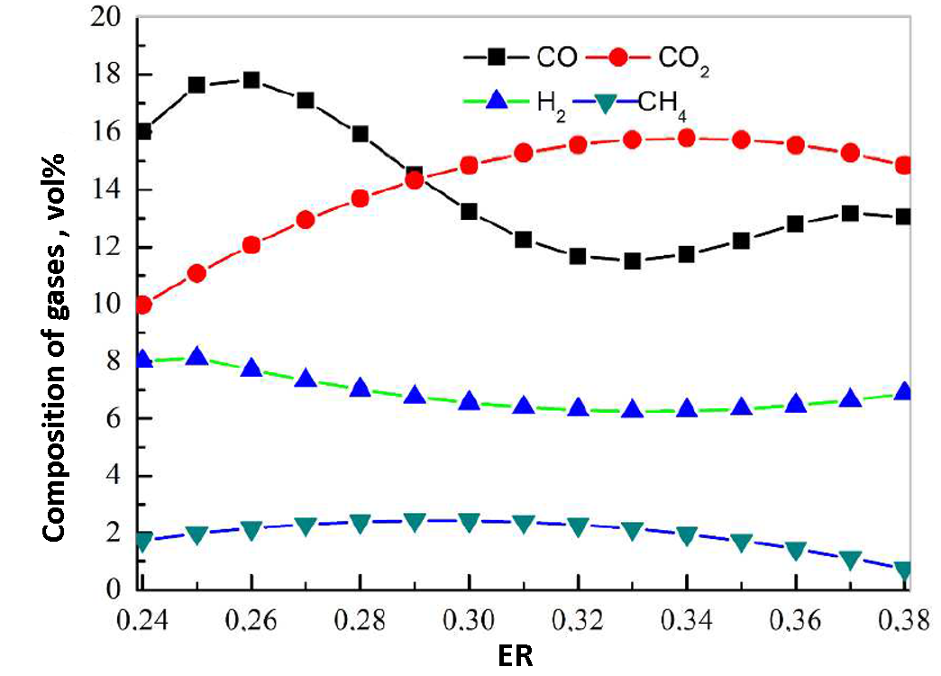
Figure 2. Variation in the composition of the synthesis gas when varying the ER in an FB reactor using sugarcane bagasse.

According to Figure 2, increasing the ER ratio decreases the amount of CH₄. Low ER ratios show higher CO values when compared to the composition of CO₂. For ER values of 0.29-0.38, the composition of CO₂ predominates, and the amount of H₂ is altered in small proportions, unlike what happens with the other three gases analyzed (CO, CO_{2,} and CH₄). A synthesis gas composition, the HHV of the gas, and products yield in the FB reactor, when using a specific ER (with air) ratio, are presented in Table 3.

Table 3: Characterization of synthesis gas using ER
Syngas Composition, vol% ER:0.25 |  | Yield of products from gasification (%) ER:0.3
CO | 18.0 | Y_{gas} | 86.06
CO₂ | 11.0 | Y_{liquid} | 3.46
H₂ | 8.0 | Y_{solid} | 10.48
CH₄ | 2.0
HHV | 4.08ª
ª HHV= 12.75(H₂ )+ 12.65(CO)+39.82(CH₄) / 100 Radmanesh et al (2006)

The gas yield of 86.06% is significantly high for a fixed-bed reactor, suggesting that the Aspen Plus™ model effectively captures biomass decomposition and tar cracking. This reduces reliance on complex solid (char) and liquid (bio-oil) waste management systems, simplifying industrial operation. The HHV of 4.08 MJ/Nm³ is due to a synergistic mixture where carbon monoxide (18.0% vol) acts as the primary energy carrier, complemented by hydrogen and methane.

    - Effect of the steam-biomass ratio (SB) on the composition of the synthesis gas
Figure 3 shows the effect of water vapor on the composition of gases in the fixed-bed reactor. Figure 3.a shows that high H₂ values are found when the SB ratio is varied for the FB reactor. As this ratio increases, the H₂ composition also increases, as does the CO₂ composition, while the CO composition decreases (SB values ≥ 1.75). The CH₄ composition was approximately 2% (vol). The NH₃ composition was the highest among the impurities (Figure 3.b). When the SB value was varied above 1.5, the maximum percentages of NH₃, HCl, H₂S, and NO obtained were 0.0075%, 0.0025%, 0.00125%, and < 0.001% (vol), respectively.

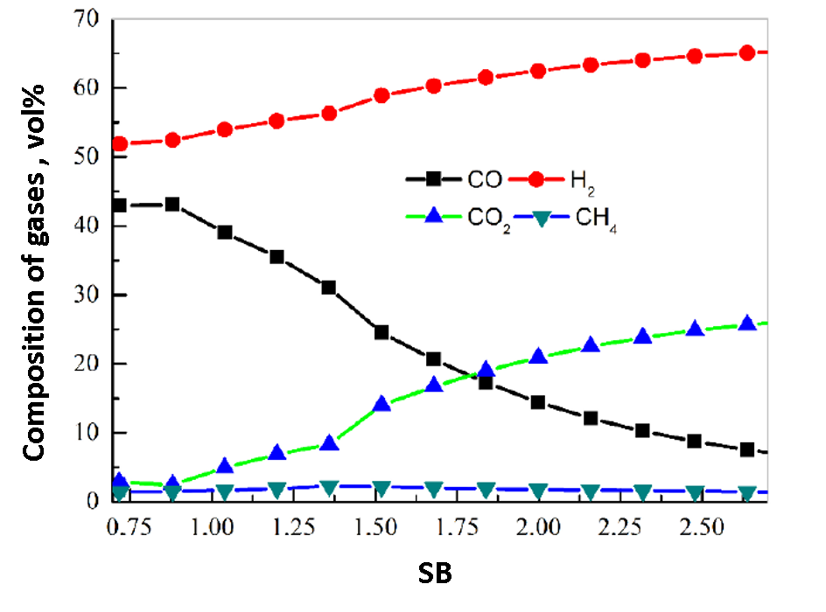  (a) | 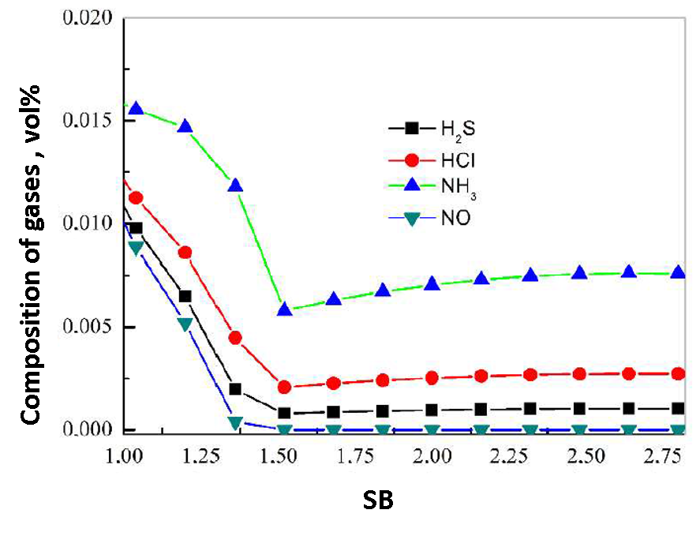  (b)
Figure 3. Effect of steam injection on syngas composition (T=800 °C) a) CO, CO₂, H₂ and CH₄ b) H₂S, HCl, NH₃ and NO

The behavior of gases in relation to gasification temperature is shown in Figure 4.

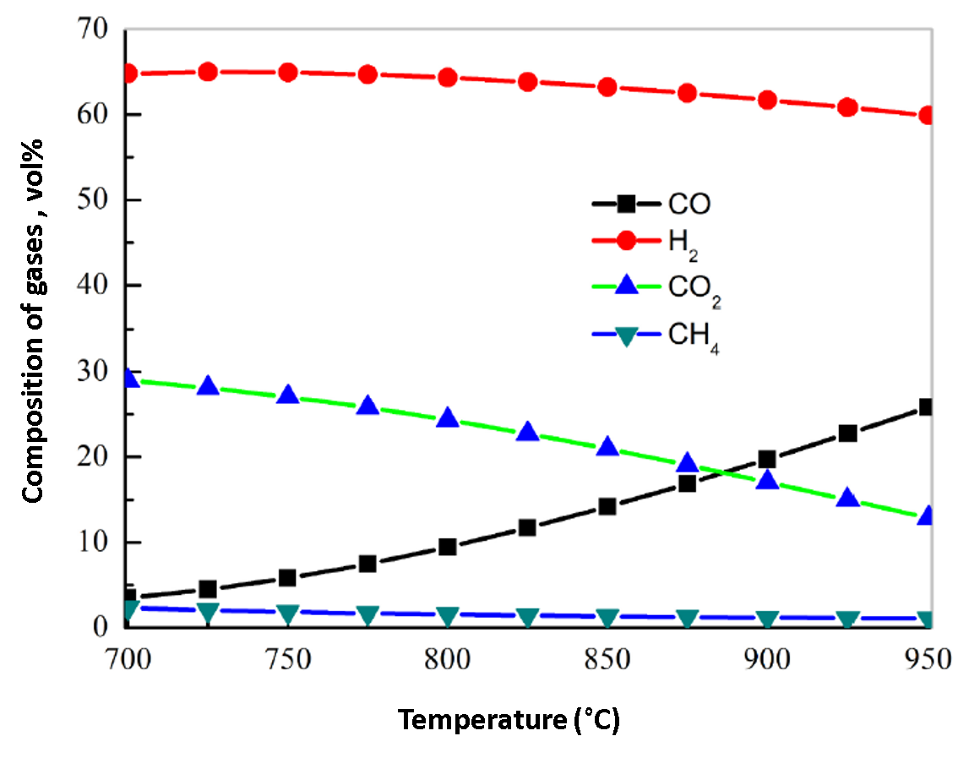
Figure 4. Effect of gasification temperature on the composition of synthesis gas in an FB reactor (SB = 2)

For a fixed value of SB, increasing the temperature favors the formation of CO and a decrease in CO₂, as well as CH₄. The composition of H₂ shows a slight reduction; however, its composition is always high, around 65% at a temperature of 700 °C and 59% at a temperature of 950 °C.
    - Effect of air preheating on the composition of synthesis gas
The influence of air preheating during gasification reactions was studied for the fixed-bed reactor (Figure 5). It was verified that the gasification temperature increases practically linearly with the air temperature, as already demonstrated by authors such as Puig Arnavat (2011) and Radmanesh et al. (2006).

The composition of H₂ and CO in the synthesis gas increases with temperature, as shown in Figure 5. At a temperature of 25 °C, an H₂ composition close to 5% vol was found, while at an air temperature of 825 °C, a composition of 7.5% vol was obtained. The CO₂ composition decreases slightly with increasing air temperature, reducing by 3% of its value when compared at temperatures of 25 °C and 825 °C.
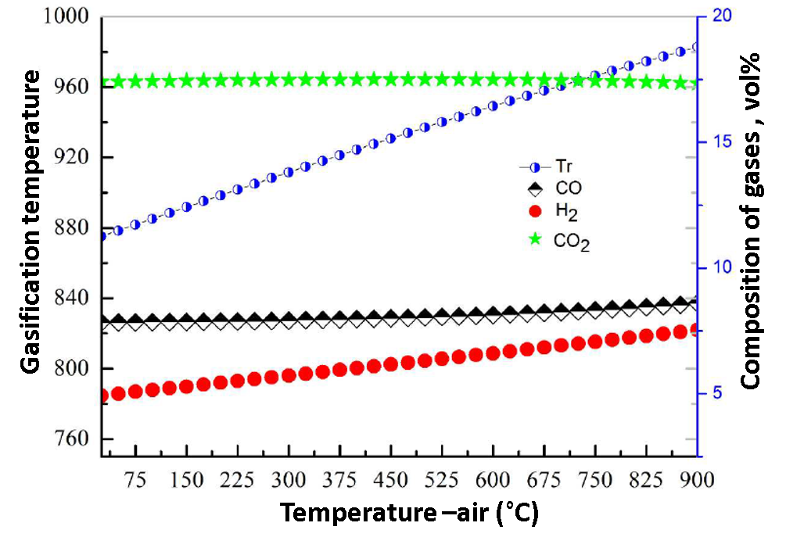
Figure 5. Effect of air preheating on the composition of the synthesis gas in a reactor of FB (ER = 0.28)

  - Conclusions
Simulation in Aspen Plus™ demonstrated that the proposed kinetic model accurately represents sugarcane bagasse gasification, with RMS values as low as 0.25 for H₂. It was determined that air preheating acts as a thermal driver, linearly raising the reactor temperature and kinetically favoring the formation of H₂ and CO while reducing CO₂ content. Furthermore, the transition to steam gasification (SB ≥ 1.75) shifts the equilibrium toward higher hydrogen production. Finally, impurity analysis revealed NH3 as the predominant contaminant (0.0075% vol), establishing critical parameters for the design of gas cleaning and purification systems.
Acknowledgments
The authors gratefully acknowledge the Laboratory of Optimization, Design, and Advanced Control (LOPCA-UNICAMP) for using the software Aspen Plus.
References

Akay, G., Jordan, C. A., 2011. Gasification of Fuel Cane Bagasse in a Downdraft Gasifier: Influence of Lignocellulosic Composition and Fuel Particle Size on Syngas Composition and Yield, Energy & Fuels, 25, 5, 2274-2283.
Ahmed, I.I., Gupta, A.K., 2012, Sugarcane bagasse gasification: Global reaction mechanism of syngas evolution, Applied Energy, 91, 1, 2012, 75-81.
Ardila C.Y., 2015. Gasification of biomass for syngas production and subsequent fermentation to bioethanol: modeling and process simulation, PhD Thesis, Universidade Estadual de Campinas, Campinas, Brasil, p. 140 (in Portuguese).
Camacho-Ardila, C. Y., Figueroa, J.E.J., Wolf M., M.R., 2024. Mathematical models for predicting the higher heating value and ultimate analysis of biomass, Industrial Crops and Products, 208, 117777.
Camacho-Ardila Y., Figueroa J.E.J., Coha-Vesga P.M., 2025. Simulation of the Pyrolysis of Biomass Based on Ultimate and Proximate Characterizations, Chemical Engineering Transactions, 118, 373-378.
Castro, J. A., Cassiano, D. A. Ferreira, N. L., 2009, Gaseificação do bagaço de cana-de-açúcar: modelagem, análise e comparação com sistema real. Exacta, 7, 1, 39-47.
Doherty, W., Reynolds, A., Kennedy, D., 2009, The effect of air preheating in a biomass CFB gasifier using ASPEN Plus simulation, Biomass and Bioenergy, 33, 9, 1158-1167.
Figueroa, J.E.J., Ardila, Y.C., Hoss L.B., Filho, R.M. Wolf M.M.R., 2013, Evaluation of pyrolysis and steam gasification processes of sugarcane bagasse in a fixed bed reactor, Chemical Engineering Transactions, 32, 925-930.
Figueroa, J. E.J., Ardila, Y.C., Filho, R. M., Wolf, M.R., 2014, Fluidized bed reactor for gasification of sugarcane bagasse: Distribution of syngas, bio-tar and char. Chemical Engineering Transactions, 37, 229-234.
Hu, Y.; Chen, Z., 2025, Thermochemical Conversion of Sewage Sludge: Progress in Pyrolysis and Gasification. Water,17, 1833.
Puig Arnavat M., 2011, Performance modelling and validation of biomass gasifiers for trigeneration plants, PhD Thesis, Universitat RoviraI Virgili, Tarragona.
Radmanesh, R., Chaouki, J., Guy, C., 2006, Biomass gasification in a bubbling fluidized bed reactor: Experiments and modeling. AIChE Journal, 52, 12, 4258-4272.

